A1: Supplemented Historic Data
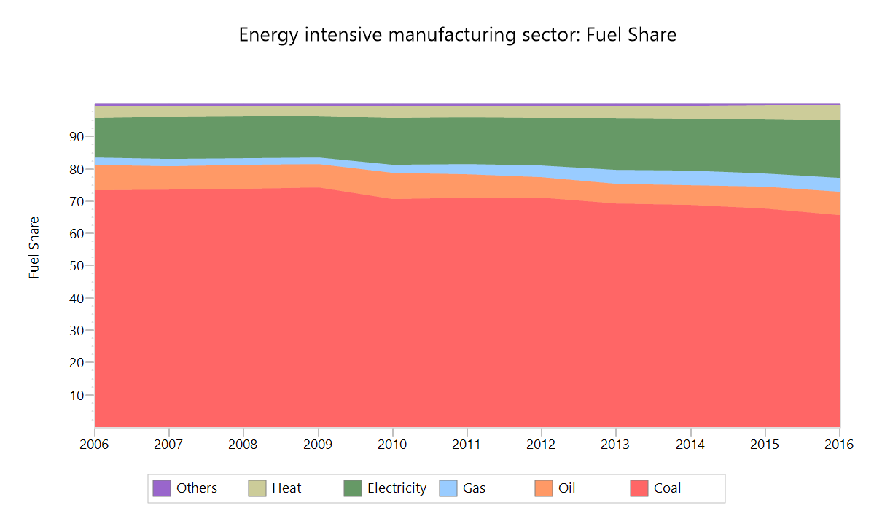
Data Source: self-collected from NBSC (2007a; 2017b) and self-recalculated
A1-1. Fuel share of energy-intensive manufacturing sector
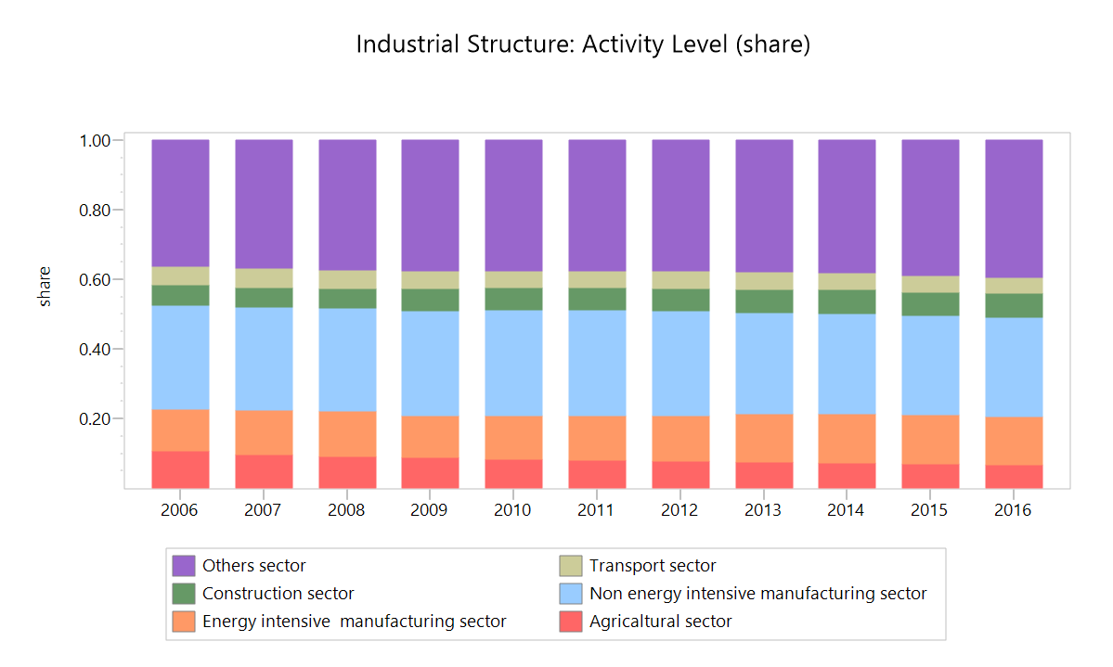
Data Source: self-collected from NBSC (2007a; 2017b), NBSC (2001-2006, 2007, 2008-2016, 2017c) and NBSC (http://www.stats.gov.cn/)
A1-2. Share of GDP for various sectors in China

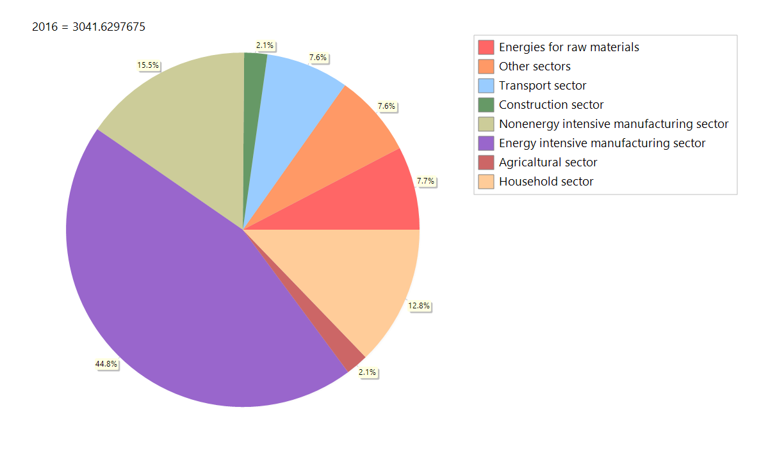
Data Source: self-collected from NBSC (2007a; 2017b) and self-calculated
A1-3. Share of energy consumption for each sector in China (2016)
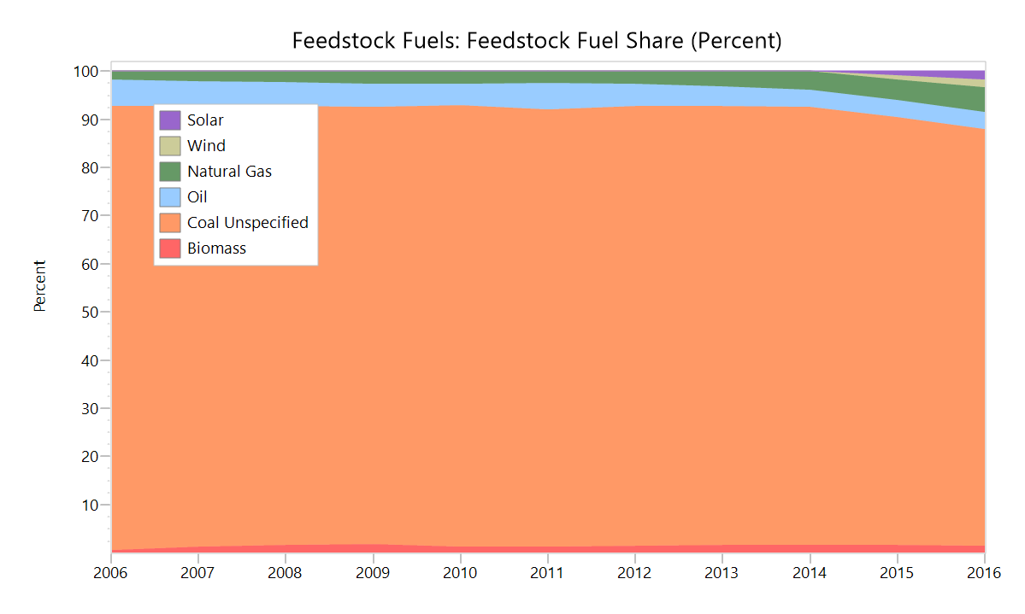
Data Source: self-collected from NBSC (2007a; 2017b) and self-calculated

A1-4. Historical fuel mix for heat production
A2: Supplemented Hypothesis Data

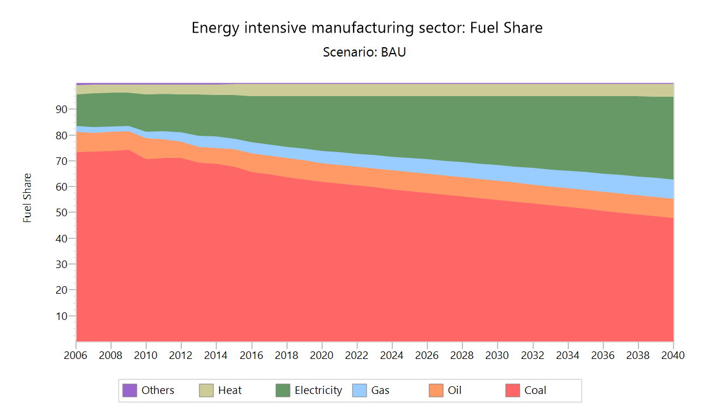
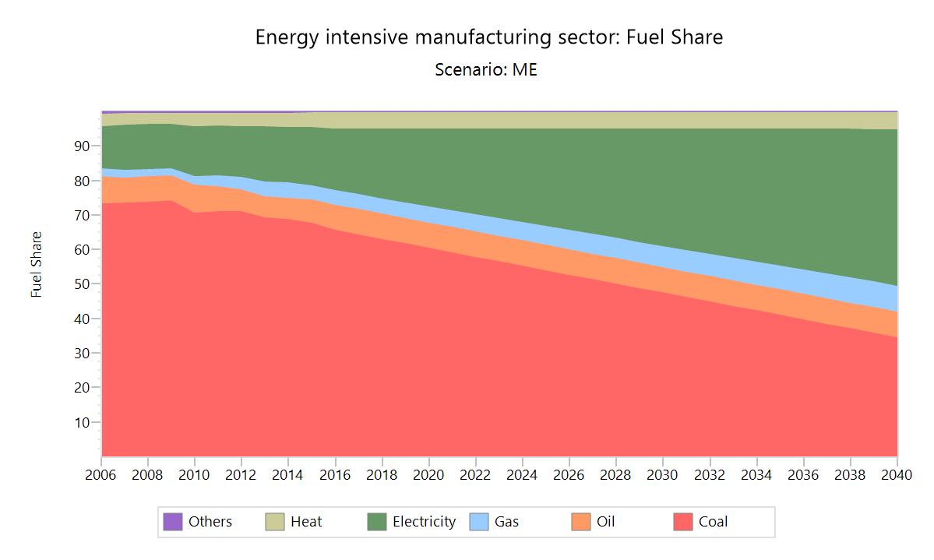
A2-1. Evolution of the fuel mix for energy-intensive manufacturing sector in the BAU and ME scenarios

A2-3. Comparison of the energy intensities of AV for energy-intensive manufacturing sector in BAU and EE scenarios

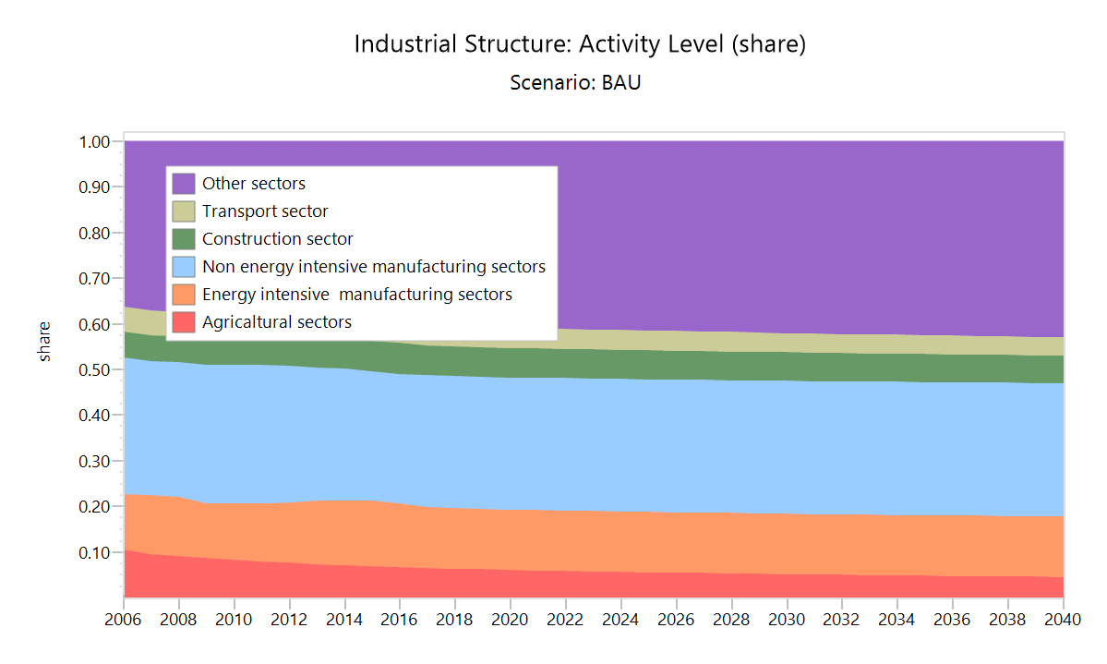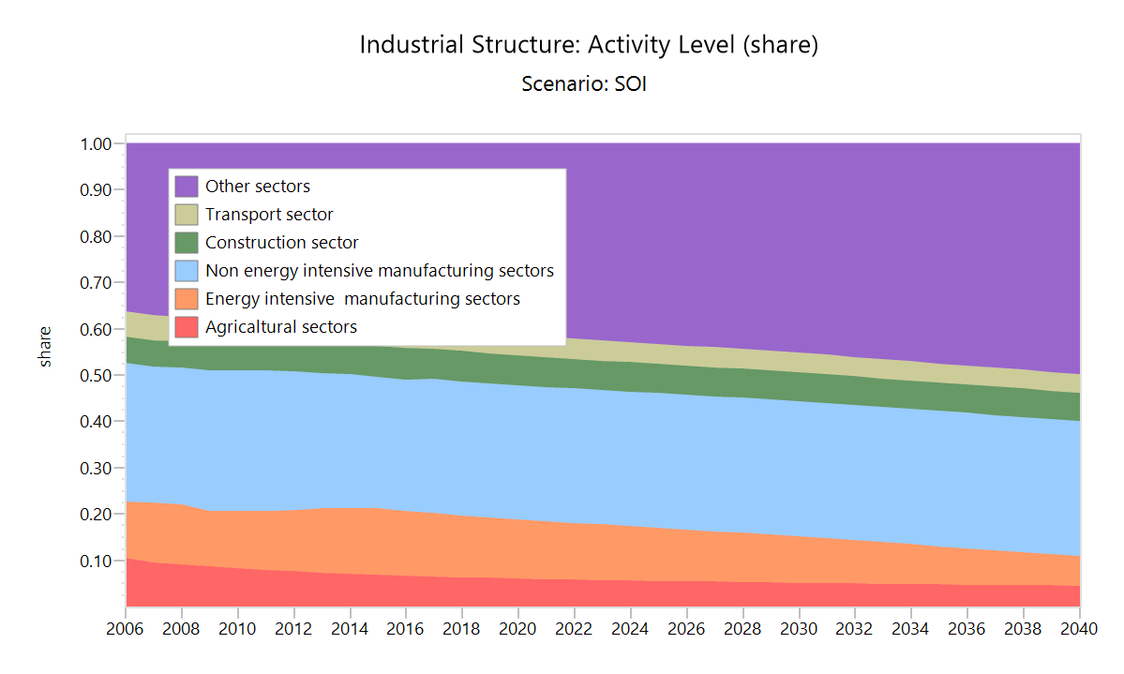
A2-3. Comparison of the industrial structures in BAU and SOI

A3: Supplemented Simulation Results

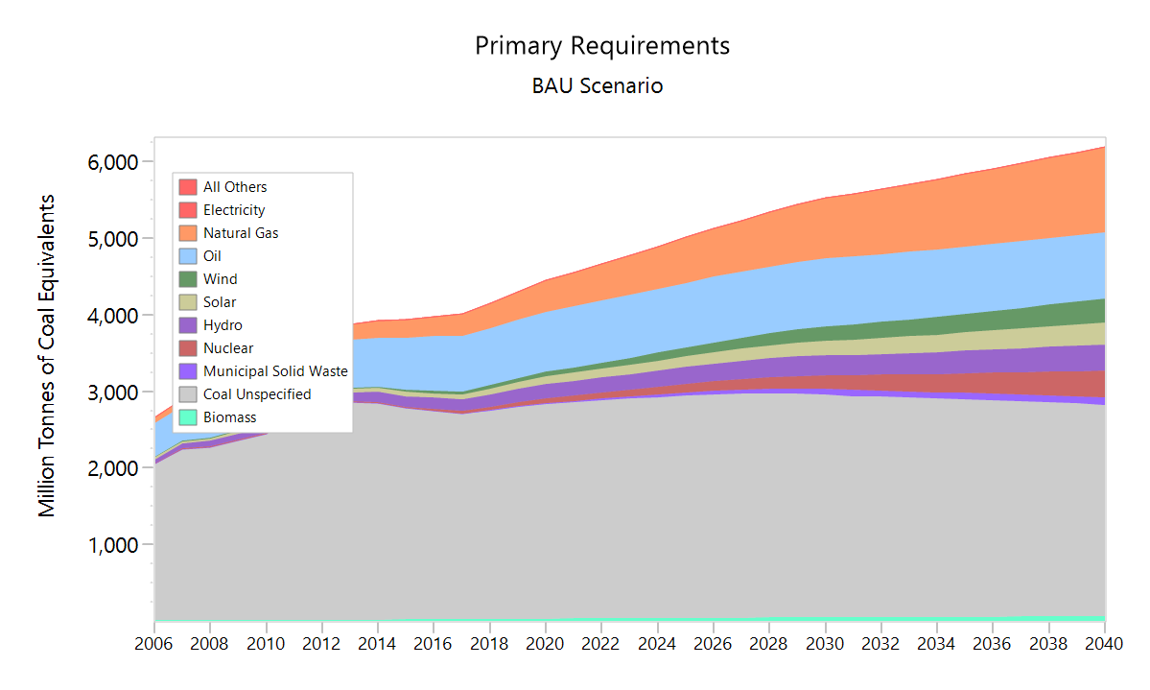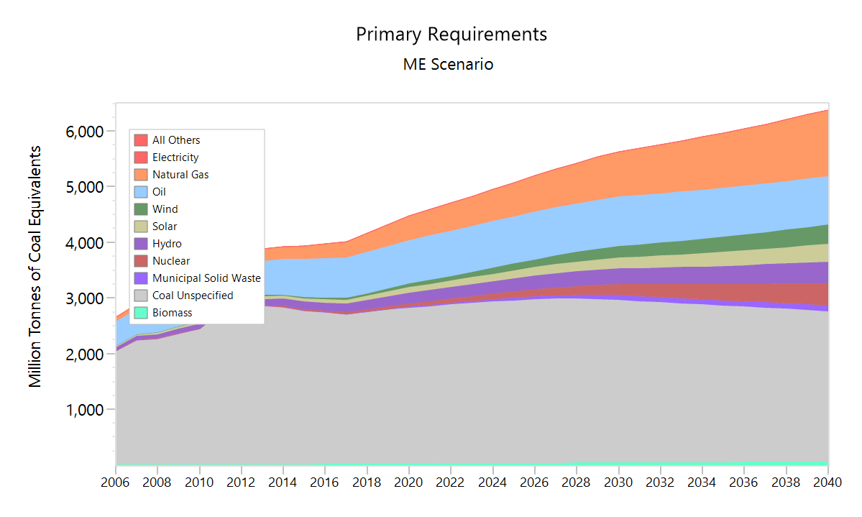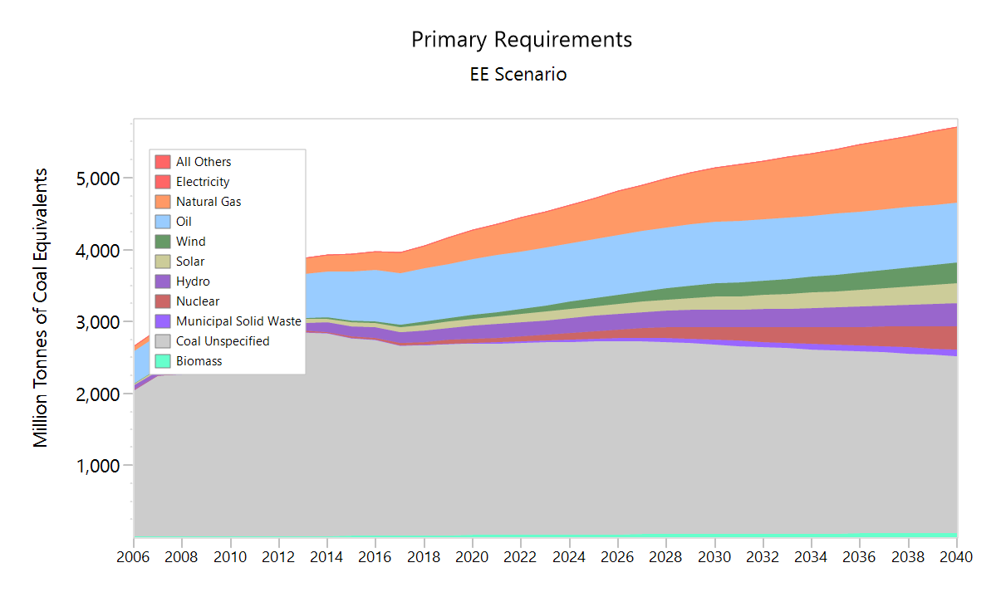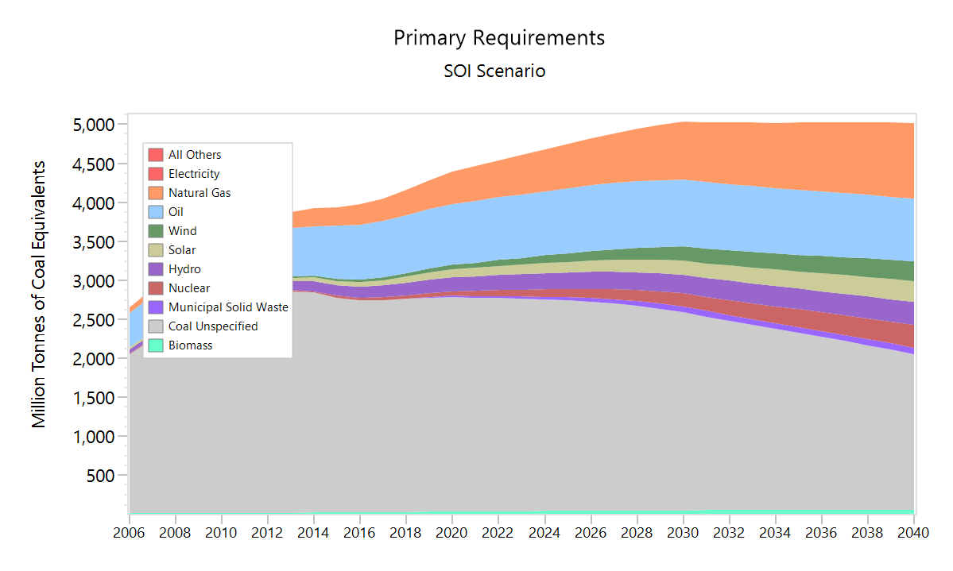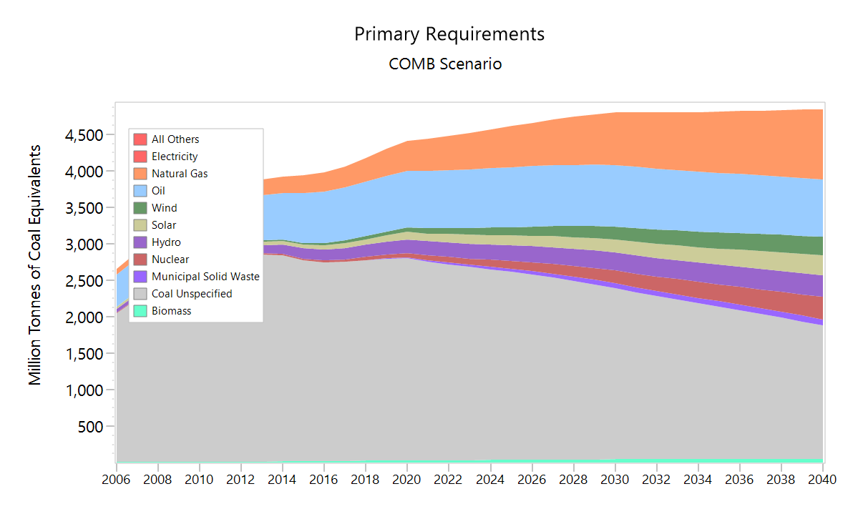
A3-1. Simulation results of the fuel mix for all scenarios

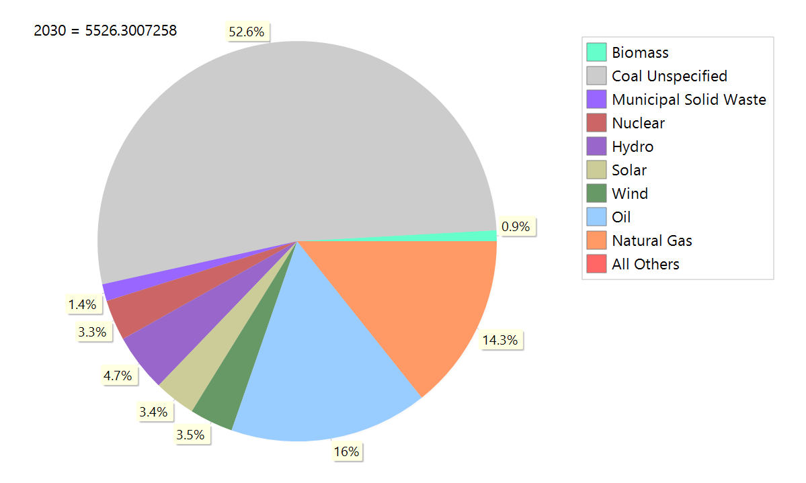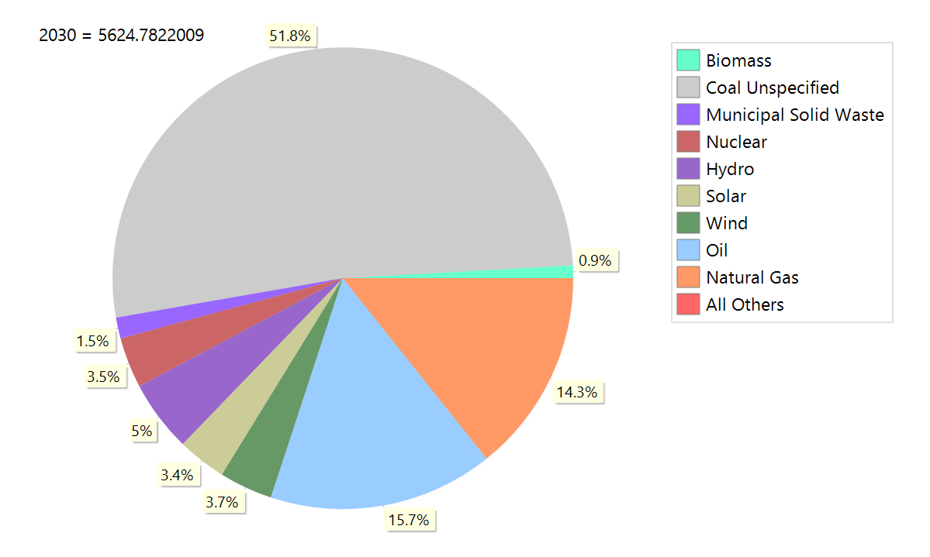
BAU ME
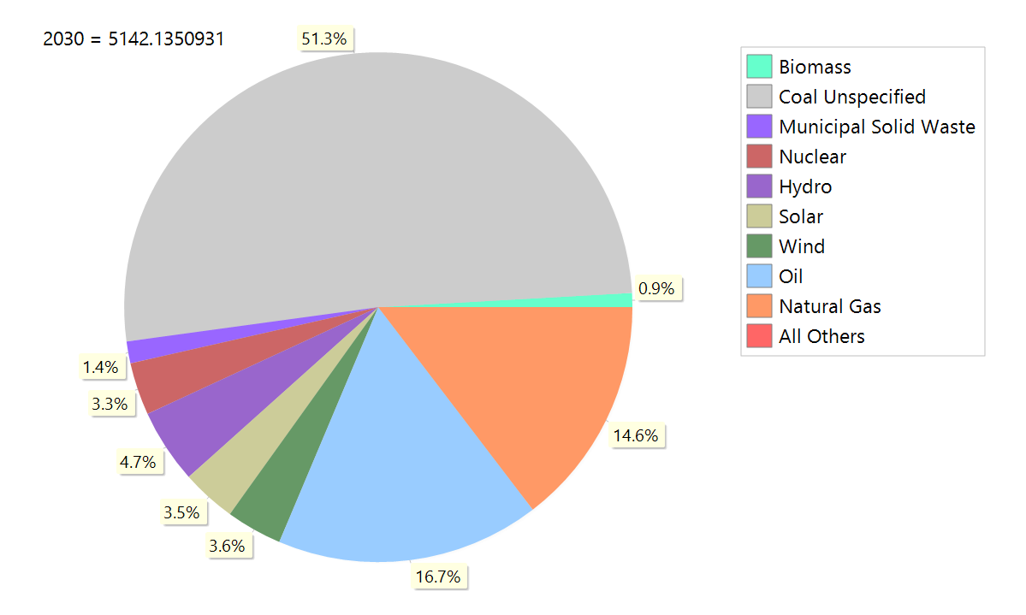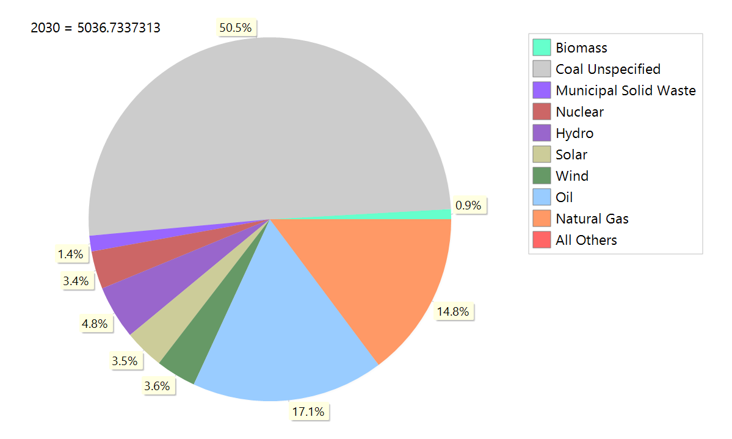
EE SOI
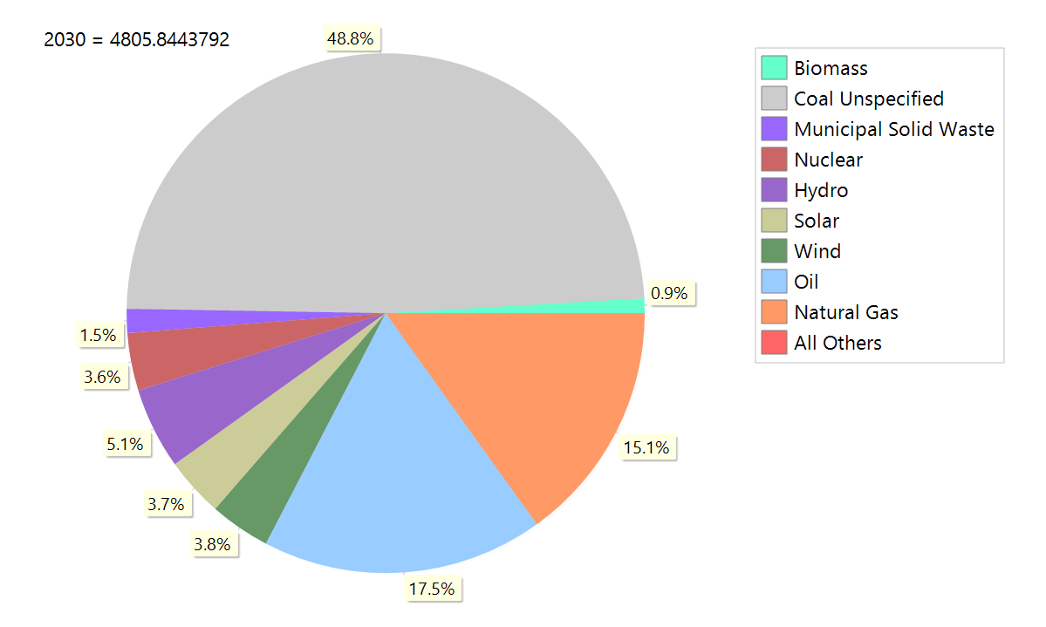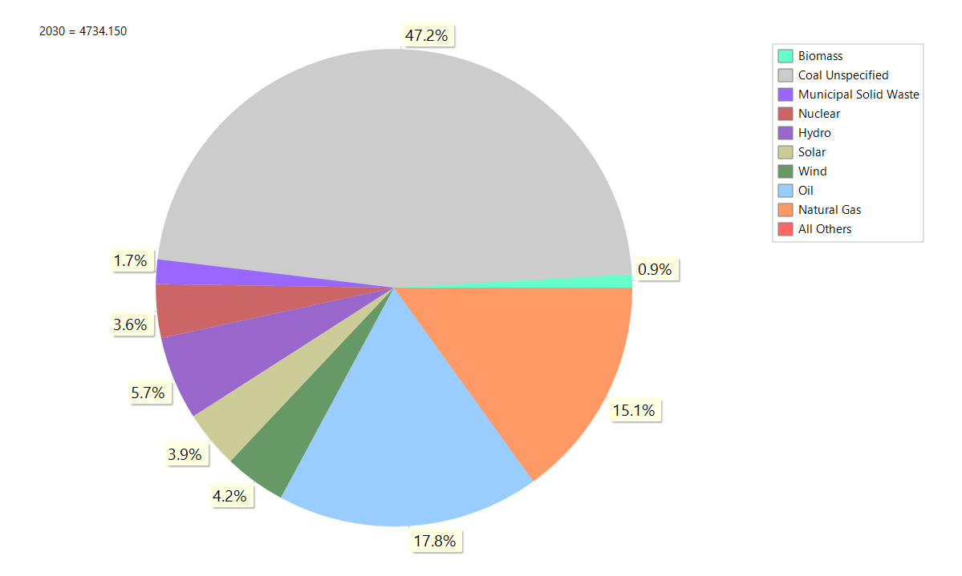
COMB COMB with 10% more non-fossil energy for electricity generation
A3-2. Simulation results of the fuel mix in 2030 for all the scenario
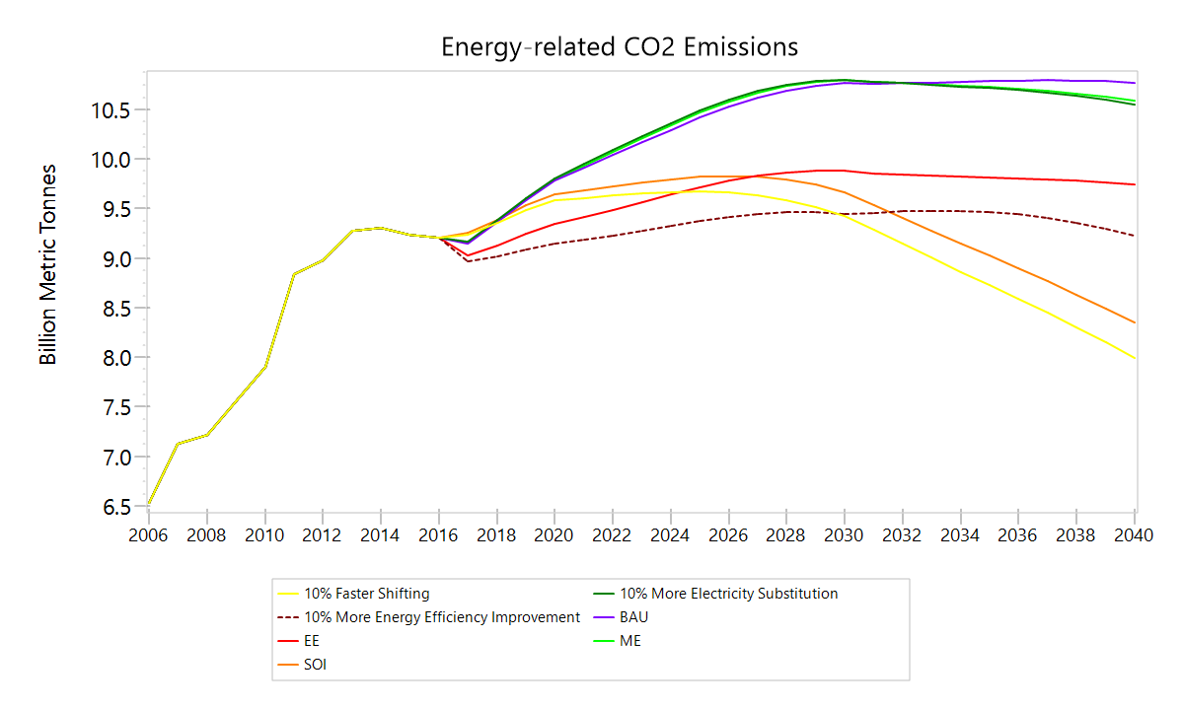
A3-3. Sensitive analysis Results of the energy-related CO₂ emissions for each scenario

A3-4. Simulation results of the energy-related CO₂ intensity of electricity generation

A3-5. Simulation results of the energy intensity of GDP (tons of coal equivalent per 1,000 yuan)

A1: Supplemented Historic DataA1-1. Fuel share of energy-intensive manufacturing sector
A1-2. Share of GDP for various sectors in China
A1-3. Share of energy consumption for each sector in China (2016)
A1-4. Historical fuel mix for heat production
A2: Supplemented Hypothesis Data
A2-1. Evolution of the fuel mix for energy-intensive manufacturing sector in the BAU and ME scenarios
A2-3. Comparison of the energy intensities of AV for energy-intensive manufacturing sector in BAU and EE scenarios
A2-3. Comparison of the industrial structures in BAU and SOI
A3: Supplemented Simulation Results
A3-1. Simulation results of the fuel mix for all scenarios
A3-2. Simulation results of the fuel mix in 2030 for all the scenario
A3-3. Sensitive analysis Results of the energy-related CO₂ emissions for each scenario
A3-4. Simulation results of the energy-related CO₂ intensity of electricity generation
A3-5. Simulation results of the energy intensity of GDP (tons of coal equivalent per 1,000 yuan)

