Characterization of a Novel N-Acylhomoserine Lactonase, AidP, from Antarctic Planococcus sp.
Wah Seng See-Too^{1,2}, Peter Convey^{2,3}, David A. Pearce^{2,3,4}, Kok-Gan Chan*^{1,5}
¹ Division of Genetics and Molecular Biology, Institute of Biological Sciences, Faculty of Science University of Malaya, 50603 Kuala Lumpur, Malaysia
² National Antarctic Research Centre, IPS Building, University Malaya, 50603 Kuala Lumpur, Malaysia
³ British Antarctic Survey, NERC, High Cross, Madingley Road, Cambridge CB3 OET, UK
⁴Applied Sciences, University of Northumbria at Newcastle, Newcastle-upon-Tyne NE1 8ST, UK
⁵ International Genome Centre, Jiangsu University, Zhenjiang, China
*Corresponding author: Institute of Biological Sciences (Division of Genetics and Molecular Biology), Faculty of Science, University of Malaya, 50603 Malaysia. Tel: +603-79675162, Fax: +603-79674509. Email: kokgan@um.edu.my

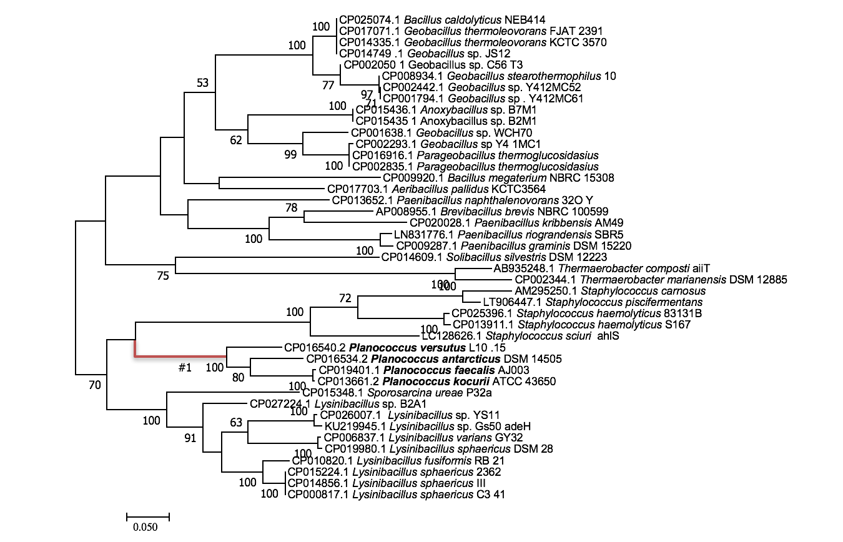
Figure S1 Phylogenetic tree constructed using NCBI BLAST result of aidP gene from P. versutus L10.15^{T}. The foreground branch is highlighted in red colour.

Table S1 Bacterial strains and plasmids
Strain or plasmid | Description | Source
Strains
E.coli
Top 10 | Cloning strain | Invitrogen
BL21 StarTM | Expression strain | Invitrogen
Planococcus versutus L10.15^{T} | AHL-degrading strain isolated from soil collected from Lagoon Island, maritime Antarctic | See-Too et al., 2017
Pectobacterium carotovarum
GS101 | Wild type strain of P. carotovarum | McGowan et al., 1995
PNP22 | LuxI (carI) mutant of strain GS101 | McGowan et al., 1995
Plasmids
pET200 | Km^{r} ; expression vector | Invitrogen
pET200-aidP | Km^{r} ; pET200 carrying the aidP gene | This study

Table S2 Colour coding for multiple sequences alignment analysis
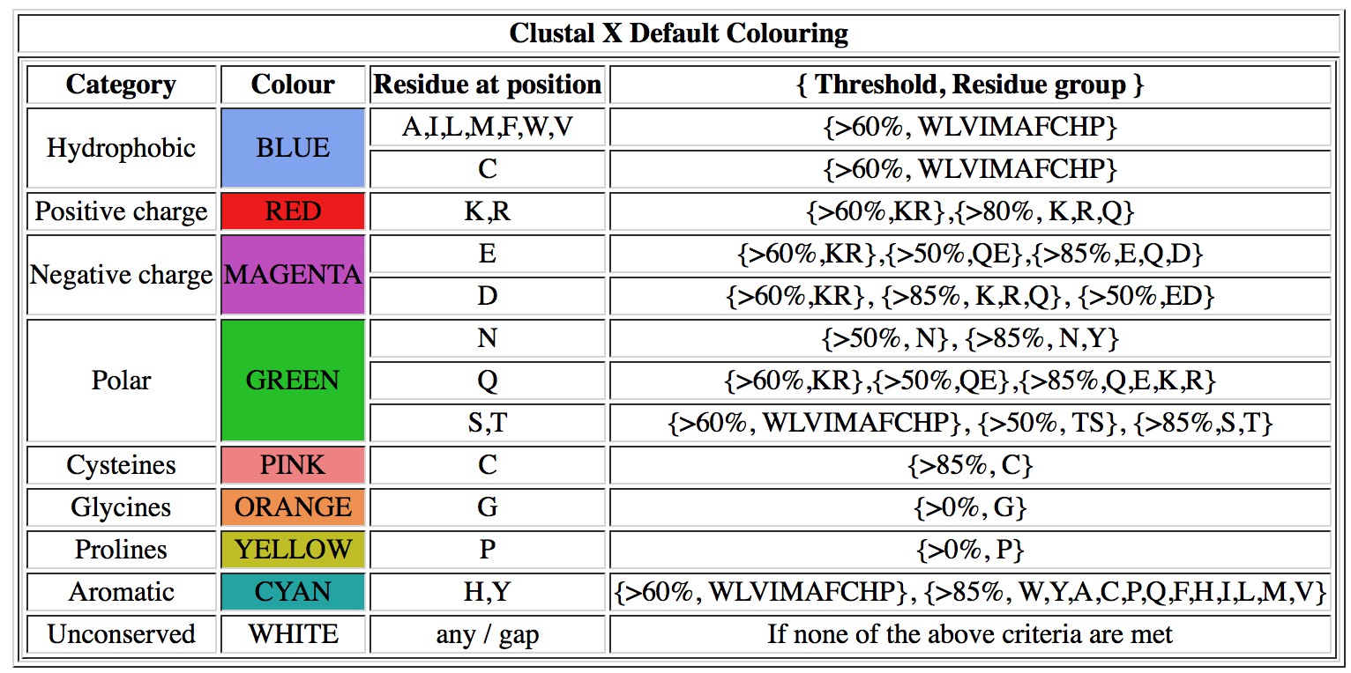

References:

- See-Too WS, Ee R, Lim YL, Convey P, Pearce DA, Yin WF, Chan KG. AidP, a novel N-acyl homoserine lactonase gene from Antarctic Planococcus sp. Sci Rep. 2017;7:42968
- McGowan S, Sebaihia M, Jones S, Yu B, Bainton N, Chan P, Bycroft B, Stewart G, Williams P, Salmond G. Carbapenem antibiotic production in Erwinia carotovora is regulated by CarR, a homologue of the LuxR transcriptional activator. Microbiology. 1995;141:541-50

