Supporting information

Template synthesis of the Cu₂O nanoparticles doped hollow carbon nanofibers and their application as nonenzymatic glucose biosensors
Yingjie Li, Renhao Cai, Renjiang Lü*, Lidi Gao,Shili Qin

College of Chemistry and Chemical Engineering, Qiqihar University, Qiqihar, Heilongjiang, 161006, P. R. China,
Tel: +86 0452 2738251 ; Email:lvrenjiang123@163.com

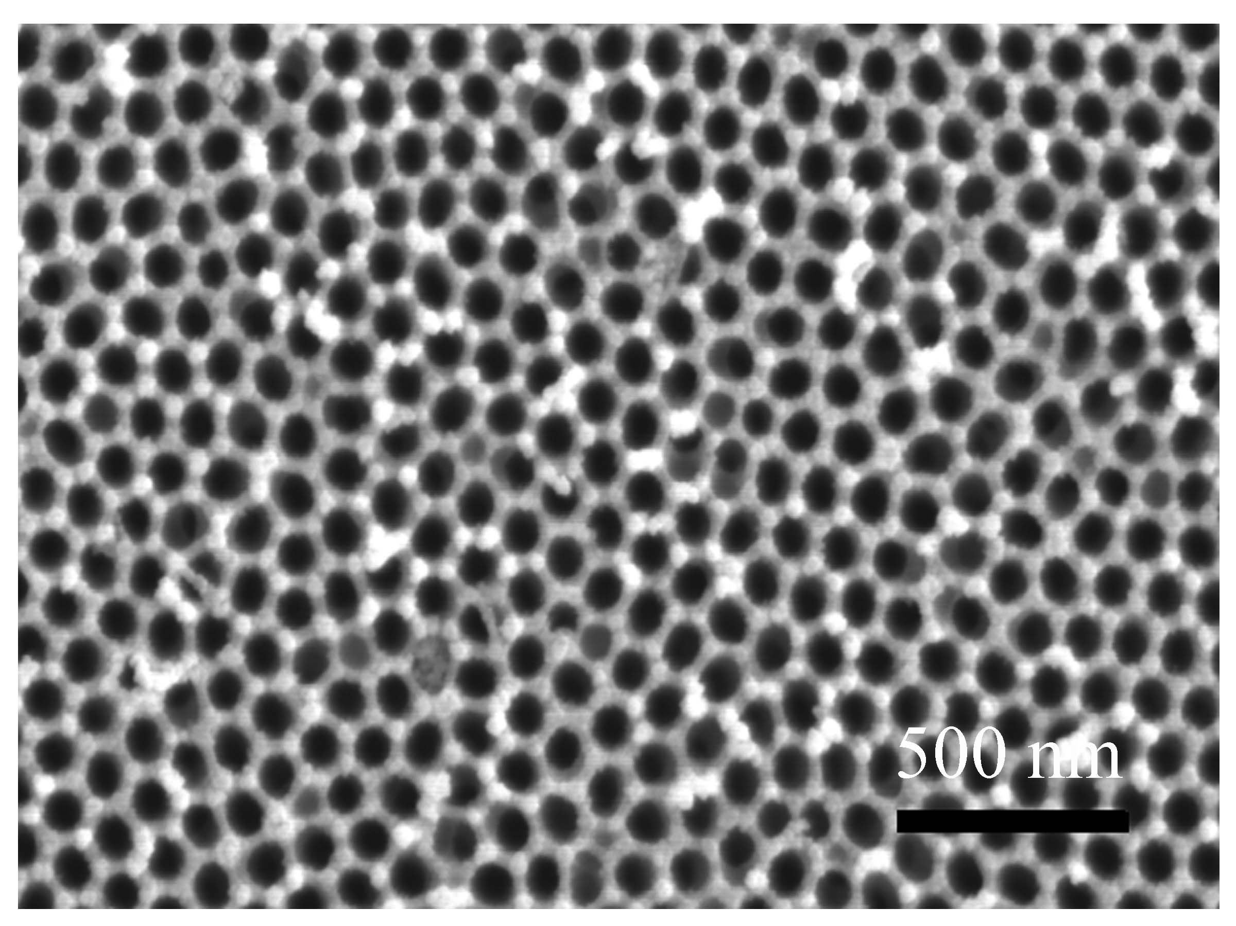
Fig. S1 SEM images of the prepared AAO membrane with ∼60 nm
pore diameters ( top view ).
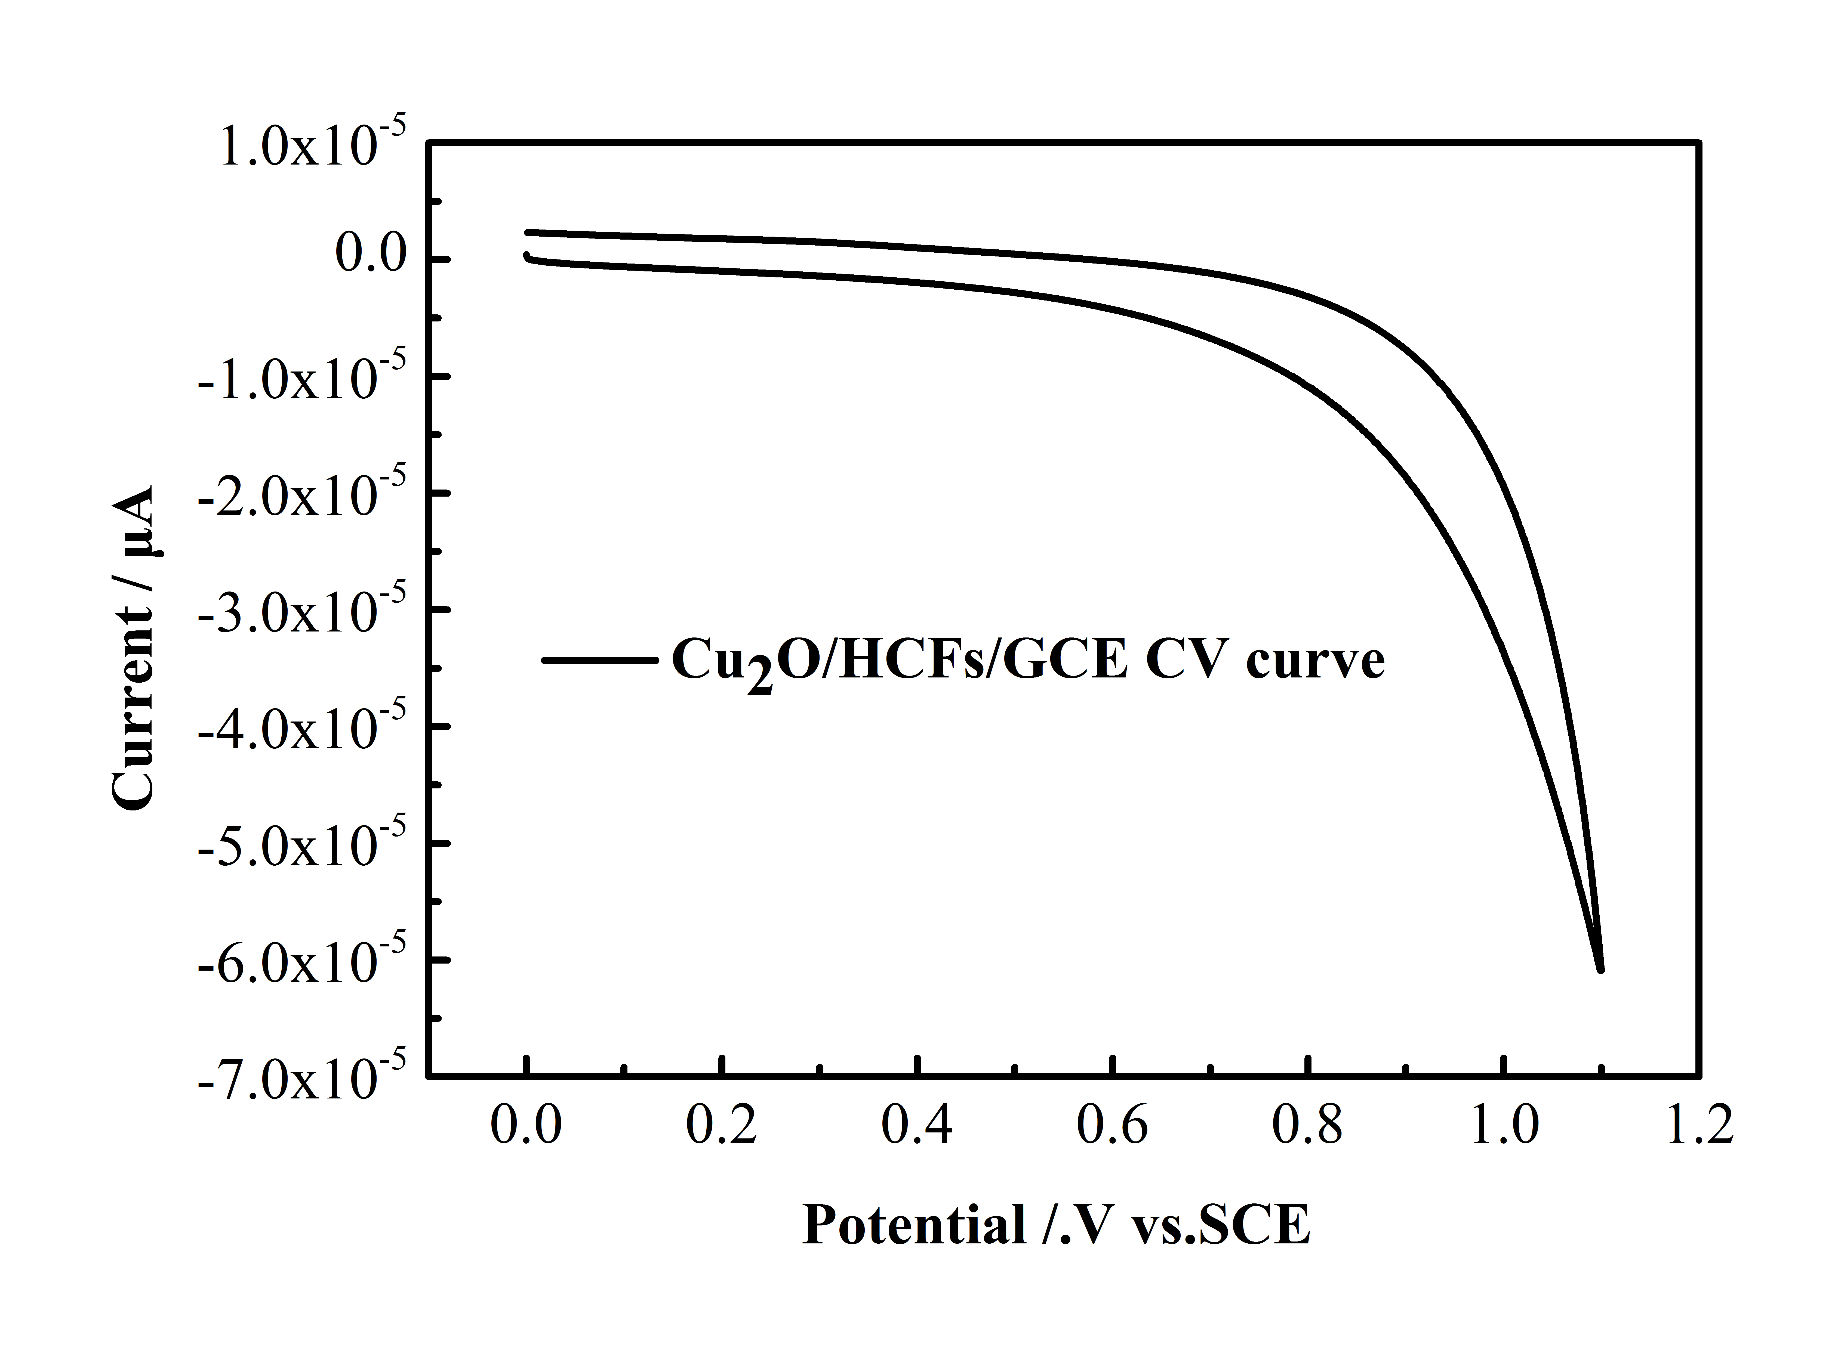
Fig.S2 CV curve of Cu₂O/HCFs/GCE modified electrode for glucose detection
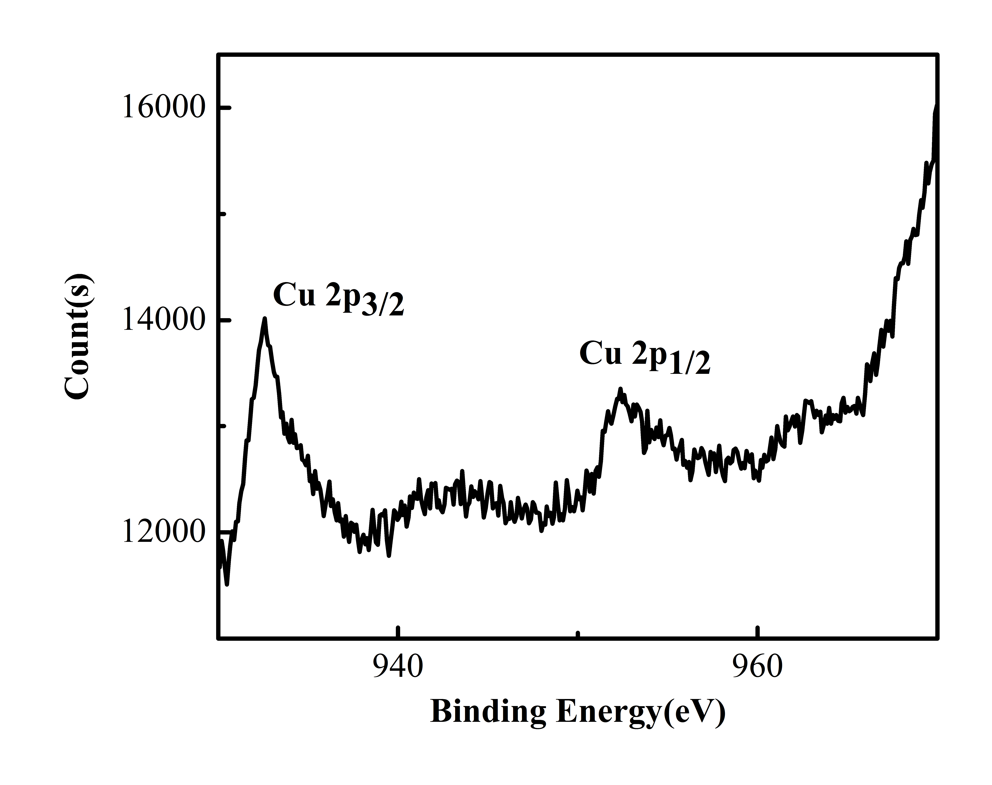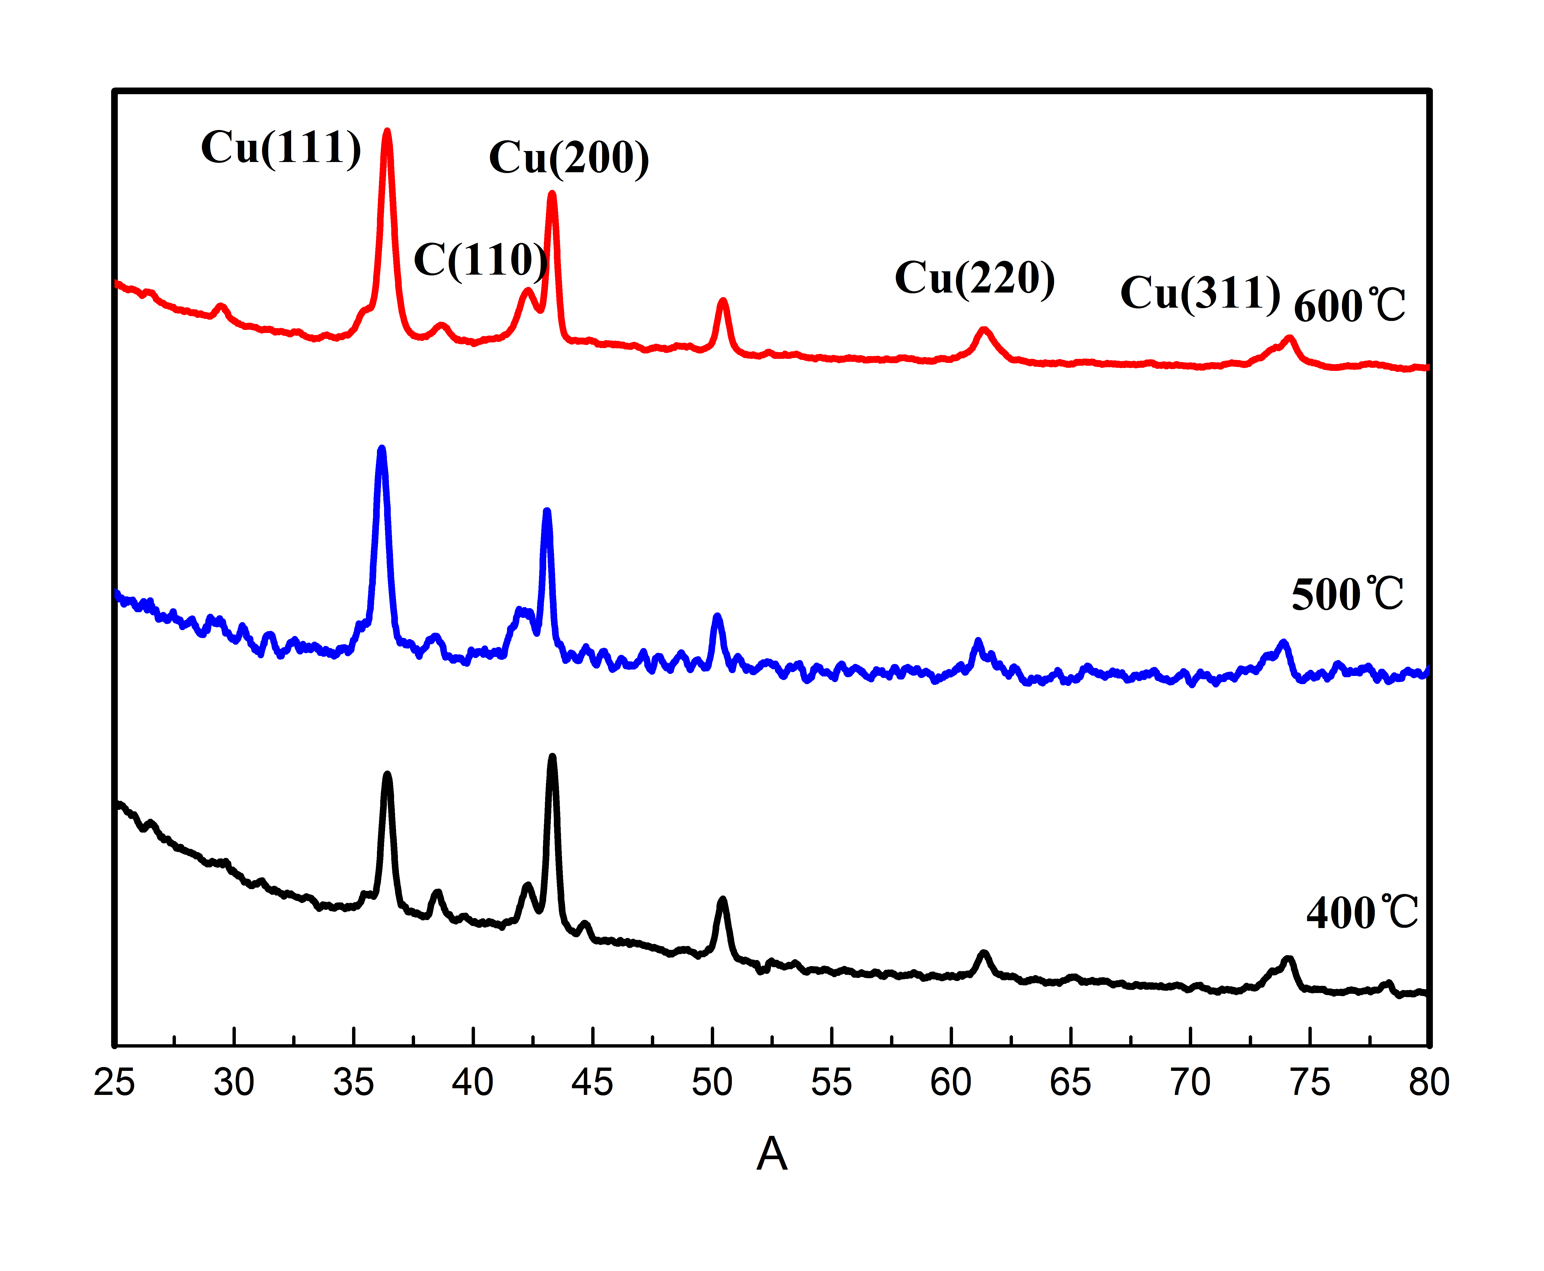
Fig.S3 The above two pictures prove that we successfully prepared Cu₂O in the experiment.

