Supporting information
Synthesis of palladium nanoparticles using triazolium based ionic liquids: A reusable catalyst for addition of arylboronic acids to nitrostyrenes
Kavya Sundararaju, Vijaya Kumar Veeraragavan, Ramesh Kumar Chidambaram*
Organic Chemistry Laboratory, Department of Chemistry, Vel Tech Rangarajan Dr. Sagunthala R&D Institute of Science and Technology, Avadi, Chennai - 600 062, India.
*E-mail: nscrameshkumar@gmail.com. Phone: (+91) 9442982145.
General information
The starting materials and reagents used during the course of preparing the ionic liquid and nanoparticles were purchased from Aldrich and used as such. Reagent grade solvents were used without further purification. Reactions were monitored by thin layer chromatography (TLC) using aluminium plates coated with silica gel (Merck) visualized with UV light and/ or by permanganate (KMnO₄) staining. The isolated products were further purified by column chromatography using silica gel (100-200 mesh). Melting points were measured on a digital melting point apparatus. FT-IR spectra were recorded on JASCO FT-IR 4600, Japan. NMR spectra were recorded on Jeol-FT-NMR spectrometers at ambient temperature. Chemical shifts (δ) are given in ppm relative to TMS as the internal standard. The XRD measurements were performed with X’pert PRO PAN analytical equipped with Cu Kα radiation. SEM analysis were recorded using Tescan instrument (Model VEGA3 TESCAN) with 15 kV acceleration voltage. The TEM imaging was recorded using JEOL 3010 model TEM 1200EX. EDX was determined by Thermo Electron Corporation, USA which was collected at an accelerating voltage of 20 kV.
General procedure for addition reaction of arylboronic acids to nitrostyrene 6(a-o)
Nitrostyrene (2 mmol) and arylboronic acid (3 mmol) were added to the suspension of Pd-NPs (5 mol%) in MeOH (5 mL). The reaction mixture was stirred at 40 °C for 3 h under an air atmosphere (Table 3). After complete conversion, the catalyst was separated and the solvent was removed by a rotary evaporator under reduced pressure to afford a crude adducts, which was purified by column chromatography on silica gel using 5% ethyl acetate in hexane.
1-chloro-4-(2-nitro-1-phenylethyl)benzene (6a)^{[1,2]}
Yield 80%, pale yellow oil; IR (KBr, cm^{–1}): 3064, 3027, 2915, 1554, 1491, 1376, 1091, 1015, 820, 755; ¹H NMR: (400 MHz, CDCl₃) δ (ppm): 7.38–7.28 (5H, m), 7.24–7.19 (4H, m), 4.98 (2H, d, J = 8 Hz), 4.91 (1H, t, J = 8 Hz); ¹³C NMR: (100 MHz, CDCl₃) δ (ppm): 138.7, 137.7, 133.5, 129.2 (2C), 129.1 (2C), 129.0 (2C), 127.8 (2C), 127.5, 79.0, 48.3; HRMS (ESI⁺): m/z Calcd for C₁₄H₁₂ClNO₂ [M+Na]⁺ 284.0557, found 284.0459.
1-fluoro-4-(2-nitro-1-phenylethyl)benzene (6b)^{[1,2]}
Yield 56%, white solid, mp: 92–96 °C; IR (KBr, cm^{–1}): 3066, 3031, 2919, 1551, 1507, 1453, 1373, 1227, 1082, 1013, 832, 738; ¹H NMR: (400 MHz, CDCl₃) δ (ppm): 7.28–7.12 (7H, m), 6.98–6.92 (2H, m), 4.89 (2H, d, J = 8 Hz), 4.82 (1H, t, J = 8 Hz); ¹³C NMR: (100 MHz, CDCl₃) δ (ppm): 160.4, 138.9, 135.0, 129.3 (2C), 129.2 (2C), 129.1 (2C), 127.5, 116.0, 115.8, 79.2, 48.2.
1-methoxy-4-(2-nitro-1-phenylethyl)benzene (6c)^{[1,2]}
Yield 95%, yellow oil; IR (KBr, cm^{–1}): 3030, 3004, 2934, 1550, 1512, 1377, 1252, 1181, 1031, 830, 700; ¹H NMR: (400 MHz, CDCl₃) δ (ppm): 7.33–7.24 (5H, m), 7.18 (2H, d, J = 8 Hz), 6.88 (2H, d, J = 8 Hz), 4.98 (2H, d, J = 8 Hz), 4.88 (1H, t, J = 8 Hz), 3.80 (3H, s); ¹³C NMR: (100 MHz, CDCl₃) δ (ppm): 158.9, 139.5, 131.2, 129.0 (2C), 128.7 (2C), 127.5 (2C), 127.5, 114.4 (2C), 79.4, 55.2, 48.2.
1-methoxy-3-(2-nitro-1-phenylethyl)benzene (6d)^{[1]}
Yield 83%, yellow oil; IR (KBr, cm^{–1}): 3027, 2944, 2843, 1548, 1361, 1260, 1145, 1040, 875, 694; ¹H NMR: (400 MHz, CDCl₃) δ (ppm): 7.38–7.26 (6H, m), 6.87–6.80 (3H, m), 5.00 (2H, d, J = 8 Hz), 4.90 (1H, t, J = 8 Hz), 3.80 (3H, s); ¹³C NMR: (100 MHz, CDCl₃) δ (ppm): 159.9, 140.7, 139.0, 130.0 (3C), 129.0 (2C), 127.6, 119.8, 114.0, 112.5, 79.1, 55.2, 48.9.
1-methyl-3-(2-nitro-1-phenylethyl)benzene (6e)^{[1]}
Yield 91%, pale yellow oil; IR (KBr, cm^{–1}): 3029, 2919, 1550, 1492, 1432, 1376, 764, 700; ¹H NMR: (400 MHz, CDCl₃) δ (ppm): 7.37–7.06 (9H, m), 5.00 (2H, d, J = 8 Hz), 4.89 (1H, t, J = 8 Hz), 2.35 (1H, s); ¹³C NMR: (100 MHz, CDCl₃) δ (ppm): 139.3, 139.1, 138.7, 129.0, 128.8 (2C), 128.4, 128.3 (2C), 127.6, 127.5, 124.5, 79.2, 48.9, 21.4.
1,3-dimethyl-5-(2-nitro-1-phenylethyl)benzene (6f)^{[1]}
Yield 91%, pale yellow oil; IR (KBr, cm^{–1}): 3028, 2915, 2865, 1548, 1496, 1440, 1377, 1044, 766, 702; ¹H NMR: (500 MHz, CDCl₃) δ (ppm): 7.27–7.20 (5H, m), 6.85–6.80 (3H, m), 4.92–4.74 (3H, m), 2.23 (6H, s); ¹³C NMR: (125 MHz, CDCl₃) δ (ppm): 139.6 (2C), 139.3 (2C), 138.6 (2C), 129.4, 129.1 (2C), 127.7, 127.6, 125.5, 79.3, 49.0, 21.4 (2C).
1-chloro-2-(2-nitro-1-phenylethyl)benzene (6g)^{[1]}
Yield 93%, pale yellow oil; IR (KBr, cm^{–1}): 3067, 3028, 2920, 1558, 1468, 1372, 1083, 1036, 748, 702; ¹H NMR: (400 MHz, CDCl₃) δ (ppm): 7.45–7.23 (9H, m), 5.49 (1H, t, J = 8 Hz), 5.06–4.96 (2H, m); ¹³C NMR: (100 MHz, CDCl₃) δ (ppm): 137.6, 136.5, 134.1, 130.4, 128.9, 128.8 (2C), 128.1, 127.9, 127.7 (2C), 127.2, 77.7, 45.1; HRMS (ESI⁺): m/z Calcd for C₁₄H₁₂ClNO₂ [M+Na]⁺ 284.0557, found 284.0459.
1-chloro-3-(2-nitro-1-phenylethyl)benzene (6h)^{[2]}
Yield 63%, yellow oil; IR (KBr, cm^{–1}): 3062, 3033, 2918, 1558, 1481, 1433, 1376, 1083, 702; ¹H NMR: (400 MHz, CDCl₃) δ (ppm): 7.36–7.13 (9H, m), 4.96 (2H, d, J = 8 Hz), 4.88 (1H, t, J = 8 Hz); ¹³C NMR: (100 MHz, CDCl₃) δ (ppm): 141.2, 138.4, 134.8, 130.2, 129.1 (2C), 127.9 (2C), 127.8, 127.5 (2C), 125.7, 78.8, 48.5.
1-chloro-4-(2-nitro-1-phenylethyl)benzene (6i)^{[1,2]}
Yield 82%, yellow oil; IR (KBr, cm^{–1}): 3064, 3027, 2915, 1554, 1491, 1376, 1091, 1015, 820, 755; ¹H NMR: (400 MHz, CDCl₃) δ (ppm): 7.35–7.16 (9H, m), 4.95 (2H, d, J = 8 Hz), 4.88 (1H, t, J = 8 Hz); ¹³C NMR: (100 MHz, CDCl₃) δ (ppm): 138.6, 137.6, 133.5, 129.1 (2C), 129.1 (2C), 128.9 (2C), 127.7 (2C), 127.5, 78.9, 48.2.
1-methoxy-2-(2-nitro-1-phenylethyl)benzene (6j)^{[3]}
Yield 87%, pale yellow oil; IR (KBr, cm^{–1}): 3020, 2952, 2835, 1542, 1369, 1137, 1040, 873, 694; ¹H NMR: (400 MHz, CDCl₃) δ (ppm): 7.34–7.22 (6H, m), 7.07 (1H, d, J = 8 Hz), 6.90 (2H, t, J = 8 Hz), 5.28 (1H, t, J = 8 Hz), 5.06–4.94 (2H, m), 3.83 (3H, s); ¹³C NMR: (100 MHz, CDCl₃) δ (ppm): 156.7, 138.8, 136.1, 128.7, 128.7, 128.4, 127.9 (2C), 127.4, 127.2, 120.7, 111.0, 77.9, 55.4, 43.2.
1-methoxy-3-(2-nitro-1-phenylethyl)benzene (6k)^{[3]}
Yield 84%, pale yellow oil; IR (KBr, cm^{–1}): 3027, 2944, 2843, 1548, 1361, 1260, 1145, 1040, 875, 694; ¹H NMR: (400 MHz, CDCl₃) δ (ppm): 7.34–7.22 (6H, m), 6.84–6.77 (3H, m), 4.96 (2H, d, J = 8 Hz), 4.87 (1H, t, J = 8 Hz), 3.75 (3H, s); ¹³C NMR: (100 MHz, CDCl₃) δ (ppm): 159.9, 140.7, 139.0, 130.0 (2C), 128.9 (2C), 127.5 (2C), 119.7, 113.9, 112.4, 79.1, 55.1, 48.8.
1-methoxy-4-(2-nitro-1-phenylethyl)benzene (6l)^{[2,3]}
Yield 88%, yellow oil; IR (KBr, cm^{–1}): 3030, 3004, 2934, 1550, 1512, 1377, 1252, 1181, 1031, 830, 700; ¹H NMR: (500 MHz, CDCl₃) δ (ppm): 7.37–7.13 (7H, m), 6.85 (2H, d, J = 20 Hz), 4.98–4.81 (3H, m), 3.77 (3H, s); ¹³C NMR: (125 MHz, CDCl₃) δ (ppm): 158.9, 139.6, 131.3, 129.4 (3C), 129.0 (2C), 128.8, 127.6, 114.4, 79.4, 55.3, 48.3; HRMS (ESI⁺): m/z Calcd for C₁₄H₁₂ClNO₂ [M+Na]⁺ 280.1052, found 280.0948.
1, 2-dimethoxy-4-(2-nitro-1-phenylethyl)benzene (6m)^{[4]}
Yield 82%, yellow oil; IR (KBr, cm^{–1}): 3047, 2935, 1551, 1516, 1453, 1377, 1262, 1144, 1025, 702; ¹H NMR: (500 MHz, CDCl₃) δ (ppm): 7.37–7.21 (5H, m), 6.85–6.71 (3H, m), 4.98–4.81 (3H, m), 3.85 (3H, s), 3.83 (3H, s); ¹³C NMR: (125 MHz, CDCl₃) δ (ppm): 149.2 (2C), 148.4, 139.5, 131.6 (2C), 129.0 (2C), 127.6, 119.4, 111.3, 111.2, 79.3, 55.8 (2C), 48.6.
1-methyl-4-(2-nitro-1-phenylethyl)benzene (6n)^{[3,4]}
Yield 85%, pale yellow oil; IR (KBr, cm^{–1}): 3028, 2921, 1549, 1513, 1432, 1376, 815, 718, 700, 607; ¹H NMR: (500 MHz, CDCl₃) δ (ppm): 7.35–7.12 (9H, m), 4.99–4.82 (3H, m), 2.30 (3H, s); ¹³C NMR: (125 MHz, CDCl₃) δ (ppm): 142.0, 139.6, 132.3, 129.4 (2C), 129.0 (2C), 128.8 (2C), 128.4 (2C), 126.4, 79.3, 49.0, 21.5.
1-(2-nitro-1-phenylethyl)naphthalene (6o)^{[2]}
Yield 87%, yellow oil; IR (KBr, cm^{–1}): 3064, 3031, 2913, 1548, 1372, 1025, 781, 623; ¹H NMR: (500 MHz, CDCl₃) δ (ppm): 8.11 (1H, d, J = 20 Hz), 7.90–7.78 (2H, m), 7.55–7.42 (3H, m), 7.36–7.25 (6H, m), 5.75 (1H, t, J = 20 Hz), 5.15–4.99 (2H, m); ¹³C NMR: (125 MHz, CDCl₃) δ (ppm): 138.9, 134.6, 134.2, 131.1, 129.0 (2C), 128.4, 127.9 (2C), 127.6, 126.7, 125.9, 125.1, 124.2, 122.9, 79.0, 44.6.
1-nitro-2-(2-nitro-1-phenylethyl)benzene (6p)
Yield 82%, pale yellow oil; IR (KBr, cm^{–1}): 3065, 3032, 2918, 1555, 1375, 1112, 856, 746, 621; ¹H NMR: (500 MHz, CDCl₃) δ (ppm): 7.90 (d, J = 20 Hz, 1H), 7.60 (t, J = 15 Hz, 1H), 7.46–7.22 (m, 7H), 5.65 (t, J = 20 Hz, 1H), 5.16–4.94 (m, 2H); ¹³C NMR: (125 MHz, CDCl₃) δ (ppm): 149.5, 137.5, 133.5, 133.4, 129.2 (2C), 129.2, 128.7 (2C), 128.0, 127.9, 125.3, 78.0, 43.1; HRMS (ESI⁺): m/z Calcd for C₁₄H₁₂N₂O₄ [M+Na]⁺ 295.0797, found 295.0387.
1,3-dimethyl-5-(2-nitro-1-(2-nitrophenyl)ethyl)benzene (6q)
Yield 90%, white solid, mp. 109–112 °C; IR (KBr, cm^{–1}): 3005, 2921, 2837, 1550, 1460, 1376, 1025, 852, 704; ¹H NMR: (500 MHz, CDCl₃) δ (ppm): 7.89 (1H, d, J = 20 Hz), 7.59 (1H, t, J = 20 Hz), 7.46–7.38 (2H, m), 6.90 (1H, s), 6.84 (2H, s), 5.56 (1H, t, J = 20 Hz), 5.12–4.90 (2H, m), 2.26 (6H, s); ¹³C NMR: (125 MHz, CDCl₃) δ (ppm): 149.5, 138.7 (2C), 137.16, 134.0, 133.1, 129.6, 129.0, 125.5 (3C), 125.2, 77.9, 42.8, 21.2 (2C); HRMS (ESI⁺): m/z Calcd for C₁₆H₁₆N₂O₄ [M+Na]⁺ 323.1110, found 323.0319.
1-(1-(3,5-dimethylphenyl)-2-nitroethyl)naphthalene (6r)
Yield 86%, white solid, mp. 121–123 °C; IR (KBr, cm^{–1}): 3055, 3021, 2935, 1548, 1486, 1376, 1089, 1015, 826, 706; ¹H NMR: (500 MHz, CDCl₃) δ (ppm): 8.13 (1H, d, J = 20 Hz), 7.84–7.77 (2H, m), 7.56–7.34 (4H, m), 6.90 (2H, s), 6.87 (1H, s), 5.67 (1H, t, J = 20 Hz), 5.13–4.95 (2H, m), 2.25 (6H, s); ¹³C NMR: (125 MHz, CDCl₃) δ (ppm): 138.7, 138.5 (2C), 134.6, 133.8, 131.2, 129.4, 129.0, 128.3 (2C), 126.7, 125.9, 125.6, 125.2, 124.1, 123.0, 79.1, 44.4, 21.3; HRMS (ESI⁺): m/z Calcd for C₂₀H₁₉NO₂ [M+Na]⁺ 328.1416, found 328.0455.

NMR Spectrum of the synthesized compounds
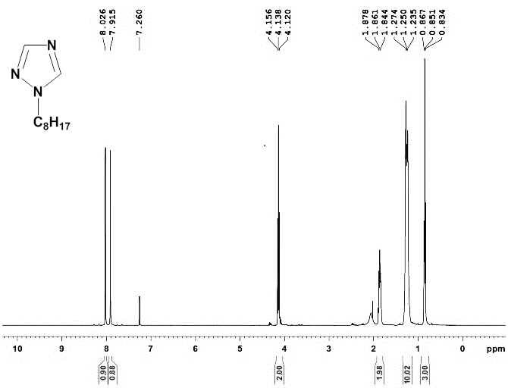
Fig. S1. ¹H NMR spectrum of compound 2
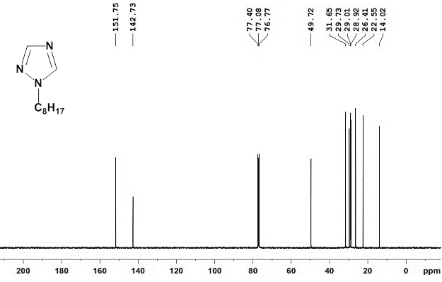
Fig. S2. ¹³C NMR spectrum of compound 2
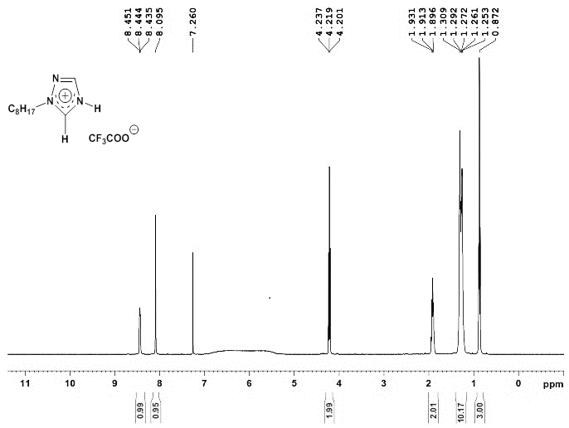
Fig. S3. ¹H NMR of compound 3
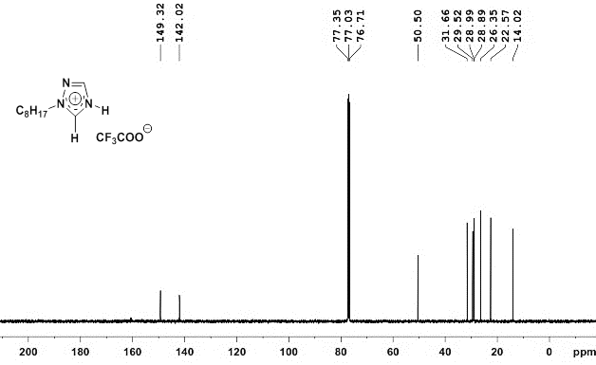
Fig. S4. ¹³C NMR of compound 3
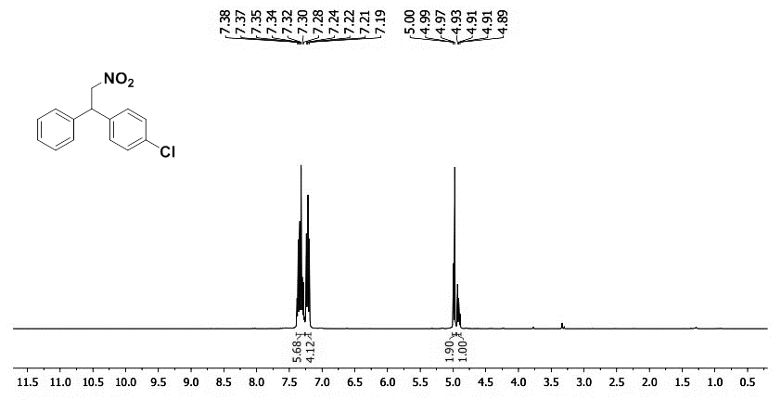
Fig. S5. ¹H NMR of compound 6a
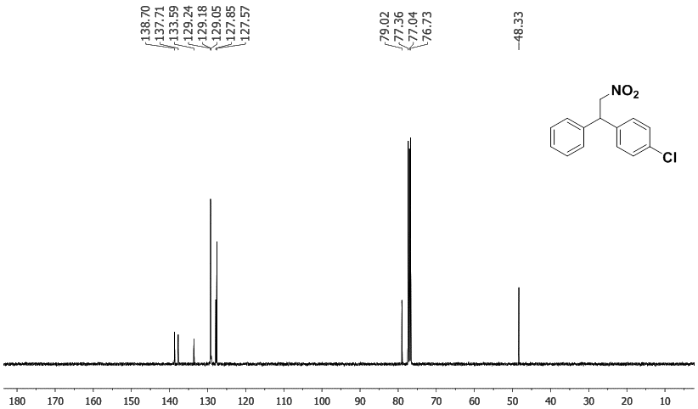
Fig. S6. ¹³C NMR of compound 6a
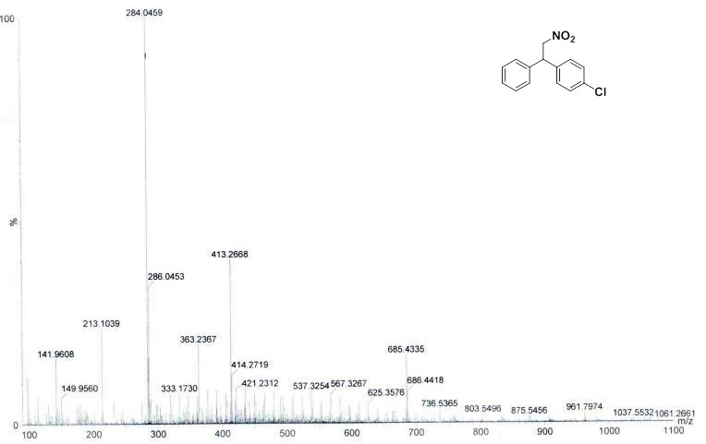
Fig. S7. MASS spectra of compound 6a
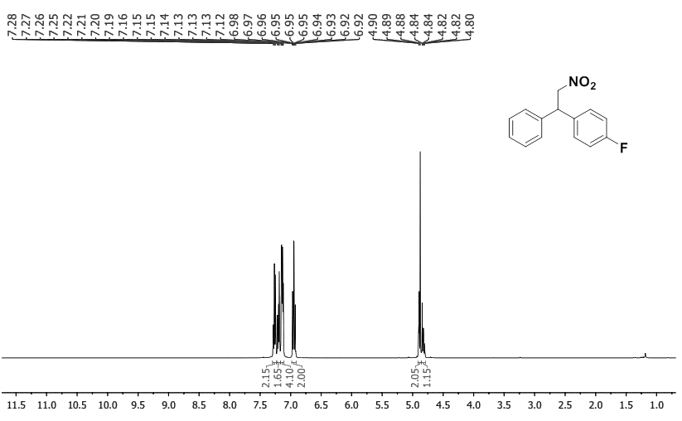
Fig. S8. ¹H NMR of compound 6b
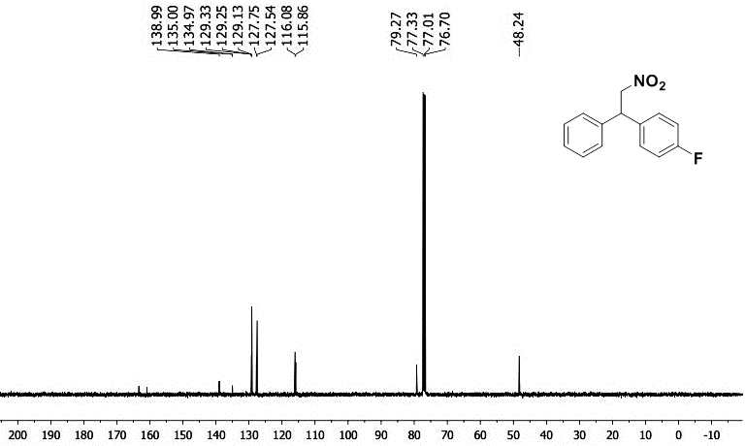
Fig. S9. ¹³C NMR of compound 6b
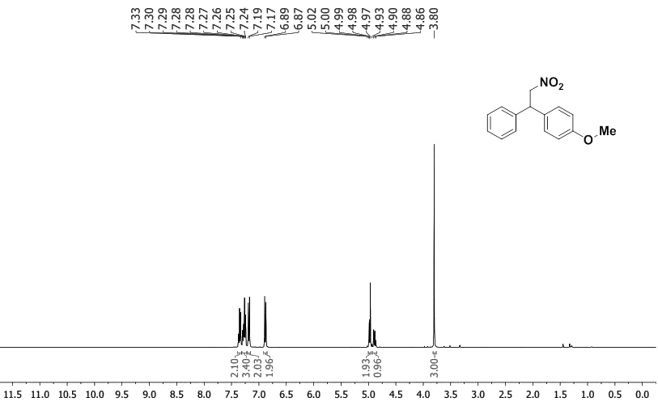
Fig. S10. ¹H NMR of compound 6c
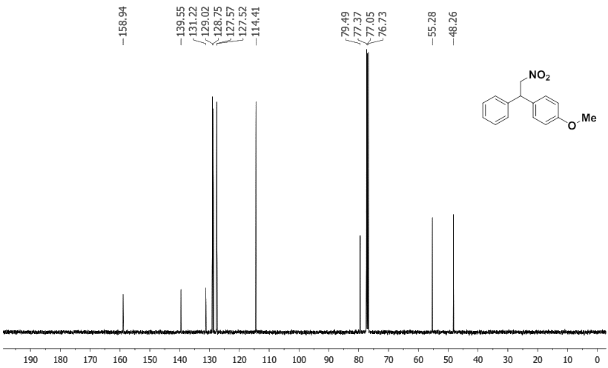
Fig. S11. ¹³C NMR of compound 6c
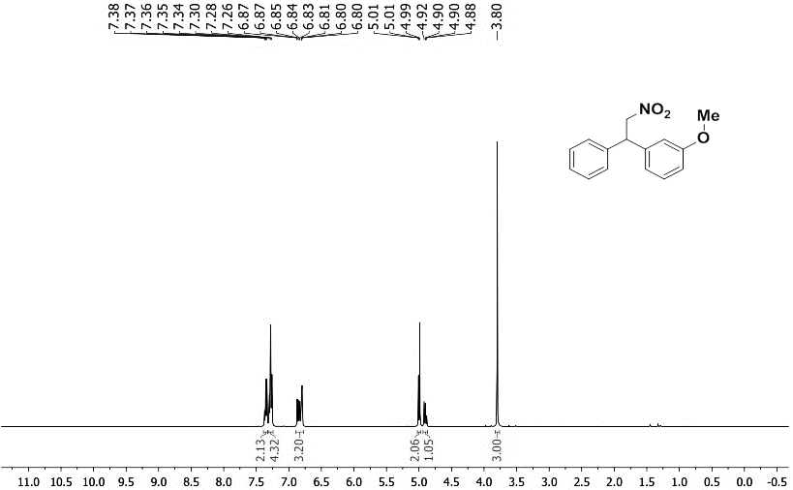
Fig. S12. ¹H NMR of compound 6d
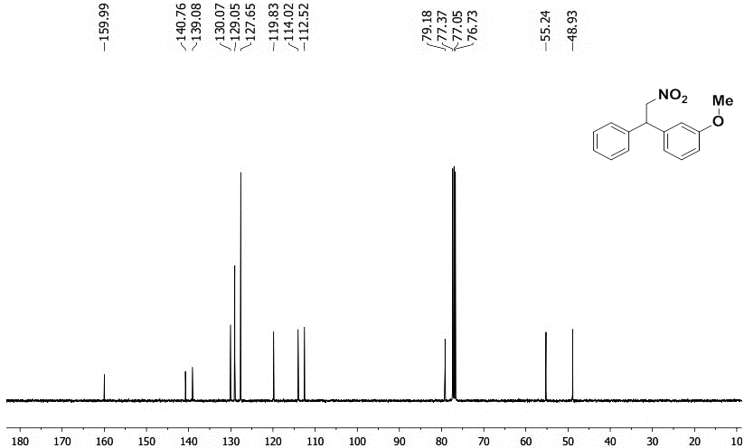
Fig. S13. ¹³C NMR of compound 6d
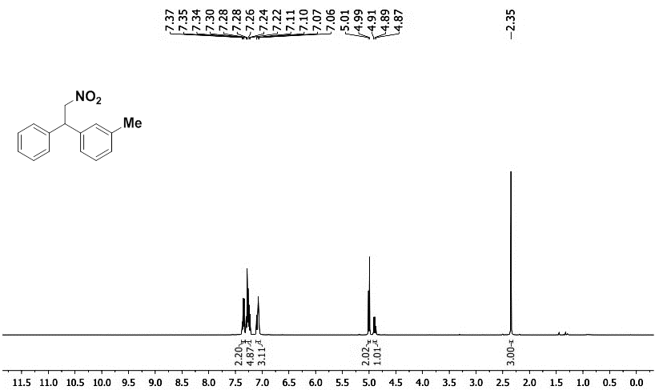
Fig. S14. ¹H NMR of compound 6e
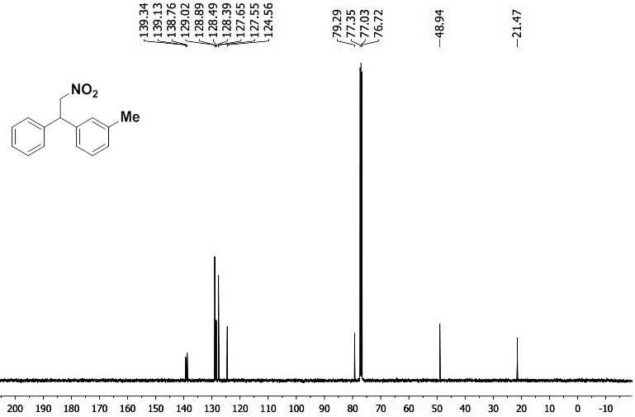
Fig. S15. ¹³C NMR of compound 6e
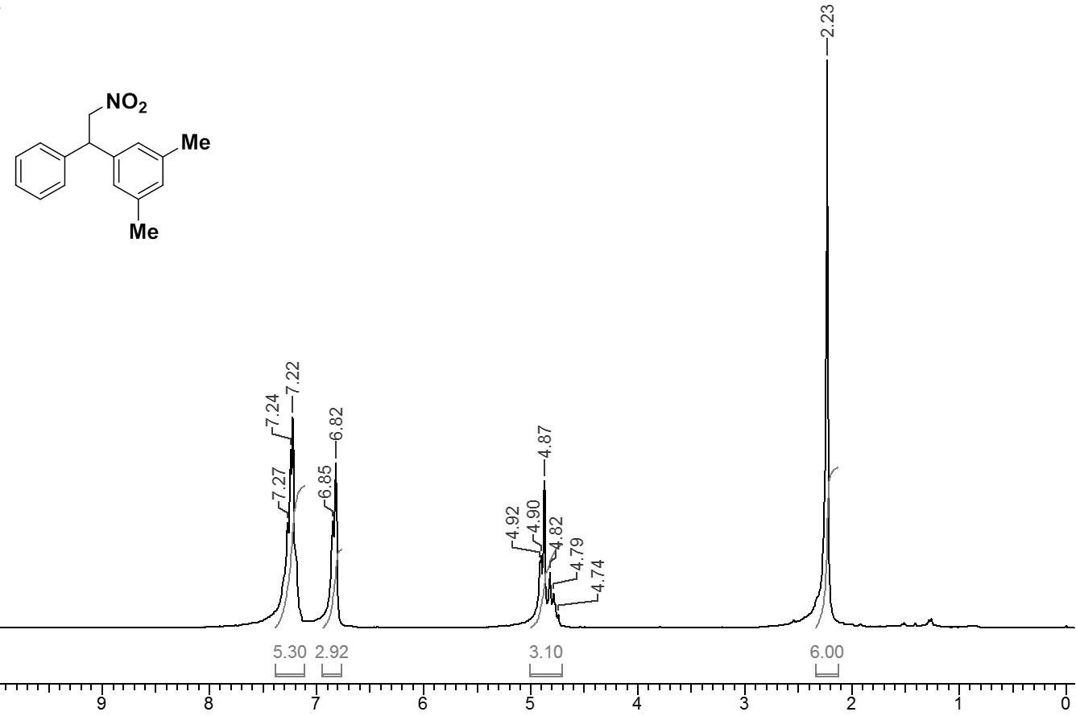
Fig. S16. ¹H NMR of compound 6f
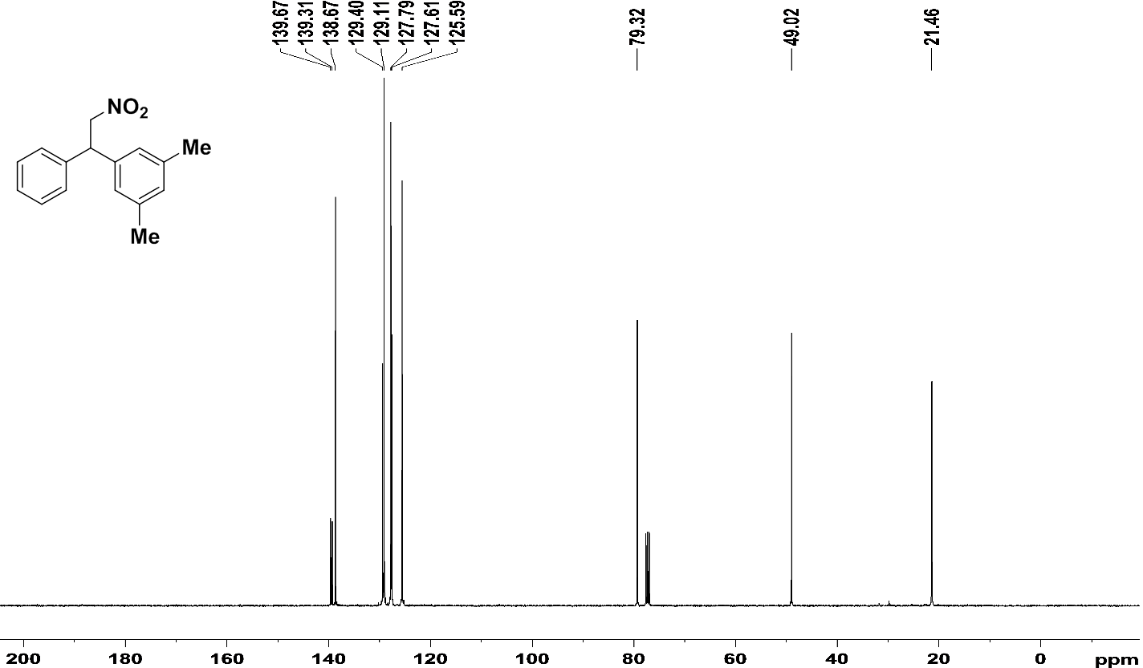
Fig. S17. ¹³C NMR of compound 6f
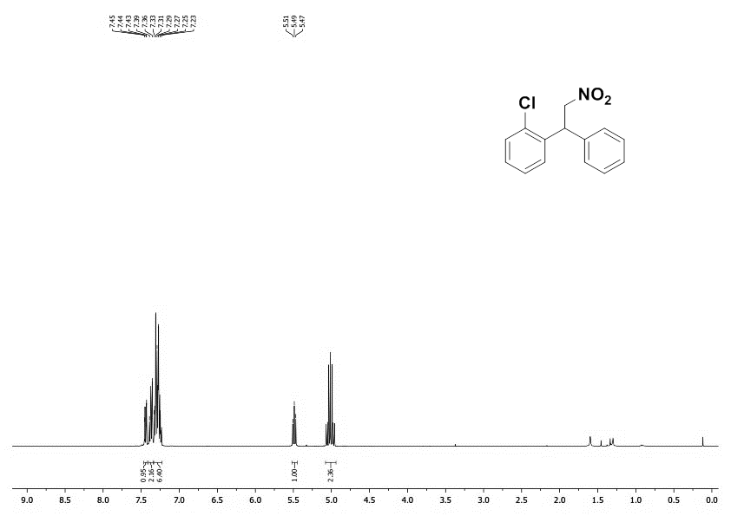
Fig. S18. ¹H NMR of compound 6g
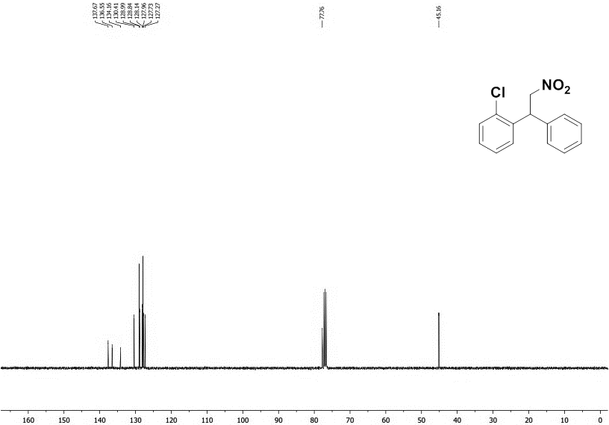
Fig. S19. ¹³C NMR of compound 6g
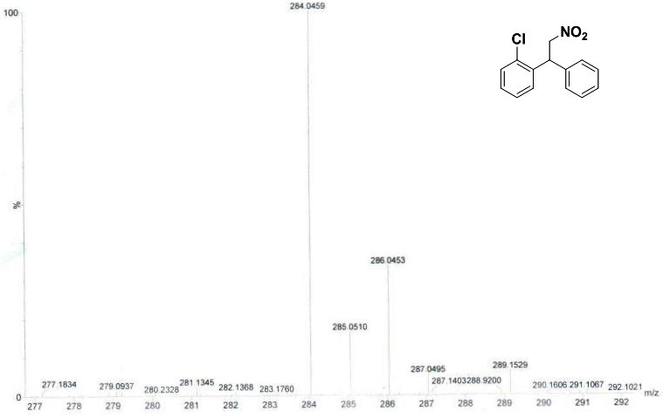
Fig. S20. MASS spectra of compound 6g
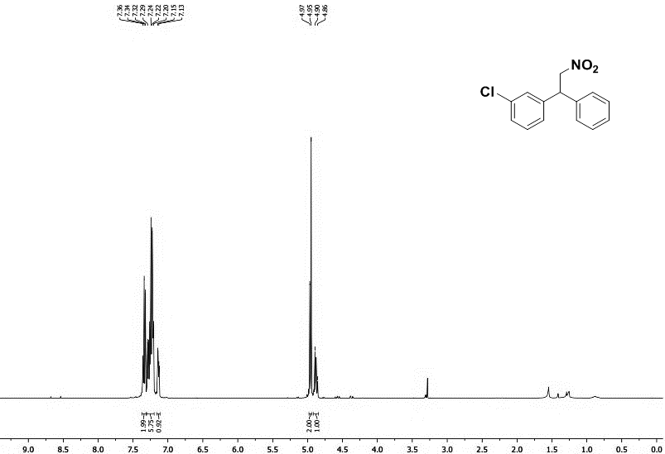
Fig. S21. ¹H NMR of compound 6h
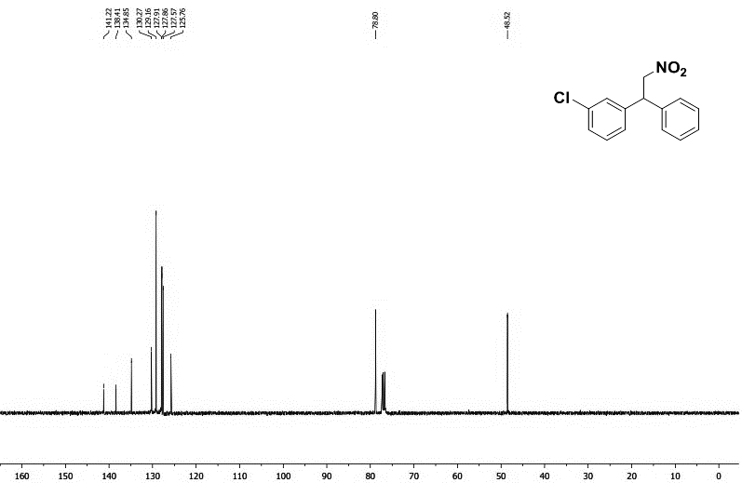
Fig. S22. ¹³C NMR of compound 6h
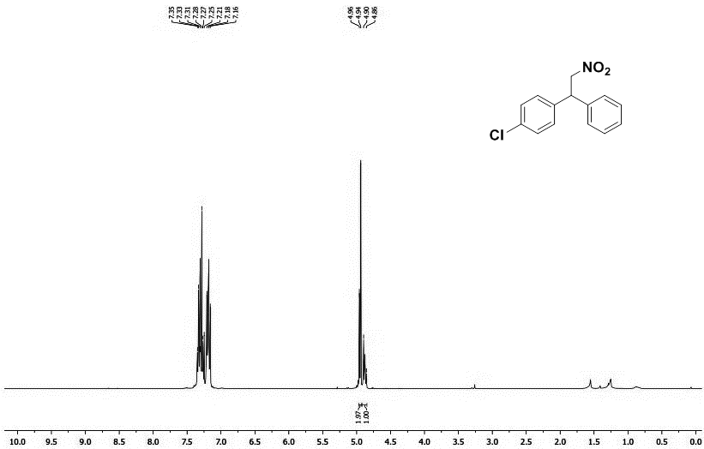
Fig. S23. ¹H NMR of compound 6i
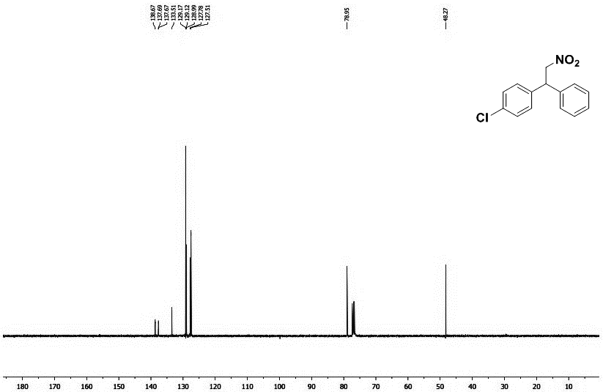
Fig. S24. ¹³C NMR of compound 6i
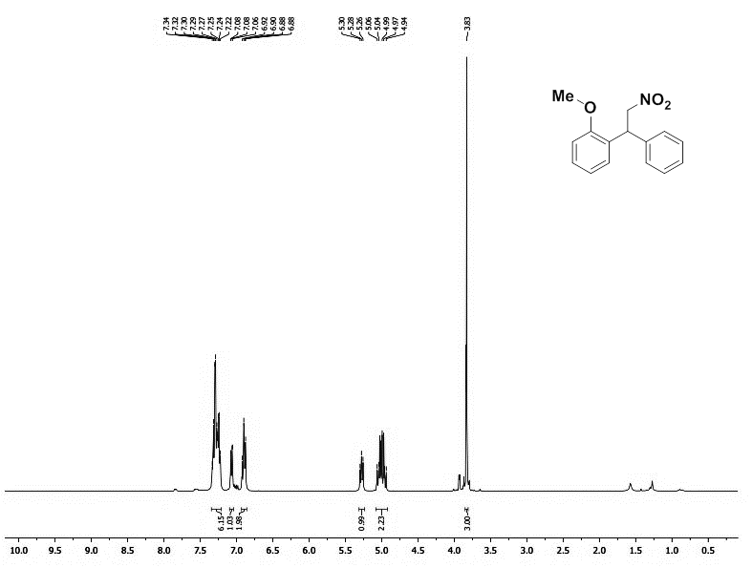
Fig. S25. ¹H NMR of compound 6j
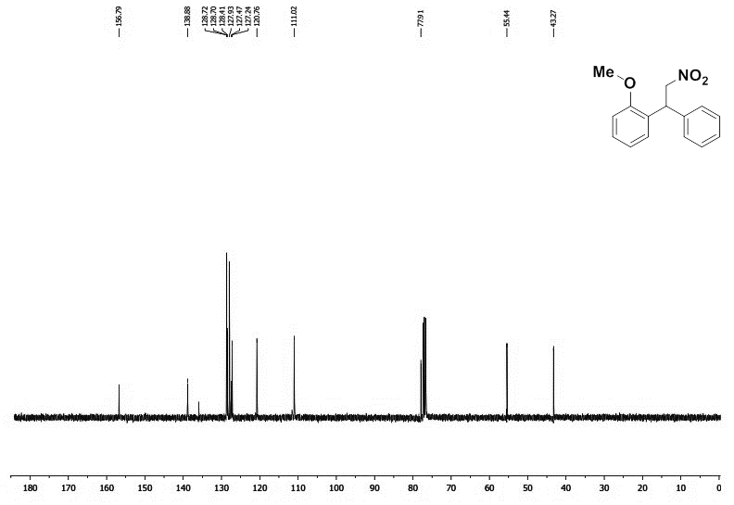
Fig. S26. ¹³C NMR of compound 6j
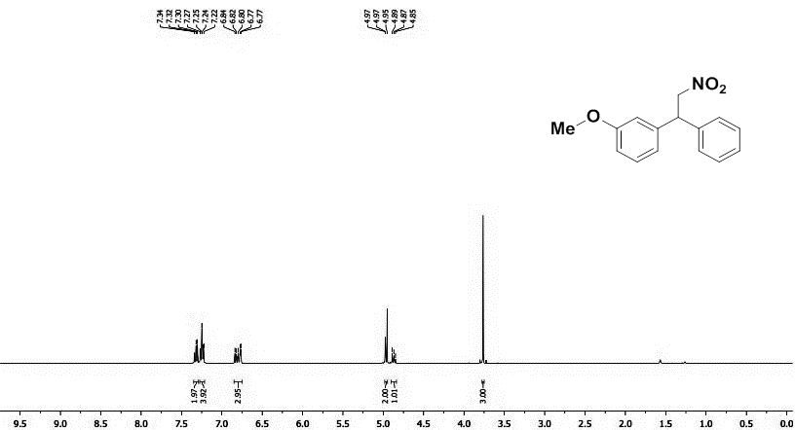
Fig. S27. ¹H NMR of compound 6k
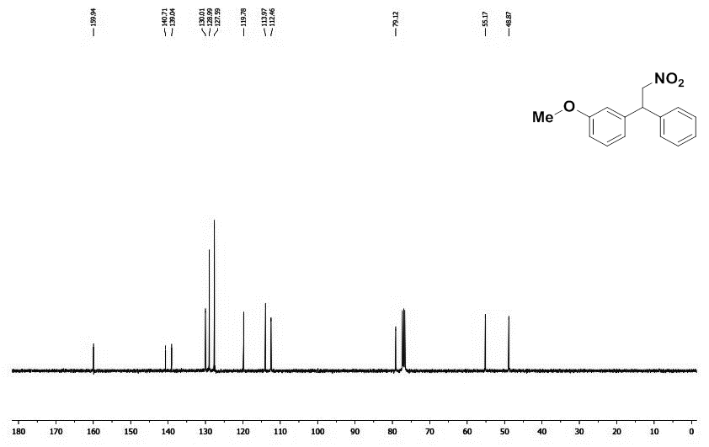
Fig. S28. ¹³C NMR of compound 6k
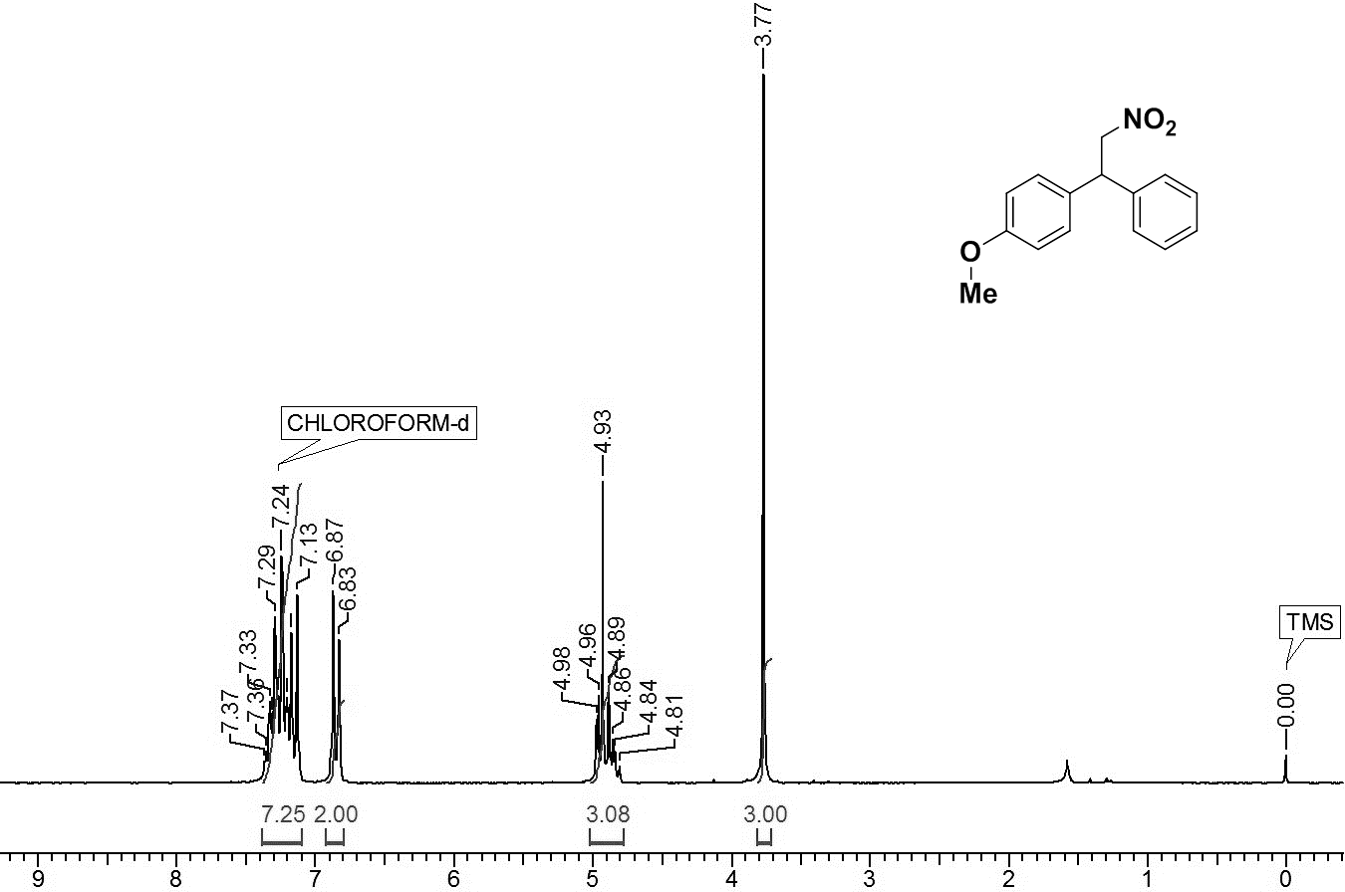
Fig. S29. ¹H NMR of compound 6l
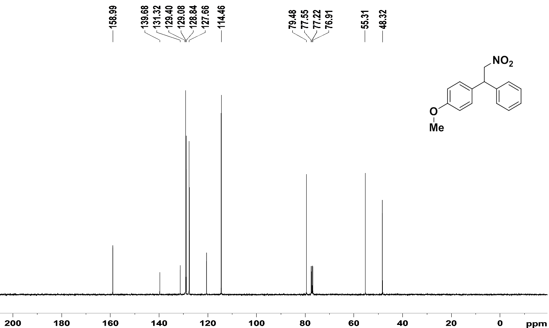
Fig. S30. ¹³C NMR of compound 6l
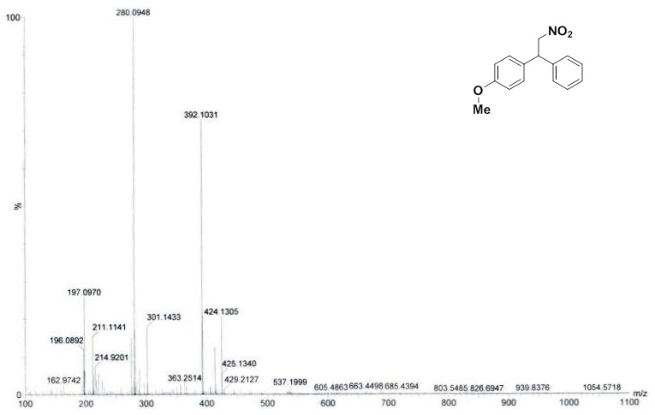
Fig. S31. MASS spectra of compound 6l
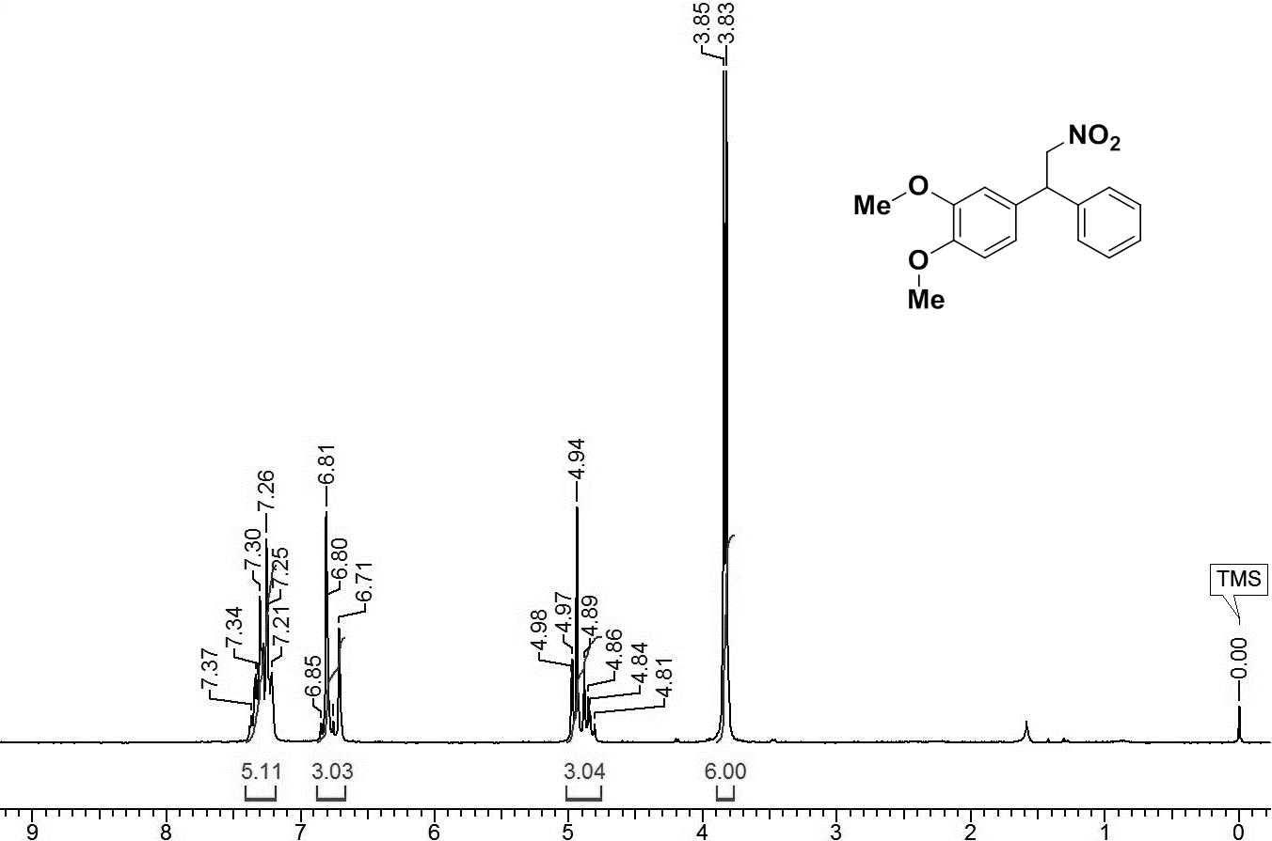
Fig. S32. ¹H NMR of compound 6m
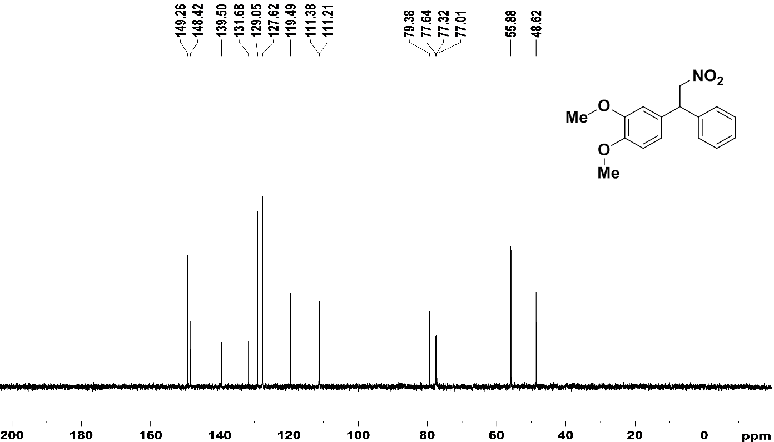
Fig. S33. ¹³C NMR of compound 6m
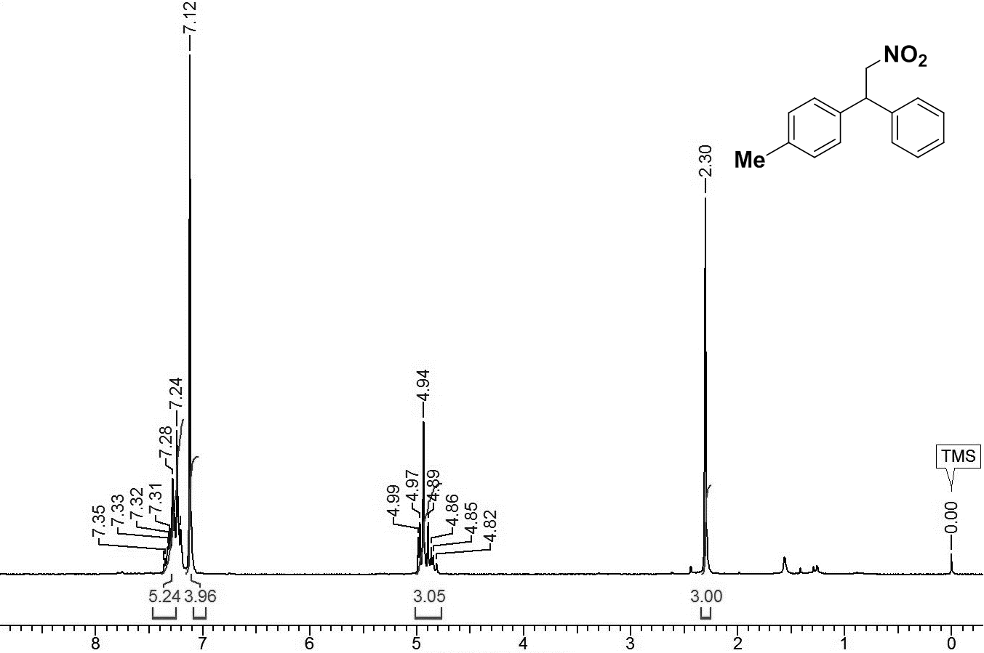
Fig. S34. ¹H NMR of compound 6n
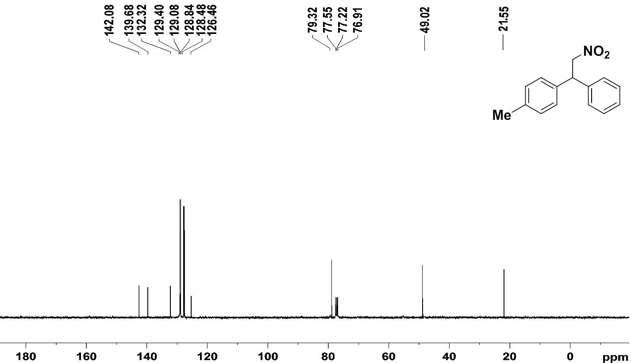
Fig. S35. ¹³C NMR of compound 6n
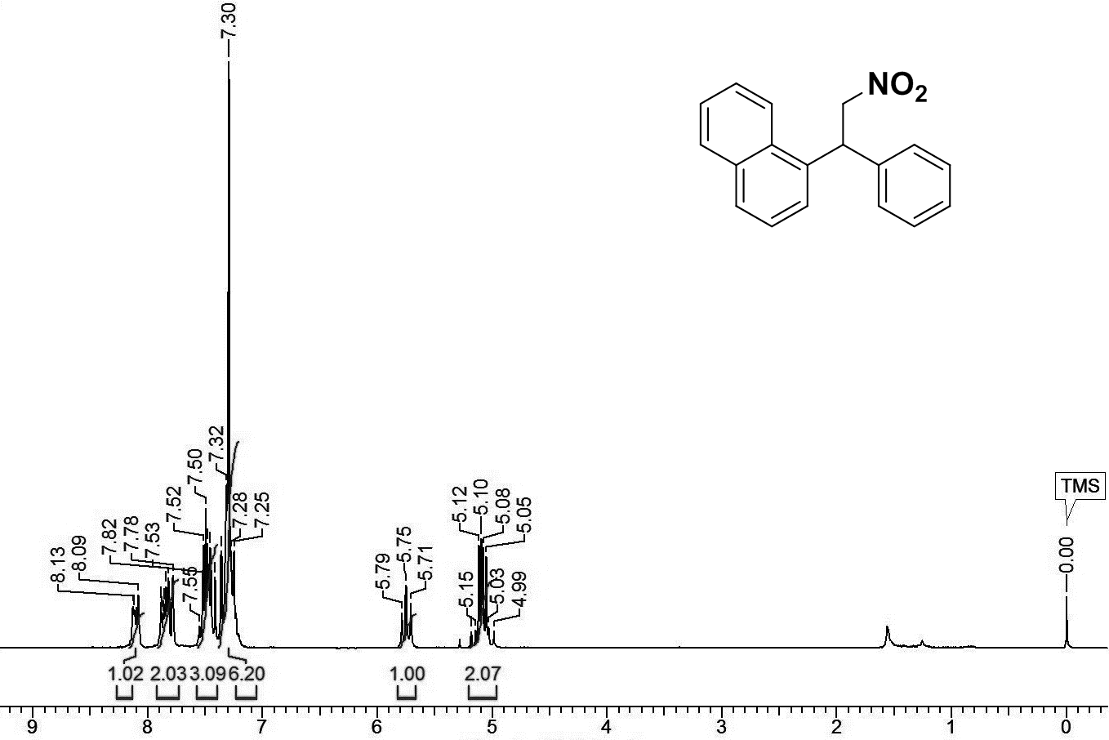
Fig. S36. ¹H NMR of compound 6o
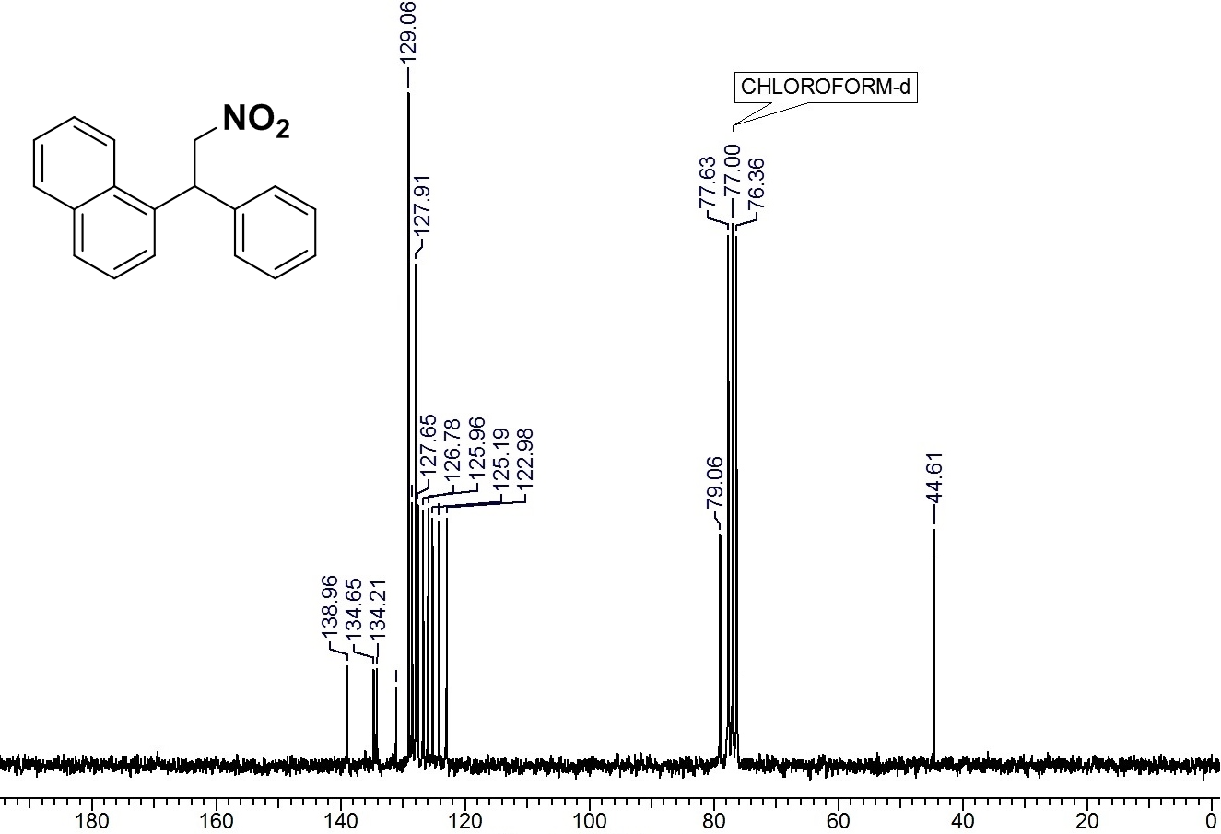
Fig. S37. ¹³C NMR of compound 6o
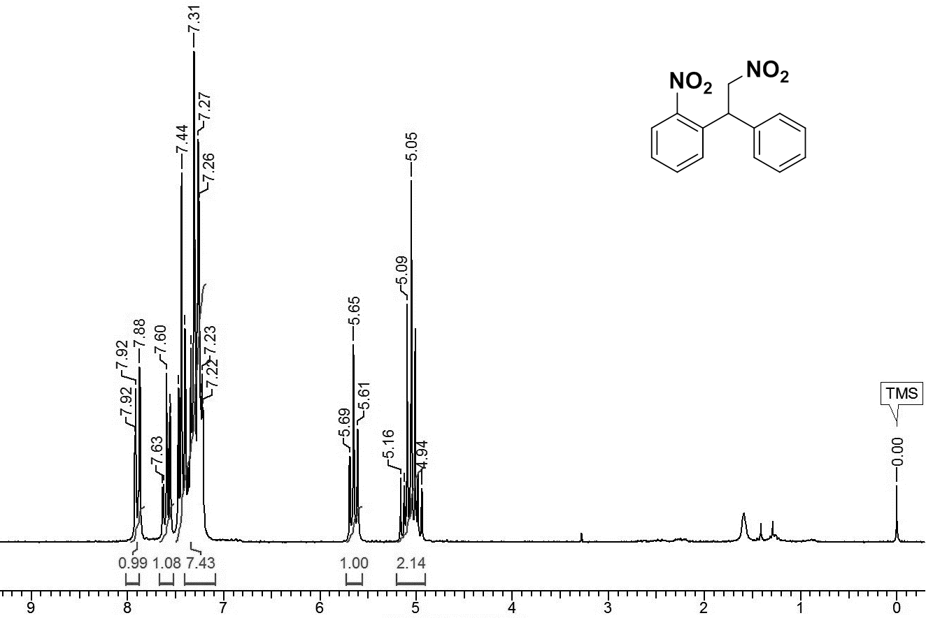
Fig. S38. ¹H NMR of compound 6p
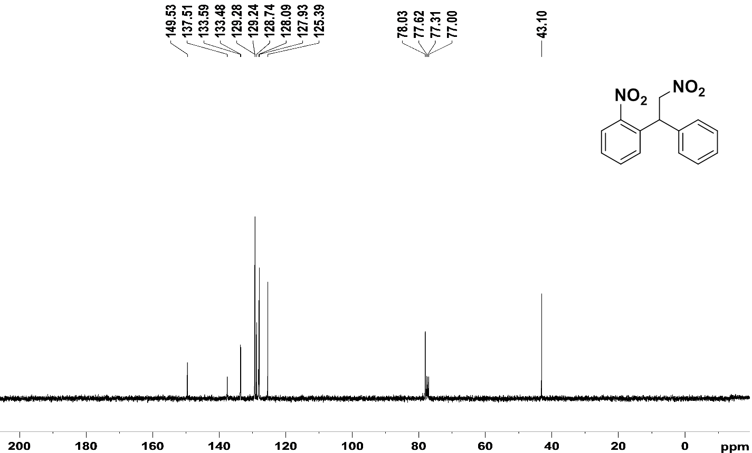
Fig. S39. ¹³C NMR of compound 6p
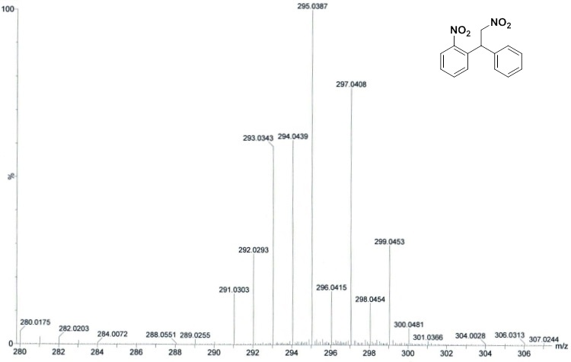
Fig. S40. MASS spectra of compound 6p
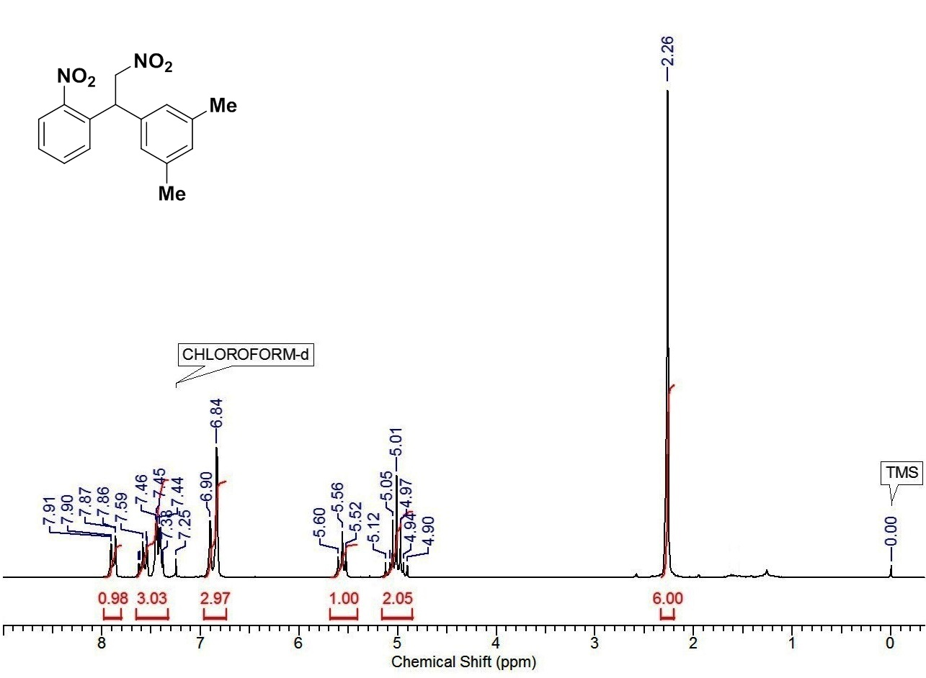
Fig. S41. ¹H NMR of compound 6q
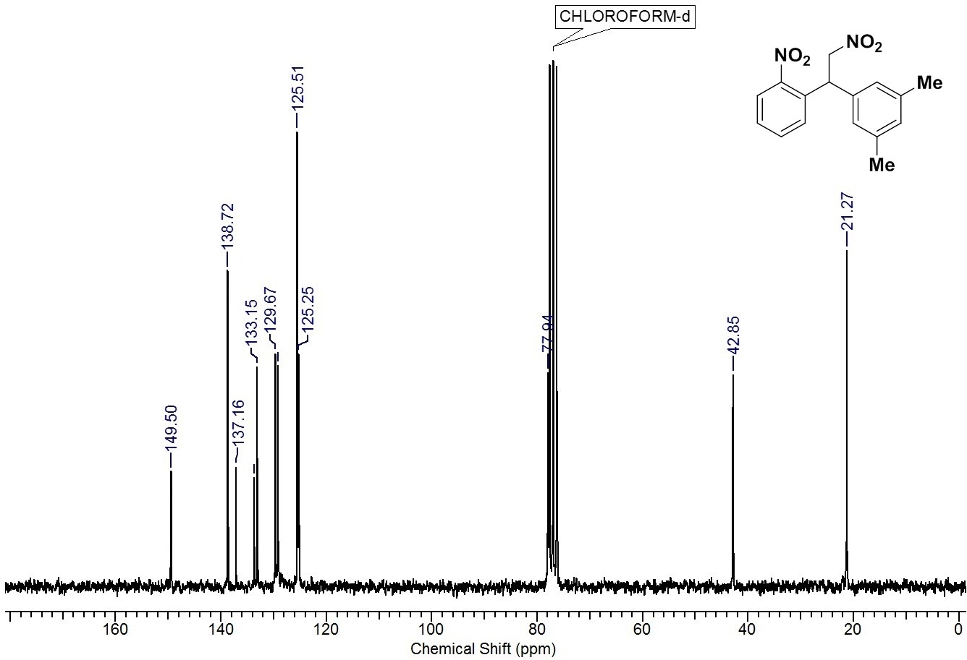
Fig. S42. ¹³C NMR of compound 6q
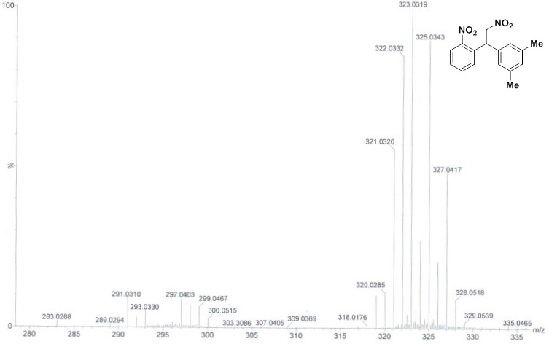
Fig. S43. MASS spectra of compound 6q
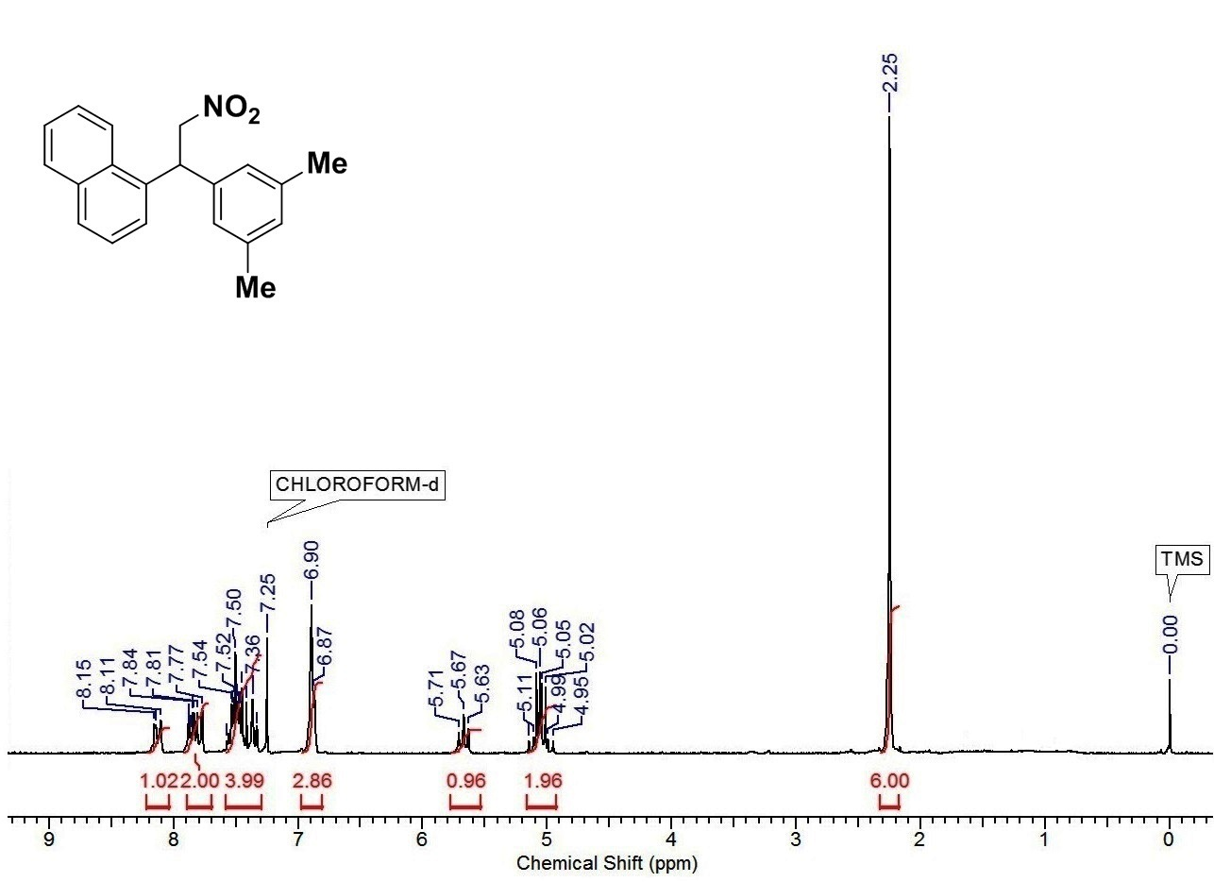
Fig. S44. ¹H NMR of compound 6r
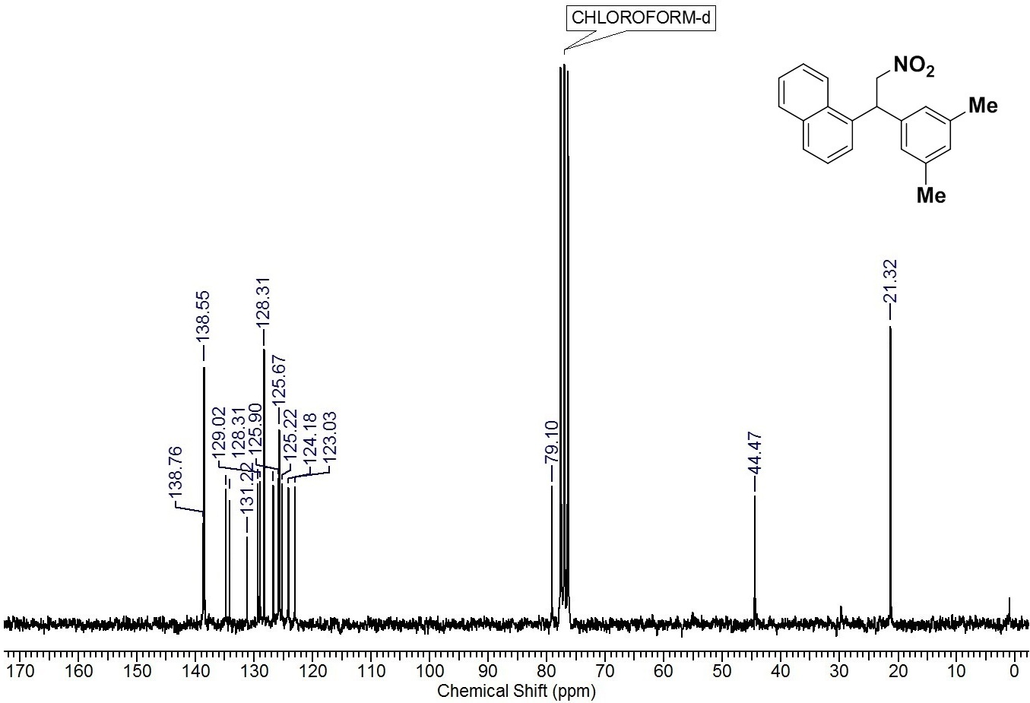
Fig. S45. ¹³C NMR of compound 6r
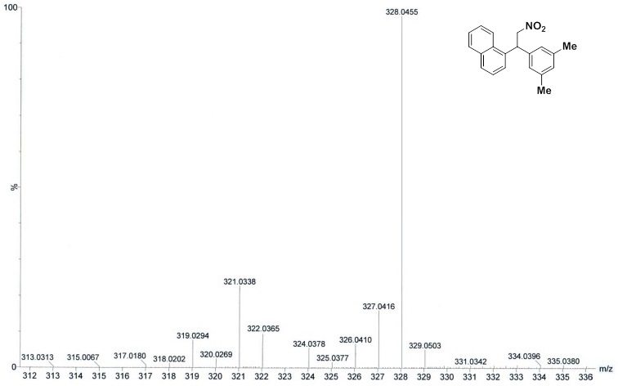
Fig. S46. MASS spectra of compound 6r
References
[1] He, Q.; Xie, F.; Fu, G.; Quan, M.; Shen, C.; Yang, G.; Gridnev, I. D.; Zhang, W. Palladium-Catalyzed Asymmetric Addition of Arylboronic Acids to Nitrostyrenes. Org. Lett. 2015, 17, 2250-2253. DOI: 10.1021/acs.orglett.5b00863.
[2] Wang, Z-Q.; Feng, C-G.; Zhang, S-S.; Xu, M-H.; Lin, G-Q. Rhodium-Catalyzed Asymmetric Conjugate Addition of Organoboronic Acids to Nitroalkenes Using Chiral Bicyclo[3.3.0] Diene Ligands. Angew. Chem. Int. Ed. 2010, 49, 5780-5783. DOI: 10.1002/anie.201001883.
[3] Xue, F.; Wang, D.; Li, X.; Wan, B. Rhodium-Catalyzed Asymmetric Conjugate Addition of Arylboronic Acids to Nitroalkenes Using Olefin-Sulfoxide Ligands. J. Org. Chem. 2012, 77, 3071-3081. DOI: 10.1021/jo3003562.
[4] Huang, K-C.; Gopula B.; Kuo, T-S.; Chiang, C-W.; Wu, P-Y.; Henschke, J. P.; Wu, H-L. Rhodium-Catalyzed Asymmetric Addition of Arylboronic Acids to β-Nitroolefins: Formal Synthesis of (S)-SKF 38393. Org. Lett. 2013, 15, 5730-5733. DOI: 10.1021/ol4027599.

