The internal and watershed controls on hypolimnetic sediment phosphorus release in Lake Auburn, Maine, USA

Supplemental Materials

Heather A. Doolittle,¹ Stephen A. Norton,² Linda C. Bacon,³ Holly A. Ewing,⁴ and Aria Amirbahman^{1,*}

¹ Department of Civil and Environmental Engineering, University of Maine, Orono, Maine 04469
² School of Earth and Climate Sciences, University of Maine, Orono, Maine 04469
³ The Maine Department of Environmental Protection, Augusta, Maine 04333
⁴ Program in Environmental Studies, Bates College, Lewiston, Maine 04240

* Corresponding author; ariaa@maine.edu
Method to determine lake water budget
The Auburn Water District (AWD) used a combination of flow meters and weirs to record flow. Due to regular complications with frozen apparatus, data from November to March were interpolated based on flow observed from April to October, assuming equal seasonal flow. The Basin Stream and Townsend Brook are perennial (Dudley 2004). Daily precipitation and temperature data were obtained from the Auburn/Lewiston Municipal Airport weather station located 9.3 km south of the lake.
Precipitation records were used to calculate direct precipitation input to the lake. Mean daily temperature records were used to calculate evaporation from the lake using the Hamon equation for evapotranspiration during the ice-free season (January-April and December of 2014) (Hamon 1961):
$$ET=\left[0.55D^{2}Pt\right]2.54$$
Where, ET = potential evapotranspiration (cm/d), D = daylight hours over a 12 h period, $Pt={9.95e^{(0.062T_{a})}}/{100}$, and T_{a} = daily mean temperature (C).
The AWD provided data on monthly withdrawal volume from the lake for water distribution. We also compiled data collected by Dudley (2004) and CDM Smith (2013) to form a water budget for Lake Auburn dating back to 2001.

Aqueous sample collection and analysis
All metal samples were collected in acid-washed HDPE bottles. Samples for total metals were unfiltered and acidified to pH < 2 with HNO₃ in the field. Dissolved metals samples were filtered (0.45 µm) and acidified to pH < 2 with HNO₃ in the field. Organically-bound Al and Fe samples were filtered in the field, passed through a column containing cation exchange resin (Dowex HCR-W2), and field-acidified to pH < 2 with HNO₃. All samples were preserved at 4 C until analysis. Total metals, dissolved metals, and organically-bound Al and Fe samples were analyzed by high resolution ICP-MS (Thermo Element 2). Particulate Al and Fe concentrations were calculated as the difference between the total and dissolved concentrations. The inorganic dissolved concentrations were calculated as the difference between dissolved and organically-bound concentrations. Total phosphorus, collected in acid-washed amber glass bottles, was measured on a Varian Cary 50 spectrophotometer using a molybdate blue coloring reagent following an ammonium peroxydisulfate digestion (250 C, 0.5 h).
A blank, a replicate analysis, and an analyte-spiked sample were run for every ten field samples to establish quality control within 5% error for all samples.

On the presence of apatite in Lake Auburn sediment
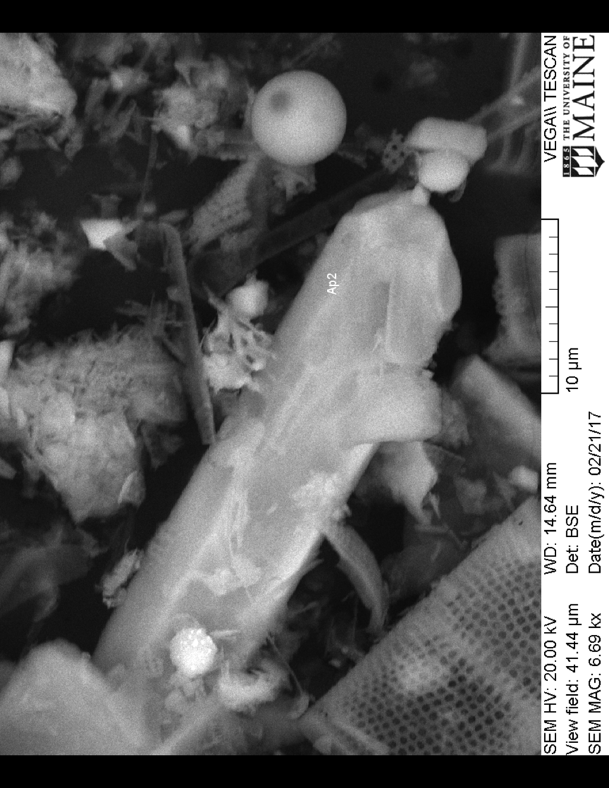
Based on the relatively constant Ca_{HCl}:P_{HCl} molar ratio of approximately 2:1 in the Psenner extractions, we hypothesized the presence of apatite in the sediment. We analyzed (mapped) selected intervals of sediment for Ca and P in the 60 cm long sediment core collected at sites 8 (n = 4; Doolittle, 2015) for Ca and P using an EDAX Pegasus system with energy dispersive x-ray spectrometry (EDX) with an Apollo40 SDD. In 2016, we also collected another long core (4.3 m) in Lake Auburn close to site 8, and analyzed its top 100 cm similarly with SEM and EDX (n = 3). We imaged targets of coincidences of high Ca and P with a Tescan Vega II XMU tungsten filament scanning electron microscope (SEM) and analyzed the grains. We identified apatite in all seven sections (Figures S1 and S2).

Figure S1. An apatite crystal in a typical SEM micrograph of Lake Auburn sediment taken at the 55-57 cm depth increment from the 60 cm long sediment core collected at sites 8 (36 m deep).
The chemical half-life of apatite in well-drained soils is approximately 2,500 years (Norton et al. 2011; Boyle et al. 2013), being abundant in early post-glacial sediment (ca. 16,000 cal Y BP in Maine) and decreasing to undetectable by the present. Interestingly, we found apatite in all of the analyzed segments of the 60 cm long core, and the 4.3 m long core collected in 2016. The entire sequence of evaluated sediment (ca. 1.3 m) contained ¹³⁷Cs, implying that at least some component of the sediment was post-1945, probably post-1963/4. Additionally, the stable Pb isotopes of this section of sediment were systematically changing in response to air pollution (Norton, unpublished data). The shoreline of Lake Auburn has been subjected to erosion, with mobilization and redeposition of post-glacial impermeable marine sediments, the Presumpscot Formation (now uplifted). These sediments, composed of clay to silt-sized rock flour, contained unweathered minerals, including apatite. The solubility of apatite is less than that of calcite, but measurable and orders of magnitude higher than that of silicate minerals. In the early post-glacial time, most lakes underwent a period of eutrophication as a consequence of apatite dissolving from landscape soils (e.g., Norton et al., 2011).

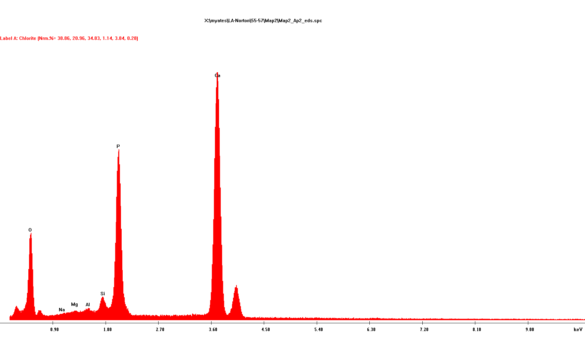
Figure S2. The energy dispersive x-ray (EDX) spectrum of the apatite crystal shown in Figure S1.

Annual aqueous species budget
To determine the average mass of total Al and Fe entering the lake on an annual basis, we used total seasonal input water volumes from Townsend and the Basin streams, and outlet/withdrawal calculated from AWD’s biweekly flow measurements. The seasonal lake input and output mass of species were then determined as the product of the volume and concentration for the corresponding period, and these values were summed across seasons to create the annual budget (Doolittle 2015).
The calculation was based on the assumption of the lake as a mixed flow through reactor, a modeling framework that has been used extensively in lake mass balance studies (e.g., Vollenweider 1975; Chapra 1997; Brett and Benjamin 2008). The mass balance expression is derived by setting mass accumulation in the water column of the lake equal to the sum of all inputs minus the sum of all the outputs and storage:
$V\frac{dC}{dt}=Q_{in}C_{in}-Q_{out}C-r_{S}$ Eq. S1
where, V is the lake volume; C is the species concentration in the lake, which for a mixed system is equal to the concentration at the outlets; C_{in} is the species concentration in the inflow; and r_{S} is the net zero-order storage rate (i.e., the difference between sedimentation and internal release), and atmospheric input of Al and Fe was assumed to be negligible. Assuming a steady-state concentration of the species C, as is commonly done in lake mass balance studies, Eq. S1 reduced to,
$Q_{in}C_{in}-Q_{out}C=r_{S}$ Eq. S2
The terms in this equation have the units of mass/time; multiplying these terms by time results in the total mass of species in each term for a given time span.
References
Boyle JF, Chiverrel RC, Norton SA, Plater AJ. 2013. A leaky model of long-term soil phosphorus dynamics. Global Geochem Cycle. 27:516-525.
Brett MT, Benjamin MM. 2008. A review and reassessment of lake phosphorus retention and the nutrient loading concept. Freshwater Biol. 53:194–211.
CDM Smith. 2014. Diagnostic Study of Lake Auburn and its Watershed. Final report to Lake Auburn Watershed Protection Commission. http://lakeauburnwater.org/wp-content/uploads/2014/05/2014-05-20-LAWPC-Final-Report.pdf.
Chapra SC. 1997. Surface Water-Quality Modeling. Long Grove (IL): Waveland Press, Inc.
Doolittle H. The role of aluminum and iron in controlling phosphorus loading, Lake Auburn, Maine. M.S. Thesis. University of Maine, Orono, Maine, USA. December 2015.
Dudley RW. 2004. Water budget for Lake Auburn, Maine, May 1, 2000 through April 30, 2003. United States Geologic Survey Scientific Investigations Report 2004-5106.
Hamon WR. 1961. Estimating potential evapotranspiration. J Hydr Div-ASCE. 87:107–120.
Norton SA, Perry RH, Saros JE, Jacobson GL, Fernandez IJ, Kopáček J, Wilson TA, SanClements MD. 2011. The controls on phosphorus availability in a Boreal lake ecosystem since deglaciation. J Paleolimnol. 46:107-122.
Vollenweider RA. 1975. Input-output models with special reference to the phosphorus loading concept in limnology. Schweiz Z Hydrol. 37:53–84.

Table S1. Mass budget for Fe and Al in the presence and absence of wetlands in 2014. All values are in kg.

 | Existing Fe mass | Fe mass w/o wetlands | Existing  Al mass | Al mass w/o wetlands
Inputs
Basin Stream | 3,310 | 1,220 | 630 | 420
Townsend Brook | 880 | 600 | 210 | 200
Outputs | 280 | 280* | 140 | 140*
Retained in lake | 3,900 | 1,540 | 700 | 480
* Constitute higher-end estimates

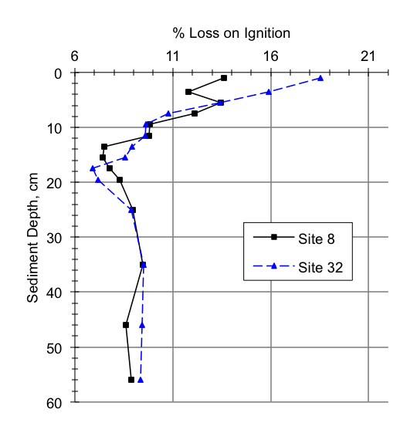

Figure S3. Loss-on-ignition (LOI) for sediment cores from sites 8 (36 m) and 32 (17 m).

