¹H NMR and ¹³C NMR of target compounds

(E)-4-{[3-[4-(3-phenylacryloyl) piperazine-1-carbonyl]-4-fluorophenyl]methyl}-2H-phthalazin-1-one (5a)
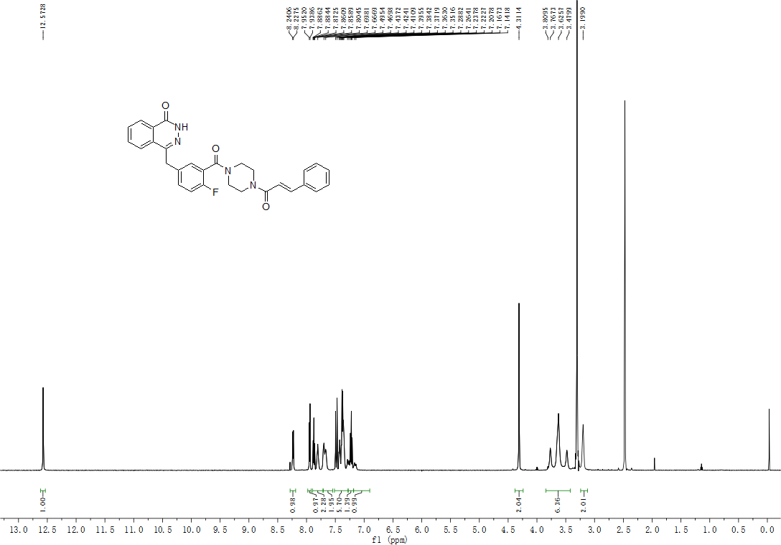
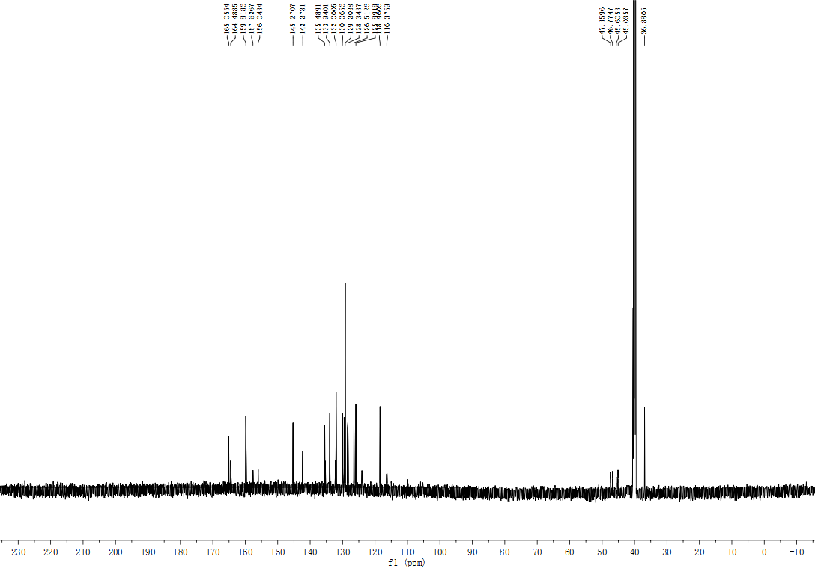

(E)-4-{[3-[4-(3-(3,4-dimethoxyphenyl)acryloyl)piperazine-1-carbonyl]-4-fluorophenyl]methyl}-2H-
phthalazin-1-one (5b)

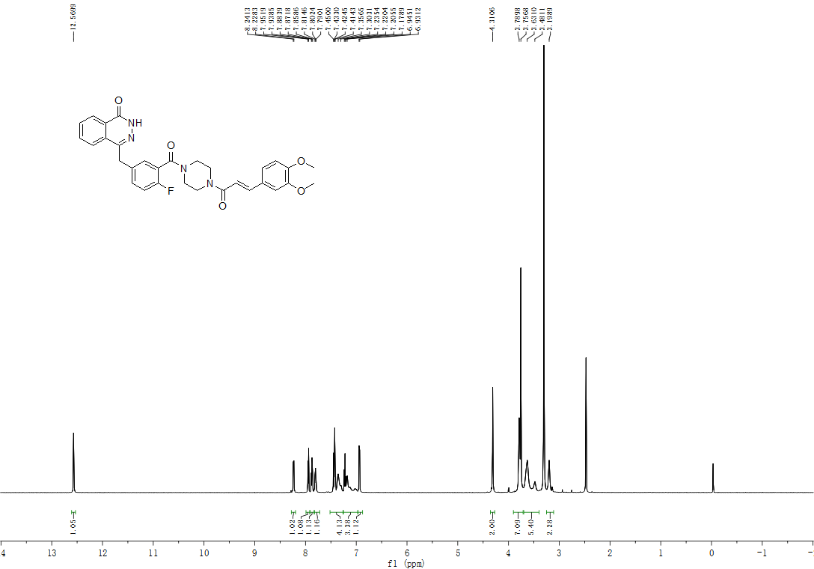

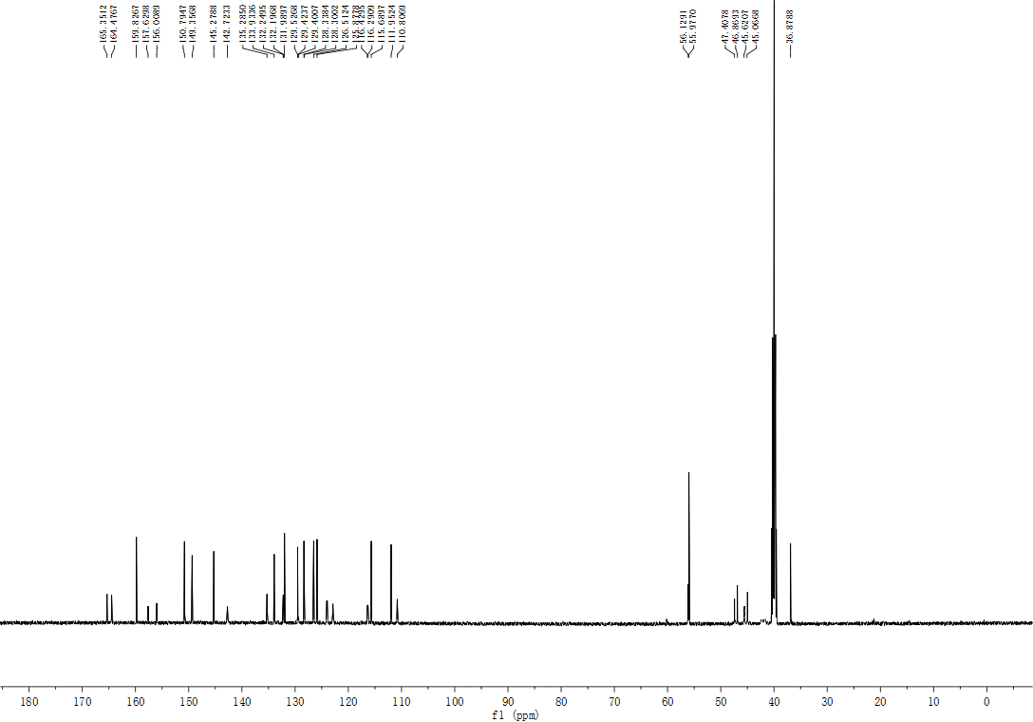

(E)-4-{[3-[4-(3-(4-methoxyphenyl) acryloyl) piperazine-1-carbonyl]-4-fluorophenyl] methyl} -2H-phthalazin-1-one (5c)

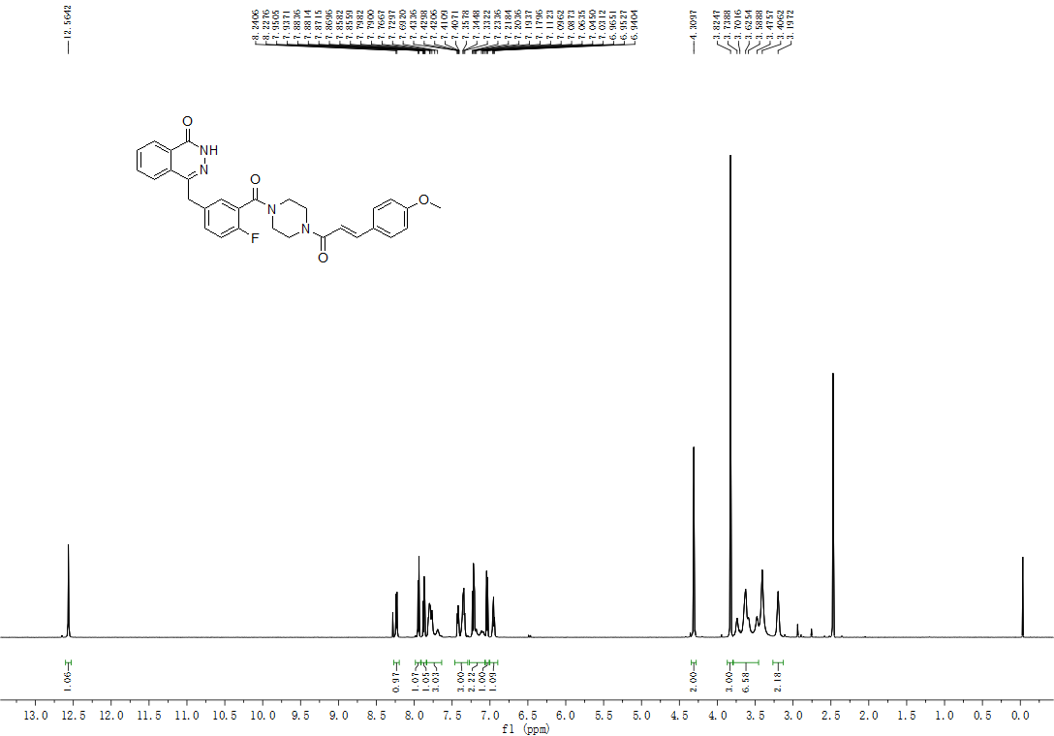

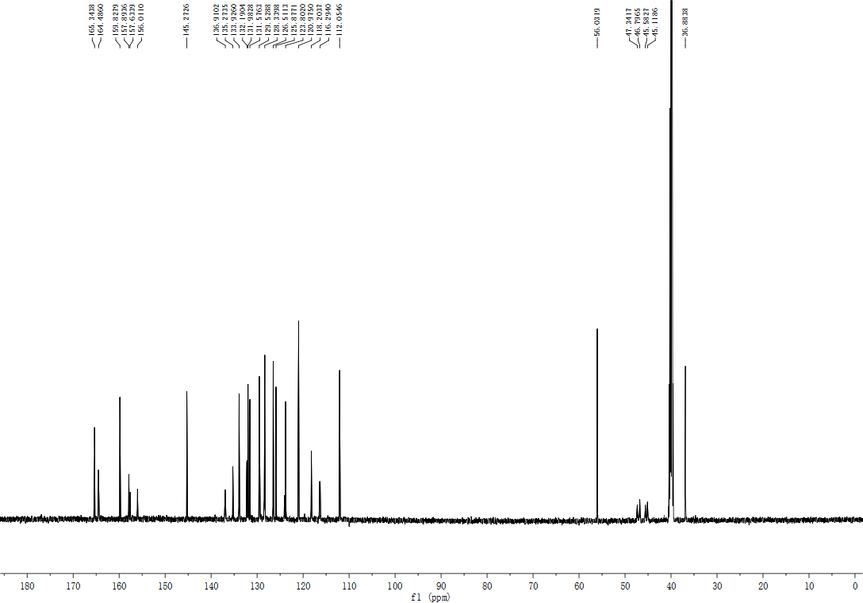

(E)-4-{[3-[4-(3-(4-methylphenyl) acryloyl) piperazine-1-carbonyl]-4-fluorophenyl] methyl} -2H-phthalazin-1-one (5d)

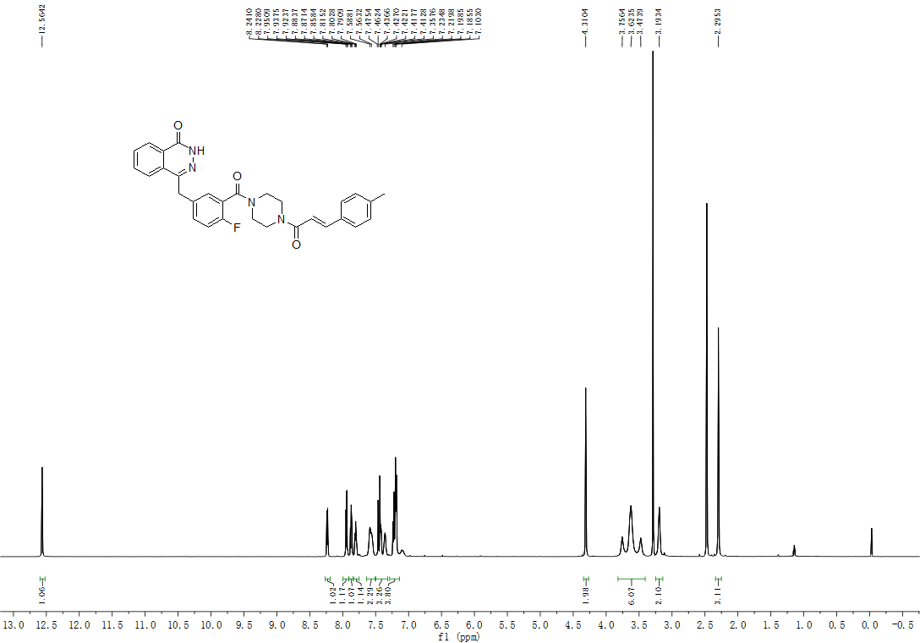

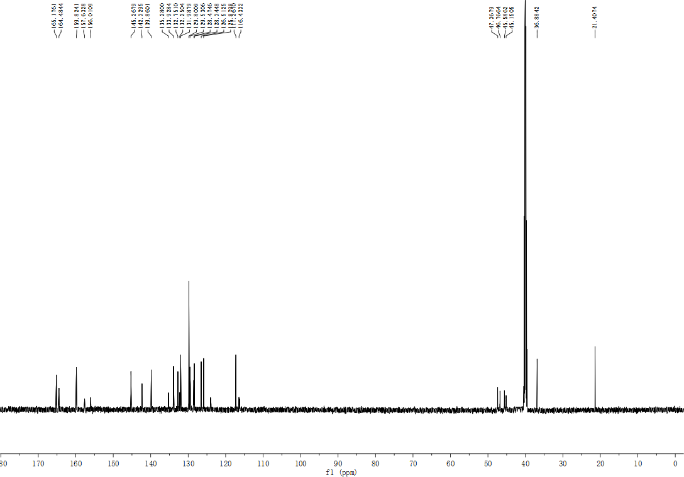

(E)-4-{[3-[4-(3-(2-methoxyphenyl)acryloyl)piperazine-1-carbonyl]-4-fluorophenyl]methyl}-2H-
phthalazin-1-one (5e)

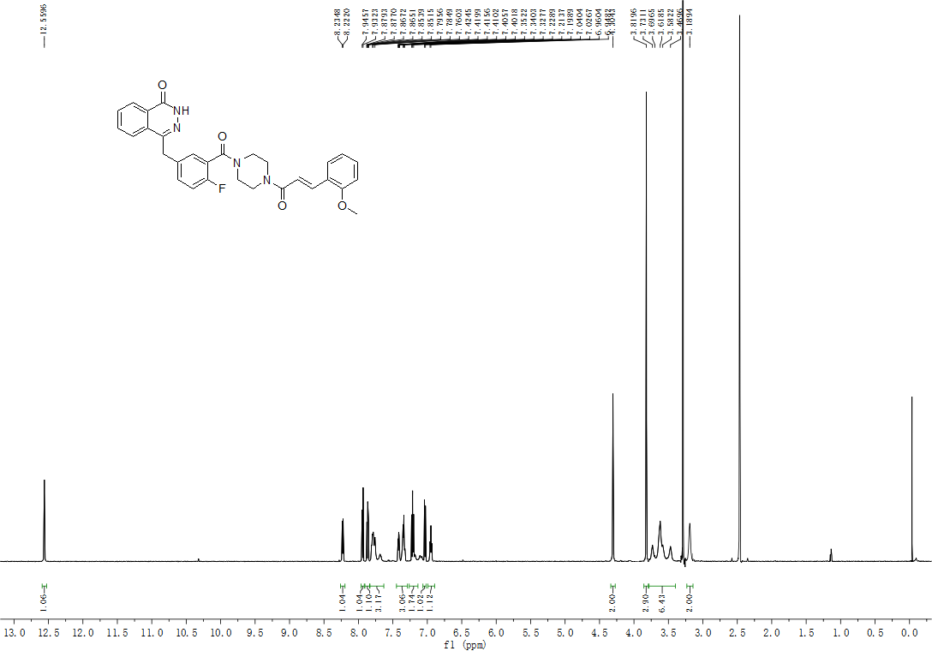

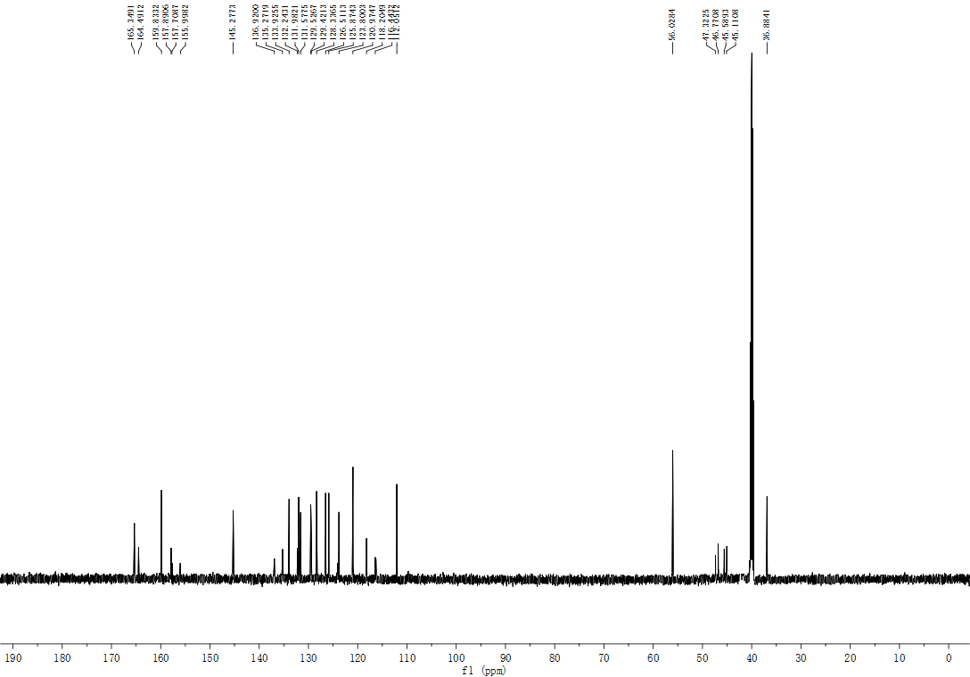

(E)-4-{[3-[4-(3-(2, 5-dimethoxyphenyl) acryloyl) piperazine-1-carbonyl]-4-fluorophenyl] methyl} -2H-phthalazin-1-one (5f)

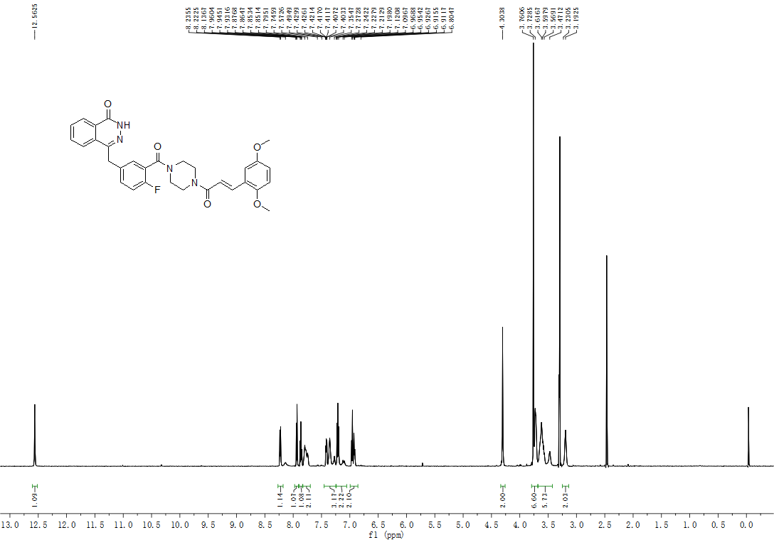

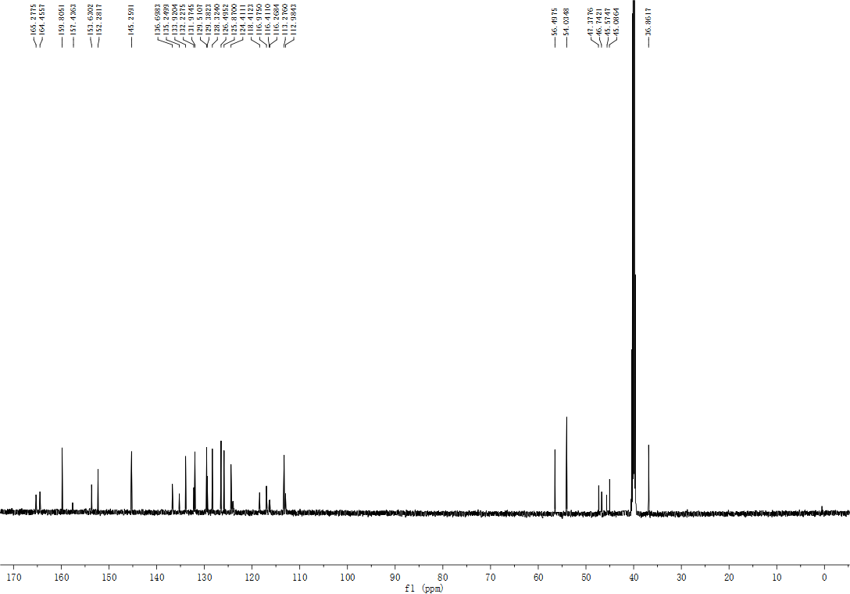

(E)-4-{[3-[4-(3-(4-fluorophenyl) acryloyl) piperazine-1-carbonyl]-4-fluorophenyl] methyl} -2H -phthalazin-1-one (5g)

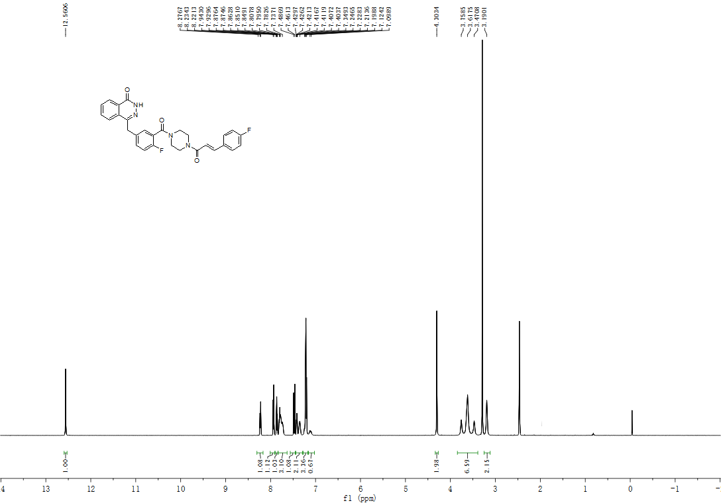

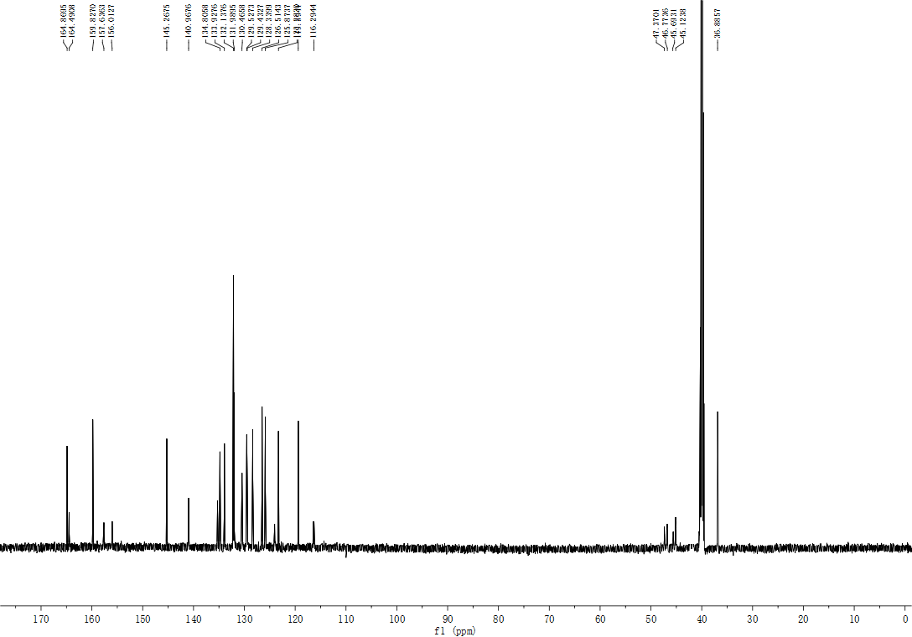

(E)-4-{[3-[4-(3-(4-trifluoromethylphenyl) acryloyl) piperazine-1-carbonyl]-4-fluorophenyl] methyl} -2H -phthalazin-1-one (5h)

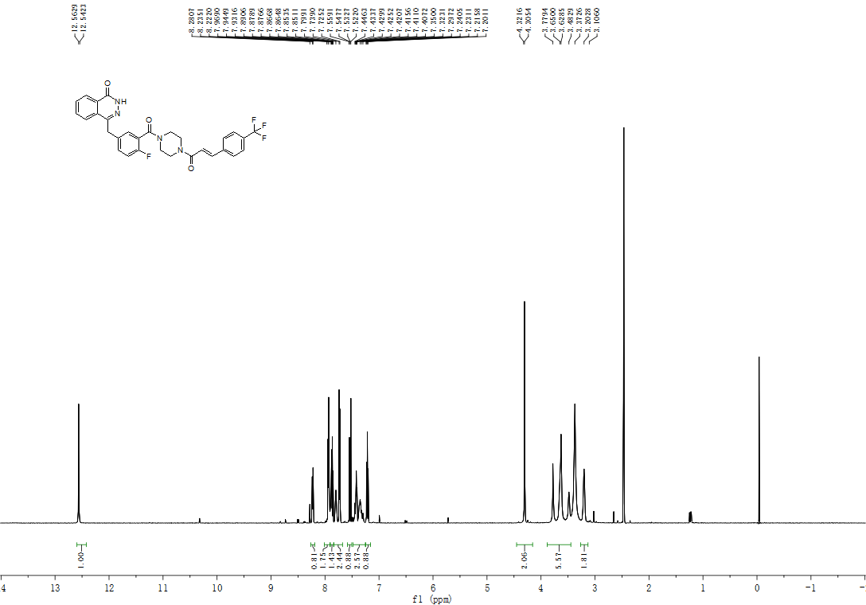

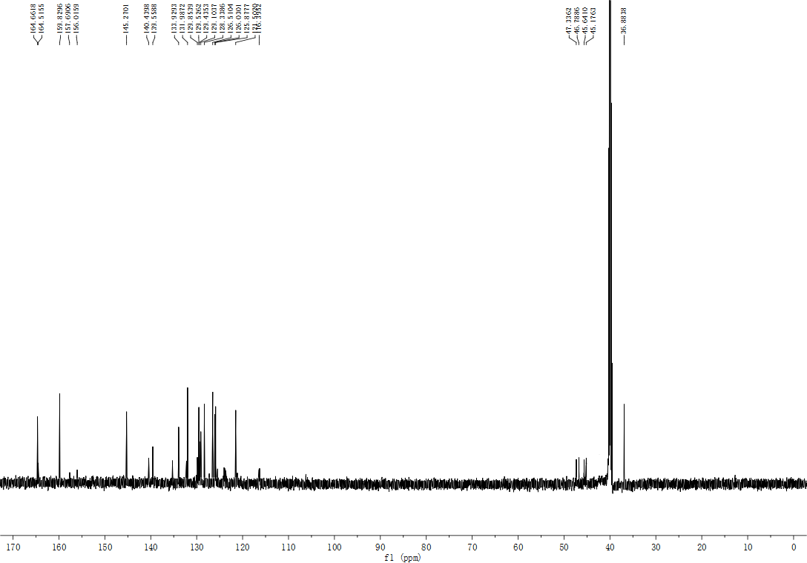

(E)-4-{[3-[4-(3-(3-fluorophenyl) acryloyl) piperazine-1-carbonyl]-4-fluorophenyl] methyl} -2H -phthalazin-1-one (5i)

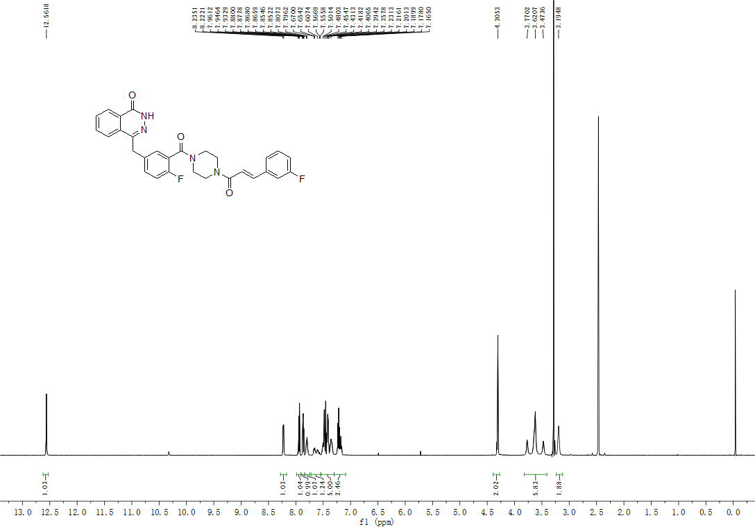

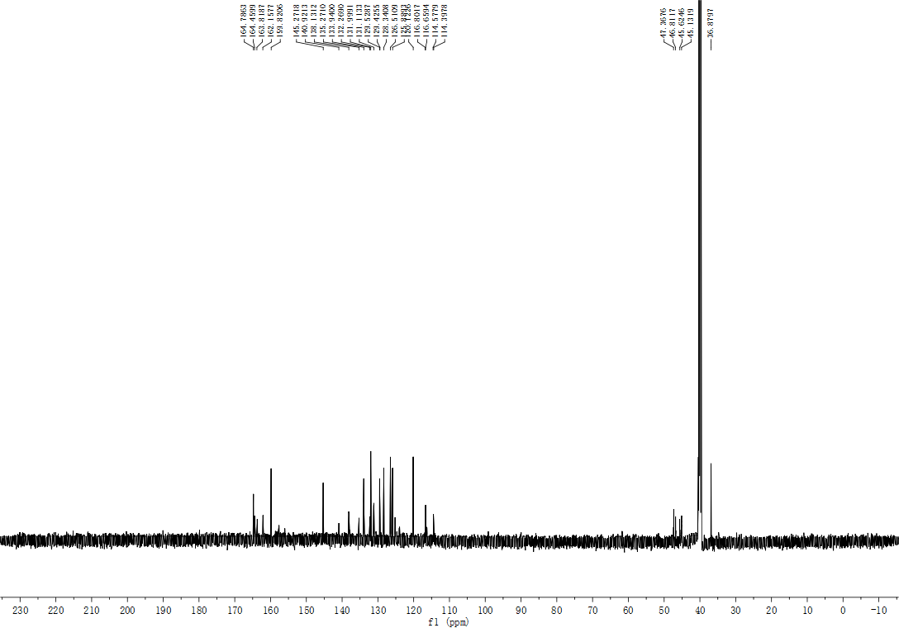

(E)-4-{[3-[4-(3-(4-chlorophenyl) acryloyl) piperazine-1-carbonyl]-4-fluorophenyl] methyl} -2H -phthalazin-1-one (5j)

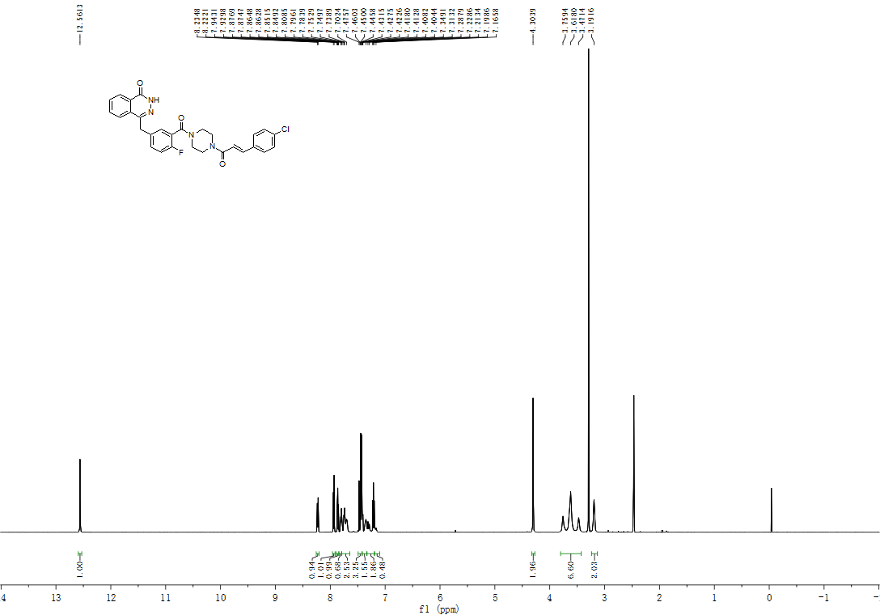

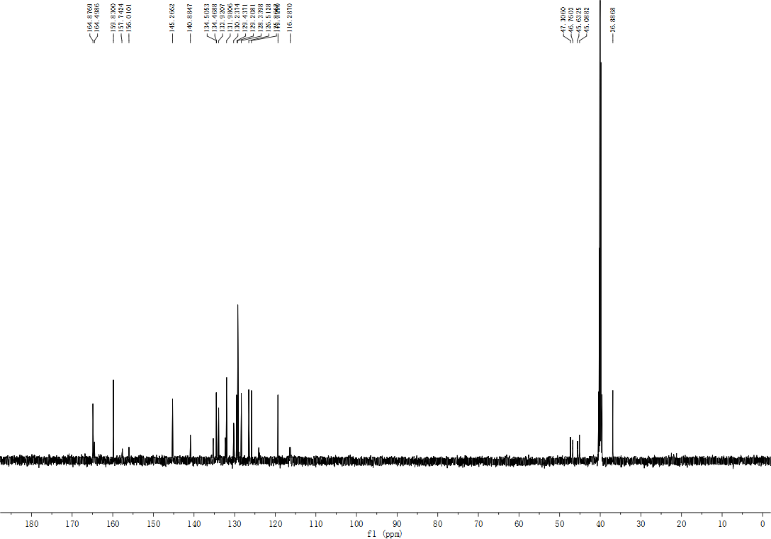

(E)-4-{[3-[4-(3-(4-bromophenyl) acryloyl) piperazine-1-carbonyl]-4-fluorophenyl] methyl} -2H -phthalazin-1-one (5k)

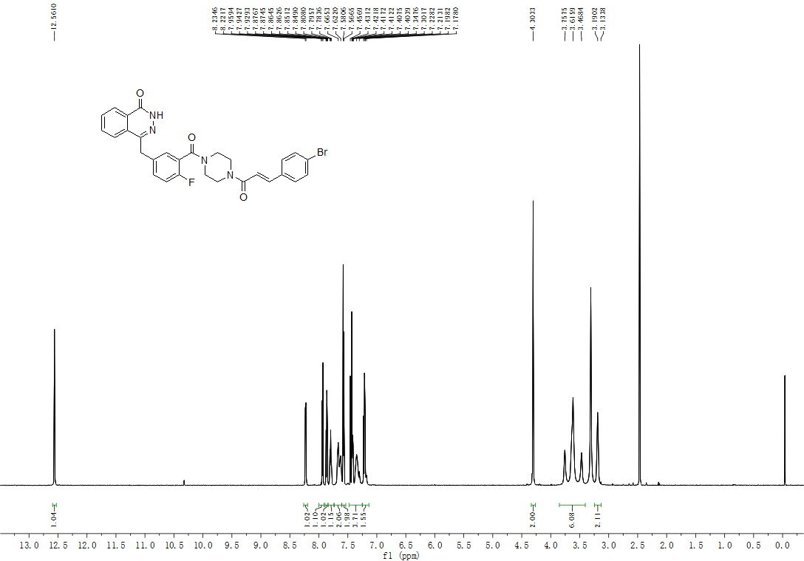

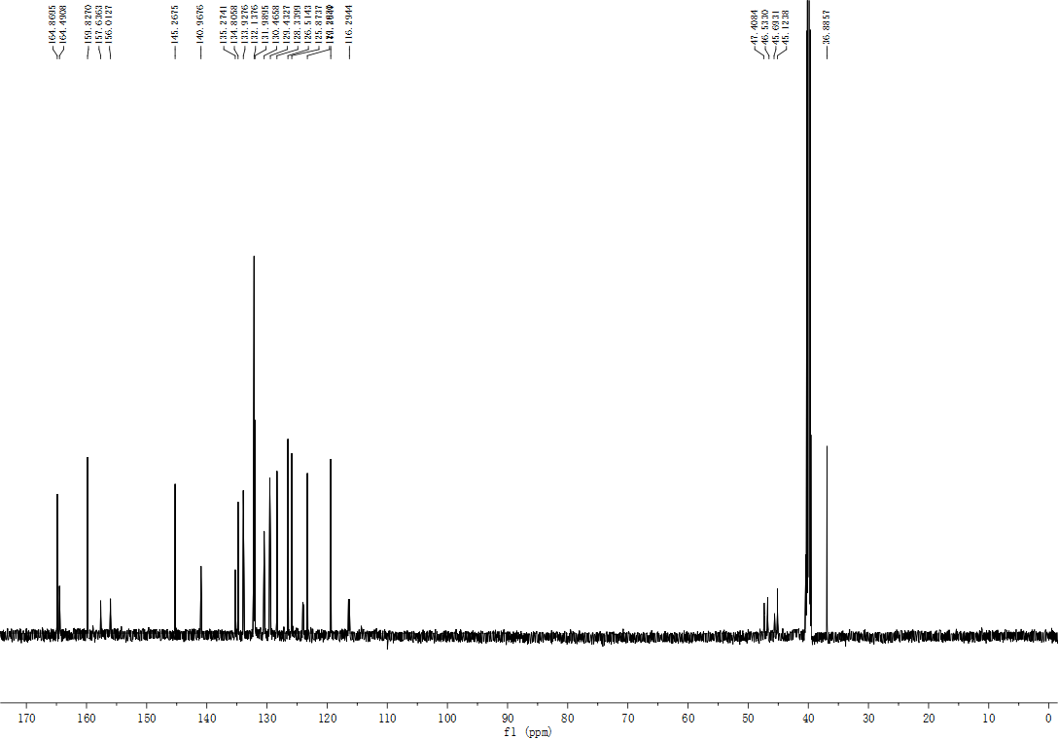

(E)-4-{[3-[4-(3-(3-nitrophenyl) acryloyl) piperazine-1-carbonyl]-4-fluorophenyl] methyl} -2H -phthalazin-1-one (5l)

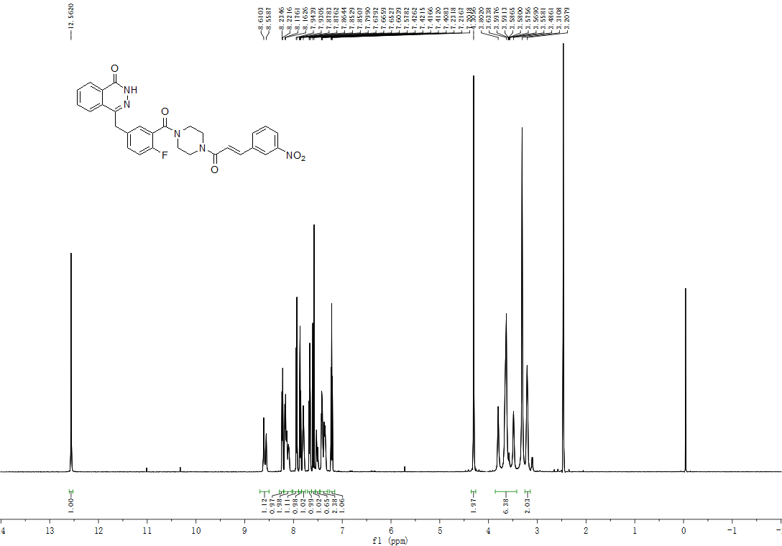

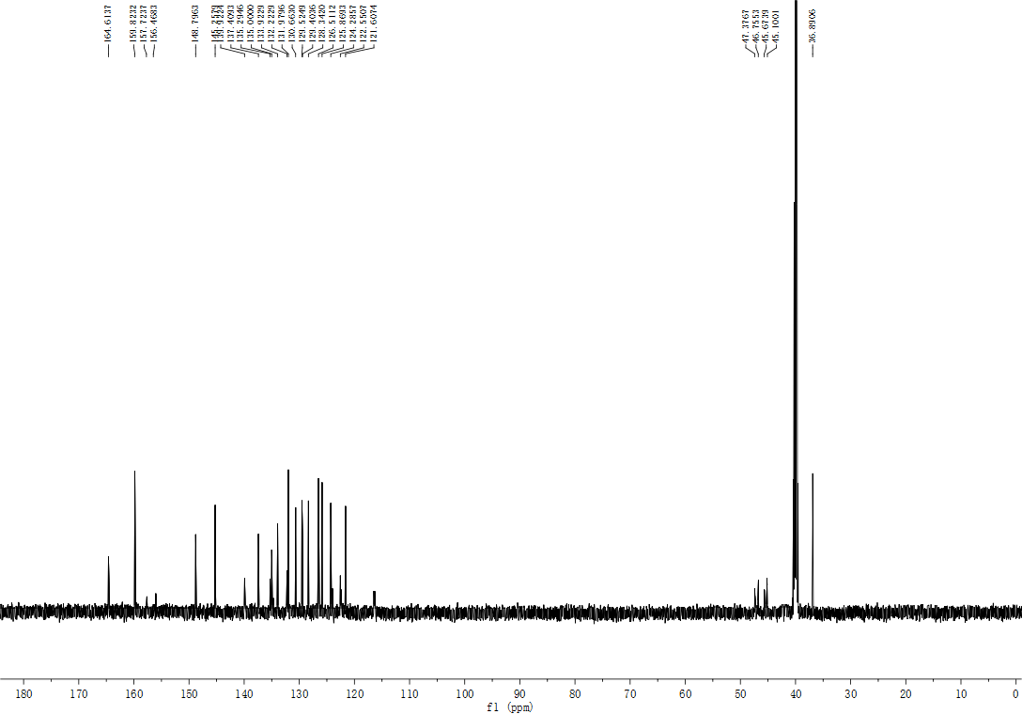

(E)-4-{[3-[4-(3-(4-nitrophenyl) acryloyl) piperazine-1-carbonyl]-4-fluorophenyl] methyl} -2H -phthalazin-1-one (5m)

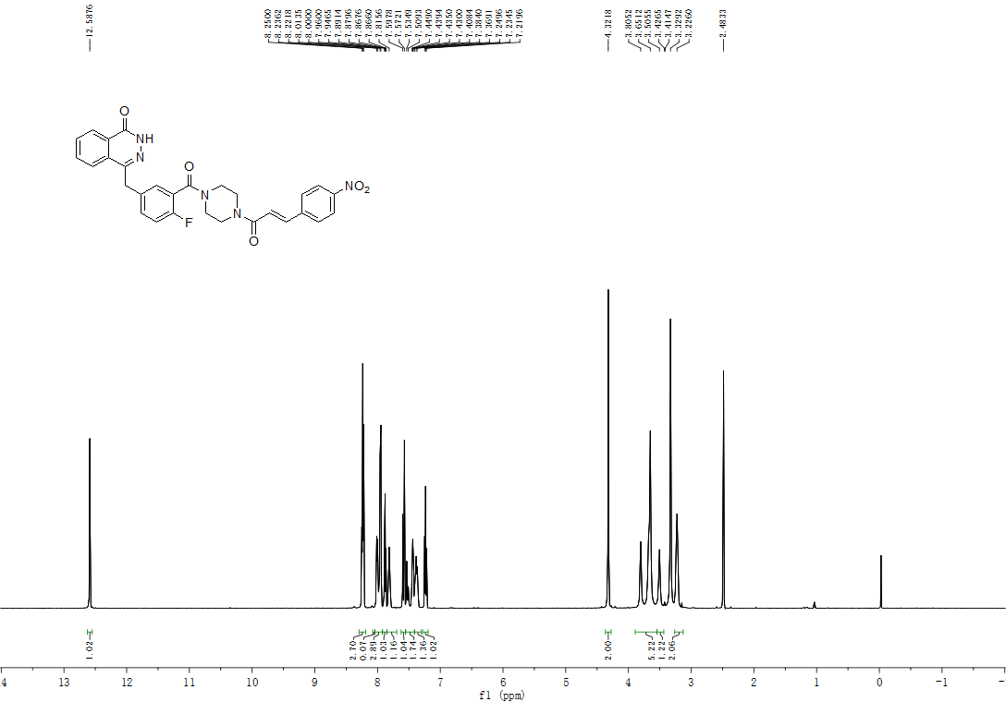

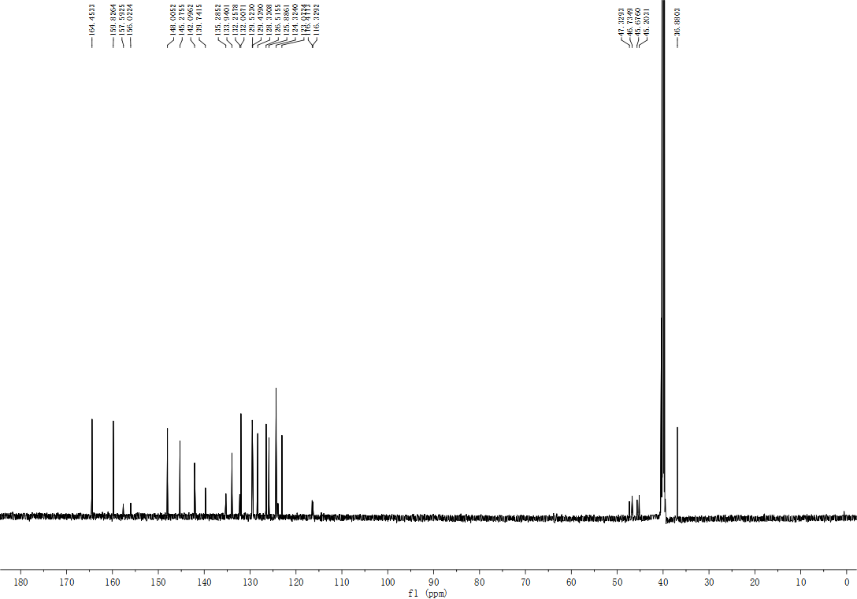

(E)-4-{[3-[4-(3-(3, 4, 5-trimethoxyphenyl) acryloyl) piperazine-1-carbonyl]-4-fluorophenyl] methyl} -2H -phthalazin-1-one (5n)

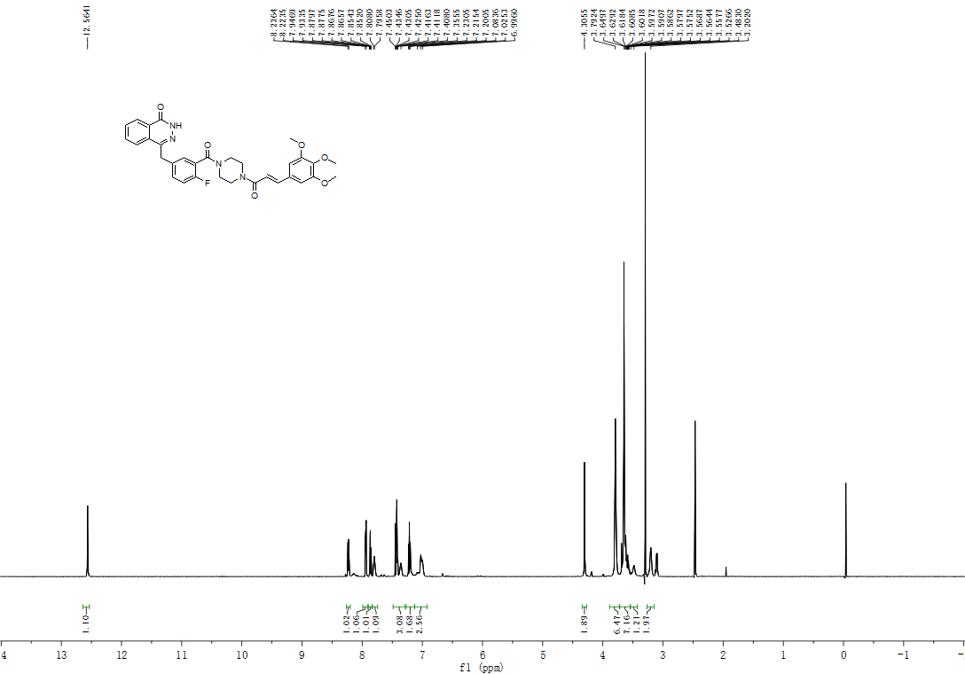

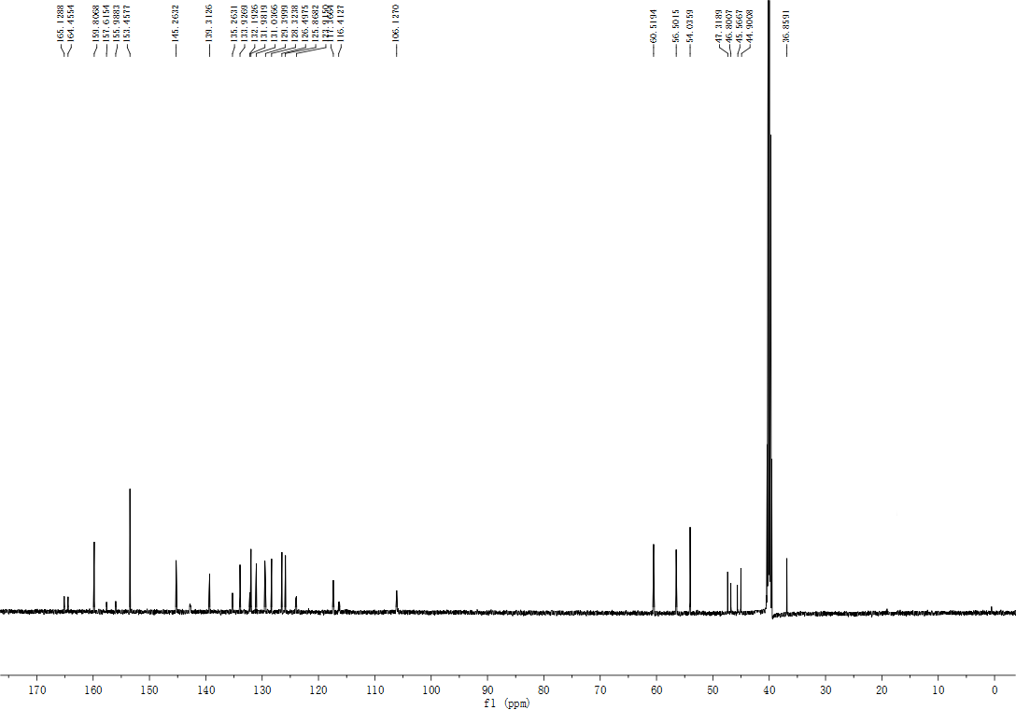
(E)-4-{[3-[4-(3-(furan-2-yl) acryloyl) piperazine-1-carbonyl]-4-fluorophenyl] methyl} -2H -phthalazin-1-one (5o)



