Supplemental Information
As detailed in the main body of the report, midodrine patients were dissimilar from potential control patients in aggregate (leftmost column, Table S1 & Figure S2A). To mitigate resultant confounding, we matched midodrine patients to eligible controls on four key variables: vintage, pre-dialysis blood pressure, nadir intradialytic blood pressure, and the percent of treatments impacted by IDH. For the purposes of accomplishing the matching, these were defined for the calendar month immediately preceding midodrine start for exposed patients and for the contemporaneous calendar month for controls. We successfully matched 3,133 midodrine patients to one (n= 161) or two (n= 2972) controls.
As of month start, midodrine patients and controls were well-matched on all four variables (second column, Table S1 & Figure S2B). However as of index date (the date of midodrine initiation for the exposed patients from each group), pre-dialysis blood pressure and nadir intradialytic blood pressure had fallen among midodrine patients and the percent of treatments affected by IDH had risen such that differences emerged between the two groups (third column, Table S1 & Figure S2C). However, balanced remained at index for the subset of matched groups among whom index date occurred within the first 10 days of the month (among whom there was less opportunity for clinical differences to emerge; rightmost column, Table S1 & Figure S2D); these formed the analytic cohort for the present study.

Table S1: Patient Characteristics in Unmatched, Matched, and Analytic Cohorts
 | Unmatched |  | All Matched Groups: Calendar Month Prior to Index Date ^{c} |  | All Matched Groups:  as of Index Date^{d} |  | Analytic Cohort:  as of Index Date ^{c,e}
 | Control ª  N=887 735 | Midodrine ^{b}  N=3201 | Control ^{b}  N=6105 | Midodrine ^{b}  N=3133 | Control ^{b}  N=6105 | Midodrine ^{b}  N=3133 | Control ^{b}  N=2037 | Midodrine ^{b}  N=1046
Vintage, mo, mean±SD | 30.7 ± 21.8 | 27.6 ± 22.4* | 27.2 ± 21.7 | 27.1 ± 22.1 | 27.2 ± 21.7 | 27.1 ± 22.1 | 27.1 ± 21.4 | 27.2 ± 21.7
Pre-dialysis SBP, mean±SD | 149 ± 20 | 128 ± 20* | 128 ± 19 | 128 ± 19 | 129 ± 20 | 126 ± 20* | 128 ± 21 | 127 ± 20
Nadir SBP, mean±SD | 112 ± 18 | 91 ± 14* | 92 ± 13 | 91 ± 13 | 92 ± 14 | 89 ± 13* | 91 ± 13 | 90 ± 13*
IDH, % treatments | 18.1 ± 22.8 | 50.0 ± 31.3* | 48.5 ± 30.9 | 49.3 ± 31.1 | 46.1 ± 31.3 | 53.4 ± 31.0* | 49.8 ± 30.6 | 50.8 ± 30.6*
ª N represents patient-months, not unique patients
^{b} N represents unique patients
^{c} Values presented are as of time of matching (ie, considering data as of the start of the calendar month)
^{d} Values presented are as of index date
^{e} Includes only matched groups among whom index date occurred within the first 10 days of the month
*Significantly different than control within the cohort, p<0.05

Abbreviations: IDH, intradialytic hypotension; SBP, systolic blood pressure; SD, standard deviation

Figure S1: Study schema
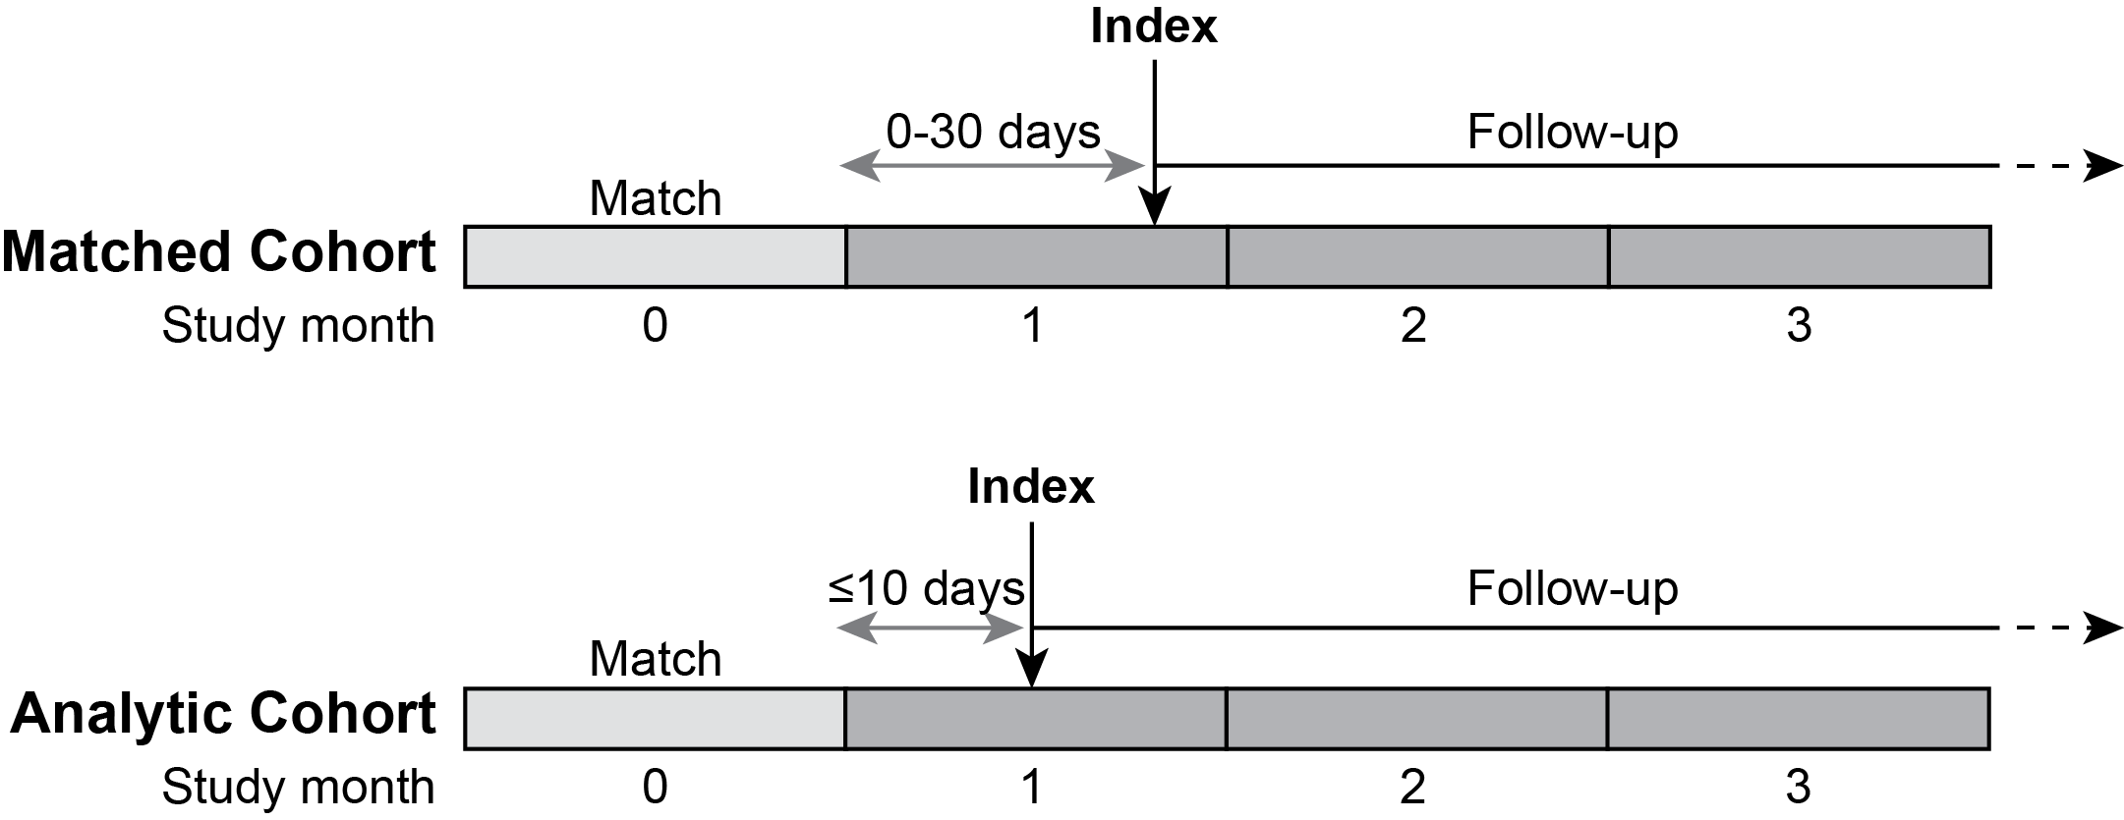
A schematic of the study design is presented. Index date was defined as the date of the first visible midodrine order for exposed patients, and the corresponding date for controls. Matching was conducted on the basis of characteristics as observed in the month prior to the index date (study month 0). Thus, within the matched cohort, up to 30 days could have occurred between the end of study month 0 and the index date itself (matched cohort, grey double-headed arrow). Because significant drift in the values of these critical variables was observed between study month 0 and study month 1 (see Table S1 and Figure S2), the analytic cohort was restricted to those patient clusters for whom the index date was ≤10 days from the beginning of study month 1 (analytic cohort, grey double-headed arrow).
Figure S2: Vintage and blood pressure characteristics in study cohort
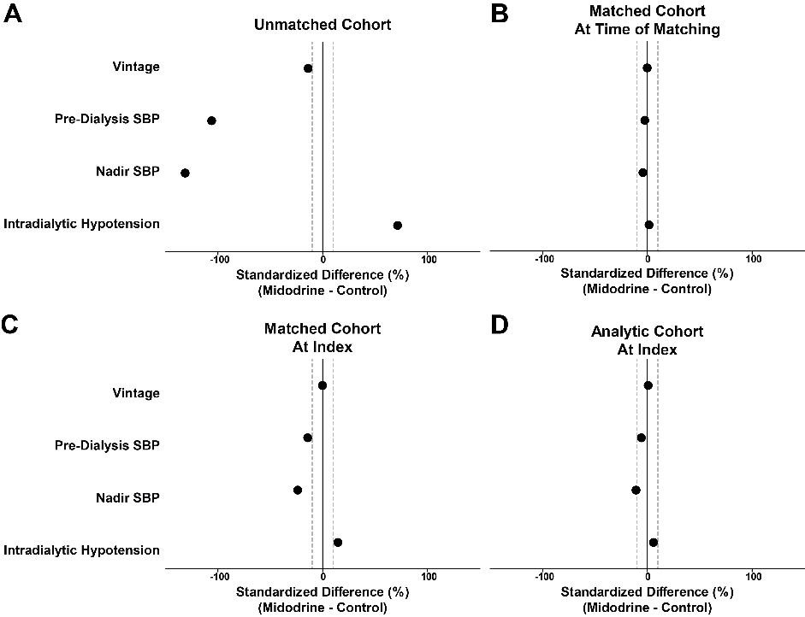

A) Values of standardized difference for dialysis vintage, pre-dialysis systolic blood pressure (SBP), nadir SBP, and percent of treatments affected by intradialytic hypotension in the unmatched cohort are presented. Dashed grey lines indicate standardized differences of + and -10%; differences of greater magnitude than this are considered indicative a high likelihood of confounding. B) as for A, but considering the matched cohort as of study month 0 (see Figure S1). C) As for A, but considering the matched cohort as of index (study month 1, Figure S1). D) Analytic cohort, considered as of index (study month 1, Figure S1).

Figure S3: Hospitalization and Mortality by Midodrine Exposure Status among Specified Patient Subsets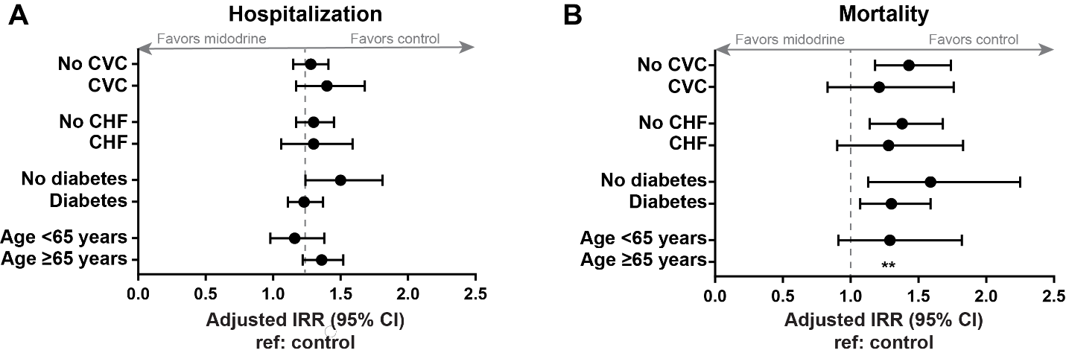
A) Point estimates for the adjusted incidence rate ratio and corresponding 95% confidence intervals for the outcome of hospitalization are displayed for the indicated patient subgroups, referent to control (ie no midodrine exposure) in each case. Comparisons were adjusted as described in the Methods section. B) Point estimates for the adjusted incidence rate ratio and corresponding 95% confidence intervals for the outcome of mortality are displayed for the indicated patient subgroups, referent to control (ie no midodrine exposure) in each case.
**model did not converge
Abbreviations: CI, confidence interval; IRR, incidence rate ratio

