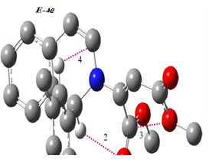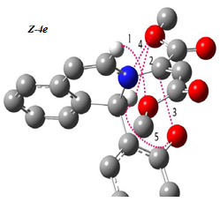
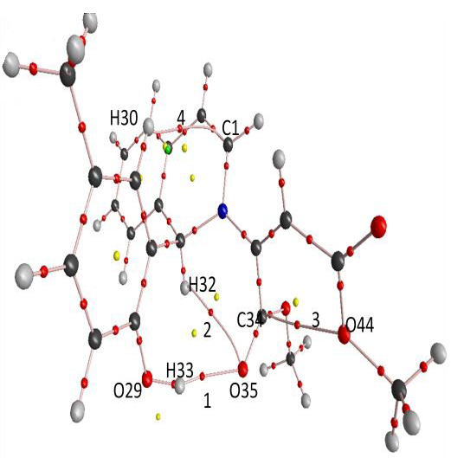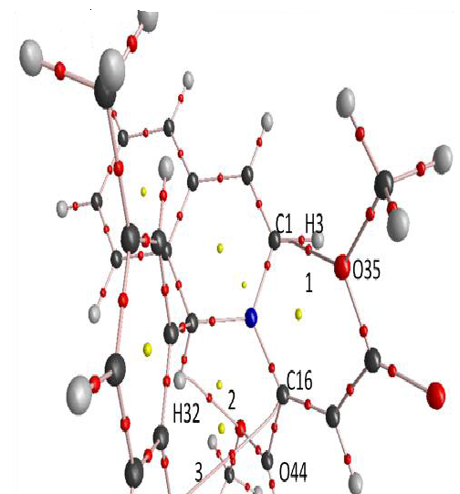

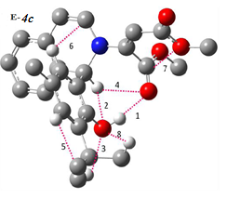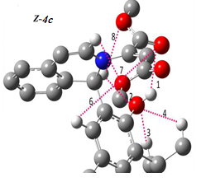

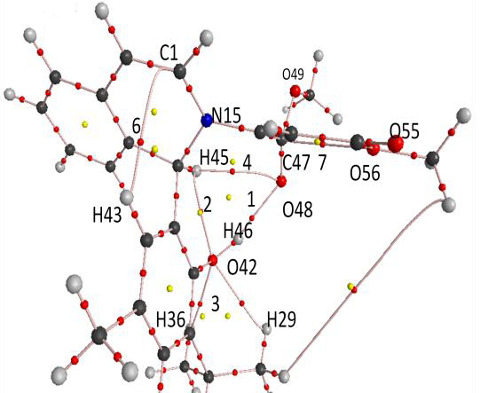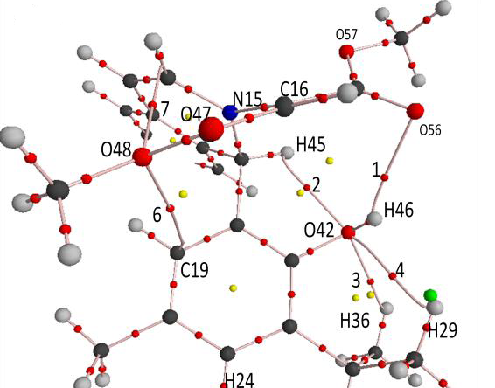
Figure S1 Intramolecular hydrogen bonds (dotted line) in the two E and Z-4e-c geometrical isomers of enaminoesters.

Table S1. The values of ρ, ∇²ρ and Hamiltonian -H(r) for E-4b isomer calculated at the BCP
E-4e | Gas phase |  |  | Polar solvent (ε=3.75) |  |  | Non polar solvent (ε=0.19)
 | ρ×10³ | ▽²ρ×10³ | -H(r)×10⁴ | ρ×10³ | ▽²ρ×10³ | -H(r)×10⁴ | ρ×10³ | ▽²ρ×10³ | -H(r)×10⁴
1 | 21.38 | 74.73 | 4.72 | 23.18 | 81.79 | 8.06 | 22.31 | 78.32 | 6.37
2 | 10.60 | 42.55 | 16.65 | 10.35 | 43.42 | 19.38 | 10.59 | 42.41 | 16.45
3 | 13.93 | 59.09 | 14.33 | 14.33 | 60.47 | 14.23 | 14.00 | 59.37 | 14.34
4 | 6.32 | 20.89 | 9.00 | 6.67 | 21.69 | 9.17 | 6.40 | 21.00 | 8.97

Table S2. The values of ρ, ∇²ρ and Hamiltonian -H(r) for Z-4b isomer calculated at the BCP

Z-4e | Gas phase |  |  | Polar solvent (ε=3.75) |  |  | Non polar solvent (ε=0.19)
 | ρ×10³ | ▽²ρ×10³ | H(r)×10⁴ | ρ×10³ | ▽²ρ×10³ | H(r)×10⁴ | ρ×10³ | ▽²ρ×10³ | H(r)×10⁴
1 | 12.08 | 50.38 | 14.20 | 11.25 | 46.97 | 14.18 | 11.83 | 49.23 | 13.90
2 | 11.78 | 47.71 | 11.75 | 11.72 | 48.18 | 12.70 | 11.94 | 48.26 | 11.76
3 | 6.89 | 25.79 | 8.33 | 5.78 | 22.17 | 7.77 | 6.52 | 24.57 | 8.22
4 |  |  |  | 10.77 | 41.93 | 7.54
5 |  |  |  | 11.72 | 48.18 | 12.70 | 14.71 | 73.52 | 28.47

Table S3. The values of ρ, ∇²ρ and Hamiltonian -H(r) for E-4c isomer calculated at the BCP
E-4c | Gas phase |  |  | Polar solvent (ε=3.75) |  |  | Non polar solvent (ε=0.19)
 | ρ×10³ | ▽²ρ×10³ | -H(r)×10⁴ | ρ×10³ | ▽²ρ×10³ | -H(r)×10⁴ | ρ×10³ | ▽²ρ×10³ | -H(r)×10⁴
1 | 22.09 | 77.35 | 5.70 | 22.10 | 77.33 | 5.46 | 22.38 | 78.48 | 6.11
2 | 15.55 | 72.46 | 24.84 | - | - | - | 15.48 | 72.64 | 25.22
3 | 14.05 | 52.96 | 9.63 | 13.81 | 51.75 | 9.37 | 14.00 | 52.67 | 9.54
4 | 10.62 | 42.49 | 16.28 | 10.37 | 46.83 | 23.54 | 10.50 | 42.70 | 17.38
5 | 13.68 | 67.25 | 31.16 | 13.73 | 67.69 | 31.39 | 13.70 | 67.39 | 31.22
6 | 6.58 | 22.00 | 9.49 | 6.89 | 23.05 | 9.94 | 6.66 | 22.19 | 9.53
7 | 13.92 | 59.12 | 14.36 | 14.33 | 60.42 | 14.20 | 14.05 | 59.53 | 14.31
8 | - | - | - | 13.22 | 48.86 | 9.66 | 13.31 | 49.15 | 9.62

Table S4 The values of ρ, ∇²ρ and Hamiltonian -H(r) for Z-4c isomer calculated at the BCP
Z-4c | Gas phase |  |  | Polar solvent (ε=3.75) |  |  | Non polar solvent (ε=0.19)
 | ρ×10³ | ▽²ρ×10³ | -H(r)×10⁴ | ρ×10³ | ▽²ρ×10³ | -H(r)×10⁴ | ρ×10³ | ▽²ρ×10³ | -H(r)×10⁴
1 | 10.6 | 40.4 | 6.85 | 6.10 | 28.90 | 13.52 | 9.63 | 38.07 | 8.42
2 | 17.29 | 72.81 | 18.4 | 17.19 | 74.48 | 20.57 | 17.27 | 72.98 | 18.69
3 | 13.75 | 50.65 | 8.69 | 13.48 | 49.35 | 8.49 | 13.64 | 50.21 | 8.66
4 | 11.44 | 47.42 | 17.08 | 11.20 | 48.88 | 20.35 | 11.40 | 47.56 | 17.49
5 | 13.81 | 67.62 | 31.17 | 13.90 | 68.20 | 31.40 | 13.83 | 67.77 | 31.24
6 | 3.38 | 13.53 | 6.37 | - | - | - | 3.32 | 13.38 | 6.33
7 | 11.98 | 50.13 | 15.37 | 11.30 | 47.23 | 14.77 | 11.87 | 49.65 | 15.25
8 |  |  |  | 5.58 | 22.29 | 9.08

Table S5. The most important geometrical parameters corresponding to H Bonds (Bond Lengths) and bonding angles for the two isomers of 4e.
E-4e | Gas phase | Solvent ε₌3.75 | solvent ε₌0.19 | Z-4e | Gas phase | Solvent ε₌3.75 | solvent ε₌0.19
O₂₉ H₃₃…O₃₅ | 1.96ª(163.55)^{b} | 1.92 (168.23) | 1.94 (165.84) | C₁ H₃…O₃₅ | 2.57 (93.04) | 2.59 (94.83) | 2.58 (93.19)
C₃₁ H₃₂…O₃₅ | 2.53 (119.02) | 2.56 (101.85) | 2.53 (119.33) | C₃₁ H₃₂…O₄₄ | 2.43 (114.79) | 2.44 (113.68) | 2.43 (114.79)
C₄₅ O₄₄…C₃₄ | 2.64 (148.09) | 2.63 (146.56) | 2.64 (131.49) | C₁₇ C₁₆…O₂₉ | 3.17 (106.03) | 3.24 (107.04) | 3.19 (106.67)
C₁₅ H₃₀…C₁ | 2.90 (115.10) | 2.89 (114.65) | 2.90 (114.68) | C₃₁N₁₅…O₃₅ |  | 2.96 (116.14)
 |  |  |  | C₃₁H₃₂…O₂₉ |  | 2.33 (103.85) | 2.33 (103.67)
ª Bond lengths are in angstroms
^{b} bonding angles

Table S6 The most important geometrical parameters corresponding to H Bonds (Bond Lengths) and bonding angles for the two isomers of 4c.
E-4c | Gas phase | Solvent ε₌3.75 | solvent ε₌0.19 | Z-4c | Gas phase | Solvent ε₌3.75 | solvent ε₌0.19
O₄₂ H₄₆…O₄₈ | 1.95ª (165.08)^{b} | 1.94 (164.98) | 1.94 (165.45) | O₄₂ H₄₆…O₅₅ | 2.34 (137.99) | 2.64 (123.25) | 2.39 (135.79)
C₄₄ H₄₅…O₄₂ | 2.34 (107.32) | 2.35 (107.05) | 2.34 (107.25) | C₄₄ H₄₅…O₄₂ | 2.31 (106.86) | 2.31 (105.26) | 2.31 (106.65)
C₃₄ H₃₆…O₄₂ | 2.33 (118.19) | 2.35 (118.06) | 2.34 (118.13) | C₃₄ H₃₆…O₄₂ | 2.37 (118.85) | 2.38 (118.75) | 2.37 (118.79)
C₄₄ H₄₅…O₄₈ | 2.53 (165.08) | 2.58 (117.20) | 2.54 (118.56) | C₂₆ H₂₉…O₄₂ | 2.48 (113.81) | 2.51 (113.25) | 2.49 (113.74)
C₂₃ H₂₄…C₃₀ | 2.42 (102.46) | 2.42 (102.50) | 2.42 (102.48) | C₂₃ H₂₄…O₃₀ | 2.42 (102.52) | 2.41 (102.58) | 2.41(102.54)
C₁₉ H₄₃…C₁ | 2.86(115.92) | 2.83(116.78) | 2.86(115.98) | C₁₉H₄₃…O₄₈ | 3.46 (85.45) |  | 3.51 (83.81)
O₄₈ C₄₇…O₅₆ | 2.64(100.91) | 2.63( 98.92) |  | C₁ H₃…O₄₈ | 2.55 (94.79) | 2.58 (95.59) | 2.56 (94.91)
C₂₆H₂₉…O₄₂ |  | 2.40(116.43) | 2.39(116.39) | C₄₄H₄₅…O₅₇ |  | 2.53 (112.96)
ª Bond lengths are in angstroms
^{b} bonding angles

