Compositional patterns of overstorey and understorey woody communities in a forest-savanna boundary in Ghana

Mohammed Armani^{*1, 2}, Frank van Langevelde ^{3,5}, Kyle Warwick Tomlinson ¹, Stephen Adu-Bredu ⁴, Gloria Djagbletey ⁴, Elmar M. Veenendaal ²
Supplementary Information (SI)
Fig. SI. 1: Cluster dendrogram of study plots in Kogyae Strict Nature Reserve
Fig. S1. 2: Vegetation map of KNSR
Fig. S1. 3: Non-metric multi-dimensional scaling (NMDS) ordination of overstorey and understorey communities of 24 plots with significant (p < 0.05) environmental variables.
Table SI. 1. Pairwise PERMANOVA testing for differences in species composition between overstorey and understorey strata in forest and savanna vegetations. Significant differences are represented as P < 0.001 = ***, < 0.01= **, < 0.05 = *.
Table SI. 2: Comparison of structural attributes between forest and savanna formations in Kogyae Strict Nature Reserve.
Table SI. 3: Output of GLMMs (with poisson error distribution) testing for significant differences in abundance of species functional types (i.e. forest, savanna and ubiquitous species) in the overstorey and understorey of forest and savanna vegetation.
Table SI. 4: Correlations between soil fertility elements and vegetation structure in the study area. Subscripts 10 and 20 denotes soil mineral concentrations sampled from 0-10 cm and 10-20 cm depths respectively.
Table SI. 5: Species summary across strata and formations (Numbers represent count data)

Fig. SI. 1: Cluster dendrogram of study plots in Kogyae Strict Nature Reserve

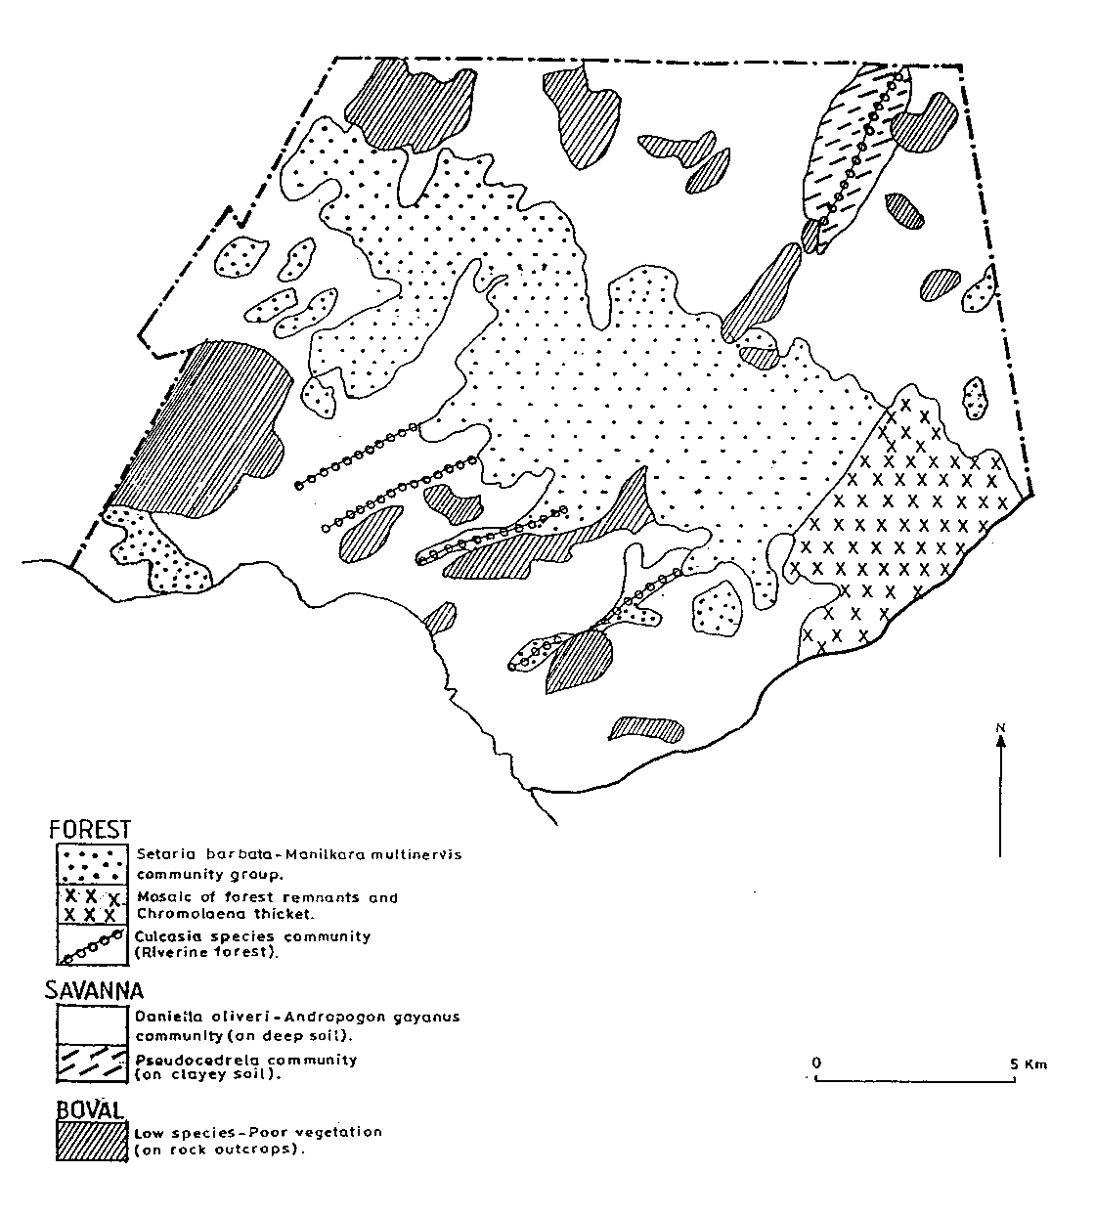
Fig. SI. 2: Vegetation map of KNSR (Source: Wildlife Department 1994: Kogyae Strict Nature Reserve Development and Management Plan)

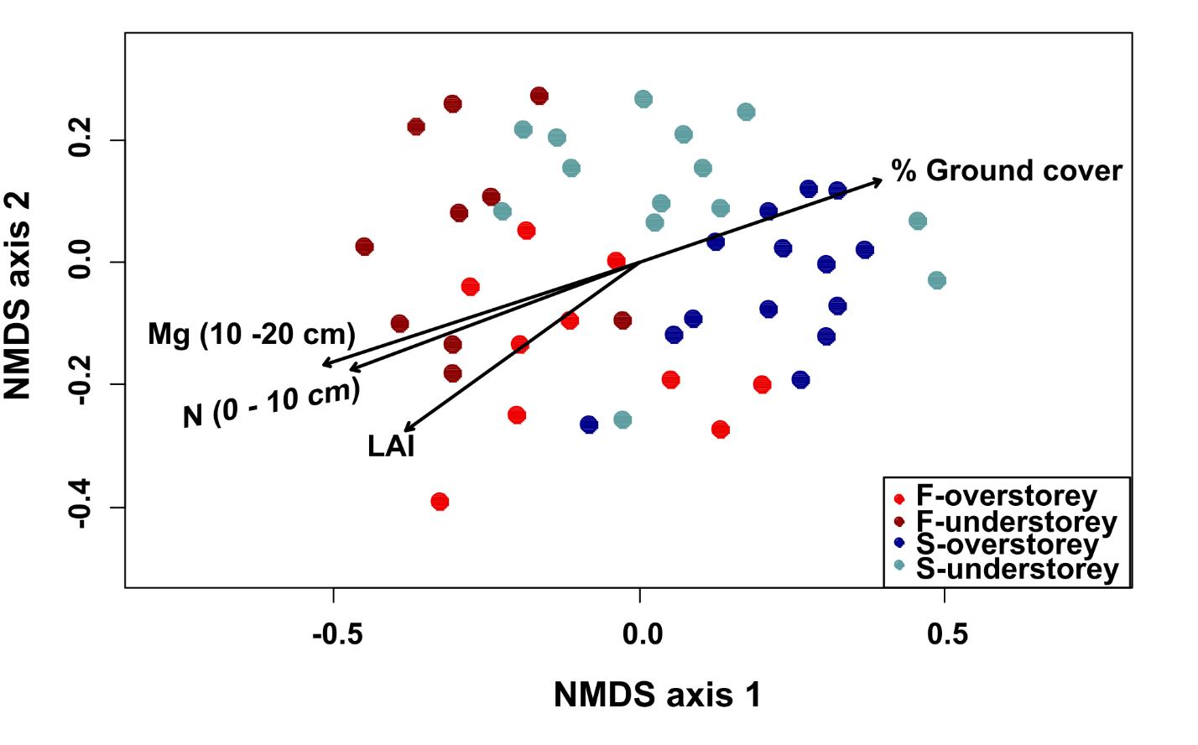
Fig. S1. 3: Non-metric multi-dimensional scaling (NMDS) ordination of overstorey and understorey communities of 24 plots with significant (p < 0.05) environmental variables.

Table SI. 1. Pairwise PERMANOVA testing for differences in species composition between overstorey and understorey strata in forest and savanna vegetations. Significant differences are represented as P < 0.001 = ***, <0.01= **, < 0.05= *.

Pairwise comparison |  | Sum Sq. | Mean Sum Sq. | df | F | R2 | P(>F)
Forest overstorey | Forest understorey | 0.985 | 0.985 | 1 | 3.753 | 0.173 | 0.013*
Forest overstorey | Savanna overstorey | 1.816 | 1.816 | 1 | 5.671 | 0.205 | 0.001***
Forest overstorey | Savanna understorey | 2.181 | 2.181 | 1 | 8.838 | 0.287 | 0.001***
Forest understorey | Savanna overstorey | 2.872 | 2.872 | 1 | 11.303 | 0.339 | 0.001***
Forest understorey | Savanna understorey | 1.251 | 1.251 | 1 | 3.817 | 0.148 | 0.001***
Savanna Overstorey | Savanna understorey | 1.371 | 1.371 | 1 | 4.506 | 0.148 | 0.001***

Table SI. 2: Comparison of structural attributes between forest and savanna formations in Kogyae Strict Nature Reserve.
Structure attribute | Unit | Forest | Savanna | statistic | df | P
Stem Density | 0.4ha⁻¹ | 18.0 ± 2.30 | 28.4 ± 4.78 | t=-1.96 | 19.599 | 0.065
Basal Area | m² | 0.77 ± 0.10 | 0.45 ± 0.11 | t=2.57 | 22.685 | 0.017
Crown Index | m²m⁻² | 1.05 ± 0.22 | 0.61 ± 0.13 | t=1.93 | 19.605 | 0.067
Leaf Area Index | m²m⁻² | 1.13 ± 0.18 | 0.73 ± 0.11 | t=1.84 | 16.938 | 0.082
Ground Cover | % | 0.40 ± 0.15 | 0.66 ± 0.0.08 | X²=0.0078 | 1 | 0.93

Table SI. 3: Output of GLMMs (with poisson error distribution) testing for significant differences in abundance of species functional types (i.e. forest, savanna and ubiquitous species) in the overstorey and understorey of forest and savanna vegetation.
 |  | Coefficient | Std. Error | Z-value | Pr(>|Z|)
Forest overstorey
Savanna.spp | Forest.spp | -1.1465 | 0.1957 | -5.858 | <0.001***
Ubiquitous.spp | Forest.spp | -1.0352 | 0.1877 | -5.515 | <0.001***
Ubiquitous.spp | Savanna.spp | 0.1112 | 0.2347 | 0.474 | 0.882
Forest understorey
Savanna.spp | Forest.spp | -0.958 | 0.1494 | -6.411 | <0.001***
Ubiquitous.spp | Forest.spp | -1.4854 | 0.1831 | -8.111 | <0.001***
Ubiquitous.spp | Savanna.spp | -0.5274 | 0.2085 | -2.529 | 0.0297*
Savanna overstorey
Savanna.spp | Forest.spp | 1.5853 | 0.1681 | 9.431 | <0.001***
Ubiquitous.spp | Forest.spp | 1.3186 | 0.1724 | 7.648 | <0.001***
Ubiquitous.spp | Savanna.spp | -0.2668 | 0.1053 | -2.534 | 0.0288*
Savanna understorey
Savanna.spp | Forest.spp | 0.6215 | 0.1271 | 4.89 | <0.001***
Ubiquitous.spp | Forest.spp | -0.3092 | 0.1576 | -1.962 | 0.12
Ubiquitous.spp | Savanna.spp | -0.9307 | 0.1413 | -6.587 | 0.0288*

Table SI. 4: Correlations between soil fertility elements and vegetation structure in the study area. Subscripts 10 and 20 denotes soil mineral concentrations sampled from 0-10 cm and 10-20 cm depths respectively.
 | Stem Density | Basal area | LAI | Ground cover | Chao’s index
N₁₀ | 0.038 | 0.734*** | 0.560** | -0.518** | 0.084
N₂₀ | 0.257 | 0.115 | 0.482* | -0.307 | -0.116
P₁₀ | 0.108 | 0.340 | 0.423* | -0.302 | -0.010
P₂₀ | 0.130 | -0.025 | 0.186 | -0.248 | -0.299
K₁₀ | -0.222 | 0.585** | 0.503* | -0.324 | 0.049
K₂₀ | -0.053 | 0.547** | 0.533** | -0.477* | -0.095
Mg₁₀ | 0.063 | 0.152 | 0.243 | -0.197 | -0.366'
Mg₂₀ | 0.044 | 0.708*** | 0.588** | -0.639*** | 0.140
Na₁₀ | 0.295 | 0.436* | 0.615** | -0.467* | 0.097
Na₂₀ | 0.230 | 0.143 | 0.416* | -0.484* | -0.119
C₁₀ | 0.059 | 0.662** | 0.589** | -0.456* | 0.080
C₂₀ | 0.095 | 0.427* | 0.667*** | -0.527** | -0.093

Table SI. 5: Species summary across strata and formations (Numbers represent count data)
Family | Species | Habitat | Overstorey |  |  | Understorey
 |  |  | Forest | Savanna | Sub-Total | Forest | Savanna | Sub-Total
Malvaceae | Sterculia tragacantha | Forest | 64 |  | 64 | 68 |  | 68
Sapotaceae | Pouteria alnifolia | Forest | 12 | 7 | 19 | 8 | 19 | 27
Apocynaceae | Holarrhena floribunda | Forest | 2 | 12 | 14 | 2 | 4 | 6
Rubiaceae | Didymosalpinx abbeokutae | Forest | 13 |  | 13 | 7 | 5 | 12
Sapotaceae | Manilkara obovata | Forest | 7 | 5 | 12 |  | 11 | 11
Leguminosae | Lonchocarpus sericeus | Forest | 1 | 9 | 10 |  | 2 | 2
Annonaceae | Monodora tenuifolia | Forest | 6 | 1 | 7 | 17 | 3 | 20
Rubiaceae | Pavetta mollissima | Forest |  | 7 | 7 |  | 9 | 9
Chrysobalanaceae | Chrysobalanus icaco | Forest | 1 | 5 | 6 |  | 3 | 3
Arecaceae | Elaeis guineensis | Forest | 4 | 2 | 6 | 1 | 1 | 2
Leguminosae | Detarium senegalense | Forest | 1 | 3 | 4 |  | 1 | 1
Burseraceae | Dacryodes klaineana | Forest | 2 | 1 | 3 |  | 5 | 5
Myrtaceae | Syzygium guineense | Forest |  | 3 | 3 |  | 2 | 2
Malvaceae | Cola caricifolia | Forest | 3 |  | 3 | 1 |  | 1
Malvaceae | Cola gigantea | Forest | 2 |  | 2 | 5 |  | 5
Ochnaceae | Gomphia squamosa | Forest | 2 |  | 2 | 1 |  | 1
Rubiaceae | Robynsia glabrata | Forest | 1 |  | 1 | 8 |  | 8
Malvaceae | Cola millenii | Forest | 1 |  | 1 | 4 |  | 4
Phyllanthaceae | Antidesma membranaceum | Forest |  | 1 | 1
Anacardiaceae | Antrocaryon micraster | Forest |  | 1 | 1
Leguminosae | Berlinia tomentella | Forest | 4 |  | 4
Malvaceae | Cola lateritia | Forest | 1 |  | 1
Moraceae | Milicia excelsa | Forest | 1 |  | 1
Sapotaceae | Mimusops kummel | Forest |  | 1 | 1
Rubiaceae | Pavetta ixorifolia | Forest |  | 1 | 1
Dichapetalaceae | Tapura fischeri | Forest | 1 |  | 1
Sapindaceae | Lecaniodiscus cupaniodes | Forest |  |  |  | 15 | 6 | 21
Dilleniaceae | Tetracera affinis | Forest |  |  |  |  | 17 | 17
Rutaceae | Clausena anisata | Forest |  |  |  | 3 | 3 | 6
Vitaceae | Leea guineensis | Forest |  |  |  | 1 | 5 | 6
Connaraceae | Agelaea pentagynatrifolia | Forest |  |  |  | 5 |  | 5
Leguminosae | Dabergia oblongifolia | Forest |  |  |  | 5 |  | 5
Malvaceae | Nesogordonia papaverifera | Forest |  |  |  |  | 4 | 4
Connaraceae | Cnestis ferruginea | Forest |  |  |  | 3 |  | 3
Apocynaceae | Saba camorensis | Forest |  |  |  | 1 | 1 | 2
Apocynaceae | saba thompsonii | Forest |  |  |  | 2 |  | 2
Rubiaceae | Coffea stenophylla | Forest |  |  |  |  | 1 | 1
Leguminosae | Erythrophleum ivorense | Forest |  |  |  |  | 1 | 1
Leguminsoae | Millettia zechiana | Forest |  |  |  | 1 |  | 1
Sapindaceae | Pancovia pedicellaris | Forest |  |  |  |  | 1 | 1
Apocynaceae | Rauvofia vomitoria | Forest |  |  |  |  | 1 | 1
Rubiaceae | Tricalysia pallerns | Forest |  |  |  | 1 |  | 1
Chrysobalanaceae | Dactyladenia dinklagei | Forest |  | 6 | 6
Combretaceae | Terminalia glaucescens | Savanna | 5 | 42 | 47 |  | 2 | 2
Phyllanthaceae | Hymenocardie acida | Savanna |  | 40 | 40 |  | 13 | 13
Ochnaceae | Lophira lanceolata | Savanna |  | 25 | 25 |  | 13 | 13
Combretaceae | Anogeissus leiocarpus | savanna | 3 | 16 | 19 | 8 | 15 | 23
Leguminosae | Daniellia oliveri | Savanna | 1 | 17 | 18 |  | 11 | 11
Sapotaceae | Vitellaria paradoxa | Savanna |  | 10 | 10 |  | 15 | 15
Rutaceae | Zanthoxylum Zanthoxyloides | Savanna | 1 | 5 | 6 |  | 7 | 7
Rubiaceae | Sarcocephalus latifolius | Savanna |  | 5 | 5 |  | 8 | 8
Annonaceae | Uvaria chamae | Savanna | 4 |  | 4 | 42 | 44 | 86
Lamiaceae | Vitex grandifolia | Savanna | 1 | 3 | 4 | 2 | 6 | 8
leguminosae | Parkia biglobosa | Savanna |  | 4 | 4 | 1 |  | 1
Icacinaceae | Icacina Oliviformis | Savanna |  | 3 | 3 |  | 17 | 17
Gentianaceae | Anthocleista djalonensis | Savanna |  | 3 | 3 |  | 5 | 5
Arecaceae | Phoenix niclinata | Savanna |  | 2 | 2 |  | 5 | 5
Leguminosae | Pterocarpus erinaceus | Savanna | 5 | 8 | 13
Araliaceae | Cussonia arborea | savanna | 2 | 2 | 4
Myrtaceae | Eugenia coronata | Savanna |  | 2 | 2
Arecaceae | Borassus aethiopum | savanna | 1 |  | 1
Salicaceae | Oncoba spinoza | savanna |  |  |  | 3 | 3 | 6
Annonaceae | Uvaria afzelii | savanna |  |  |  | 5 |  | 5
Meliaceae | Khaya senegalensis | Ubiquitous | 6 | 41 | 47 | 3 | 19 | 22
Phyllanthaceae | Bridelia micrantha | Ubiquitous | 2 | 32 | 34 |  | 7 | 7
Anacardiaceae | Lannea nigritana | Ubiquitous | 1 | 18 | 19 | 1 | 11 | 12
Moraceae | Ficus sur | Ubiquitous |  | 17 | 17 |  | 5 | 5
Leguminosae | Dialium guineense | Ubiquitous | 4 |  | 4 | 5 |  | 5
Sapindaceae | Allophylus africanus | Ubiquitous |  | 4 | 4 |  | 1 | 1
Phyllanthaceae | Phyllanthus muellerianus | Ubiquitous | 1 | 3 | 4 |  | 1 | 1
Ebenaceae | Diospyros mespiliformis | Ubiquitous | 3 |  | 3 | 18 | 14 | 32
Phyllanthaceae | Margaritaria discoidea | Ubiquitous |  | 3 | 3 |  | 1 | 1
Apocynaceae | Landolphia owariensis | Ubiquitous |  | 1 | 1 | 6 |  | 6
Annonaceae | Annona glabra | Ubiquitous |  | 5 | 5
Olacaceae | Olax subcorpioidea | Ubiquitous |  | 2 | 2
Sapindaceae | Paullinia pinnata | Ubiquitous |  |  |  | 3 | 9 | 12

