Online Supplementary Material

Neonatal Glycemia and Neurodevelopmental Outcomes: A Systematic Review and Meta-analysis

Contents
1. Early Childhood (2-5 years) Outcomes
eFigure 1.1: Neurodevelopmental impairment
eFigure 1.2: Visual-motor impairment
eFigure 1.3: Executive dysfunction
eFigure 1.4: Any cognitive impairment
eFigure 1.5: Mild cognitive impairment
eFigure 1.6: Moderate-severe cognitive impairment
eFigure 1.7: Epilepsy
eFigure 1.8: Emotional behavioral difficulty
eFigure 1.9: Visual impairment
eFigure 1.10: Hearing impairment
eFigure 1.11: Motor impairment
eFigure 1.12: Low language/literacy

2. Mid-Childhood (6-11 years) Outcomes
eFigure 2.1: Neurodevelopmental impairment
eFigure 2.2: Emotional behavioral difficulty
eFigure 2.3: Motor impairment
eFigure 2.4: Low language/literacy
eFigure 2.56: Low numeracy

3. Search Strategy

1. Early Childhood (2-5 years) Outcomes
eFigure 1.1: Neurodevelopmental impairment
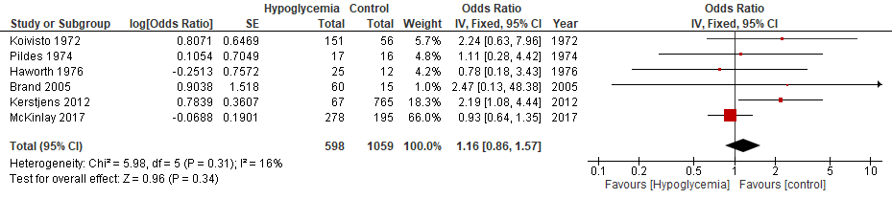
eFigure 1.2: Visual-motor impairment
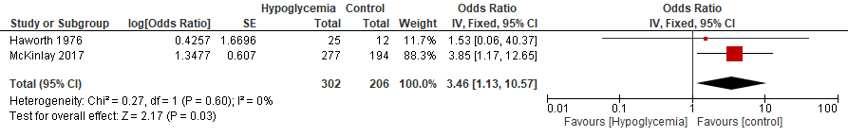
eFigure 1.3: Executive dysfunction
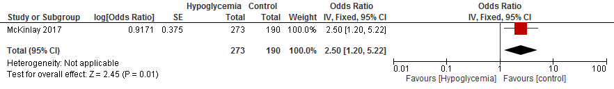
eFigure 1.4: Any cognitive impairment
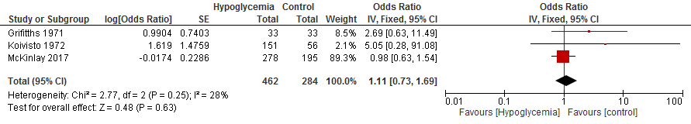
eFigure 1.5: Mild cognitive impairment
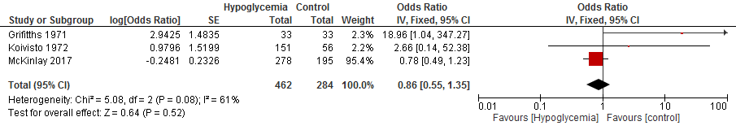
eFigure 1.6: Moderate-severe cognitive impairment
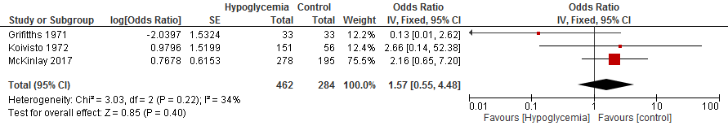
eFigure 1.7: Epilepsy
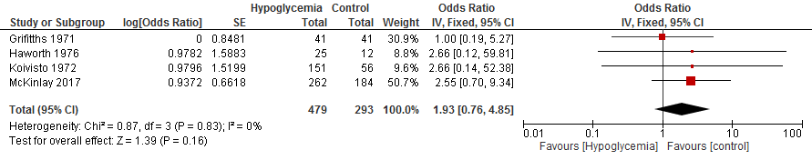
eFigure 1.8: Emotional behavioural difficulty
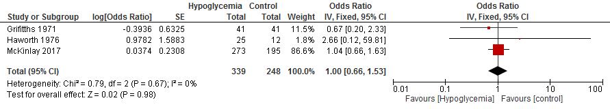
eFigure 1.9: Visual impairment
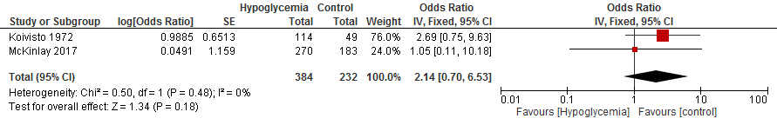
eFigure 1.10: Hearing impairment
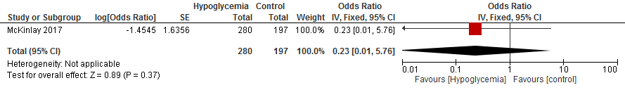
eFigure 11: Motor impairment
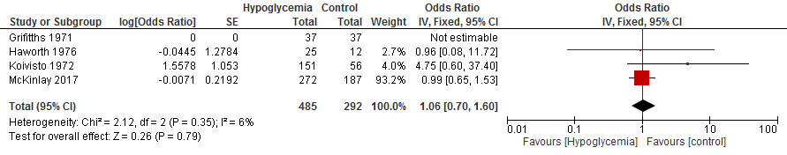
eFigure 1.12: Low language/literacy
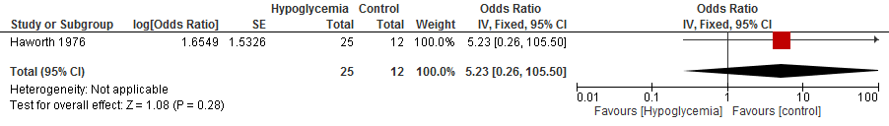
2. Mid-Childhood (6-11 years) Outcomes
eFigure 2.1: Neurodevelopmental impairment
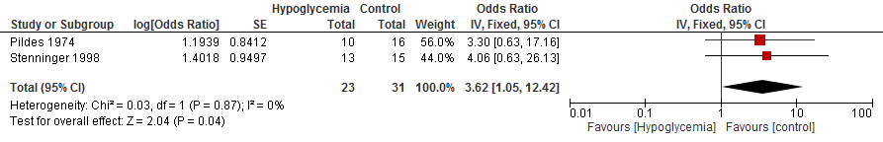
eFigure 2.2: Emotional behavioural difficulty
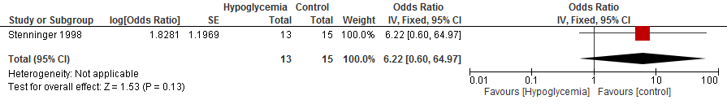
eFigure 2.3: Motor impairment
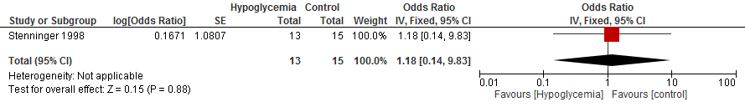
eFigure 2.4: Low language/literacy
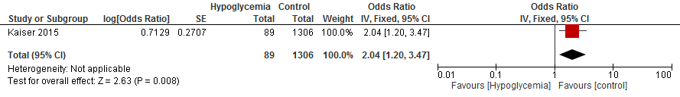
eFigure 2.5: Low numeracy
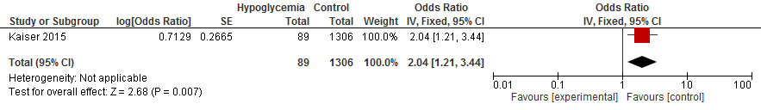
3. Search Strategy
- Infant, Newborn/
- (neonat* or newborn* or infant*).mp. [mp=title, abstract, original title, name of substance word, subject heading word, keyword heading word, protocol supplementary concept word, rare disease supplementary concept word, unique identifier, synonyms]
- Hypoglycemia/
- hypoglyc*.mp. [mp=title, abstract, original title, name of substance word, subject heading word, keyword heading word, protocol supplementary concept word, rare disease supplementary concept word, unique identifier, synonyms]
- exp Neurodevelopmental Disorders/
- (neurodevelopment* disorder* or neurodevelopment* outcome* or neurodevelopment* disabilit*).mp. [mp=title, abstract, original title, name of substance word, subject heading word, keyword heading word, protocol supplementary concept word, rare disease supplementary concept word, unique identifier, synonyms]
- neurodevelopment*.mp. [mp=title, abstract, original title, name of substance word, subject heading word, keyword heading word, protocol supplementary concept word, rare disease supplementary concept word, unique identifier, synonyms]
- neurological sequelae.mp. [mp=title, abstract, original title, name of substance word, subject heading word, keyword heading word, protocol supplementary concept word, rare disease supplementary concept word, unique identifier, synonyms]
- exp Neuroimaging/
- neuroimag*.mp. [mp=title, abstract, original title, name of substance word, subject heading word, keyword heading word, protocol supplementary concept word, rare disease supplementary concept word, unique identifier, synonyms]
- brain imag*.mp. [mp=title, abstract, original title, name of substance word, subject heading word, keyword heading word, protocol supplementary concept word, rare disease supplementary concept word, unique identifier, synonyms]
- cranial imag*.mp. [mp=title, abstract, original title, name of substance word, subject heading word, keyword heading word, protocol supplementary concept word, rare disease supplementary concept word, unique identifier, synonyms]
- (CT scan* or CT imag* or computed tomography scan* or computed tomography imag*).mp. [mp=title, abstract, original title, name of substance word, subject heading word, keyword heading word, protocol supplementary concept word, rare disease supplementary concept word, unique identifier, synonyms]
- (ultrasonography or sonograph* finding*).mp. [mp=title, abstract, original title, name of substance word, subject heading word, keyword heading word, protocol supplementary concept word, rare disease supplementary concept word, unique identifier, synonyms]
- (magnetic resonance imaging or MRI).mp. [mp=title, abstract, original title, name of substance word, subject heading word, keyword heading word, protocol supplementary concept word, rare disease supplementary concept word, unique identifier, synonyms]
- exp Neurologic Manifestations/
- neurologic* manifestation*.mp. [mp=title, abstract, original title, name of substance word, subject heading word, keyword heading word, protocol supplementary concept word, rare disease supplementary concept word, unique identifier, synonyms]
- 1 or 2
- 3 or 4
- 5 or 6 or 7 or 8 or 9 or 10 or 11 or 12 or 13 or 14 or 15 or 16 or 17
- 18 and 19 and 20
- limit 21 to English language
- limit 22 to humans

