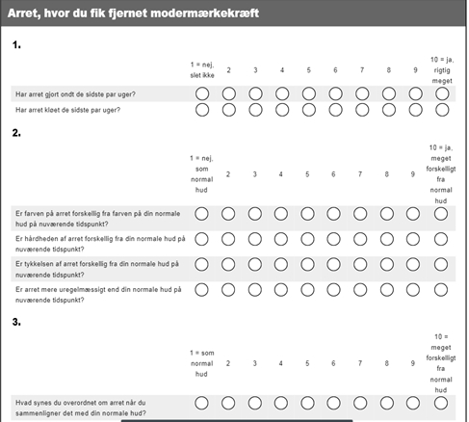
Supplementary material. The translated vision of The Patient and Observer Scar Assessment Scale (POSAS) as used in the present study. Translated and reproduced with permission from the POSAS group.

