Supporting Information for
Lithospheric structure of the Southwest South China Sea: implications for rifting and extension
Miao Dong^{1, 2}, Shiguo Wu^{1, 2, 3,} *, Jian Zhang¹, Xing Xu⁴, Jinwei Gao², Taoran Song²
¹ University of Chinese Academy of Sciences, Beijing 100049, China.
² Key Laboratory of Marine Georesources and Prospecting, Institute of Deep-sea Science and Engineering, Chinese Academy of Sciences, Sanya 572000, China.
³ Laboratory for Marine Geology, Qingdao National Laboratory for Marine Science and Technology, Qingdao, 266061, China.
⁴ Guangzhou Marine Geological Survey, Guangzhou 510760, China.

Contents of this file

Text S1
Figures S1 to S3

Introduction
The supporting Information provides details of analytical solution for Eq. (3) and additional figures to supplement the main article.

Text S1.
For the sedimentary layer, A and k is constant, the equation (3) in main article can be solved by transform to a boot-strapping equation as follow:
(4)
The vertical column is divided into arbitrarily thin layers. Temperature, T_{i+1}, and heat flow, Q_{i+1}, at bottom of each layer are determined from the temperature, T_{i}, and heat flow, Q_{i}, at the top of each layer.
For the upper crust, the thermal conductivity is k₀/(1+mT) coupled with temperature, HG is A₀exp(-z/D) coupled with depth. Therefore, equation (3) has the analytical solution:
(5)
where Q₀ is basement heat flow; T₀ is basement temperature.
For the lower crust, the thermal conductivity is k₀/(1+mT) coupled with temperature, HG is constant. Therefore, equation (3) has the analytical solution:
(6)
where Q₀ is the heat flow at the bottom of upper crust; T₀ is the temperature at the bottom of upper crust.
For the mantle, when temperature is larger than 230ºC, the thermal conductivity is k₀/(1+mT)+m₁+m₂T ; HG is constant. Therefore, equation (3) has the analytical solution:
(7)
where Q₀ is Moho heat flow; T₀ is Moho temperature.
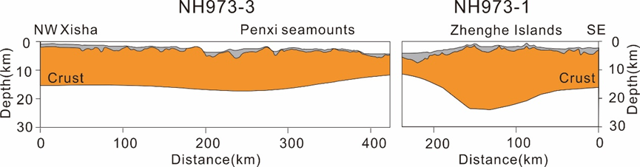

Figure S1. The crustal structure along Profiles NH973-3 (Lü et al., 2011) and NH973-1 (Qiu et al., 2011) in the southwestern South China Sea. See Figure 1 for locations.
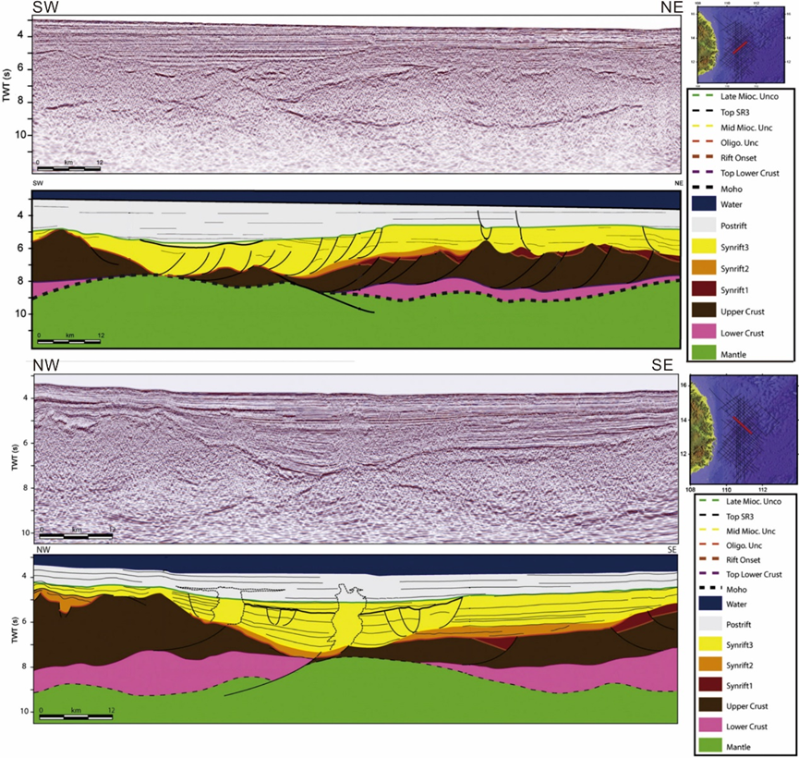

Figure S2. Seismic line with line drawing which show the 3 syn-rift episodes (Savva et al., 2013).

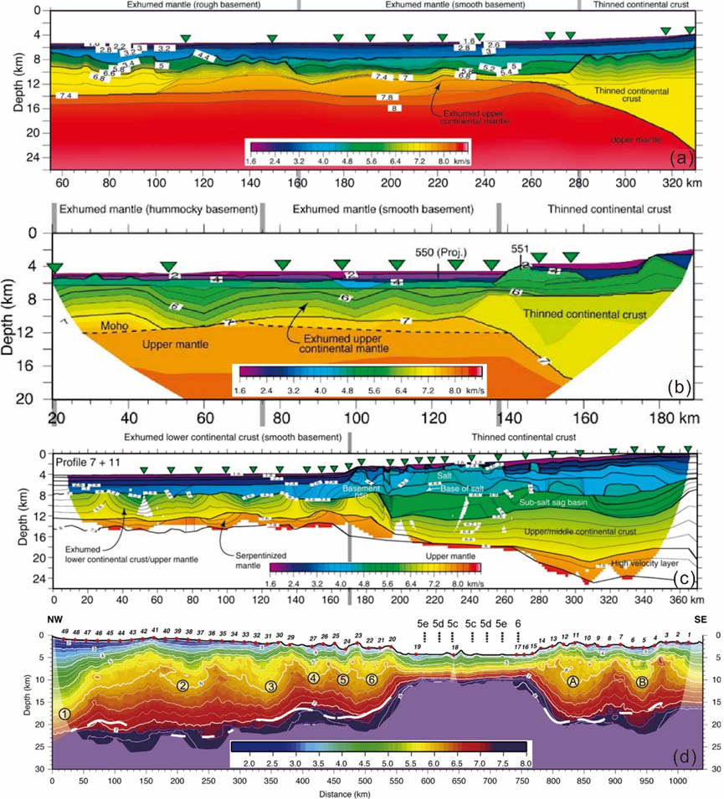

Figure S3. Comparison of the velocity model along (a) IAM9 seismic transect across the Iberia Abyssal Plain margin (Dean et al., 2000), (b) a segment of WAM seismic transect across the Goban Spur margin (Bullock and Minshull, 2005), (c) profiles 7+11 across the Angola-Congo margin (Contrucci et al., 2004), and (d) profile 2011 across the Southwest Sub-Basin of SCS (Pichot et al., 2014).

Reference
Bullock, A. D., and T. A. Minshull (2005), From continental extension to seafloor spreading: crustal structure of the Goban Spur rifted margin, southwest of the UK, Geophysical Journal International, 163(2), 527-546.
Contrucci, I., L. Matias, M. Moulin, L. Géli, F. Klingelhofer, H. Nouzé, D. Aslanian, J.-L. Olivet, J.-P. Réhault, and J.-C. Sibuet (2004), Deep structure of the West African continental margin (Congo, Zaïre, Angola), between 5°S and 8°S, from reflection/refraction seismics and gravity data, Geophysical Journal International, 158(2), 529-553.
Dean, S. M., T. A. Minshull, R. B. Whitmarsh, and K. E. Louden (2000), Deep structure of the ocean-continent transition in the southern Iberia Abyssal Plain from seismic refraction profiles: The IAM-9 transect at 40°20′N, Journal of Geophysical Research: Solid Earth, 105(B3), 5859-5885.
Lü, C. C., T. Y. Hao, X. L. Qiu, M. H. Zhao, and Q. Y. You (2011), A study on the deep structure of the northern part of southwest sub-basin from ocean bottom seismic data, South China Sea, Chinese Journal of Geophysics, 54(12), 3129-3138.
Pichot, T., Delescluse, M., Chamot-Rooke, N., Pubellier, M., Qiu, Y., Meresse, F., Sun, G., Savva, D., Wong, K. P., Watremez, L., and Auxiètre, J. L., 2014, Deep crustal structure of the conjugate margins of the SW South China Sea from wide-angle refraction seismic data: Marine and Petroleum Geology, v. 58, p. 627-643.
Qiu, X. L., M. Zhao, W. Ao, C. Lu, T. Hao, Q. You, A. Ruan, and J. Li (2011), OBS Survey and Crustal Structure of the SW Sub‐Basin and Nansha Block, South China Sea, Chinese Journal of Geophysics, 54(6), 1009–1021.
Savva, D., Meresse, F., Pubellier, M., Chamot-Rooke, N., Lavier, L., Po, K. W., Franke, D., Steuer, S., Sapin, F., Auxietre, J. L., and Lamy, G., 2013, Seismic evidence of hyper-stretched crust and mantle exhumation offshore Vietnam: Tectonophysics, v. 608, p. 72-83.

