Straightforward preparation of naphtodianthrone-rich ethanolic extracts from wild St. John’s Wort

Carmen Elena Ţebrencu a, Tanţa-Verona Iordache†b, Elena Ionescua, Ruxandra Mihaela Creţu a,Ana-Mihaela Floreab, Sandu Teodorb, Steluta Apostolb, Anamaria Zahariab, Anita-Laura Radub, Andrei Sârbu†b

a Commercial Society for Research and Processing of Medicinal Plants “PLANTAVOREL” S.A., Cuza Voda St., 46, Piatra Neamt, 610019, Romania

b National Research and Development Institute for Chemistry and Petrochemistry INCDCP-ICECHIM, Advanced Polymer Materials and Polymer Recycling, 202 Splaiul Independentei, 060021, Bucharest, Romania

*† Corresponding authors:*

*Dr. Eng. Andrei Sarbu,* INCDCP-ICECHIM, Advanced Polymer Materials and Polymer Recycling, 202 Splaiul Independentei, 060021, Bucharest, Romania, [*andr.sarbu@gmail.com*](mailto:andr.sarbu@gmail.com)

*Dr.Eng. Tanta-Verona Iordache,* INCDCP-ICECHIM, Advanced Polymer Materials and Polymer Recycling, 202 Splaiul Independentei, 060021, Bucharest, Romania, [*iordachev.icechim@gmail.com*](mailto:iordachev.icechim@gmail.com)

Separation of naphtodianthrones (NTs) from *Hypericum perforatum* L. (aerial part of St. John’s Wort) is still topical due to some hard-to-beat medicinal attributes of these bioactive compounds. Unfortunately, their low bio-availability (0.06-0.4%) complicates the extraction process. Therefore, developing straightforward and lower cost methodologies for NTs separation is still a priority. In support to this purpose, for preparing NT formulations from flowers and leaves of wild St. John’s Wort(*Hyperici Herba*) a cut-off preparative methodology is described herein. Combining Soxhlet extraction and reflux extraction, some concentrated and rather pure NT ethanolic-based formulations without chlorophyll and grease were obtained.

**Acknowledgements:** The authors wish to thank UEFISCDI Romanian Agency through the Project PN II- Partnership Project no. 117/2012 and PN II TE Project no. 44/01.10.2015, for the financial support.

**A. Experimental**

***A.1. Materials***

Laboratory studies were performed using the flowers and leaves of a batch of *Hypericum perforatum* L. (referred as *Hyperici Herba*) from the own collection of PLANTAVOREL S.A. Piatra Neamt (Romania), harvested during flowering time (specimen of wild *Hipericum perforatum* L. flowers and leaves - lot 2/2012). The extraction solvents: methanol (MetOH) p.a., ethanol 96% (EtOH), purified water (W), hexane (Hx), acetonitril (ACN). HPTLC Materials: HPTLC silica gel plates (G60F254) from Merck KGaA (200x100 cm and 100x100 cm), cellulose Merck (200x100 cm); reference compounds: hypericin (Sigma-Aldrich Co); identification reagents: β-ethylamine biphenyl borate (NP), polyethylene glycol 400 (PEG) (Merck KGaA).

***A.2. Instruments***

*A.2.1. High Performance Thin Layer Chromatograph*

The HPTLC profiles were recorded using a CAMAG System with an LINOMAT IV band-type applicator, CANON digital camera and a CAMAG data base. Another digital photo camera with 16 mm lens, CAMAG- REPROSTAR III- DIGISTORE II + Win CATS Planar Chromatography Manager Software having Image Comparison Viewer permitted visualization of multiple samples and the retention times of specific compounds compared with adequate references, at a high resolution.

HPTLC Screening, using the CAMAG TLC Scanner 3, provides the highest accuracy in HPTLC evaluation. It is also used for identification, by comparing the profile curves with individual tracks. Developer ethyl acetate: formic acid: acetic acid: water = 20 : 2.2 : 2.2 : 5.4 v/v. Reagents: (NP) (0.1 g in 10 ml methanol) and PEG 400 (0.5 g in 10 ml methanol). Reference: hypericin as 0.02% in methanol. Application parameters: plate width 100 mm; volume of syringe-100 µl; D2&W lamp. Procedure for determination of hypericin: The characteristic track of hypericin standard by scanning in the appropriate wavelength range is first identified. The maximum adsorption of the hypericin standard and its corresponding spot in the samples is further determined. Overlapping absorption curves indicate the presence of the hypericin in the analyzed samples and its content is quantified after scanning at 295 nm.

*A.2.2. Ultraviolet-visible Spectroscope*

UV-vis spectral analyses in the 200-800 nm wavelength range were performed for identification of naphtodianthrones in the resulted extracts using CARY 50 and CINTRA 101 Spectrophotometers, 1 cm quartz cuvettes; wavelength range: 200-800 nm.

***A.3. Processing Procedures for the extracts from Hyperici Herba plant material***

The plant material was shredded, homogenized and subjected to several procedures (specific for each proposed extraction methodology), as follows: (i) Primary extractions: direct naphtodianthrones extraction from the plant material with hydro-alcoholic solvents-I.1; direct dechlorophyllation and degreasing with hexane of plant material-II.1. (ii) Secondary extractions: dechlorophyllation and degreasing with hexane of dry extracts-I.2; naphtodianthrones extraction with hydro-alcoholic solvents of the degreased and dechlorophyllised plant material-II.2; extraction of polyphenolcarboxylic acids and flavones of the degreased and dechlorophyllised plant material -III.1. (iii)Tertiary extraction: naphtodianthrones extraction with hydro-alcoholic solvents-III.2.

*A.3.1. Removing the chlorophyll and grease from dry naphtodianthrone extracts (I)*

Extraction steps:

(1) Naphtodianthrone extraction. The primary extracts were obtained according to the following recipes: Batch reflux extraction- extraction solvent EtOH: Water=70:30 (vol. %), plant / solvent = 1/15, extraction temperature 60 °C, extraction time 90 minutes (extract notation EtOH 70 %); and, Extraction at room temperature- extraction solvent EtOH: Water=70:30 (vol. %), plant / solvent = 1/10, extraction temperature= 20-22 °C, extraction time = 10 days in the absence of light with periodical stirring (extract notation T 70 %).

(2) Degreasing and dechlorophyllation of dry naphtodianthrone extracts. The primary extracts were brought to dryness using a rotavap under vacuum at 40 °C. The dried extracts were washed (dechlorophyllised and degreased) with small portions of hexane (Hx), dry extract/solvent ration of 1 to 10 wt. % and dried again. The secondary dry extracts without ballast (grease and chlorophyll) were reconstituted with EtOH 70 % and noted T 70 % -Hx and EtOH 70 % -Hx respectively.

*A.3.2. Removing the chlorophyll and grease from plant materials prior to naphtodianthrone extraction (II)*

Extraction steps:

(1) Direct dechlorophyllation and degreasing of the plant material. Primary extracts from raw plant material were obtained directly with small portions of hexane (Hx) using a plant to solvent ration of 1 to 10 wt. % and two different methods: Batch reflux extraction (R)- extraction solvent Hx, extraction temperature 60 °C, extraction time 2 h; and, Continuous Soxhlet extraction (S)- extraction solvent Hx, extraction temperature 60 °C, extraction time 8 h. Subsequently, the extracts noted S-Hx and R-Hx, were brought to dryness using a rotavap under vacuum at 40 °C.

(2) Naphtodianthrone extraction. Degreased and dechlorophyllised plant materials were enriched in naphtodianthrone content by solvent extraction using the four methods: Batch reflux extraction- extraction solvent EtOH: Water=70:30 (vol. %), plant / solvent = 1/15, extraction temperature 60 °C, extraction time 90 min (Sample noted Hx- R 70 %); Continuous Soxhlet extraction- extraction solvent EtOH: Water=70:30 (vol. %), plant / solvent = 1/10, extraction temperature 60 °C, extraction time 8 h (Sample noted Hx- S 70 %); Accelerated ultrasound extraction- extraction solvent EtOH: Water=70:30 (vol. %), plant / solvent = 1/10, extraction temperature 20-22 °C, extraction time 1 h, with permanent stirring (Sample noted Hx- U 70 %); and, Extraction at room temperature-extraction solvent EtOH: Water=70:30 (vol. %), plant / solvent = 1/10, temperature= 20-22 °C, time = 10 days in the absence of light with periodical stirring (Sample noted Hx- T 70 %).

*A.3.3. Advanced purification of degreased and dechlorophylised plant material prior to naphtodianthrone extraction (III)*

(1) Extraction of polyphenols and flavones. After the plant product was dechlorophyllised and degreased (batches resulted in II.1.), an attempt to remove some of the bioactive polyphenolcarboxylic acids and flavones was considered, to obtain richer and purer naphtodianthrone extracts. In this respect, a solvent used in thin-layer chromatography i.e. acetonitril, ensured extraction of a considerable part of these phytochemicals. The approached methodology considered: Batch reflux extraction- extraction solvent ACN : Water=30:70 (vol. %) or ACN : Water=60:40 (vol. %), plant / solvent= 1/10, extraction temperature 80 °C; extraction times 30 and 60 min, respectively (Samples noted ACN 30 and ACN 60); and Extraction at room temperature- extraction solvent ACN, plant / solvent = 1/10, extraction temperature 20-22 °C, extraction time 5 days in the absence of light (Sample noted ACNR).

(2) Naphtodianthrone extraction. Following the extraction of polyphenolcarboxylic acids and flavones, the naphtodianthrones were properly extracted using procedure I.1., meaning: Batch reflux extraction- extraction solvent: EtOH: Water=70:30 (vol. %), plant /solvent = 1/15, extraction temperature 60 °C, extraction time 90 min. Samples noted ACN30-EtOH 70 %, ACN 60 EtOH 70 %, and ACNR EtOH 70 %.

**B. Meta DATA for HPTLC screening of extracts and UV-vis analyses**

***Conditions:*** *Developer* ethyl acetate: formic acid: acetic acid: water = 20: 2.2: 2.2: 5.4 v/v. *Reagents:* (NP) (0.1 g in 10 ml methanol) and PEG 400 (0.5 g in 10 ml methanol) for compounds identification.

***Reference:*** hypericin 0.02 % in methanol.

***Application parameters*:** plate width 100 mm; volume of syringe -100 µl; D2&W lamp. *Procedure*: at the onset point of the plate, the samples and references are applied. The plate is placed in the developing box for migration (approximately 7 cm long) and subsequently the plate is dried at 105 °C for 5 minutes. Examination of plates at 254 and at 366 nm is performed before and after spraying the reagents homogenously (process called derivatisation), followed by air drying.

***Interpretation of chromatoplates:*** Traces of targeted ballast (**Figure S1** and **Figure S2**) were developed at 254 and 366 nm, followed by derivatisation that consisted of spraying with an identification reagent (NP&PEG) for hypericin at 366 nm. After visualizing the chromatograms of secondary dry extracts purified with Hx, it was noticed an incomplete dechlorophyllation, which was suggested by the presence of green spots in the chromatoplates. Nevertheless, the presence of NTs was registered in the both extracts after derivatisation at 366 nm. Yet, this characteristic spot was noticeable in the analyzed samples even before developing at 254 and 366 nm. Chromatoplates in **Figure S3**a, revealed a pronounced spot of hypericin for the extract with hexane obtained by Soxhlet, noted SHx70%. Further on, comparing the intensity of hypericin characteristic spots identified in all the extracts without ballast, led to important observations. For instance, more intense spots indicated higher content of hypericin after direct degreasing.

** a b c**

**Fig. S1.** Identification chromatograms for ballast compounds and hypericin in *Hyperici Herba* degreased and dechlorophyllised hydro-alcoholic extracts: a) at 254 nm after developing; b) at 366 nm after developing; c) at 366 nm after derivatisation. *Tracks: 1- EtOH70%-Hx; 2-T70%-Hx; 3-reference: hypericin.*

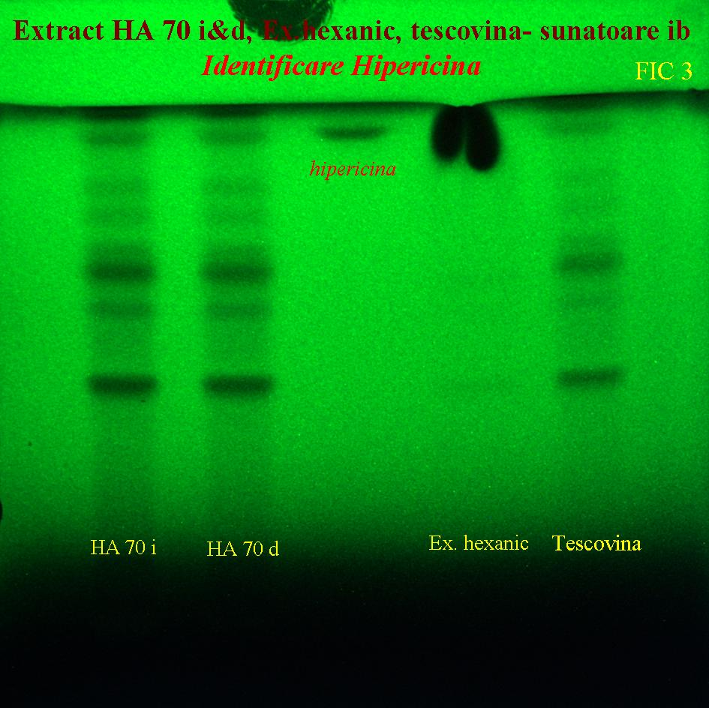 **a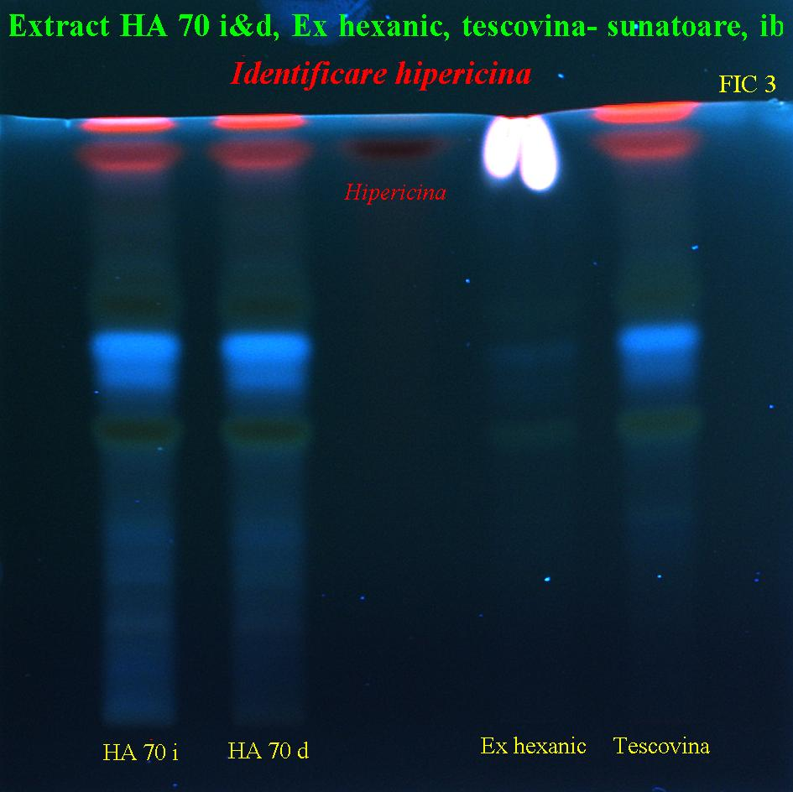 b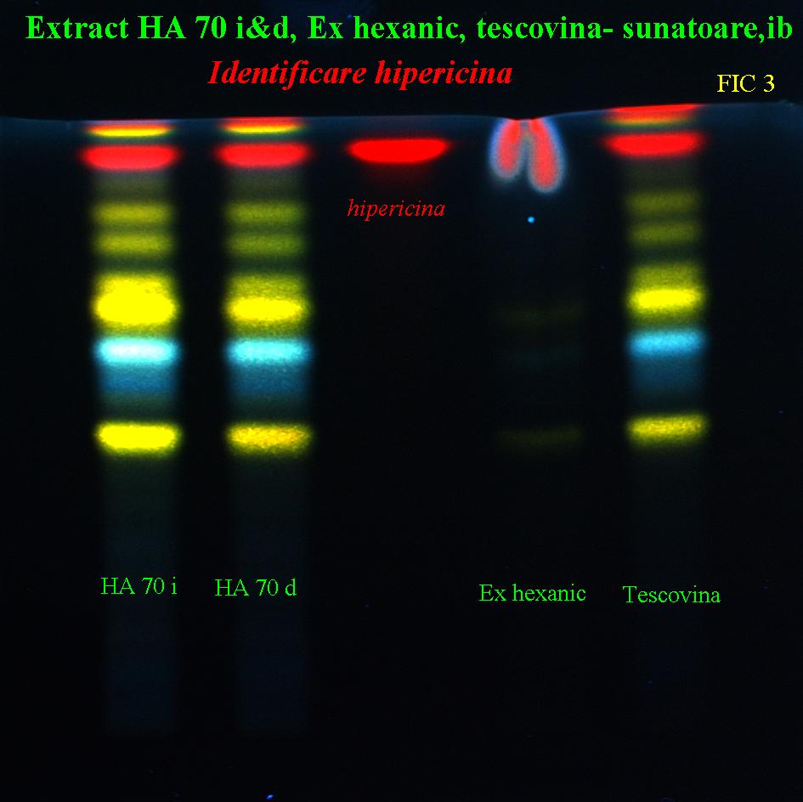 c Fig. S2.** Identification chromatograms for ballast compounds and hypericin in *Hyperici Herba* degreased and dechlorophyllised hydro-alcoholic extracts: a) at 254 nm after developing; b) at 366 nm after developing; c) at 366 nm after derivatisation. *Tracks: 1- SHx70%; 2-* *RHx70%; 3-reference: hypericin.*

|  |  |
| --- | --- |
| **a** | **b** |
| **Fig. S3**Identification chromatograms for hypericin in degreased,dechlorophyllised and enriched hydro-alcoholic extractsof *Hyperici Herba* at 366 nm after derivatisation. *Tracks: (a) 1-reference substance: hypericin; 2-Hx-U70%; 3-Hx-S70%; (b) 1- reference substance: hypericin; 2- ACN30; 3- ACN60; 4- ACNR.* | |

***HPTLC screening of chromatoplates***

**Fig S4.tif**

**Fig. S4.** HPTLC analyses of hypericin in the SHx70% extract from *Hyperici Herba*: analogue curve at 254 nm, before derivatisation.

**Fig. S5.tif**

**Fig. S5.** HPTLC analyses of hypericin in the Hx-U70% extract from *Hyperici Herba*: analogue curve at 254 nm, before derivatisation.

**Fig S6.tif**

**Fig. S6.** HPTLC analyses of hypericin in the ACN60-EtOH70% extract from *Hyperici Herba*: analogue curve at 254 nm, before derivatisation.

**Fig 2.tif**

**Figure S7.** HPTLC 3D profile screening for hypericin: in various batches of SHx70% extract (plots 1, 4) and RHx70% extract (plots 2, 5) against the hypericin standard 0.02 wt. % in methanol (plot 3).

***UV-vis analyses***

**Fig.1.tif**

**Figure S8.** UV spectra of SHx 70 % and RHx 70 % extracts from *Hyperici Herba* against a hypericin standard of 0.02 wt. % in methanol.

**Fig 4.tif**

**Figure S9.** UV spectrum of Hx-U 70 % extract from *Hyperici Herba* against a hypericin standard of 0.02 wt. % in methanol.

**Fig 6.tif**

**Figure S10.** UV spectrum of ACN30-EtOH 70 % extract from *Hyperici Herba* against a hypericin standard of 0.02 wt. % in methanol.

**C. Quantitative determinations of the plant product (Romanian Pharmacopoeia 10th Edition, 1998, Medical Ed., Bucharest)**

***C.1. Humidity and dry plant material (Table S1)***

Determination of humidity and dry plant material, U and S [Eq.(1a) and Eq. (1b), respectively] was performed by drying 2 g of green plant product at 105 °C for 4 h.

*U%*= (1a), *and*

*S%= * (1b)

Where, U= humidity; G and G1 plant weight before and after drying (g);

***C.2. Dry substance (Table S1and Table S2)***

For this determination, 5 g of vegetal product is lyophilized and immersed in 100 ml of solvent (70 vol. % alcohol/ water), followed by stirring for 24 h at room temperature. The extract is evaporated to dryness and the residue is further dried at 105 °C until constant weight. The ultimate dry extract relative to the initial weight of the extract [calculated in Eq.(2) for 100 g] represents the dry substances, DS.

*DS wt.%*= (2)

Where, DS wt. %= dry substance percent, m1 and m2 (g) the weight of resulted residue and that of the plant extract, respectively

**D. Quantitative analyses of extracts (Romanian Pharmacopoeia 10th Edition, 1998, Medical Ed., Bucharest)**

***D.1. Determination of flavones (as rutoside) (Table S2)***

Flavones in the presence of Al+3 cation form complexes colored in bright yellow, observable at λ = 430 nm. Reagents: ethyl alcohol 50 % v/v; sodium acetate solution 100 g/l; aluminum chloride solution 25 g/l; rutoside 0.1 g/l in ethanol 50% v/v. For this determination, 3 ml of each extract were brought in 10 mL flasks and completed with 8 mL of ethyl alcohol 50 % v/v (solution A). 0.5 ml of solution A are distributed in 25 ml volumetric flasks, and mixed with 5 ml of sodium acetate 100 g/l and 3 ml of aluminum chloride 25 g/l, shaking after each reagent addition and completed up to 25 ml with ethyl alcohol 50% v/v (solution B). Calibration of rutoside was determined in the 0.004-0.012 g/L concentration range using a similar protocol with the sample preparation. The absorbency of samples was verified after 15 min. at 430 nm, using 10 mm quartz cuvettes, against a blank ethylic alcohol 50% v/v solution. Quantification of flavones content was performed according to Eq.(3) :

*Total flavones wt.%*=  (3)

Where, Ap= sample absorbance (a.u.); f= calibration factor (0,850x 10-3 g/a.u.); V=volume of solution A (ml); B= volume of solution used for the colorimetric reaction (ml).

***D.2. Determination of polyphenolcarboxylic acids (as caffeic acid) (Table S2)***

*Polyphenolcarboxylic acids* give a brick-red color with Arrow reagent detectable at 500 nm. Reagents: ethyl alcohol 50% v/v; Arrow reagent: 10 g of sodium nitrite (R) and 10 g of sodium molybdate (R) was dissolved in 100 ml of distilled water; hydrochloric acid 0.5 mol/l; caffeic acid 0.01% in ethyl alcohol 50% v/v; sodium hydroxide 1 mol/l. For this measurement, 3 mL of each extract was mixed with ethyl alcohol 50% v/v (solution A) in a 10 mL volumetric flask. From each solution, 0.5 ml were taken and contacted with 2.5 ml of hydrochloric acid 0.5 mol/l, 2.5 ml sodium hydroxide 1 mol/l and 2.5 ml reagent Arrow in 25 ml flasks. After each reagent addition the vials were shacked followed by complexation up to the mark with distilled water (solution B). The absorbance of solution B was read after 10 minutes at 500 nm and compared to the control sample obtained under the same conditions without Arrow reagent. In parallel, the absorbance of a solution C (obtained using 2 ml of caffeic acid 0.01 % in ethyl alcohol 50 % v/v, 2.5 ml of hydrochloric acid 0.5 mol/l, 2.5 ml Arrow reagent and 2.5 ml of sodium hydroxide 0.1 mol/l and distilled water up to the mark) was measured as standard. The calculation of total polyphenolcarboxylic acids content expressed in caffeic acid equivalents was made using Eq.(4).

*Total Polyphenolcarboxylic acids* *wt.%*=  (4)

Where, Ap= sample absorbance (a.u.); f= calibration factor (0,8789x 10-3 g/a.u.); V=volume of solution A (ml); B= volume of solution used for the colorimetric reaction (ml).

***D.3. Determination of naphtodianthrones as hypericin (Table S1and Table S2)***

The extracts containing naphtodianthrones is red colored and quantification is possible by measuring the absorbance at 590 nm. Reagents: dichloromethane; methanol p.a. The extinction of samples at 590 nm using 10 mm cuvettes was read against a witness, i.e. methanol p.a.

* *Analysis of plant product*: 1 g of grounded plant material was brought to into a Soxhlet separator with dichloromethane, to remove chlorophyll. Afterwards, the dried plant material was extracted with 100 ml of methanol p.a. for 60 minutes at reflux on the heated water bath. The sample was filtered after cooling and the filtrate was adjusted to 100 mL with methanol p.a. in a graded flask. Calculation of total naphtodianthrones content in expressed in hypericin was done according to Eq.(5):

*Total naphtodianthrones* *content in plant wt. %*=  (5)

Where, Ap= sample absorbance (a.u.); 870= absorbance of 1 mg/ml hypericin standard; V=total volume of solution (ml); a= the content of plant material (g); S= percentage of dry content in the plant material (100- U/100); U=humidity of plant material.

* *Analysis of extracts* (hydro-alcoholic, alcohol, glycerin): 5 ml of extract sample is brought to dryness on a heated water bath. The obtained residue is washed with a small amount of dichloromethane, filtered and the filtrate volume is adjusted to 25 ml with methanol p.a. in graded flask. Calculation of total naphtodianthrones content in expressed in hypericin was done according to Eq. (6):

*Total naphtodianthrones* *content in extracts wt. %*=  (6)

Where, Ap= sample absorbance (a.u.); 870= absorbance of 1 mg/ml hypericin standard; V=total volume of solution (ml); v= volume of extract (mL).

***D.4. Determination of chlorophyll and grease content (Table S1)***

For carrying out this determination, 10 to 30 g of chopped vegetable is introduced into the filter cartridge of the Soxhlet extractor. In advance, the product moisture is determined. The extractor is filled with hexane and the extraction is carried out for 8-10 hours at 60-70°C. The hexane extract is decanted in a flask and distilled to dryness. The obtained dry extract was brought to a constant weight held in an oven at 105°C. The content of chlorophyll pigments and fatty substances is expressed in weight percentage (%) according to Eq. (7).

*Chlorophyll and Grease wt. %*=  (7)

Where, a= weight of flask containing the chlorophyll and grease (g); b= weight of empty flask (g); c= the quantity of plant material taken into consideration (g); U= humidity of the plant material (wt. %).

**Table S1.** Composition of extracts afterdegreasing and dechlorophyllation

|  |  |  |  |  |
| --- | --- | --- | --- | --- |
| **Extract** | **Dry substance (wt.% relative to the extract)** | **Chlorophyll and grease (wt.% rel. to dry substance)** | **NT (wt.% rel. to dry substance)** | **NT (wt.% rel. to the extract)·103** |
| **T70%** | **1.95** | **14.63** | **0.224** | **4.3** |
| **EtOH 70%** | **1.88** | **19.93** | **0.195** | **3.7** |
| EtOH 70%-Hx | *7.45* | 1.98 | 0.222 | 16.5 |
| T70%-Hx | 5.95 | *5.71* | 0.156 | 14.3 |
| SHx70% | **1.76** | **4.65** | **0.335** | **5.9** |
| RHx70% | 1.44 | 2.65 | 0.278 | 4.0 |

**Table S2.** Acetonitril extracts of flavones and polyphenolcarboxylic acids from degreased and dechlorophyllised plant materials

|  |  |  |  |
| --- | --- | --- | --- |
| **Extract** | **Dry substance (wt.% relative to the extract)** | **Flavones expressed in rutoside (wt.% relative to the extract)** | **Polyphenolcarboxylic acids in acid caffeic (wt.% relative the extract)** |
| ACN30 | 0.46 | 0.04 | 0.02 |
| ACN60 | 0.49 | 0.12 | 0.06 |
| ACNR | 0.24 | 0.02 | 0.01 |