Supporting Information

CeCl₃-catalyzed a highly efficient and eco-friendly synthesis of new and densely functionalized thiazolo[3,2-a]pyrimidins via Biginelli-type reaction

Tayebeh Jazinizadeh ª, Afshin Yazdani-Elah-Abadi ^{b}, Malek Taher Maghsoodlou ^{a, *}, Reza Heydari ª

ªDepartment of Chemistry, Faculty of Science, University of Sistan and Baluchestan, P. O. Box 98135-674, Zahedan, Iran
^{b}Department of Biology, Science and Art University, Yazd, Iran
*Corresponding author; Tel: +985412416586; Fax: +985412416586; E-mail: mt_maghsoodlou@yahoo.com, mt_maghsoodlou@chem.usb.ac.ir

Table of contents
Experimental procedure…………………………………….……………………………… Page 2
Spectral data…………………………………………………………………………........ Page 3-6
Copies of FT-IR, ¹H, ¹³C NMR and Mass spectra of compounds ..……………………. Page 7-36

Experimental
General
Melting points and IR spectra of all compounds were determined by using an Electro thermal 9100 apparatus and JASCO FT/IR-460 plus spectrometer. The ¹H NMR and ¹³C NMR spectra were recorded on a Bruker DRX-300 Avanve instrument with deuterated DMSO and CDCl₃ as a solvent and using TMS as internal reference at 300 and 75 MHz, respectively. The mass spectra were recorded on a Shimadzu GCMS-QP5050A mass spectrometer operating at an ionization potential of 70 eV. Elemental analyses for C, H, and N were performed using a Heraeus CHN-O-Rapid analyzer at Iranian Central Research of Petroleum Company. Thin-layer chromatography (TLC) was performed on silica-gel Polygram SILG/UV 254 plates. All chemicals were provided by chemical producer Merck (Darmastadt, Germany) and Fluka (Buchs, Switzerland) and used without further purification.

General procedure for synthesis of tetrahydropyrimidine-5-carboxamide derivatives (4):
A mixture of acetoacetanilide (1 mmol, 0.177 g), appropriate aldehyde (1 mmol), thiourea (1.1 mmol, 0.084 g) and CeCl₃ catalyst (10 mol %, 0.037 g) was heated in ethanol (10 mL) at 70 °C for one hour. The reaction progress was monitored by TLC. After completion of the reaction, the mixture was cooled to room temperature and then H₂O (5 mL) was added. The solid product was filtered, washed with cold distilled water/EtOH (1:1) (2 × 2 mL) to obtain pure products in good to high yields.

General procedure for synthesis of thiazolo[3,2-a]pyrimidin derivatives (6a-l):
A solution of DMAD (0.001 mol, 0.140 g) or DEAD (0.001 mol, 0.172 g) in 2 mL ethanol was added to a solution of tetrahydropyrimidine derivatives (0.001 mol, 0.322g (4a)) in ethanol (10 mL) in small portions. The mixture was stirred at ambient temperature in 120 minutes. The resulting yellow precipitate was filtered and washed with cold ethanol. The product was obtained without purification as a yellow powder. The structure of all the new products was characterized by IR, ¹H and ¹³C NMR spectra along with elemental analysis data. The mass spectra of these compounds displayed molecular ion peaks with the appropriate m/z values.

Spectral and analytical data
Methyl 2-(7-methyl-3-oxo-5-phenyl-6-(phenylcarbamoyl)-3,5-dihydro-2H-thiazolo[3,2-a]pyrimidin-2-ylidene)acetate (6a): Yellow powder; yield 0.372 g (86%), mp 248-250 °C; IR (KBr): ν_{max} = 3287, 2925, 1718, 1694, 1645, 1581, 1516, 1442, 1377, 1333 cm^{–1}; ¹H NMR (300 MHz, DMSO-d₆): δ 2.15 (s, 3H, CH₃), 3.80 (s, 3H,CH₃), 6.19 (s, 1H, C-H), 6.85 (s, 1H, C=CH), 7.04-7.09 (m, 1H, Ar-H), 7.27-7.39 (m,7H, Ar-H), 7.45 (d, J = 7.5, 2H, Ar-H), 10.03 (s, 1H, N-H) ppm; ¹³C NMR (300 MHz, DMSO-d₆): 21.5, 53.2, 56.8, 116.4, 117.1, 120.3, 124.3, 127.5, 129.0, 129.1, 129.3, 138.9, 139.0, 139.8, 140.1, 152.9, 163.3, 164.9, 166.3 ppm; MS (EI, 70 eV) m/z (%): 433 (M⁺, 12), 401 (8), 341 (100), 155 (15), 128 (7), 77 (9); Anal. Calcd for C₂₃H₁₉N₃O₄S: C, 63.73; H, 4.42; N, 9.69; S, 7.40 %. Found: C, 63.98; H, 4.82; N, 9.36; S, 7.62 %.
Ethyl 2-(7-methyl-3-oxo-5-phenyl-6-(phenylcarbamoyl)-3,5-dihydro-2H-thiazolo[3,2-a]pyrimidin-2-ylidene)acetate (6b): Yellow powder; yield 0.380 g (85%), mp 236-238 °C; IR (KBr): ν_{max} = 3346, 2986, 1722, 1691, 1640, 1573, 1518, 1320, 1207 cm^{–1}; ¹H NMR (300 MHz, CDCl₃): δ 1.25 (t, J = 7.2, 3H, CH₃), 2.33 (s, 3H,CH₃), 4.21 (q, J = 7.2, 2H, CH₂), 6.03 (s, 1H, C-H), 6.79 (s, 1H, C=CH ), 6.89 (s, 1H, N-H), 7.00-7.05 (m, 1H, Ar-H ), 7.10-7.30 (m , 9H, Ar-H) ppm; ¹³C NMR (300 MHz, DMSO-d₆): 14.1, 21.5, 56.5, 62.0, 115.7, 118.2, 120.0, 124.9, 127.4, 129.0, 129.4, 137.0, 138.4,139.0, 139.5, 141.3, 154.2, 163.4, 164.7, 165.7 ppm; Anal. Calcd for C₂₄H₂₁N₃O₄S: C, 64.41; H, 4.73; N, 9.39; S, 7.17 %. Found: C, 64.72; H, 4.91; N, 9.52; S, 7.43 %.
Methyl 2-(7-methyl-3-oxo-6-(phenylcarbamoyl)-5-(m-tolyl)-3,5-dihydro-2H-thiazolo[3,2-a]pyrimidin-2-ylidene)acetate (6c): Yellow powder; yield 0.398 g (89%), mp 215-217 °C; IR (KBr): ν_{max} = 3293, 3065, 2950, 1718, 1694, 1649,1581, 1336, 1311 cm^{–1}; ¹H NMR (300 MHz, CDCl₃): δ 2.34 (s, 6H, CH₃), 3.87 (s, 3H, CH₃), 6.08 (s, 1H, C-H), 6.90 (s, 1H, C=CH), 7.11-7.19 (m, 5H, Ar-H, N-H), 7.25-7.31 (m, 5H, Ar-H) ppm; ¹³C NMR (300 MHz, DMSO-d₆): 21.4, 21.5, 52.7, 56.5, 115.7, 117.5, 120.1, 124.4, 124.9, 127.9, 129.0, 129.2, 130.2, 137.0, 138.3, 139.2, 140.0, 141.3, 154.0, 163.3, 164.7, 166.2 ppm; MS (EI, 70 eV) m/z (%): 447 (M⁺, 13), 415 (11), 356 (24), 355 (100), 267 (3), 169 (20), 115 (4), 65 (9); Anal. Calcd for C₂₄H₂₁N₃O₄S: C, 64.41; H, 4.73; N, 9.39; S, 7.17 %. Found: C, 64.73; H, 5.04; N, 9.62; S, 7.31 %.
Ethyl 2-(7-methyl-3-oxo-6-(phenylcarbamoyl)-5-(m-tolyl)-3,5-dihydro-2H-thiazolo[3,2-a]pyrimidin-2-ylidene)acetate (6d): Yellow powder; yield 0.392 g (85%), mp 220-221 °C; IR (KBr): ν_{max} = 3430, 2926, 1723, 1690, 1641, 1579, 1519, 1321, 1201 cm^{–1}; ¹H NMR (300 MHz, CDCl₃): δ 1.36 (t, J = 7.2, 3H, CH₃), 2.34 (s, 3H,CH₃), 2.35 (s, 3H,CH₃), 4.33 (q, J = 7.2, 2H, CH₂), 6.09 (s, 1H, C-H), 6.90 (s, 1H, C=CH), 6.98 (s, 1H, N-H), 7.11-7.20 (m, 4H, Ar-H), 7.26-7.32 (m, 5H, Ar-H) ppm; ¹³C NMR (300 MHz, DMSO-d₆): 14.1, 21.4, 21.5, 56.5, 62.0, 115.6, 118.1, 120.1, 124.4, 124.9, 127.9, 129.0, 129.3, 130.2, 137.0, 138.4, 139.3, 139.6, 141.4, 154.2, 163.4, 164.7, 165.7 ppm; MS (EI, 70 eV) m/z (%): 461 (M⁺, 8), 415 (12), 369 (100), 279 (18), 149 (68), 145 (33), 57 (23); Anal. Calcd for C₂₅H₂₃N₃O₄S: C, 65.06; H, 5.02; N, 9.10; S, 6.95 %. Found: C, 65.40; H, 5.21; N, 9.37; S, 7.21 %.
Methyl 2-(7-methyl-3-oxo-6-(phenylcarbamoyl)-5-(p-tolyl)-3,5-dihydro-2H-thiazolo[3,2-a]pyrimidin-2-ylidene)acetate (6e): Yellow powder; yield 0.367 g (82%), mp 204-206 °C; IR (KBr): ν_{max} = 3290, 3084, 2952, 1714, 1692, 1654,1581, 1333, 1315 cm^{–1}; ¹H NMR (300 MHz, CDCl₃): δ 2.35 (s, 6H, CH₃), 3.87 (s, 3H,CH₃), 6.10 (s, 1H, C-H), 6.90 (s, 1H, C=CH), 7.05 (s, 1H, N-H), 7.10-7.20 (m, 3H, Ar-H), 7.28-7.35(m, 6H, Ar-H) ppm; ¹³C NMR (300 MHz, DMSO-d₆): 21.2, 21.5, 52.7, 56.3, 115.6, 117.5, 120.0, 124.8, 127.4, 129.0, 130.0, 135.3, 137.1, 139.4, 140.1, 141.6, 153.9, 163.3, 164.7 ppm; MS (EI, 70 eV) m/z (%): 447 (M⁺, 13), 415 (8), 355 (100), 267 (3), 169 (17), 115 (5), 65 (9); Anal. Calcd for C₂₄H₂₁N₃O₄S: C, 64.41; H, 4.73; N, 9.39; S, 7.17 %. Found: C, 64.85; H, 5.01; N, 9.12; S, 6.89 %.
Ethyl 2-(7-methyl-3-oxo-6-(phenylcarbamoyl)-5-(p-tolyl)-3,5-dihydro-2H-thiazolo[3,2-a]pyrimidin-2-ylidene)acetate (6f): Yellow powder; yield 0.406 g (88%), mp 200-202 °C; IR (KBr): ν_{max} = 3395, 2924, 1721, 1694, 1650, 1574, 1523, 1337, 1216 cm^{–1}; ¹H NMR (300 MHz, CDCl₃): δ 1.35 (t, J = 7.2, 3H, CH₃), 2.34 (s, 6H,CH₃), 4.32 (q, J = 7.2, 2H, CH₂), 6.10 (s, 1H, C-H), 6.88 (s, 1H, C=CH), 7.10-7.20 (m, 4H, Ar-H), 7.28-7.35 (m, 6H, Ar-H, N-H) ppm; ¹³C NMR (300 MHz, DMSO-d₆): 14.1, 21.2, 21.5, 56.2, 62.0, 115.6, 118.1, 120.1, 124.8, 127.4, 129.0, 130.0, 137.1, 139.4, 139.7, 141.6, 154.0, 163.4, 164.8, 165.7 ppm; Anal. Calcd for C₂₅H₂₃N₃O₄S: C, 65.06; H, 5.02; N, 9.10; S, 6.95 %. Found: C, 65.32; H, 4.76; N, 9.35; S, 7.18 %.
Methyl 2-(5-(4-chlorophenyl)-7-methyl-3-oxo-6-(phenylcarbamoyl)-3,5-dihydro-2H-thiazolo[3,2-a]pyrimidin-2-ylidene)acetate (6g): Yellow powder; yield 0.420 g (90%), mp 231-233 °C; IR (KBr): ν_{max} = 3288, 2923, 2863, 1718, 1695, 1647, 1582, 1333, 1214 cm^{–1}; ¹H NMR (300 MHz, DMSO-d₆): δ 2.15 ( s, 3H, CH₃), 3.80 (s, 3H,CH₃), 6.18 (s, 1H, C-H), 6.85 (s, 1H, C=CH), 7.07 (t, J = 7.2, 1H, Ar-H), 7.30-7.35 (m, 4H, Ar-H), 7.43 (d, J = 9, 2H, Ar-H), 7.53 (d, J = 7.5, 2H), 10.04 (s, 1H, N-H) ppm; ¹³C NMR (300 MHz, DMSO-d₆): 21.6, 53.2, 56.2, 115.9, 117.1, 120.3, 124.3, 129.1, 129.2, 129.7, 133.7, 137.8, 138.8, 140.0, 140.0, 152.9, 163.3, 164.8, 166.3 ppm; MS (EI, 70 eV) m/z (%): 467 (M⁺, 13), 375 (100), 377 (39), 189 (9), 128 (4), 67 (11), 65(9); Anal. Calcd for C₂₃H₁₈ClN₃O₄S: C, 59.04; H, 3.88; N, 8.98; S, 6.85 %. Found: C, 58.82; H, 4.15; N, 9.27; S, 6.96 %.
Ethyl 2-(5-(4-chlorophenyl)-7-methyl-3-oxo-6-(phenylcarbamoyl)-3,5-dihydro-2H-thiazolo[3,2-a]pyrimidin-2-ylidene)acetate (6h): Yellow powder; yield 0.418 g (87%), mp 240-243 °C; IR (KBr): ν_{max} = 3320, 2965, 1721, 1697, 1651, 1581, 1518, 1450, 1347, 1231 cm^{–1}; ¹H NMR (300 MHz, DMSO-d₆): δ 1.27 (t, J = 6.9, 3H, CH₃), 2.14 (s, 3H,CH₃), 4.26 (q, J = 6.9, 2H, CH₂), 6.17 (s, 1H, C-H), 6.81 (s, 1H, C=CH), 7.05-7.09 (m, 1H, Ar-H), 7.27-7.54 (m, 8H, Ar-H), 10.04 (s, 1H, N-H) ppm; ¹³C NMR (300 MHz, DMSO-d₆): 14.1, 21.2, 21.5, 56.2, 115.9, 117.4, 120.3, 124.4, 129.1, 129.2, 129.7, 137.8, 138.8, 139.9, 140.0, 153.0, 163.3, 164.8, 165.8 ppm; MS (EI, 70 eV) m/z (%): 481 (M⁺, 8), 421 (6), 391 (40), 389 (100), 324 (3), 261 (3), 189 (6), 163 (6), 67 (7); Anal. Calcd for C₂₄H₂₀ClN₃O₄S: C, 59.81; H, 4.18; N, 8.72; S, 6.65 %. Found: C, 60.12; H, 4.45; N, 9.07; S, 6.86 %.
Methyl 2-(5-(4-methoxyphenyl)-7-methyl-3-oxo-6-(phenylcarbamoyl)-3,5-dihydro-2H-thiazolo[3,2-a]pyrimidin-2-ylidene)acetate (6i): Yellow powder; yield 0.370 g (80%), mp 192-194 °C; IR (KBr): ν_{max} = 3326, 2993, 1718, 1693, 1644, 1570, 1514, 1327, 1209 cm^{–1}; ¹H NMR (300 MHz, CDCl₃): δ 2.35 (s, 3H, CH₃), 3.80 (s, 3H,CH₃), 3.87(s, 3H,CH₃), 6.08 (s, 1H, C-H), 6.88-6.91 (m, 3H, C=CH, N-H, Ar-H), 7.10-7.14 (m, 2H, Ar-H), 7.27-7.36 (m, 6H, Ar-H) ppm; ¹³C NMR (300 MHz, DMSO-d₆): 21.5, 52.7, 55.3, 55.9, 114.7, 115.5, 117.5, 120.0, 124.8, 129.0, 129.0, 130.2, 137.1, 140.1, 141.8, 153.9, 160.3, 163.4, 164.7, 166.2 ppm; MS (EI, 70 eV) m/z (%): 463 (M⁺, 13), 431 (8), 371 (100), 343 (8), 185 (14), 159 (7), 65(7); Anal. Calcd for C₂₄H₂₁N₃O₅S: C, 62.19; H, 4.57; N, 9.07; S, 6.92 %. Found: C, 62.48; H, 4.40; N, 9.41; S, 7.21 %.
Ethyl 2-(5-(4-methoxyphenyl)-7-methyl-3-oxo-6-(phenylcarbamoyl)-3,5-dihydro-2H-thiazolo[3,2-a]pyrimidin-2-ylidene)acetate (6j): Yellow powder; yield 0.405 g (85%), mp 210-212 °C; IR (KBr): ν_{max} = 3311, 2930, 1733, 1693, 1641, 1569, 1318, 1198 cm^{–1}; ¹H NMR (300 MHz, CDCl₃): δ 1.35 (t, J = 7.2, 3H, CH₃), 2.35 (s, 3H,CH₃), 3.80 (s, 3H,CH₃), 4.31 (q, J = 7.2, 2H, CH₂), 6.07 (s, 1H, C-H), 6.90 (d, J = 7.8, 3H, C=C-H), 7.09-7.15 (m, 2H, Ar-H), 7.26-7.35 (m, 6H, Ar-H, N-H) ppm; ¹³C NMR (300 MHz, DMSO-d₆): 14.1, 21.5, 55.3, 55.9, 62.0, 114.7, 115.5, 118.1, 120.0, 124.8, 129.0, 130.3, 137.1, 139.7, 141.9, 154.0, 160.3, 163.4, 164.7, 165.7 ppm; MS (EI, 70 eV) m/z (%): 477 (M⁺, 10), 385 (100), 357 (9), 185 (6), 159 (5), 65(3); Anal. Calcd for C₂₅H₂₃N₃O₅S: C, 62.88; H, 4.85; N, 8.80; S, 6.71 %. Found: C, 63.11; H, 5.14; N, 9.23; S, 6.91 %.
Methyl 2-(5-(4-bromophenyl)-7-methyl-3-oxo-6-(phenylcarbamoyl)-3,5-dihydro-2H-thiazolo[3,2-a]pyrimidin-2-ylidene)acetate (6k): Yellow powder; yield 0.467 g (91%), mp 224-226 °C; IR (KBr): ν_{max} = 3271, 2923, 2852, 1719, 1697, 1645, 1588, 1333, 1209 cm^{–1}; ¹H NMR (300 MHz, DMSO-d₆): δ 2.14 (s, 3H, CH₃), 3.81 (s, 3H,CH₃), 6.16 (s, 1H, C-H), 6.85 (s, 1H, C=CH), 7.07 (t, J = 9, 1H, Ar-H), 7.24-7.32 (m, 4H, Ar-H), 7.52-7.58 (m, 4H, Ar-H), 10.04 (s, 1H, N-H) ppm; ¹³C NMR (300 MHz, DMSO-d₆): 21.6, 53.2, 56.3, 115.8, 117.1, 120.3, 122.3, 124.3, 129.1, 129.9, 132.2, 138.2, 138.8, 140.0, 140.0, 153.0, 163.3, 164.8, 166.3 ppm; MS (EI, 70 eV) m/z (%): 513 (M⁺, 16), 481 (6), 421 (94), 419 (100), 235 (8), 209 (7), 65 (16); Anal. Calcd for C₂₃H₁₈N₃O₄S: C, 53.91; H, 3.54; N, 8.20; S, 6.26 %. Found: C, 54.34; H, 3.86; N, 8.57; S, 6.43 %.
Methyl 2-(7-methyl-3-oxo-6-(phenylcarbamoyl)-5-(3,4,5-trimethoxyphenyl)-3,5-dihydro-2H-thiazolo[3,2-a]pyrimidin-2-ylidene)acetate (6l): Yellow powder; yield 0.460 g (88%), mp 197-198 °C; IR (KBr): ν_{max} = 3423, 2997, 1717, 1694, 1651, 1574, 1521, 1330, 1217 cm^{–1}; ¹H NMR (300 MHz, DMSO-d₆): δ 2.31 (s, 3H, CH₃), 3.79 (s, 6H, CH₃), 3.82 (s, 3H, CH₃), 3.87 (s, 3H, CH₃), 6.07 (s, 1H, C-H), 6.55 (s, 2H, Ar-H), 6.93 (s, 1H, N-H), 7.13 (t , J = 7.2, 1H, Ar-H), 7.21 (s, 1H, Ar-H), 7.27-7.37 (m, 4H, Ar-H) ppm; ¹³C NMR (300 MHz, DMSO-d₆): 21.4, 52.8, 56.2, 56.5, 60.7, 104.0, 115.5, 117.7, 120.1, 125.0, 129.1, 133.9, 137.0, 138.6, 139.9, 141.4, 153.9, 154.0, 163.3, 164.8, 166.2 ppm; MS (EI, 70 eV) m/z (%): 523 (M⁺, 34), 491 (40), 431 (100), 403 (10), 356 (7), 245 (45), 65 (8); Anal. Calcd for C₂₆H₂₅N₃O₇S: C, 59.65; H, 4.81; N, 8.03; S, 6.12 %. Found: C, 59.93; H, 4.67; N, 7.88; S, 6.53 %.

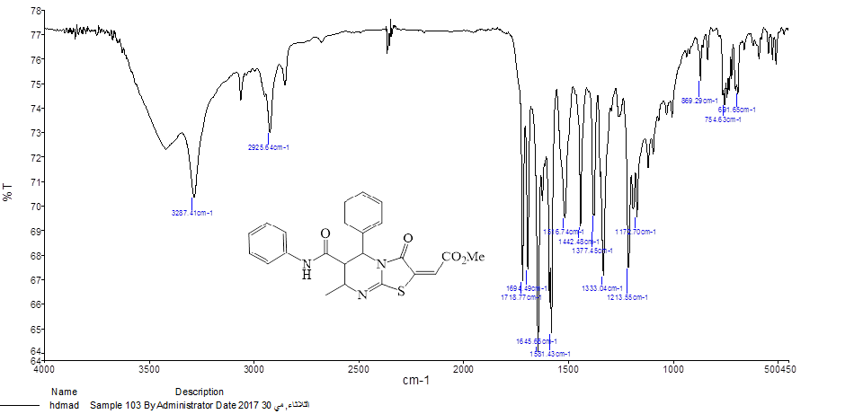
FT-IR spectra of compound 6a

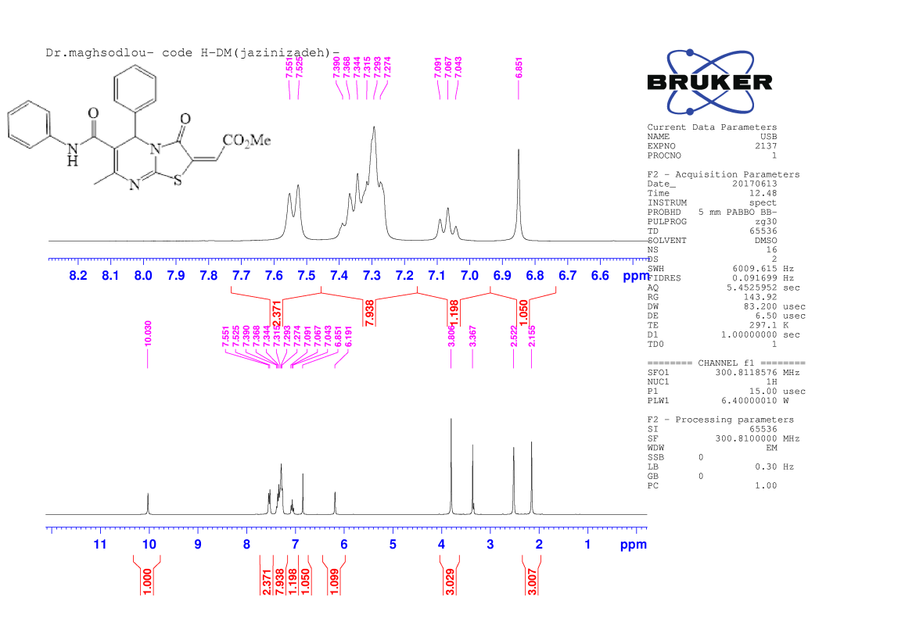
¹H NMR spectra of compound 6a
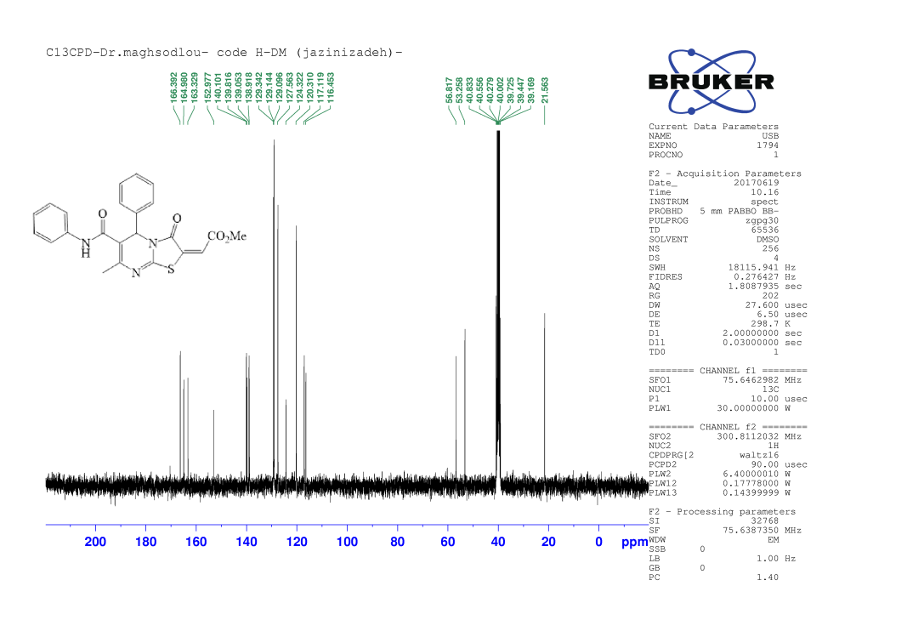
¹³C NMR spectra of compound 6a

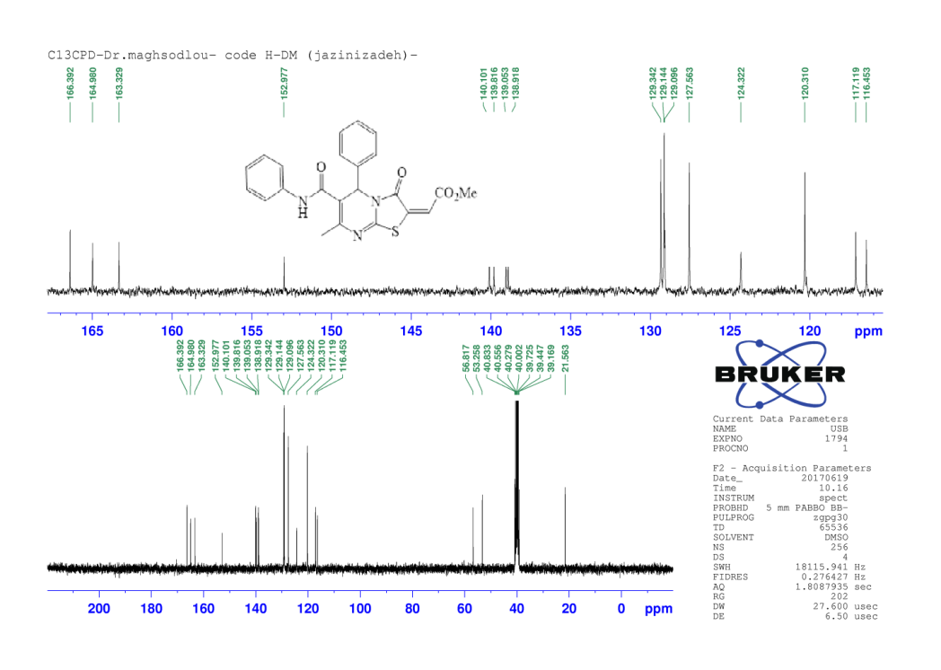
Expanded ¹³C NMR spectra of compound 6a

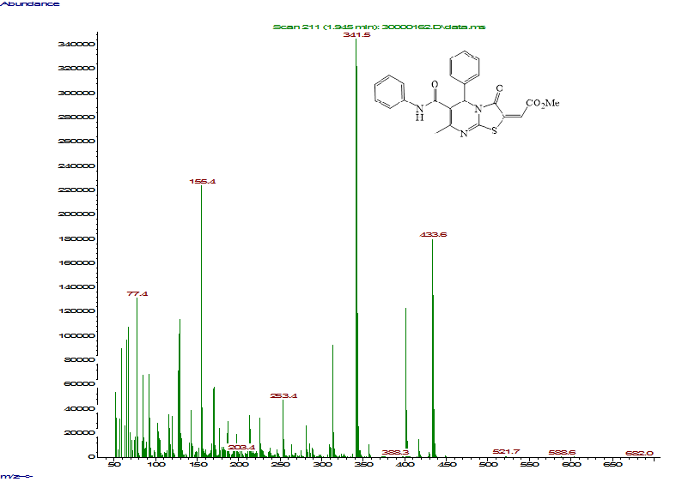
Mass spectra of compound 6a

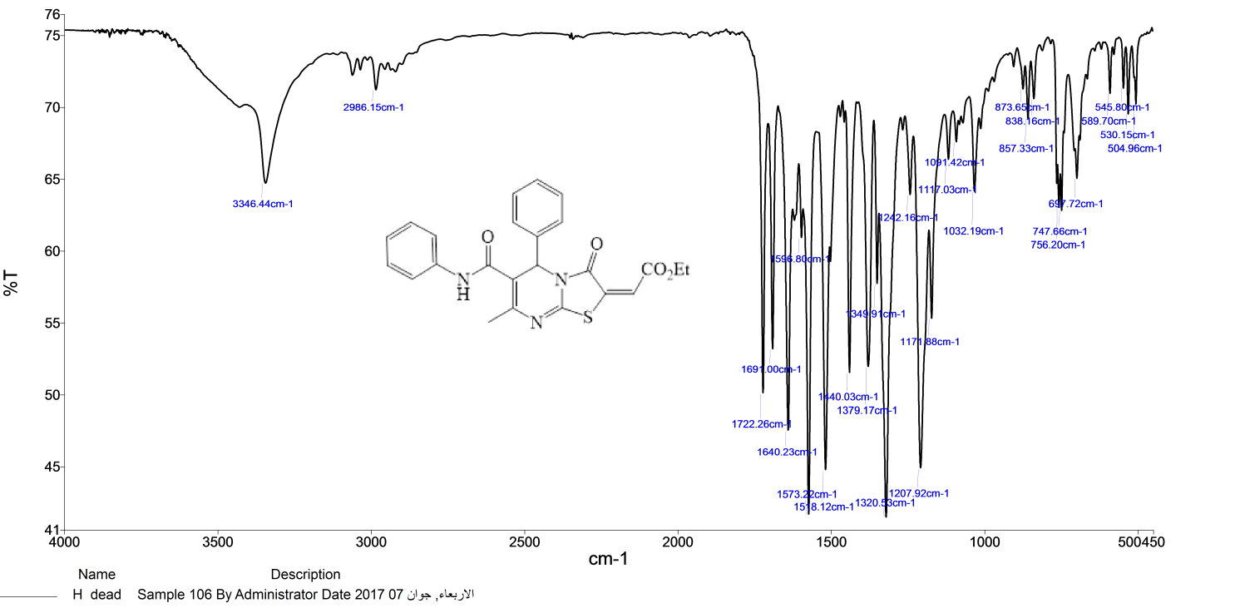
FT-IR spectra of compound 6b

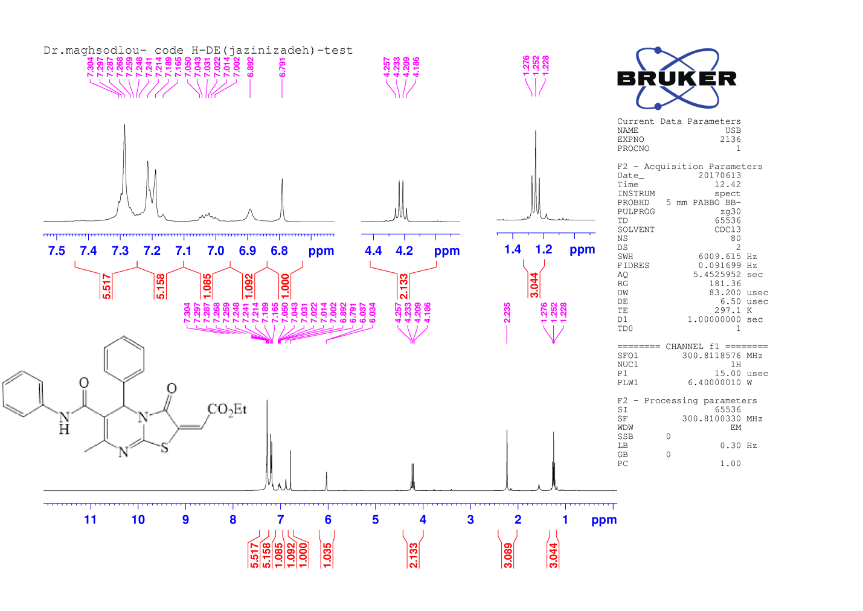
¹H NMR spectra of compound 6b

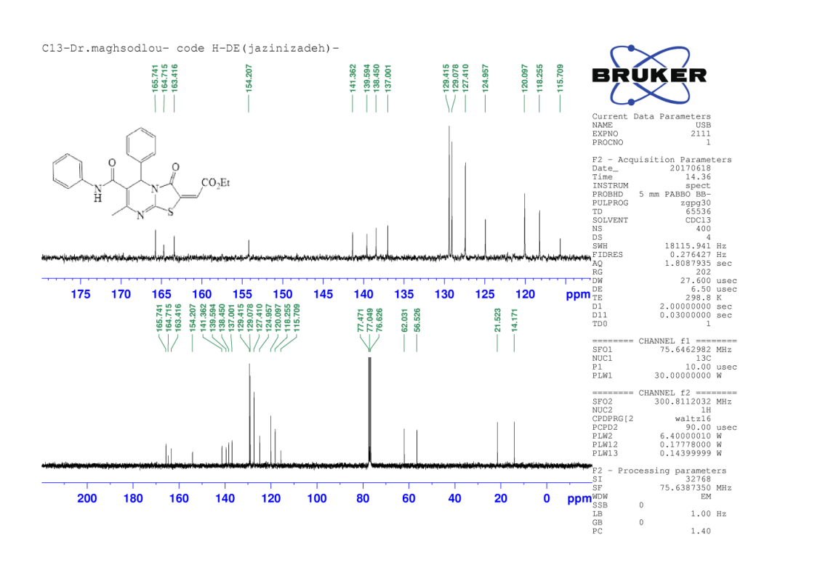
Expanded ¹³C NMR spectra of compound 6b
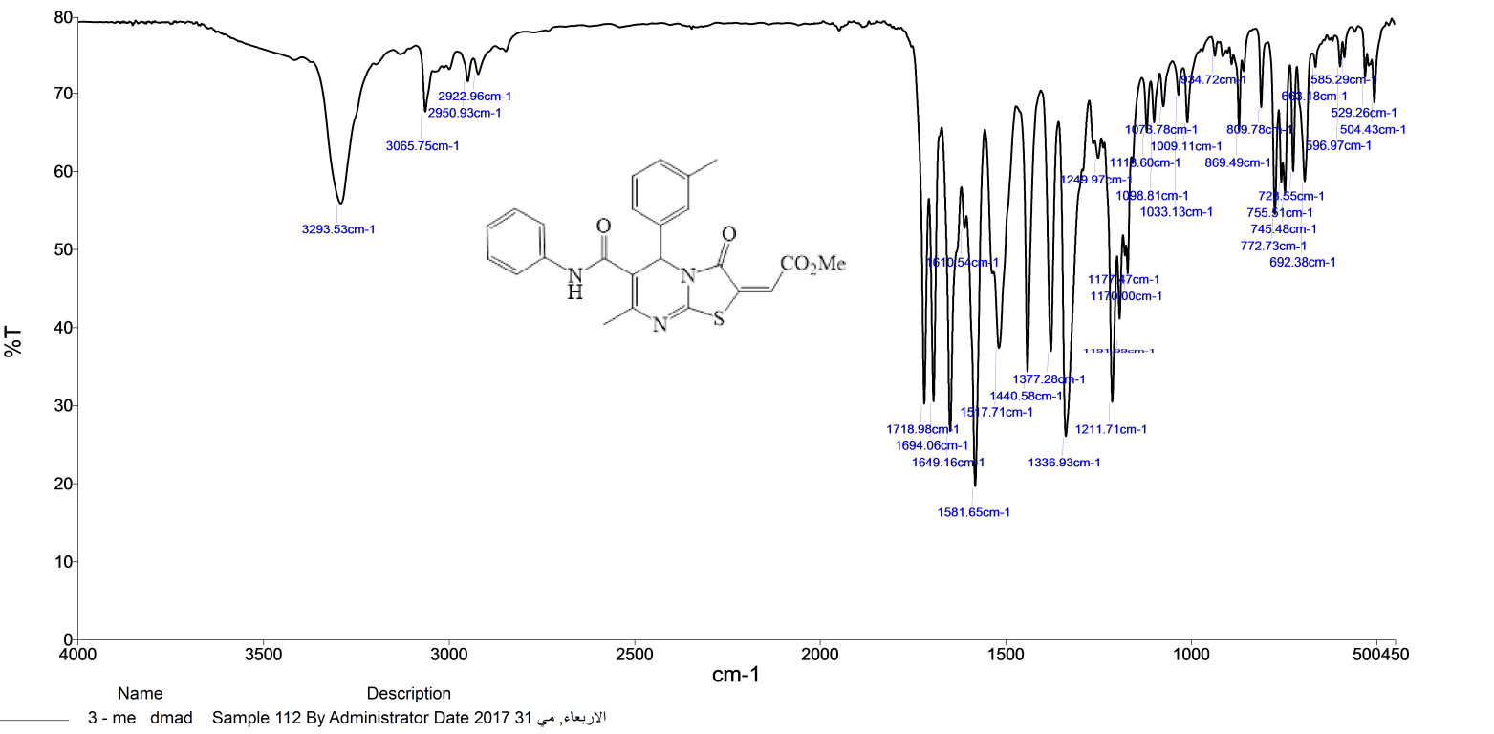
FT-IR spectra of compound 6c

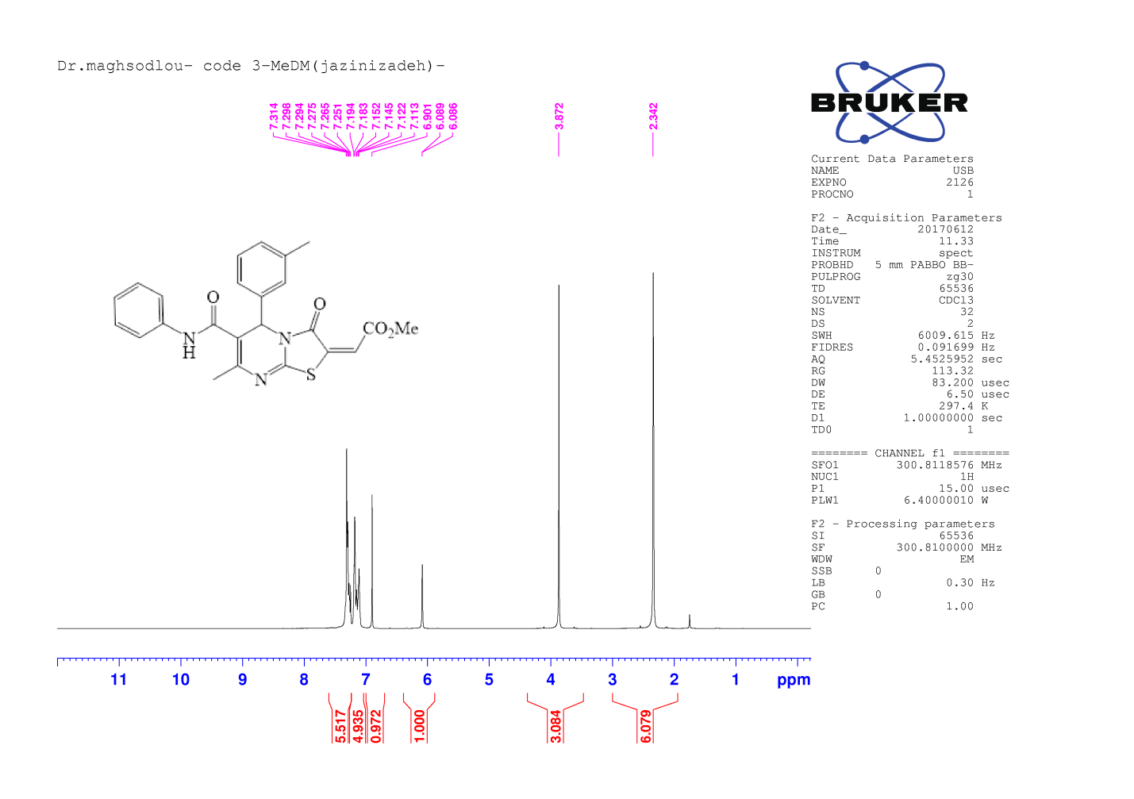
¹H NMR spectra of compound 6c

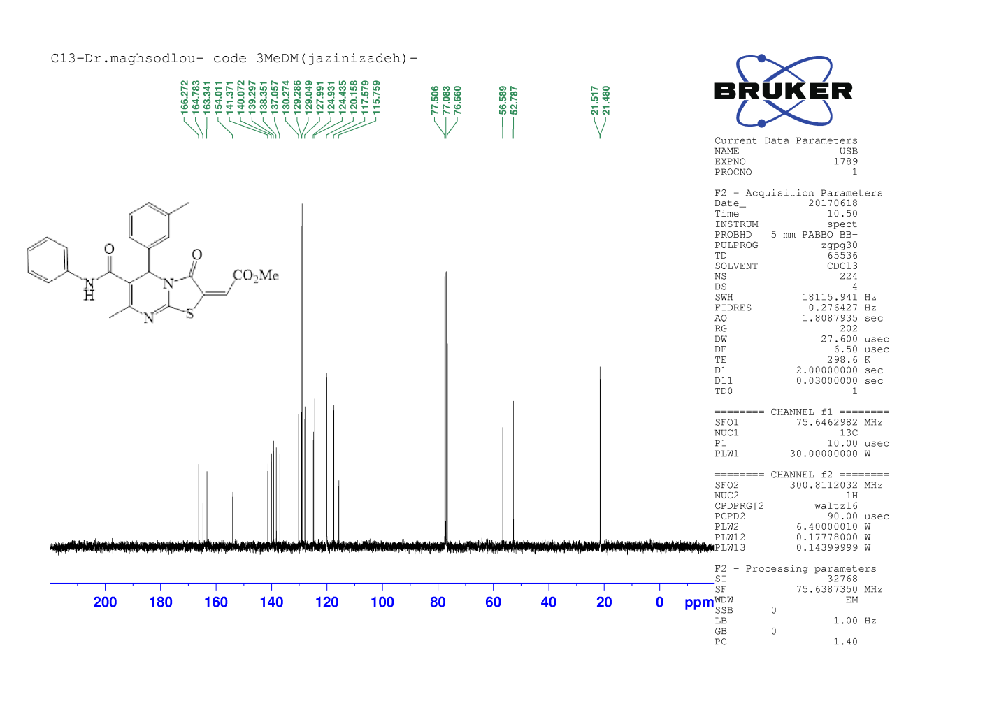
¹³C NMR spectra of compound 6c

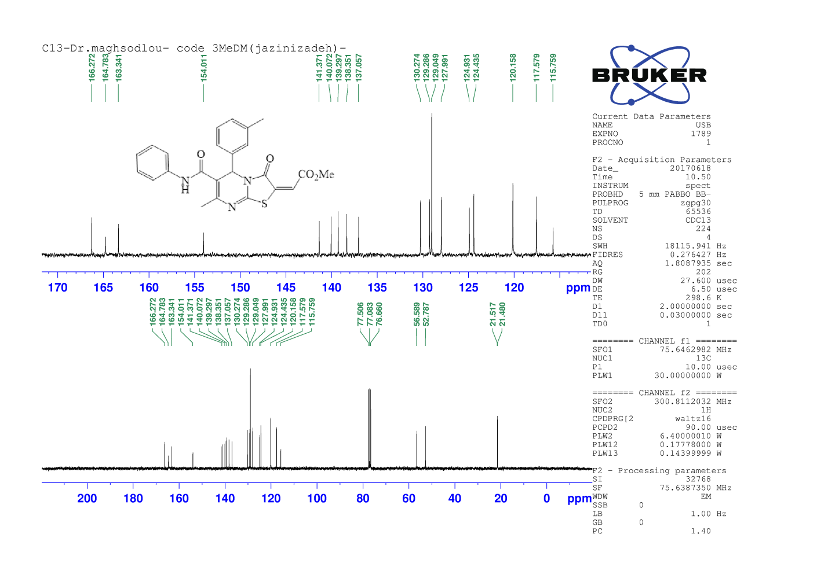
Expanded ¹³C NMR spectra of compound 6c
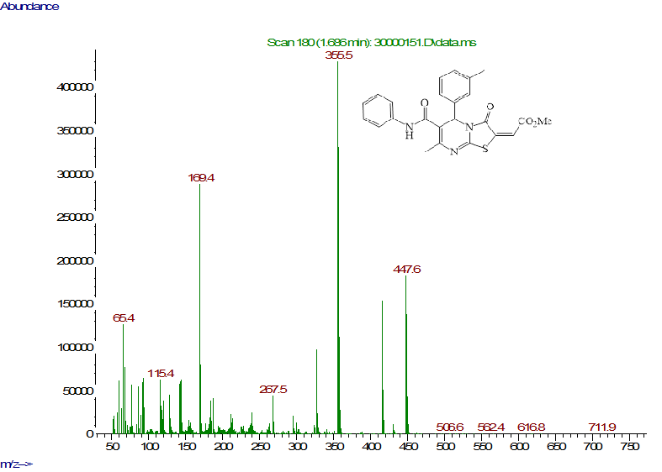
Mass spectra of compound 6c

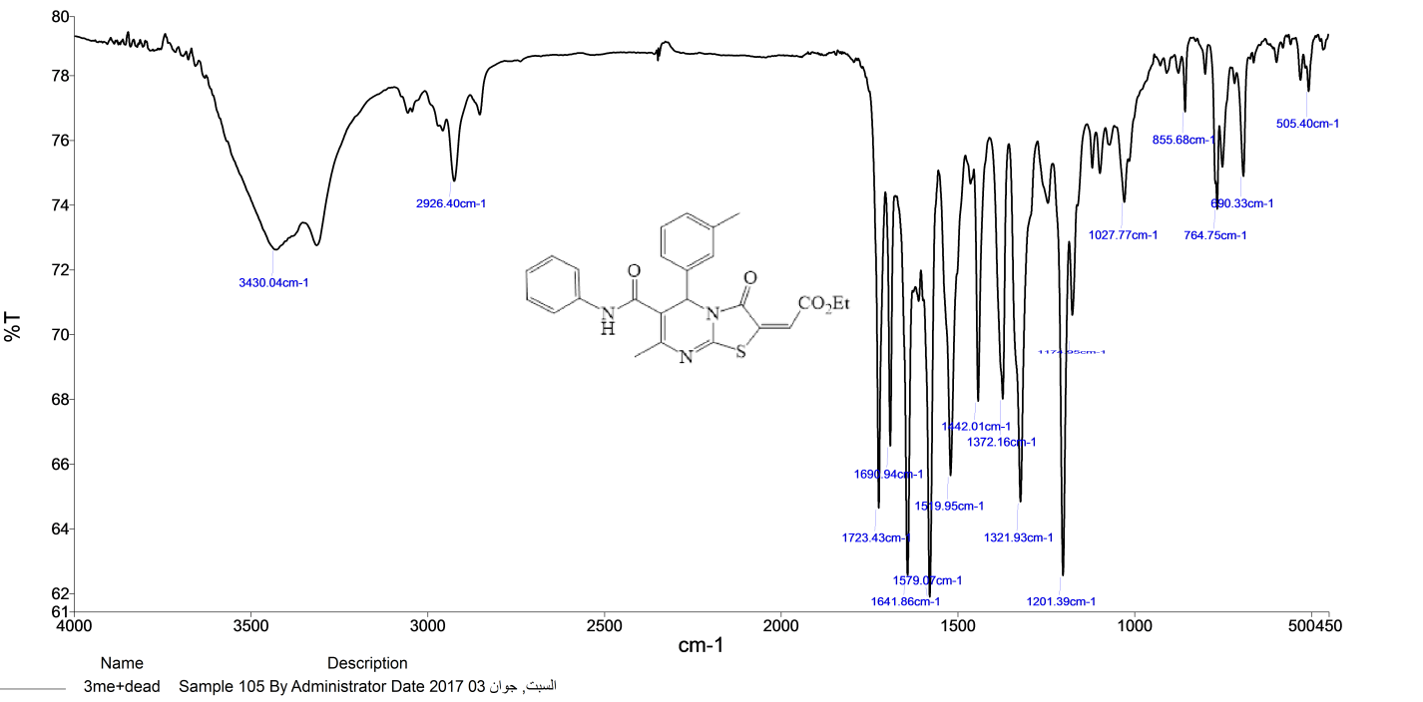 FT-IR spectra of compound 6d
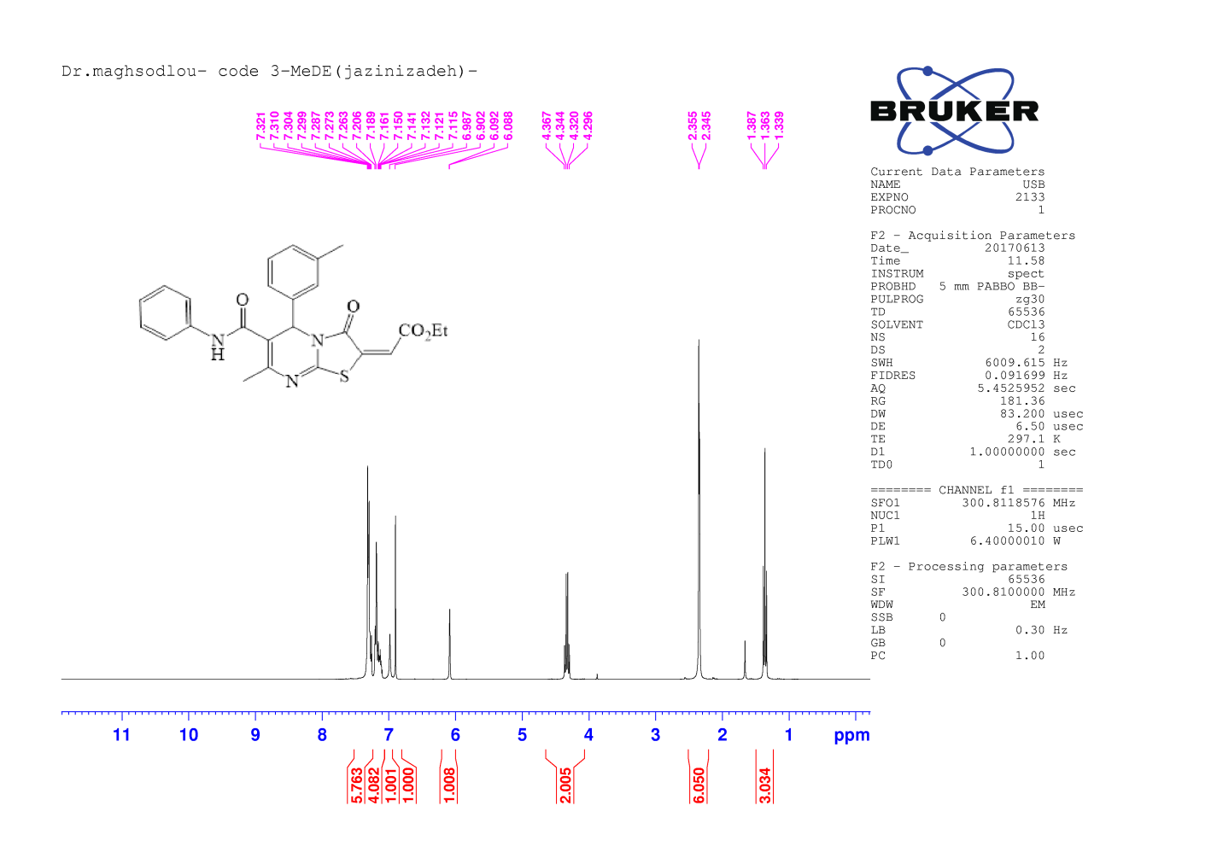
¹H NMR spectra of compound 6d

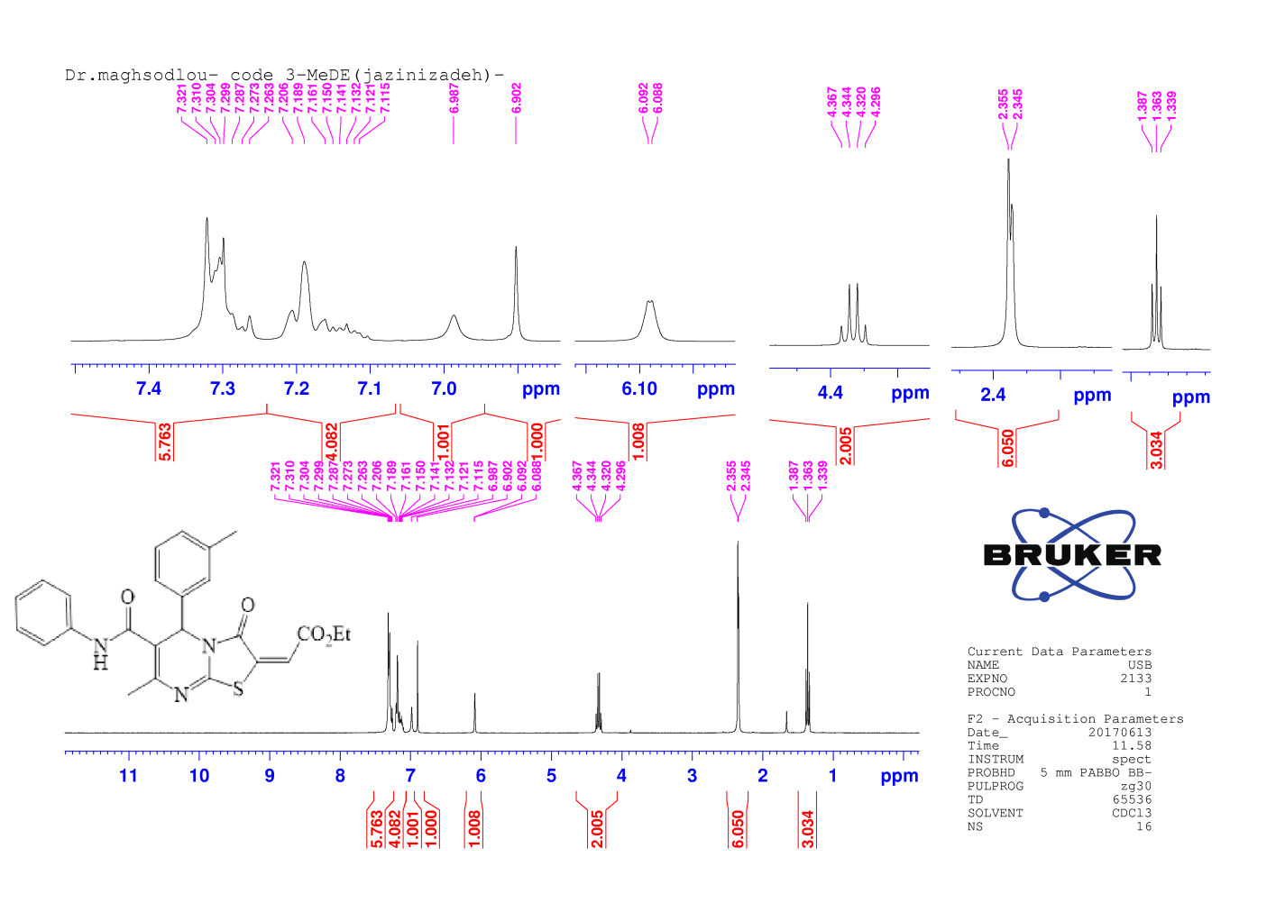
¹H NMR spectra of compound 6d
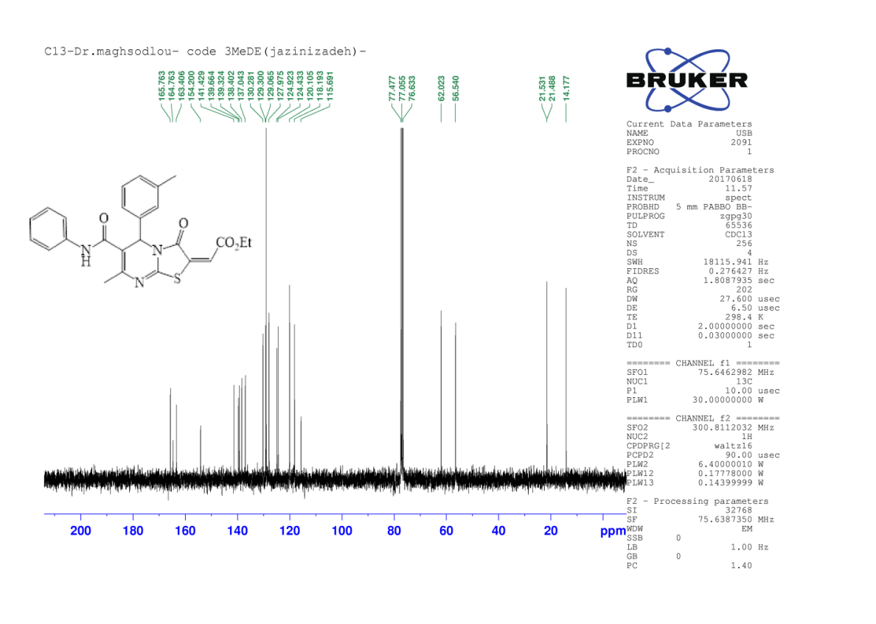
¹³C NMR spectra of compound 6d

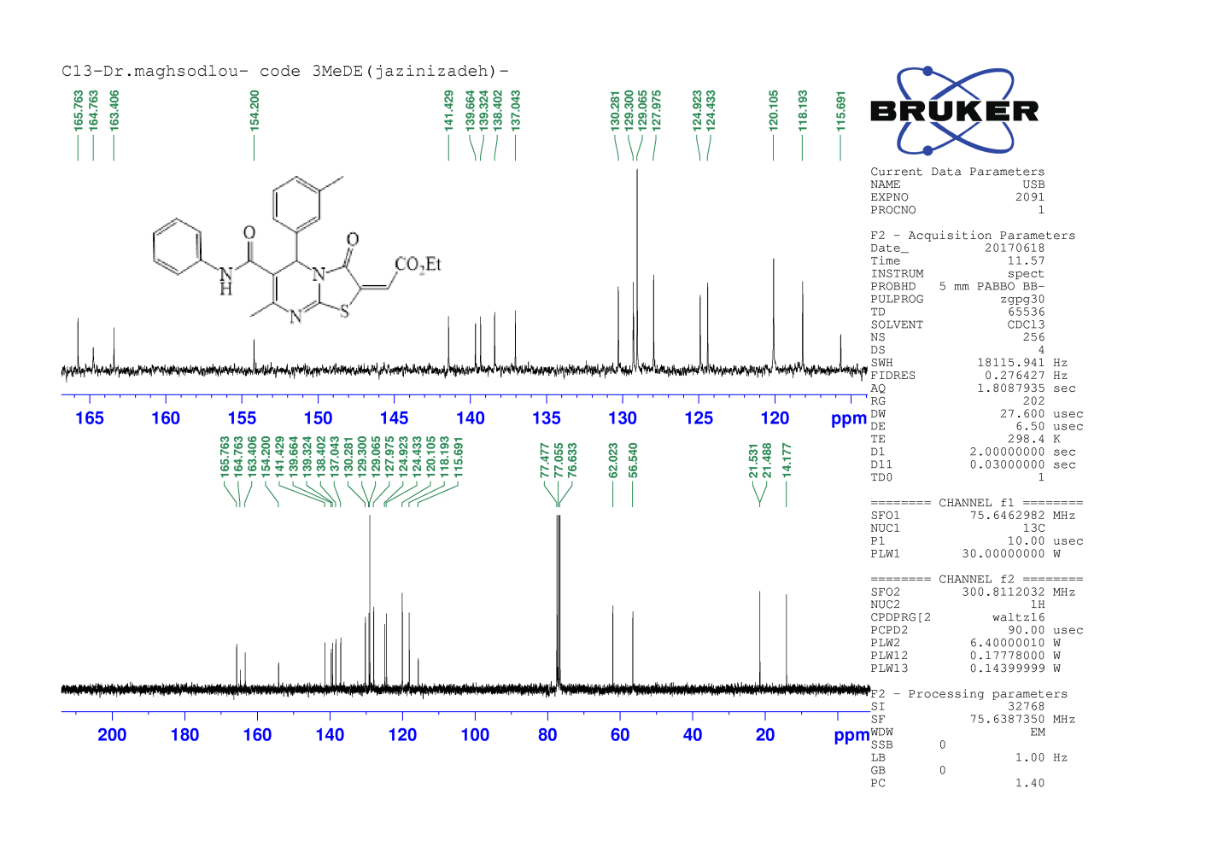
Expanded ¹³C NMR spectra of compound 6d
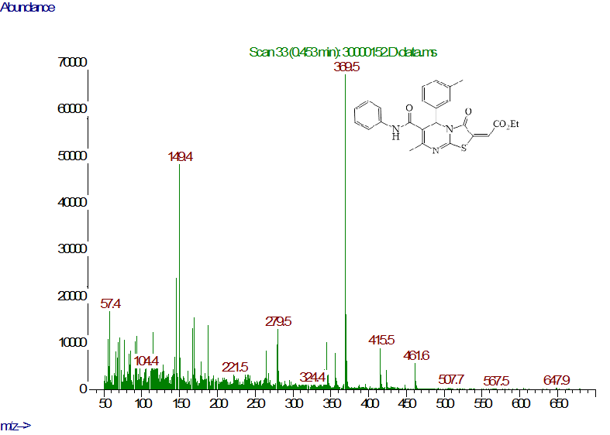
Mass spectra of compound 6d

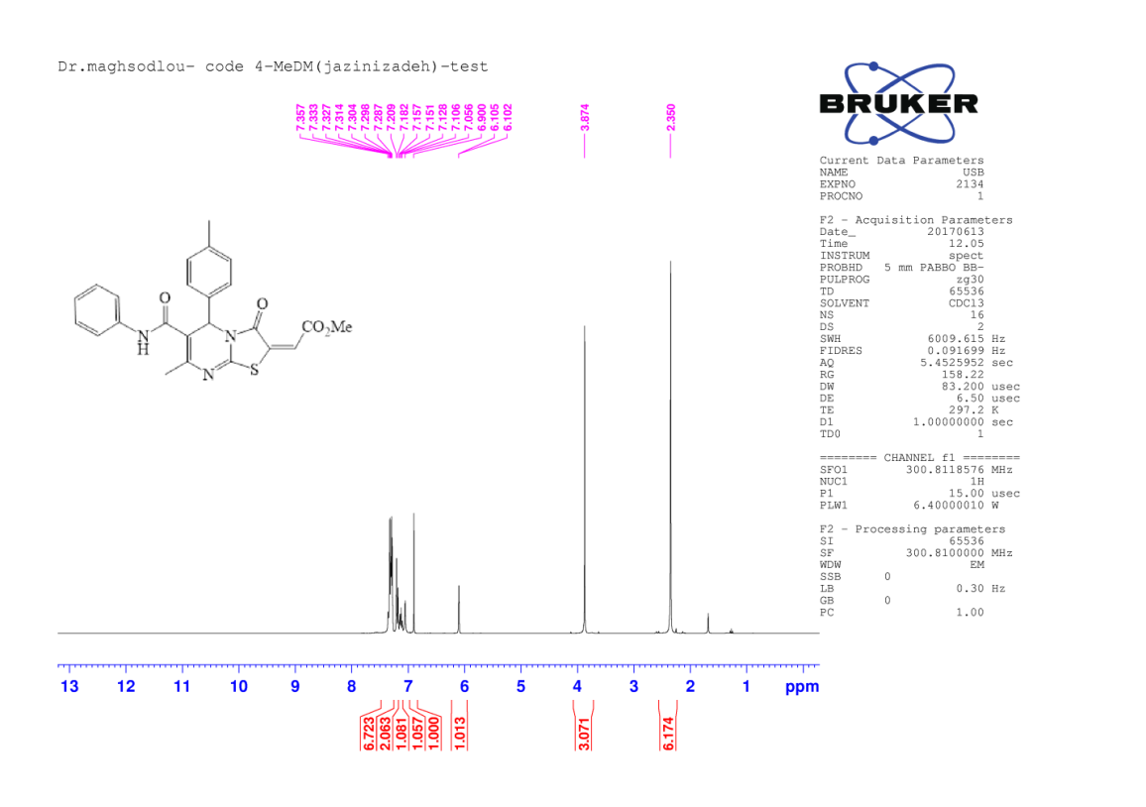
¹H NMR spectra of compound 6e

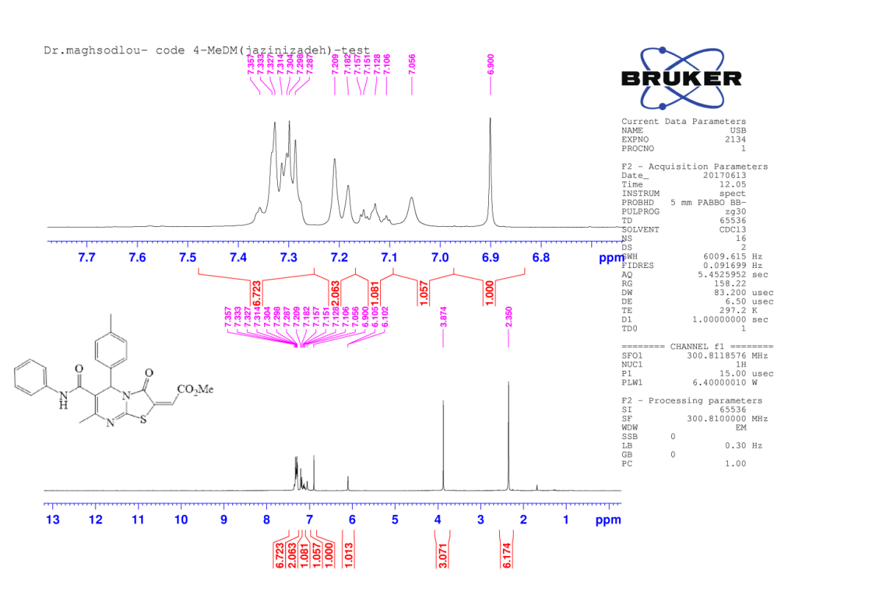
Expanded ¹H NMR spectra of compound 6e

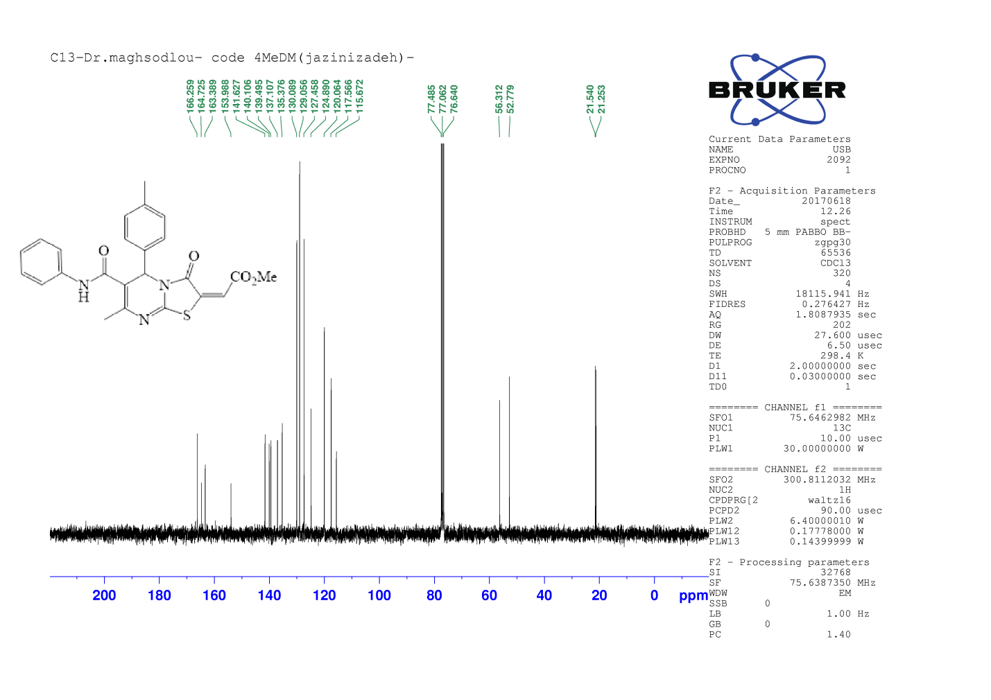
¹³C NMR spectra of compound 6e
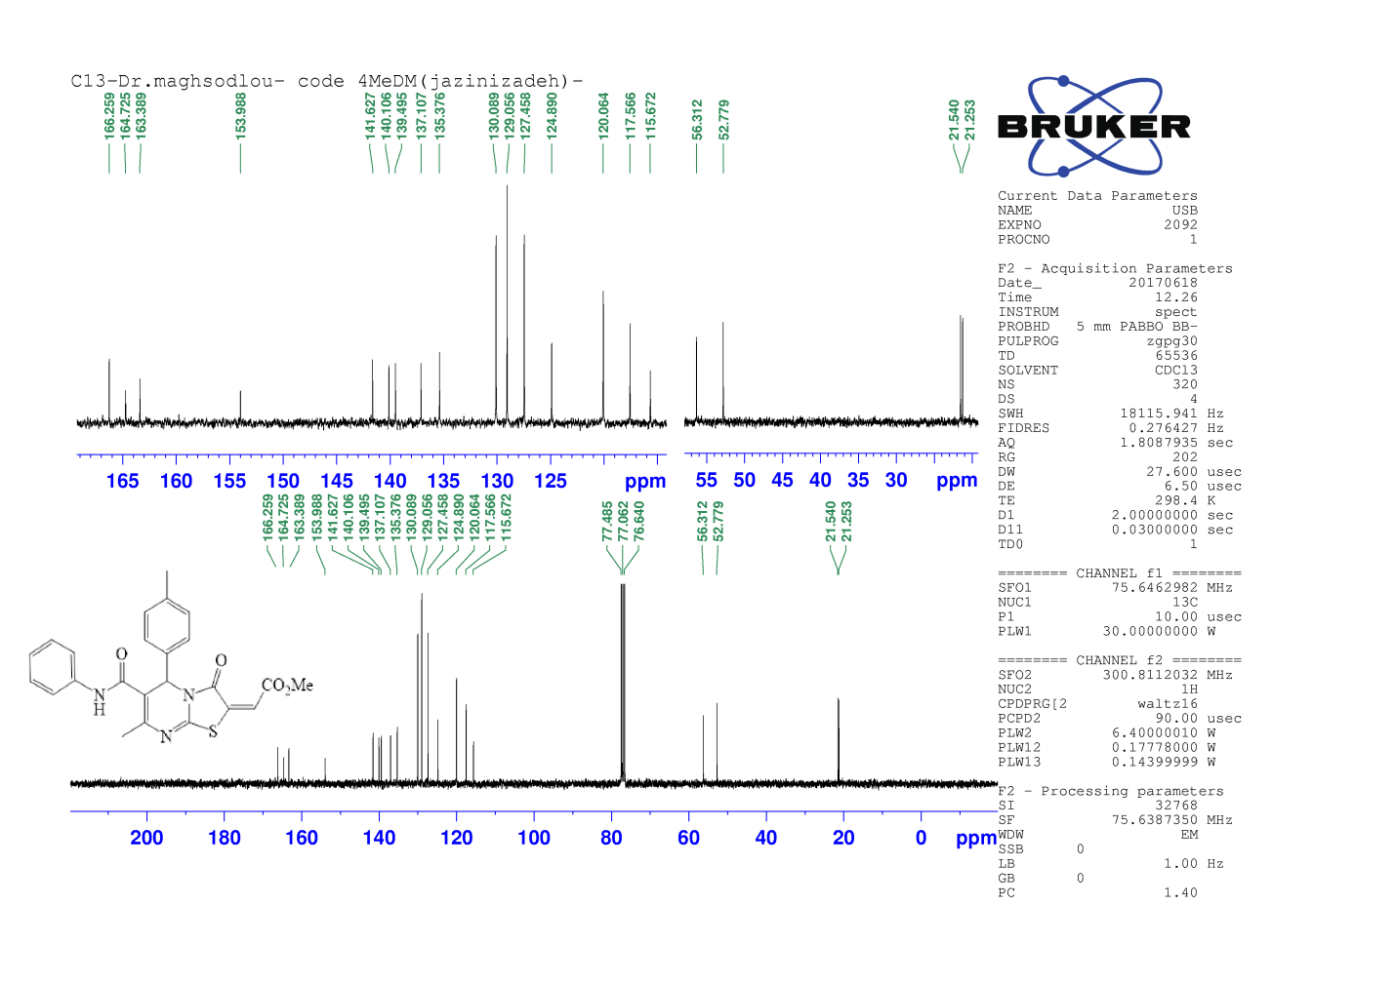
¹³C NMR spectra of compound 6e

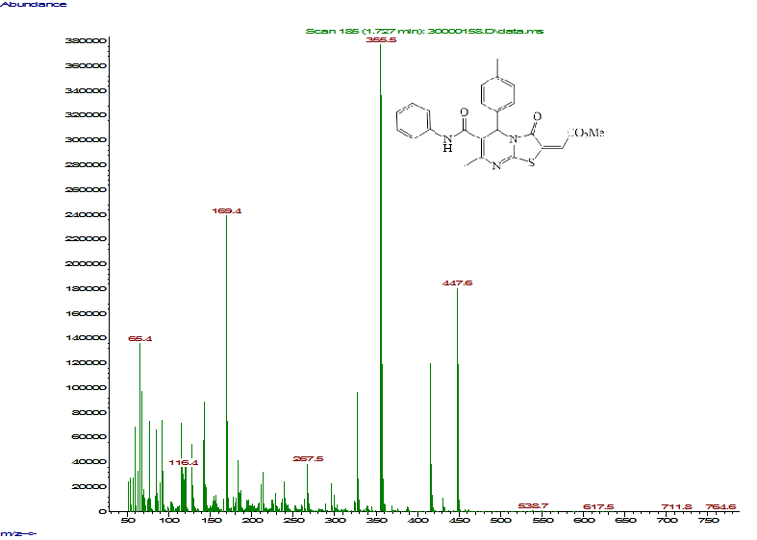
Mass spectra of compound 6e
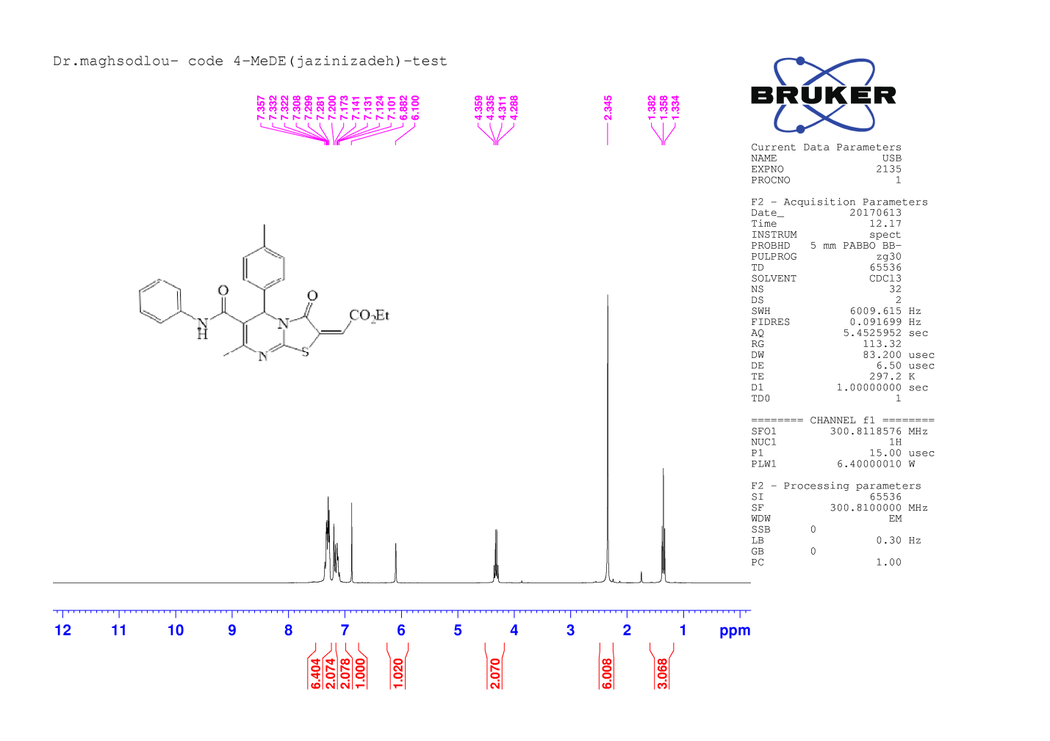
¹H NMR spectra of compound 6f

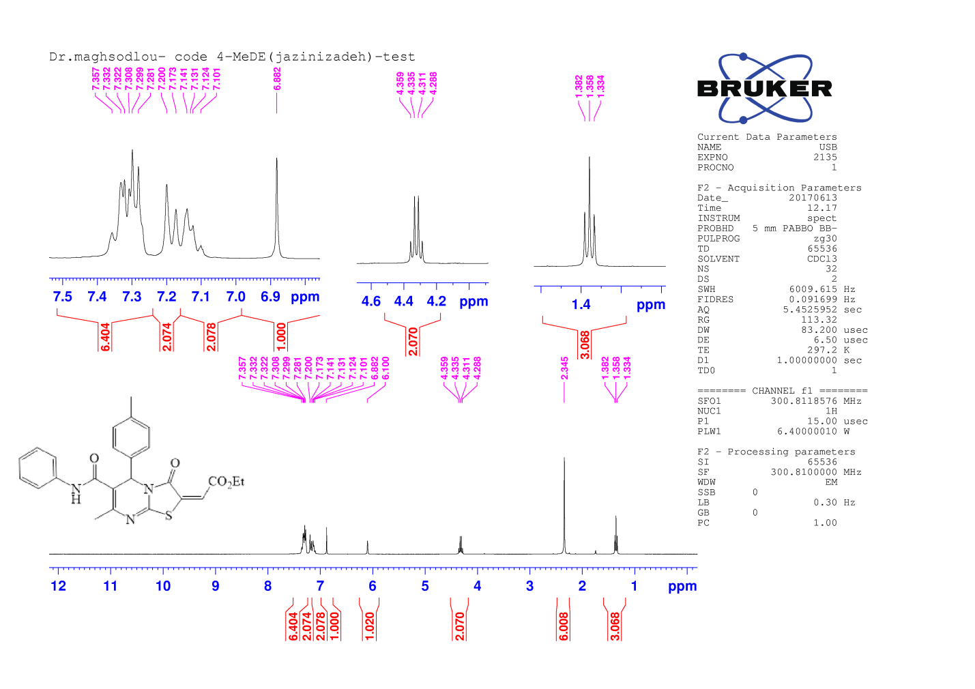
Expanded ¹H NMR spectra of compound 6f
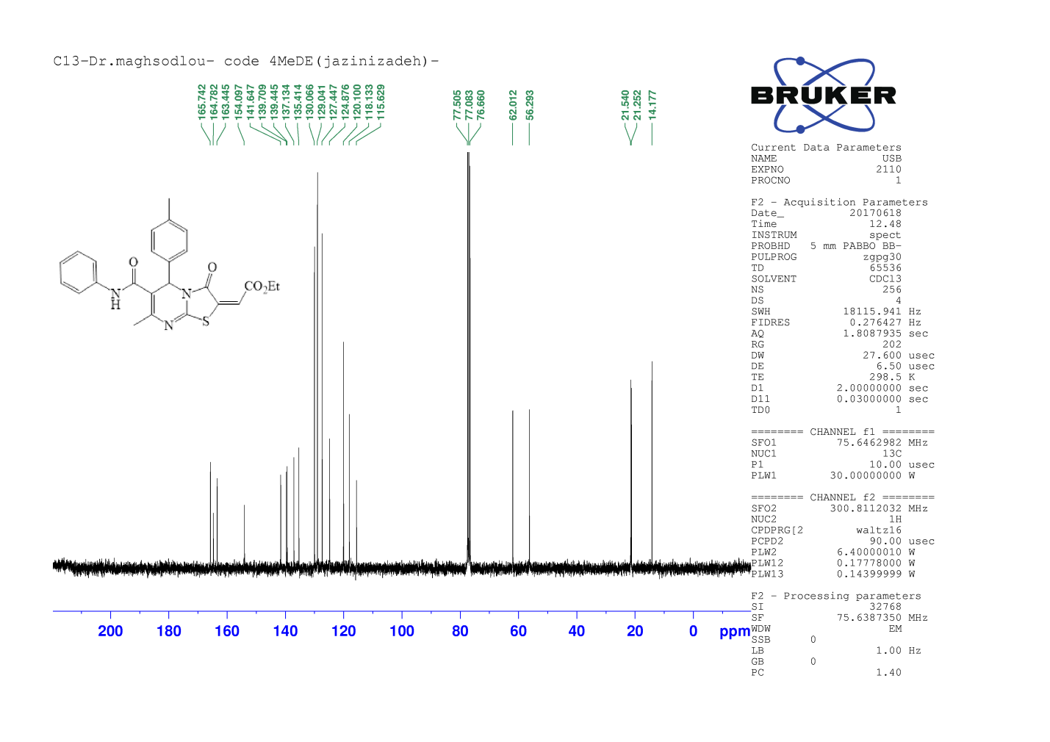
¹³C NMR spectra of compound 6f

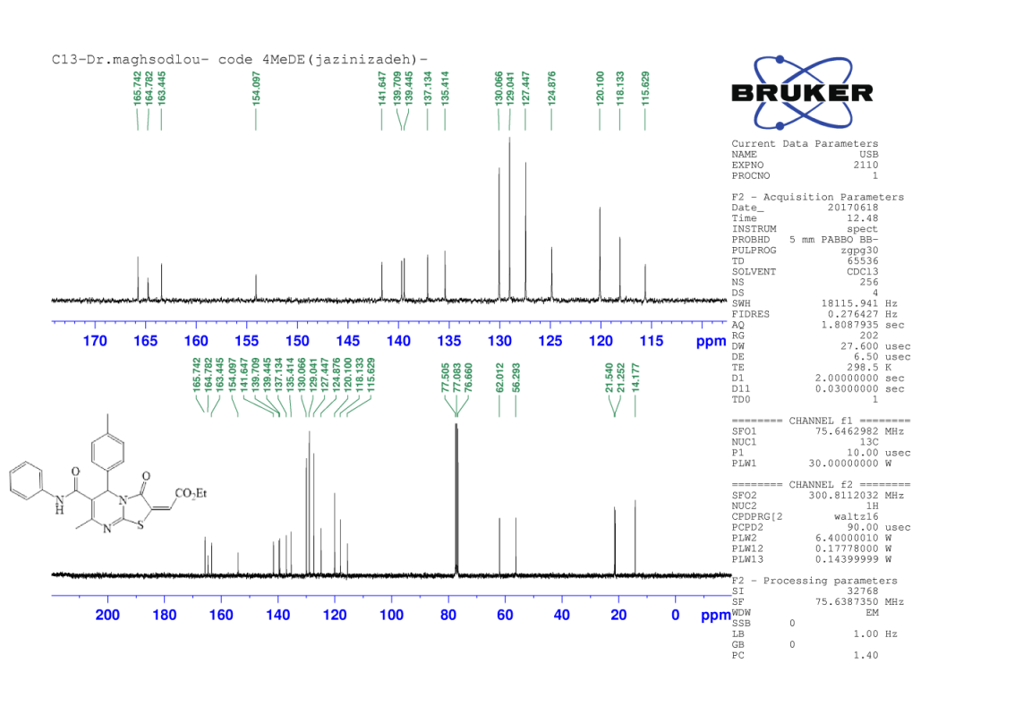
Expanded ¹³C NMR spectra of compound 6f

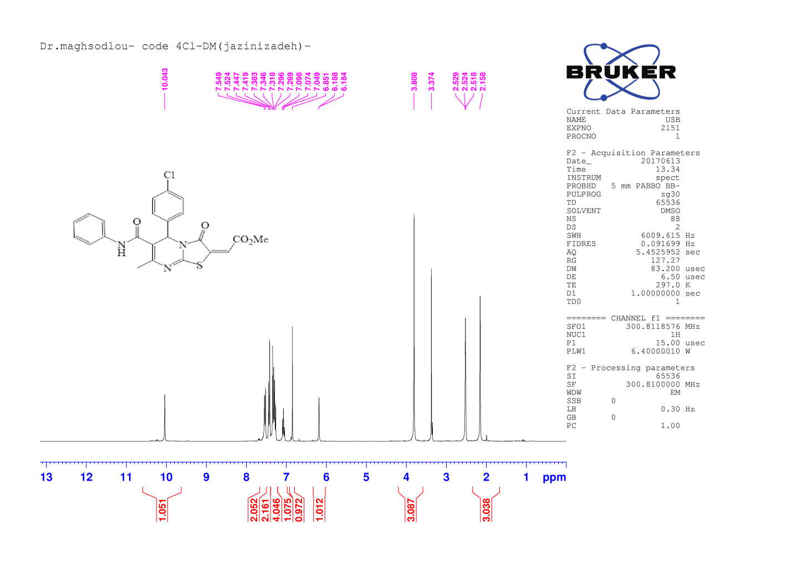
¹H NMR spectra of compound 6g

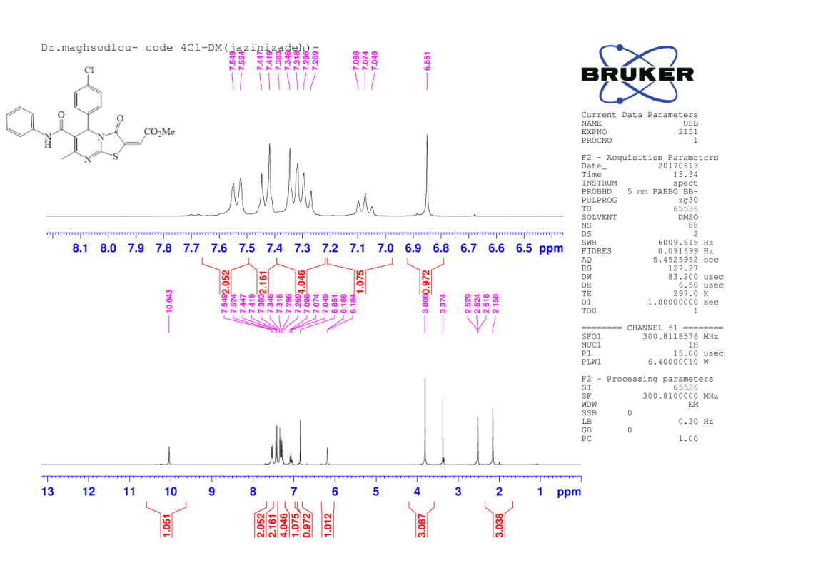
Expanded ¹H NMR spectra of compound 6g

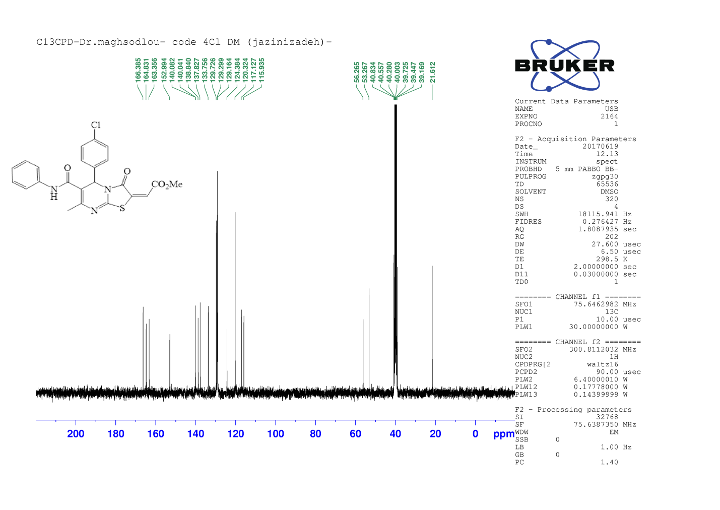
¹³C NMR spectra of compound 6g

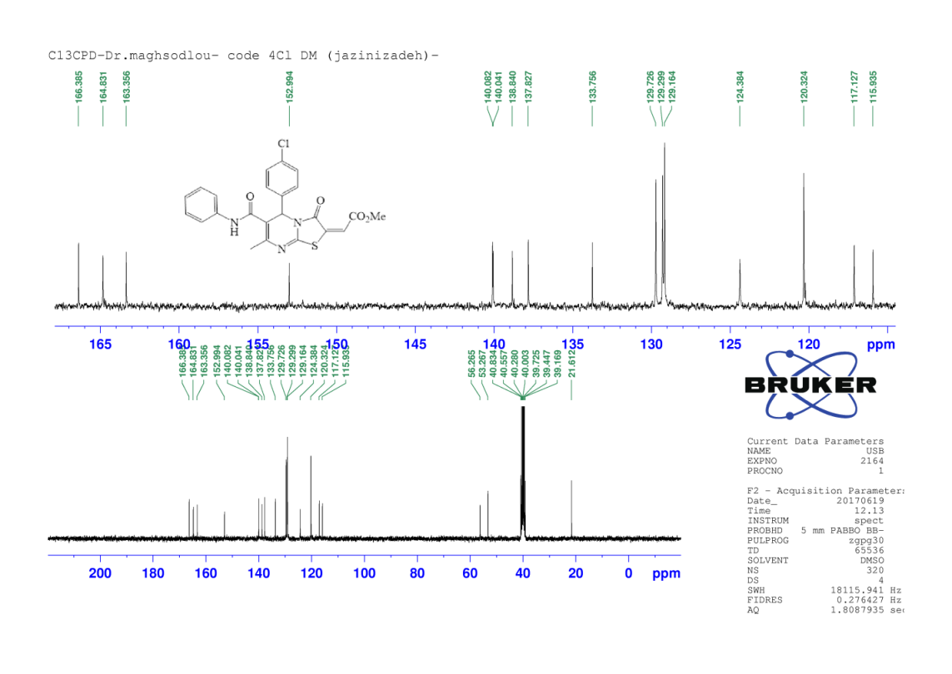
Expanded ¹³C NMR spectra of compound 6g
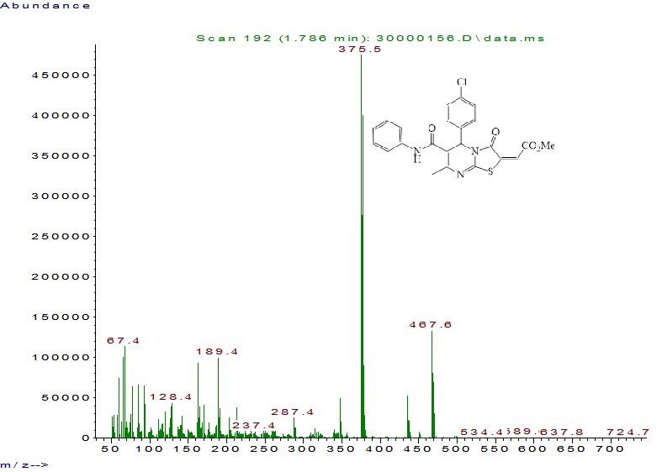
Mass spectra of compound 6g

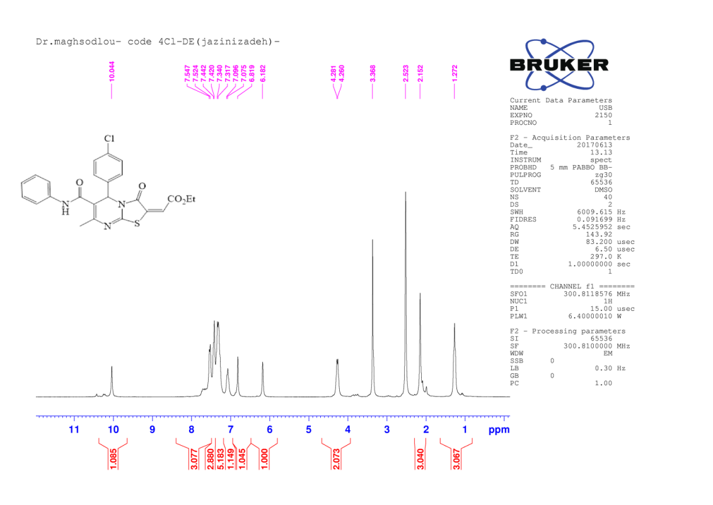
¹H NMR spectra of compound 6h
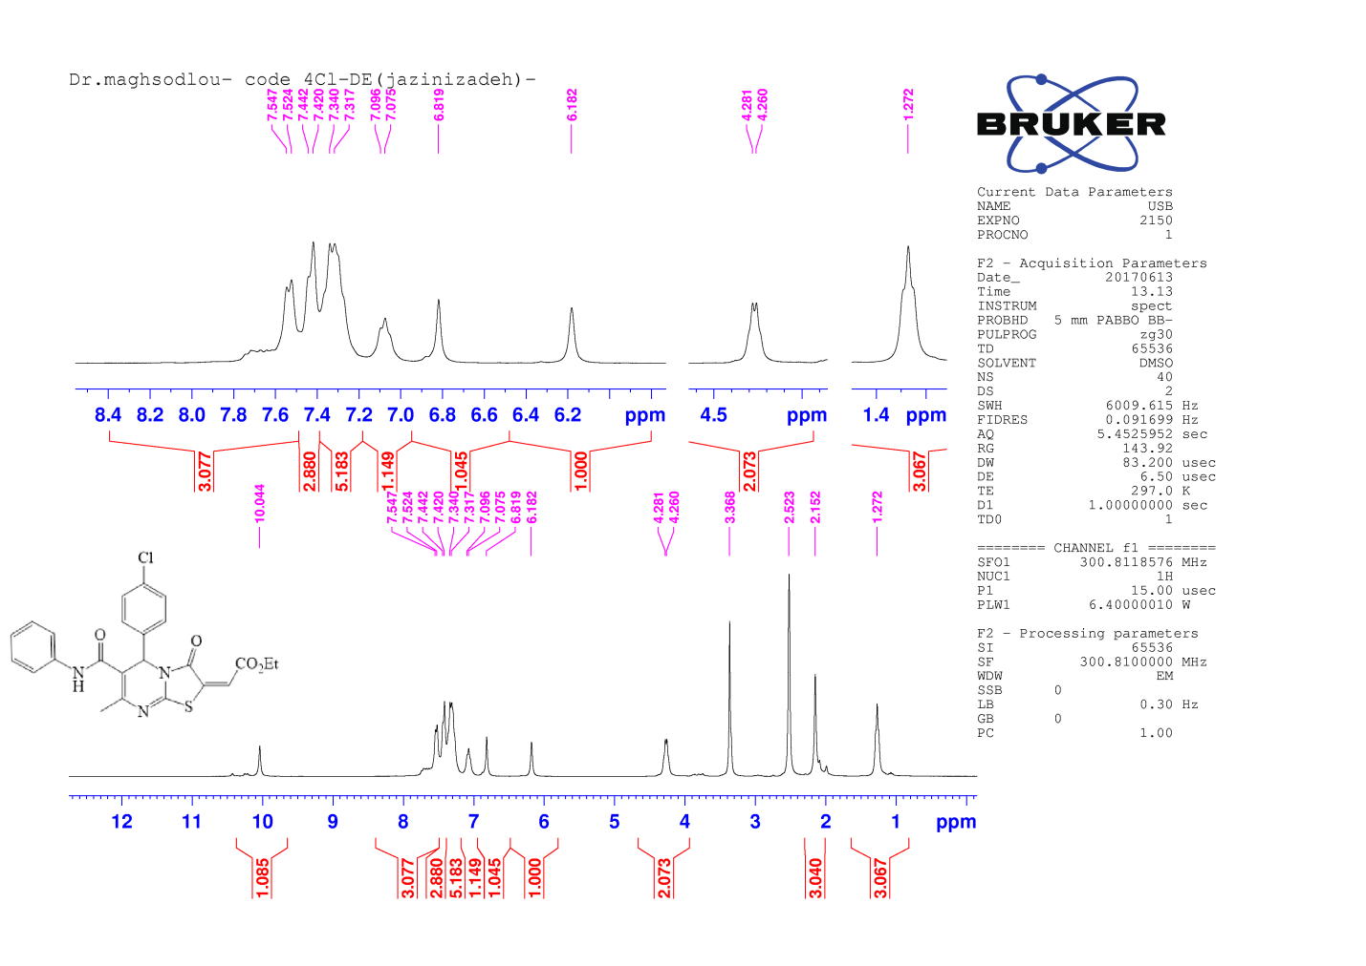
Expanded ¹H NMR spectra of compound 6h

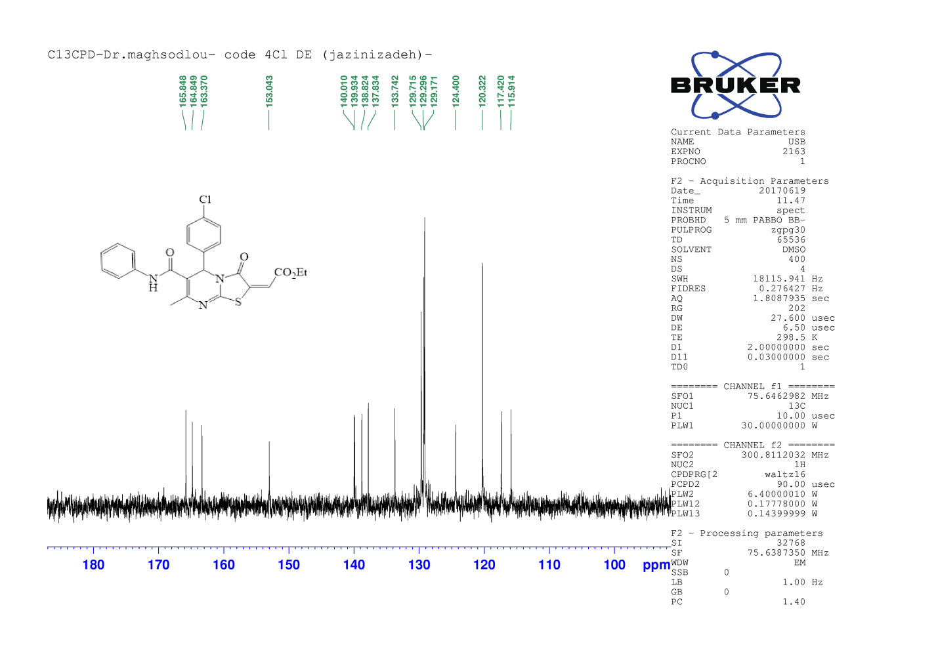
¹³C NMR spectra of compound 6h
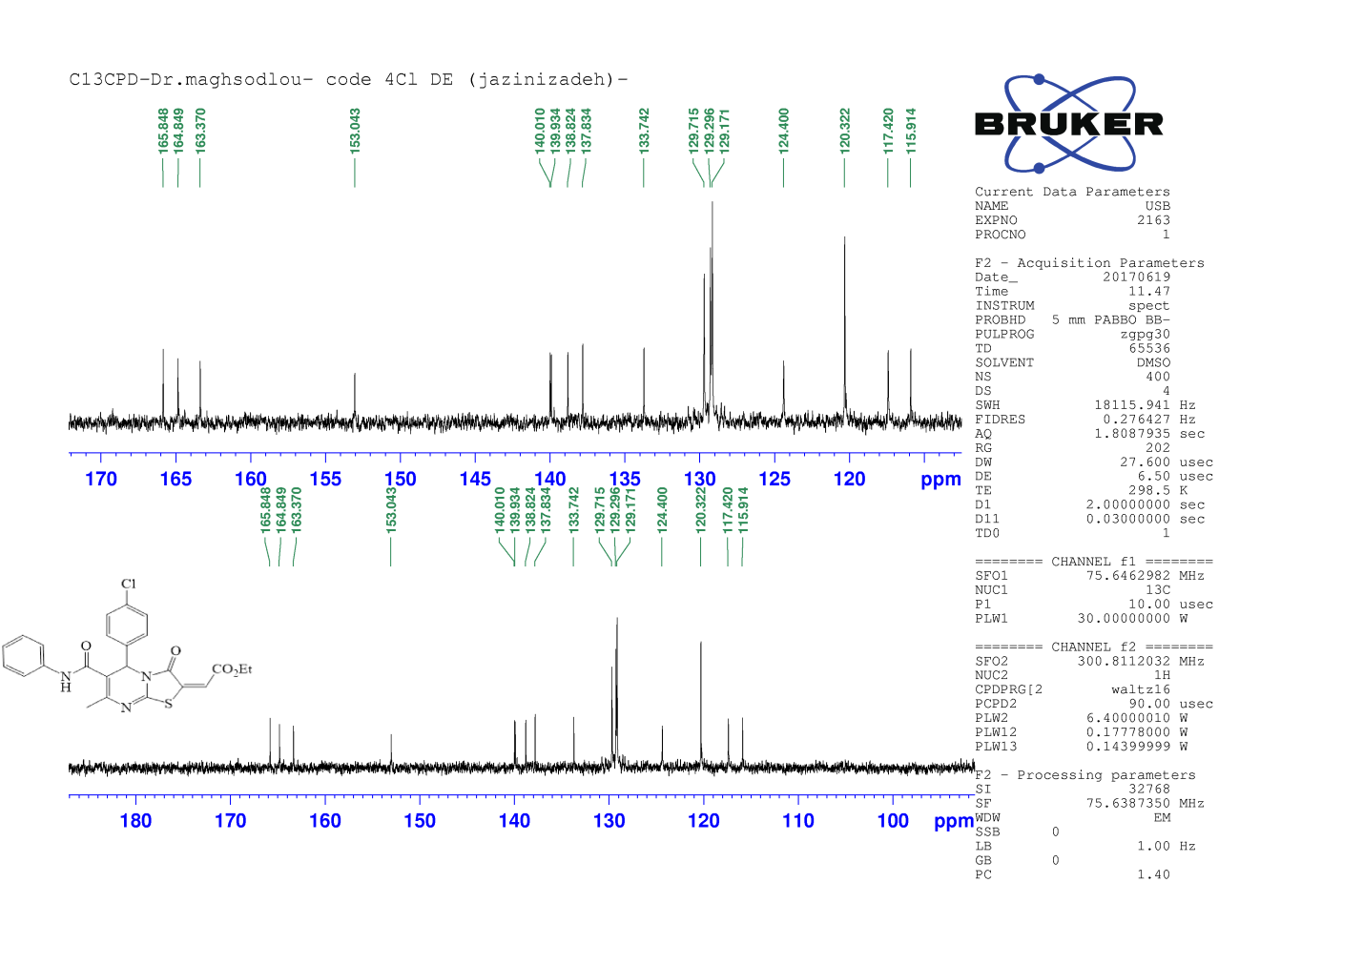
Expanded ¹³C NMR spectra of compound 6h

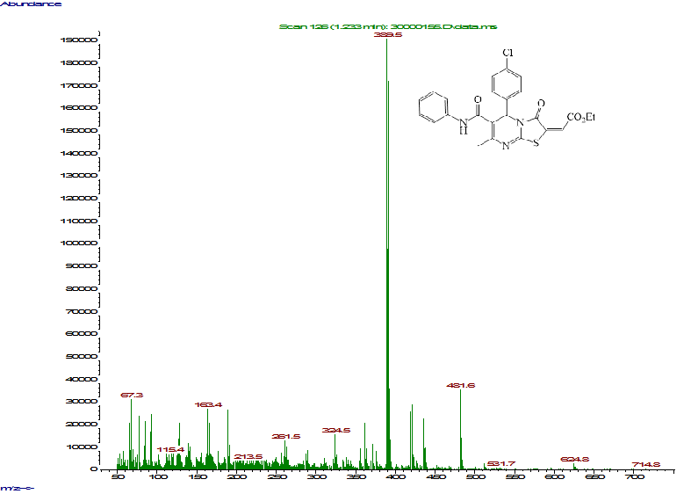
Mass spectra of compound 6h
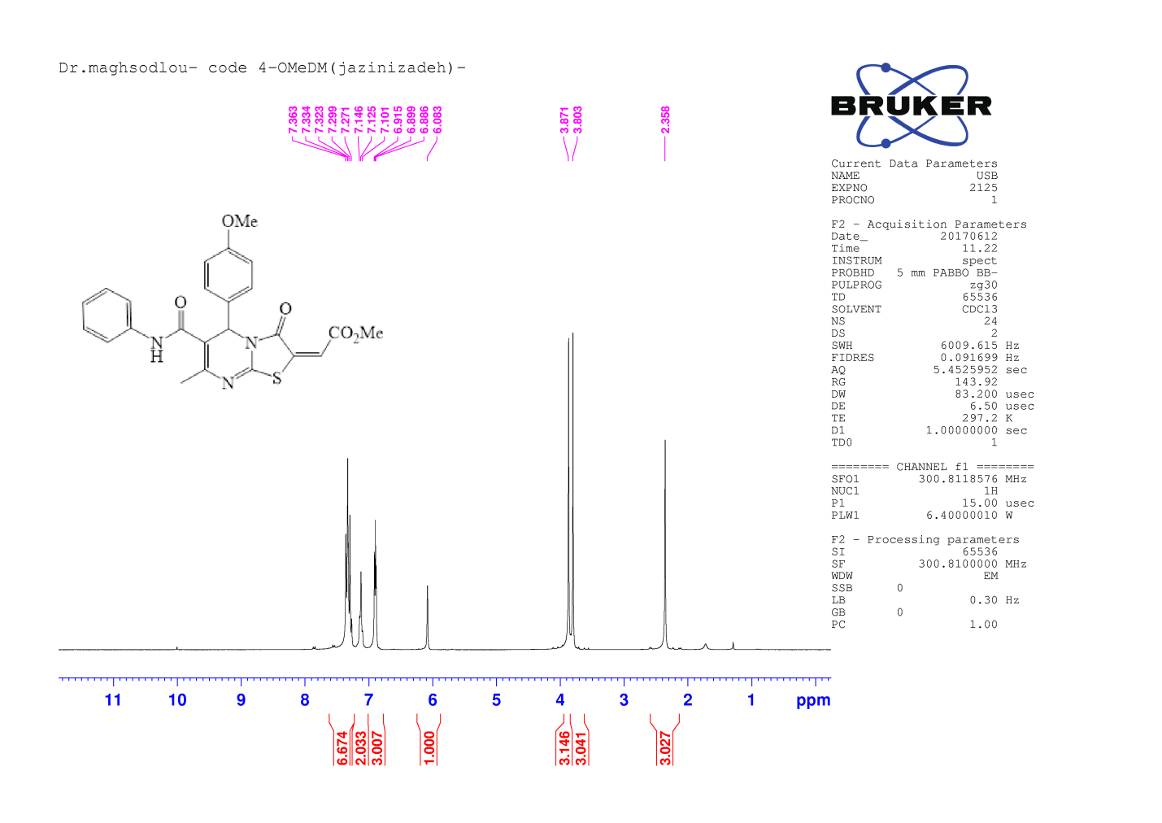
¹H NMR spectra of compound 6i

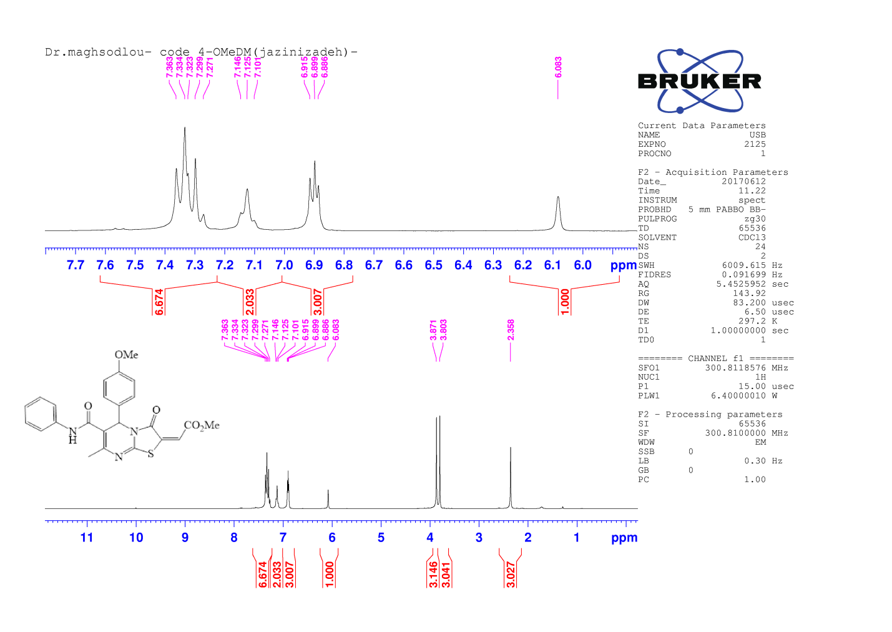
Expanded ¹H NMR spectra of compound 6i
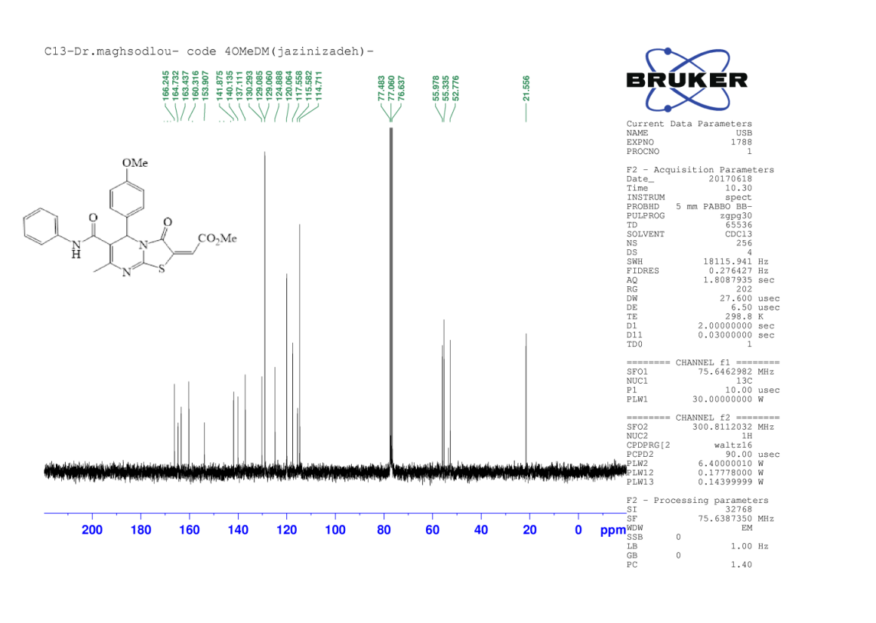
¹³C NMR spectra of compound 6i

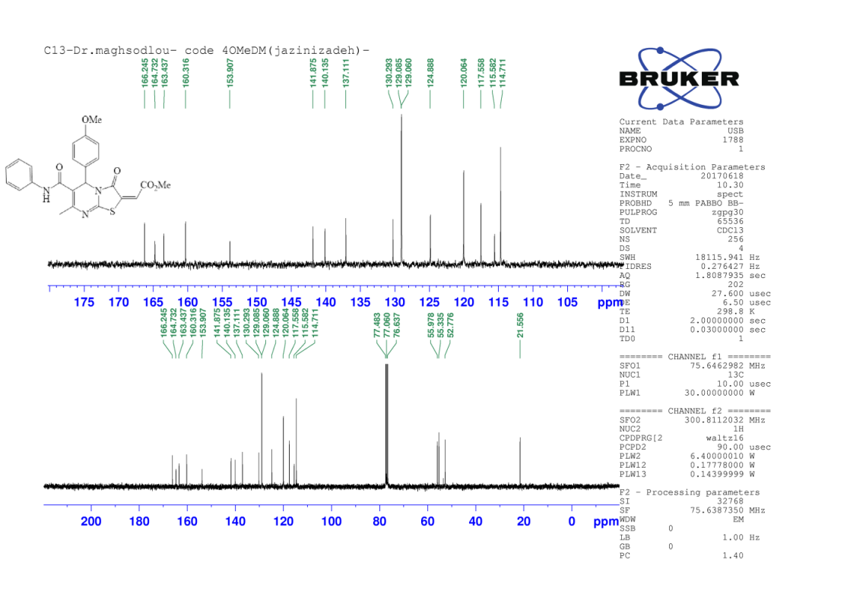
Expanded ¹³C NMR spectra of compound 6i

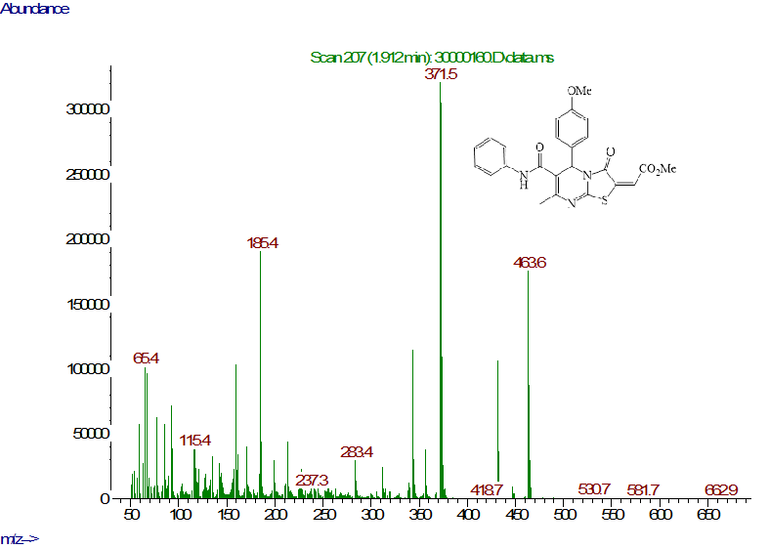
Mass spectra of compound 6i

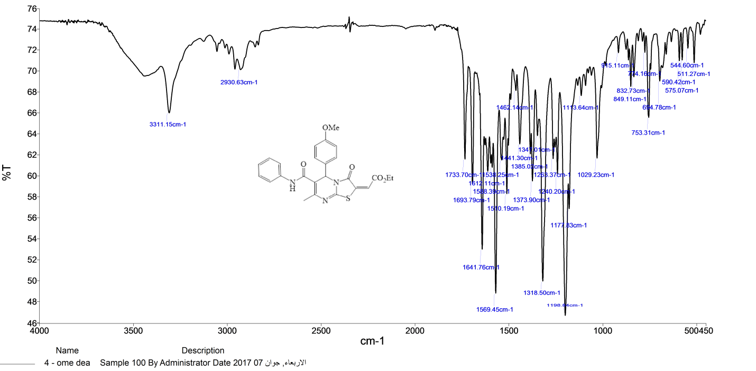
FT-IR spectra of compound 6j
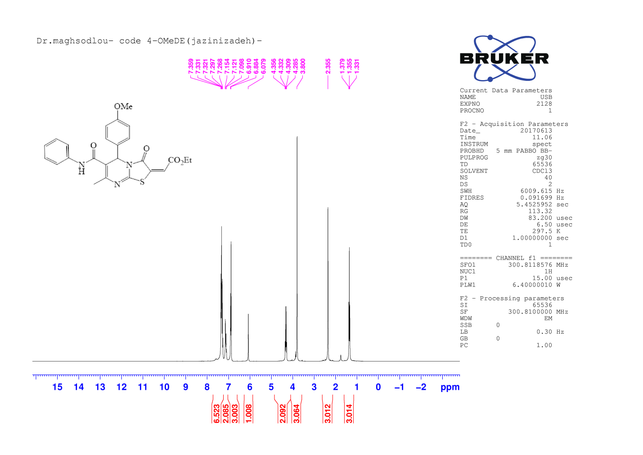
¹H NMR spectra of compound 6j

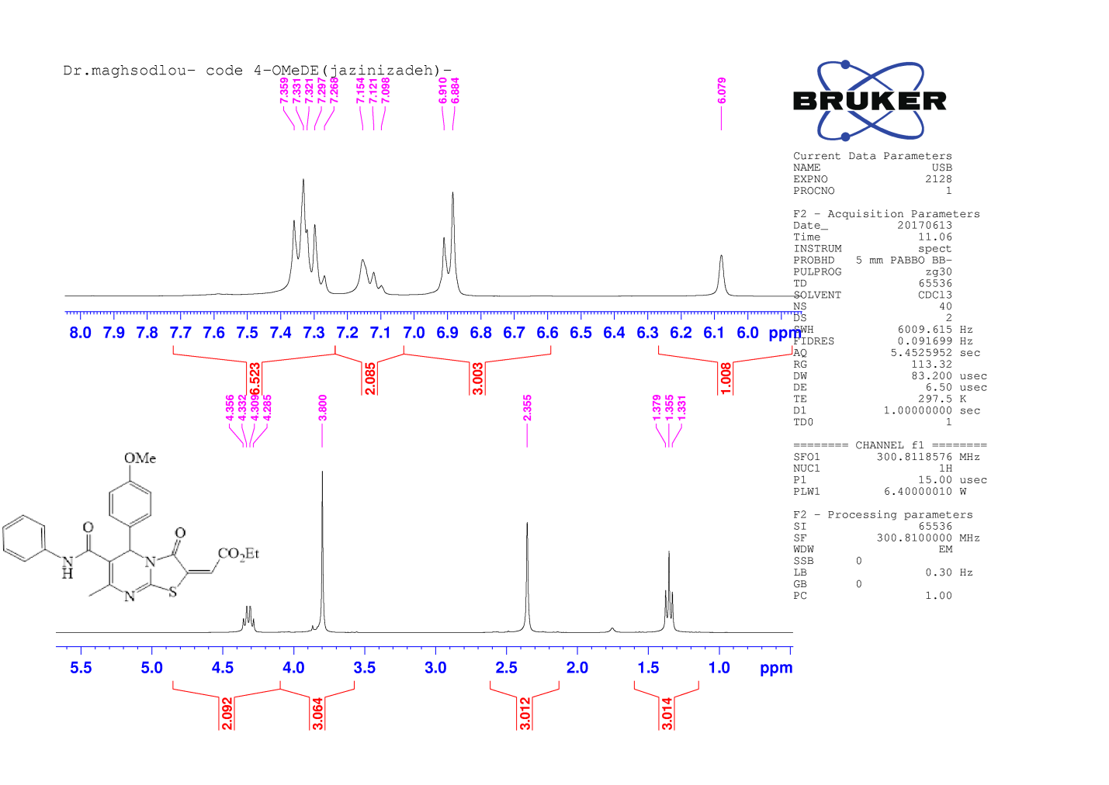
Expanded ¹H NMR spectra of compound 6j
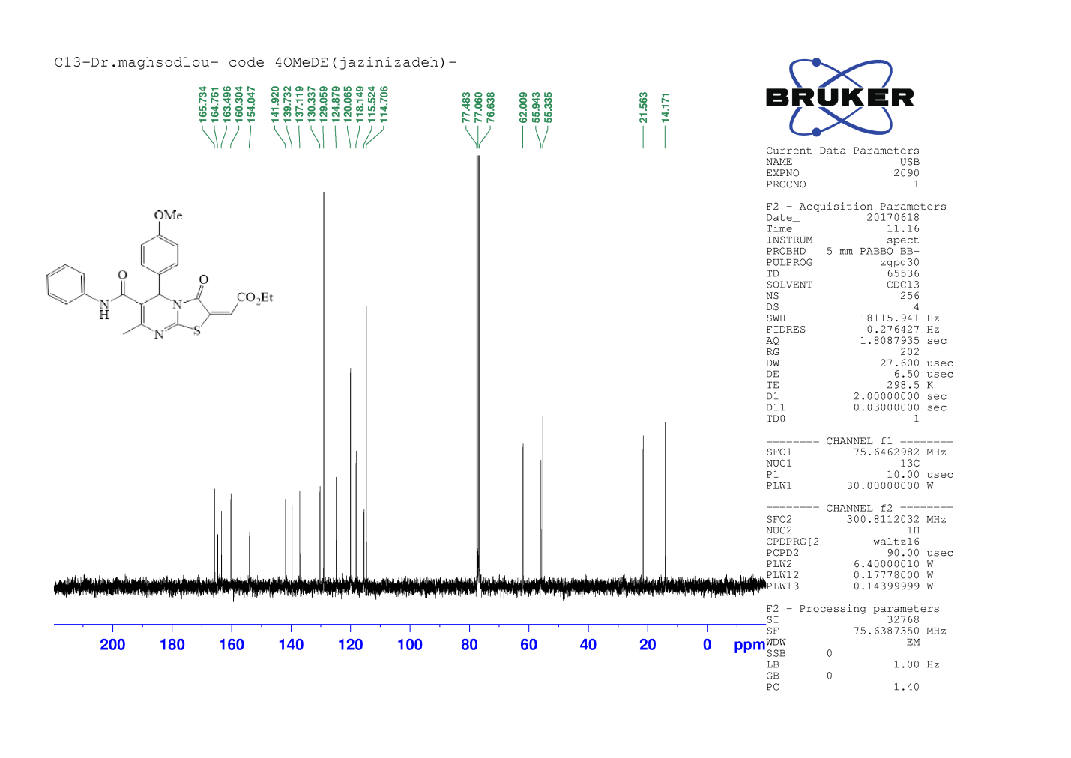
¹³C NMR spectra of compound 6j

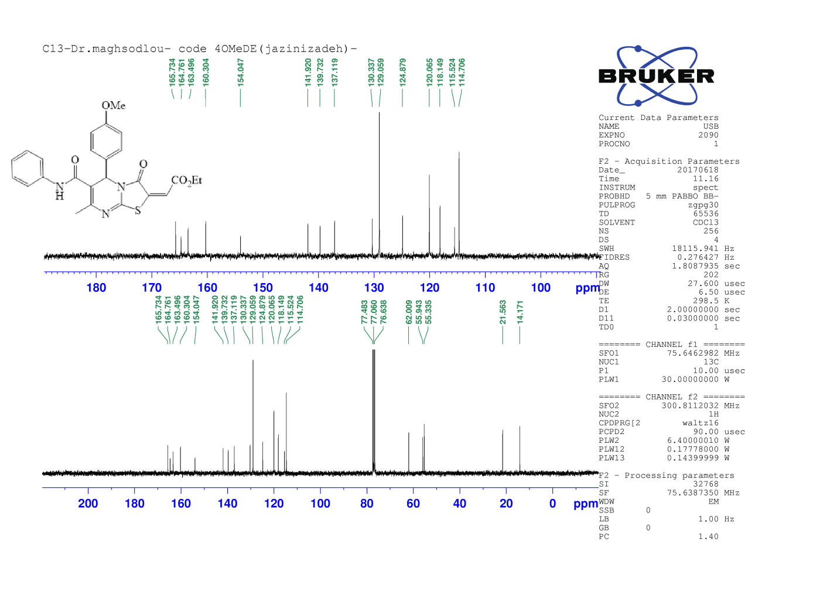
Expanded ¹³C NMR spectra of compound 6j

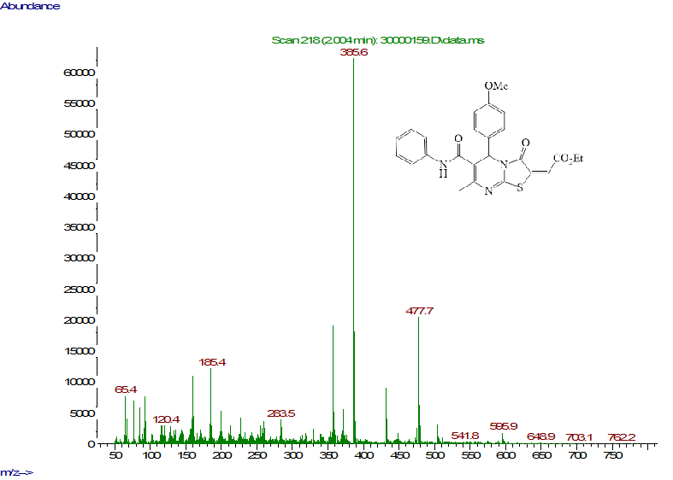
Mass spectra of compound 6j

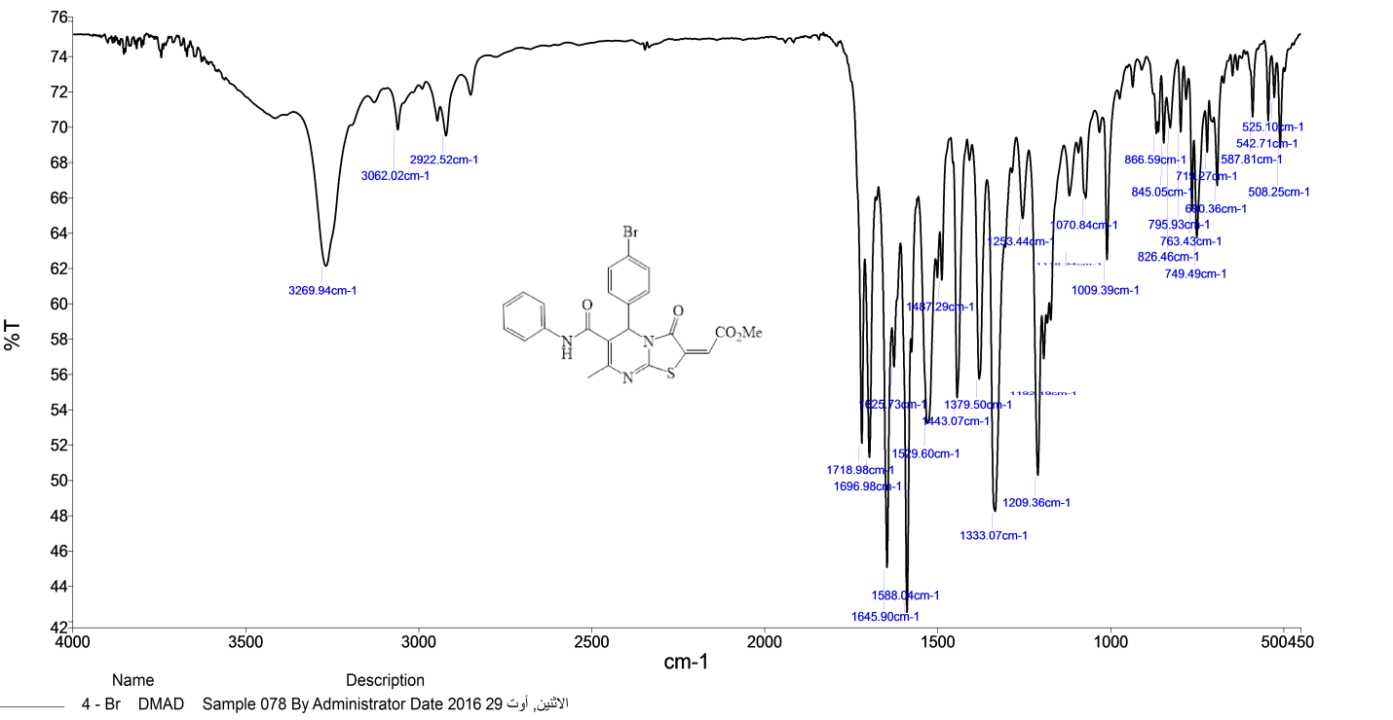
FT-IR spectra of compound 6k
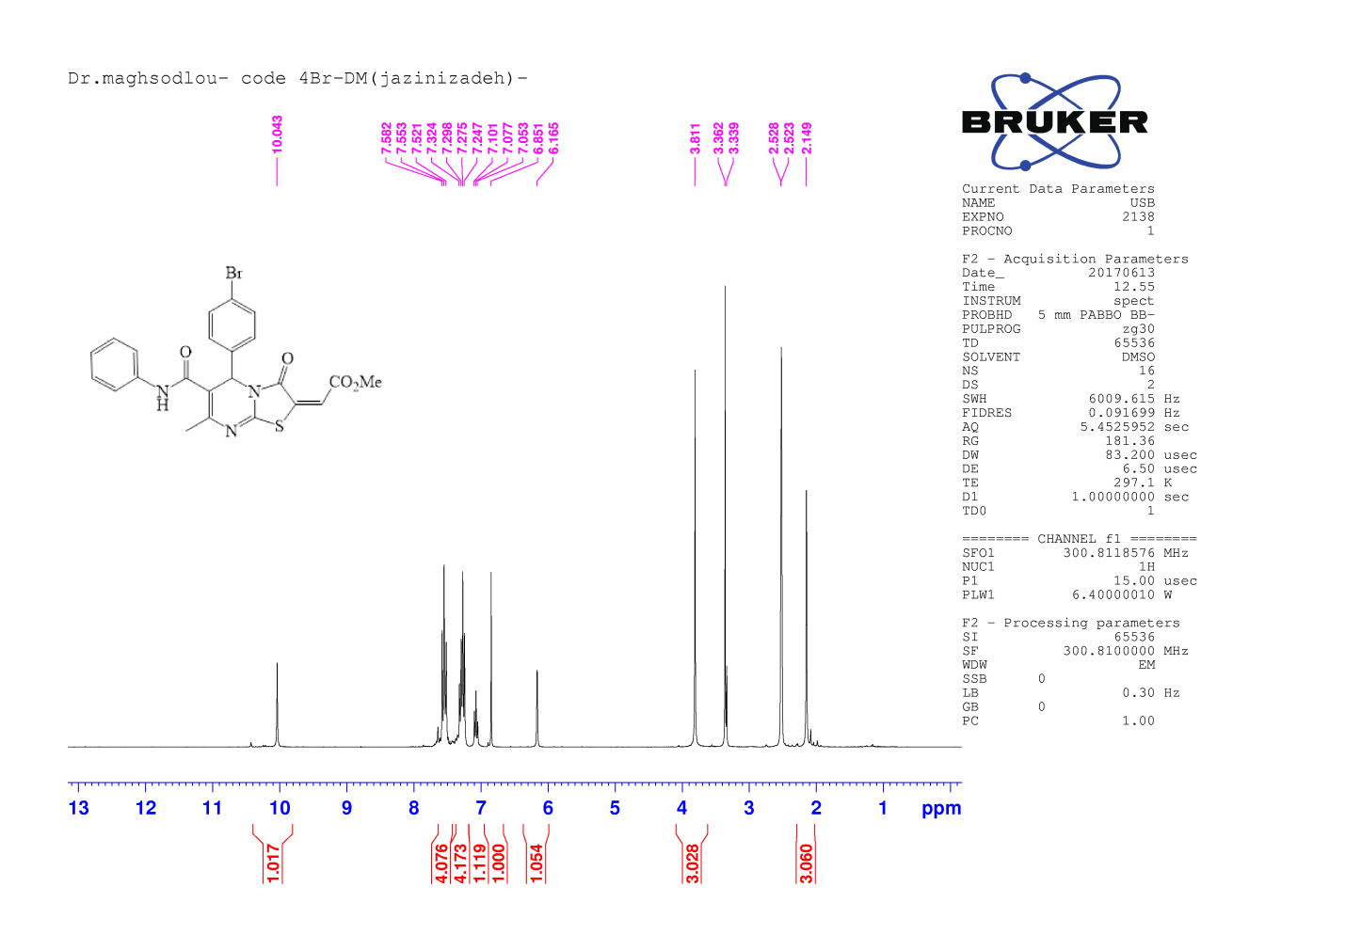
¹H NMR spectra of compound 6k

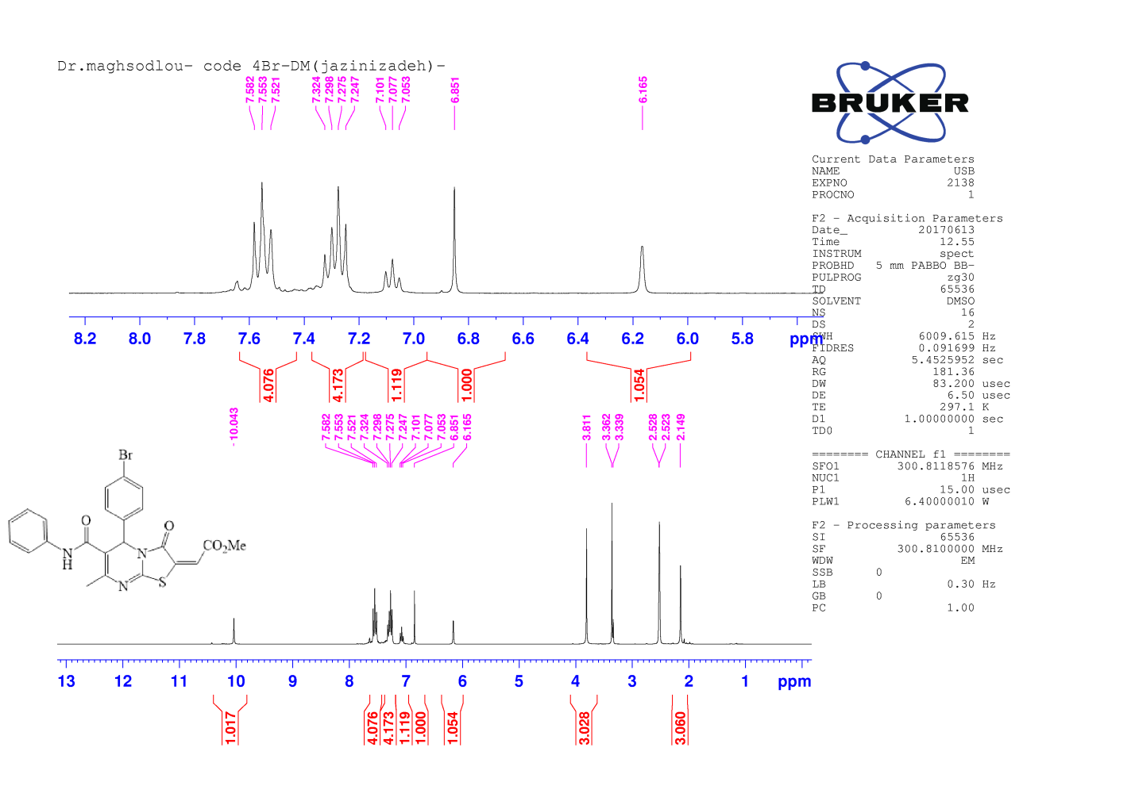
Expanded ¹H NMR spectra of compound 6k
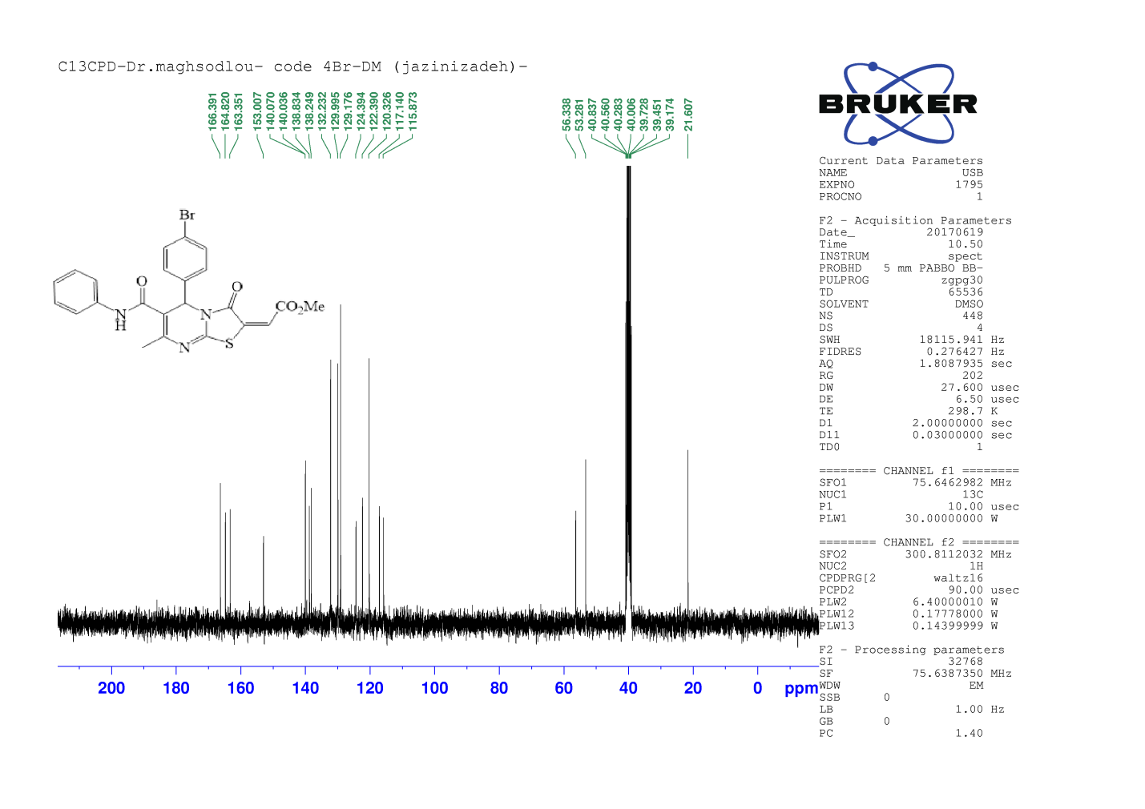
¹³C NMR spectra of compound 6k

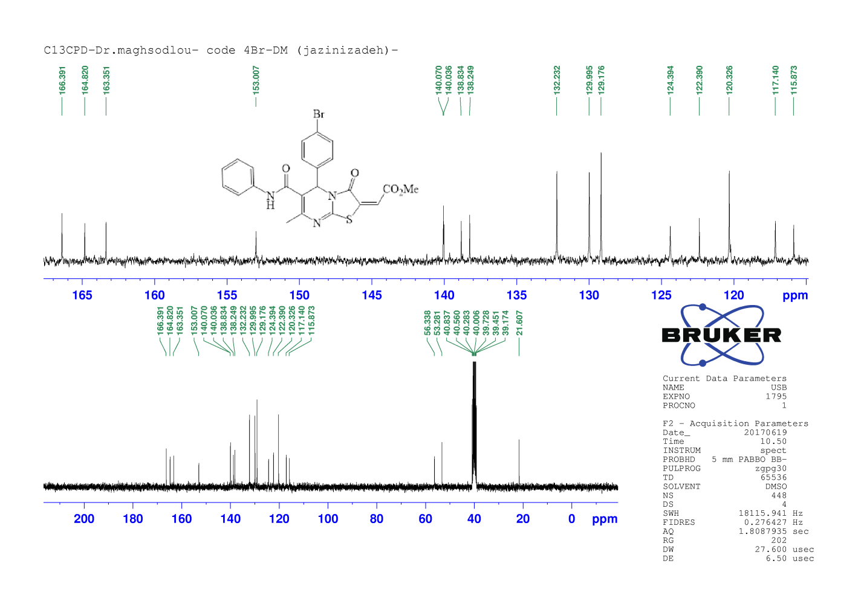
Expanded ¹³C NMR spectra of compound 6k

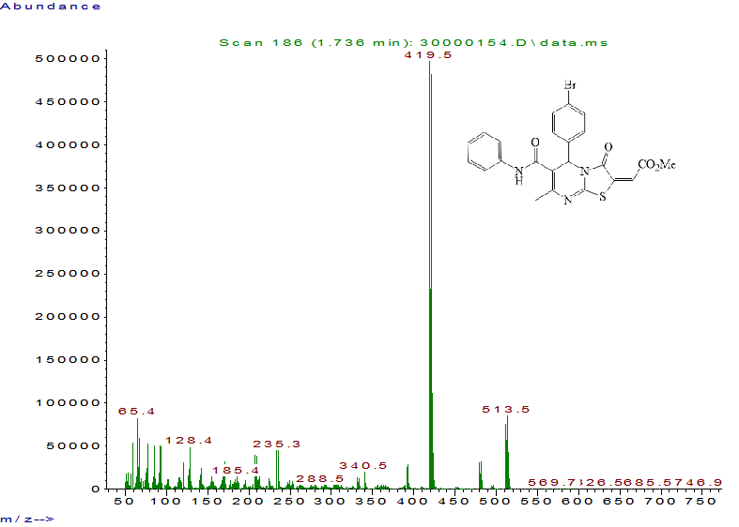
Mass spectra of compound 6k

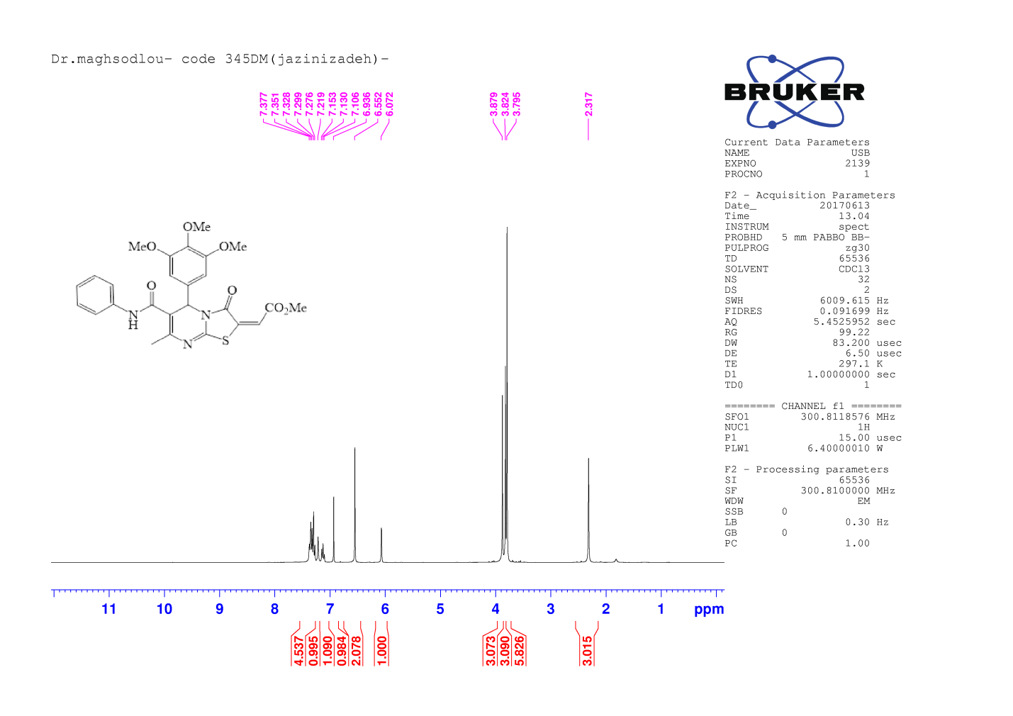
¹H NMR spectra of compound 6l
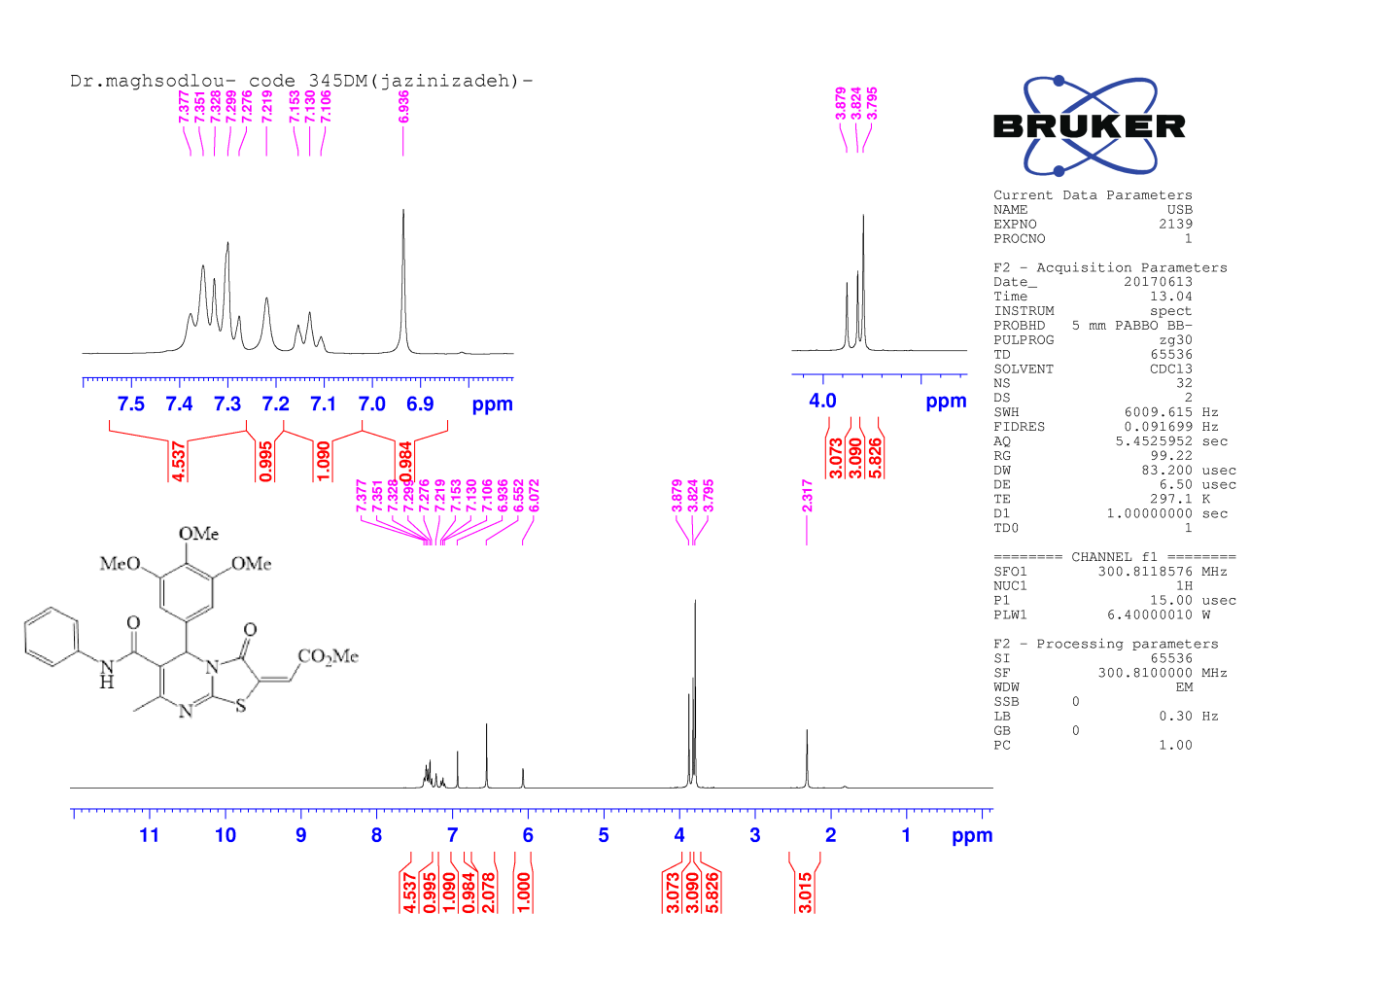
Expanded ¹H NMR spectra of compound 6l

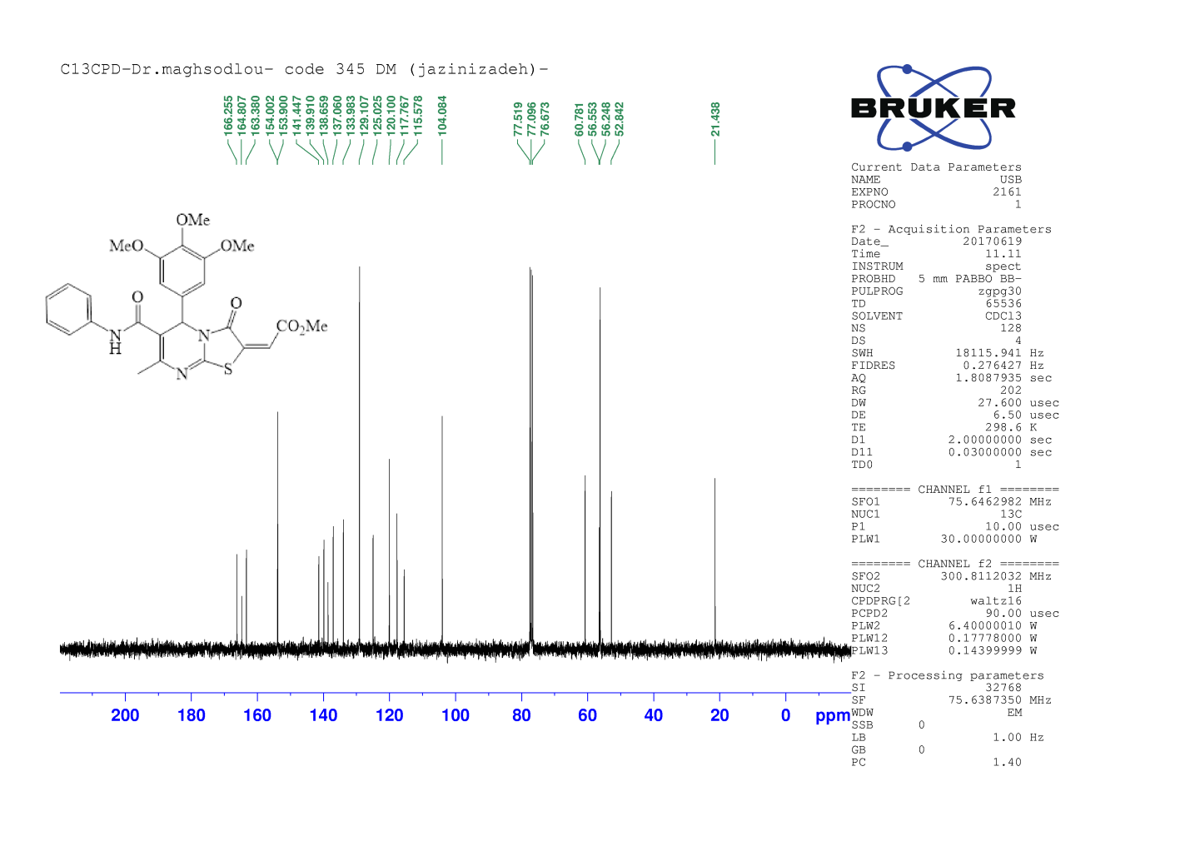
¹³C NMR spectra of compound 6l
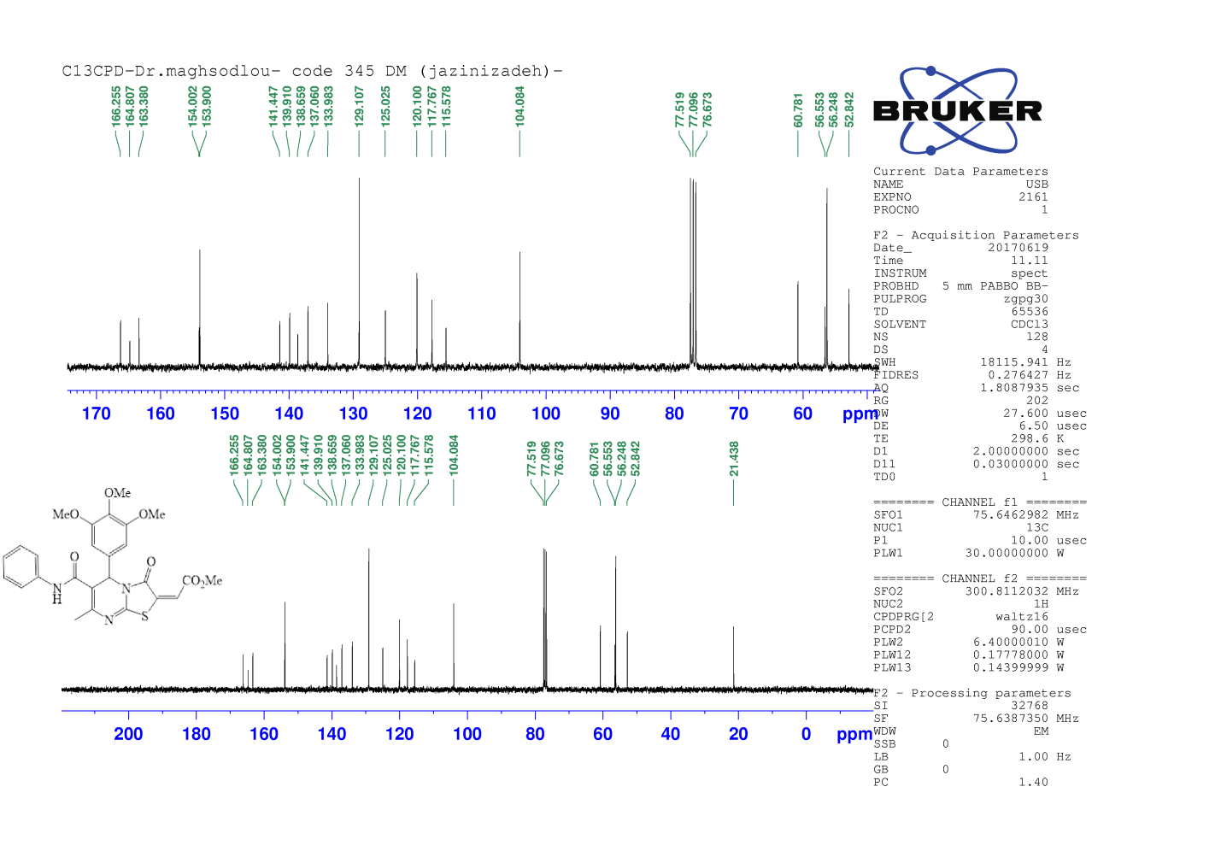
Expanded ¹³C NMR spectra of compound 6l

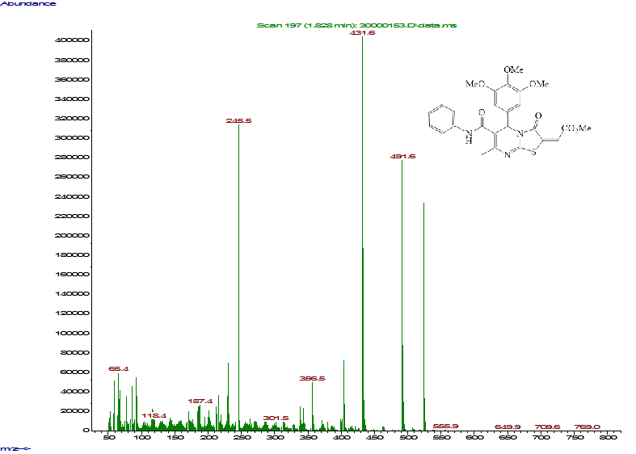
Mass spectra of compound 6l

