Rearing a virulent common cuckoo is not extra costly for its only cavity-nesting host

Peter Samaš, Jarkko Rutila, Marcel Honza, Michal Kysučan and Tomáš Grim

Proceedings of the Royal Society B

ELECTRONIC SUPPLEMENTARY MATERIAL

Article DOI: 10.1098/rspb.2018.1710

Supplementary Results

During a previous study [1], we cross-fostered cuckoo eggs (52 out of total n=82) into randomly chosen synchronous redstart host nests, randomizing parasitism status of particular host pairs. The cross-fostering of eggs is a standard established method used in brood parasitism studies to disentangle the potential cues that hosts can use to recognize and reject foreign eggs [2]. However, this could be problematic if cuckoo parasitism in nature is non-random with respect to host age [3] or phenotypes [4]. In a previous study we found that cuckoos selected redstart pairs randomly with respect to host phenotypes and that cross-fostering was also done randomly in respect to host phenotypes [5].
In the present study, we found no difference between the scaled mass index (a measure of body condition, calculated from mass and tarsus on nest hatching day: [6]) of redstarts naturally parasitised by cuckoos (mean±SD: 15.40±1.32g, n=34 individuals) and those that were not parasitised (15.36±1.24g, n=111; Welsch’s t-test t_{52.1}=0.16, p=0.87). Also, redstart parents fed cuckoos in naturally parasitised nests at similar rates (mean±SD: 9.6±5.3 feeds.hour^{–1}, n=21 nests) as cuckoos that were cross-fostered into unparasitised nests (11.1±4.0 feeds.hour^{–1}, n=49; F_{1,40}=2.46, p=0.12) after controlling for a significant non-linear effect of nestling age (F_{1,40}=36.06, p<0.0001). Additionally, clutch size did not differ between naturally parasitised (mean±SD: 6.4±0.9 eggs, n=54) and non-parasitised nests (6.7±0.9 eggs, n=219; Welsch’s t-test t₈₀=1.56, p=0.12; figure S2). Thus, we found no evidence that cuckoos choose redstart hosts according to host phenotypes.
Although the cross-fostered cuckoo eggs were placed in randomly selected non-parasitised nests, we directly tested for any potential biases due to cross-fostering activities statistically. We found no difference in the initial host body condition between redstarts raising cross-fostered cuckoos (mean±SD: 15.25±1.33 g, n=50 individuals) and the rest of the host population in our sample (15.44±1.22 g, n=95; Welsch’s t-test t_{92.4}=0.84, p=0.40). Redstart parents fed cross-fostered cuckoos at similar rates (mean±SD: 11.2±4.1 feeds.hour^{–1}, n=48 nests) as cuckoos in naturally parasitised nests (10.3±4.2 feeds.hour^{–1}, n=22; F_{1,40}=1.47, p=0.23) after controlling for a significant non-linear effect of nestling age (F_{1,40}=55.7, p<0.0001). Host clutch size was also similar between nests with a cross-fostered cuckoo (mean±SD: 6.6±0.9, n=74) and naturally parasitised nests without cross-fostering (6.7±0.9, n=198; Welsch’s t-test t_{126.3}=0.62, p=0.53). Thus, in all tested parameters the nests that received cross-fostered cuckoos were representative of the host population.

References

1. Samaš P, Rutila J, Grim T. 2016 The common redstart as a suitable model to study cuckoo-host coevolution in a unique ecological context. BMC Evol. Biol. 16, 255. (doi:10.1186/s12862-016-0835-5)
2. Davies N. 2000 Cuckoos, cowbirds and other cheats. London: T & AD Poyser.
3. Grim T. 2002 Why is mimicry in cuckoo eggs sometimes so poor? J. Avian Biol. 33, 302–305. (doi:10.1034/j.1600-048X.2002.330312.x)
4. Polačiková L, Procházka P, Cherry MI, Honza M. 2009 Choosing suitable hosts: common cuckoos Cuculus canorus parasitize great reed warblers Acrocephalus arundinaceus of high quality. Evol. Ecol. 23, 879–891. (doi:10.1007/s10682-008-9278-9)
5. Grim T, Tyller Z, Samaš P. 2017 Unusual diet of brood parasitic nestlings and its fitness consequences. Auk 134, 732–750. (doi:10.1642/AUK-16-242.1)
6. Peig J, Green AJ. 2009 New perspectives for estimating body condition from mass/length data: the scaled mass index as an alternative method. Oikos 118, 1883–1891. (doi:10.1111/j.1600-0706.2009.17643.x)

Figure S1. Pearson's correlations with 95% confidence intervals (see below) for sex-specific host feeding frequencies (FF), adult body condition changes (BC), and H/L ratio changes (H/L) calculated separately for cuckoo nestlings and redstart broods. Confidence intervals overlapping with dashed line suggest non-significant difference from zero (because all CIs overlap with 0 there was no need for Bonferroni correction). Females = open circles, males = closed circles.

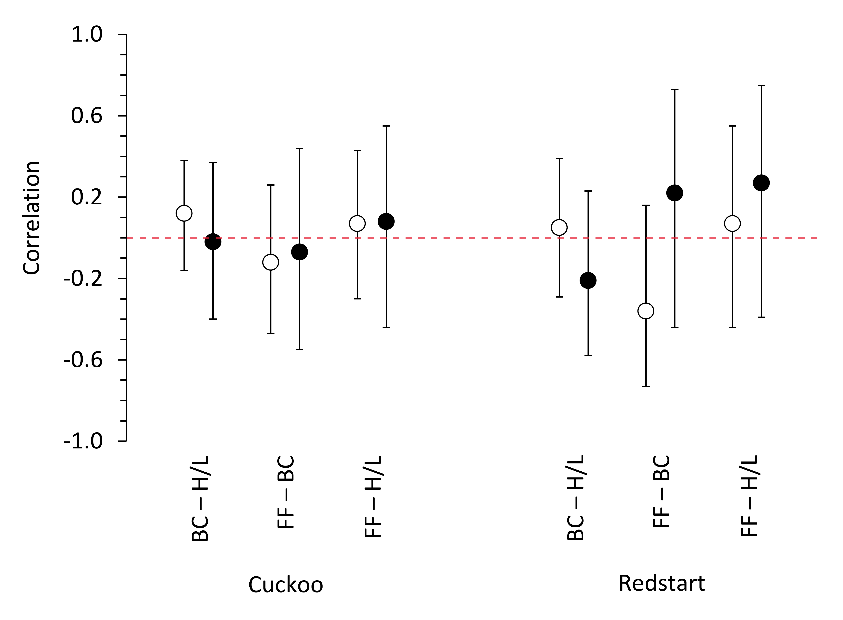

Figure S2. Distribution of final clutch size of common redstart hosts which were parasitised (grey bars; n=54; median=7, mean=6.4±0.1) or were not naturally parasitised by the common cuckoo (black bars; n=219; median=7, mean=6.7±0.1).

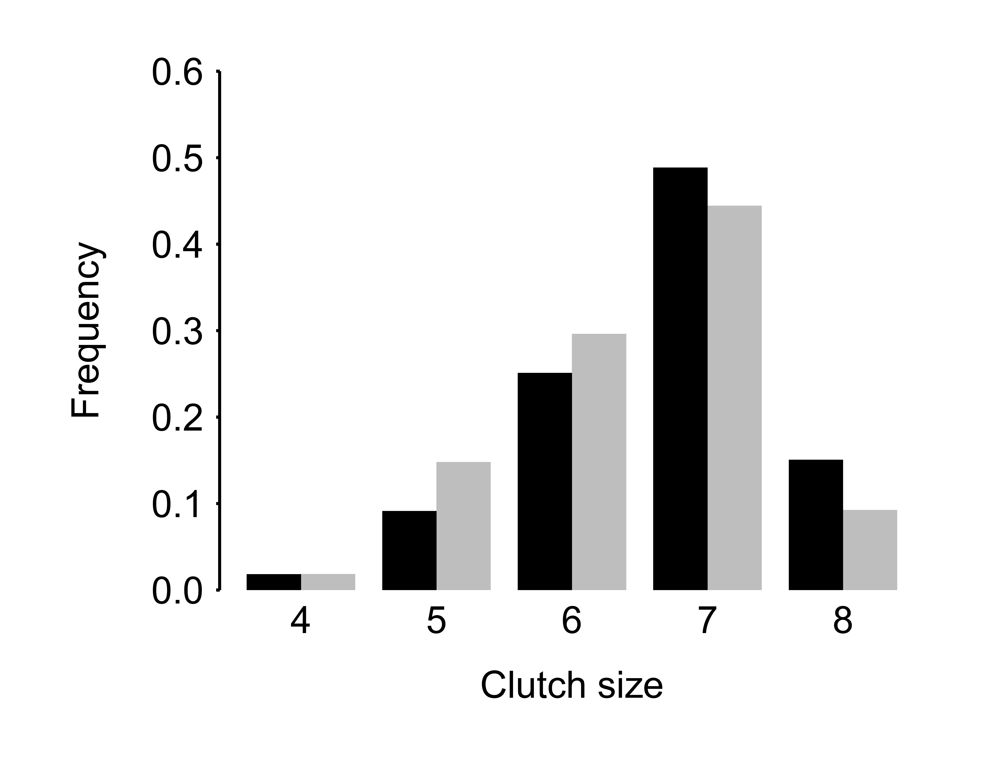
Table S1. Outputs of full and final models for (a) change in body condition and (b) H/L ratio of parents/hosts rearing either own redstart brood or a cuckoo nestling during first 10 days from hatching (i.e., time-standardised cost of rearing). Parental sex (‘sex’ in interaction term) and nestling species (‘species’ in interaction term) were predictors of key interest and were kept in model regardless of their significance. ‘Individual TME’ = total metabolizable energy, ‘R’ = redstart as reference level, ‘M’ = male redstart as reference level.

(a)

Predictor | Full model |  |  | Final model
 | F_{11,86}=14.55, p<0.01, R²=0.61,  AIC_{c}=201.2 |  |  | F_{3,94}=49.29, p<0.01, R²=0.60,  AIC_{c}=191.9
 | χ² | p | Estimate±SE | χ² | p | Estimate±SE
Intercept | – | – | −0.86±0.08 | – | – | −0.92±0.06
Nestling species [R] | 0.57 | 0.45 | −0.10±0.14 | 0.13 | 0.72 | −0.04±0.13
Parental sex [M] | 26.26 | <0.0001 | −0.91±0.22 | 28.48 | <0.0001 | −0.87±0.16
Individual TME | 0.10 | 0.75 | −0.0001±0.0002 | – | – | –
Initial condition | 26.85 | <0.0001 | −0.33±0.06 | 30.41 | <0.0001 | −0.35±0.06
Day span | 0.02 | 0.89 | 0.01±0.10 | – | – | –
Date | 2.66 | 0.11 | 0.010±0.007 | – | – | –
Clutch size | 5.02 | 0.03 | 0.22±0.10 | – | – | –
Species*sex | 1.72 | 0.19 | −0.34±0.27 | – | – | –
Species*TME | 0.42 | 0.52 | −0.0003±0.0005 | – | – | –
Species*clutch size | 0.76 | 0.38 | 0.15±0.18 | – | – | –
Sex*Initial condition | 1.32 | 0.25 | −0.15±0.14 | – | – | –

(b)

Predictor | Full model |  |  | Final model
 | F_{12,85}=2.45, p=0.008, R²=0.15,  AIC_{c}=204.3 |  |  | F_{3,94}=7.33, p<0.01, R²=0.16,  AIC_{c}=190.4
 | χ² | p | Estimate±SE | χ² | p | Estimate±SE
Intercept | – | – | 0.30±0.08 | – | – | 0.35±0.06
Nestling species [R] | 7.83 | 0.005 | −0.05±0.18 | 6.33 | 0.01 | −0.32±0.13
Parental sex [M] | 0.07 | 0.79 | −0.37±0.14 | 2.37 | 0.12 | −0.20±0.13
Individual TME | 0.47 | 0.49 | 0.0002±0.0002 | – | – | –
Initial H/L ratio | 12.15 | 0.0005 | −0.51±0.15 | 10.52 | 0.001 | −0.48±0.15
Initial mass | 2.51 | 0.11 | 0.10±0.06 | – | – | –
Day span | 1.04 | 0.31 | 0.10±0.11 | – | – | –
Date | 0.01 | 0.94 | 0.001±0.01 | – | – | –
Clutch size | 0.02 | 0.90 | 0.01±0.10 | – | – | –
Species*sex | 3.38 | 0.07 | −0.49±0.28 | – | – | –
Species*TME | 0.79 | 0.37 | −0.0004±0.0005 | – | – | –
Species*clutch size | 0.67 | 0.41 | 0.14±0.18 | – | – | –
Sex*Initial mass | 1.17 | 0.28 | 0.15±0.14 | – | – | –
Table S2. Outputs of full and final models for (a) change in body condition and (b) H/L ratio of parents/hosts rearing either own redstart brood during the first 10 days post-hatch or a cuckoo nestling during 18 days (i.e., full rearing cost across the nestling period). Parental sex (‘sex’ in interaction term) and nestling species (‘species’ in interaction term) were predictors of key interest and were kept in models regardless of their significance. ‘TME’ = total metabolizable energy, ‘R’ = redstart as reference level, ‘M’ = male redstart as reference level.

(a)

Predictor | Full model |  |  | Final model
 | F_{11,71}=12.92, p<0.01, R²=0.62,  AIC_{c}=178.7 |  |  | F_{3,79}=46.09, p<0.01, R²=0.62,  AIC_{c}=165.5
 | χ² | p | Estimate±SE | χ² | p | Estimate±SE
Intercept | – | – | −0.82±0.09 | – | – | −0.94±0.07
Nestling species [R] | 0.14 | 0.71 | −0.06±0.18 | 0.00 | 0.97 | −0.005±0.15
Parental sex [M] | 30.51 | <0.0001 | −1.14±0.20 | 21.34 | <0.0001 | −1.01±0.21
Individual TME | 1.10 | 0.29 | −0.0002±0.0002 | – | – | –
Initial condition | 16.05 | <0.0001 | −0.29±0.07 | 13.01 | 0.0003 | −0.39±0.11
Day span | 0.28 | 0.60 | −0.06±0.12 | – | – | –
Date | 1.63 | 0.20 | 0.009±0.008 | – | – | –
Clutch size | 4.14 | 0.04 | 0.23±0.12 | – | – | –
Species*sex | 0.02 | 0.89 | −0.04±0.34 | – | – | –
Species*TME | 0.01 | 0.91 | −0.0001±0.0004 | – | – | –
Species*clutch size | 0.25 | 0.62 | −0.10±0.22 | – | – | –
Sex*Initial condition | 1.43 | 0.23 | −0.18±0.16 | – | – | –

(b)
Predictor | Full model |  |  | Final model
 | F_{12,70}=1.96, p=0.04, R²=0.12,  AIC_{c}=195.5 |  |  | F_{3,79}=4.60, p<0.01, R²=0.12,  AIC_{c}=182.8
 | χ² | p | Estimate±SE | χ² | p | Estimate±SE
Intercept | – | – | 0.44±0.10 | – | – | 0.46±0.08
Nestling species [R] | 0.71 | 0.40 | −0.16±0.20 | 0.35 | 0.55 | −0.32±0.13
Parental sex [M] | 2.38 | 0.12 | −0.32±0.22 | 5.70 | 0.01 | −0.20±0.13
Individual TME | 0.68 | 0.41 | 0.0001±0.0002 | – | – | –
Initial H/L ratio | 6.73 | 0.009 | −0.46±0.19 | 6.34 | 0.01 | −0.48±0.15
Initial condition | 1.03 | 0.31 | −0.08±0.08 | – | – | –
Day span | 0.23 | 0.63 | 0.06±0.13 | – | – | –
Date | 0.29 | 0.59 | 0.004±0.01 | – | – | –
Clutch size | 0.11 | 0.75 | 0.04±0.13 | – | – | –
Species*sex | 0.15 | 0.70 | −0.13±0.38 | – | – | –
Species*TME | 1.28 | 0.26 | −0.0005±0.0004 | – | – | –
Species*clutch size | 2.89 | 0.09 | −0.37±0.24 | – | – | –
Sex*Initial condition | 0.25 | 0.62 | 0.08±0.18 | – | – | –
Table S3. Outputs of full and final models for response variable of change in body mass of parents/hosts rearing (a) own redstart brood and a cuckoo nestling the first 10 days from hatching (i.e., time-standardised cost of rearing) and (b) own redstart brood during the first 10 days post-hatch and a cuckoo nestling during 18 days (i.e., cost of rearing for full nestling period). Parental sex (‘sex’ in interaction term) and nestling species (‘species’ in interaction term) were predictors of key interest and were kept in model regardless of their significance. ‘Individual TME’ = total metabolizable energy, ‘R’ = redstart as reference level, ‘M’ = male redstart as reference level.

(a)

Predictor | Full model |  |  | Final model
 | F_{11,86}=15.50, p<0.01, R²=0.62,  AIC_{c}=170.6 |  |  | F_{4,93}=42.33, p<0.01, R²=0.63,  AIC_{c}=158.6
 | χ² | p | Estimate±SE | χ² | p | Estimate±SE
Intercept | – | – | −0.81±0.08 | – | – | −0.78±0.08
Nestling species [R] | 1.14 | 0.29 | −0.11±0.11 | 0.42 | 0.51 | −0.07±0.11
Parental sex [M] | 27.80 | <0.0001 | −0.94±0.18 | 30.38 | <0.0001 | −0.99±0.17
Individual TME | 1.58 | 0.21 | −0.0003±0.0002 | – | – | –
Initial mass | 17.51 | <0.0001 | −0.35±0.09 | 15.58 | <0.0001 | −0.33±0.08
Day span | 0.59 | 0.44 | 0.07±0.09 | – | – | –
Date | 0.94 | 0.33 | 0.005±0.006 | – | – | –
Clutch size | 3.61 | 0.06 | 0.16±0.09 | – | – | –
Species*sex | 0.01 | 0.93 | −0.02±0.23 | – | – | –
Species*TME | 2.44 | 0.12 | −0.0006±0.0004 | – | – | –
Species*clutch size | 0.00 | 0.97 | 0.005±0.15 | – | – | –
Sex*Initial mass | 4.73 | 0.03 | −0.40±0.19 | 8.04 | 0.005 | −0.50±0.18

(b)

Predictor | Full model |  |  | Final model
 | F_{11,71}=13.41, p<0.01, R²=0.62,  AIC_{c}=153.4 |  |  | F_{3,79}=45.6, p<0.01, R²=0.62,  AIC_{c}=142.4
 | χ² | p | Estimate±SE | χ² | p | Estimate±SE
Intercept | – | – | −0.87±0.09 | – | – | −0.95±0.06
Nestling species [R] | 0.79 | 0.37 | −0.13±0.15 | 0.05 | 0.83 | −0.03±0.13
Parental sex [M] | 27.46 | <0.0001 | −1.05±0.20 | 27.49 | <0.0001 | −0.96±0.17
Individual TME | 0.28 | 0.59 | −0.0001±0.0001 | – | – | –
Initial mass | 11.39 | 0.0007 | −0.30±0.09 | 12.55 | 0.0004 | −0.32±0.09
Day span | 0.26 | 0.61 | 0.05±0.10 | – | – | –
Date | 2.39 | 0.12 | 0.009±0.006 | – | – | –
Clutch size | 3.90 | 0.05 | 0.19±0.11 | – | – | –
Species*sex | 0.60 | 0.44 | −0.20±0.28 | – | – | –
Species*TME | 0.40 | 0.53 | −0.0002±0.0003 | – | – | –
Species*clutch size | 0.01 | 0.91 | −0.20±0.19 | – | – | –
Sex*Initial mass | 1.66 | 0.20 | −0.25±0.21 | – | – | –

Table S4. Outputs of full and final models for feeding frequency of parents rearing (a) cuckoo nestling or all redstart broods (range: 2–8 nestlings) and (b) cuckoo nestling or modal redstart broods (6 nestlings). Nominator degrees of freedom are 4 for ‘Year’ and 2 for ‘Brood type’. Model fits are summarised using marginal (R²_{m}) and conditional (R²_{c}) R-squared accompanied with AIC_{c}.

(a)
Predictor | Full model |  |  | Final model
 | R²_{m}=0.29, R²_{c}=0.47,  AIC_{c}=3761 |  |  | R²_{m}=0.30, R²_{c}=0.44,  AIC_{c}=3756
 | χ² | p | Log(estimate±SE) | χ² | p | Log(estimate±SE)
Intercept | – | – | 2.53±0.06 | – | – | 2.52 ± 0.06
Brood type | 50.6 | <0.0001 | – | 53.3 | <0.0001 | –
Brood mass | 92.4 | <0.0001 | 0.010±0.001 | 182.3 | <0.0001 | 0.009±0.001
Year | 13.6 | 0.009 | – | 15.5 | 0.004 | –
Date | 0.00 | 0.96 | −0.0001±0.002 | – | – | –
Daytime | 1.74 | 0.19 | −0.003±0.006 | – | – | –
Brood type*mass | 4.56 | 0.10 | – | – | – | –

(b)
Predictor | Full model |  |  | Final model
 | R²_{m}=0.28, R²_{c}=0.45,  AIC_{c}=2862 |  |  | R²_{m}=0.30, R²_{c}=0.48,  AIC_{c}=2868
 | χ² | p | Log(estimate±SE) | χ² | p | Log(estimate±SE)
Intercept | – | – | 2.54±0.07 | – | – | 2.53 ± 0.07
Brood type | 19.7 | <0.0001 | – | 23.2 | <0.0001 | –
Brood mass | 88.9 | <0.0001 | 0.010±0.001 | 118.0 | <0.0001 | 0.009±0.001
Year | 13.8 | 0.008 | – | 15.5 | 0.004 | –
Date | 0.01 | 0.92 | −0.0002±0.002 | – | – | –
Daytime | 0.14 | 0.71 | −0.002±0.007 | – | – | –
Brood type*mass | 4.10 | 0.13 | – | – | – | –

