Supplementary information

Table S1
The standard deviations from each sample (3 tests)
Sample | ε_{r} of Unpoled PMN-PT  (average) | σ of unpoled | ε_{r} of DCP  (average) | σ of DCP | ε_{r} of ACP  (average) | σ of ACP
A | 2820 | ±180 | 6400 | ±10 | 7990 | ±20
B | 2780 | ±220 | 6420 | ±10 | 8390 | ±30
C | 2630 | ±200 | 6050 | ±90 | 8320 | ±30
D | 2670 | ±130 | 5930 | ±60 | 8100 | ±40
E | 2570 | ±110 | 5830 | ±20 | 8000 | ±100
Average | 2690 | ±160 | 6130 | ±260 | 8160 | ±180

Table S1. Five samples were prepared, and each sample was tested three times. The standard deviations from three tests of each sample are summarized above. Sample to sample variation can be controlled less than 10% and the test variation can be controlled less than 1.5% after poling. (Dielectric constant (ε_{r}), standard deviation (σ))

FIG. S1
PFM results showing both in-plane and out-plane polarizations
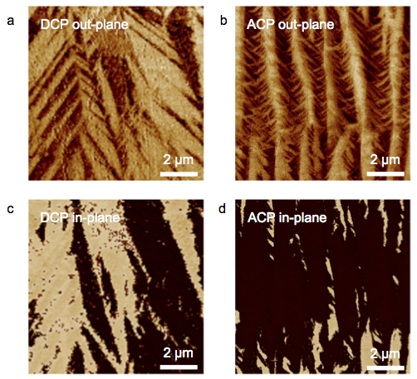
FIG. S1. PFM results showing both (a)(b) out-plane and (c)(d) in-plane polarizations from (a)(c) DCP and (b)(d) ACP samples. Here, (a)(c), (b)(d) are from the same scanned regions, respectively. In details, out-plane PFM results mark the <010> polarization direction and in-plane PFM results mark the <100> polarization direction. By combining the two directions of <010> and <100> and known <001> direction same as the poling field, ‘4R’ domain configuration ([111], [1-11], [-111], [-1-11]) can be achieved.

FIG. S2
In situ XRD on (004) peak of an ACP sample (zero field heating)
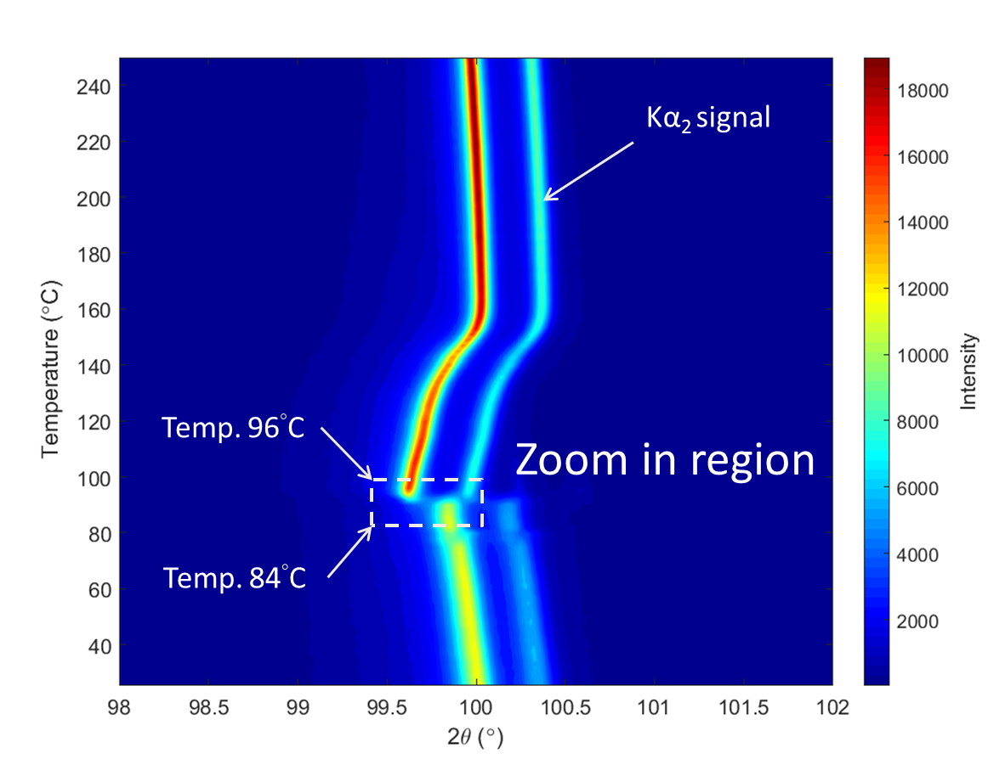
FIG. S2. In situ XRD on (004) peak of an ACP sample under the condition of zero field heating. FIG. 4(c) shows the 1D cuts of the zoom in region providing the evidence of the phase coexistence.

