7-Phenyl-2-(phenylamino)pyrazolo[1,5-a]pyrimidine-3-carboxamide (15a) ^{[30].}
7-(3,4-Dimethoxyphenyl)-2-(phenylamino)pyrazolo[1,5-a]pyrimidine-3-carboxamide (15b)
Yellow crystals, mp 225-227 °C, yield: (63%). IR (KBr) ν_{max}/cm⁻¹ 3383, 3150 (NH, NH₂), 1659 (C=O). ¹H NMR (DMSO-d₆, 400 MHz, δ ppm): 3.87, 3.88 (2s, 6H, 2OCH₃), 6.94 (t, 1H, H_{arom}), 7.18 (d, 1H, J = 8.5 Hz, H_{arom}), 7.28 (d, 1H, J = 4.9 Hz, pyrimidine), 7.30 (t, 2H, H_{arom}), 7.58 (s, 1H, NH₂), 7.65 (s, 1H, NH₂), 7.67 (d, 2H, J = 8.0 Hz, H_{arom}), 7.73, 7.75 (dd, 1H, J = 1.5, 8.4 Hz, H_{arom}), 8.03 (s, 1H, H_{arom}), 8.58 (1H, d, J = 4.7 Hz, pyrimidine), 9.71 (1H, s, NH). MS (m/z, %): 389 (M⁺, 100). Anal. Calcd. (%) for C₂₁H₁₉N₅O₃ (389.41): C, 64.77; H, 4.92; N, 17.98. Found: C, 64.70; H, 5.00; N, 18.05 %.
7-(2,4-Dichlorophenyl)-2-(phenylamino)pyrazolo[1,5-a]pyrimidine-3-carboxamide (15c)
Yellow crystals, mp 236-238 °C, yield: (79%). IR (KBr) ν_{max}/cm⁻¹ 3389, 3155 (NH, NH₂), 1661 (C=O). ¹H NMR (DMSO-d₆, 400 MHz, δ ppm): 6.90 (t, 1H, H_{arom}), 7.23 (t, 2H, H_{arom}), 7.25 (d, 1H, J = 4.5 Hz, pyrimidine), 7.48 (s, 1H, NH₂), 7.59 (d, 2H, J = 7.7 Hz, H_{arom}), 7.71 (s, 1H, NH₂), 7.71 & 7.73 (dd, 1H, J = 1.9 & 8.3 Hz, H_{arom}), 7.81 (d, 1H, J = 8.3 Hz, H_{arom}), 7.99 (d, 1H, J = 1.9 Hz, H_{arom}), 8.74 (d, 1H, J = 4.6 Hz, pyrimidine), 9.61 (s, 1H, NH). ¹³C NMR (DMSO-d₆, 100 MHz, δ ppm): 87.39 (C, C₃-pyrazolopyrimidine), 109.77 (C, C₆-pyrazolopyrimidine), 117.11, 121.12, 127.80, 128.92, 129.00, 129.34, 132.97 (9C, Ar), 133.65 (C, C_{3a}-pyrazolopyrimidine), 136.30, 139.90, 143.18 (3C, Ar), 146.51 (C, C₇-pyrazolopyrimidine), 151.12 (C, C₂-pyrazolopyrimidine), 156.55 (C, C₅-pyrazolopyrimidine), 165.52 (C=O). MS (m/z, %): 398 (M⁺, 51.40). Anal. Calcd. (%) for C₁₉H₁₃C_{l2}N₅O (398.25): C, 57.30; H, 3.29; N, 17.59. Found: C, 57.40; H, 3.25; N, 17.55 %.
7-(Furan-2-yl)-2-(phenylamino)pyrazolo[1,5-a]pyrimidine-3-carboxamide (15d)
Yellow crystals, mp 235-236 °C, yield (70%). IR (KBr) ν_{max}/cm⁻¹ 3384, 3155 (NH, NH₂), 1657 (C=O). ¹H NMR (DMSO-d₆, 400 MHz, δ ppm): 6.91, 6.92 (dd, 1H, J = 1.7, 3.4 Hz, furan), 6.99 (t, 2H, H_{arom}), 7.33 (d, 1H, J = 4.9 Hz, pyrimidine), 7.37 (t, 2H, H_{arom}), 7.48 (s, 1H, NH₂), 7.62 (s, 1H, NH₂), 7.63 (d, 2H, J = 7.9 Hz, H_{arom}), 8.00 (d, 1H, J = 3.4 Hz, furan), 8.14 (d, 1H, J = 1.0 Hz, furan), 8.52 (d, 1H, J = 4.9 Hz, pyrimidine), 9.68 (s, 1H, NH). ¹³C NMR (DMSO-d₆, 100 MHz, δ ppm): 86.72 (C, C₃-pyrazolopyrimidine), 102.71 (C, C₆-pyrazolopyrimidine), 113.60 (C, furan), 117.30 (2C, Ar), 119.70 (C, furan), 121.24 (C, Ar), 129.14 (2C, Ar), 134.64 (C, C_{3a}-pyrazolopyrimidine), 129.87 (C, Ar), 142.75 (C, furan), 146.97 (C, C₂-pyrazolopyrimidine), 147.77 (C, C₅-pyrazolopyrimidine), 150.06 (C, furan), 156.66 (C, C₇-pyrazolopyrimidine), 165.65 (C=O). Anal. Calcd. (%) for C₁₇H₁₃N₅O₂ (319.32): C, 63.94; H, 4.10; N, 21.93. Found: C, 64.00; H, 4.05; N, 22.00 %.
2-(4-Methoxyphenylamino)-7-phenylpyrazolo[1,5-a]pyrimidine-3-carboxamide (15e) ^{[30]}
7-(2,4-Dichlorophenyl)-2-(4-methoxyphenylamino)pyrazolo[1,5-a]pyrimidine-3-carboxamide (15g)
Orange crystals, mp 198-200 °C, yield (77%). IR (KBr) ν_{max}/cm⁻¹ 3375, 3148 (NH, NH₂), 1660 (C=O). ¹H NMR (DMSO-d₆, 400 MHz, δ ppm): 3.68 (s, 3H, OCH₃), 6.80 (d, 2H, J = 8.9 Hz, H_{arom}), 7.19 (d, 1H, J = 4.5 Hz, pyrimidine), 7.42 (d, 2H, J = 8.9 Hz, H_{arom}), 7.47 (s, 1H, NH₂), 7.66 (s, 1H, NH₂), 7.69 & 7.71 (dd, 1H, J = 1.8 & 8.3 Hz, H_{arom}), 7.78 (d, 1H, J = 8.3 Hz, H_{arom}), 7.95 (d, 1H, J = 1.8 Hz, H_{arom}), 8.68 (d, 1H, J = 4.6 Hz, pyrimidine), 9.40 (s, 1H, NH). Anal. Calcd. (%) for C₂₀H₁₅Cl₂N₅O₂ (428.27): C, 56.09; H, 3.53; N, 16.35. Found: C, 56.00; H, 3.60; N, 16.30 %.
7-(Furan-2-yl)-2-(4-methoxyphenylamino)pyrazolo[1,5-a]pyrimidine-3-carboxamide (15h)
Orange crystals, mp 244-246 °C, yield (69%). IR (KBr) ν_{max}/cm⁻¹ 3378, 3150 (NH NH₂), 1657 (C=O). ¹H NMR (DMSO-d₆, 400 MHz, δ ppm): 3.77 (s, 3H, OCH₃), 6.98 (d, 1H, J = 3.6 Hz, furan), 7.01 (d, 2H, J = 9.0 Hz, H_{arom}), 7.44 (d, 1H, J = 4.9 Hz, pyrimidine), 7.52 (s, 1H, NH₂), 7.62 (s, 1H, NH₂), 7.63 (d, 2H, J = 8.9 Hz, H_{arom}), 8.11 (d, 1H, J = 3.4 Hz, furan), 8.22 (d, 1H, J = 0.88 Hz, furan), 8.60 (d, 1H, J = 4.9 Hz, pyrimidine), 9.51 (s, 1H, NH). Anal. Calcd. (%) for C₁₈H₁₅N₅O₃ (349.34): C, 61.89; H, 4.33; N, 20.05. Found: C, 62.00; H, 4.25; N, 20.15 %.
5-(Benzylideneamino)-3-(phenylamino)-1H-pyrazole-4-carboxamide (22a) ^{[39]}
5-(4-Fluorobenzylideneamino)-3-(phenylamino)-1H-pyrazole-4-carboxamide (22c)
Yellow crystals, mp 280 °C, yield (78%). IR (KBr) ν_{max}/cm⁻¹ 3380, 3185 (NH, NH₂), 1650 (C=O). ¹H NMR (DMSO-d₆, 400 MHz, δ ppm): 6.87 (t, 1H, H_{arom}), 7.27 (t, 2H, H_{arom}), 7.39-7.50 (m, 6H, 2H of NH₂ & 4H of H_{arom}), 8.08 (d, 2H, J = 8.7 Hz, H_{arom}), 8.94 (s, 1H, ـN=CHـ), 9.11 (s, 1H, NH), 12.72 (s, 1H, NH). Anal. Calcd. (%) for C₁₇H₁₄FN₅O (323.32): C, 63.15; H, 4.36; N, 21.66. Found: C, 63.10; H, 4.40; N, 21.60 %.
5-(4-Nitrobenzylideneamino)-3-(phenylamino)-1H-pyrazole-4-carboxamide (22d)
Reddish-orange crystals, mp ˃ 300 °C, yield (81%). IR (KBr) ν_{max}/cm⁻¹ 3370, 3175 (NH, NH₂), 1655 (C=O). ¹H NMR (DMSO-d₆, 400 MHz, δ ppm): 6.89 (t, 1H, H_{arom}), 7.24 (s, 1H, NH₂), 7.28 (t, 2H, H_{arom}), 7.45 (d, 2H, J = 8.1 Hz, H_{arom}), 7.48 (s, 1H, NH₂), 8.26 (d, 2H, J = 8.5 Hz, H_{arom}), 8.38 (d, 2H, J = 8.5 Hz, H_{arom}), 8.85 (s, 1H, ـN=CHـ), 9.13 (s, 1H, NH), 12.69 (s, 1H, NH). Anal. Calcd. (%) for C₁₇H₁₄N₆O₃ (350.33): C, 58.28; H, 4.03; N, 23.99. Found: C, 58.40; H, 3.95; N, 24.10 %.
5-(Benzylideneamino)-3-(4-methoxyphenylamino)-1H-pyrazole-4-carboxamide (22e) ^{[39]}
5-(4-Fluorobenzylideneamino)-3-(4-methoxyphenylamino)-1H-pyrazole-4-carboxamide (22f)
Reddish-orange crystals, mp 276-278 °C, yield (79%). IR (KBr) ν_{max}/cm⁻¹ 3384, 3171 (NH, NH₂), 1652 (C=O). ¹H NMR (DMSO-d₆, 400 MHz, δ ppm): 3.71 (s, 3H, OCH₃), 6.88 (d, 2H, J = 6.3 Hz, H_{arom}), 7.39-7.43 (m, 6H, 2H of NH₂ & 4H of H_{arom}), 8.08 (d, 2H, J = 8.6 Hz, H_{arom}), 8.86 (s, 1H, ـN=CHـ), 9.13 (s, 1H, NH), 12.62 (s, 1H, NH). Anal. Calcd. (%) for C₁₈H₁₆FN₅O₂ (353.35): C, 61.18; H, 4.56; N, 19.82. Found: C, 61.10; H, 4.60; N, 19.90 %.
3-(4-Methoxyphenylamino)-5-(4-nitrobenzylideneamino)-1H-pyrazole-4-carboxamide (22g)
Reddish-brown crystals, mp ˃ 300 °C yield (80%). IR (KBr) ν_{max}/cm⁻¹ 3367, 3181 (NH, NH₂), 1658 (C=O). ¹H NMR (DMSO-d₆, 400 MHz, δ ppm): 3.72 (s, 3H, OCH₃), 6.90 (s, 2H, H_{arom}), 7.21 (s, 2H, H_{arom}), 7.44 (s, 2H, NH₂), 8.26 (d, 2H, J = 8.4 Hz, H_{arom}), 8.38 (d, 2H, J = 8.6 Hz, H_{arom}), 8.69 (s, 1H, ـN=CHـ), 9.22 (s, 1H, NH), 12.76 (s, 1H, NH). Anal. Calcd. (%) for C₁₈H₁₆N₆O₄ (380.36): C, 56.84; H, 4.24; N, 22.10. Found: C, 56.70; H, 4.32; N, 22.00 %.

REFERENCES
[30] Hassan, A. S.; Masoud, D. M.; Sroor, F. M.; Askar, A. A. Med. Chem. Res. 2017, 26, 2909-2919.
- Hafez, T. S.; Osman, S. A.; Yosef, H. A. A.; Abd El-All, A. S.; Hassan, A. S.; El-Sawy, A. A.; Abdallah, M. M.; Youns, M. Sci Pharm. 2013, 81, 339-357

Crystal structure and data refinement of compound 15b
Empirical Formula | C₂₁H₁₉N₅O_{3.} CH₃COOH
Formula Weight | 449.46
Crystal System / Space Group | Monoclinic/Pc
a/Å | 4.2046 (4)
b/Å | 13.3420 (11)
c/Å | 19.439 (2)
α/º | 90.00
β/º | 95.695 (4)
γ/º | 90.00°
V/Å³ | 1085.1 (2)
Z | 2
D_{calc} (g/cm³) | 1.376
μ (mm⁻¹) | 0.10
Colour/Shape | Yellow/prismatic
Wavelength (Ǻ) | Mo Ka (0.71073)
Temperature (K) | 298
Theta range for collection/º | 2.910-27.485
Reflections collected | 3568
Independent reflections | 3480
Data/restraints/parameters | 3480/2/298
Goodness of fit on F² | 0.836
Final R indices [I > 2σ (I)]  R indices (all data) | 0.0602  0.1912
Largest difference peak/hole | 0.146/-0.160

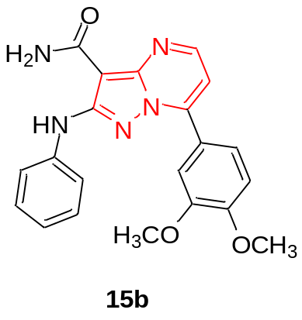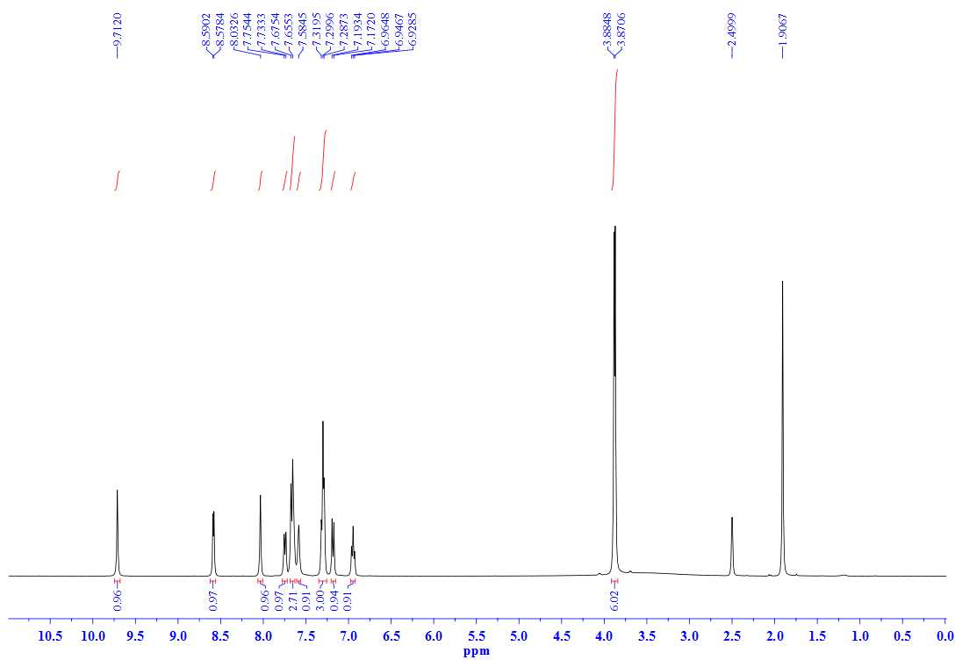
¹H NMR spectrum (400 MHz, DMSO-d₆) of compound 15b

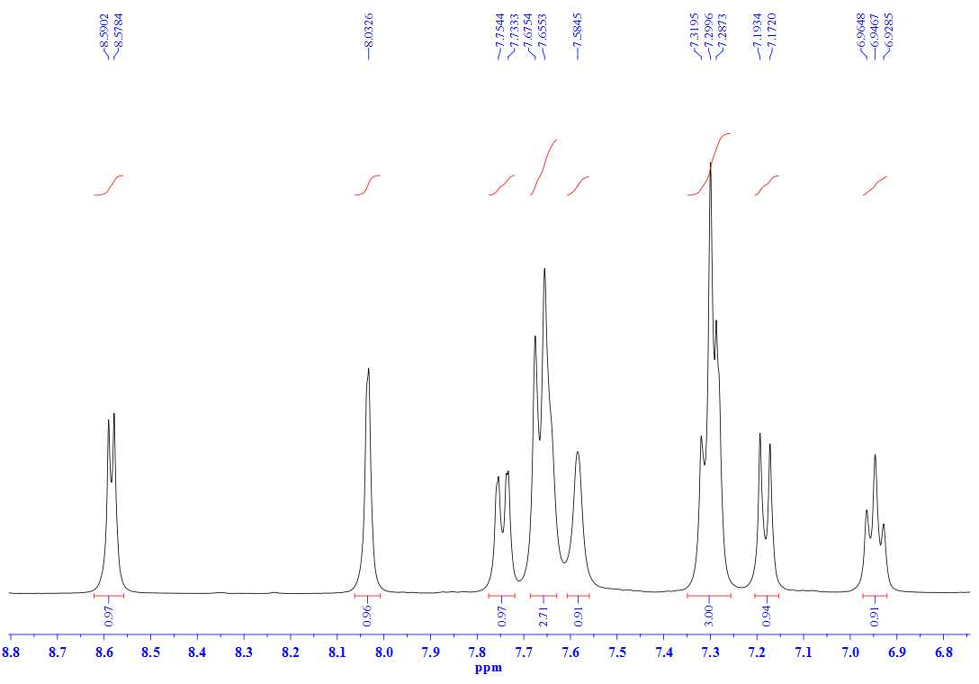
¹H NMR spectrum (400 MHz, DMSO-d₆) aromatic region of compound 15b

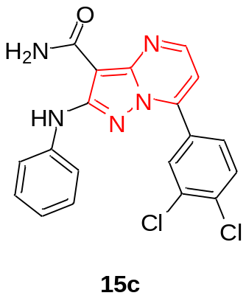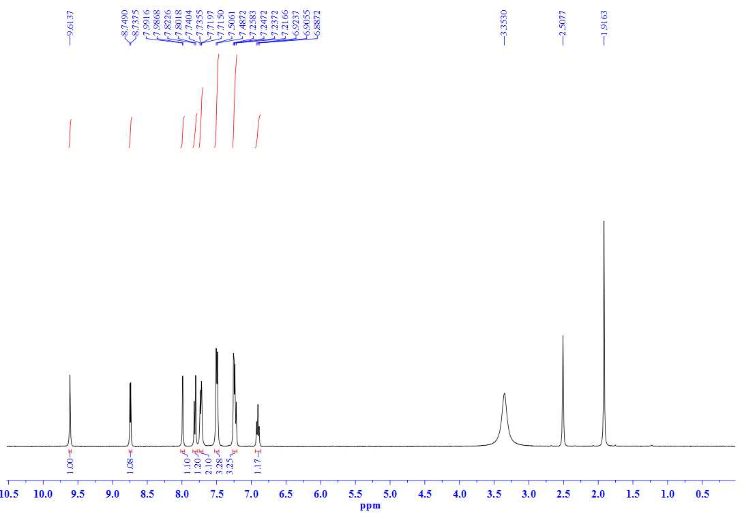
¹H NMR spectrum (400 MHz, DMSO-d₆) of compound 15c

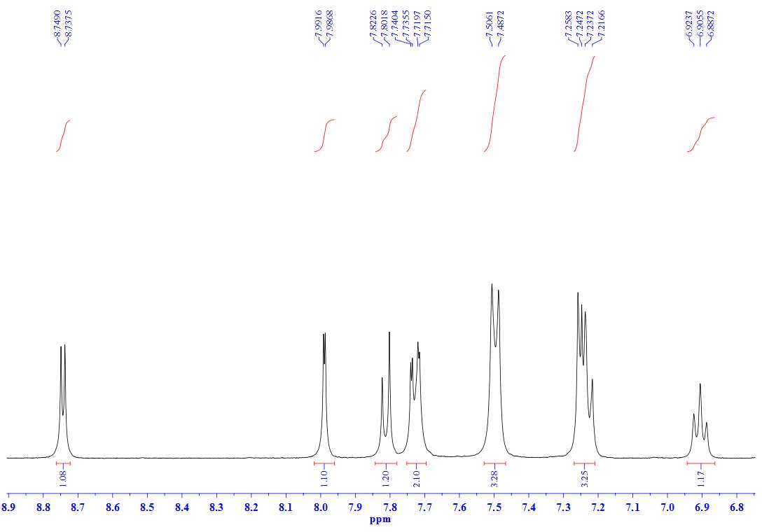
¹H NMR spectrum (400 MHz, DMSO-d₆) aromatic region of compound 15c

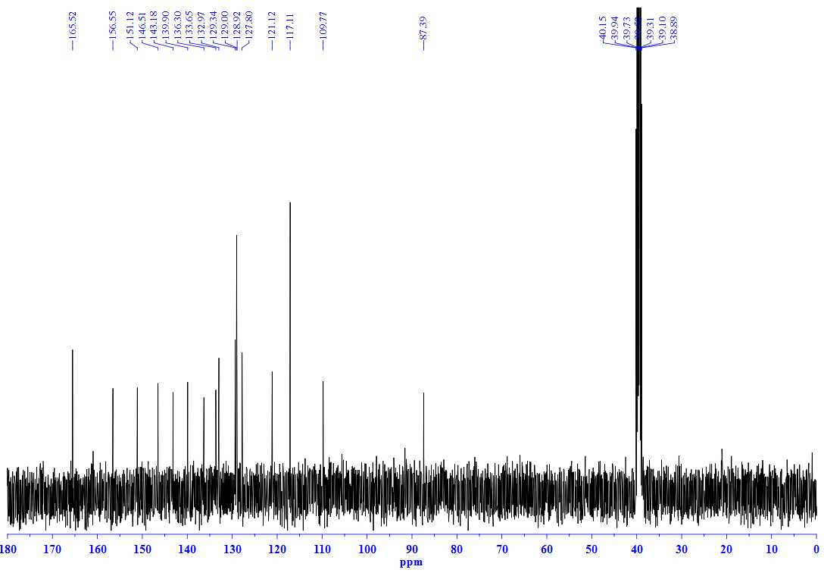
¹³C NMR spectrum (100 MHz, DMSO-d₆) of compound 15c

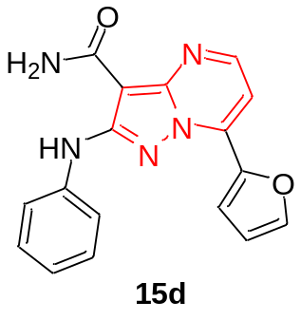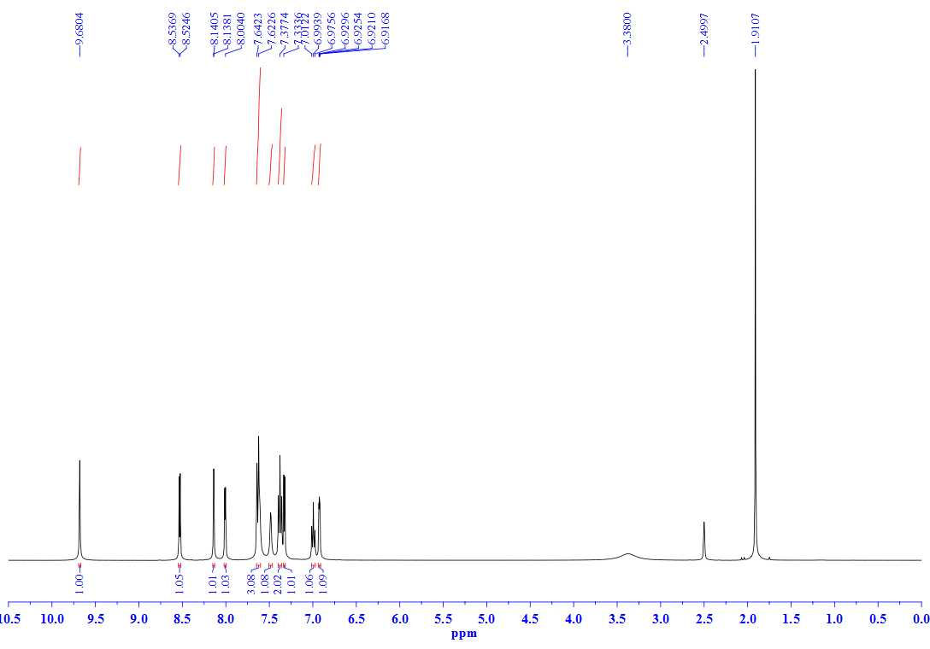
¹H NMR spectrum (400 MHz, DMSO-d₆) of compound 15d

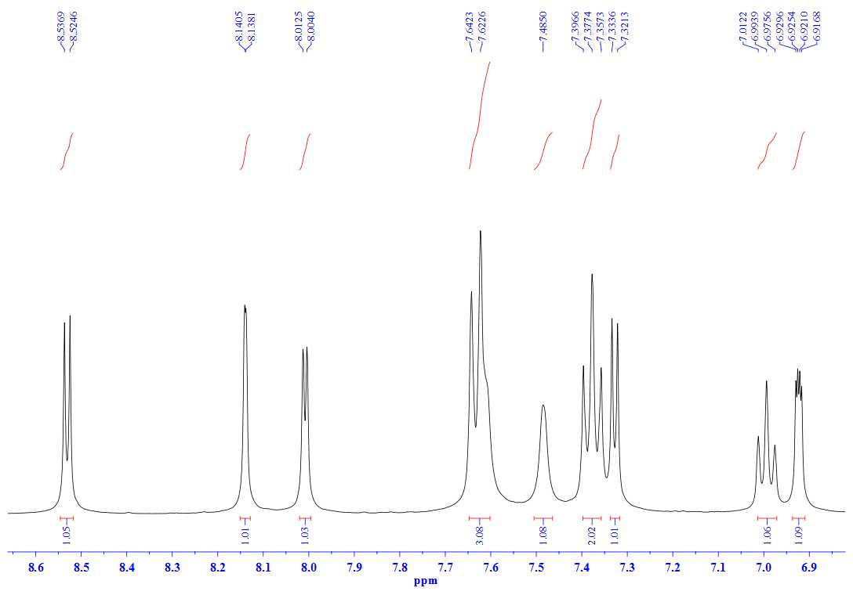
¹H NMR spectrum (400 MHz, DMSO-d₆) aromatic region of compound 15d

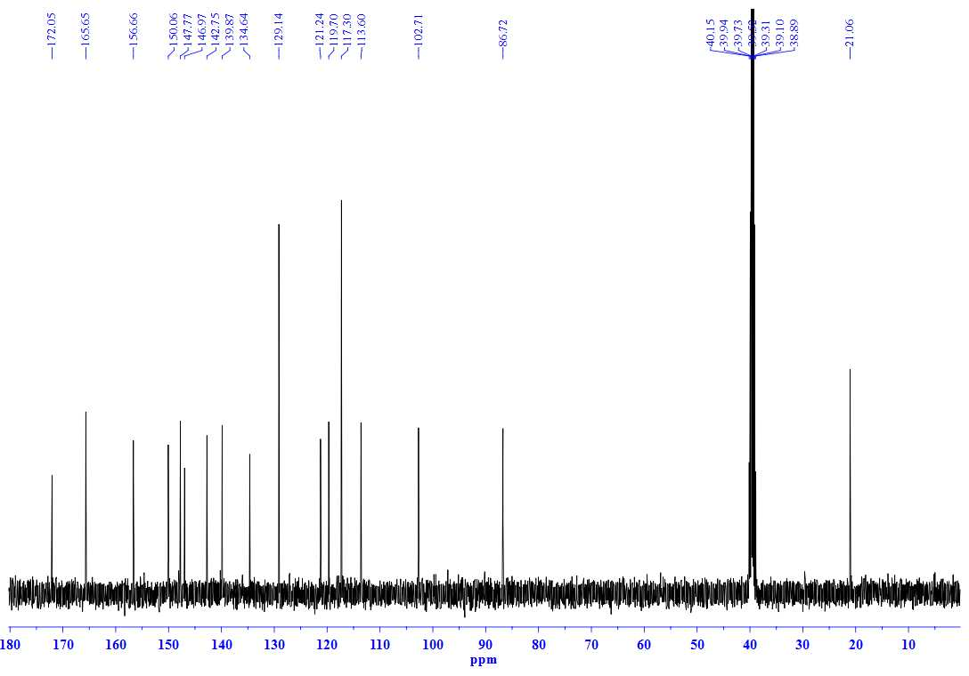
¹³C NMR spectrum (100 MHz, DMSO-d₆) of compound 15d

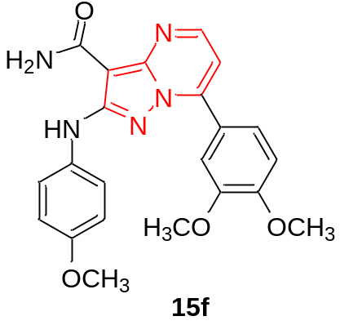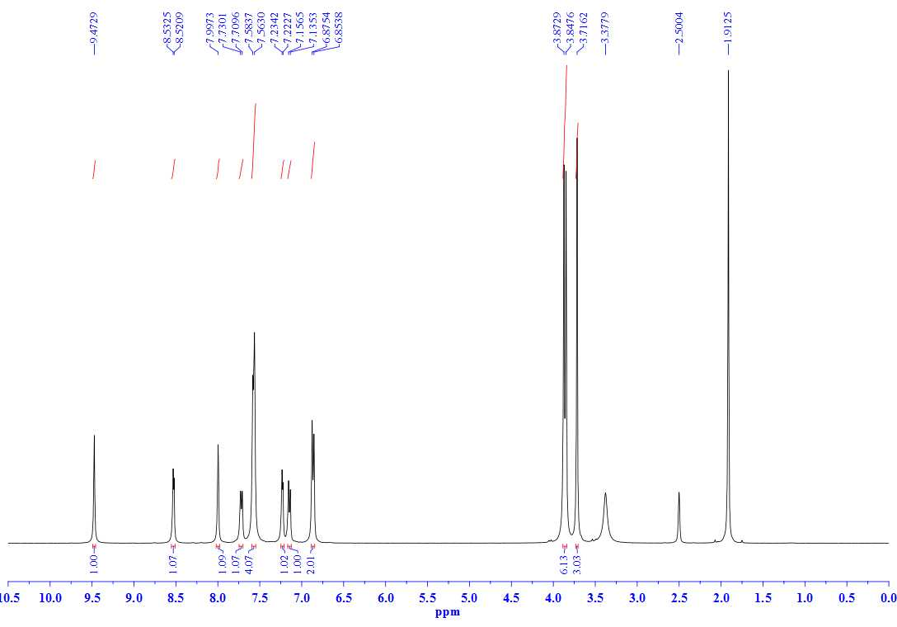
¹H NMR spectrum (400 MHz, DMSO-d₆) of compound 15f

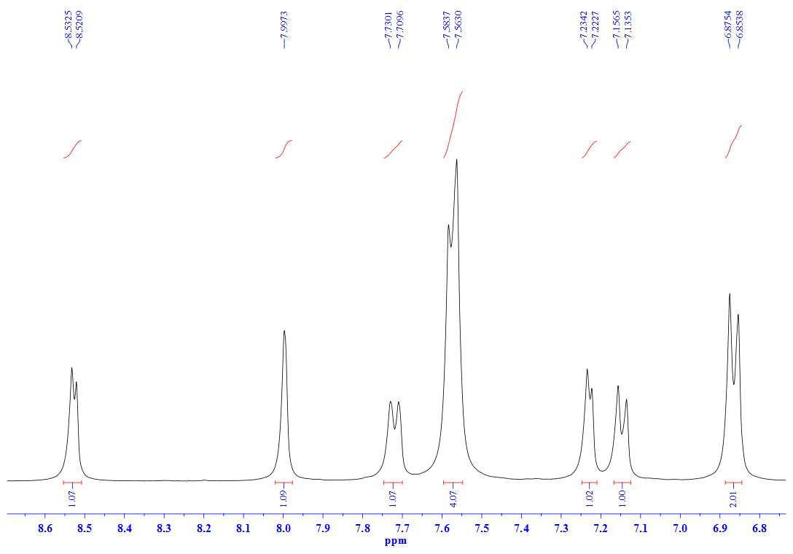
¹H NMR spectrum (400 MHz, DMSO-d₆) aromatic region of compound 15f

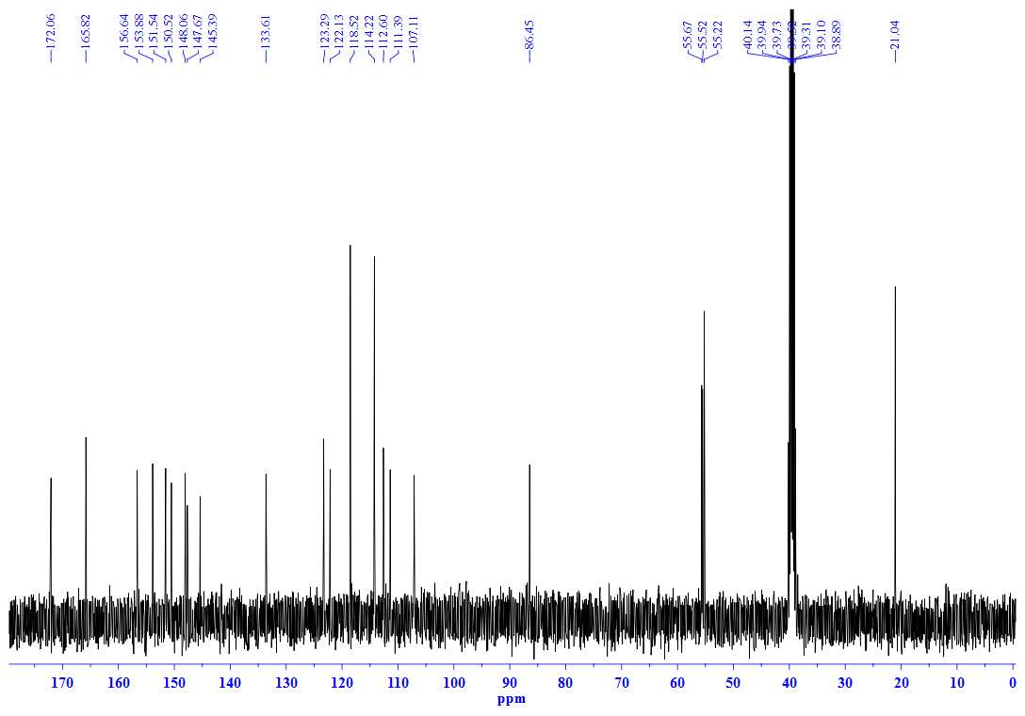
¹³C NMR spectrum (100 MHz, DMSO-d₆) of compound 15f

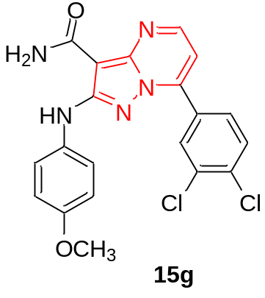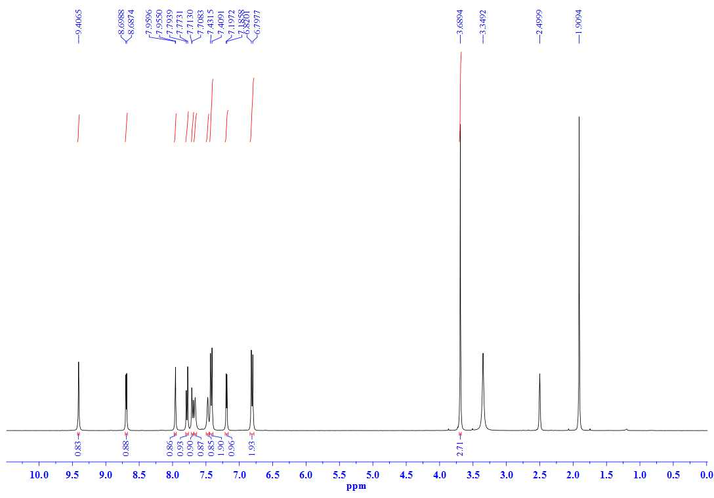
¹H NMR spectrum (400 MHz, DMSO-d₆) of compound 15g

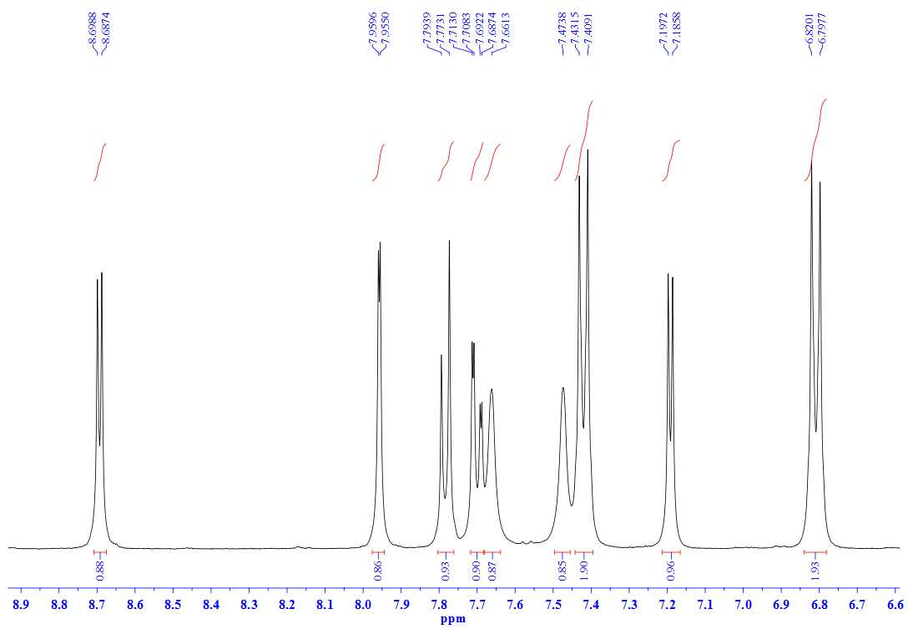
¹H NMR spectrum (400 MHz, DMSO-d₆) aromatic region of compound 15g

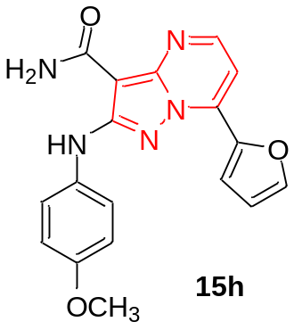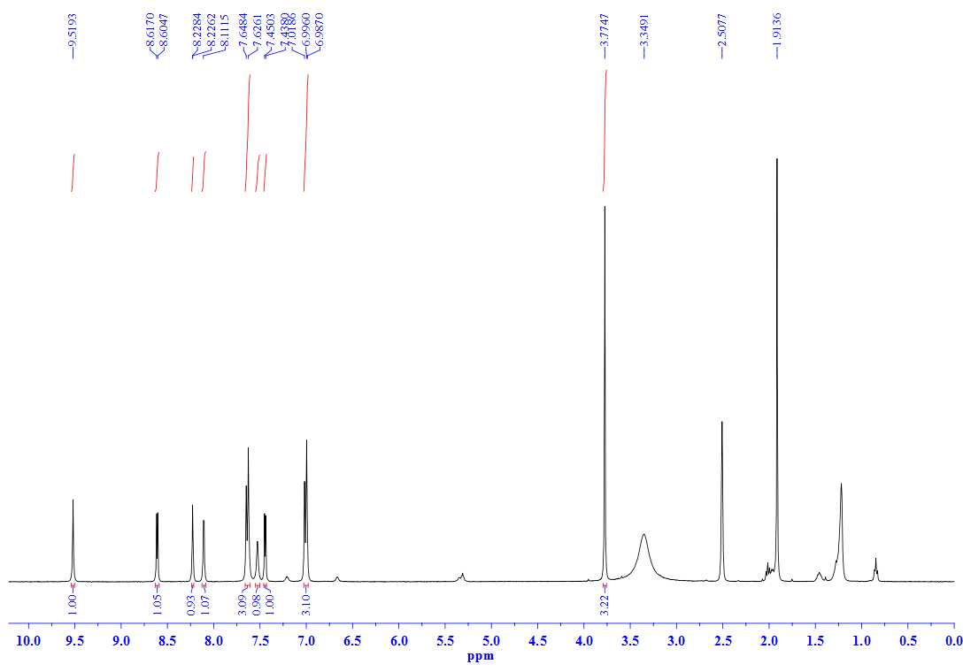
¹H NMR spectrum (400 MHz, DMSO-d₆) of compound 15h

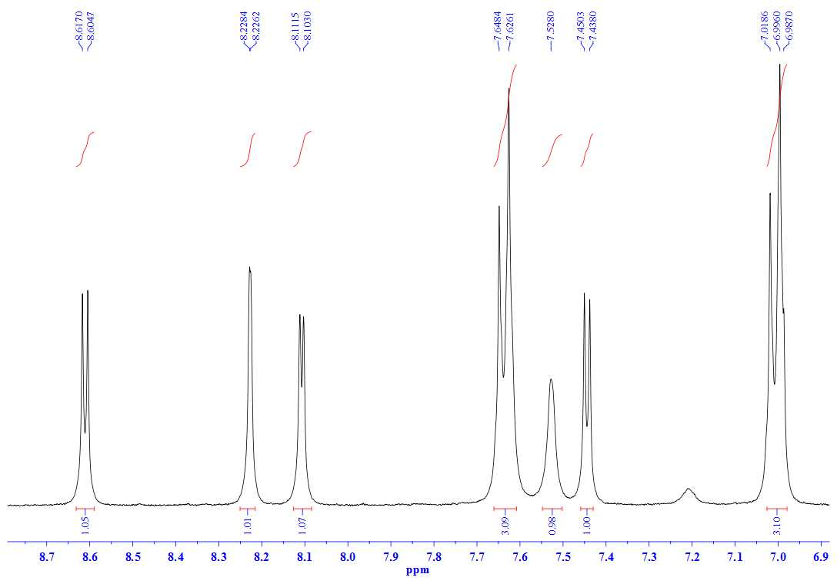
¹H NMR spectrum (400 MHz, DMSO-d₆) aromatic region of compound 15h

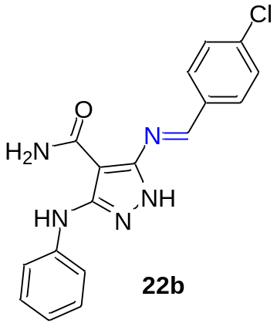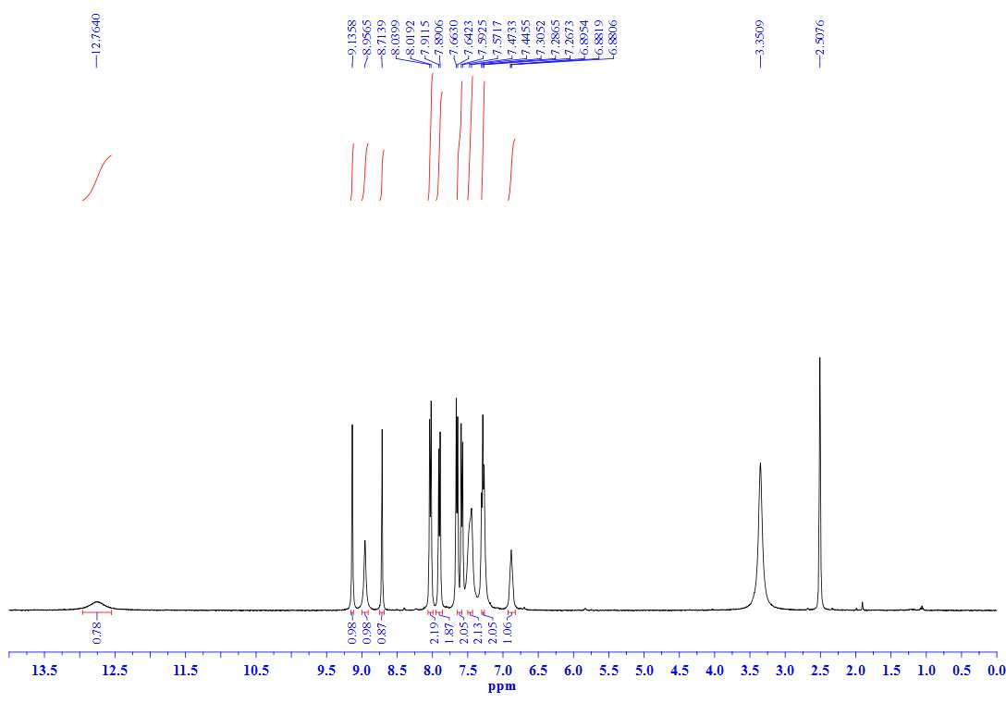
¹H NMR spectrum (400 MHz, DMSO-d₆) of compound 22b

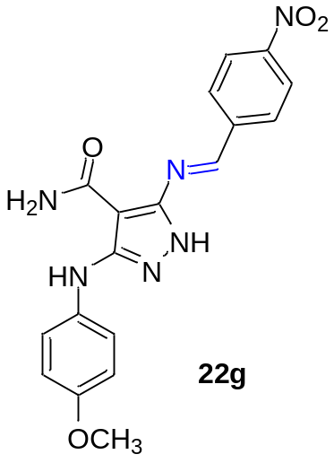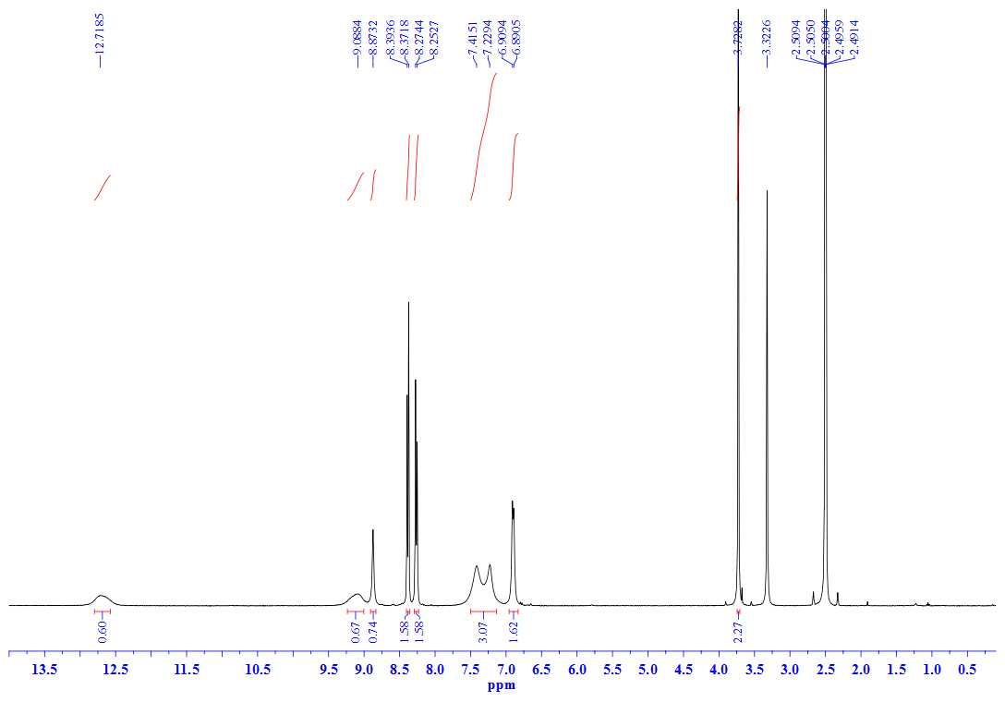
¹H NMR spectrum (400 MHz, DMSO-d₆) of compound 22g

