Table S1 Primers used in this study
Gene or region amplified | Purpose | Primer name | Sequence (5´ to 3´) | Amplicon  size (bp) | Reference
MAT | Determining mating type for crosses and molecular marker for determining octad pairs | MAT1-1  MAT1-2  MATidiom | CTCGATGCAATGTACTTGG  AGCCGGAGGTGAAGTTGAAGCCG  TGGCGAATTAAGGGATTGCTG | 688 (MAT1-1)  442 (MAT1-2) | Cozijnsen and Howlett (2003)
AvrLm1 | Molecular marker for determining octad pairs | AvrLm1-F  AvrLm1-R | AATCCATTCCTCACCTCGTG  GCACCAGAGGCAAAGACTTC | 1124 | Gout et al. (2006)
AvrLm4 | Molecular marker for determining octad pairs | AvrLm4F  AvrLm4R | AGAAGGGTAAGGGGCAAGTC  GAAGAACCCTGCTAGATAGGTAAGC | 1127 | Van de Wouw and Howlett (2012)
AvrLm6 | Molecular marker for determining octad pairs | AvrLm6F  AvrLm6R | TCAATTTGTCTGTTCAAGTTATGGA  CCAGTTTTGAACCGTAGAGGTAGCA | 751 | Fudal et al. (2007); Van de Wouw et al. (2010)
AvrLm5 | Molecular marker for determining octad pairs | AvrLmJ1F  AvrLmJ1R | ACAACCACTCTTCTTCACAGT  TGGTTTGGGTAAAGTTGTCCT | 479 | Van de Wouw et al. (2017)
NPS10 | Amplification of NPS10 for generation of hairpin construct | NPS10RNAiF | GGGGACAAGTTTGTACAAAAAAGCAGGCTGCTGACCTCGAATTGCACCAT | 620 | This study
 |  | NPS10RNAiR | GGGGACCACTTTGTACAAGAAAGCTGGGTTTAGCTATAACCCGCCAGAGCGTA
AvrLm1 | Amplification of AvrLm1 gene region for cloning | A1CloningF  A1CloningR | GCTAGGTACCGCATAGACCTTAGGCTTGG  GCTAGATATCTTACAAAAGAGAGGCGTAAGGA | 1805 | Van de Wouw et al. (2014b)
AvrLm4 | Amplification of AvrLm4 gene region for cloning | A4CloningF | GCTAGGTACCAGTCCTATAAATCCAAGCGCTATCT | 1675 | Van de Wouw et al. (2014a)
 |  | A4CloningR | GCTAGGTACCTTAGGCGGTAGATTTGCTACTAAAA
AvrLm1 | Amplification and sequencing of endogenous copy of AvrLm1 | A1UPF  A1inner | GGTTAGGCAAGGTTTAGGTTAGC  TAGCTTGGGGTAGCAAATGG | 1241 | This study
AvrLm1 | Amplification and sequencing of construct copy of AvrLm1 | M13For  A1innerR | GTAAAACGACGGCCAG  TAGCTTGGGGTAGCAAATGG | 1232 | This study
AvrLm4 | Amplification and sequencing of endogenous copy of AvrLm4 | A4UPF  A4innerR | CCATATCTATATTTACGTGTGCGTAG  CTCGAGGGATAGTGGCATGT | 689 | This study
AvrLm4 | Amplification and sequencing of construct copy of AvrLm4 | M13For  A4innerR | GTAAAACGACGGCCAG  CTCGAGGGATAGTGGCATGT | 635 | This study
Lema006030 | Amplification, cloning and sequencing of Lema006030 | CE498 | GAGCCGGCTACGAGAATCAG | 779 | This study
 |  | CE473 | CGATTGTCCGTTGCAGGAGT
 |  | KCP014 | TCGAAACCTAATCAATCAACAATGGCCTAGCTTGACGCGCCCGCCCA | 1131 | This study
 |  | KCP015 | ACCCTCGAGGTCGACAAGCTCAGTTGCTTTTTCCAGGCCC
hph | Molecular marker for determining octad pairs and sequencing for presence of RIP | CE249  CE250 | GATGTAGGAGGGCGTGGATA  GATGTTGGCGACCTCGTATT | 579 | This study
hos1 | Amplification of gene and sequencing to detect RIP mutations | MAI0216  MAI0017  MAI0217  MAI0218  MAI0219  MAI0220  MAI0221  MAI0222  MAI0207 | CTACTGGGACAATCCTCG  GAATTCCTACTGAACGTTATGACG  CTCCGCAGCAATGGTCCG  GCACAGAGGGAAGGCTTG  GGTGTCGAGGGTACCTGG  ATGGAGGGCAAATTTACG  CGCAAGACCAAGAATGCG  CTGGTCTCGGACCACTCG  TCCCAGAATTCTTAATTAAGATTGACACCCTTCGCACAAC | 5097 | Idnurm et al. (2017)  REF
Double-hph construct | Amplification of hph for generation of double-hph construct | Hph-cloningF | GCTAGGTACCATGAAAAAGCCTGAACTCAC | 1026 | This study
 |  | Hph-cloning R | GCTAGATATCCTATTCCTTTGCCCTCGGAC
 | Amplification and sequencing of double-hph construct for detecting RIP | M13Flong | GTTTTCCCAGTCACGAC | 794 | This study
 |  | CE250 | GATGTTGGCGACCTCGTATT
 |  | CE249 | GATGTAGGAGGGCGTGGATA | 938 | This study
 |  | RIPcassR1 | ATTCGCGGCCAATTCTTAAT
 |  | CE48R | GTCCGAGGGCAAAGGAATAG | 317 | This study
 |  | TrpCpromR1 | AAGTTATCGTGCACCAAGCA
 |  | TrpCPromF1 | CGACAGAAGATGACATTGAAGG | 399 | This study
 |  | Hyg-TrpSeq | ACAGACGTCGCGGTGAGT
 |  | RIPcassF2 | CCTTCCTCCCTTTATTTCAGA | 753 | This study
 |  | CE250 | GATGTTGGCGACCTCGTATT
 |  | CE249 | GATGTAGGAGGGCGTGGATA | 962 | This study
 |  | RIPCassR2 | TCAAGCTGTTTGATGATTTCAG
 |  | CE48R | GTCCGAGGGCAAAGGAATAG | 802 | This study
 |  | M13R | CAGGAAACAGCTATGAC
NPS10 Hairpin construct | Molecular marker for determining octad pairs and sequencing for presence of RIP | CE245  CE261 | TGTGGGCGAGGTCTTAGTCT  GTGTCCATCATGGTGCTGAG | 359 | This study
 |  | M13FL | AAGCTAGCTTGGCGCGCCT | 1268 | This study
 |  | CE261 | GTGTCCATCATGGTGCTGAG
 |  | CE262 | CCATGTCTCCCTGGTACGTC | 1672 | This study
 |  | CE476 | TCGCGGCCAATTCTTAAT
 |  | CE47 | ATGAAAAAGCCTGAACTCAC | 1670 | This study
 |  | CE488 | CGGGCATTTTGGAGTTTGGA
NPS10 | Sequencing of endogenous copy of NPS10 gene | CE245  CE246 | TGTGGGCGAGGTCTTAGTCT  TAGGCGACACACTGCGATAG | 420 | This study
T-DNA | Identification of T-DNA insertion sites | M13F  ai076  MAI0324  MAI0022  MAI0338  MAI0341 | GTAAAACGACGGCCAG  AACAGTTGCGCAGCCTGAATG  ATGGCGAATGAGCTTGAG  ATGAAAAAGCCTGAACTCAC  ATGGTGATTGGCAAGTCACC  ATTCGAGACATGCTTCTGCG | unknown | This study
LopP | Amplification and sequencing with these and internal primers for presence of RIP | MAI0111  MAI0112  MAI0023  MAI0203  MAI0204  MAI0205 | GCTGGCGTAATAGCGAAG  TTAAGTTGGGTAACGCCAG  CTATTCCTTTGCCCTCGGAC  CAGCTATTTACCCGCAGG  AGAATTATGCAGTGCTGC  CAGTCGGGAAACCTGTCG | 5030 | This study

Table S2. Frequency of RIP mutations in specific regions sequenced from crosses generated to trigger RIP in targeted avirulence genes of Leptosphaeria maculans
Cross number | Octad number | Pair numberª | Progeny name | Region sequenced (size) | Frequency of RIP mutations (%) | Number of G-A transitions | Number of C-T transitions
28 | 1 | 1 | 28A2 | Endogenous AvrLm1  (670 bp) | 0 | 0 | 0
 |  |  | 28A8 |  | 0 | 0 | 0
 |  | 2 | 28A4 |  | 0 | 0 | 0
 |  |  | 28A7 |  | 0 | 0 | 0
 |  | 3 | 28A3 |  | 0 | 0 | 0
 |  |  | 28A5 |  | 0 | 0 | 0
 |  | 4 | 28A6 |  | 0 | 0 | 0
 |  |  | 28A1 |  | 0 | 0 | 0
 | 2 | 1 | 28B4 |  | 0 | 0 | 0
 |  |  | 28B7 |  | 0 | 0 | 0
 |  | 2 | 28B1 |  | 0 | 0 | 0
 |  |  | 28B2 |  | 0 | 0 | 0
 |  | 3 | 28B3 |  | 0 | 0 | 0
 |  |  | 28B5 |  | 0 | 0 | 0
 | 1 | 1 | 28A2 | Construct AvrLm1  (323 bp) | 0 | 0 | 0
 |  |  | 28A8 |  | 0 | 0 | 0
 |  | 2 | 28A4 |  | 0 | 0 | 0
 |  |  | 28A7 |  | 0 | 0 | 0
 | 2 | 1 | 28B4 |  | 0 | 0 | 0
 |  |  | 28B7 |  | 0 | 0 | 0
 | 1 | 1 | 28A2 | hph (586 bp) | 0 | 0 | 0
 |  |  | 28A8 |  | 0 | 0 | 0
 |  | 2 | 28A4 |  | 0 | 0 | 0
 |  |  | 28A7 |  | 0 | 0 | 0
 | 1 | 1 | 28B4 |  | 0 | 0 | 0
 |  |  | 28B7 |  | 0 | 0 | 0
27 | 1 | 1 | 27A1 | Endogenous AvrLm4  (1290 bp) | 0 | 0 | 0
 |  |  | 27A3 |  | 0 | 0 | 0
 |  | 2 | 27A2 |  | 0 | 0 | 0
 |  |  | 27A4 |  | 0 | 0 | 0
 |  | 3 | 27A5 |  | 0 | 0 | 0
 |  |  | 27A7 |  | 0 | 0 | 0
 |  | 4 | 27A8 |  | 0 | 0 | 0
 |  |  | 27A6 |  | 0 | 0 | 0
 | 2 | 1 | 27B2 |  | 0 | 0 | 0
 |  | 2 | 27B4 |  | 0 | 0 | 0
 |  |  | 27B6 |  | 0 | 0 | 0
 |  | 3 | 27B1 |  | 0 | 0 | 0
 |  | 4 | 27B7 |  | 0 | 0 | 0
 | 1 | 1 | 27A1 | Construct AvrLm4  (584 bp) | 0.17 | 1 | 0
 |  |  | 27A3 |  | 0.17 | 0 | 1
 |  | 2 | 27A2 |  | 0.17 | 1 | 0
 |  |  | 27A4 |  | 0.17 | 1 | 0
 | 2 | 1 | 27B2 |  | 0.17 | 1 | 0
 |  | 2 | 27B4 |  | 0.00 | 0 | 0
 |  |  | 27B6 |  | 0.17 | 1 | 0
 | 1 | 1 | 27A1 | hph (556 bp) | 3.78 | 18 | 3
 |  |  | 27A3 |  | 6.47 | 26 | 10
 |  | 2 | 27A2 |  | 4.49 | 20 | 5
 |  |  | 27A4 |  | 6.65 | 22 | 15
 | 2 | 1 | 27B2 |  | 2.69 | 6 | 9
 |  | 2 | 27B4 |  | 3.41 | 16 | 3
 |  |  | 27B6 |  | 3.41 | 18 | 1
67 | 1 | n.d | 67S1 | Endogenous AvrLm4 (689 bp) | 0 | 0 | 0
 |  |  | 67S5 |  | 0 | 0 | 0
 |  |  | 67S7 |  | 0 | 0 | 0
 |  |  | 67S8 |  | 0 | 0 | 0
 | 2 | n.d | 67T2 |  | 0 | 0 | 0
 |  |  | 67T3 |  | 0 | 0 | 0
 |  |  | 67T4 |  | 0 | 0 | 0
 |  |  | 67T8 |  | 0 | 0 | 0
67 | 1 | n.d | 67S1 | Construct AvrLm4 (635 bp) | 0 | 0 | 0
 |  |  | 67S5 |  | 0 | 0 | 0
 |  |  | 67S7 |  | 0 | 0 | 0
 |  |  | 67S8 |  | 0 | 0 | 0
 | 2 | n.d | 67T2 |  | 0 | 0 | 0
 |  |  | 67T3 |  | 0 | 0 | 0
 |  |  | 67T4 |  | 0 | 0 | 0
 |  |  | 67T8 |  | 0 | 0 | 0
67 | 1 | n.d | 67S1 | hph (586 bp) | 0 | 0 | 0
 |  |  | 67S5 |  | 0 | 0 | 0
 |  |  | 67S7 |  | 0 | 0 | 0
 |  |  | 67S8 |  | 0 | 0 | 0
 | 2 | n.d | 67T2 |  | 0 | 0 | 0
 |  |  | 67T3 |  | 0 | 0 | 0
 |  |  | 67T4 |  | 0 | 0 | 0
 |  |  | 67T8 |  | 0 | 0 | 0
ª n.d = not determined.

Table S3. Details of RIP mutations present within progeny of crosses between Leptosphaeria maculans isolates harboring constructs designed to trigger RIP.
Crossª | Octad | Pair | Progeny | Size of region sequenced (bp) | # of RIP mutations | # G:A transitions | # C:T transitions | Freq. of RIP mutations (%) | Decrease in GC content (%)
57 | 1 | 1 | 57A1 | 3346 | 82 | 20 | 62 | 2.55 | 2.3
 |  |  | 57A2 | 3346 | 84 | 68 | 16 | 2.78 | 2.4
 |  | 2 | 57A3 | 3346 | 65 | 7 | 58 | 2.01 | 1.8
 |  |  | No pair
 | 2 | 1 | 57B1 | 3346 | 189 | 122 | 67 | 5.99 | 5.6
 |  |  | No pair
 |  | 2 | 57B3 | 3346 | 143 | 6 | 137 | 4.36 | 4.2
 |  |  | 57B4 | 3346 | 113 | 74 | 39 | 4.17 | 3.2
 |  | 3 | 57B5 | 3346 | 66 | 17 | 49 | 3.08 | 1.8
 |  |  | 57B6 | 3346 | 93 | 78 | 15 | 2.78 | 2.6
 | 3 | 1 | 57C1 | 3346 | 77 | 30 | 47 | 2.30 | 2.2
 |  |  | No pair
 |  | 2 | 57C3 | 3346 | 86 | 20 | 66 | 2.57 | 2.5
 |  |  | 57C4 | 3346 | 149 | 61 | 88 | 4.46 | 4.4
 |  | 4 | 57C5 | 3346 | 83 | 72 | 11 | 2.48 | 2.5
 |  |  | No pair
 | 4 | 1 | 57D3 | 3346 | 68 | 5 | 63 | 2.11 | 1.9
 |  |  | No pair
 |  | 2 | 57D5 | 3346 | 87 | 80 | 7 | 2.60 | 2.5
 |  |  | 57D4 | 3346 | 102 | 94 | 8 | 3.12 | 3.0
 | 5 | 1 | 57 E5 | 3346 | 111 | 72 | 39 | 3.46 | 3.3
 |  |  | No pair
 | 6 | 1 | 57F2 | 3346 | 139 | 95 | 44 | 4.16 | 4.0
 |  |  | 57F6 | 3346 | 125 | 51 | 74 | 3.74 | 3.6
 |  | 2 | 57F3 | 3346 | 148 | 82 | 66 | 4.43 | 4.3
 |  |  | 57F4 | 3346 | 107 | 17 | 90 | 3.61 | 3.0
58 | 1 | 1 | 58A1 | 3346 | 61 | 58 | 3 | 1.90 | 1.7
 |  |  | No pair
 |  | 2 | 58A2 | 3346 | 49 | 3 | 46 | 1.47 | 1.4
 |  |  | 58A5 | 3346 | 46 | 40 | 6 | 1.48 | 1.3
 | 2 | 1 | 58B1 | 3346 | 63 | 55 | 8 | 1.89 | 1.7
 |  |  | No pair
 | 3 | 1 | 58C1 | 3346 | 35 | 3 | 32 | 1.05 | 0.9
 |  |  | 58C2 | 3346 | 46 | 45 | 1 | 1.38 | 1.3
 | 4 | 1 | 58D2 | 3346 | 50 | 37 | 13 | 1.50 | 1.3
 |  |  | 58D4 | 3346 | 34 | 6 | 28 | 1.02 | 0.9
 | 5 | 1 | 58 E1 | 3346 | 60 | 59 | 1 | 1.86 | 1.7
 |  |  | No pair
64 | 1 | 1 | 64A1 | 3346 | 104 | 24 | 80 | 3.11 | 3.0
 |  |  | 64A3 | 3346 | 124 | 53 | 71 | 3.71 | 3.6
 |  | 2 | 64A2 | 3346 | 163 | 109 | 54 | 4.88 | 4.8
 |  |  | 64A5 | 3346 | 131 | 90 | 41 | 3.92 | 3.8
 |  | 3 | 64A6 | 3346 | 161 | 62 | 99 | 4.82 | 4.7
 |  |  | 64A7 | 3346 | 125 | 67 | 58 | 3.74 | 3.6
 | 2 | 1 | 64B2 | 3346 | 141 | 47 | 94 | 4.35 | 4.1
 |  |  | 64B3 | 3346 | 133 | 79 | 54 | 4.13 | 3.9
 |  | 2 | 64B4 | 3346 | 138 | 70 | 68 | 4.30 | 4.0
 |  |  | 64B5 | 3346 | 127 | 107 | 20 | 4.03 | 3.7
 |  | 3 | 64B6 | 3346 | 148 | 88 | 60 | 4.57 | 4.4
 |  |  | No pair
 | 3 | 1 | 64C1 | 3346 | 31 | 19 | 12 | 1.72 | 0.9
 |  |  | No pair
 |  | 2 | 64C2 | 3346 | 135 | 67 | 68 | 4.18 | 3.9
 |  |  | 64C3 | 3346 | 68 | 35 | 33 | 2.72 | 1.9
 |  | 3 | 64C4 | 3346 | 113 | 106 | 7 | 3.50 | 3.3
 |  |  | 64C6 | 3346 | 80 | 33 | 47 | 2.72 | 2.3
 | 4 | 1 | 64D2 | 3346 | 119 | 102 | 17 | 3.84 | 3.5
 |  |  | No pair
 |  | 2 | 64D6 | 3346 | 111 | 23 | 88 | 4.26 | 3.3
 |  |  | 64D7 | 3346 | 127 | 34 | 93 | 4.88 | 3.7
 | 5 | 1 | 64 E1 | 3346 | 111 | 33 | 78 | 4.27 | 3.3
 |  |  | No pair
 |  | 2 | 64 E5 | 3346 | 110 | 45 | 65 | 4.24 | 3.2
 |  |  | 64 E6 | 3346 | 117 | 101 | 16 | 4.49 | 3.4
65 | 1 | 1 | 65A1 | 3346 | 93 | 29 | 64 | 3.58 | 2.7
 |  |  | 65A4 | 3346 | 99 | 94 | 5 | 3.81 | 2.9
 |  | 2 | 65A5 | 3346 | 2 | 2 | 0 | 0.11 | 0.0
 |  |  | 65A6 | 3346 | 96 | 78 | 18 | 3.68 | 2.8
22 | 1 | 1 | 22A3 | 347 | 13 | 0 | 13 | 3.74 | 3.8
 |  |  | 22A8 | 347 | 9 | 7 | 2 | 2.59 | 2.7
 |  | 2 | 22A5 | 347 | 11 | 0 | 11 | 3.16 | 3.3
 |  |  | 22A6 | 347 | 4 | 4 | 0 | 1.15 | 1.2
 | 2 | 3 | 22B2 | 347 | 5 | 5 | 0 | 1.44 | 1.5
 |  |  | 22B4 | 347 | 4 | 0 | 4 | 1.15 | 1.7
 |  | 4 | 22B3 | 347 | 11 | 8 | 3 | 3.16 | 3.4
 |  |  | 22B5 | 347 | 14 | 0 | 14 | 4.02 | 4.2
 | 3 | 5 | 22D1 | 347 | 14 | 3 | 11 | 4.02 | 4.3
 |  |  | 22D6 | 347 | 7 | 6 | 1 | 2.01 | 2.2
 |  | 6 | 22D3 | 347 | 13 | 0 | 13 | 3.74 | 3.9
 |  |  | 22D7 | 347 | 5 | 5 | 0 | 1.44 | 1.6
 | 4 | 7 | 22 E3 | 347 | 8 | 7 | 1 | 2.30 | 2.5
 |  |  | 22 E5 | 347 | 9 | 1 | 8 | 2.59 | 2.5
 |  | 8 | 22 E6 | 347 | 6 | 6 | 0 | 1.72 | 2.2
 |  |  | 22 E7 | 347 | 8 | 1 | 7 | 2.30 | 2.6
 | 5 | 9 | 22F2 | 347 | 14 | 3 | 11 | 4.02 | 4.2
 |  |  | No pair | 347
 |  | 10 | 22F5 | 347 | 8 | 4 | 4 | 2.30 | 2.5
 |  |  | 22F6 | 347 | 8 | 8 | 0 | 2.30 | 2.6
 | 6 | 11 | 22G3 | 347 | 13 | 2 | 11 | 3.74 | 3.9
 |  |  | 22G5 | 347 | 7 | 6 | 1 | 2.01 | 2.3
 |  | 12 | 22G6 | 347 | 10 | 0 | 10 | 2.87 | 3.2
 |  |  | No pair | 347
 | 7 | 13 | 22H1 | 347 | 14 | 0 | 14 | 4.02 | 4.3
 |  |  | 22H7 | 347 | 6 | 6 | 0 | 1.72 | 1.9
 |  | 14 | 22H4 | 347 | 7 | 6 | 1 | 2.01 | 2.2
 |  |  | 22H6 | 347 | 7 | 0 | 7 | 2.01 | 2.3
ª For details of parental strains used for crossing, see Table 2.

Table S4. The number and percentage of RIP mutations that are common or unique when the two repeat regions from within a construct are aligned for each individual progeny isolate that were analyzed. The majority of mutations are unique suggesting that RIP does not target each repeat similarly.
Repeat region aligned | Progeny | Number of RIP mutations in common across aligned repeat region (% of total mutations across region) |  | Number of RIP mutations that differ across aligned repeat region (% of total mutations across region)
 |  | G->A transitions | C->T transitions | G->A transitions | C->T transitions
Hph | 57B1 | 26 (26%) | 10 (9%) | 36 (36%) | 29 (29%)
 | 57B3 | 0 (0%) | 24 (36%) | 5 (7%) | 38 (57%)
 | 57B4 | 15 (16%) | 6 (7%) | 44 (48%) | 26 (29%)
 | 57B5 | 3 (8%) | 11 (27%) | 11 (27%) | 15 (38%)
 | 57B6 | 22 (32%) | 0 (0%) | 33 (49%) | 13 (19%)
Hairpin | 22A3 | 3 (6%) | 2 (4%) | 24 (44%) | 25 (46%)
 | 22A8 | 5 (11%) | 5 (11%) | 18 (38%) | 19 (40%)
 | 22A5 | 8 (19%) | 3 (7%) | 14 (33%) | 18 (41%)
 | 22A6 | 4 (10%) | 4 (10%) | 17 (44%) | 14 (36%)
 | 22B2 | 1 (2%) | 0 (0%) | 15 (37%) | 25 (61%)
 | 22B4 | 4 (13%) | 0 (0%) | 9 (28%) | 19 (59%)
 | 22B3 | 3 (7%) | 6 (13%) | 17 (38%) | 19 (42%)
 | 22B5 | 0 (0%) | 1 (2%) | 26 (52%) | 23 (46%)
 | 22D1 | 2 (4%) | 1 (2%) | 25 (47%) | 25 (47%)
 | 22D6 | 0 (0%) | 0 (0%) | 14 (45%) | 17 (55%)
 | 22D3 | 0 (0%) | 0 (0%) | 11 (52%) | 10 (48%)
 | 22D7 | 0 (0%) | 0 (0%) | 11 (58%) | 8 (42%)

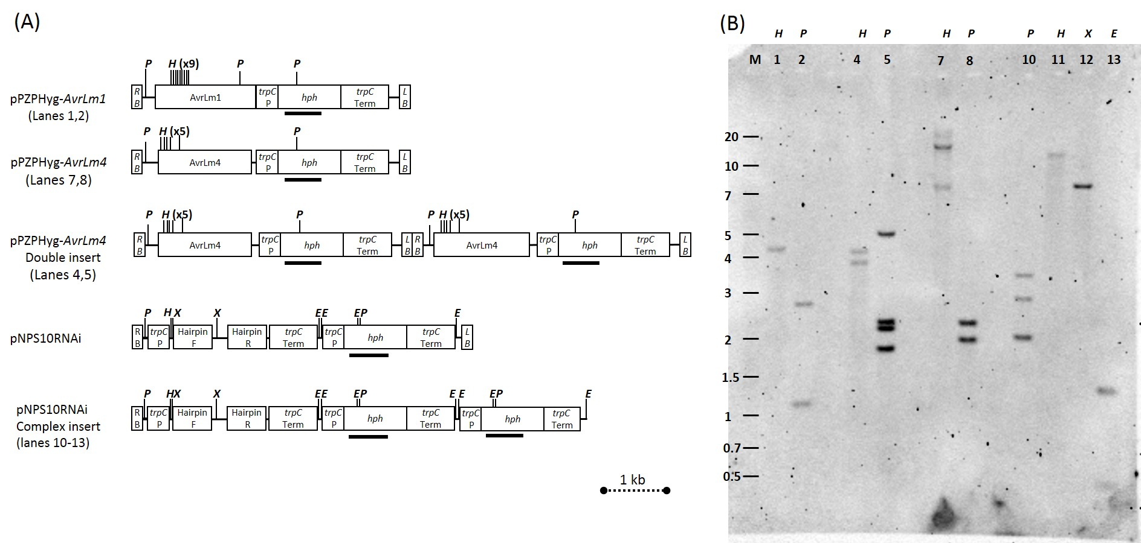
Figure S1 Diagrams of T-DNA plasmids used for transformation and Southern analysis of isolates showing nature of T-DNA insertion into Leptosphaeria maculans genome. (A) T-DNA plasmids used to transform L. maculans isolates. pPZPHyg-AvrLm1 was used to transform isolate IBCN18 to create IBCN18_AvrLm1. pPZPHyg-AvrLm4 was used to transform IBCN18 to create IBCN18+AvrLm4. pNPS10RNAi was used to transform isolate 691 to create 691+NPS10. RB-right border; trpC P-tryptophan C promoter; hph- hygromycin phosphotransferase gene; trpC Term-tryptophan C terminator; LB- left border; P-PstI, H-HindIII, X-XhoI, E-EcoRI. Black line shows sequence of hygromycin used in Southern analysis. (B) Southern analysis. Genomic DNA (10 µg) was digested with restriction enzymes as indicated above the lane and electrophoresed on a 0.7% TAE agarose gel. Blot was probed with a PCR fragment of the hygromycin phosphotransferase gene into which digoxigenin-11-dUTP was incorporated. Lane 1 and 2 show single insertion of pPZPHyg-AvrLm1 in isolate IBCN18+AvrLm1. Lanes 4 and 5 show a double insertion of pPZPHyg-AvrLm4 in isolate IBCN18+AvrLm4#8, whereas lanes 7 and 8 show a single insertion of pPZPHyg-AvrLm4 in isolate IBCN18+AvrLm4#9. Lanes 10 to 13 show isolate 691+NPS10 does not have a single insertion as there are 3 bands after digestion with PstI (lane 10), and a single band after both HindIII and XhoI digestion suggests that it cannot be a double insertion. Location of the T-DNA insertion site revealed a partial duplication of the DNA (nNPS10RNAi Complex insert).

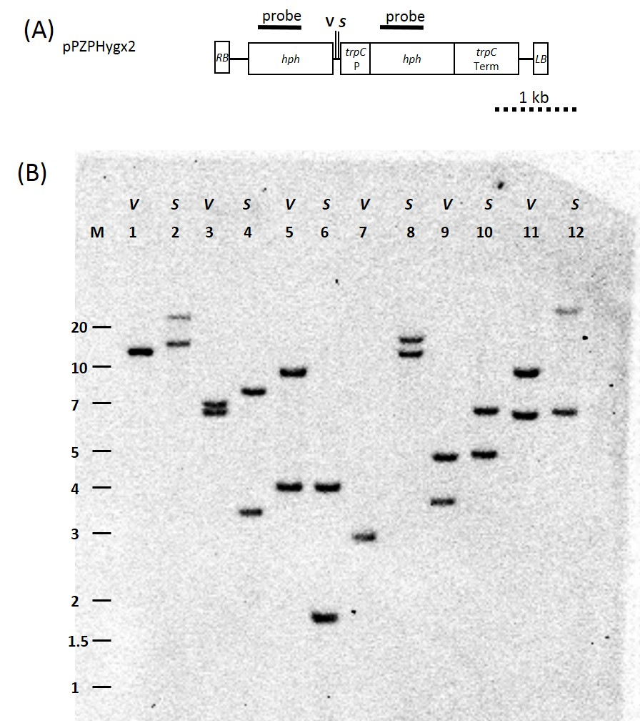
Figure S2 Diagram of the T-DNA plasmid pPZPHygx2 and Southern blot analysis of transformants carrying this plasmid showing nature of T-DNA insertion into the genome of each Leptosphaeria maculans transformant. (A) Diagrams of T-DNA plasmids used to transform L. maculans isolates D9, D3 and IBCN18. RB-right border; trpC P-tryptophan C promoter; hph- hygromycin phosphotransferase gene; trpC Term-tryptophan C terminator; LB- left border; P-PstI, H-HindIII, X-XhoI, E-EcoRI. Black line shows where hygromycin probe binds. (B) Southern analysis. Genomic DNA (10 µg) was digested with restriction enzymes EcoRV (V) or SpeI (S) as indicated above the lane and electrophoresed on a 0.7% TAE agarose gel. Blot was probed with a PCR fragment of the hygromycin phosphotransferase gene into which digoxigenin-11-dUTP was incorporated. Lane 1 and 2: D9+double-hph#4, Lanes 3 and 4: D9+double-hph#7; Lanes 5 and 6: D3+double-hph#2; Lanes 7 and 8: D3+double-hph#5; lanes 9 and 10: IBCN18+double-hph#8 and Lanes 11 and 12 IBCN18+double-hph#9. All lanes show two hybridizing bands corresponding to the two copies of the hygromycin phosphotransferase gene, apart from lane 7 where a small DNA fragment may have run off the gel.

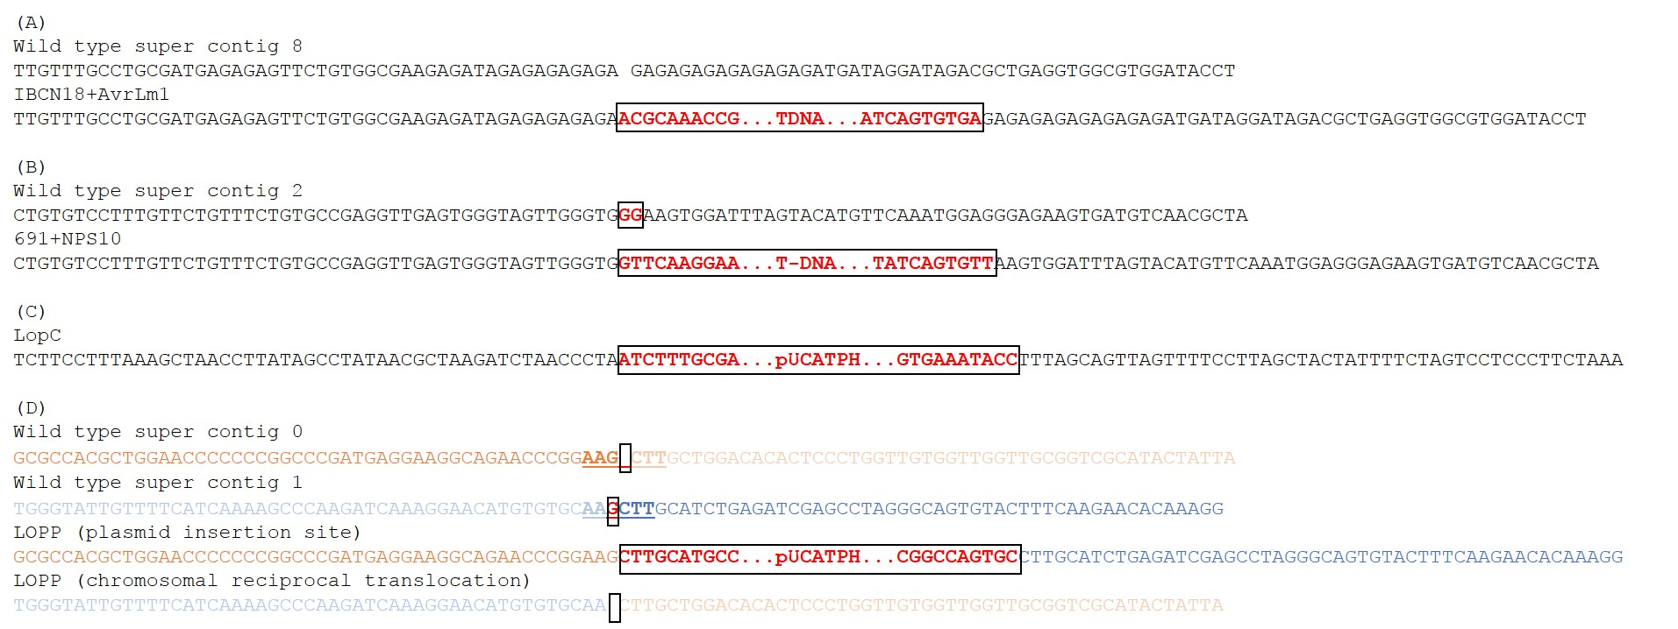
Figure S3 Genomic location of the plasmids transformed into Leptosphaeria maculans isolates that were used for triggering RIP. (A) Insertion site for the pPZPHyg_AvrLm1 construct in isolate IBCN18+AvrLm1. The insertion is located on Supercontig 8 of the L. maculans v23.1.3 genome and results in a single insertion of the construct with no alteration to the surrounding original genome sequence. The endogenous copy of AvrLm1 is located on Supercontig 6, showing that the insertion site of the AvrLm1 duplication (via the insertion of the pPZPHyg_AvrLm1 plasmid) is unlinked to the endogenous copy of the gene. (B) Insertion site of the pNPS10RNAi vector in isolate 691+NPS10. The insertion is located on Supercontig 2 and results in a two base pair deletion of the original surrounding genome sequence. The endogenous copy of NPS10 is located on Supercontig 11, demonstrating that the vector is inserted into an unlinked region of the genome. Insertion sites are indicated by the black box with the alteration in sequence indicated with red text. (C) Sequences flanking the insertion of multiple copies of the plasmid pUCTAPH in strain LopC. Both sides are in repetitive elements so cannot be assigned to a specific Supercontig. (D) A chromosomal rearrangement is associated with the insertion of the copies of pUCATPH into strain LopP. For clarity, DNA from Supercontig 0 is in orange and Supercontig 1 is in blue font. The strain was transformed using REMI with HindIII restriction enzyme. The HindIII sites on Supercontigs 0 and 1 are underlined. As part of the translation, a single nucleotide (red font, boxed) was deleted.

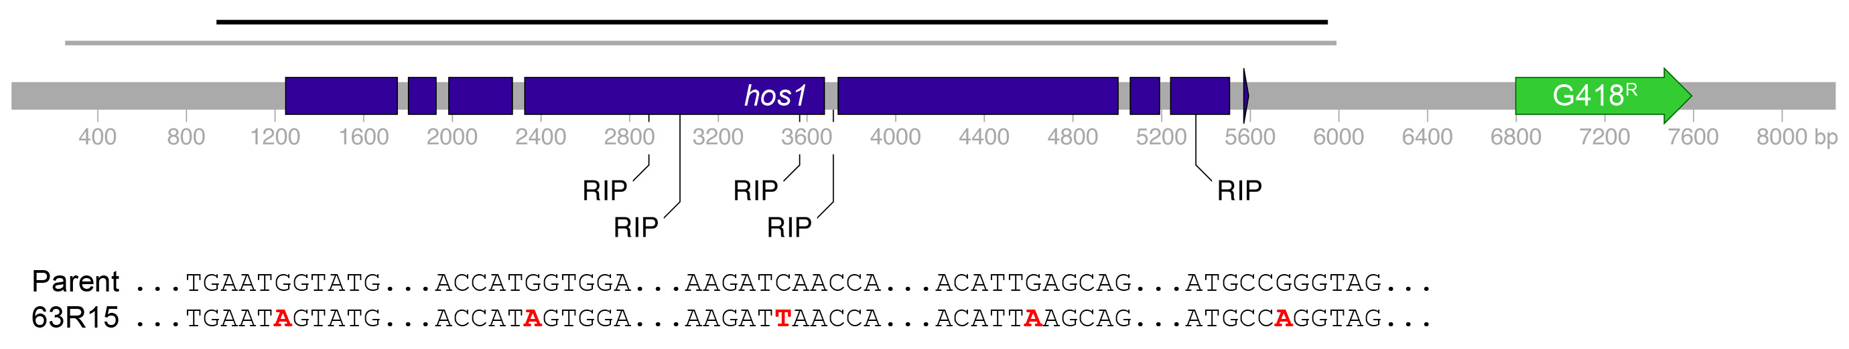

Figure S4 RIP occurs at a low frequency in unlinked duplications in Leptosphaeria maculans. Diagram of the construct used to complement a hos1 point mutation, with the duplicated region marked as a grey line, and fused adjacent to a construct conferring resistance to G418. This complemented parent was crossed, and progeny 63R15 exhibited both iprodione and G418 resistance. The region in black was sequenced, revealing five RIP sequences at the marked positions. These changes, and five adjacent nucleotides, are listed below the map of the construct.

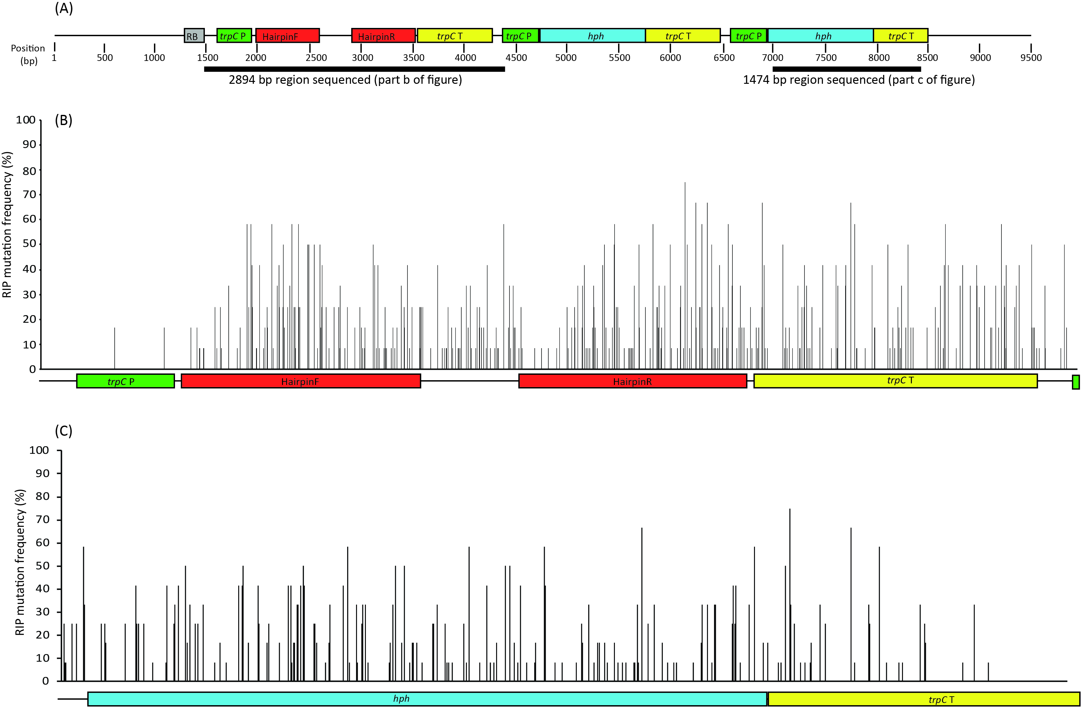
Figure S5 Analysis of RIP mutations in progeny of L. maculans isolates following a single sexual cycle. (A) Representation of the construct inserted into one of the parents, 691+NPS10, used to generate the octad progeny. (B) The frequency of RIP mutations for 12 octad progeny (22A, 22B and 22D) across a 2,894 bp region including the repeated hairpin regions and the single copy spacer region. (c) The frequency of RIP mutations at each nucleotide position for the 12 octad progeny across the 1,474 bp region including the hph duplicated gene region.

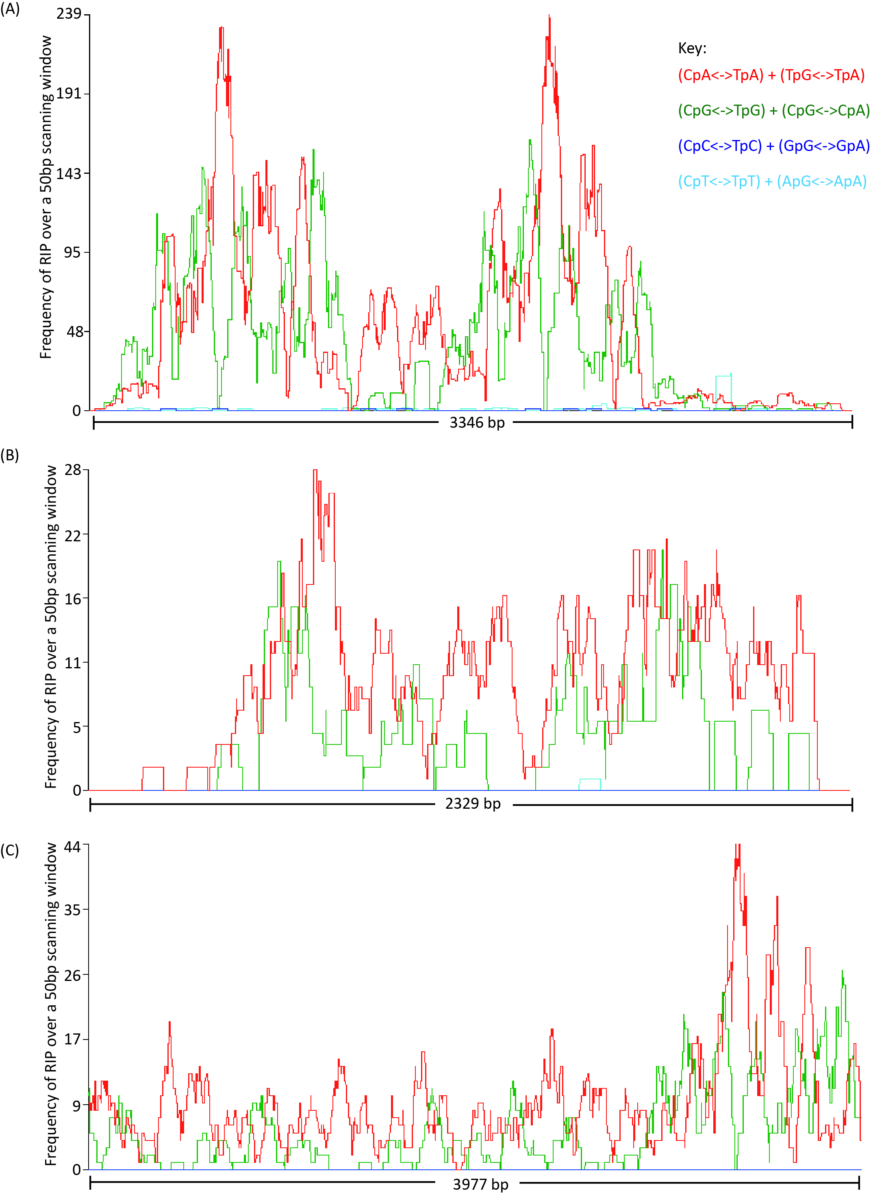
Figure S6 RIPCAL analysis of sequences from progeny collected from crosses using isolates harboring different constructs that are triggering RIP. (A) A 3,346 bp region sequenced from 55 progeny collected from crosses of isolates harboring the double-hph construct (see Figure 1). (B) A 2,329 bp region sequenced from eight progeny collected from a cross of an isolate harboring an NPS10 silencing construct (see Figure 2). (C) A 3,977 bp region sequenced from four octad progeny collected from the T-DNA insertion mutant, LopP (see Figure 3). The predominant dinucleotide transitions generated by RIP are CpA to TpA and CpG to TpG for all progeny screened.

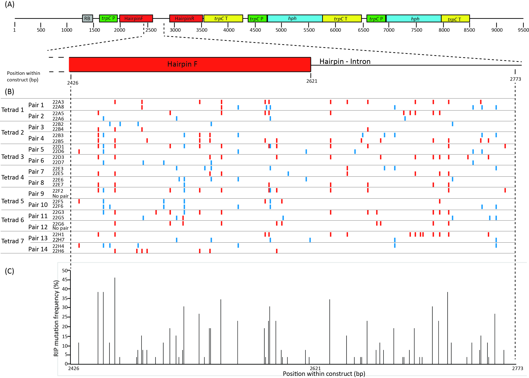
Figure S7 Analysis of RIP mutations in progeny of L. maculans isolates following a single sexual cycle. (A) Representation of the construct inserted into one of the parents, 691+NPS10, used to generate the tetrad progeny (22A3 through 22H6). A specific region of the construct (Hairpin F and Hairpin-Intron) were sequenced from the progeny. (B) The pattern of RIP mutations within the octad progeny. Octad pairs 1-3 are also presented in figure 2B. For each octad, two pairs of progeny (generated via a single round of mitosis following meiosis), contained the construct and were sequenced. C:T transitions are represented in red whilst G:A transitions are represented in blue. The patterns of RIP mutations differ for each of the octad pairs. (C) The frequency of RIP mutations at each nucleotide position was determined from the 26 progeny analyzed.

Cozijnsen, A. J., and B. J. Howlett, 2003 Characterisation of the mating-type locus of the plant pathogenic ascomycete Leptosphaeria maculans. Curr Genet 43: 351-357.
Fudal, I., S. Ross, L. Gout, F. Blaise, M. L. Kuhn et al., 2007 Heterochromatin-like regions as ecological niches for avirulence genes in the Leptosphaeria maculans genome: map-based cloning of AvrLm6. Molecular Plant-Microbe Interactions 20: 459-470.
Gout, L., I. Fudal, M. L. Kuhn, F. Blaise, M. Eckert et al., 2006 Lost in the middle of nowhere: the AvrLm1 avirulence gene of the Dothideomycete Leptosphaeria maculans. Molecular Microbiology 60: 67-80.
Idnurm, A., A. S. Urquhart, D. Vummadi, S. Chang, A. P. Van de Wouw et al., 2017 Spontaneous and CRISPR/Cas9-induced mutation of the osmosensor histidine kinase of the canola pathogen Leptopshaeria maculans. Fungal Biology and Biotechnology 4: 12.
Van de Wouw, A. P., A. J. Cozijnsen, J. K. Hane, P. C. Brunner, B. A. McDonald et al., 2010 Evolution of linked avirulence effectors in Leptosphaeria maculans is affected by genomic environment and exposure to resistance genes in host plants. PLoS Pathogens 6: e1001180.
Van de Wouw, A. P., C. E. Elliott and B. J. Howlett, 2014a Transformation of fungal isolates with avirulence genes provides tools for identification of corresponding resistance genes in the host plant. European J Plant Pathol 140: 875-882.
Van de Wouw, A. P., and B. J. Howlett, 2012 Estimating frequencies of virulent isolates in field populations of a plant pathogenic fungus, Leptosphaeria maculans, using high-throughput pyrosequencing. Journal of Applied Microbiology 113: 1145-1153.
Van de Wouw, A. P., B. J. Howlett and A. Idnurm, 2017 Changes in allele frequencies of avirulence genes in the blackleg fungus, Leptosphaeria maculans, over two decades in Australia. Crop and Pasture Science In Press.
Van de Wouw, A. P., S. J. Marcroft, A. Ware, K. Lindbeck, R. Khangura et al., 2014b Breakdown of resistance to the fungal disease, blackleg, is averted in commercial canola (Brassica napus) crops in Australia. Field Crops Research 166: 144-151.

