Supp Table 1 Scoring criteria for the developmental stage of human figure drawings
STAGE | CRITERIA
SCRIBBLE  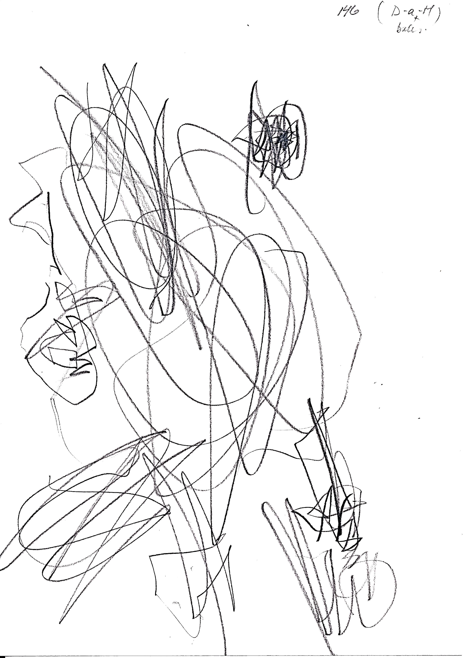 | - Nothing recognizable  - Continuous circular lines  - Child cannot describe what is drawn
PRE-TADPOLE | - Child is drawing but cannot identify the picture  - Separation of different scribbles  - Shows face only  - Face and feet consist of one line
TADPOLE  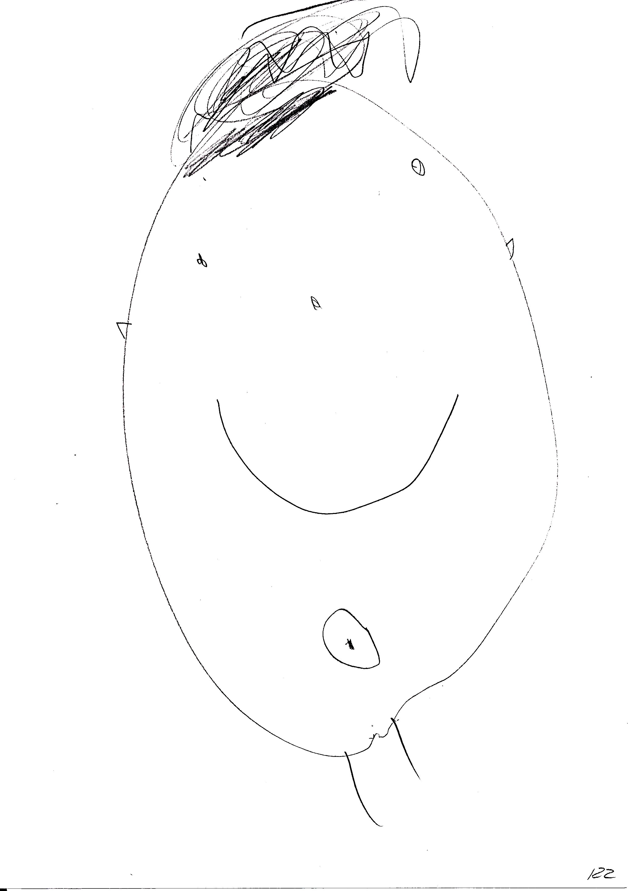 | - Head, arms, and/or legs present  - Arms/legs protrude from the head  - No head/body closure, but face, arms, and legs are present  - Sun-like with arms and legs
TRANSITIONAL | - Arms/legs are not protruding from the head  - A line is used for the body  - Arms are connected to legs or body  - No separation of head and body  - Stick-man picture: sticks are used for all body parts except head  - Body outline but no face  - Only head and body; no arms/legs  - No neck  - Body outline is distorted; no spatial order
CONVENTIONAL-I | - Body outline in four parts: head, body, two arms, two separate legs  - At least the head and body are two dimensional  - Segmented body parts  - Arms are protruding from body not head
CONVENTIONAL-II | - Body parts are integrated, continuing on from each other  - Two-dimensional arms, legs, neck, head, and body  - Fingers and toes can be drawn in stick form  - There has to be a face  - Includes drawings in profile view

Supp. Table 2 HFDs that were randomly selected in terms of gender and gestational group for ImageJ measurements
Developmental stage of HFD | Pre-term |  | Control |  | Total
 | Girls | Boys | Girls | Boys
Tadpole | 3 | 3 | 2 | 2 | 10
Transitional | 3 | 2 | 2 | 3 | 10
Conventional-I | 4 | 2 | 1 | 3 | 10
Conventional-II* | 3 | 0 | 6 | 1 | 10
Total | 13 | 7 | 11 | 9 | 40

* For this stage, HFDs could not be randomly selected from gestational and gender groups because there was a total of only 10 HFDs in the whole study group.

