A Study to Identify S-S and S-S-S bonds in organic compounds by Mass spectrometry and Ultraviolet and Raman spectroscopy techniques
Mohammad Soleiman-Beigi*¹, Elahe Ghiasbeigi¹
¹Department of Chemistry, Basic of Sciences Faculty, Ilam University, PO Box 69315-516, Ilam, Iran
Tel. / Fax. No: +98-843-2227022; Email: SoleimanBeigi@yahoo.com; m.soleimanbeigi@ilam.ac.ir

Table of Contents
Characterization of products ..........................................................................................
Figure .………………………………………………………………………………...
- Ultraviolet -visible spectra of di-t-butyl trisulfide (a) and di-t-butyl disulfide (b); 0.1
M in CH₂Cl_{2.} (Figure S1) ..............................................................................................
- Comparision TLC di-t- butyl trisulfide, di-t- butyl disulfide and mixtures (di-t- butyl
trisulfide/ di-t- butyl disulfide) in the wavelength of 365nm. (Figure S2).……............
- Ultraviolet -visible of p-tolyl disulfide (c) and bis(4-methylphenyl) trisulfide and p-tolyl
disulfide (d). (Figure S3) ……………………………………………………….….….
- Gas chromatography–Mass spectrometry of di-t- butyl trisulfide (h) and di-isopropyl
............................................................................................... trisulfide (g). (Figure S4)

Characterization of products
Di-tert- butyl trisulfide (Figure S4, h)

GC–MS m/z (%); 210 (59.6), 89 (84.6), 85 (28.8), 57 (100), 43 (63.46), 41 (32.69).

Di-isopropyl trisulfide (Figure S4, g)

GC–MS m/z (%); 182 (50. 6), 98 (8.5), 76 (7.5), 75 (82), 43 (100), 45 (12.3), 41 (44.5), 39 (14.5), 27 (28.4).

Figure

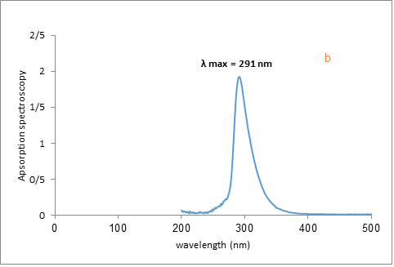
Figure S1. Ultraviolet -visible spectra of di-t-butyl trisulfide (a) and di-t-butyl disulfide (b); 0.1 M in CH₂Cl_{2.}

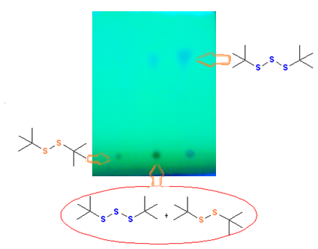
Figure S2. Comparision TLC di-t- butyl trisulfide, di-t- butyl disulfide and mixtures (di-t- butyl trisulfide/ di-t- butyl disulfide) in the wavelength of 365nm.

Figure S3. Ultraviolet -visible of p-tolyl disulfide (c) and bis(4-methylphenyl) trisulfide and p-tolyl disulfide (d)

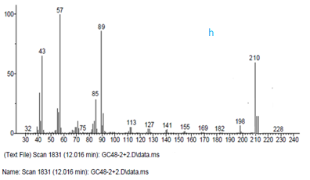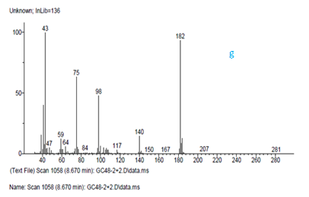
Figure S4. Gas chromatography–Mass spectrometry of di-t- butyl trisulfide (h) and di-isopropyl trisulfide (g).

