Appendix 2

An example of a Triple-Bottom-Line Framework Applied to Water Management in Murray-Darling Basin (MDBA 2016a,b)

A triple-bottom-line (TBL) framework was used by the Murray-Darling Basin Authority (MDBA) in developing the Sustainable Diversion Limits (SDLs, or water recovery volumes) for the Murray-Darling Basin (MDB) to comply with the ‘legislative need’ imposed by new federal legislation aimed at returning the over allocated system to a sustainable level (Water Act 2007). Salinity targets are included explicitly as one dimension of achieving a sustainable balance. The framework addresses both legislative and practical needs (Figure 1) and has been used recently again to re-assess management plans for the northern part of the MDB. Because a TBL approach is required by legislation, it will continue to be used as the Basin Plan is reviewed periodically. “The framework is guided by the MDBA’s ongoing commitment to accountability and transparency, and a 'no surprises' approach to decision making” (MDBA 2016).

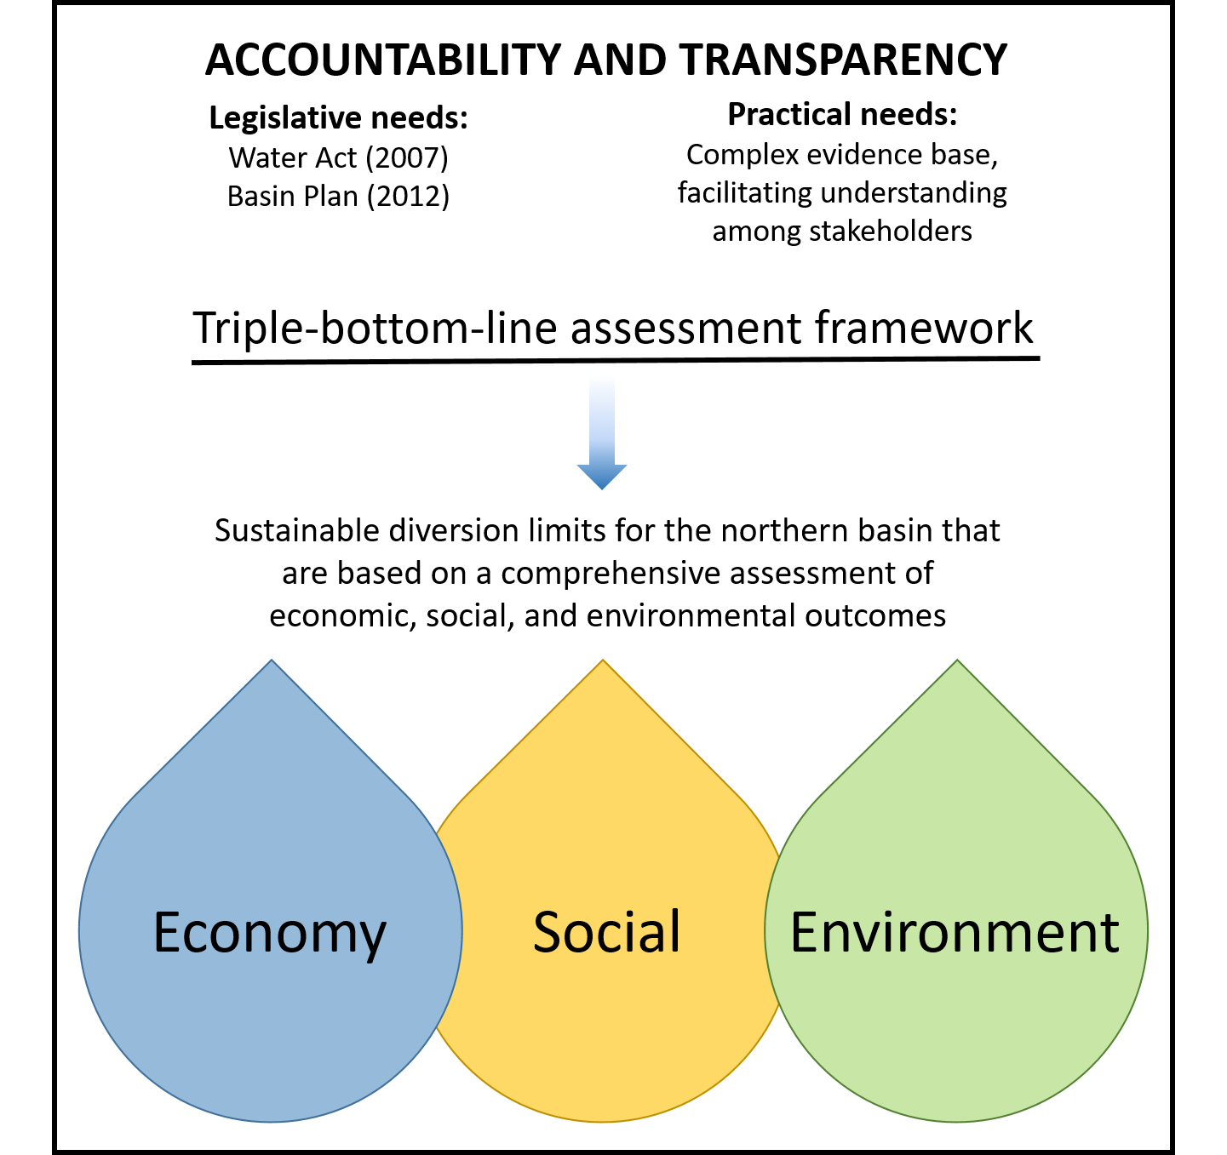
Figure 1: The legislative and practical need for a triple-bottom-line framework, guided by an overarching principle of accountability and transparency (re-drawn from MDBA 2016)

The Legislative need refers to the Water Act (2007) and the Basin Plan (2012) wherein the Act requires that the basin’s water resources are used and managed in a way that balances economic, social and environmental outcomes. The Basin Plan was designed and implemented in compliance with this Legislative direction, and the outcomes were measured (MDBA 2016b).

The steps in the triple bottom line decision-making framework used by the Murray-Darling Basin Authority in setting the new Basin Plan’s SDLs for water management in the MDB (MDBA, 2012) was concisely documented in 2016 for the review of the SDLs Northern Basin Review. The steps are excerpted here below and in in Figure 2, which illustrates the particular case of using the TBL approach for periodic reassessment and review of the Basin Plan.
(1) Define the question: Identify the assessment required and the question being asked of the decision makers.
(2) Objectives: Specify the objectives of the decision, this will be the basis against which alternative water recovery options are evaluated.
(3) Indicators: Assess the information base and specify the triple bottom line indicators for economic, social and environmental outcomes, against which the alternatives will be assessed.
(4) Alternatives: Explore different combinations of water recovery volumes for the northern basin catchments. Note: This step included a feedback loop from step 5 where assessing the triple bottom line outcomes of different scenarios lead to a refinement of scenario options.
(5) Triple bottom line assessment: Assess the evidence base, including a ‘summary outcomes table’, to compare the economic, social and environmental outcomes for each alternative. This involves a preliminary assessment at a whole-of-northern basin scale and subsequent catchment-scale assessment of selected scenarios. Bring in advice relating to other considerations. Interpret information and evaluate outcomes. Iterate new alternatives if required based on assessment of preliminary alternatives.
(6) Proposed amendment: Confirm water recovery volumes for the northern basin including water recovery advice and prospective toolkit measures. (Excerpted from: MDBA 2016)

Despite the MDBA’s attempts to follow a TBL approach that would meet legislative needs and satisfy interested parties in returning the level of use of MDB waters to sustainable levels, there has been much controversy and dispute. The volume of documented complaints is very large, as a simple internet search will reveal, topped recently with the state of South Australia’s Murray-Darling Basin Royal Commission set up to assess the MDBA’s Basin Plan and its effective impact on each of the TBL outcomes (MDBA 2016b). The contention is that the environmental gains have not been achieved and yet the economic and social costs of the Basin Plan and its SDLs have been significant. Importantly, legislating a TBL framework is clearly not an automatic solution for achieving acceptable environmental, social and economic outcomes.

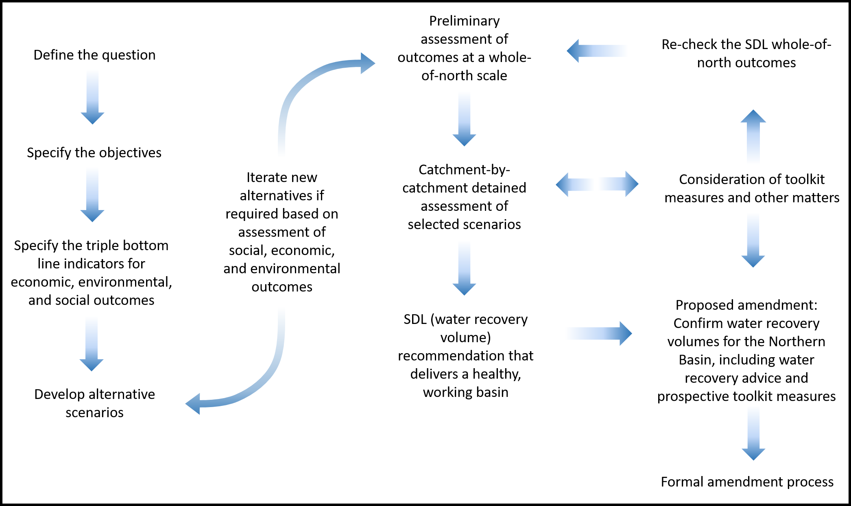

Figure 2: The triple-bottom-line framework process for setting Sustainable Diversion Limits (SDLs or water recovery volumes) in the Murray-Darling Basin (re-drawn from MDBA 2016)

References

MDBA. 2012. Basin Plan. https://www.legislation.gov.au/Details/F2018C00114.

MDBA. 2016a. The triple bottom line framework: A method for assessing the, economic, social and environmental outcomes of sustainable diversion limits for the northern basin. https://www.mdba.gov.au/sites/default/files/pubs/763-NB-triple-bottom-line-report.pdf

MDBA. 2016b. Environmental outcomes of the Northern Basin Review. https://www.mdba.gov.au/sites/default/files/pubs/Northern-basin-review-report-FINAL.pdf

Water Act. 2007. Australia. https://www.legislation.gov.au/Details/C2007A00137

