ONLINE APPENDIX FOR:

Problem detection in legislative oversight:
An analysis of legislative committee agendas in the U.K. and U.S.

Shaun Bevan (Shaun.Bevan@gmail.com )
Department of Politics and International Relations, University of Edinburgh, UK

Will Jennings (w.j.jennings@soton.ac.uk)
Department of Politics and International Relations, University of Southampton, UK

Mark Pickup (mark.pickup@gmail.com)
Department of Political Science, Simon Fraser University, Canada

ONLINE APPENDIX A: Problem Status Measures
Measures of problem status were gathered from official government sources and chosen based on their availability over time as quarterly data. In most cases only a single series was found that could be easily and directly tied to each issue area. GDP growth is the clear exception where other measures of economic performance such as inflation and unemployment are easily obtainable. However, given that these alternative measures are often tied to particular parts of society and even the interests of certain political parties we chose to use GDP growth.

United States
Table A1 lists all measures of problem status we use for the US.

Table A1: US Measures of Problem Status
Measure | Source
Gross Domestic Product Growth | Gross domestic product (billions $) (Bureau of Economic Analysis).
Average Medical Care Cost | Consumer price index: medical care services ($) (Bureau for Labor Statistics, CUSR0000SAM2).
Domestic Fuel Oil Prices | Consumer price index: Domestic fuel oil per 100 gallon barrel ($) (Bureau for Labor Statistics).
Domestic Gas Prices | U.S. Total Gasoline Through Company Outlets Price by All Sellers ($ per Gallon) (US Energy Information Administration)

With the exception of GDP growth and Domestic Gas Prices, all US data was gathered from historical trends series available through the Bureau of Labor Statistics (BLS; see http://www.bls.gov/data/). This data was seasonally adjusted in real dollar terms based on urban averages for medical care services, a 100 gallon barrel of domestic fuel oil and a gallon of gasoline (averaged across all octanes).

GDP growth was calculated using seasonally adjusted data from the Bureau of Economic Analysis (BEA; see http://www.bea.gov/). This was used as the BEA offered a more user friendly version of the dataset. Domestic gas prices was obtained through the US energy information and ministration website (https://www.eia.gov/dnav/pet/pet_pri_allmg_a_EPM0_PTC_Dpgal_m.htm). Regardless, all data sources are based on official government statistics. Figure A1 presents each of these series over time.

Figure A1: US Problem Status Measures Over Time

United Kingdom
Table A2 lists the measures of problem status for the UK.

Table A2: UK Measures of Problem Status
Measure | Source
Gross Domestic Product Growth | Gross domestic product (quarter-on-quarter growth: chained values, seasonally adjusted, percentage) (ONS, IHYQ).
Immigration inflows | Long-Term International Migration, Rolling annual data to year ending December 2012 (OFS, International Passenger Survey).
National Health Service median waiting time | Median waiting time: (Department of Health).
Domestic Fuel Oil Prices | Consumer price index: domestic fuels (fuel price index numbers relative to the GDP deflator, base=100, April 2010) (ONS).
Railroad Public Performance Measure | Public performance measure: all operators (Office of Rail Regulation).
Fear of crime | British Crime Survey: mean response to survey question “How safe do you feel walking along in this area after dark?” (Farrall et al. Long-Term Trajectories of Crime in the United Kingdom, 1982-2013. [data collection]. UK Data Service. SN: 7875, http://dx.doi.org/10.5255/UKDA-SN-7875-1).

The UK data was collected from various government sources. GDP growth is the percentage quarter-on-quarter growth (using chained, seasonally adjusted values of GDP). Immigration inflows represent a rolling count of the number of immigrants entering and staying in the country in thousands over the course of the calendar year. Median waiting time for NHS appointments in days is used as our measure of healthcare problem status. Domestic fuel oil prices fuel price index numbers relative to the GDP deflator represent energy, mostly home heating costs. Customer satisfaction with rail performance is used to measure the problem status of transport in the UK where a substantial portion of the public commute using public transport and this is a major focus of public policy. Finally, for the problem status of law and order, we aggregate responses to the survey question “How safe do you feel walking along in this area after dark?” based on data from the British Crime Survey (which later became the Crime Survey for England and Wales). This data is coded so that high numbers relate to more aggregate concern over crime and logically higher problem status. Figure A2 presents each of these series over time.

Figure A2: UK Problem Status Measures Over Time
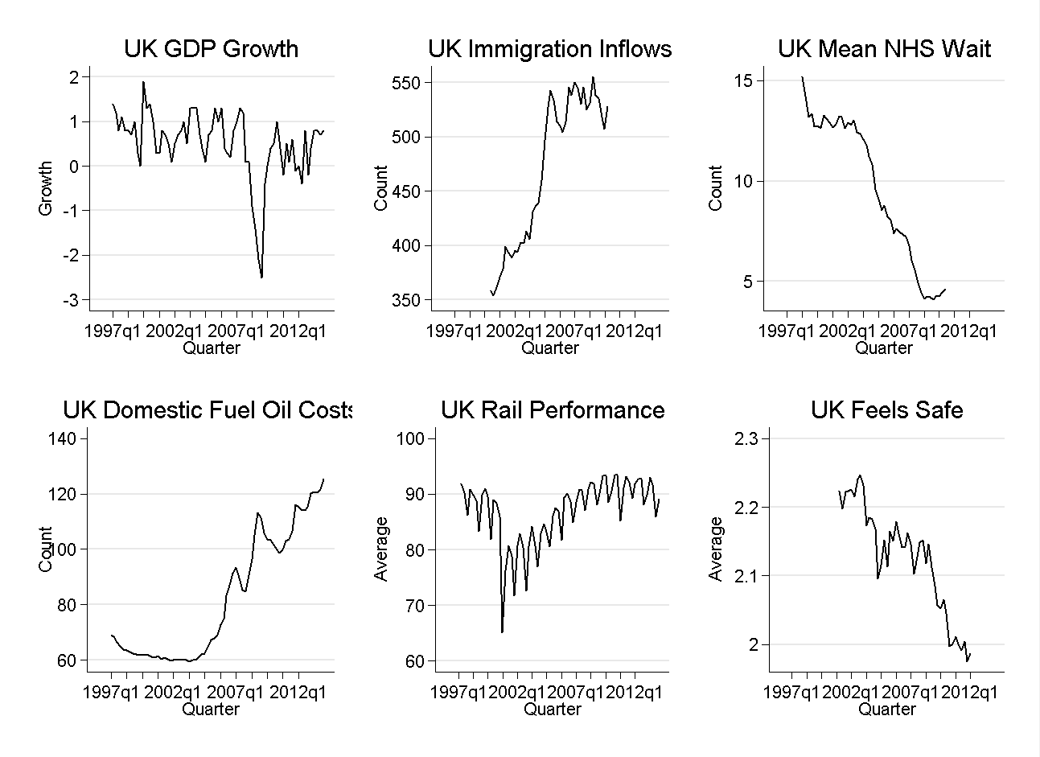

ONLINE APPENDIX B: US Results Including Divided House
Table B1: The Effects of Public Priorities and Problem Status on Congressional Hearings
 | Economy | Health | Energy | Transport
Hearings_{t-1} | -0.76 | -0.73 | -0.67 | -1.02
 | (0.07)*** | (0.07)*** | (0.07)*** | (0.10)***
ΔMIP_{t} | 4.19 | 0.75 | 44.69
 | (2.67) | (12.11) | (7.14)***
MIP_{t-1} | 6.27 | 7.04 | 33.85
 | (1.27)*** | (7.04) | (6.88)***
ΔGrowth_{t} | -14.53
 | (8.48)
Growth_{t-1} | -10.67
 | (15.94)
ΔMedical_{t} |  | 2.10
 |  | (0.61)***
Medical_{t-1} |  | -0.04
 |  | (0.07)
ΔFuel_{t} |  |  | 0.04
 |  |  | (0.02)*
Fuel_{t-1} |  |  | 0.02
 |  |  | (0.01)**
ΔGas_{t} |  |  |  | 3.58
 |  |  |  | (1.78)*
Gas_{t-1} |  |  |  | 2.32
 |  |  |  | (0.66)***
ΔDivided_{t} | 2.53 | 0.68 | -1.27 | 2.39
 | (0.92)** | (1.65) | (1.25) | (1.67)
Divided_{t-1} | -0.64 | 1.13 | 0.22 | -0.67
 | (0.40) | (0.72) | (0.55) | (0.78)
Trend | 0.03 | 0.09 | 0.09
 | (0.01)** | (0.02)*** | (0.02)***
Trend² | -0.00 | -0.00 | -0.00
 | (0.00)* | (0.00) | (0.00)***
2nd Quarter | -0.06 | 4.80 | 2.62 | 2.22
 | (0.33) | (0.57)*** | (0.42)*** | (0.64)**
3rd Quarter | -0.42 | 4.06 | 2.08 | 2.21
 | (0.38) | (0.69)*** | (0.50)*** | (0.77)**
4th Quarter | -1.61 | 0.27 | -0.30 | -0.46
 | (0.32)*** | (0.62) | (0.45) | (0.66)
Constant | -0.47 | -0.90 | -1.04 | 5.76
 | (0.48) | (1.47) | (0.63) | (1.16)***
R² | 0.53 | 0.59 | 0.57 | 0.64
N | 216 | 216 | 217 | 110
* p<0.05; ** p<0.01; *** p<0.001

To investigate the potential effects for divided government, we include a control variable that is coded as 1 if the President is from a different party than the House of Representatives majority (and zero otherwise). The only issue on which divided government has a statistical significant effect is the economy. In this issue area, it appears that under divided government the number of hearings increases. The consequence of including divided government for this issue is that the short-run effect of problem status goes from being significance at 0.05 to being significance at 0.1.

Table B2: Long Run Effects of Public Priorities and Problem Status on Congressional Hearings
 | Economy | Health | Energy | Transport
LR MIP | 8.31 | 9.60 | 50.28 | NA
 | (1.53)*** | (9.58) | (9.05)***
LR Problem | -14.13 | -0.049 | 0.035 | 2.37
 | (21.01) | (0.094) | (0.012)** | (0.53)***

Note this is different than net immigration as it does not account for the number of international and UK citizens emigrating from the UK.

