Supporting Information

Membrane Permeabilization and Perturbation Induced by Alkylbiguanidium Salts
Audrey Hébert,^{[a]} Maxime Parisotto,^{[a]} Gerardo Ferbeyre^{[b]} and Andreea R. Schmitzer*^{[a]}
[a] Département de Chimie- Faculté des Arts et des Sciences
Université de Montréal, 2900 Edouard Montpetit, CP 6128 succursalle centre ville, Montréal, H3C3J7, Québec, Canada
Email: *ar.schmitzer@umontreal.ca
[b] Département de Biochimie et Médecine Moléculaire- Faculté de Médecine, Université de Montréal

Table of contents
NMR Spectra 3
Bacterial membrane depolarization 9

NMR Spectra

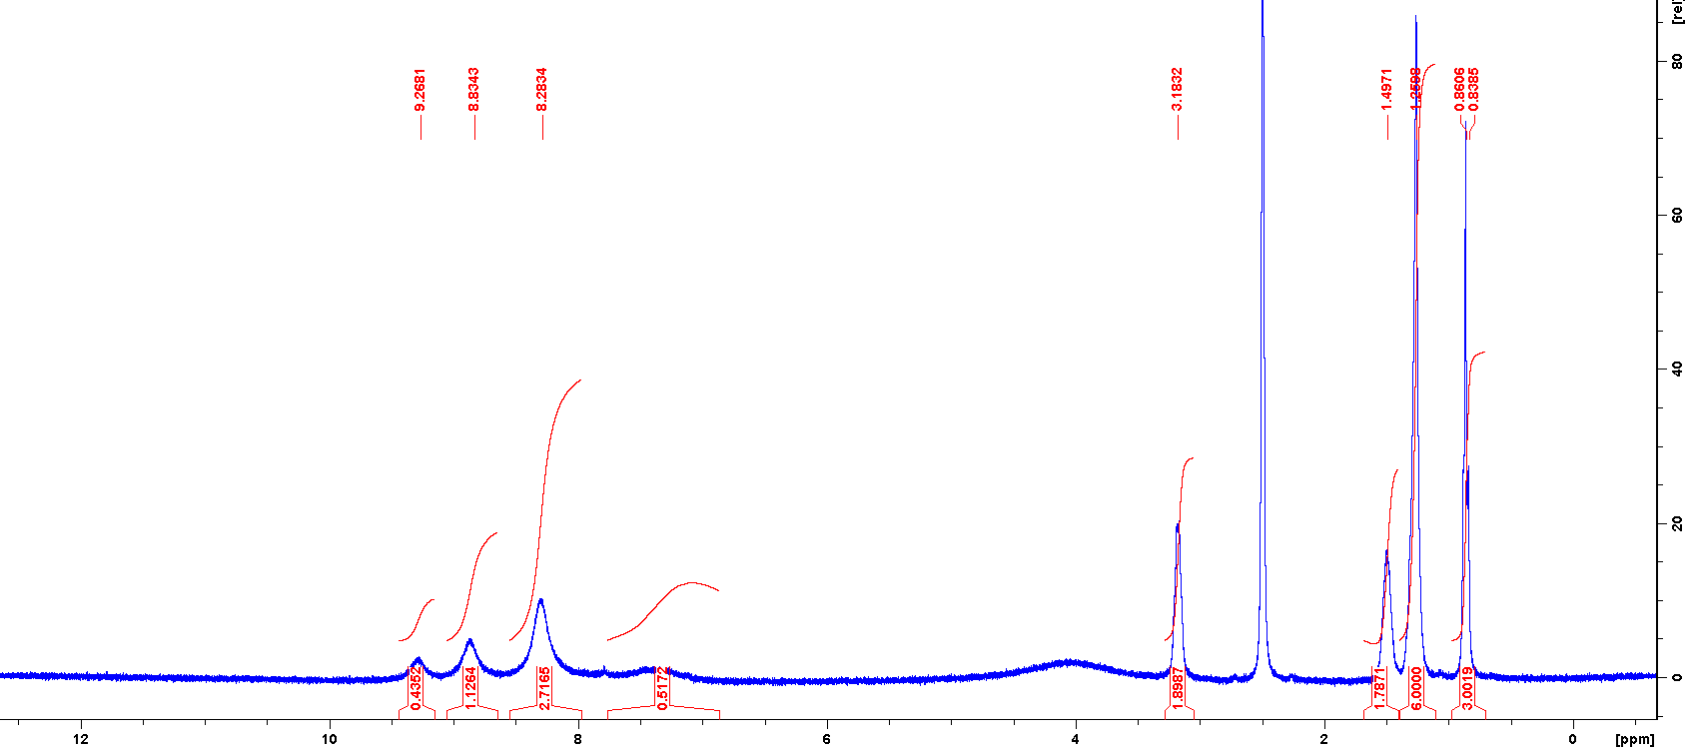

Supplementary figure S1. ¹H NMR (DMSO-d₆) spectrum of 11-Hexylbiguanidium chloride (C₆Cl)
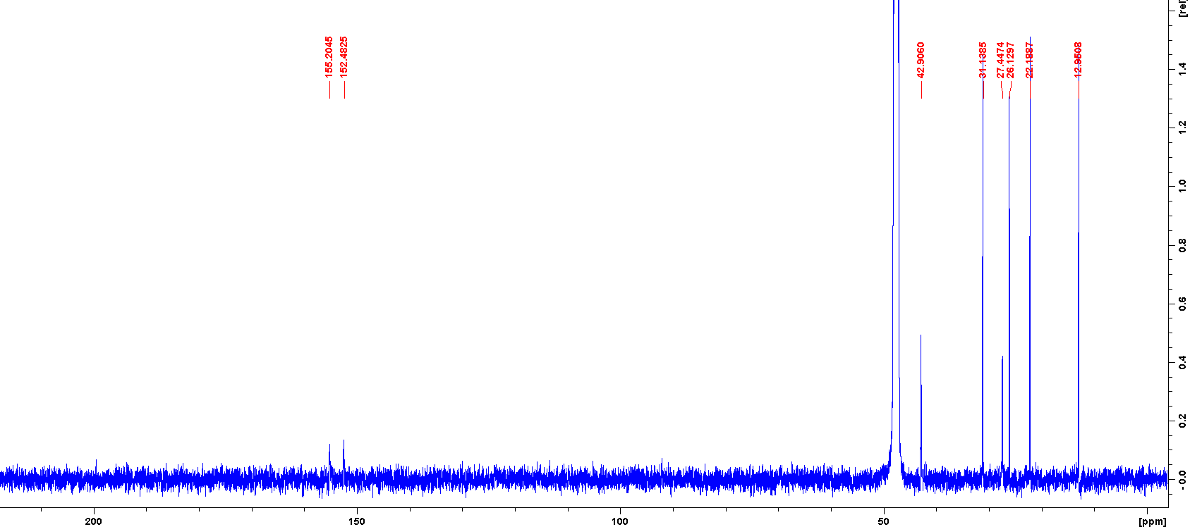

Suplementary figure S2. ¹³C NMR (MeOD) spectrum of 11-Hexylbiguanidium chloride (C₆Cl)
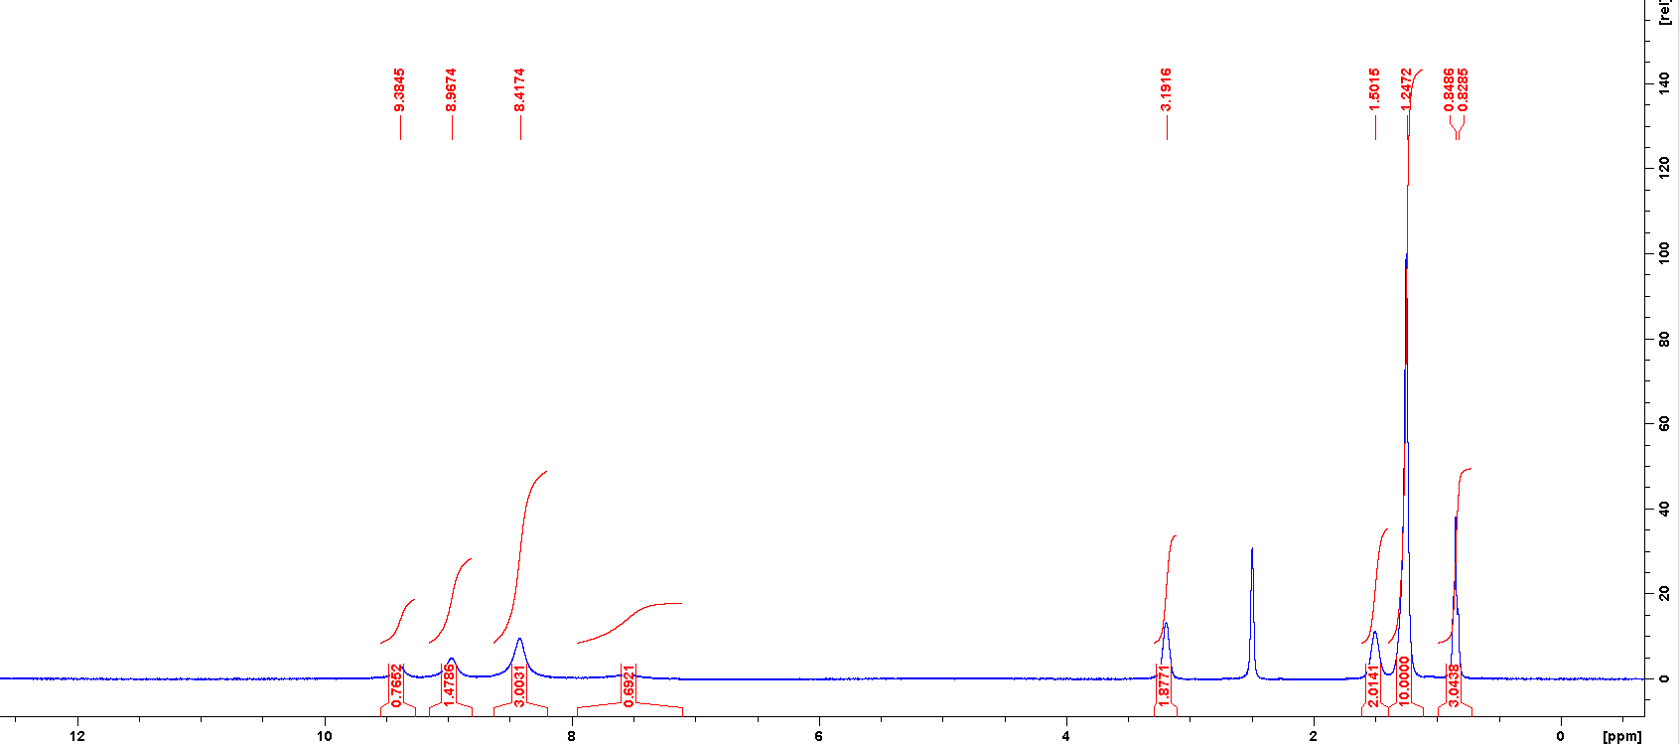

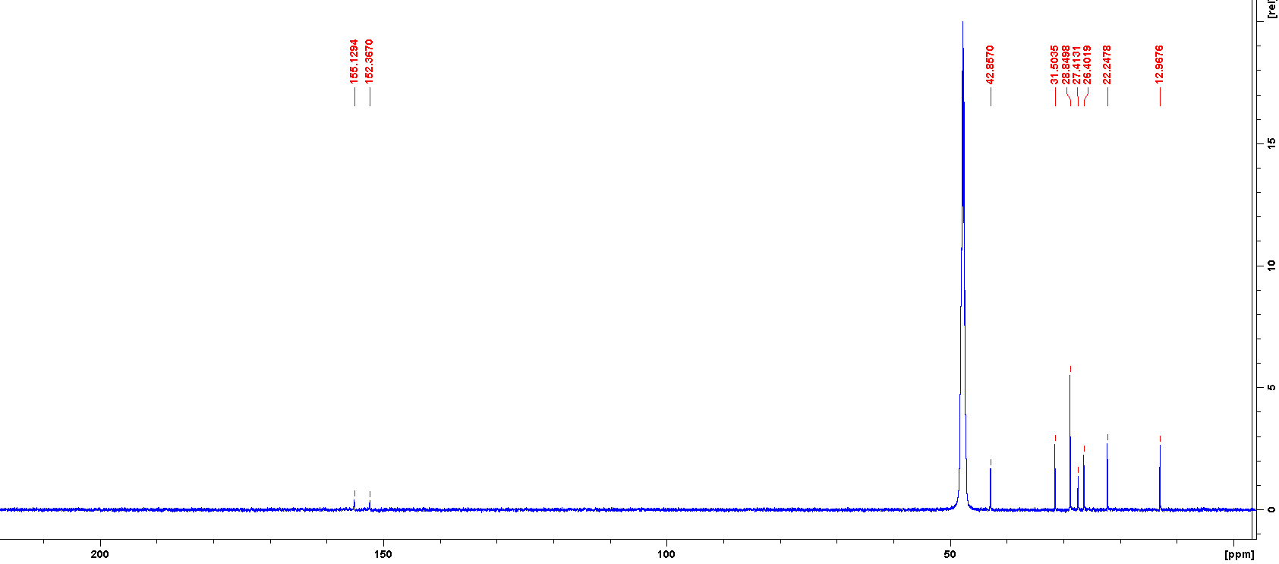
Supplementary figure S3. ¹H NMR (DMSO-d₆) spectrum of 1-Octylbiguanidium chloride (C₈Cl)

Supplementary figure S4. ¹³C NMR (MeOD) spectrum of 1-Octylbiguanidium chloride (C₈Cl)
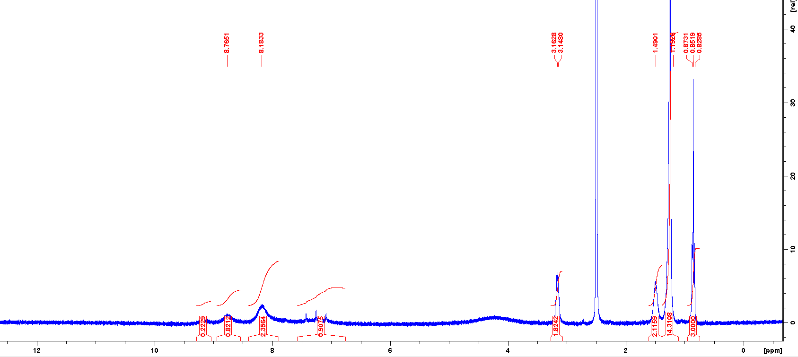

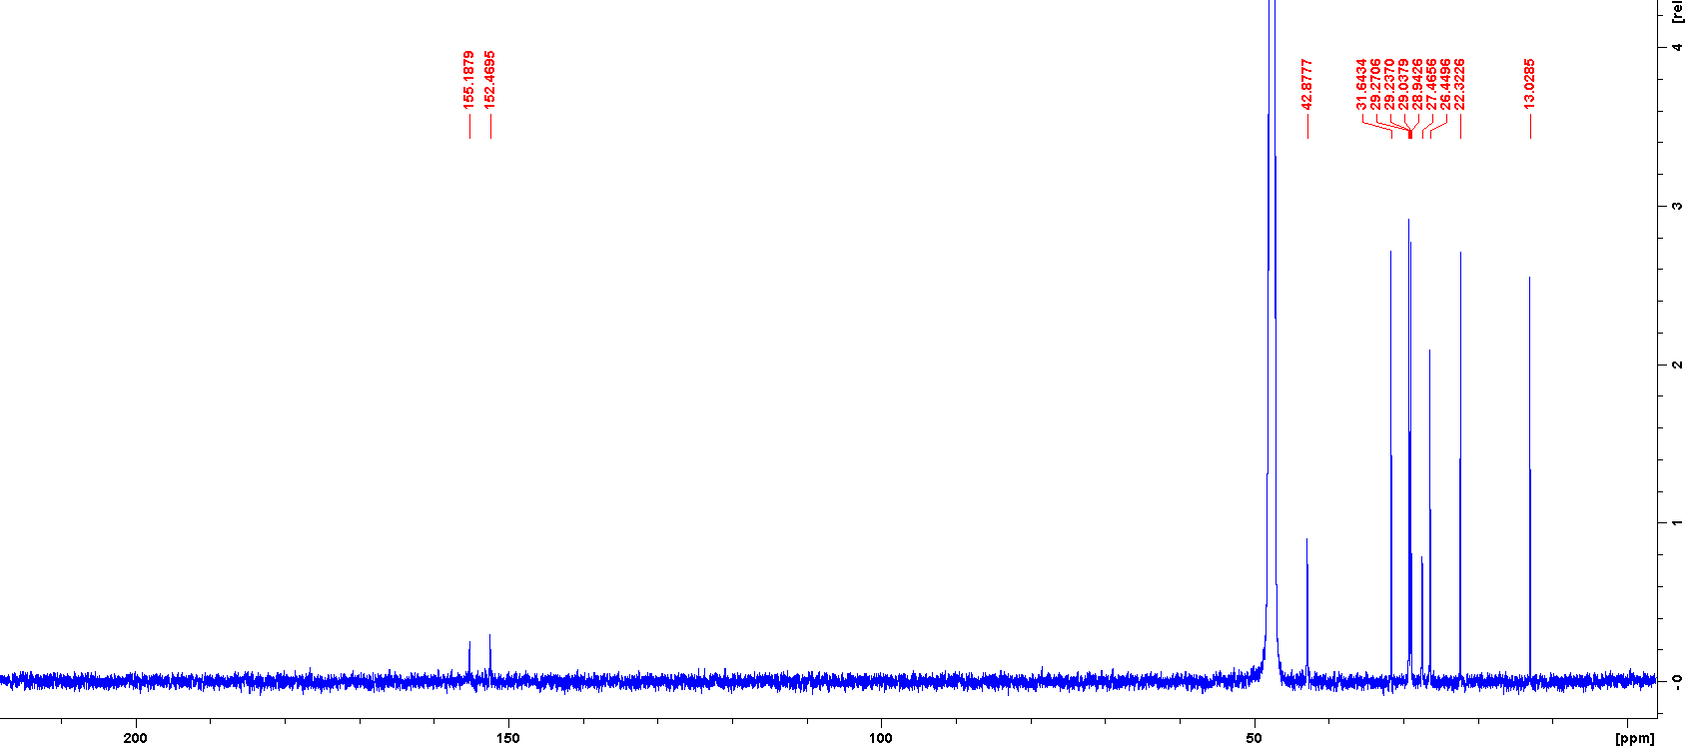
Supplementary figure S5. ¹H NMR (DMSO-d₆) spectrum of 1-Decylbiguanidium chloride (C₁₀Cl)

Supplementary figure S6. ¹³C NMR (MeOD) spectrum of 1-Decylbiguanidium chloride (C₁₀Cl)
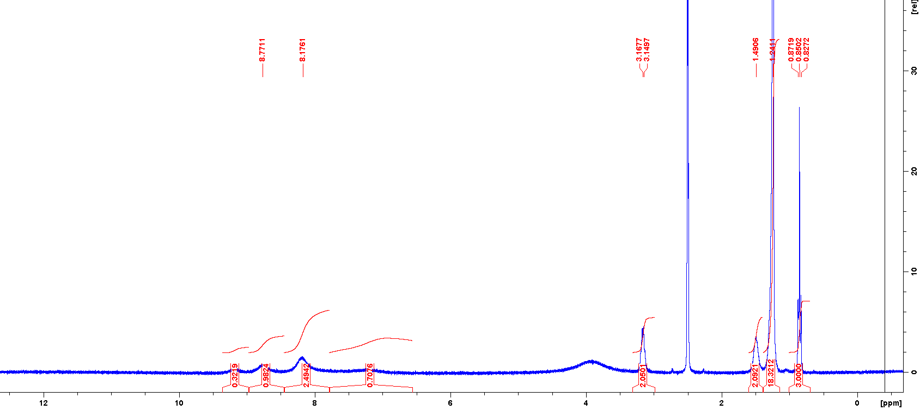

Supplementary figure S7. ¹H NMR (DMSO-d₆) spectrum of 1-Dodecylbiguanidium chloride salt (C₁₂Cl)
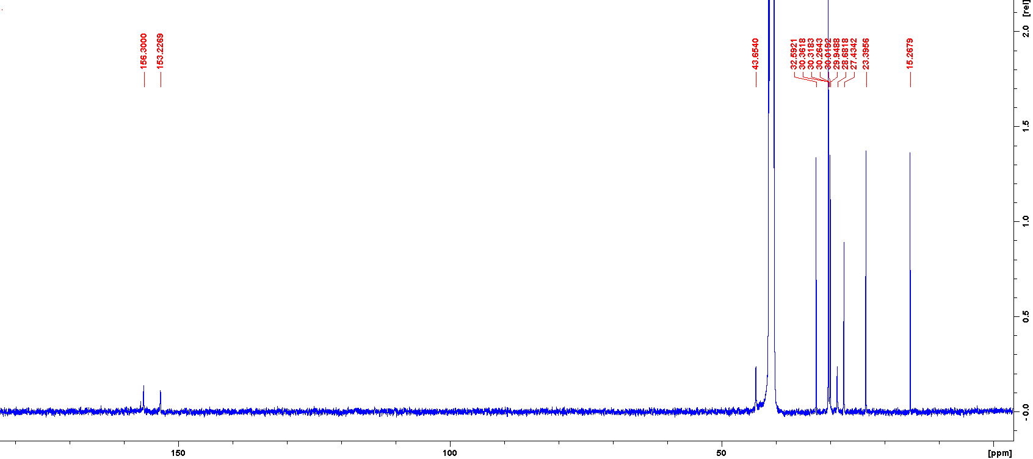

Supplementary figure S8. ¹³C NMR (MeOD) spectrum of 1-Dodecylbiguanidium chloride salt (C₁₂Cl)
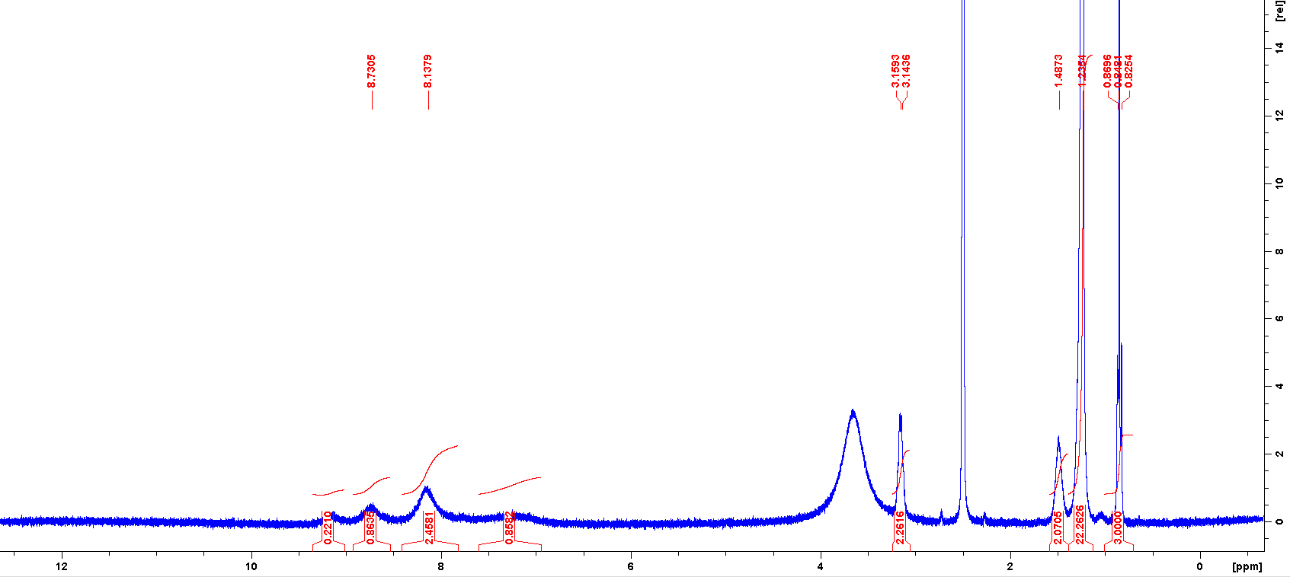

Supplementary figure S9. ¹H NMR (DMSO-d₆) spectrum of 1-Tetradecylbiguanidium chloride (C₁₄Cl)
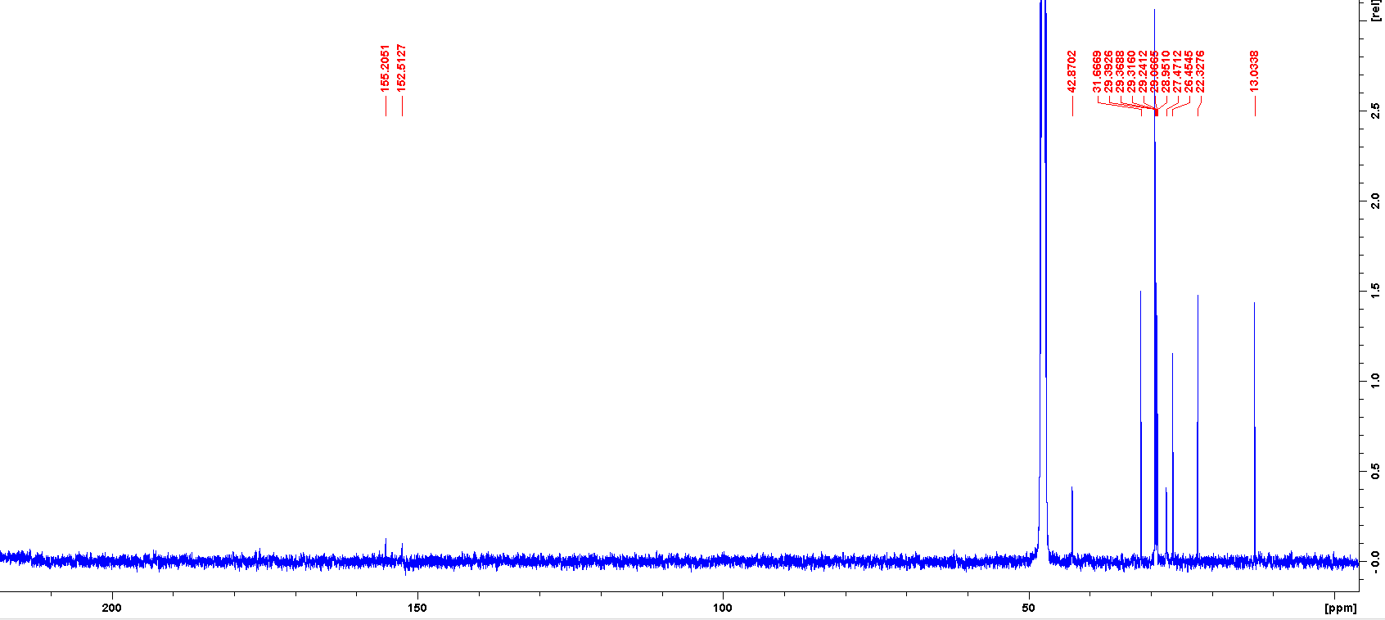

Supplementary figure S10. ¹³C NMR (MeOD) spectrum of 1-Tetradecylbiguanidium chloride (C₁₄Cl)

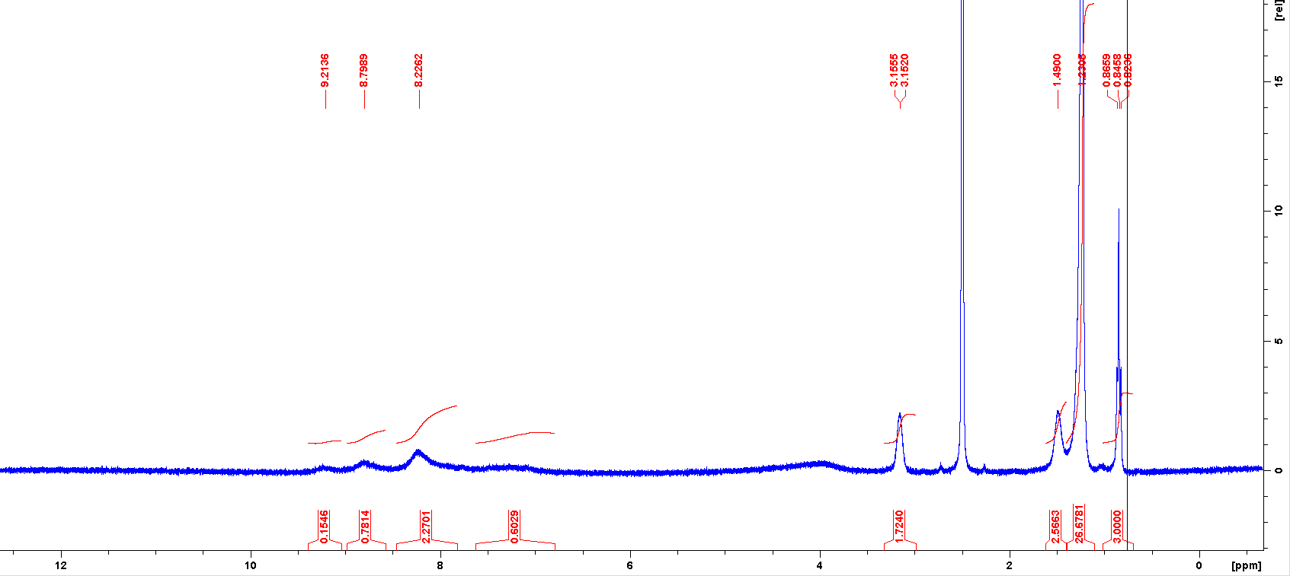

Supplementary figure S11. ¹H NMR (DMSO-d₆) spectrum of 11-+Hexadecylbiguanidium chloride (C₁₆Cl)
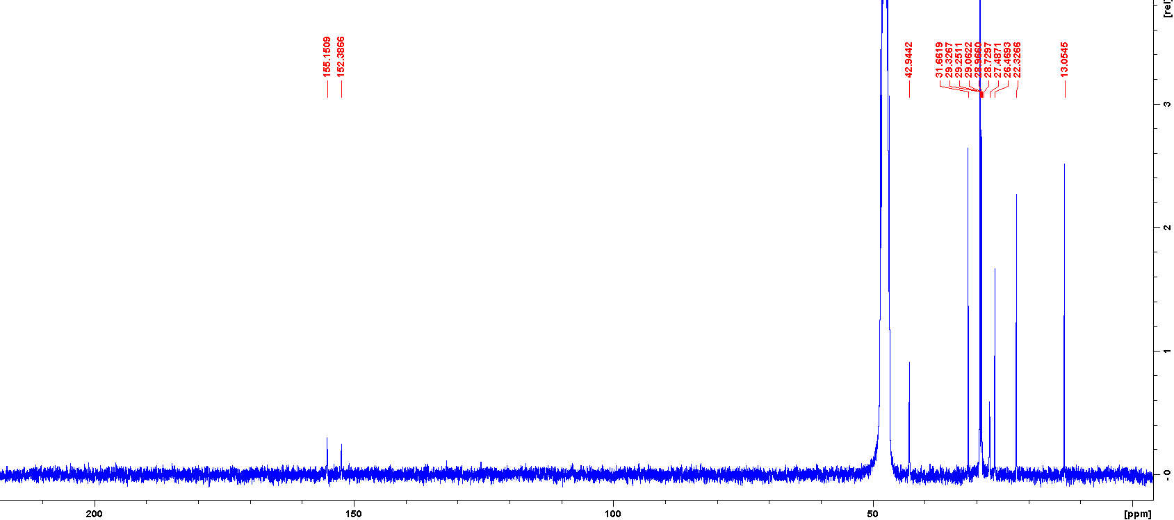

Supplementary figure S12. ¹³C NMR (MeOD) spectrum of 1-Hexadecylbiguanidium chloride (C₁₆Cl)

Bacterial membrane depolarization
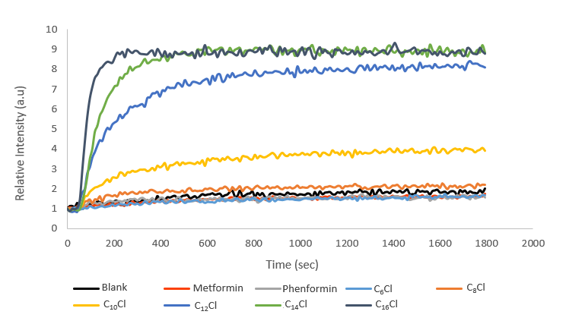
Supplementary figure S13. Depolarization assay on E. coli DH5α. Alkylbiguanidium salts were injected at 50 sec at 100 µg/ml and each value is the average of three independent experiments.
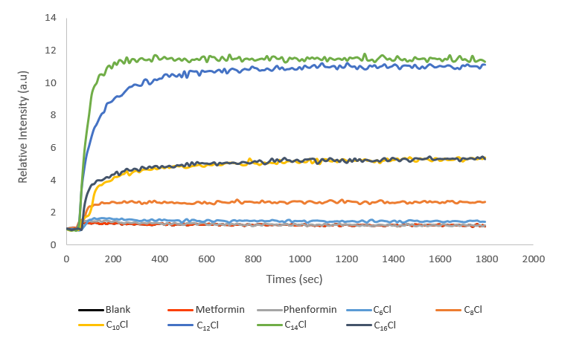
Supplementary figure S14. Depolarization assay on B. thuringiensis HD073. Alkylbiguanidium salts were injected at 50 sec at 100 µg/ml and each value is the average of three independent experiments.

