APPENDIX A

Table A1: Patient characteristics before and after propensity score reweighting in SCHOLAR-1
Figure |  | ZUMA-1  (N = 111) | SCHOLAR-1  (N = 521) | % bias | p>t
Age (years) | Unweighted | 56.2 | 52.8 | 27.4 | 0.010
 | Re-weighted | 55.9 | 57.9 | -16.1 | 0.217
Sex: Male | Unweighted | 69.4% | 64.4% | 10.5 | 0.322
 | Re-weighted | 68.5% | 66.7% | 3.9 | 0.773
Stage: III-IV | Unweighted | 84.7% | 68.2% | 39.5 | 0.001
 | Re-weighted | 84.3% | 72.1% | 29.1 | 0.088
Diagnosis: PMBCL | Unweighted | 8.1% | 1.9% | 28.6 | <0.001
 | Re-weighted | 8.3% | 5.6% | 12.8 | 0.424
Diagnosis: TFL | Unweighted | 18.9% | 3.6% | 49.6 | <0.001
 | Re-weighted | 16.7% | 18.5% | -6.0 | 0.722
Relapsed post-SCT: | Unweighted | 19.8% | 26.0% | -14.7 | 0.172
 | Re-weighted | 20.4% | 23.1% | -6.6 | 0.623
Key: SCT, stem cell transplant; PMBCL, primary mediastinal B-cell lymphoma; TFL, transformed follicular lymphoma.
Note: The full intent-to-treat population (N = 111) from ZUMA-1 was used as the largest sample of baseline characteristics in the population of interest.

Figure A1: Overall survival for SCHOLAR-1 population: before and after propensity score reweighting
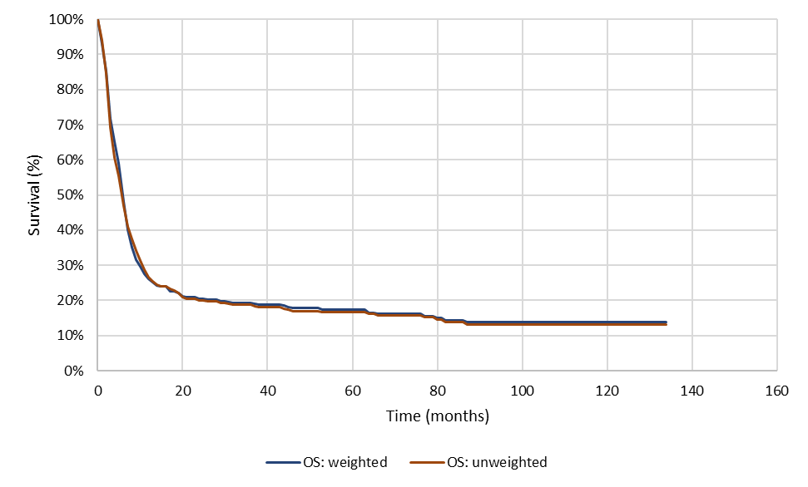
Key: OS, overall survival.

