Supplementary Material

Biomimetic complexes of Mn(II), Fe(III), Co(II) and Ni(II) with 1,10-phenanthroline and a salen type ligand: Tailored synthesis, characterization, DFT, enzyme kinetics and antibacterial screening

SATYENDRA N. SHUKLA*, PRATIKSHA GAUR, PREETI VAIDYA, BHASKAR CHAURASIA and SANGEETA JHARIYA

Figure S1. ESI-Mass of ligand o-HACPHENEN.
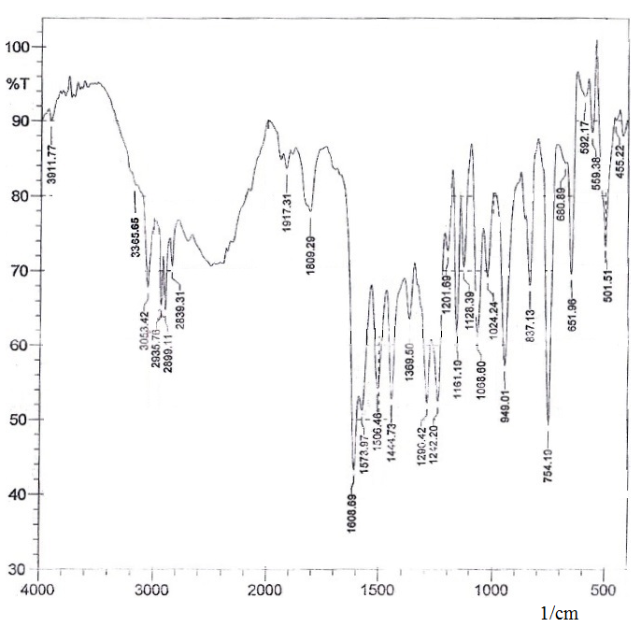
Figure S2. FT-IR spectra of ligand o-HACPHENEN.
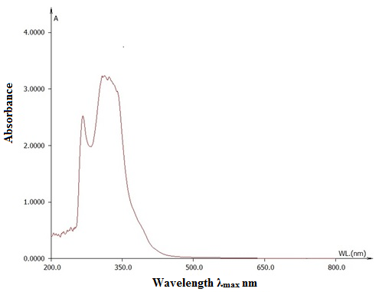
Figure S3. UV-Vis spectra of ligand o-HACPHENEN.

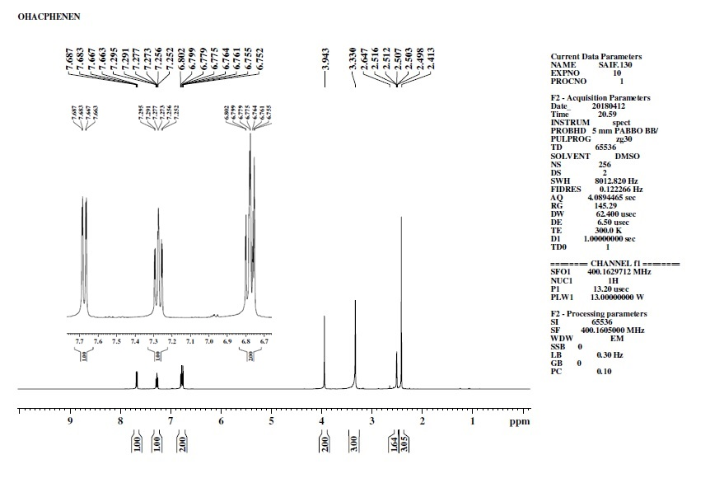

Figure S4. ¹H-NMR spectra of ligand o-HACPHENEN.

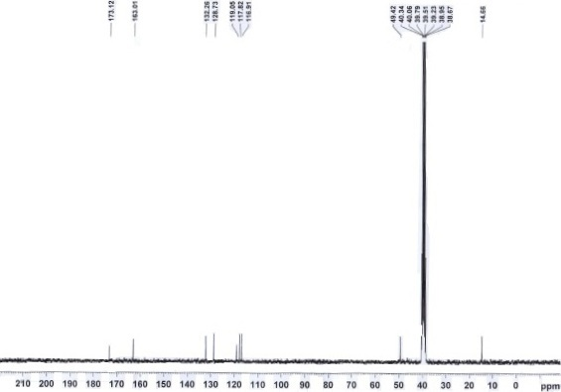
Figure S5. ¹³C-NMR spectra of ligand o-HACPHENEN.

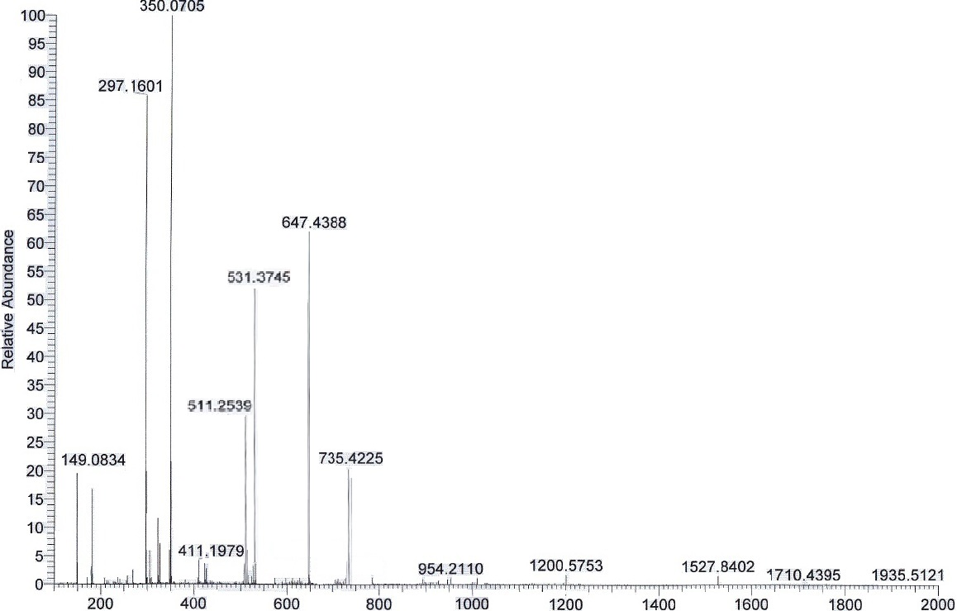

Figure S6. ESI-MS spectra of complex 2.

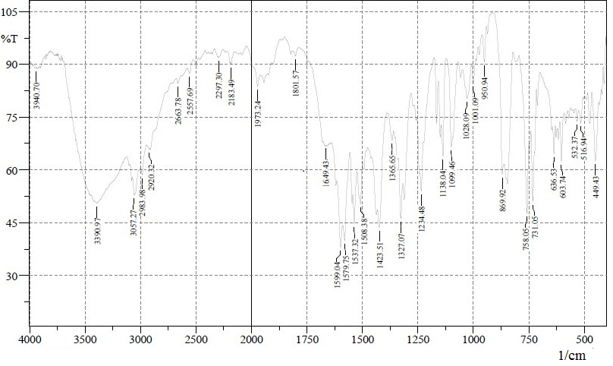
Figure S7. FT-IR spectra of complex 2.

Figure S8. UV-Vis spectra spectra of complex 2.

(a)

(b)

(c)
Figure S9. Mulliken atomic charge plot of (a) complex 1, (b) complex 3 and (c) complex 4.

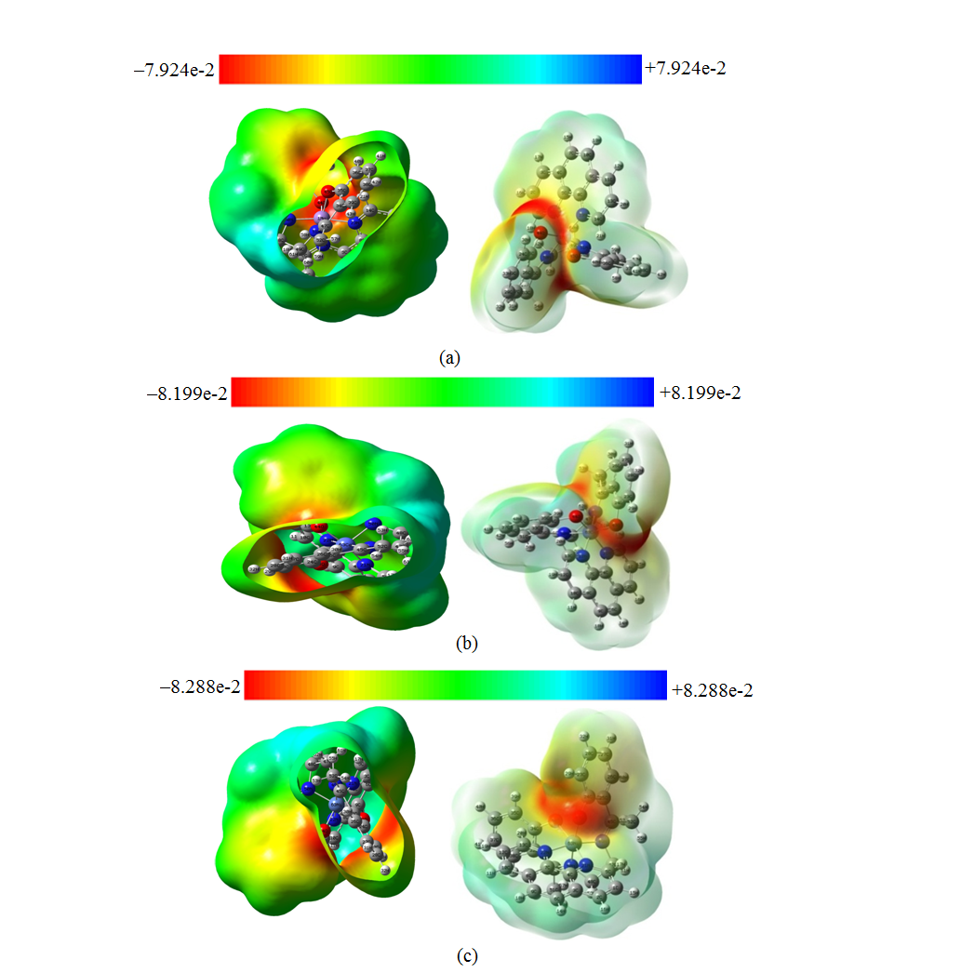
Figure S10. Molecular Electrostatic Potential (MEP) of (a) complex 1, (b) complex 3 and (c) complex 4.
Table S1. Selected Mulliken atomic charges of o-HACPHENEN and complexes 1-4.
S. No. | Atoms | o-HACPHENEN | Complex 1 | Complex 2 | Complex 3 | Complex 4
1. | C(connected to O) | (C2) 0.1554 | (C25) 0.3960 | (C24) 0.3969 | (C24) 0.3947 | (C24) 0.3840
2. | C′(connected to O) | (C16) 0.1863 | (C35) 0.0757 | (C34) 0.0766 | (C34) 0.0727 | (C34) 0.0524
3. | C(connected to imine N) | (C23) 0.1563 | (C46) 0.3545 | (C45) 0.3433 | (C45) 0.3597 | (C45) 0.3500
4. | C′(connected to imine N) | (C24) 0.1378 | (C47) 0.3620 | (C46) 0.3362 | (C46) 0.3501 | (C46) 0.3297
5. | C(phen) | - | (C6) 0.1175 | (C5) 0.1152 | (C5) 0.1110 | (C5) 0.1235
6. | C′(phen) | - | (C14) 0.2391 | (C13) 0.2217 | (C13) 0.2319 | (C13) 0.2393
7. | H(connected to O) | (H31) 0.3838 | - | - | - | -
8. | H′(connected to O) | (H32) 0.3566 | - | - | - | -
9. | O | (O21) -0.5874 | (O44) -0.6793 | (O43) -0.6784 | (O43) -0.6563 | (O43) -0.6690
10. | O′ | (O22) -0.5672 | (O45) -0.6428 | (O44) -0.6303 | (O44) -0.6308 | (O44) -0.6357
11. | N(imine) | (N29) -0.3713 | (N50) -0.6150 | (N49) -0.5826 | (N49) -0.5828 | (N49) -0.5783
12. | N′(imine) | (N30) -0.3085 | (N51) -0.6129 | (N50) -0.5624 | (N50) -0.5781 | (N50) -0.5867
13. | N(phen) | - | (N22) -0.7177 | (N21) -0.6556 | (N21) -0.7115 | (N21) -0.6740
14. | N′(phen) | - | (N23) -0.6904 | (N22) -0.6405 | (N22) -0.6534 | (N22) -0.6545
15. | M | - | 1.4672 | 1.3245 | 1.3319 | 1.3405

Table S2. The calculated quantum chemical parameters of o-HACPHENEN and complexes 1-4.
Ligand/ Complexes | E_{HOMO} (eV) | E_{LUMO} (eV) | ∆E (eV) | χ (eV) | η (eV) | σ (eV⁻¹) | Pi (eV) | S (eV⁻¹) | ω (eV) | ΔN_{max} (eV) | Total energy (a. u.) E(TD-HF/TD-KS) | Diple moment (debye)
o-HACPHENEN | -0.2022 | -0.03848 | 0.1637 | 0.1203 | 0.0818 | 12.2129 | -0.1203 | 6.1064 | 0.0884 | 1.4690 | -957.4253 | 3.8422
Complex 1 α | -0.1615 | -0.0565 | 0.1049 | 0.1090 | 0.0524 | 19.0494 | -0.1090 | 9.5240 | 0.1131 | 2.0764 | -2679.1610 | 6.7386
Complex 1 β | -0.1151 | -0.0642 | 0.0508 | 0.0896 | 0.0254 | 39.3004 | -0.0896 | 19.6502 | 0.1580 | 3.5250
Complex 2 | -0.1414 | -0.0640 | 0.0774 | 0.1027 | 0.0387 | 25.8131 | -0.1027 | 12.9065 | 0.3626 | 2.6522 | -2791.8411 | 8.2489
Complex 3 α | -0.0934 | -0.0636 | 0.0297 | 0.0785 | 0.0148 | 67.1591 | -0.0785 | 33.5795 | 0.2072 | 5.2760 | -2910.9114 | 6.4387
Complex 3 β | -0.1783 | -0.0563 | 0.1220 | 0.1173 | 0.0610 | 16.3921 | -0.1173 | 8.1960 | 0.1128 | 1.9232
Complex 4 | -0.0988 | -0.0664 | 0.0323 | 0.0826 | 0.0161 | 61.7665 | -0.0826 | 30.8832 | 0.2110 | 5.1062 | -3036.3684 | 6.9779

Table S3. Selected geometrical bond lengths of ligand o-HACPHENEN and complexes 1-4.
Bond lengths (in Angstroms)
Bond connectivity | o-HACPHENEN | Complex 1 | Complex 2 | Complex 3 | Complex 4
C-O | (C2-O21) 1.4300 | (C25-O44) 1.4357 | (C24-O43) 1.4352 | (C24-O43) 1.4361 | (C24-O43) 1.4363
C-O′ | (C16-O22) 1.4300 | (C35-O45) 1.4483 | (C34-O44) 1.4463 | (C34-O44) 1.4462 | (C34-O44) 1.4474
C=N (imine) | (C23=N29) 1.2936 | (C46=N50) 1.3319 | (C45=N49) 1.3330 | (C45=N49) 1.3330 | (C45=N49) 1.3320
C=N′ (imine) | (C24=N30) 1.2936 | (C47=51) 1.3208 | (C46=N50) 1.3231 | (C46=N50) 1.3232 | (C46=N50) 1.3222
C-C(close to imine C) | (C3-C23) 1.5400 | (C23-C47) 1.5287 | (C25-C45) 1.5366 | (C25-C45) 1.5390 | (C25-C45) 1.3733
C-C′ close to imine C) | (C15-C24) 1.5400 | (C26-C46)1.5321 | (C33-C46) 1.5341 | (C33-C46) 1.5341 | (C33-C46) 1.5343
M-O | - | M-O 441.8357 | M-O 431.8220 | M-O 431.8198 | M-O 431.8115
M-O′ | - | M-O 451.8376 | M-O 441.8227 | M-O 441.8227 | M-O 441.8121
M-N (imine) | - | M-N50 (imine) 1.8690 | M-N49 (imine) 1.8469 | M-N49 (imine) 1.8481 | M-N49 (imine) 1.8418
M-N′ (imine) | - | M-N51 (imine) 1.8950 | M-N50 (imine) 1.8738 | M-N50 (imine) 1.8787 | M-N50 (imine) 1.8676
M-N (phen) | - | M-N22 (phen) 1.8777 | M-N21 (phen) 1.8669 | M-N21 (phen) 1.8664 | M-N21 (phen) 1.8560
M-N′ (phen) | - | M-N23 (phen) 1.8776 | M-N22 (phen) 1.8667 | M-N22 (phen)1.8665 | M-N22 (phen) 1.8559

Table S4. Selected geometrical bond angles of ligand o-HACPHENEN and complexes 1-4.
Bond angles in degrees
Angles | o-HACPHENEN |  | Complex 1 |  | Complex 2 |  |  | Complex 3 |  | Complex 4
∠C-C-O | (∠C3-C2-O21) 120.0000 |  | (∠C26-C25-O44) 122.6458 |  | (∠C25-C24-O43) 121.8802 |  |  | (∠C25-C24-O43) 121.8758 |  | (∠C25-C24-O43) 122.3776
∠C-C-O′ | (∠C15-C16-O22) 119.9999 |  | (∠C34-C35-O45) 124.2890 |  | (∠C33-C34-O44) 122.7056 |  |  | (∠C33-C34-O44) 122.7075 |  | (∠C33-C34-O44) 123.0671
∠C-N-C (imine) | (∠C23-N29-C27) 120.0001 |  | (∠C45-N50-C48) 119.6797 |  | (∠C45-N49-C47) 120.8849 |  |  | (∠C45-N49-C47) 120.8849 |  | (∠C45-N49-C47) 120.6947
∠C-N′-C (imine) | (∠C24-N30-C28) 119.9995 |  | (∠C47-N51-C49) 124.3890 |  | (∠C46-N50-C48) 126.4710 |  |  | (∠C46-N50-C48) 126.4658 |  | (∠C46-N50-C48) 125.8224
∠H-O-C | (∠H31-O21-C2) 109.4712 |  | - |  | - |  |  | - |  | -
∠H-O′-C | (∠H32-O22-C16) 109.4712 |  | - |  | - |  |  | - |  | -
∠C-N-C (phen) | - |  | (∠C5-N22-C6) 121.702 |  | (∠C4-N21-C5)120.9315 |  |  | (∠C4-N21-C5) 121.6977 |  | (∠C4-N21-C5) 121.7949
∠C-N′-C (phen) | - |  | (∠C8-N23-C14) 121.6986 |  | (∠C7-N22-C13) 120.9315 |  |  | (∠C7-N22-C13) 121.7029 |  | (∠C7-N22-C13) 121.7952
Cis
∠N(phen)-M-N(imine) |  | - |  | (∠N22-M-N50) 93.55965 |  | (∠N21-M-N49) 94.24128 | (∠N21-M-N49) 94.24151 |  | (∠N21-M-N49) 93.28414
∠N(phen)-M-O |  | - |  | (∠N23-M-O45) 93.11953 |  | (∠N22-M-O44) 86.33564 | (∠N22-M-O44) 90.69392 |  | (∠N22-M-O44) 90.82575
∠N(imine)-M-O |  | - |  | (∠N50-M-O44) 96.29608 |  | ∠N49-M-O43) 96.13585 | (∠N49-M-O43) 96.13004 |  | (∠N49-M-O43) 98.05432
Trans
∠N(phen)-M-N′(imine) |  | - |  | (∠N23-M-N50) 167.65774 |  | (∠N22-M-N49) 173.70673 | (∠N22-M-N49) 173.70350 |  | (∠N22-M-N49) 168.01908
∠N-M-O′ |  | - |  | (∠N22-M-O45) 165.24018 |  | (∠N21-M-O44) 170.80335 | (∠N21-MO-44) 170.79695 |  | (∠N21-M-O44) 169.21763
∠N(imine)-M-O′ |  | - |  | (∠N51-M-O44) 172.10214 |  | (∠N50-M-O43) 175.19743 | (∠N50-M-O43) 175.19043 |  | (∠N50-M-O43) 176.28955
where M = Mn, Fe, Co and Ni
Table S5. Related kinetics parameters for synthetic CAT models and enzyme.
S. No. | Catalyst/enzyme | K_{M} (mol L⁻¹) | k_{cat} (sec⁻¹) | k_{cat}/K_{M} or ε mol⁻¹ L sec⁻¹ | Solvent, T (°C) | Reference
1. | Complex 1 | 7.11 × 10⁻⁴ | 6.76 × 10⁻² | 9.50 × 10¹ | DMSO, 25 | This work
2. | Catalase | 2.5 × 10⁻⁴ | 1.2 × 10³ | 5.0 × 10⁸ | H₂O₂/H₂O | [54]
3. | T. thermophiles | 0.083 (0.008) | 2.6 × 10⁵ | 3.13 × 10⁶ | H₂O | [55]
4. | T. album | 0.015 | 2.6 × 10⁴ | 1.73 × 10⁶ | H₂O | [55]
5. | L. plantarum | 0.35 | 2 × 10⁵ | 0.57 × 10⁶ | H₂O | [55]
6. | Na[Mn₂(3-Me-5-SO₃-salpentO)(μ-OAc)(μ-OMe)(H₂O)] • 4H₂O | 6.6(4) | 10.5(2) | 16(1) × 10² | H₂O (pH 10.6), 25 | [53]
7. | [Mn(X-salpnO)]₂ | 10-102 | 4.2-21.9 | 305-990 | CH₃CN, 25 | [56]
8. | [Fe₄(μ-O)(μ-OH)(μOAc)₄(L)₂](ClO₄)₃ | 1.010 | 1.41 × 10⁻⁴ | 1.40 × 10⁻⁴ | H₂O | [57]
9. | [Fe₄(μ-O)(μ-OH)(μOAc)₄(L)₂](ClO₄)₃ | 2.882 | 3.50 × 10⁻³ | 1.21 × 10⁻³ | H₂O, pH 7.2 | [57]
10. | [Fe₄(μ-O)(μ-OH)(μOAc)₄(L)₂](ClO₄)₃ | 0.7489 | 5.37 × 10⁻² | 7.17 × 10⁻² | CH₃CN | [57]
Complex 1 = [Mn(o-HACPHENEN)(1,10-phenanthroline)], Ligands: o-HACPHENEN = 2-[2-(E)-(2-hydroxyphenyl)ethylidene]-aminoethyl)ethanimidoyl]phen; 1,10-phen = 1,10-phenanthroline; 3-Me-5-SO₃-salpentOH = 1,5-bis(3-methyl-5-sulphonatosalicylideneamino)pentan-3-ol; HL = 1,3-bis[(2-aminoethyl)amino]-2-propanol

