Supplementary material

**Synthesis of di- and tri-substituted thiourea derivatives in water using ChCl/Urea catalyst**

Hossein Tavakol*, Amir Mahmoudi and Mohammad-Amin Ranjbari

*Department of Chemistry, Isfahan University of Technology, Isfahan 84156-83111, Iran.*

*Tell: +98-3133913241*

*Fax: +98-3133912350.*

*Email:* [*hosein_ta@yahoo.com*](mailto:hosein_ta@yahoo.com) *,* [*h_tavakol@cc.iut.ac.ir*](mailto:h_tavakol@cc.iut.ac.ir)

The Original spectra of prepared catalyst products

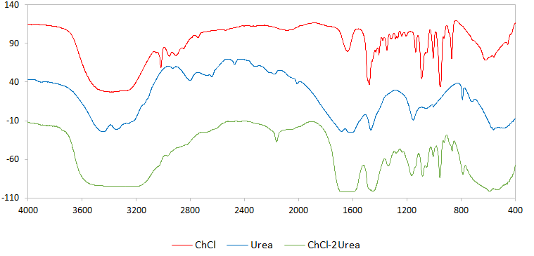

**Fig. S1** The FT-IR spectrum of ChCl, urea and ChCl-urea DES

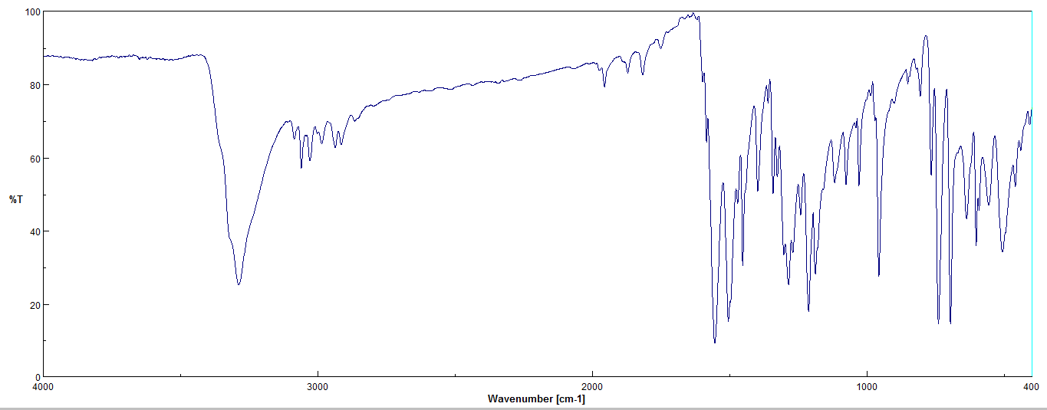



**Fig. S2.** The FT-IR spectrum of 1,3-dibenzylthiourea (3a)

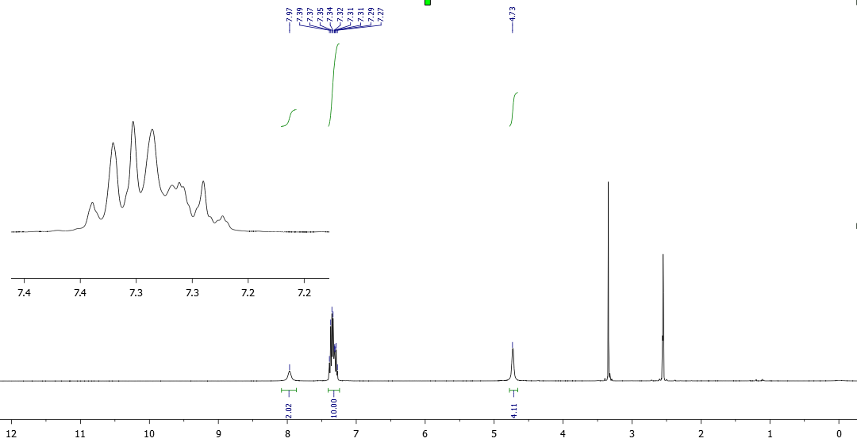



**Fig. S3.** The 1H-NMR spectrum (400 MHz, DMSO-d6) of 1,3-dibenzylthiourea (3a)

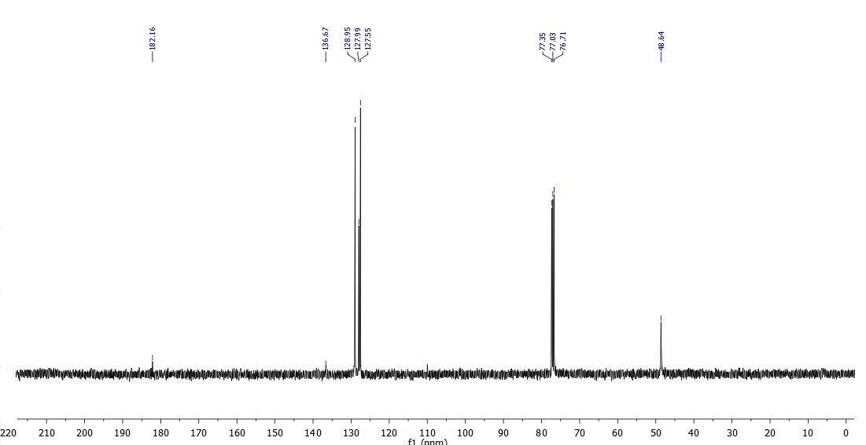



**Fig. S4.** The 13C-NMR spectrum (100 MHz, CDCl3) of 1,3-dibenzylthiourea (3a)



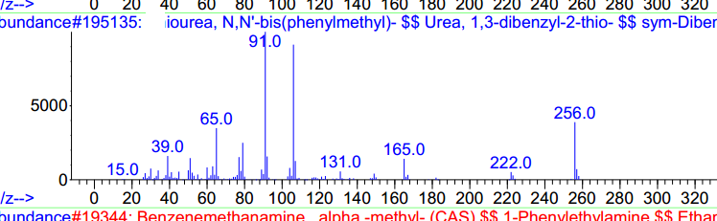

**Fig. S5**. The Mass spectrum of 1,3-dibenzylthiourea (3a)

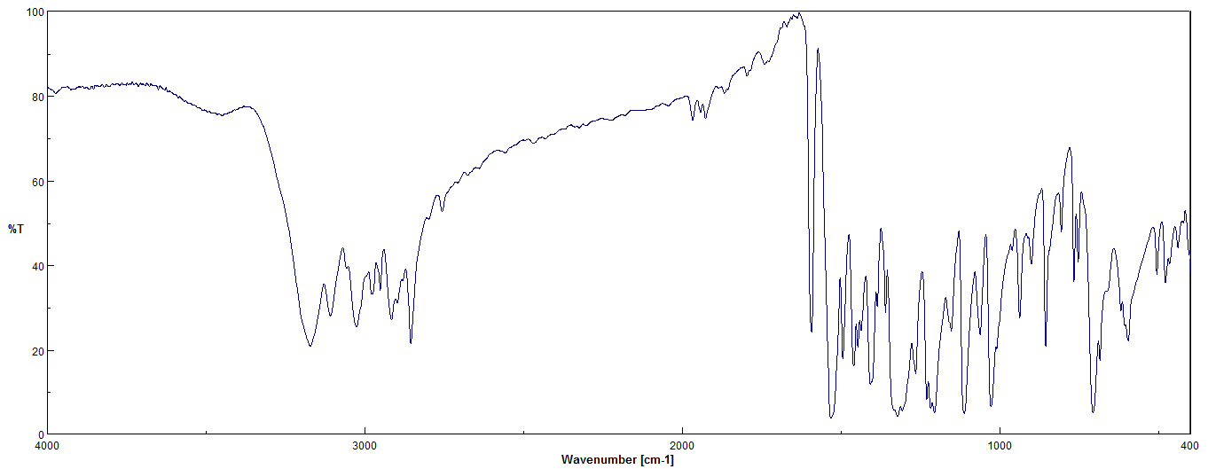



**Fig. S6.** The FT-IR spectrum of 1,3-diphenylthiourea (3b)





**Fig. S7.** The 1H-NMR spectrum (400 MHz, DMSO-d6) 1,3-diphenylthiourea (3b)





**Fig. S8.** The 13C-NMR spectrum (100 MHz, DMSO-d6) 1,3-diphenylthiourea (3b)



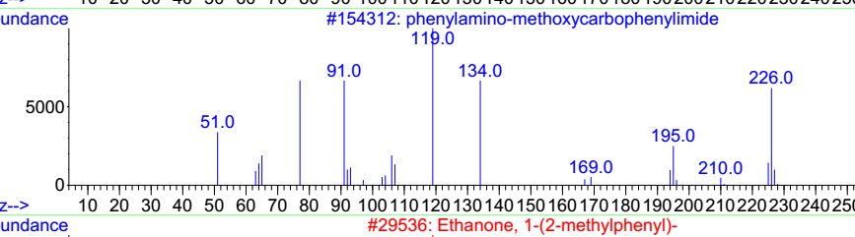

**Fig. S9.** The Mass spectrum of 1,3-diphenylthiourea (3b)

 **Fig. S10**. The 13C-NMR spectrum (400 MHz, DMSO-d6) of 1,3-bis(3-hydroxyphenyl)thiourea (3c). The extra signals in 157.34 and between 10-60 ppm are belong to DMSO-d6 and ethyl acetate (purification solvent)



 **Fig. S11**. The 1H-NMR spectrum (400 MHz, DMSO-d6) of 1,3-bis(3-hydroxyphenyl)thiourea (3c). The extra signals between 1-4 ppm are belong to DMSO-d6 and ethyl acetate (purification solvent)



 **Fig. S12**. The 1H-NMR spectrum (400 MHz, DMSO-d6) of 1,3-bis(3,4-dimethoxyphenethyl)thiourea (3d)



 **Fig. S13**. The 13C-NMR spectrum (400 MHz, DMSO-d6) of 1,3-bis(3,4-dimethoxyphenethyl)thiourea (3d)



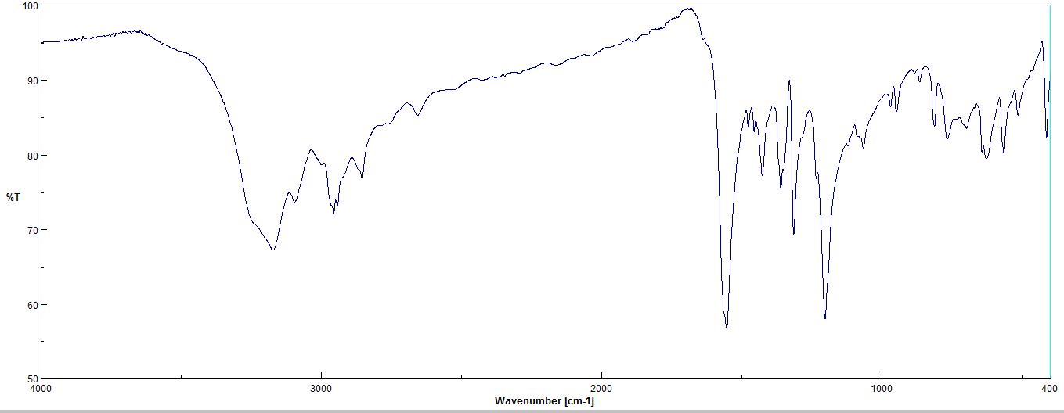



**Fig. S14.** The FT-IR spectrum of tetrahydropyrimidine-2(1H)-thione (5a)

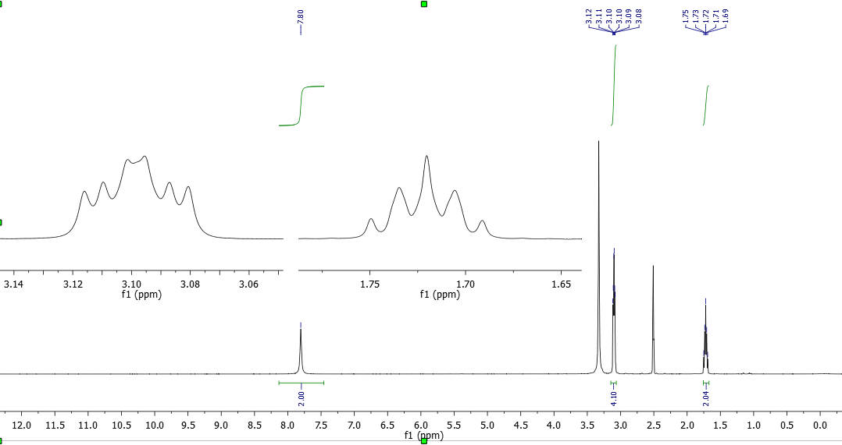



**Fig. S15.** The 1H-NMR spectrum (400 MHz, DMSO-d6) of tetrahydropyrimidine-2(1H)-thione (5a)

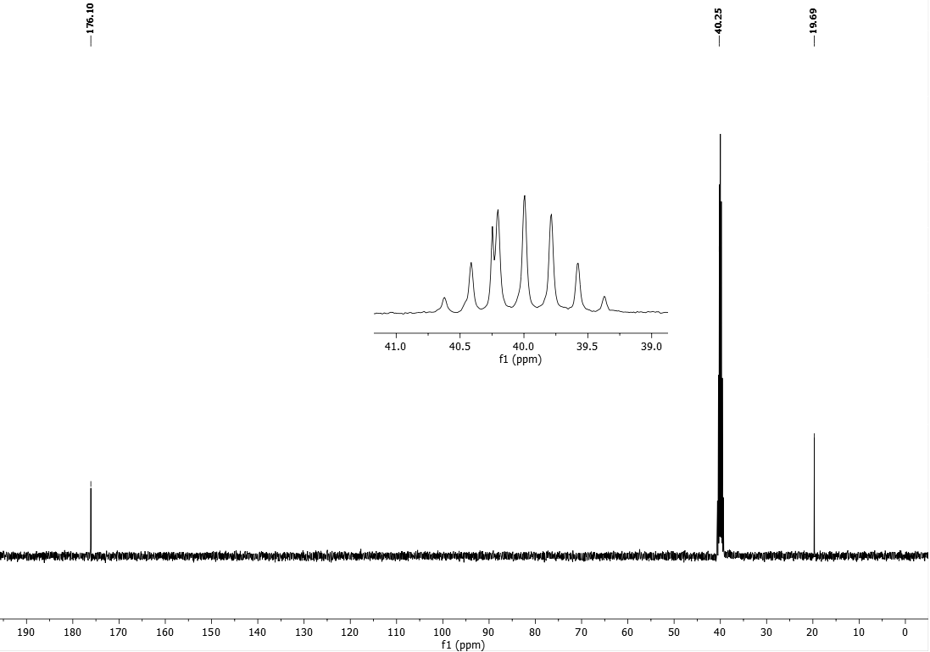



**Fig. S16.** The 13C-NMR spectrum (100 MHz, DMSO-d6) of tetrahydropyrimidine-2(1H)-thione (5a)

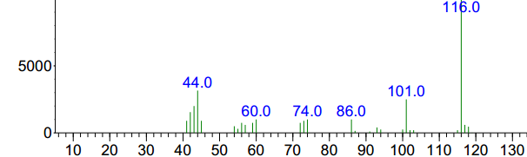



**Fig. S17.** The Mass spectrum of Tetrahydropyrimidine-2(1H)-thione (5a)

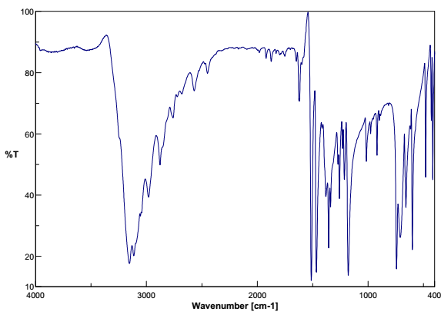



**Fig. S18.** The FT-IR spectrum of 1,3-dihydro-2H-benzo[d]imidazole-2-thione (5b)

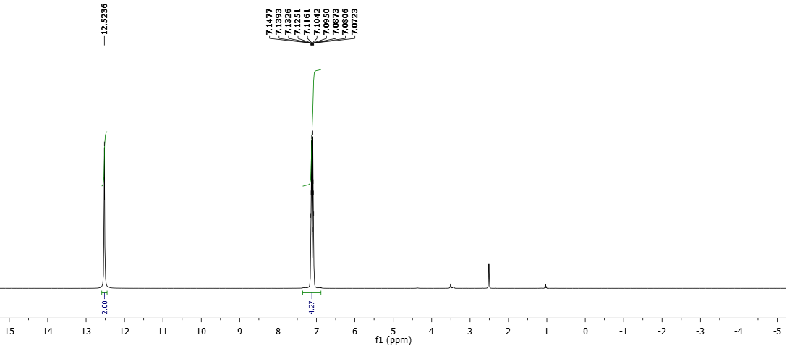



**Fig. S19.** The 1H-NMR spectrum (400 MHz, DMSO-d6) of 1,3-dihydro-2H-benzo[d]imidazole-2-thione (5b)

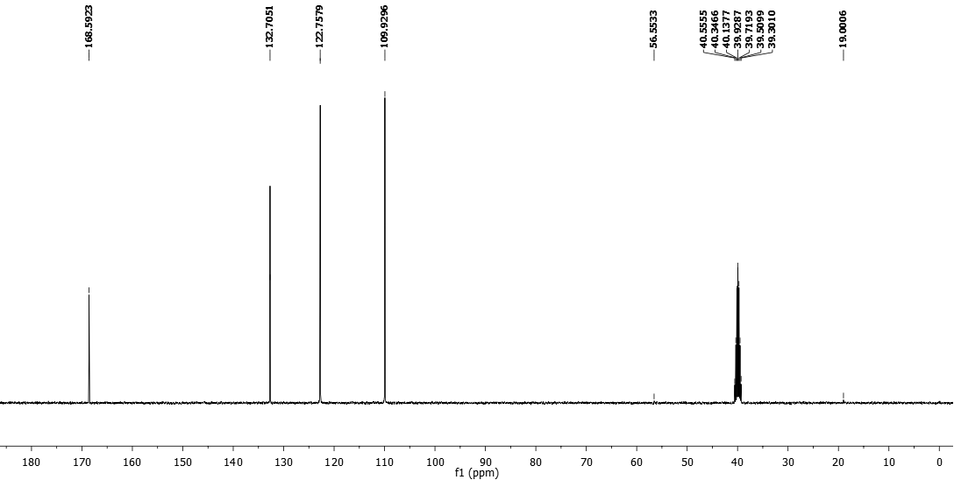



**Fig. S20.** The 13C-NMR spectrum (100 MHz, DMSO-d6) of 1,3-dihydro-2H-benzo[d]imidazole-2-thione (5b)

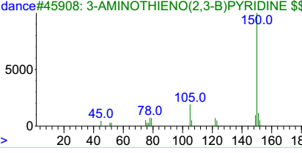



**Fig. S21.** The Mass spectrum of 1,3-dihydro-2H-benzo[d] imidazole-2-thione (5b)

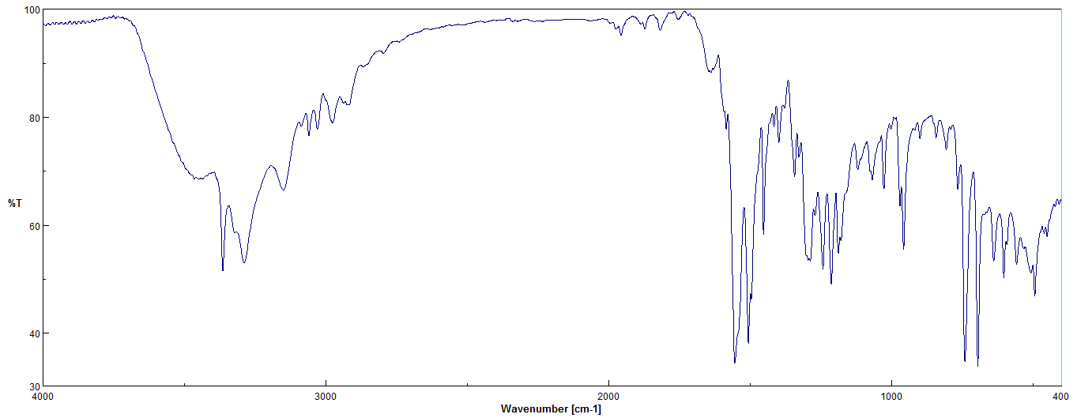



**Fig. S22.** The FT-IR spectrum of 1-benzyl-3-phenylthiourea (7a)

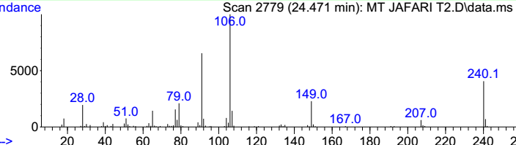



**Fig. S23.** The Mass spectrum of 1-benzyl-3-phenylthiourea (7a)

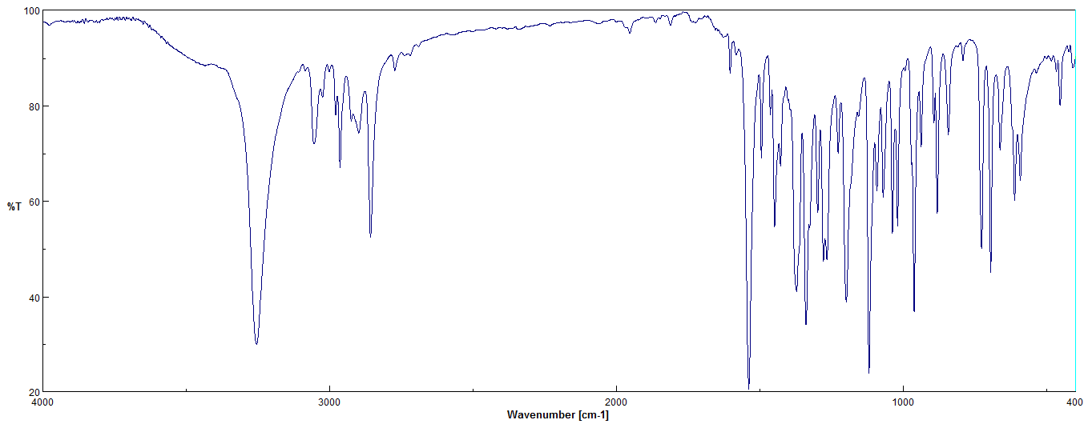



**Fig. S24.** The FT-IR spectrum ofN-benzylmorpholine-4-carbothioamide (7b)

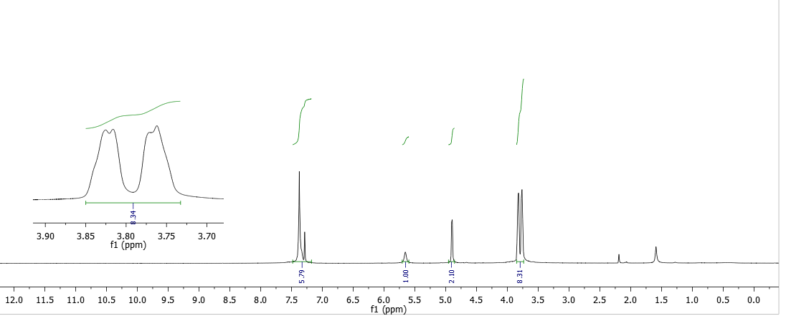



**Fig. S25.** The 1H-NMR spectrum (400 MHz, CDCl3) ofN-benzylmorpholine-4-carbothioamide (7b)

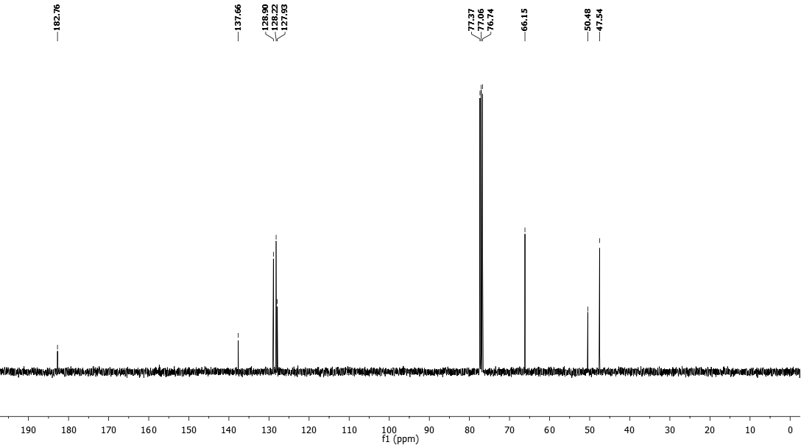



**Fig. S26.** The 13C-NMR spectrum (100 MHz, CDCl3) ofN-benzylmorpholine-4-carbothioamide (7b)

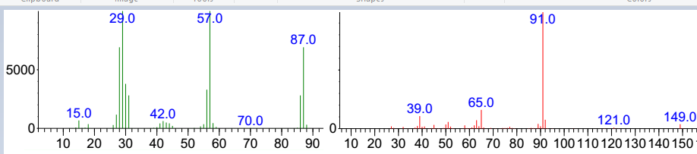



**Fig. S27.** The Mass spectrum of N-benzylmorpholine-4-carbothioamide (7b). This product was fragmented during the GC analysis and Its Mass spectrum consisted of two separate parts with M/z= 87, 149

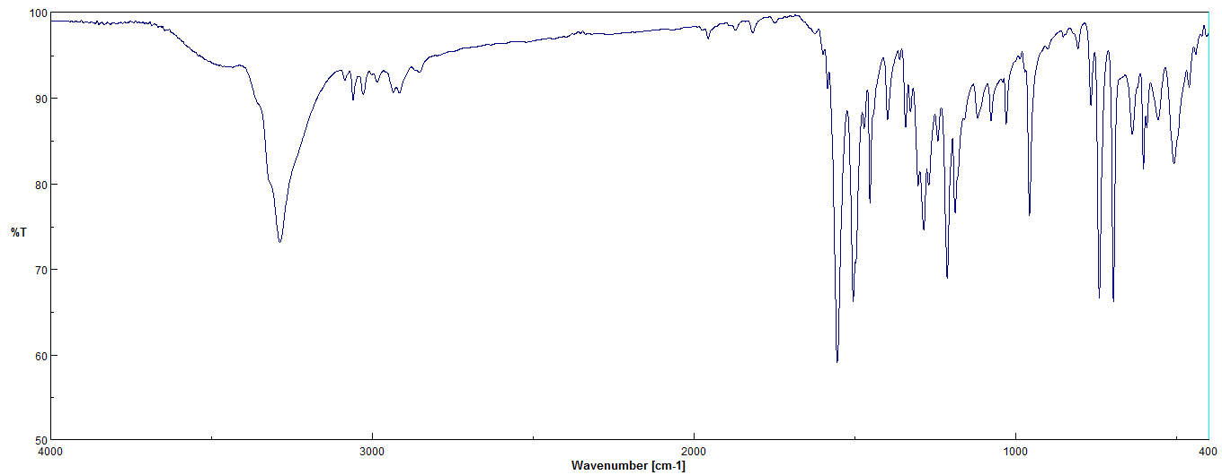



**Fig. S28.** The FT-IR spectrum of N-phenylmorpholine-4-carbothioamide (7C)

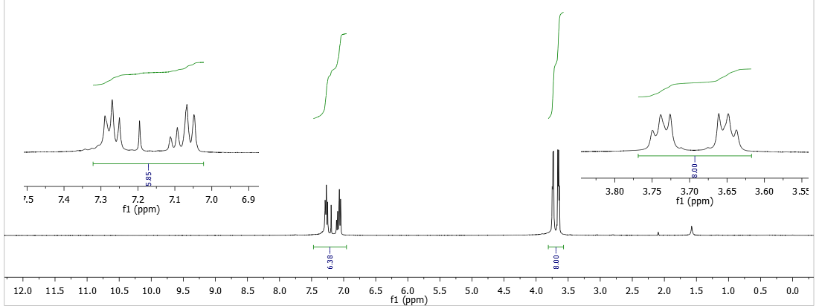



**Fig. S29.** The 1H-NMR spectrum (400 MHz, CDCl3) of N-phenylmorpholine-4-carbothioamide (7C)

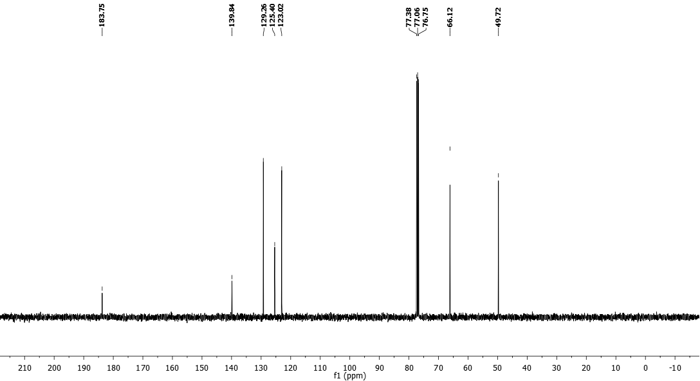



**Fig. S30.** The 13C-NMR spectrum (100 MHz, CDCl3) of N-phenylmorpholine-4-carbothioamide (7C)

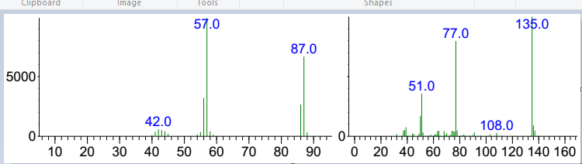



**Fig. S31.**The Mass spectrum of N-phenylmorpholine-4-carbothioamide (7C). This product was fragmented during the GC analysis and Its Mass spectrum consisted of two separate parts with M/z= 87, 135***.***

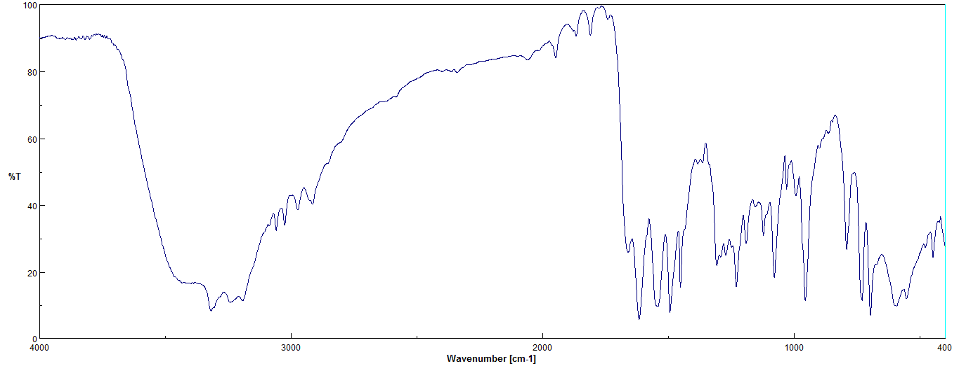



**Fig. S32.** The FT-IR spectrum of N-benzylhydrazinecarbothioamide (7d)

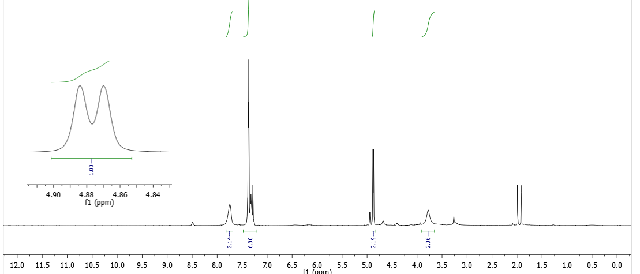



**Fig. S33.** The 1H-NMR spectrum (400 MHz, CDCl3) ofN-benzylhydrazinecarbothioamide (7d)