SUPPLEMENTARY DATA

MicroRNA Therapeutics: Design of single-stranded miR-216b mimics to target KRAS in pancreatic cancer cells †

Annalisa Ferino,^{a,&} Giulia Miglietta,^{a,& †} Raffaella Picco,ª Stefan Vogel,^{b} Jesper Wengel and Luigi E. Xodo ª *
- Department of Medicine, Laboratory of Biochemistry, University of Udine, Italy; luigi.xodo@uniud.it;
- Nucleic Acids Centre, University of Southern Denmark, DK 5230, Odense, Denmark
- .

Supplementary data, S1. miRNA and FC values calculated for three dataset (GSE43796, E-MTAB-753 and GSE41372).

Three miRNA expression datasets (GSE41372, GSE43796, E-MTAB-753) of pancreatic cancer were retrieved from GEO (Barrett, 2011) and ArrayExpress (Parkinson, 2007). The available raw files have been downloaded. As for the affymetrix platform, the CEL files were processed using standard tools available within the affy package in R (Gautier, 2004), they were normalized using the standard RMA algorithm (Irizarry, 2003). The Agilent raw data text files were normalized between arrays by quantile normalization using the limma library (Ritchie, 2015). A statistical analysis was performed using the standard t-test for unpaired samples (tumour samples and non-tumour samples were unrelated). Differentially expressed miRNAs in the malignant tissues were defined as those characterized by a P <0.05 and a fold change FC >1.5 or FC < -1.5. We searched for a correlation between KRAS and the differentially expressed miRNAs by using miRGate (Andrés-León et al., 2015), Targetscan (Lewis et al., 2005) and Miranda (Betel et al., 2010).

Supplementary data, S2. Levels of KRAS mRNA in Panc-1 cells measured by quantitative real-time PCR. The assay has been performed 16, 40 and 72 h after the second treatment with 10 nM single-stranded miR-216b and UNA-modified miRNA mimics with and without a phosphate at the 5’ end. .

RNA Extraction and Real-time PCR
Panc-1 cells (15x10³) were transfected in a 96-well plate with 10 nM miRNA 216b as described above. RNA was extracted 16, 40 and 72 h after the second transfection by using iScript™ RT-qPCR Sample Preparation Reagent (Bio Rad) following the manufacturer’s instructions. For cDNA synthesis 1.25 μl of RNA (extracted from about 10³ cells) was heated at 55 °C and placed in ice. The solution was added to 11.25 μl of mix containing (final concentrations) 1 x buffer, 0.01 M DTT (Invitrogen), 1.6 μM primer dT (MWG Biotech, Ebersberg, Germany; d(T)16), 1.6 μM Random hexamer primers (Microsynth), 0.4 mM dNTPs solution containing equimolar amounts of dATP, dCTP, dGTP, and dTTP (Euroclone, Pavia, Italy), 0.8 units/μl RNase OUT, and 8 units/μl of Maloney murine leukemia virus reverse transcriptase (Invitrogen). The reactions were incubated for 1 h at 37 °C and stopped with heating at 95 °C for 5 min.
Real-time PCR multiplex reactions were performed with 1 x Kapa Probe fast qPCR kit (KAPA Biosystems, Wilmington, MA, USA) for KRAS and housekeeping genes β2-microglobulin and HPRT, 1.0 μl of cDNA in 10 μl final and primers/probes at the following concentrations: for KRAS, the probe was FAM-TACTCCTCTTGACCTGCTGTG-BHQ1 (accession No. NM_033360, from 352 to 372, 90 nM), the sense primer was 5′-CGAATATGATCCAACAATAGAG (from 271 to 292, 180 nM) and the antisense primer was 5′-ATGTACTGGTCCCTCATT (from 379 to 396, 180 nM). For β2-microglobulin accession n. NM_004048 probe ROX-TATGCCTGCCGTGTGAACC-BHQ2 (from 352 to 370, 60 nM), the primer sense was 5′-CCCCACTGAAAAAGATGA (from 333 to 350, 100 nM), the primer antisense was 5′-CCATGATGCTGCTTACAT (from 415 to 432, 100 nM). For HPRT accession n. NM_000194 probe 5′-Cy5-CTTGCGACCTTGACCATCTT-BHQ2 (from 633 to 652, 180 nM), the primer sense was 5′-CTTGATTGTGGAAGATATAATTG (from 557 to 575, 210 nM), the primer antisense was 5′-TATATCCAACACTTCGTGG (from 672 to 690, 230 nM). The PCR cycle was: 3 min at 95 °C, 50 cycles 10 s at 95 °C, 60s at 58 °C. PCR reactions were carried out with a CFX-96 real-time PCR apparatus controlled by an Optical System software (version 3.1) (BioRad Laboratories, CA, USA). KRAS mRNA was normalized with the two housekeeping genes.

Supplementary S3

Table 1. Molecular masses of UNA-modified RNAs by MALDI MS
miRNA sequence* | Name | Calculated | Found
5’-rArArArUrCrUrCrUrGrCrArGrGrCrArArArUrGrUrGuA | U1 | 7051,4 | 7051,3
5’-rArArArUrCrUrCrUrGrCuArGrGrCrArArArUrGrUrGuA | U2 | 7053,4 | 7053,4
5’-rArArArCrUrGrUrGrGrCrArGrGrCrArCrCrUrGrUrGuA | mut | 7082,4 | 7082,7
5’P-rArArArUrCrUrCrUrGrCrArGrGrCrArArArUrGrUrGuA | U1-P | 7131,3 | 7131,3
5’P-rArArArUrCrUrCrUrGrCuArGrGrCrArArArUrGrUrGuA | U2-P | 7133,3 / | 7133,6
* uA= unlocked nucleic acid

Maldi spectrum of miR-216b with one UNA modification (U1)
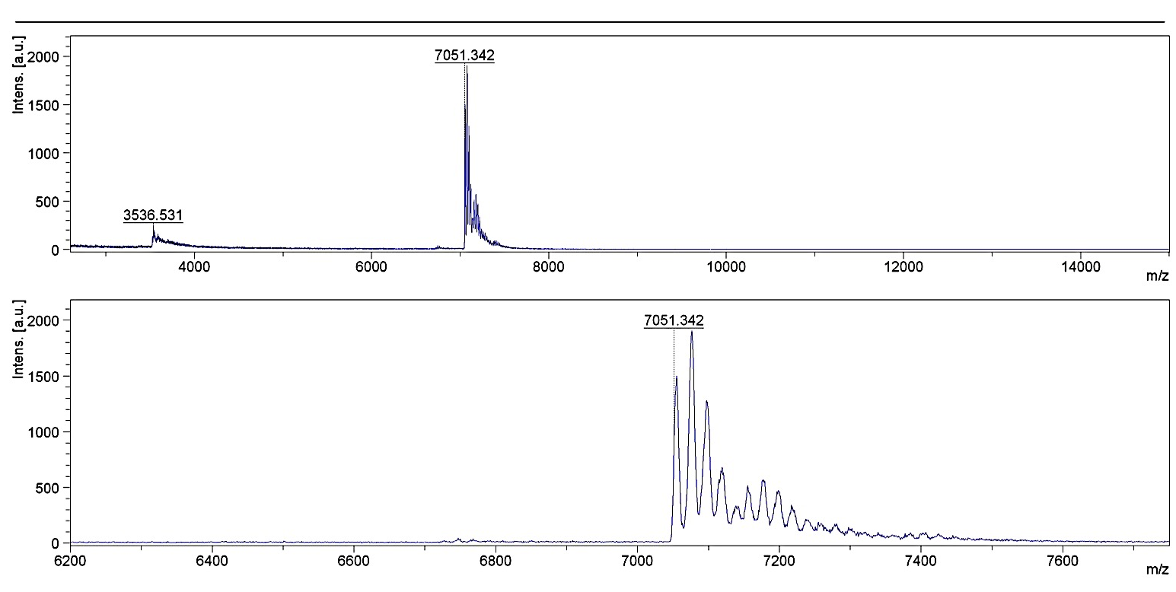

Maldi spectrum of miR-216b with two UNA modification (U2)
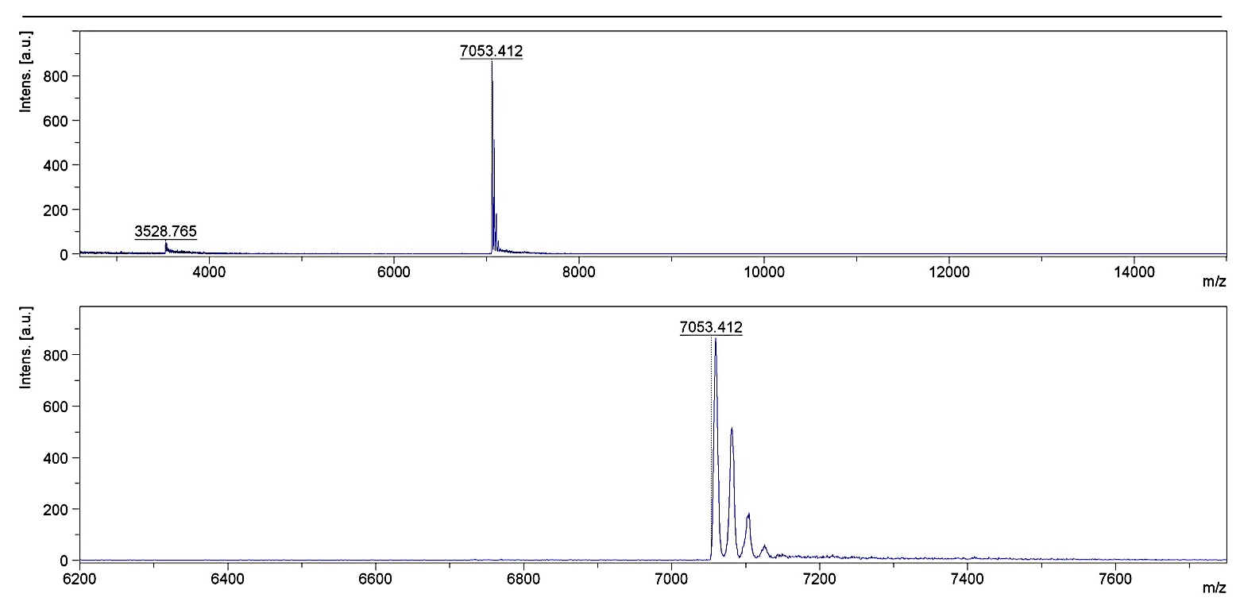

Maldi spectrum of mut with one UNA modification (U1)
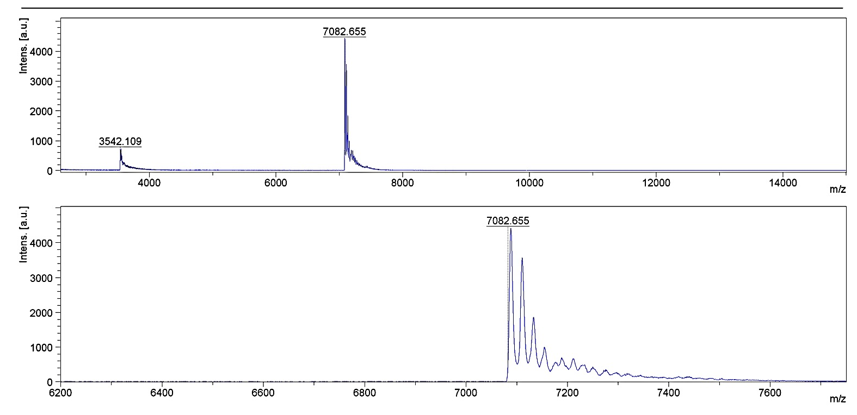

Maldi spectrum of miR-216b with one UNA modification and 5’-phosphate (U1-P)
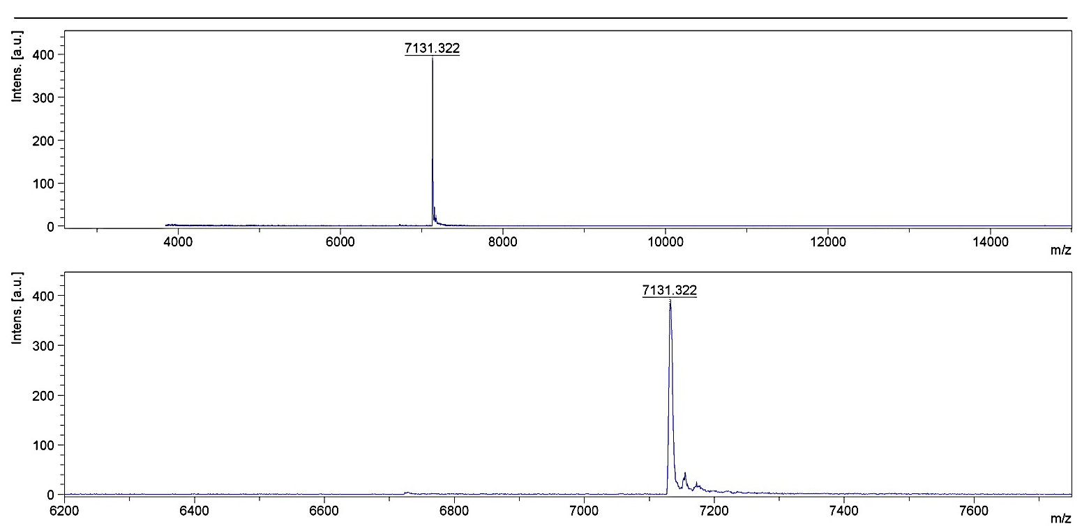

Maldi spectrum of miR-216b with two UNA modifications and 5’-phosphate (U2-P)
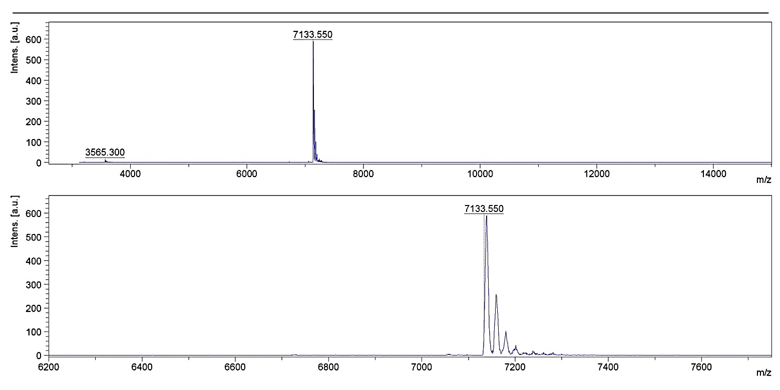

Supplementary S4
Table 2. Oligonucleotides used in this study.
216b | 5’-rArArArUrCrUrCrUrGrCrArGrGrCrArArArUrGrUrGrA
U1 | 5’-rArArArUrCrUrCrUrGrCrArGrGrCrArArArUrGrUrGuA
U2 | 5’-rArArArUrCrUrCrUrGrCuArGrGrCrArArArUrGrUrGuA
mut | 5’-rArArArCrUrGrUrGrGrCrArGrGrCrArCrCrUrGrUrGuA
216b-P | 5’P-rArArArUrCrUrCrUrGrCrArGrGrCrArArArUrGrUrGrA
U1-P | 5’P-rArArArUrCrUrCrUrGrCrArGrGrCrArArArUrGrUrGuA
U2-P | 5’P-rArArArUrCrUrCrUrGrCuArGrGrCrArArArUrGrUrGuA
mut-P | 5’P-rArArArCrUrGrUrGrGrCrArGrGrCrArCrCrUrGrUrGrA
complementary-216b | 5’-rCrArCrArUrUrUrGrCrCrUrGrCrArGArGrArUrUrUrU
complementary-mut: | 5’-rCrArCrArGrGrUrGrCrCrUrGrCrCrArCrArGrUrUrUrU
uA= unlocked nucleic acid modification;

Bibliography
Barrett T, Troup DB, Wilhite SE, et al. NCBI GEO: archive for functional genomics data sets—10 years on. Nucleic Acids Res. 2011 Jan; 39: D1005–1010.

Parkinson H, Kapushesky M, Shojatalab M, et al. Array Express a public database of microarray experiments and gene expression profiles. Nucleic Acids Res. 2007; 35:D747–750.

Gautier L, Cope L, Bolstad BM, et al., Affy--analysis of Affymetrix GeneChip data at the probe level. Bioinformatics. 2004; 20:307-315.

Irizarry RA, Bolstad BM, Collin F, et al., Summaries of Affymetrix GeneChip probe level data. Nucleic Acids Res. 2003; 31:e15.

Ritchie ME, Phipson B, Wu D, et al. limma powers differential expression analyses for RNA-sequencing and microarray studies. Nucleic Acids Res. 2015; 43:e47.

Andrés-León E, González Peña D, Gómez-López G, et al., MiRGate: a curated database of human, mouse and rat miRNA-mRNA targets. Database (Oxford) 2015; 2015:bav035.

Lewis BP, Burge CB, Bartel DP. Conserved seed pairing, often flanked by adenosines, indicates that thousands of human genes are microRNA targets. Cell 2005; 120:15-20.

Betel D, Koppal A, Agius P, et al. Comprehensive modeling of microRNA targets predicts functional non-conserved and non-canonical sites. Genome Biol. 2010;11:R90.

