Supporting Information

Brønsted Acid Promoted Intramolecular Cyclization of O- Alkynyl benzoic acids: Concise Total Synthesis of Exserolide F
Mohan Dumpala, Lingaswamy Kadari and Palakodety Radha Krishna*

D-211, Discovery Laboratory, Organic & Biomolecular Chemistry Division
CSIR-Indian Institute of Chemical Technology, Hyderabad 500007, India.

E-mail: prkgenius@iict.res.in

List of Contents

- General experimental procedure S2
- Experimental procedure S3
- Copies of ¹H NMR and ¹³C NMR spectra S9
- LCMS of compound 4a S19
- References S20

General experimental procedure

Dried organic solvents were used (anh. Na₂SO₄). Air sensitive reagents were transferred by double-ended needle. TLC: Merck 60 F₂₅₄ silica-gel plates. All column chromatographic separations were performed using silica gel (Acme’s, 60-120, 100-200 mesh). Yields refer to chromatographically and spectroscopically (¹H- and ¹³C-NMR) homogenous material. ¹H-NMR spectra were measured on 300 MHz, 400 MHz, and 500 MHz, instruments, and ¹³C-NMR spectra on 50 MHz, 75 MHz and 125 MHz) spectrometer in CDCl₃/Acetone D₆ (7-10 mM soln), TMS as internal standard. J values are given in Hz. All ¹H and ¹³C chemical shifts are reported in ppm (δ). Infrared (IR) spectra were recorded on a Thermo Nicolet Nexus 670 spectrometer. Optical rotations were measured with a JASCO P-1020 instrument and [α]_{D} values were in units of 10⁻¹deg cm² g⁻¹ at 25 ºC. Mass spectra were recorded on Finnigan Mat 1210 double focusing mass spectrometer operating at a direct inlet system and ESI-MS was measured using ion-trap mass spectrometer.

Experimental procedure

(S)-3-(Benzyloxy)hexan-1-ol (5)
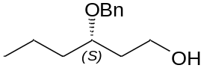
(4S)-2-phenyl-4-propyl-1,3-dioxane was prepared from commercially available trans-2-hexenol according to lit. procedure.¹ To a solution of benzylidene derivative {(4S)-2-phenyl-4-propyl-1,3-dioxane} (2.0 g, 9.7 mmol) in anhydrous CH₂Cl₂ (20 mL) at 0 °C, DIBAL-H (15 mL, 19.4 mmol, 2 M solution in toluene) was added drop wise and stirred for 1 h at room temperature. MeOH (3 mL), followed by saturated aq. sodium potassium tartrate solution (4 mL) were added to the reaction mixture, filtered through a pad of celite and washed with EtOAc (40 mL). The organic layers were dried (Na₂SO₄), evaporated and the residue was purified by silica gel column chromatography (85:15, hexane/EtOAc) to afford compound 5 (1.9 g, 95% yield) as a light yellow liquid. [α]_{D}²⁵ = +25.8 (c 0.4, CHCl₃). ¹H NMR (500 MHz, CDCl₃): δ 7.37-7.26 (m, 5H), 4.59 (d, J = 11.4 Hz, 1H), 4.48 (d, J = 11.4 Hz, 1H), 3.80-3.69 (m, 2H), 3.67-3.62 (m, 1H), 1.88-1.60 (m, 3H), 1.56-1.47 (m, 1H), 1.43-1.32 (m, 2H), 0.93 (t, J = 7.3 Hz, 1H). ¹³C NMR (100 MHz, CDCl₃): δ 138.4, 128.5, 127.8, 127.7, 127.0, 78.4, 70.9, 60.8, 35.8, 35.7, 18.4, 14.3. HRMS m/z: calcd for C₁₃H₂₁O₂ [M+H]⁺ 209.15361 found: 209.15387.
(6S)-6-(Benzyloxy)non-1-yn-4-ol (6)
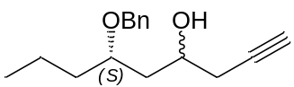
Compound 5 (1.6 g, 7.7 mmol) was dissolved in anhydrous CH₂Cl₂ (20 mL), cooled to 0 °C and Dess-Martin periodinane (3.2 g, 7.7mmol) was added and the resultant mixture was stirred at room temperature for 2 hours. The reaction was quenched with 10% aqueous sodium thiosulfate (20 mL) and saturated aqueous sodium bicarbonate (20 mL), stirred for 10 min, separated, concentrated to provide the aldehyde (1.6 g, 95%) as a yellow oil.
To a stirred suspension on zinc powder (1.5 g, 23.3 mmol) in THF (10 mL) at 0 °C was added propargyl bromide (1.4 mL, 15.2 mmol). The mixture was stirred for 1.5 h, and then a solution of aldehyde (1.6 g, 7.6 mmol) in THF (6 mL) was added drop wise. The resultant mixture was stirred at 0 °C for 15 min, and then the reaction was quenched with sat. aq. NH₄Cl (2 mL). The solid residue was removed by filtration, and 2 M HCl (5 mL) was added to the filtrate. The filtrate was extracted with EtOAc (3 x 15 mL), and the combined organic extracts were washed with sat. aq NaCl (15 mL), dried over Na₂SO₄, and concentrated in vacuo. The residue was purified by silica gel column chromatography (90:10, hexane/EtOAc) to afford a diastereomeric mixture of 6 (1.5 g, 85%, dr = 3:2) as a yellow oil. ¹H NMR (400 MHz, CDCl₃): δ 7.38-7.30 (m, 5H), 4.60 (dd, J = 22.0, 11.2 Hz, 1H), 4.49 (dd, J = 32.2, 11.1Hz, 1H), 4.12-4.03 (m, 0.6H), 3.99-3.90 (m, 0.4H), 3.78-3.71 (m, 1H), 2.39-2.31 (m, 2H), 2.03 (t, J = 2.6 Hz, 0.6H), 2.01 (t, J = 2.6 Hz, 0.4H), 1.86-1.58 (m, 4H), 1.43-1.32 (m, 2H), 0.93 (t, J = 7.3 Hz, 3H). ¹³C NMR (100 MHz, CDCl₃): δ 138.2, 137.8, 128.5, 128.4, 127.8, 127.7, 80.9, 79.4, 71.2, 70.5, 70.4, 70.2, 69.9, 67.0, 39.6, 38.7, 35.5, 27.3, 27.1, 18.6, 17.8, 14.2, 14.1. HRMS m/z: calcd for C₁₆H₂₃O₂ [M+H]⁺ 247.16926 found: 247.16942.
(((4S,6S)-Non-1-yne-4,6-diylbis(oxy))bis(methylene))dibenzene (4a)

NaH (60% in mineral oil, 0.35 g, 14.6 mmol) was washed twice with hexanes and dried in vacuo. To a stirred solution of NaH in THF (12 mL) at 0 °C was added a solution of 6 (1.2 g, 4.8 mmol) in THF (5.0 mL). The mixture was stirred for 40 min, and then BnBr (1.1 mL, 9.6 mmol) was added drop wise followed by TBAI (0.180 g, 0.50 mmol). The resultant mixture was heated to 60 °C and stirred for 1 h. The mixture was then cooled to 0 °C, and the reaction was quenched by the addition of water (5 mL) and EtOAc. The organic layer was separated, and then the aqueous layer was further extracted with EtOAc (2 x 20 mL). The combined organic extracts were washed with sat. aq. NaCl, dried over Na₂SO₄ and concentrated in vacuo. The residue was purified by silica gel column chromatography (95:5, hexane/EtOAc) to afford 4a (0.88 g, 54%) and 4b (0.59 g, 36%) as pale yellow oils:
(((4S,6S)-Non-1-yne-4,6-diylbis(oxy))bis(methylene))dibenzene (4a):
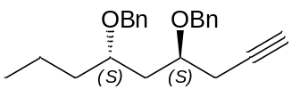
[α]_{D}²⁵ = +29.5 (c 0.4, CHCl₃). ¹H NMR (400 MHz, CDCl₃): δ 7.37-7.26 (m, 10H), 4.64 (d, J = 11.4 Hz, 1H), 4.53 (d, J = 11.4 Hz, 1H), 4.32 (dd, J = 24.6, 11.4 Hz, 2H), 3.81 (td, J = 9.2, 5.1 Hz, 1H), 3.67 (td, J = 9.4, 5.3 Hz, 1H), 2.47 (dd, J = 5.5, 2.5 Hz, 2H), 2.02 (t, J = 2.6 Hz, 1H), 1.83-1.77 (m, 2H), 1.65-1.57 (m, 1H), 1.55-1.47 (m, 1H), 1.40 (dt, J = 15.0, 7.4 Hz, 2H), 0.92 (t, J = 7.3 Hz, 3H). ¹³C NMR (100 MHz, CDCl₃): δ 139.0, 138.4, 128.3, 128.3, 127.9, 127.8, 127.6, 127.4, 81.0, 75.3, 74.0, 71.5, 70.8, 70.3, 40.0, 36.3, 24.1, 18.2, 14.4. IR (neat) νmax 3300, 2927, 2866, 1728, 1456, 1095 cm⁻¹. HRMS m/z: calcd for C₂₃H₂₈O₂Na [M+Na]⁺ 359.19815 found: 359.19831.
(((4R,6S)-Non-1-yne-4,6-diylbis(oxy))bis(methylene))dibenzene (4b)
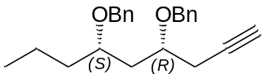
¹H NMR (500 MHz, CDCl₃): δ 7.33-7.26 (m, 10H), 4.64 (d, J = 11.7 Hz, 1H), 4.49 (d, J = 6.2 Hz, 1H), 4.48 (d, J = 5.3, 2H), 3.70-3.65 (m, 1H), 3.56-3.50 (m, 1H), 2.46-2.43 (m, 2H), 2.01 (t, J = 2.7 Hz, 1H), 1.88-1.82 (m, 2H), 1.55-1.27 (m, 4H), 0.87 (t, J = 7.3 Hz, 3H). ¹³C NMR (100 MHz, CDCl₃): δ 138.8, 138.2, 128.3, 128.2, 127.8, 127.7, 127.6, 127.4, 80.9, 75.6, 74.0, 71.0, 70.4, 70.2, 38.1, 36.1, 23.7, 18.4, 14.1. EI-ESI m/z: calcd for C₂₃H₂₈O₂Na [M+Na]⁺ 336.
(4S,6S)-2,2-Dimethyl-4-(prop-2-yn-1-yl)-6-propyl-1,3-dioxane (7a)
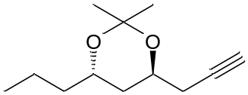
Compound 4a (0.200 g, 0.6 mmol) was dissolved in anhydrous CH₂Cl₂ (6 mL), cooled to 0 °C and TiCl₄ (1.2 mL, 1.2 mmol, 1 M in CH₂Cl₂) was added the resultant mixture was stirred at room temperature for 4 h. After completion of the reaction (monitored by TLC), it was quenched with a saturated solution of NaHCO₃ (10 mL). The organic phase was separated and the aqueous phase extracted with ethyl acetate (5 x 15 mL). The combined organic layers were dried over anhydrous Na₂SO₄ and concentrated under reduced pressure, and then the residue was purified by silica gel column chromatography (85:15, hexane/EtOAc) to afford compound diol (0.08 g, 95%) as a yellow oil.
To a solution of diol (0.08 g, 0.5 mmol) in anhydrous CH₂Cl₂ (10 mL), 2,2-DMP (1.32 mL, 2.16 mmol) and a catalytic amount of p-TSA were added. The mixture was stirred at ambient temperature for 2 h. After completion of the reaction, solid NaHCO₃ was added to neutralize the p-TSA. The solvent was removed in vacuo and the residue was purified by silica gel column chromatography (95:5, hexane/EtOAc) to afford the pure acetonide compound (0.08 g, 80%) as a light yellow liquid. [α]_{D}²⁵ = -25.5 (c 0.2, CHCl₃). ¹H NMR (500 MHz, CDCl₃): δ 4.01-3.93 (m, 1H), 3.88-3.79 (m, 1H), 2.46 (dd, J = 2.6, 7.7 Hz,1H), 2.26 (dd, J = 2.6, 7.7 Hz, 1H), 2.00 (t, J = 2.6, Hz, 1H), 1.75-1.60 (m, 2H), 1.45-1.30 (m, 4H), 1.44 (s, 6H), 0.91 (t, J = 6.9 Hz, 3H). ¹³C NMR (100 MHz, CDCl₃): δ 100.4, 80.6, 69.7, 66.3, 65.3, 37.9, 37.6, 25.6, 24.9, 24.7, 18.5, 13.9. EI-ESI m/z: calcd for C₁₂H₂₀O₂Na [M+Na]⁺ 219.
(4R,6S)-2,2-Dimethyl-4-(prop-2-yn-1-yl)-6-propyl-1,3-dioxane (7b)
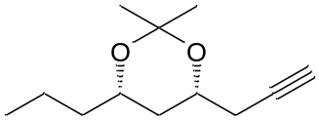
[α]_{D}²⁵ = +10.5 (c 0.3, CHCl₃). ¹H NMR (400 MHz, CDCl₃): δ 3.99-3.96 (m, 1H), 3.84-3.83 (m, 1H), 2.46 (dd, J = 2.6, 7.7 Hz, 1H), 2.27 (dd, J = 2.6, 7.9 Hz, 1H), 2.08 (t, J = 2.6 Hz, 1H), 1.76 (m, 1H), 1.6-1.2 (m, 11H), 0.91 (t, J = 6.9 Hz, 3H). ¹³C NMR (100 MHz, CDCl₃): δ 98.7, 80.4, 70.2, 68.6, 67.8, 38.5, 36.1, 30.1, 26.3, 19.8, 18.1, 14.0. EI-ESI m/z: calcd for C₁₂H₂₀O₂Na [M+Na]⁺ 219.
7-(Benzyloxy)-2,2-dimethyl-4-oxo-4H-benzo[d][1,3]dioxin-5-yl trifluoro-methanesulfonate (3)

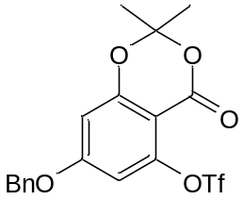

Compound 3 was prepared from commercially available 2,4,6 tri hydroxyl benzoic acid according to lit. procedure.² Mp: 87-90 ºC. ¹H NMR (500 MHz, CDCl₃): δ 7.46-7.36 (m, 5H), 6.61 (d, J = 2.2 Hz, 1H), 6.56 (d, J = 2.3 Hz, 1H), 5.10 (s, 2H), 1.74 (s, 6H). ¹³C NMR (125 MHz, CDCl₃): δ 164.6, 158.8, 157.0, 149.9, 134.6, 128.9, 128.8, 127.7, 117.5, 106.6, 105.8, 102.0, 101.2, 71.2, 25.5. HRMS m/z: calcd for C₁₈H₁₅O₇F₃NaS [M+Na]⁺ 455. 03828 found: 455. 03811.
7-(Benzyloxy)-5-((4S,6S)-4,6-bis(benzyloxy)non-1-yn-1-yl)-2,2-dimethyl-4H-benzo[d][1,3]dioxin-4-one (2)
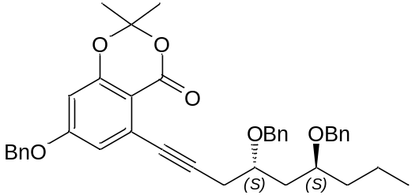

CuI (0.03 g, 0.19 mmol), diethylamine (0.54 mL, 3.8 mmol), PdCl₂(PPh₃)₂ (0.067 g, 0.09 mmol), and 3 (0.82 g, 1.9 mmol) were added to a solution of 4a (0.64 g, 1.9 mmol) in anhydrous acetonitrile (10 mL) under Nitrogen atmosphere and the mixture was allowed to stir at 70 ºC for 30 min. H₂O (5 mL) was added and the mixture was extracted with ethyl acetate (3 x 5 mL) and the combined organic solution was washed with saturated aqueous NaCl (5 mL) solution, dried over anhydrous NaSO₄, and the solvent was evaporated under reduced pressure. The residue was purified by silica gel column chromatography (90:10 hexane/EtOAc) to afford compound 2 (0.82 g, 70%) as a yellow oil liquid; [α]_{D}²⁵ = +40.0 (c 0.2, CHCl₃). ¹H NMR (400 MHz, CDCl₃): δ 7.41- 7.28 (m, 15H), 6.82 (d, J = 2.5 Hz, 1H), 6.44 (d, J = 2.4 Hz, 1H), 5.02 (s, 1H), 4.74 (d, J = 11.5 Hz, 1H), 4.53 (d, J = 11.4 Hz, 1H), 4.44 (d, J = 11.4 Hz, 1H), 4.34 (d, J = 11.4 Hz, 1H), 3.99-3.91 (m, 1H), 3.75-3.67 (m, 1H), 2.77 (dd, J = 20.1, 9.3 Hz, 2H), 1.97 (ddd, J = 14.5, 9.3, 2.9 Hz, 1H), 1.85 (ddd, J = 14.5, 9.5, 3.1 Hz, 1H), 1.68 (s, 6H), 1.63-1.55 (m, 2H), 1.48-1.37 (m, 2H), 0.91 (t, J = 7.3 Hz, 3H). ¹³C NMR (125 MHz, CDCl₃): δ 163.5, 158.7, 158.1, 139.0, 138.6, 135.5, 128.7, 128.3, 128.2, 128.2, 127.9, 127.7, 127.5, 127.3, 116.3, 105.4, 102.5, 94.5, 80.2, 75.5, 74.5, 71.6, 70.6, 70.3, 60.3, 40.3, 36.4, 29.6, 25.8, 25.6, 18.3, 14.3. IR (neat) νmax 3031, 2926, 2866, 2235, 1740, 1601, 1573, 1276, 1170 cm⁻¹. HRMS m/z: calcd for C₄₀H₄₂O₆Na [M+Na]⁺ 641.28736 found: 641.28763.

6-(Benzyloxy)-3-((2R,4S)-2,4-bis(benzyloxy)heptyl)-8-hydroxy-1H-isochromen-1-one (8)

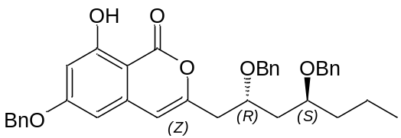

Trifliuoromethanesulfonic acid (0.02 mL, 0.3 mmol) was added to a solution of 2 (0.200 g, 0.3 mmol) in THF (5 mL) at room temperature and the mixture was refluxed for 7 h. The reaction mixture was poured to ice-water and neutralized with saturated aqueous NaHCO₃. The aqueous solution was extracted with ethyl acetate (3 x 5 mL) and the combined organic solution was washed with saturated aqueous NaCl solution, dried over anhydrous MgSO₄, and the solution was concentrated under reduced pressure. The residue was purified by silica gel column chromatography (92:8, hexane/EtOAc) to afford compound 8 (0.16 g, 90%) as a yellow oil; [α]_{D}²⁵ = +15.0 (c 0.1, CHCl₃). ¹H NMR (500 MHz, CDCl₃): δ 11.09 (s, 1H), 7.43-7.29 (m, 10H), 7.25-7.18 (m, 5H), 6.54 (d, J = 2.3 Hz, 1H), 6.33 (d, J = 2.3 Hz, 1H), 6.20 (s, 1H), 5.12 (s, 2H), 4.54 (d, J = 11.4 Hz, 1H), 4.48 (d, J = 11.4 Hz, 1H), 4.37 (d, J = 11.4 Hz, 1H), 4.30 (d, J = 11.4 Hz, 1H), 4.06-3.99 (m, 1H), 3.67-3.60 (m, 1H), 2.73 (dd, J = 14.7, 6.3 Hz, 1H), 2.67 (dd, J = 14.5, 6.0 Hz, 1H), 1.74 (td, J = 6.1, 3.1 Hz, 2H), 1.65-1.46 (m, 2H), 1.42-1.28 (m, 2H), 0.92 (t, J = 7.3 Hz, 3H). ¹³C NMR (100 MHz, CDCl₃): δ 166.0, 165.7, 163.5, 154.6, 139.1, 138.7, 138.1, 135.7, 128.7, 128.3, 128.3, 127.9, 127.8, 127.6, 127.5, 127.4, 106.1, 101.9, 101.1, 100.2, 75.4, 73.9, 71.9, 70.7, 70.2, 40.4, 39.0, 36.1, 29.6, 18.1, 14.3. IR (neat) νmax 3031, 2925, 2857, 1685, 1621, 1165, 1064 cm⁻¹. HRMS m/z: calcd for C₃₇H₃₈O₆Na [M+Na]⁺ 601. 25606 found: 601. 25533.

3-((2R,4S)-2,4-Dihydroxyheptyl)-6,8-dihydroxy-1H-isochromen-1-one (1)

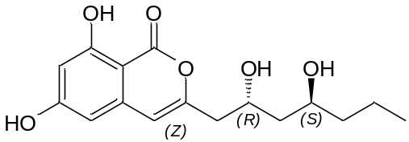

To a stirred solution of 8 (0.05 g, 0.08 mmol) in CH₂Cl₂ (5 mL), TiCl₄ (1.0 mL, 0.24 mmol, 1 M in CH₂Cl₂) was added at 0 °C and the reaction mixture stirred at room temperature for 4 h. After completion of the reaction (monitored by TLC), it was quenched with a saturated solution of NaHCO₃ (10 mL). The organic phase was separated and the aqueous phase extracted with ethyl acetate (5 x 15 mL). The combined organic layers were dried over anhydrous Na₂SO₄ and concentrated under reduced pressure, and then the residue was purified by silica gel column chromatography (60:40, hexane/EtOAc) to afford compound 1 (0.02 g, 95%) as a white amorphous solid. [α]_{D}²⁵ = -15.0 (c = 0.05, MeOH), lit.³ [α]_{D}²⁵ = -15.6 (c = 0.09, MeOH). ¹H NMR (500 MHz, Acetone-d₆): δ 11.15 (s, 1 H), 6.43 (s, 1H), 6.40 (d, J = 2.2 Hz, 1 H), 6.37 (d, J = 2.2 Hz, 1H), 4.31 (m, 1H), 4.20 (br. s, 1H), 3.89 (m, 1H), 3.74 (br. s, 1H), 2.66 (dd, J = 14.4, 4.4 Hz, 1H), 2.60 (dd, J = 14.3, 8.0 Hz, 1H), 1.62-1.58 (m, 2H), 1.46-1.36 (m, 4H), 0.89 (t, J = 7.0 Hz, 3H). ¹³C NMR (100 MHz, Acetone-d6): δ 167.2, 166.5, 164.5, 156.5, 141.0, 106.5, 103.4, 102.2, 99.8, 68.3, 66.7, 44.9, 42.8, 41.2, 19.6, 14.5. IR (neat) ν_{max} 3421, 2926, 2860, 1681, 1625, 1462, 1384, 1168, 845 cm⁻¹. HRMS m/z: calcd for C₁₆H₂₀O₆Na [M+Na]⁺ 331.11521 found: 331.11609.

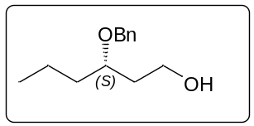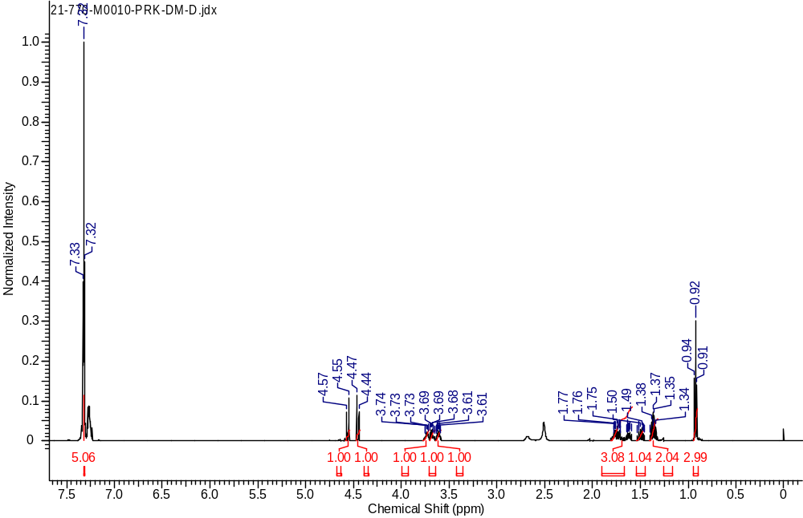
¹H NMR Spectrum of compound 5 in CDCl₃ (500 MHz)
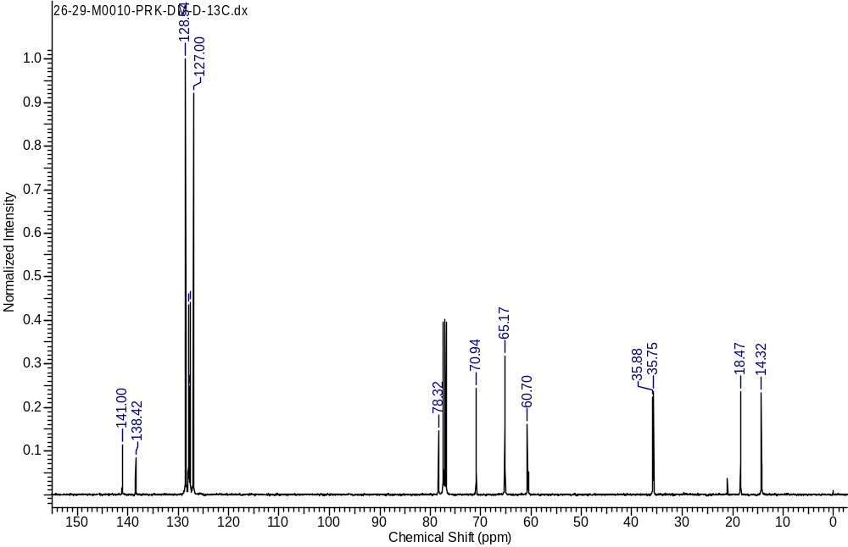
¹³C NMR Spectrum of compound 5 in CDCl₃ (100 MHz)

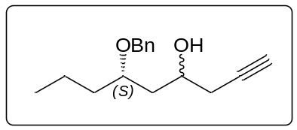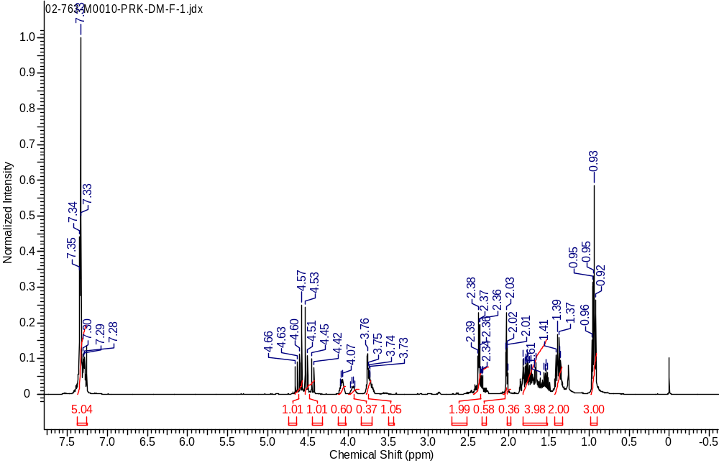
¹H NMR Spectrum of compound 6 in CDCl₃ (400 MHz)
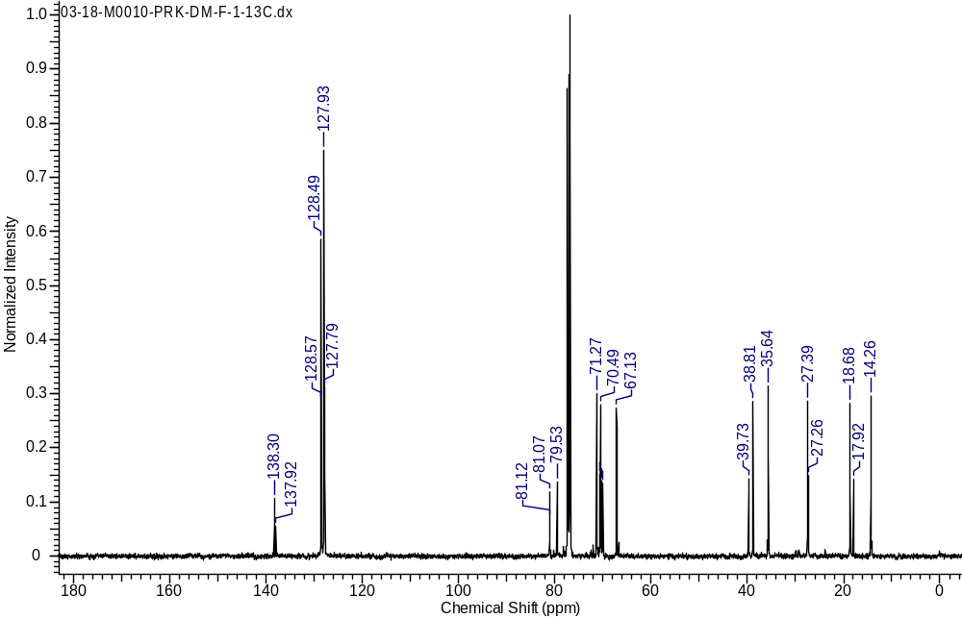
¹³C NMR Spectrum of compound 6 in CDCl₃ (100 MHz)

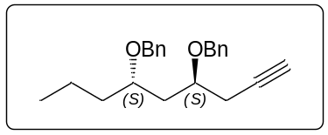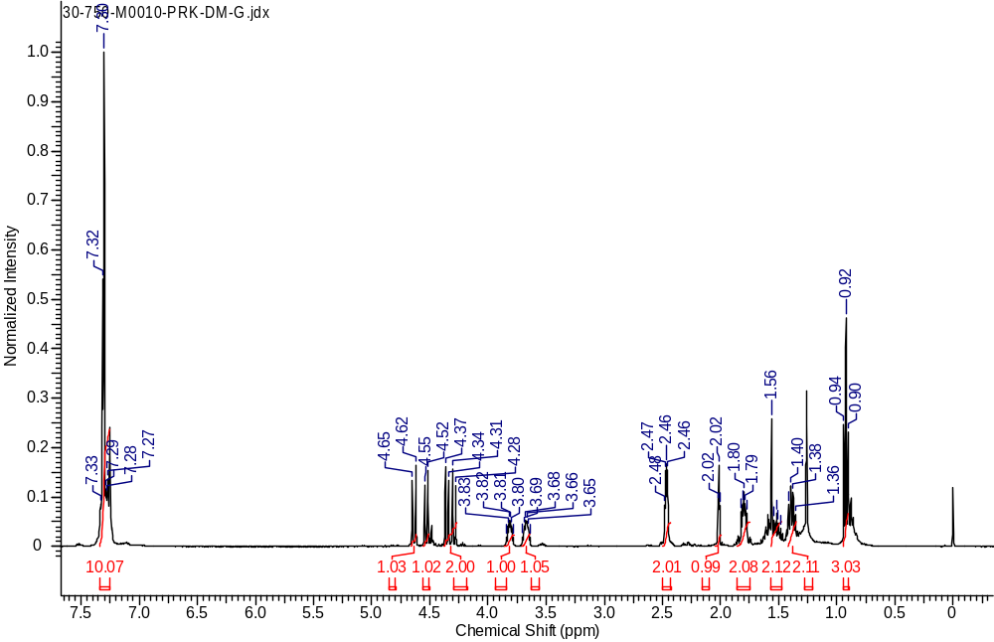
¹H NMR Spectrum of compound 4a in CDCl₃ (400 MHz)

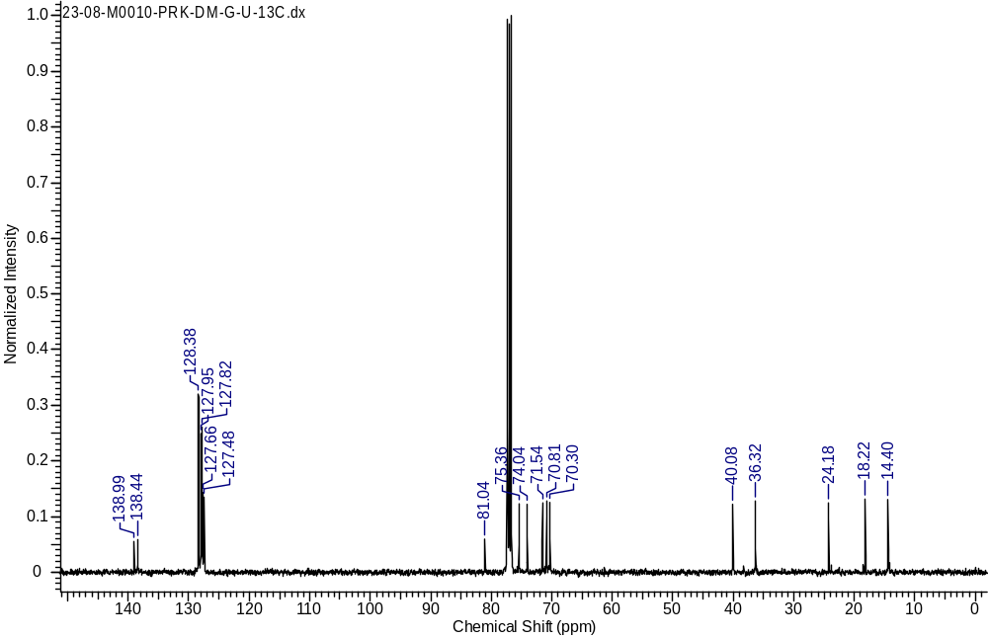
¹³C NMR Spectrum of compound 4a in CDCl₃ (100 MHz)

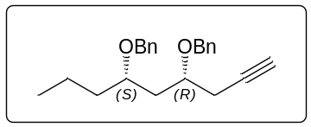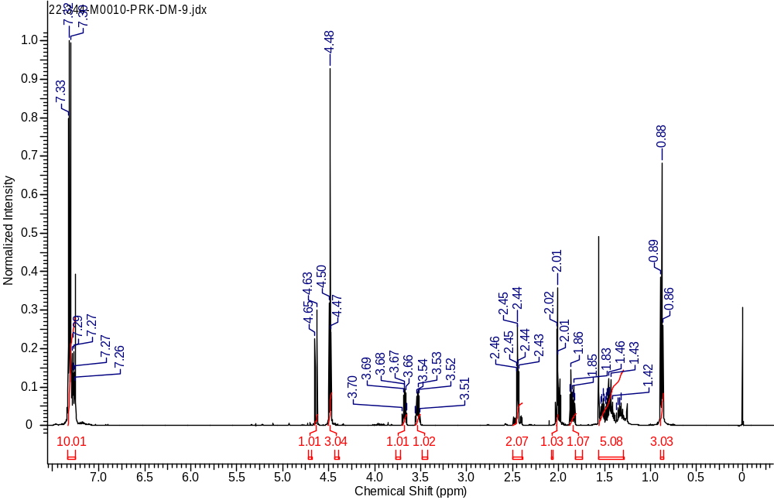
¹H NMR Spectrum of compound 4b in CDCl₃ (500 MHz)
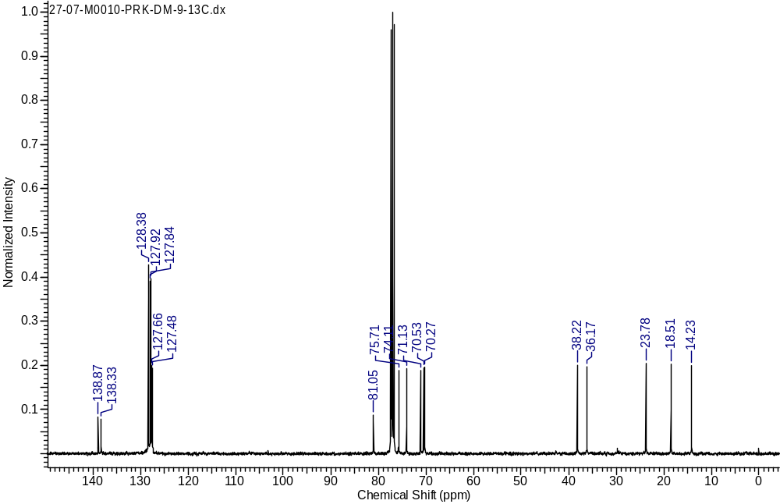
¹³C NMR Spectrum of compound 4b in CDCl₃ (100 MHz)
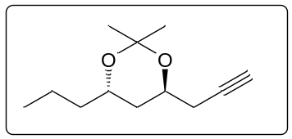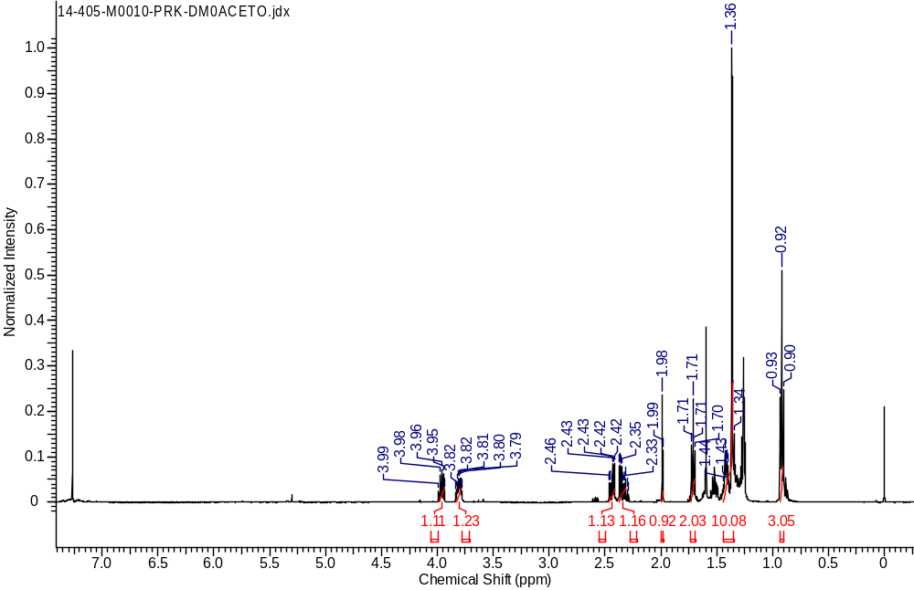
¹H NMR Spectrum of compound 7a in CDCl₃ (500 MHz)
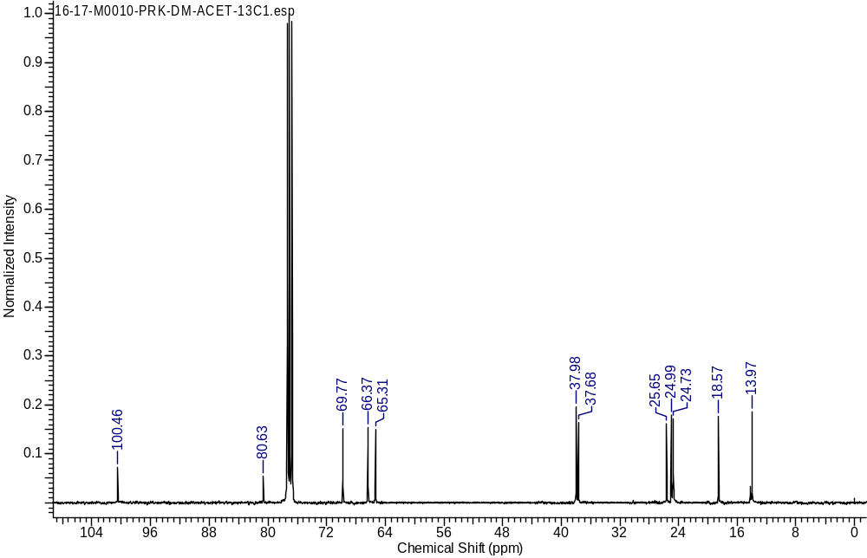
¹³C NMR Spectrum of compound 7a in CDCl₃ (100 MHz)
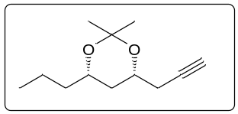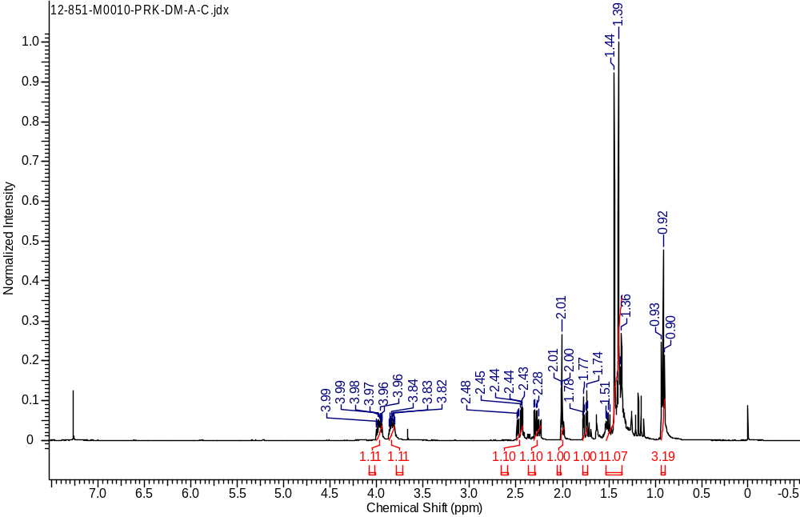
¹H NMR Spectrum of compound 7b in CDCl₃ (400 MHz)
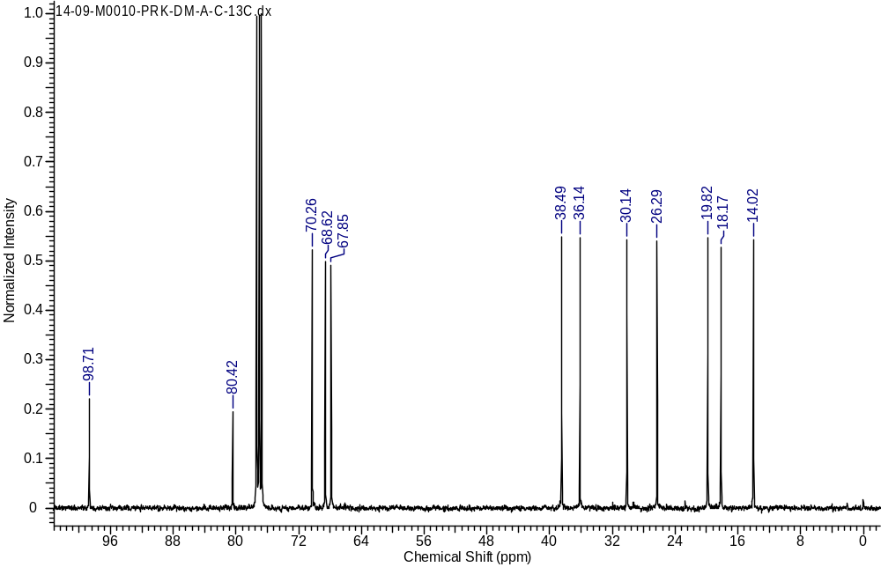
¹³C NMR Spectrum of compound 7b in CDCl₃ (100 MHz)

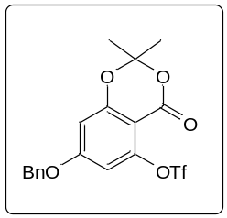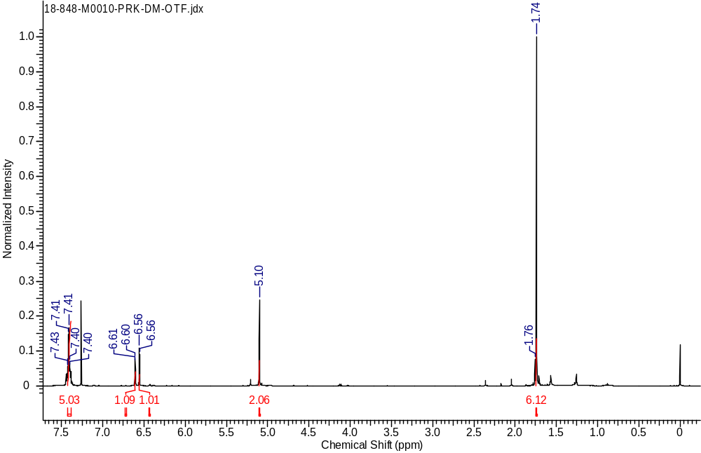
¹H NMR Spectrum of compound 3 in CDCl₃ (500 MHz)
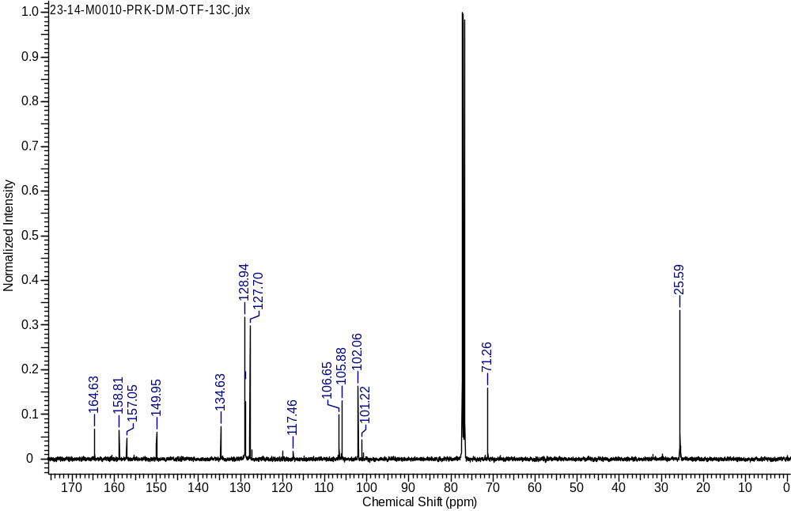
¹³C NMR Spectrum of compound 3 in CDCl₃ (125 MHz)

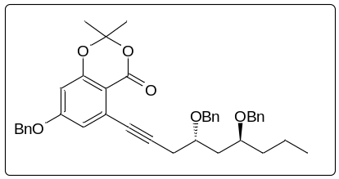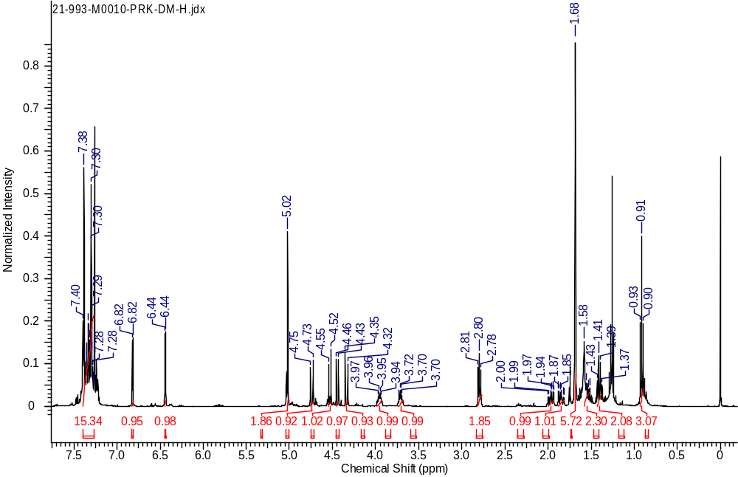
¹H NMR Spectrum of compound 2 in CDCl₃ (400 MHz)
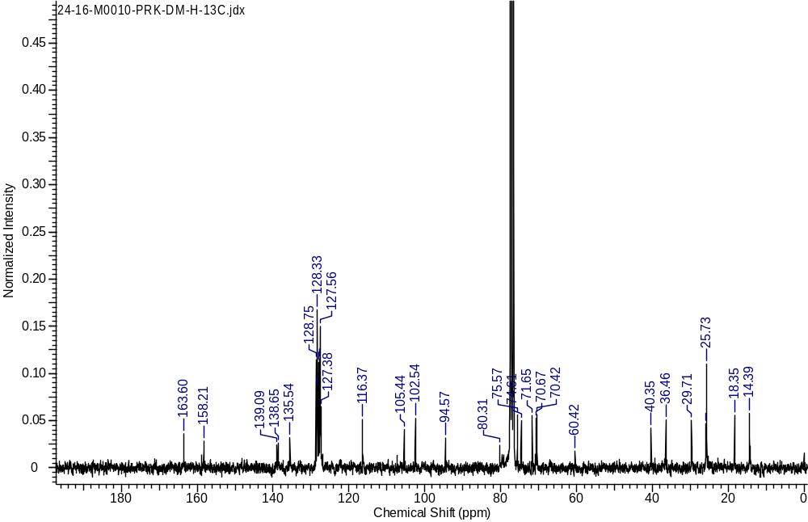
¹³C NMR Spectrum of compound 2 in CDCl₃ (125 MHz)

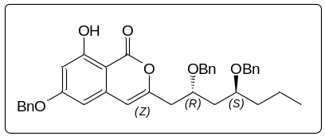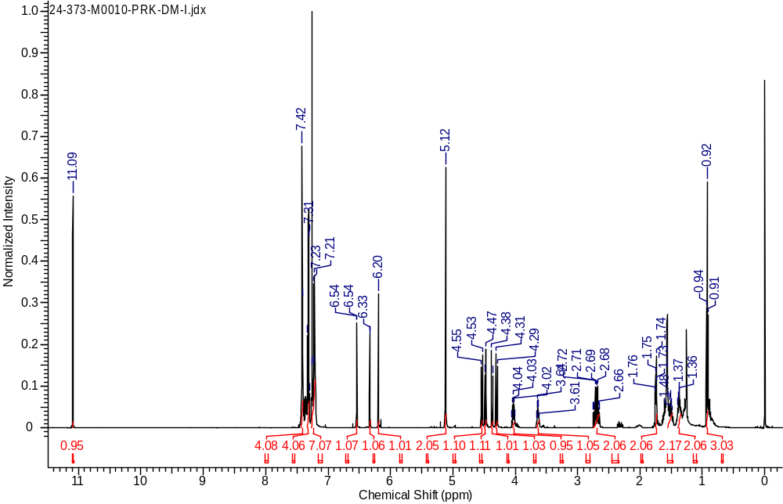
¹H NMR Spectrum of compound 8 in CDCl₃ (500 MHz)

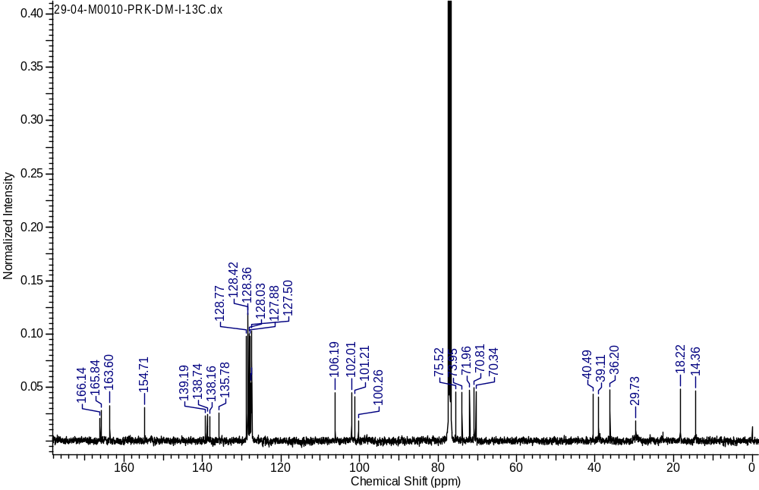
¹³C NMR Spectrum of compound 8 in CDCl₃ (100 MHz)

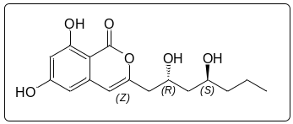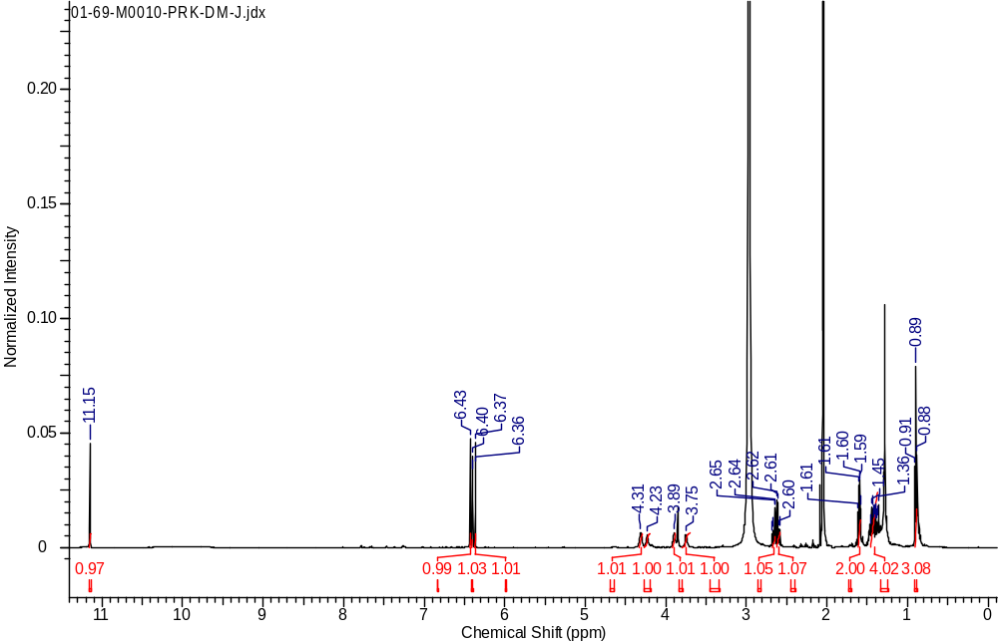
¹H NMR Spectrum of compound 1 in Acetone d₆ (500 MHz)
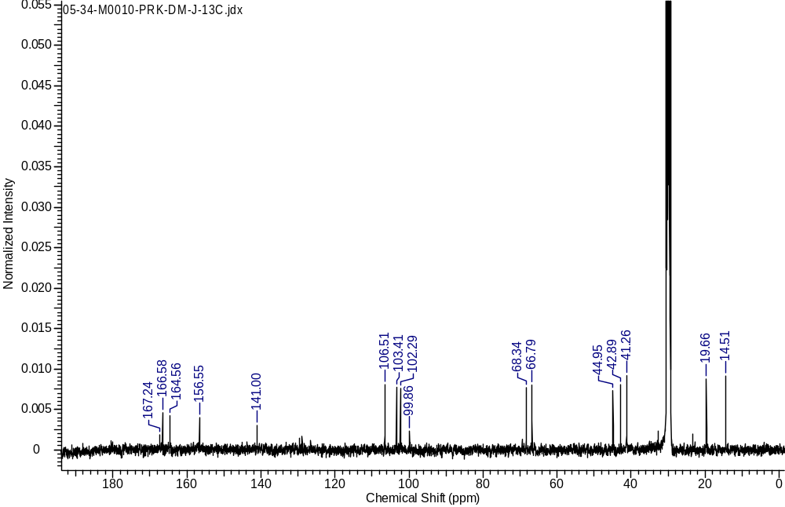
¹³C NMR Spectrum of compound 1 in Acetone d₆ (100 MHz)
PRK-DM
1.0
2.0
3.0
4.0
5.0
6.0
7.0
8.0
9.0
min
0
10
20
30
40
50
60
70
80
90
mAU
254nm4nm (1.00)
2.108
2.614
LCMS of compound 4a isomer
Peak table:

Peak | Ret. Time | Area | Area%
1 | 2.108 | 638207 | 97.787
2 | 2.614 | 14444 | 2.213
Total |  | 652651 | 100.000
Instrument : LCMS-2020 SHIMADZU
Software : Lab Solutions (5.41.240 Version)
Mobile Phase : Acetonitrile: Water (0.1 % formic acid) (80:20)
Flow Rate : 0.6 mL/min
Wavelength : 254 nm
Column : Waters X Bridge C18
Column Size : 4.6x50 mm
Particle Size : 3.5 µ

References
- Radha Krishna, P.; Dayaker, G. Tetrahedron Lett., 2007, 48, 7279-7282.
- Namecek, G.; Cudaj, J.; Podlech, J. Eur. J. Org. Chem., 2012, 3863-3870.
- Li, R.; Chen, S.; Niu, S.; Guo, L.; Yin, J.; Ch, Y. Fitoterapia 2014, 96, 88-94.

