A one-pot three-component synthesis of fused Spiro-Indoline/Indene Derivatives Derived from Ethynyl Azaindole by 1,3-Dipolar Cycloaddition Reaction
Manjunatha Narayanarao ª, Lokesh Koodlur^{*, b}, Subramanya Gopal ^{b}, Suman Y. Reddy ^{c} Susmita Kamila ^{*, a}
ªEast Point College of Engineering and Technology, Visvesvaraya Technological University, Bangalore-560 049, India.
^{b}Department of Studies and Research in Chemistry, ViJayanagara Sri Krishnadevaraya University, Bellary-583105, India.
^{c}Apotex Research, Bommasandra Industrial Area, 4th Phase, Jigani Link Road, Bangalore-560099
Email: sushkam@yahoo.co.in, lokeshsk@gmail.com
* Corresponding author

Table of contents

General Information S2

Synthesis of trimethylsilyl ethynyl pyrrolo pyridine S2

Synthesis of ethynyl pyrrolo pyridine S3

Synthesis of N-alkyl ethynyl pyrrolo pyridines (general procedure) S3

Characterization data for N-alkyl ethynyl pyrrolo pyridines (4a-d) S4

Synthesis of spiro-Indoline/Indene cycloadducts (general procedure) S5

Characterization data for spiro-Indoline/Indene cycloadducts (4a-d) S5-S16
(9a-d), (10a-d), (12a-d), (13a-d) and (14a-d)

Copies of all NMR spectra S17-S35

General Information

All reagents and solvents were pure and analytical grade purchased from commercial sources and were used without further purification, if not stated otherwise. Melting points were measured using Buchi B-540 apparatus and were uncorrected. ¹H-NMR and ¹³C NMR spectra were recorded on Bruker DPX 400 MHz FT-NMR spectrometer. Chemical shifts were expressed in δ (ppm) units relative to tetramethylsilane (TMS) signal as internal reference. Mass spectra were recorded on ESQUIRE 3000 Mass Spectrometer. Column chromatography was performed on silica gel (60-120 mesh) using ethyl acetate and hexane as eluent. All reactions were carried out in an over-dried Schlenk tube equipped with a magnetic stir bar under N2 atmosphere.
4-(2-(trimethylsilyl) ethynyl)-1H-pyrrolo[2,3-b] pyridine 2: General Procedure
To a suspension of 4-Bromo-1H-pyrrolo[2,3-b] pyridine (5.0 g, 25.3 mmol) in 50 ml of dry triethylamine was added Bis(triphenylphosphine)palladium(II) dichloride (535 mg, 76.2 mmol, 3% mol) under argon atmosphere. Copper (I) iodide (290 mg, 152 mmol, 6% mol) was added and the suspension stirred at ambient temperature for 30 min. Trimethylsilyl acetylene (2.99 g, 3.05 mmol) was added and the suspension stirred for 12 h at 45 °C. When the reaction was complete [TLC (EtOAc: hexane, 1:5)], the mixture was diluted with water (50ml) and extracted with EtOAc (2 × 40 mL). The organic layer was separated, dried over anhydrous Na₂SO₄ and removed under reduced pressure. The residue obtained was purified by flash column chromatography [silica gel (230-400 mesh; Merck), EtOAc-hexane (1:5)]. Colorless viscous liquid. δ_{H} (400 MHz, DMSO-d₆) 8.19 (d, J = 4.9 Hz, 1 H), 7.59-7.53 (m, 1 H), 7.10 (d, J = 4.9 Hz, 1 H), 6.46 (dd, J = 3.4, 1.8 Hz, 1 H), 0.28 (s, 9 H). δ_{C} (100 MHz, DMSO-d₆) 148.3, 142.3, 127.3, 120.9, 120.4, 117.4, 101.9, 100.4, 98.9. MS (ESI) m/z 215.2 [M + H+]. Anal. Calcd. for C₁₂H₁₄N₂Si: C, 67.24; H, 6.58; N, 13.07; Si, 13.10 %. Found: C, 66.92; H, 6.34; N, 12.80 %.
4-ethynyl-1H-pyrrolo[2,3-b] pyridine 3: General Procedure
4-(2-(trimethylsilyl) ethynyl)-1H-pyrrolo[2,3-b] pyridine (5.0 g, 2.47mmol) was dissolved in 60 ml of methanol and potassium fluoride (1.72 g, 2.96 mmol) was added. The solution was stirred at ambient temperature during 3h, subsequently diluted with water, and extracted with methylene chloride (2 x 100 ml). The combined organic layers were washed with water (100 ml) and twice with brine (2 x 100 ml). After drying over sodium sulfate, the solvent was evaporated under reduced pressure and the crude product purified by column chromatography (silica gel, gradient: methylene chloride 80% to MeOH 20%), A brown solid Yield, 57 %; mp 155-157 °C; δ_{H} (400 MHz, CDCl₃) 8.23 (d, J = 5.1 Hz, 1 H), 7.40 (d, J = 3.5 Hz, 1 H), 7.18 (d, J = 5.0 Hz, 1 H), 6.64 (d, J = 3.5 Hz, 1 H), 3.50 (s, 1 H). δ_{C} (100 MHz, CDCl₃) 141.6, 126.4, 122.5, 122.2, 118.7, 100.2, 83.4, 80.4. MS (ESI) m/z 142.2 [M + H+]. Anal. Calcd. for C₉H₆N₂: C, 76.04; H, 4.25; N, 19.71 %. Found: C, 75.72; H, 3.97; N, 19.44 %.
N-Alkyl 4-ethynyl-1H-pyrrolo[2,3-b] pyridine; General Procedure (4a-d)
NaH (5.2 mmol, 1.5 eq) was added portion wise to a solution of 4-ethynyl-1H-pyrrolo[2,3-b] pyridine (3.5 mmol, 1 eq) in DMF (10 mL) at 0 °C. The mixture was stirred at 0 °C for 10 min then the alkyl halide (5.2 mmol, 1.5 eq) was added at the same temperature. The reaction mixture was continued to stir at ambient temperature for 2 h. When the reaction was complete [TLC (EtOAc/hexane 1:5)], the mixture was extracted with EtOAc (2 × 30 mL) and washed with water (2 × 30 mL). The organic layer was separated, dried over anhydrous Na₂SO₄ and the solvent removed under reduced pressure. The residue obtained was purified by flash column chromatography [silica gel (230–400 mesh; Merck), EtOAc/hexane 1:5].

4-ethynyl-1-methyl-1H-pyrrolo[2,3-b] pyridine (4b)
Yield, 45 %; mp 132-135 °C; δ_{H} (400 MHz, CDCl₃) 8.29 (d, J = 4.7 Hz, 1 H), 7.22-7.38 (m, 1 H), 7.16 (d, J = 5.0 Hz, 1 H), 6.60 (d, J = 3.5 Hz, 1 H), 3.90 (s, 3 H), 3.44 (s, 1 H). δ_{C} (100 MHz, CDCl₃) 42.7, 72.5, 74.7, 100.2, 120.1, 123.7, 126.5, 127.3, 143.2, 148.5. MS (ESI) m/z 157.2 [M + H+]. Anal. Calcd. for C₁₀H₈N₂: C, 76.90; H, 5.16; N, 17.94 %. Found: C, 76.55; H, 4.78; N, 17.63 %.
1-ethyl-4-ethynyl-1H-pyrrolo[2,3-b] pyridine (4c)
Yield, 60 %; mp 151-153 °C; δ_{H} (400 MHz, CD₃OD) 8.19 (d, J = 5.0 Hz, 1 H), 7.50 (d, J = 3.1 Hz, 1 H), 7.16 (d, J = 5.0 Hz, 1 H), 6.58 (d, J = 3.5 Hz, 1 H), 4.29-4.38 (m, 2 H), 3.99 (s, 1 H), 1.44 (t, J = 7.2 Hz, 3 H). δ_{C} (100 MHz, CD₃OD) 16.8, 46.3, 70.2, 74.7, 100.2, 120.1, 123.7, 125.1, 126.9, 143.2, 148.5. MS (ESI) m/z 171.2 [M + H+]. Anal. Calcd. for C₁₁H₁₀N₂: C, 77.70; H, 5.92; N, 16.46 %. Found: C, 77.97; H, 5.56; N, 16.10 %.
1-benzyl-4-ethynyl-1H-pyrrolo[2,3-b] pyridine (4d)
Yield, 55 %; mp 157-160 °C; δ_{H} (400 MHz, CDCl₃) 8.30 (d, J = 5.0 Hz, 1 H), 7.27-7.33 (m, 3 H), 7.22-7.26 (m, 1 H), 7.17-7.21 (m, 3 H), 6.63 (d, J = 3.5 Hz, 1 H), 5.50 (s, 2 H), 3.44 (s, 1 H). δ_{C} (100 MHz, CDCl₃) 59.7, 70.2, 74.7, 100.2, 120.1, 123.7, 125, 126.5, 127.3, 129.3, 129.5, 130.7, 131.0, 136.9, 143.2, 148.5. MS (ESI) m/z 233.2 [M + H+]. Anal. Calcd. for C₁₆H₁₂N₂: C, 82.73; H, 5.21; N, 12.06 %. Found: C, 82.97; H, 4.89; N, 11.83 %.

General procedure for the preparation of spiro-Indoline/Indene derivatives compounds
To the solution of 4 (1 mmol, 1 eq) in dry methanol (5 mL) in a single-necked round-bottomed flask, ninhydrin/Isatin (1.2 mmol, 1.2 eq) and L-proline/sarcosine/thioproline (1.2 mmol, 1.2 equiv) were added. The reaction mixture was heated to 50 °C for 30 min and reaction progress was monitored by TLC (EtOAc/hexanes 1:1). After completion of the reaction, the organic solvent was evaporated to dryness. The crude product obtained was purified by flash chromatography on silica gel (EtOAc/hexane 1:1) to get corresponding spiro-pyrrolidine derivatives.
1'-methyl-3'-(1H-pyrrolo[2,3-b] pyridin-4-yl)-1',5'-dihydrospiro[indoline-3,2'-pyrrole]-2-one (7a)
Yield, 73 %; mp 198-200 °C; δ_{H} (400 MHz, DMSO-d₆) 11.70 (br. S., 1 H), 10.54 (s, 1 H), 7.88 (d, J = 5.1 Hz, 1 H), 7.49 (t, J = 2.8 Hz, 1 H), 7.21 (t, J = 7.1 Hz, 1 H), 7.08 (d, J = 7.3 Hz, 1 H), 6.99-6.82 (m, 3 H), 6.69 (d, J = 1.5 Hz, 1 H), 6.22 (d, J = 5.1 Hz, 1 H), 4.02-3.86 (m, 2 H), 2.16 (s, 3 H). δ_{C} (100 MHz, DMSO-d₆) 34.9, 60.2, 79.3, 100.2, 110.3, 111.4, 117.7, 122.4, 125.6, 126.8, 129.6, 129.8, 133.6, 134.5, 140.1, 142.5, 143.0, 149.3, 177.1. MS (ESI) m/z 317.2 [M + H+]. Anal. Calcd. for C₁₉H₁₆N₄O: C, 72.13; H, 5.10; N, 17.71%. Found: C, 71.80; H, 5.33; N, 18.0 %.
1'-methyl-3'-(1-methyl-1H-pyrrolo[2,3-b] pyridin-4-yl)-1',5'-dihydrospiro[indoline-3,2'-pyrrole]-2-one (7b)
Yield, 76 %; mp 205-207 °C; δ_{H} (400 MHz, CDCl₃ ) 9.81 (br. S., 1 H), 7.87-7.95 (m, 2 H), 7.75-7.84 (m, 2 H), 7.20-7.33 (m, 1 H), 6.65 (t, J = 2.0 Hz, 1H), 6.60 (d, J = 3.5 Hz, 1 H), 6.34 (d, J = 5.0 Hz, 1 H), 4.18 (d, J = 2.0 Hz, 2 H), 3.90 (s, 3 H), 2.47 (s, 3 H). δ_{C} (100 MHz, CDCl₃) 31.2, 33.3, 56.9, 71.9, 72.2, 72.5, 78.4, 96.1, 109.2, 114.1, 118.7, 120.4, 129.7, 131.6, 133.3, 135.2, 136.8, 137.5, 143.8, 196.3. MS (ESI) m/z 331.2 [M + H+]. Anal. Calcd. for C₂₀H₁₈N₄O: C, 72.71; H, 5.49; N, 16.96 %. Found: C, 72.48; H, 5.24; N, 16.63 %.
1'-methyl-3'-(1-ethyl-1H-pyrrolo[2,3-b] pyridin-4-yl)-1',5'-dihydrospiro[indoline-3,2'-pyrrole]-2-one (7c)
Yield, 70 %; mp 200-203 °C; δ_{H} (400 MHz, CD₃OD) 7.87 (d, J = 5.0 Hz, 1 H), 7.45-7.38 (m, 2 H), 7.31-7.24 (m, 1 H), 7.00-6.88 (m, 2 H), 6.81 (d, J = 2.0 Hz, 1 H), 6.68 (d, J = 3.5 Hz, 1 H), 6.31 (d, J = 5.5 Hz, 1 H), 4.30-4.22 (m, 2 H), 4.18 (d, J = 2.0 Hz, 2 H), 2.47 (s, 3 H), 1.44 (t, J = 7.2 Hz, 3 H). δ_{C} (100 MHz, CD₃OD) 31.2, 56.9, 71.9, 72.2, 72.5, 78.4, 96.1, 109.2, 114.1, 118.5, 118.7, 120.4, 129.7, 131.4, 131.6, 133.3, 135.2, 136.8, 137.5, 143.8, 196.3. MS (ESI) m/z 345.1 [M + H+]. Anal. Calcd. for C₂₁H₂₀N₄O: C, 73.23; H, 5.85; N, 16.27 %. Found: C, 73.00; H, 5.51; N, 15.95 %.
3'-(1-benzyl-1H-pyrrolo[2,3-b] pyridin-4-yl)-1'-methyl-1',5'-dihydrospiro[indoline-3,2'-pyrrol]-2-one (7d)
Yield, 84 %; mp 210-212 °C; δ_{H} (400 MHz, CDCl₃) 8.63 (s, 1 H), 8.09 (d, J = 5.0 Hz, 1 H), 7.52 (d, J = 7.5 Hz, 1 H), 7.40-7.32 (m, 5 H), 7.13-7.06 (m, 1 H), 6.98 (d, J = 8.0 Hz, 1 H), 6.86 (d, J = 2.5 Hz, 1 H), 6.73 (d, J = 4.0 Hz, 1 H), 6.62 (d, J = 4.0 Hz, 1 H), 6.39 (d, J = 5.5 Hz, 1 H), 5.52 (s, 2 H), 4.18 (d, J = 2.0 Hz, 2 H), 2.47 (s, 3 H). δ_{C} (100 MHz, CDCl₃) 31.2, 33.3, 56.9, 71.9, 72.2, 72.4, 72.5, 78.4, 96.1, 109.2, 112.8, 114.1, 118.5, 118.7, 120.4, 129.2, 129.7, 131.4, 131.6, 133.3, 135.2, 136.8, 137.5, 143.8, 196.3, 198.7. MS (ESI) m/z 407.2 [M + H+]. Anal. Calcd. for C₂₆H₂₂N₄O: C, 76.83; H, 5.46; N, 13.78 %. Found: C, 76.55; H, 5.10; N, 13.44 %.
2'-(1H-pyrrolo[2,3-b] pyridin-4-yl)-5',6',7',7a'-tetrahydrospiro[indoline-3,3'-pyrrolizine]-2-one (9a)
Yield, 78 %; mp 202-205 °C; δ_{H} (400 MHz, DMSO-d₆) 11.65 (br. S., 1 H), 10.43 (s, 1 H), 8.31 (s, 1 H), 7.86 (d, J = 5.0 Hz, 1 H), 7.47 (t, J = 1.0 Hz, 1 H), 7.19 (dt, J = 1.0, 7.8 Hz, 1 H), 6.96-6.90 (m, 2 H), 6.89-6.78 (m, 1 H), 6.71-6.63 (m, 1 H), 6.14 (d, J = 5.0 Hz, 1 H), 4.56 (t, J = 1.0 Hz, 1 H), 3.50 (s, 1 H), 2.75-2.63 (m, 1 H), 2.16-2.06 (m, 1 H), 1.87-1.64 (m, 3 H). δ_{C} (100 MHz, DMSO-d₆) 26.3, 29.4, 31.5, 48.8, 71.0, 79.1, 99.8, 110.0, 111.6, 117.5, 121.2, 126.6, 129.6, 133.3, 137.0, 138.2, 142.0, 142.8, 148.8, 149.0, 168.4. MS (ESI) m/z 343 [M + H+]. Anal. Calcd. for C₂₁H₁₈N₄O: C, 73.67; H, 5.30; N, 16.36 %. Found: C, 73.44; H, 4.93; N, 16.0 %.
2'-(1-methyl-1H-pyrrolo[2,3-b] pyridin-4-yl)-5',6',7',7a'-tetrahydrospiro[indoline-3,3'-pyrrolizine]-2-one (9b)
Yield, 78 %; mp 210-212 °C; δ_{H} (400 MHz, DMSO-d₆) 8.31 (s, 1 H), 7.86 (d, J = 5.0 Hz, 1 H), 7.47 (t, J = 1.0 Hz, 1 H), 7.19 (dt, J = 1.0, 7.8 Hz, 1 H), 6.96-6.90 (m, 2 H), 6.89-6.78 (m, 1 H), 6.71-6.63 (m, 1 H), 6.14 (d, J = 5.0 Hz, 1 H), 4.56-4.55 (t, J = 1.0 Hz, 1 H), 3.90 (s, 3 H), 3.50 (s, 1 H), 2.75-2.63 (m, 1 H), 2.16-2.06 (m, 1 H), 1.87-1.64 (m, 3 H). δ_{C} (100 MHz, DMSO-d₆) 26.3, 29.0, 29.4, 30.8, 31.5, 48.8, 71.0, 78.9, 79.1, 99.8, 110.0, 111.6, 117.5, 121.2, 126.5, 129.6, 133.3, 137.0, 138.2, 142.8, 148.8, 178.6. MS (ESI) m/z 357.2 [M + H+]. Anal. Calcd. for C₂₂H₂₀N₄O: C, 74.14; H, 5.66; N, 15.72 %. Found: C, 74.42; H, 5.35; N, 15.39 %.
2'-(1-ethyl-1H-pyrrolo[2,3-b] pyridin-4-yl)-5',6',7',7a'-tetrahydrospiro[indoline-3,3'-pyrrolizine]-2-one (9c)
Yield, 72 %; mp 210-212 °C; δ_{H} (400 MHz, CD₃OD) 7.87 (d, J = 5.0 Hz, 1 H), 7.45-7.38 (m, 2 H), 7.31-7.24 (m, 1 H), 7.00-6.88 (m, 2 H), 6.81 (d, J = 2.0 Hz, 1 H), 6.68 (d, J = 3.5 Hz, 1 H), 6.31 (d, J = 5.5 Hz, 1 H), 5.02 (t, J = 1.0 Hz, 1 H), 4.30-4.22 (m, 2 H), 3.50 (s, 1 H), 2.75-2.63 (m, 1 H), 2.16-2.06 (m, 1 H), 1.87-1.64 (m, 3 H), 1.44 (t, J = 7.2 Hz, 3 H). δ_{C} (100 MHz, CD₃OD) 26.3, 29.0, 29.4, 30.8, 31.56, 48.8, 71.0, 78.9, 79.1, 99.8, 110.0, 111.6, 117.5, 121.2, 126.5, 129.6, 133.3, 137.0, 138.2, 142.0, 142.8, 148.8, 178.6. MS (ESI) m/z 371.1 [M + H+]. Anal. Calcd. for C₂₃H₂₂N₄O: C, 74.57; H, 5.99; N, 15.12 %. Found: C, 74.22; H, 5.73; N, 14.80 %.
2'-(1-benzyl-1H-pyrrolo[2,3-b] pyridin-4-yl)-5',6',7',7a'-tetrahydrospiro[indoline-3,3'-pyrrolizin]-2-one (9d)
Yield, 80 %; mp 213-215 °C; δ_{H} (400 MHz, CDCl₃) 8.63 (s, 1 H), 8.09 (d, J = 5.0 Hz, 1 H), 7.52 (d, J = 7.5 Hz, 1 H), 7.40-7.32 (m, 5 H), 7.13-7.06 (m, 1 H), 6.98 (d, J = 8.0 Hz, 1 H), 6.86 (d, J = 2.5 Hz, 1 H), 6.73 (d, J = 4.0 Hz, 1 H), 6.62 (d, J = 4.0 Hz, 1 H), 6.39 (d, J = 5.5 Hz, 1 H), 5.52 (s, 2 H), 4.56-4.55 (t, J = 1.0 Hz, 1 H), 3.50 (s, 1 H), 2.75-2.63 (m, 1 H), 2.16 -2.06 (m, 1 H), 1.87-1.64 (m, 3 H). δ_{C} (100 MHz, CDCl₃) 26.3, 29.0, 29.4, 30.8, 31.5, 48.8, 71.0, 78.9, 79.1, 99.8, 110.0, 111.6, 117.5, 121.2, 126.2, 126.5, 126.6, 128.2, 129.6, 133.3, 137.0, 138.2, 142.0, 142.7, 142.8, 148.8, 168.3, 178.6. MS (ESI) m/z 433.2 [M + H+]. Anal. Calcd. for C₂₈H₂₄N₄O: C, 77.75; H, 5.59; N, 12.95 %. Found: C, 77.48; H, 5.23; N, 12.61 %.
6'-(1H-pyrrolo[2,3-b] pyridin-4-yl)-1',7a'-dihydro-3' H-spiro[indoline-3,5'-pyrrolo[1,2-c] thiazol]-2-one (10a)
Yield, 75 %; mp 209-211 °C; δ_{H} (400 MHz, DMSO-d₆ ) 11.70 (br. S., 1 H), 10.56 (s, 1 H), 7.88 (d, J = 5.0 Hz, 1 H), 7.50 (t, J = 3.0 Hz, 1 H), 7.29-7.17 (m, 2 H), 6.95 (d, J = 2.0 Hz, 1 H), 6.92-6.84 (m, 2 H), 6.72-6.64 (m, 1 H), 6.16 (d, J = 5.0 Hz, 1 H), 4.82 (t, J = 1.0 Hz, 1 H), 3.95 (d, J = 10.5 Hz, 1 H), 3.51 (d, J = 10.5 Hz, 1 H), 3.28-3.16 (m, 1 H), 3.01 (dd, J = 5.5, 10.5, 1 H). δ_{C} (100 MHz, DMSO-d₆) 37.7, 40.0, 54.8, 75.4, 79.9, 100.2, 110.4, 111.8, 116.3, 118.0, 122.0, 125.7, 127.3, 130.8, 132.8, 135.6, 137.8, 142.7, 142.9, 149.0. MS (ESI) m/z 361.2 [M + H+]. Anal. Calcd. for C₂₀H₁₆N₄OS: C, 66.65; H, 4.47; N, 15.54; S, 8.90 %. Found: C, 66.86; H, 4.15; N, 15.20 %.
6'-(1-methyl-1H-pyrrolo[2,3-b] pyridin-4-yl)-1',7a'-dihydro-3' H-spiro[indoline-3,5'-pyrrolo[1,2-c] thiazol]-2-one (10b)
Yield, 70 %; mp 221-223 °C; δ_{H} (400 MHz, DMSO-d₆) 11.70 (br. S., 1 H), 7.88 (d, J = 5.0 Hz, 1 H), 7.50 (t, J = 3.0 Hz, 1 H), 7.29-7.17 (m, 2 H), 6.95 (d, J = 2.0 Hz, 1 H), 6.92-6.84 (m, 2 H), 6.72-6.64 (m, 1 H), 6.16 (d, J = 5.0 Hz, 1 H), 4.82 (t, J = 1.0 Hz, 1 H), 3.95 (d, J = 10.5 Hz, 1 H), 3.90 (s, 3 H), 3.51 (d, J = 10.5 Hz, 1 H), 3.28-3.16 (m, 1 H), 3.01 (dd, J = 5.5, 10.5, 1 H). δ_{C} (100 MHz, DMSO-d₆) 41.2, 55.7, 62.0, 99.8, 103.2, 113.2, 114.5, 116.7, 117.5, 121.1, 122.8, 127.8, 129.6, 133.3, 137.0, 142.3, 142.7, 148.8, 161.4, 168.2, 196.7. MS (ESI) m/z 375.2 [M + H+]. Anal. Calcd. for C₂₁H₁₈N₄OS: C, 67.36; H, 4.85; N, 14.96; S, 8.56 %. Found: C, 67.0; H, 4.50; N, 14.61; S, 8.23 %.
6'-(1-ethyl-1H-pyrrolo[2,3-b] pyridin-4-yl)-1',7a'-dihydro-3' H-spiro[indoline-3,5'-pyrrolo[1,2-c] thiazol]-2-one (10c)
Yield, 77 %; mp 215-218 °C; δ_{H} (400 MHz, CD₃OD) 7.87 (d, J = 5.0 Hz, 1 H), 7.45-7.38 (m, 2 H), 7.31-7.24 (m, 1 H), 7.00-6.88 (m, 2 H), 6.81 (d, J = 2.0 Hz, 1 H), 6.68 (d, J = 3.5 Hz, 1 H), 6.31 (d, J = 5.5 Hz, 1 H), 5.02-4.89 (t, J = 1.0 Hz, 1 H), 4.30-4.22 (m, 2 H), 4.04 (d, J = 10.5 Hz, 1 H), 3.68 (d, J = 10.5 Hz, 1 H), 3.33 (dd, J = 7.5, 10.54 Hz, 1 H), 3.04 (dd, J = 5.5, 10.5 Hz, 1 H), 1.44 (t, J = 7.2 Hz, 3 H). δ_{C} (100 MHz, CD₃OD) 14.4, 22.3, 29.3, 37.1, 39.1, 54.0, 75.3, 80.8, 99.0, 110.1, 111.8, 113.2, 119.7, 122.0, 125.4, 128.3, 133.9, 137.9, 138.7, 142.4, 146.9, 180.2. MS (ESI) m/z 388.1 [M + H+]. Anal. Calcd. for C₂₂H₂₀N₄OS: C, 68.02; H, 5.19; N, 14.42; S, 8.25 %. Found: C, 67.72; H, 4.85; N, 14.25; S, 7.86 %.

6'-(1-benzyl-1H-pyrrolo[2,3-b] pyridin-4-yl)-1',7a'-dihydro-3' H-spiro[indoline-3,5'-pyrrolo[1,2-c] thiazol]-2-one (10d)
Yield, 78 %; mp 218-220 °C; δ_{H} (400 MHz, CDCl₃) 8.63 (s, 1 H), 8.09 (d, J = 5.0 Hz, 1 H), 7.52 (d, J = 7.5 Hz, 1 H), 7.40-7.32 (m, 5 H), 7.13-7.06 (m, 1 H), 6.98 (d, J = 8.0 Hz, 1 H), 6.86 (d, J = 2.5 Hz, 1 H), 6.73 (d, J = 4.0 Hz, 1 H), 6.62 (d, J = 4.0 Hz, 1 H), 6.39 (d, J = 5.5 Hz, 1 H), 5.52 (s, 2 H), 5.15 (t, J = 1.0 Hz, 1 H), 4.25 (d, J = 10.5 Hz, 1 H), 3.84 (d, J = 10.5 Hz, 1 H), 3.43 (dd, J = 7.5, 10.5 Hz, 1 H), 3.07 (dd, J = 5.5, 10.5 Hz, 1 H). δ_{C} (100 MHz, CDCl₃) 22.6, 29.1, 29.6, 31.9, 33.8, 38.1, 47.9, 55.1, 75.2, 80.5, 99.8, 110.4, 112.7, 118.9, 122.7, 125.3, 127.5, 127.6, 128.6, 130.4, 133.1, 134.4, 137.5, 138.5, 141.4, 142.8, 179.3. MS (ESI) m/z 451.1 [M + H+]. Anal. Calcd. for C₂₇H₂₂N₄OS: C, 71.98; H, 4.92; N, 12.44; S, 7.12 %. Found: C, 71.63; H, 4.58; N, 12.10; S, 6.82 %.
1'-methyl-3'-(1H-pyrrolo[2,3-b] pyridin-4-yl)-1',5'-dihydrospiro[indene-2,2'-pyrrole]-1,3-dione (12a)
Yield, 69 %; mp 213-215 °C; δ_{H} (400 MHz, CDCl₃) 9.81 (br. S., 1 H), 7.95-7.86 (m, 3 H), 7.85-7.76 (m, 2 H), 6.66 (t, J = 2.0 Hz, 1 H), 6.60 (d, J = 3.5 Hz, 1 H), 6.34 (d, J = 5.0 Hz, 1 H), 4.18 (d, J = 2.0 Hz, 2 H), 2.47 (s, 3 H). δ_{C} (100 MHz, CDCl₃) 31.2, 56.9, 71.9, 72.2, 72.4, 72.5, 78.4, 96.1, 109.2, 114.1, 118.7, 120.4, 129.7, 131.6, 133.3, 135.2, 136.8, 137.5, 143.8, 196.3. MS (ESI) m/z 330.2 [M + H+]. Anal. Calcd. for C₂₀H₁₅N₃O₂: C, 72.94; H, 4.59; N, 12.76 %. Found: C, 72.58; H, 4.89; N, 12.48 %.
1'-methyl-3'-(1-methyl-1H-pyrrolo[2,3-b] pyridin-4-yl)-1',5'-dihydrospiro[indene-2,2'-pyrrole]-1,3-dione (12b)
Yield, 71 %; mp 217-219 °C; δ_{H} (400 MHz, CDCl₃) 9.81 (br. S., 1 H), 7.87-7.95 (m, 2 H), 7.75-7.84 (m, 2 H), 7.20-7.33 (m, 1 H), 6.65 (t, J = 2.0 Hz, 1 H), 6.60 (d, J = 3.5 Hz, 1 H), 6.34 (d, J = 5.0 Hz, 1 H), 4.18 (d, J = 2.0 Hz, 2 H), 3.90 (s, 3 H), 2.47 (s, 3 H). δ_{C} (100 MHz, CDCl₃) 31.2, 33.3, 56.9, 71.9, 72.4, 72.5, 78.4, 96.1, 109.2, 114.1, 118.7, 120.4, 129.2, 129.7, 131.6, 133.3, 135.2, 136.8, 137.5, 143.8, 196.3. MS (ESI) m/z 344.1 [M + H+]. Anal. Calcd. for C₂₁H₁₇N₃O₂: C, 73.45; H, 4.99; N, 12.24 %. Found: C, 73.70; H, 4.66; N, 12.61 %.
1'-methyl-3'-(1-ethyl-1H-pyrrolo[2,3-b] pyridin-4-yl)-1',5'-dihydrospiro[indene-2,2'-pyrrole]-1,3-dione (12c)
Yield, 73 %; mp 203-205 °C; δ_{H} (400 MHz, DMSO-d₆) 8.31 (s, 1 H), 7.86 (d, J = 5.0 Hz, 1 H), 7.47 (t, J = 1.0 Hz, 1 H), 7.19 (dt, J = 1.0, 7.8 Hz, 1 H), 6.96-6.90 (m, 2 H), 6.89-6.78 (m, 1 H), 6.71-6.63 (m, 1 H), 6.14 (d, J = 5.0 Hz, 1 H), 4.30-4.22 (m, 2 H), 4.02-3.86 (m, 2 H), 2.16 (s, 3 H), 1.44 (t, J = 7.28 Hz, 3 H). δ_{C} (100 MHz, DMSO-d₆) 16.5, 31.2, 33.3, 56.9, 71.9, 72.2, 72.4, 72.5, 78.4, 96.1, 109.2, 114.1, 118.5, 120.4, 129.7, 131.6, 133.3, 135.2, 136.8, 137.5, 143.8, 196.3. MS (ESI) m/z 358.1 [M + H+]. Anal. Calcd. for C₂₂H₁₉N₃O₂: C, 73.93; H, 5.36; N, 11.76 %. Found: C, 73.60; H, 5.12; N, 11.46 %.
3'-(1-benzyl-1H-pyrrolo[2,3-b] pyridin-4-yl)-1’-methyl-1',5'-dihydrospiro[indene-2,2'-pyrrole]-1,3-dione (12d)
Yield, 78 %; mp 199-201 °C; δ_{H} (400 MHz, CDCl₃) 8.63 (s, 1 H), 8.09 (d, J = 5.0 Hz, 1 H), 7.52 (d, J = 7.5 Hz, 1 H), 7.40-7.32 (m, 5 H), 7.13- 7.06 (m, 1 H), 6.98 (d, J = 8.0 Hz, 1 H), 6.86 (d, J = 2.5 Hz, 1 H), 6.73 (d, J = 4.0 Hz, 1 H), 6.62 (d, J = 4.0 Hz, 1 H), 6.39 (d, J = 5.5 Hz, 1 H), 5.52 (s, 2 H), 4.18 (d, J = 2.0 Hz, 2 H), 2.47 (s, 3 H). δ_{C} (100 MHz, CDCl₃) 25.5, 30.8, 37.6, 47.7, 52.7, 67.4, 76.4, 82.0, 99.9, 113.2, 118.2, 124.3, 128.8, 128.9, 130.9, 132.4, 134.5, 135.9, 136.9, 138.5, 141.4, 142.6, 147.7, 152.6, 169.1, 199.6, 199.7. MS (ESI) m/z 420.2 [M + H+]; Anal. Calcd. for C₂₇H₂₁N₃O₂: C, 77.31; H, 5.05; N, 10.02 %. Found: C, 76.95; H, 4.80; N, 9.71 %.

2'-(1H-pyrrolo[2,3-b] pyridin-4-yl)-5',6',7',7a'-tetrahydrospiro[indene-2,3'-pyrrolizine]-1,3-dione (13a)
Yield, 73 %; mp 210-212 °C; δ_{H} (400 MHz, DMSO-d₆) 10.43 (s, 1 H), 8.31 (s, 1 H), 7.86 (d, J = 5.0 Hz, 1 H), 7.4 (t, J = 1.0 Hz, 1 H), 7.19 (dt, J = 1.0, 7.8 Hz, 1 H), 6.96-6.90 (m, 2 H), 6.89-6.78 (m, 1 H), 6.71-6.63 (m, 1 H), 6.14 (d, J = 5.0 Hz, 1 H), 4.56-4.55 (t, J = 1.0 Hz, 1 H), 3.50 (s, 1 H), 2.75-2.63 (m, 1 H), 2.16-2.06 (m, 1 H), 1.87-1.64 (m, 3 H). δ_{C} (100 MHz, DMSO-d₆) 31.5, 48.8, 71.0, 78.9, 79.1, 99.8, 110.0, 111.6, 117.5, 121.2, 126.2, 126.5, 126.6, 129.6, 133.3, 137.0, 138.2, 142.0, 142.8, 148.8, 178.6, 178.7. MS (ESI) m/z 356.2 [M + H+]. Anal. Calcd. for C₂₂H₁₇N₃O₂: C, 74.35; H, 4.82; N, 11.82 %. Found: C, 74.0; H, 4.52; N, 11.47 %.
2'-(1-methyl-1H-pyrrolo[2,3-b] pyridin-4-yl)-5',6',7',7a'-tetrahydrospiro[indene-2,3'-pyrrolizine]-1,3-dione (13b)
Yield, 77 %; mp 215-217 °C; δ_{H} (400 MHz, DMSO-d₆) 8.31 (s, 1 H), 7.86 (d, J = 5.0 Hz, 1 H), 7.47 (t, J = 1.0 Hz, 1 H), 7.19 (dt, J = 1.0, 7.8 Hz, 1 H), 6.96-6.90 (m, 2 H), 6.89-6.78 (m, 1 H), 6.71-6.63 (m, 1 H), 6.14 (d, J = 5.0 Hz, 1 H), 4.56-4.55 (t, J = 1.0 Hz, 1 H), 3.90 (s, 3 H), 3.50 (s, 1 H), 2.75-2.63 (m, 1 H), 2.16-2.06 (m, 1 H), 1.87-1.64 (m, 3 H). δ_{C} (100 MHz, DMSO-d₆) 26.3, 29.4, 30.8, 31.5, 48.8, 71.0, 78.9, 79.1, 99.8, 110.0, 111.6, 117.5, 121.2, 126.5, 126.6, 129.6, 133.3, 137.0, 138.2, 142.0, 142.8, 148.8, 178.6. MS (ESI) m/z 370.2 [M + H+]. Anal. Calcd. for C₂₃H₁₉N₃O₂: C, 74.78; H, 5.18; N, 11.37 %. Found: C, 74.98; H, 4.82; N, 11.04 %.
2'-(1-ethyl-1H-pyrrolo[2,3-b] pyridin-4-yl)-5',6',7',7a'-tetrahydrospiro[indene-2,3'-pyrrolizine]-1,3-dione (13c)
Yield, 75 %; mp 219-221 °C; δ_{H} (400 MHz, DMSO-d₆) 8.31 (s, 1 H), 7.86 (d, J = 5.0 Hz, 1 H), 7.47 (t, J = 1.0 Hz, 1 H), 7.19 (dt, J = 1.0, 7.8 Hz, 1 H), 6.96-6.90 (m, 2 H), 6.89-6.78 (m, 1 H), 6.71-6.63 (m, 1 H), 6.14 (d, J = 5.0 Hz, 1 H), 4.56-4.55 (t, J = 1.0 Hz, 1 H), 4.30-4.22 (m, 2 H), 3.50 (s, 1 H), 2.75-2.63 (m, 1 H), 2.16-2.06 (m, 1 H), 1.87-1.64 (m, 3 H), 1.44 (t, J = 7.2 Hz, 3 H). δ_{C} (100 MHz, DMSO-d₆) 16.5, 26.3, 29.4, 30.8, 31.5, 48.8, 71.0, 78.9, 79.1, 99.8, 110.0, 111.6, 117.5, 121.2, 126.6, 129.6, 133.3, 137.0, 138.2, 142.8, 148.8, 178.6. MS (ESI) m/z 358.2 [M + H+]. Anal. Calcd. for C₂₂H₁₉N₃O₂: C, 73.93; H, 5.36; N, 11.76 %. Found: C, 73.58; H, 5.09; N, 11.50 %.
2'-(1-benzyl-1H-pyrrolo[2,3-b] pyridin-4-yl)-5',6',7',7a'-tetrahydrospiro[indene-2,3'-pyrrolizine]-1,3-dione (13d)
Yield, 79 %; mp 223-225 °C; δ_{H} (400 MHz, DMSO-d₆) 8.40- 8.22 (m, 1 H), 8.09-7.97 (d, J = 5.0 Hz, 1 H), 7.88 (d, J = 5.0 Hz, 1 H), 7.68 (d, J = 3.5 Hz, 1 H), 7.30-7.19 (m, 5 H), 7.13 (d, J = 7.0 Hz, 2 H), 6.99 (d, J = 2.0 Hz, 1 H), 6.66 (d, J = 3.5 Hz, 1 H), 6.07 (d, J = 5.0 Hz, 1 H), 5.41 (s, 2 H), 4.56-4.55 (t, J = 1.0 Hz, 1 H), 3.50 (s, 1 H), 2.75-2.63 (m, 1 H), 2.16-2.06 (m, 1 H), 1.87-1.64 (m, 3 H). δ_{C} (100 MHz, DMSO-d₆) 25.5, 30.8, 37.6, 47.7, 52.7, 67.4, 76.4, 82.0, 99.9, 113.2, 118.2, 124.3, 128.8, 128.9, 130.9, 132.4, 134.5, 135.9, 136.9, 138.5, 141.4, 142.6, 147.7, 148.8, 152.6, 169.1, 196.4, 196.6, 199.7. MS (ESI) m/z 446.2 [M + H+]. Anal. Calcd. for C₂₉H₂₃N₃O₂: C, 78.18; H, 5.20; N, 9.43 %. Found: C, 77.80; H, 5.01; N, 9.11 %.
6'-(1H-pyrrolo[2,3-b] pyridin-4-yl)-1',7a'-dihydro-3'H-spiro[indene-2,5'-pyrrolo[1,2-c] thiazole]-1,3-dione (14a)
Yield, 76 %; mp 216-218 °C; δ_{H} (400 MHz, DMSO-d₆) 10.56 (s, 1 H), 7.88 (d, J = 5.0 Hz, 1 H), 7.50 (t, J = 3.0 Hz, 1 H), 7.29-7.17 (m, 2 H), 6.95 (d, J = 2.0 Hz, 1 H), 6.92-6.84 (m, 2 H), 6.72-6.64 (m, 1 H), 6.16 (d, J = 5.0 Hz, 1 H), 4.82 (t, J = 1.0 Hz, 1 H), 3.95 (d, J = 10.5 Hz, 1 H), 3.51 (d, J = 10.5 Hz, 1 H), 3.28-3.16 (m, 2 H). δ_{C} (100 MHz, DMSO-d₆) 41.2, 56.0, 62.4, 96.3, 100.2, 103.3, 113.5, 116.4, 121.1, 128.8, 128.9, 132.3, 132.6, 138.6, 139.1, 141.6, 141.8, 142.7, 148.8, 196.5, 196.7. MS (ESI) m/z 374.2 [M + H+]. Anal. Calcd. for C₂₁H₁₅N₃O₂S: C, 67.54; H, 4.05; N, 11.25; S, 8.59 %. Found: C, 67.30; H, 3.78; N, 11.00; S, 8.31 %.
6'-(1-methyl-1H-pyrrolo[2,3-b] pyridin-4-yl)-1',7a'-dihydro-3'H-spiro[indene-2,5'-pyrrolo[1,2-c] thiazole]-1,3-dione (14b)
Yield, 77 %; mp 214-216 °C; δ_{H} (400 MHz, DMSO-d₆ ) 7.88 (d, J = 5.0 Hz, 1 H), 7.50 (t, J = 3.0 Hz, 1 H), 7.29-7.17 (m, 2 H), 6.95 (d, J = 2.0 Hz, 1 H), 6.92-6.84 (m, 2 H), 6.72-6.64 (m, 1 H), 6.16 (d, J = 5.0 Hz, 1 H), 4.82 (t, J = 1.0 Hz, 1 H), 3.95 (d, J = 10.5 Hz, 1 H), 3.90 (s, 3 H), 3.51 (d, J = 10.5 Hz, 1 H), 3.28-3.16 (m, 1 H), 3.01 (dd, J = 5.5, 10.5, 1 H). δ_{C} (100 MHz, DMSO-d₆) 41.2, 42.1, 55.7, 62.0, 99.8, 103.2, 113.2, 114.5, 116.7, 117.5, 121.1, 122.8, 127.8, 129.6, 133.3, 137.0, 142.3, 148.8, 161.4, 161.5, 196.3, 196.7. MS (ESI) m/z 388.2 [M + H+]. Anal. Calcd. for C₂₂H₁₇N₃O₂S: C, 68.20; H, 4.42; N, 10.85; S, 8.28 %. Found: C, 67.90; H, 4.07; N, 10.56; S, 8.01 %.
6'-(1-ethyl-1H-pyrrolo[2,3-b] pyridin-4-yl)-1',7a'-dihydro-3' H-spiro[indene-2,5'-pyrrolo[1,2-c] thiazole]-1,3-dione (14c)
Yield, 70 %; mp 203-205 °C; δ_{H} (400 MHz, CD₃OD) 7.87 (d, J = 5.0 Hz, 1 H), 7.45-7.38 (m, 2 H), 7.31-7.24 (m, 1 H), 7.00-6.88 (m, 2 H), 6.81 (d, J = 2.0 Hz, 1 H), 6.68 (d, J = 3.5 Hz, 1 H), 6.31 (d, J = 5.5 Hz, 1 H), 5.15 (t, J = 1.0 Hz, 1 H), 4.30-4.22 (m, 2 H), 4.25 (d, J = 10.5 Hz, 1 H), 3.84 (d, J = 10.5 Hz, 1 H), 3.43 (dd, J = 7.5, 10.5 Hz, 1 H), 3.07 (dd, J = 5.5, 10.5 Hz, 1 H), 1.44 (t, J = 7.2 Hz, 3 H). δ_{C} (100 MHz, CD₃OD) 41.2, 42.1, 55.7, 62.0, 99.8, 103.2, 113.2, 114.5, 116.7, 117.5, 121.1, 122.8, 127.8, 129.6, 133.3, 137.0, 142.3, 142.4, 146.9, 148.8, 161.4, 180.2, 196.7. MS (ESI) m/z 402.1 [M + H+]. Anal. Calcd. for C₂₃H₁₉N₃O₂S: C, 68.81; H, 4.77; N, 10.47; S, 7.99 %. Found: C, 68.50; H, 4.60; N, 10.10; S, 7.77 %.
6'-(1-benzyl-1H-pyrrolo[2,3-b] pyridin-4-yl)-1',7a'-dihydro-3' H-spiro[indene-2,5'-pyrrolo[1,2-c] thiazole]-1,3-dione (14d)
Yield, 85 %; mp 214-216 °C; δ_{H} (400 MHz, DMSO-d₆) 8.40-8.22 (m, 1 H), 8.09-7.97 (d, J = 5.0 Hz, 1 H), 7.88 (d, J = 5.0 Hz, 1 H), 7.68 (d, J = 3.5 Hz, 1 H), 7.30-7.19 (m, 5 H), 7.13 (d, J = 7.0 Hz, 2 H), 6.99 (d, J = 2.0 Hz, 1 H), 6.66 (d, J = 3.5 Hz, 1 H), 6.07 (d, J = 5.0 Hz, 1 H), 5.41 (s, 2 H), 4.69 (t, J = 7.3 Hz, 1 H), 4.01 (d, J = 10.0, 1 H), 3.70 (d, J = 10.0 Hz, 1 H), 3.23 (dd, J = 6.0, 10.0 Hz, 1 H), 2.89 (t, J = 1.0 Hz, 1 H). δ_{C} (100 MHz, DMSO-d₆) 25.5, 37.6, 47.7, 53.1, 67.4, 76.4, 82.0, 99.9, 113.2, 118.2, 124.3, 127.8, 128.9, 130.5, 132.4, 134.5, 135.9, 136.9, 136.8, 138.2, 138.5, 141.4, 142.6, 147.7, 152.6, 169.1, 198.1, 199.7. MS (ESI) m/z 464.1 [M + H+]. Anal. Calcd. for C₂₈H₂₁N₃O₂S: C, 72.55; H, 4.57; N, 9.06; S, 6.92 %. Found: C, 72.20; H, 4.25; N, 8.87; S, 6.62 %.
Experimental and characterization data of all new compounds
¹H NMR spectrum for 4b
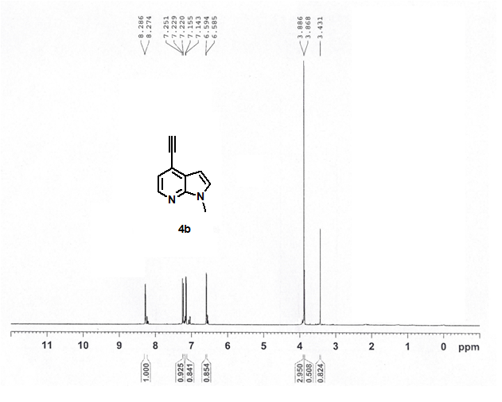

¹³C NMR spectrum for 4b

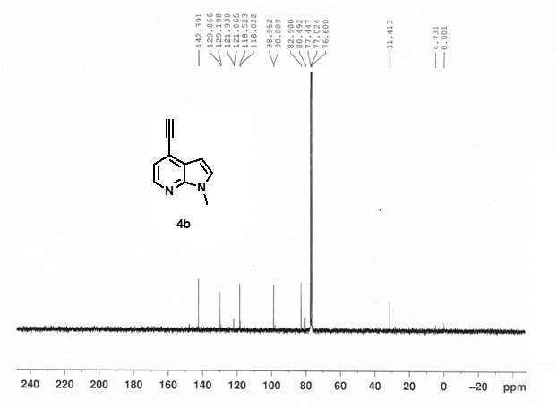

¹H NMR spectrum for 4c

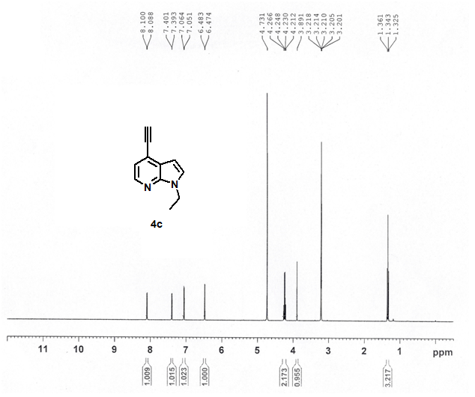

¹H NMR spectrum for 7a

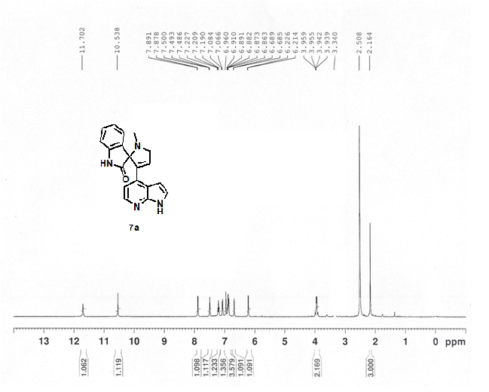

¹³C NMR spectrum for 7a

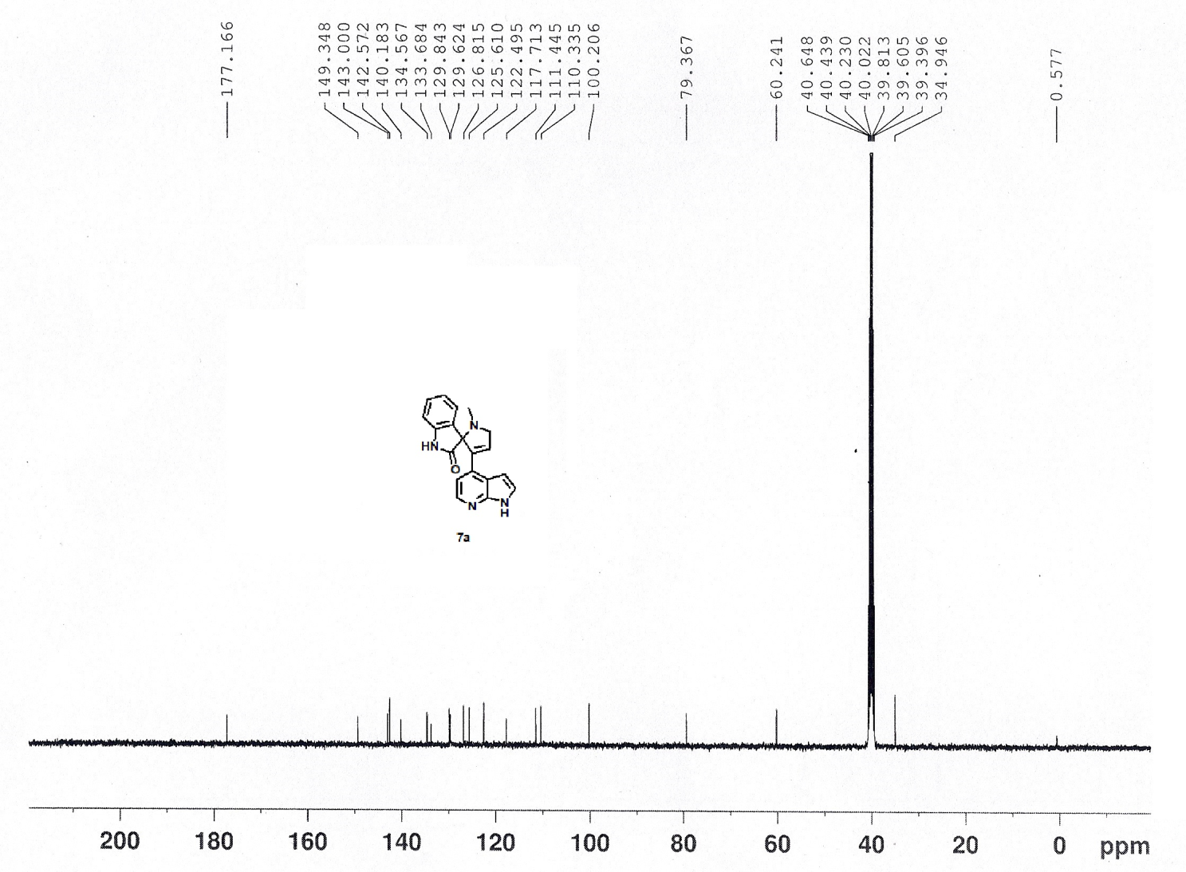

HPLC spectrum for 7a
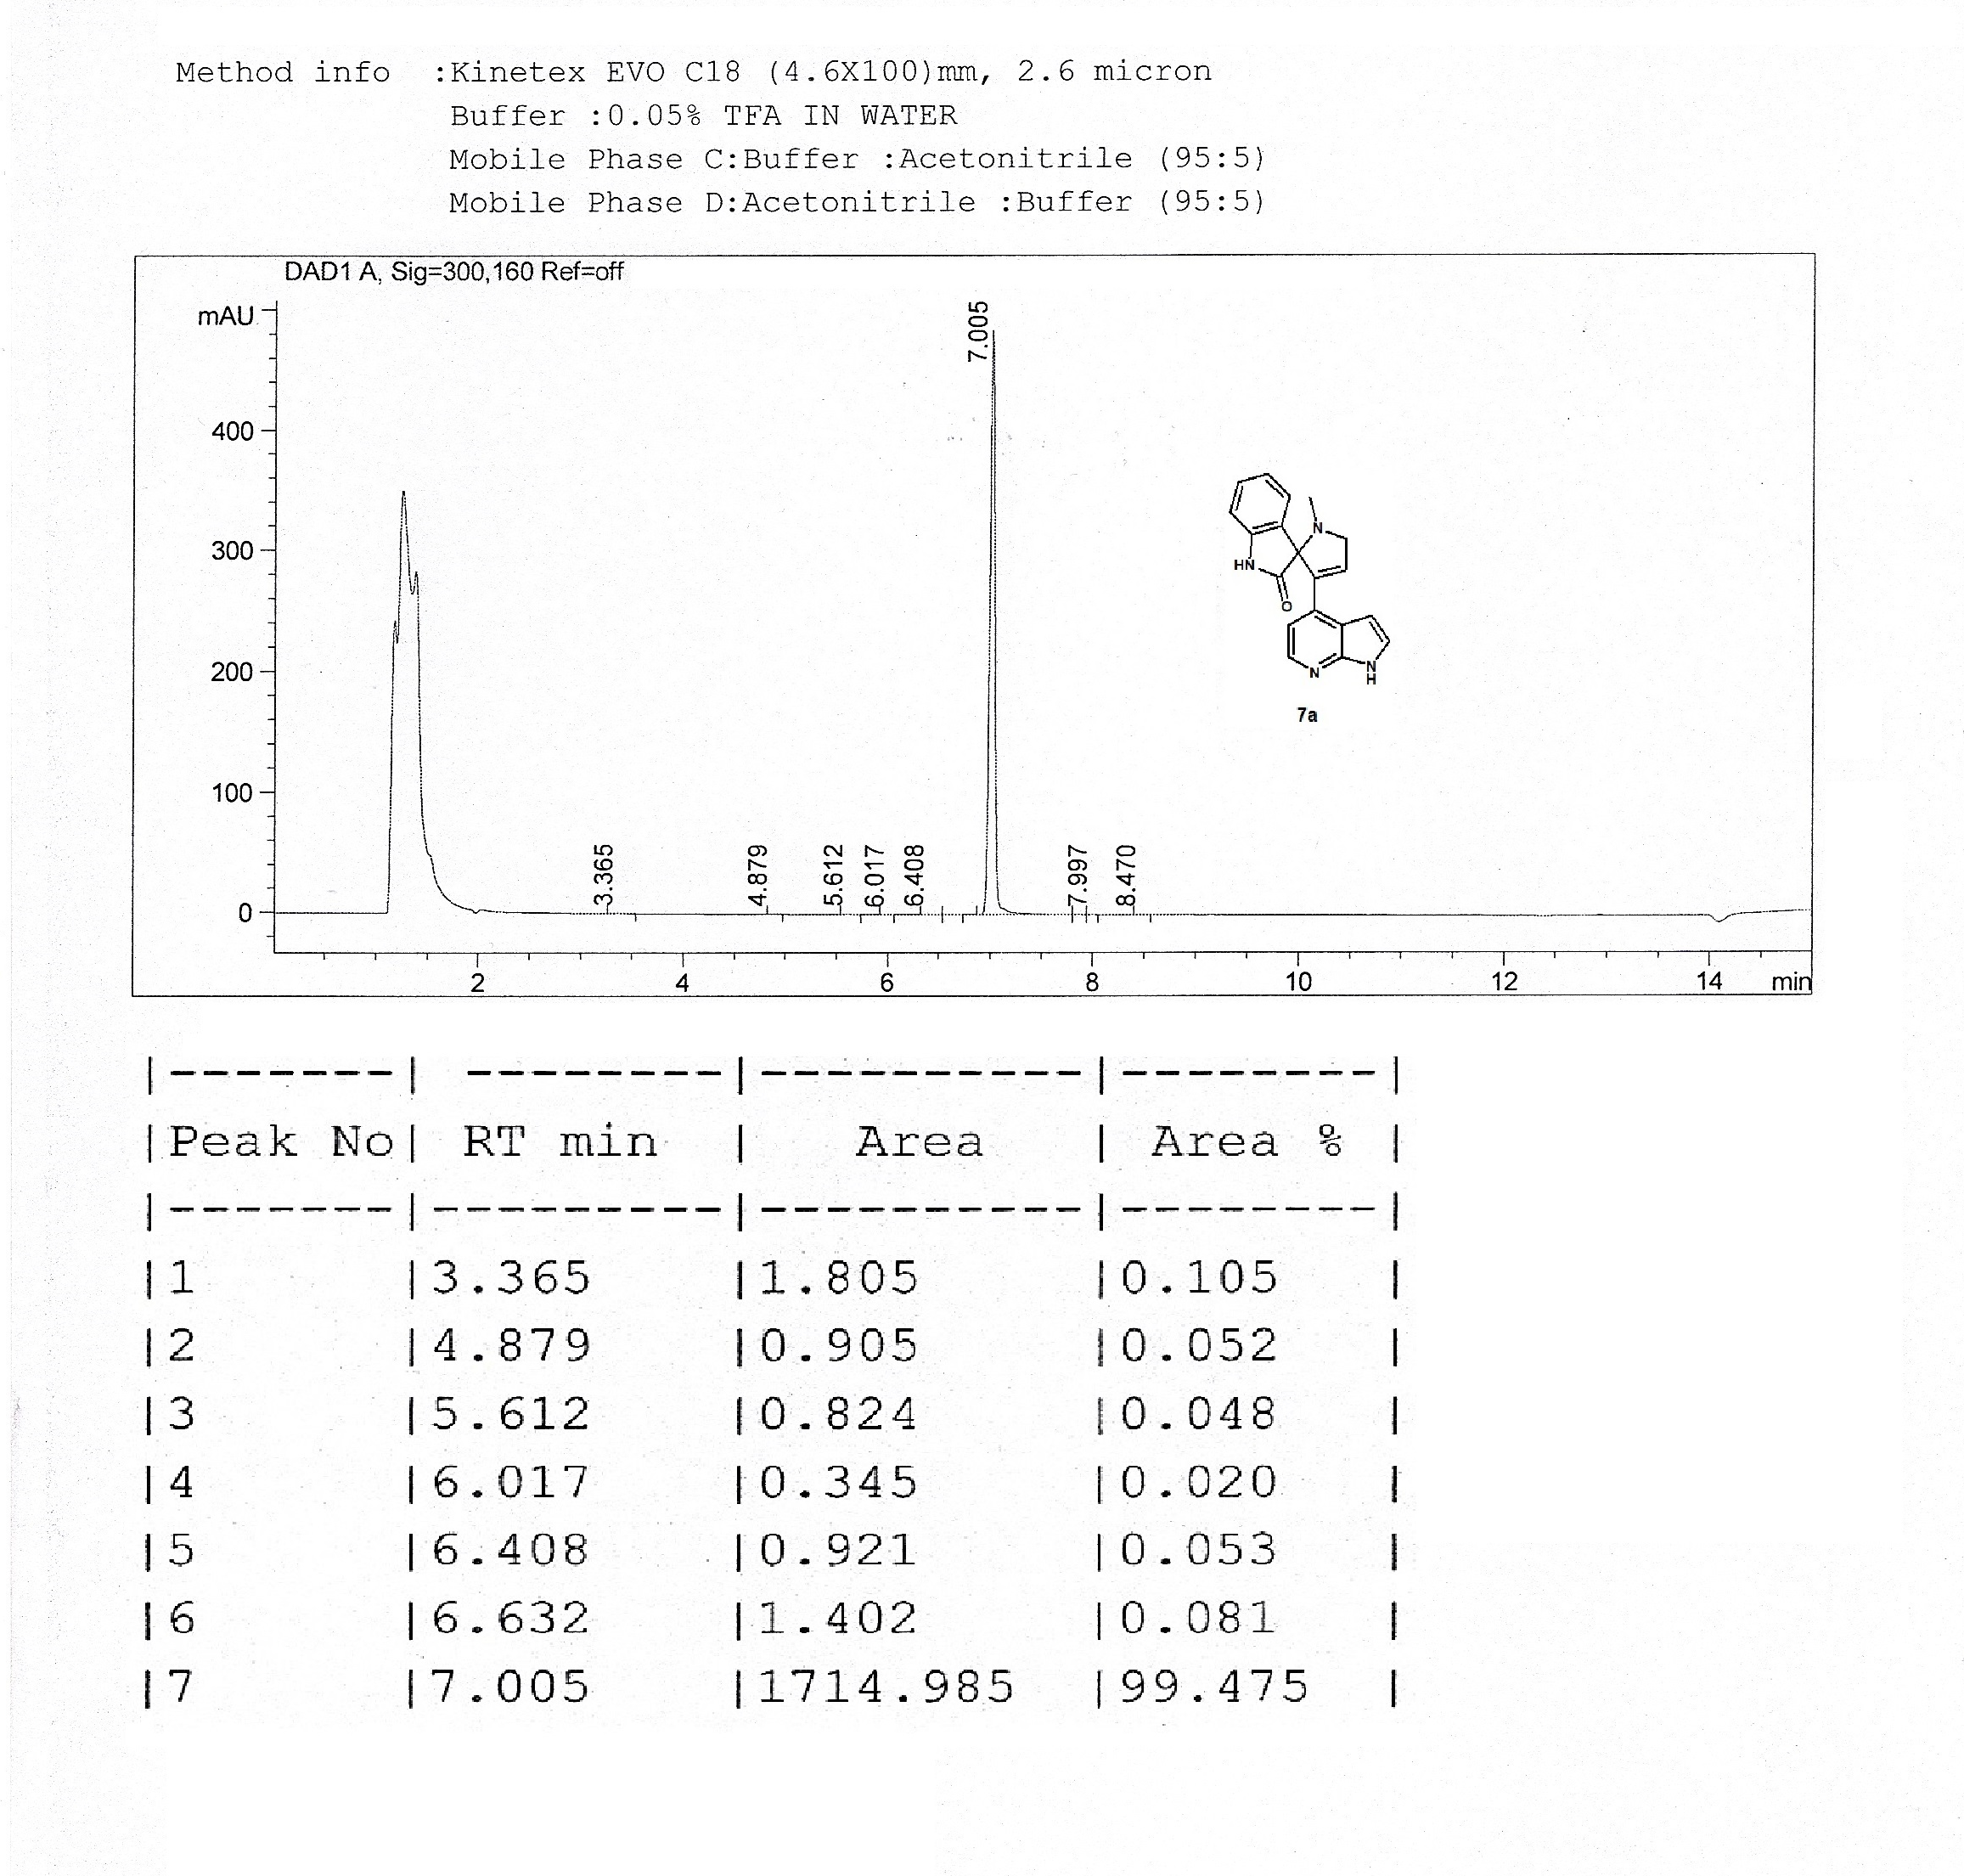

¹H NMR spectrum for 9a

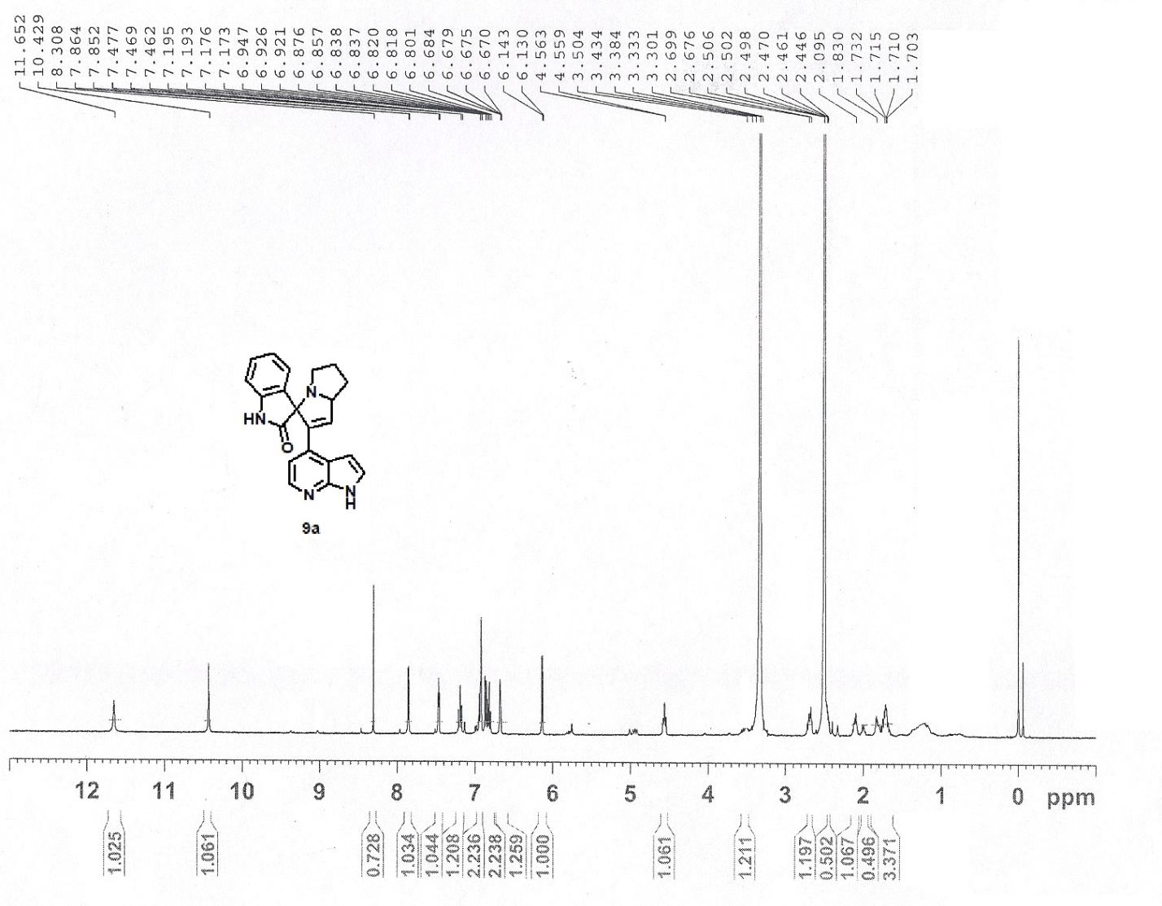

¹³C NMR spectrum for 9a

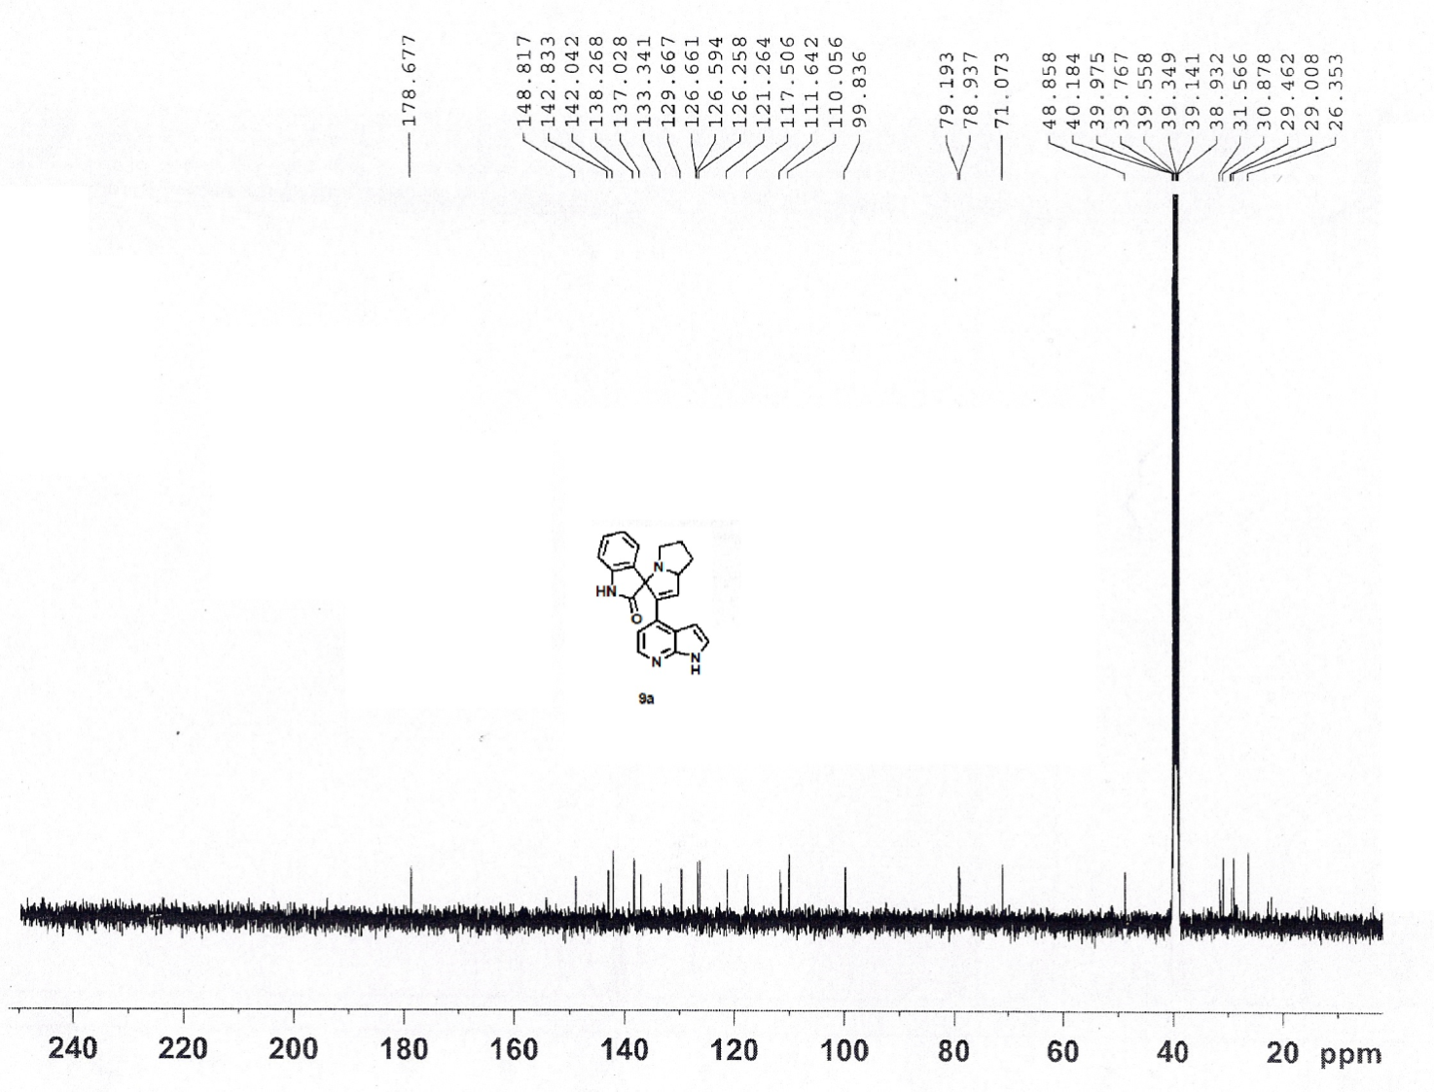

HPLC spectrum for 9a
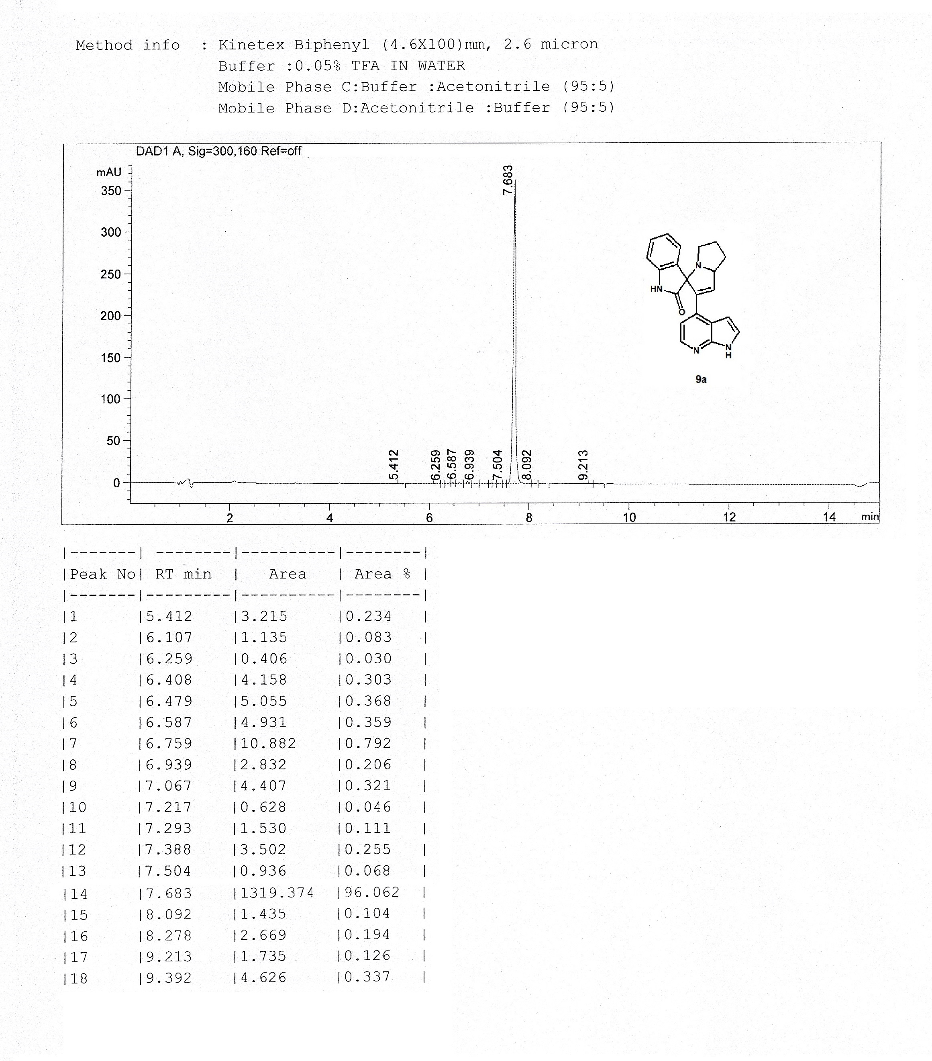

LCMS spectrum for 9a
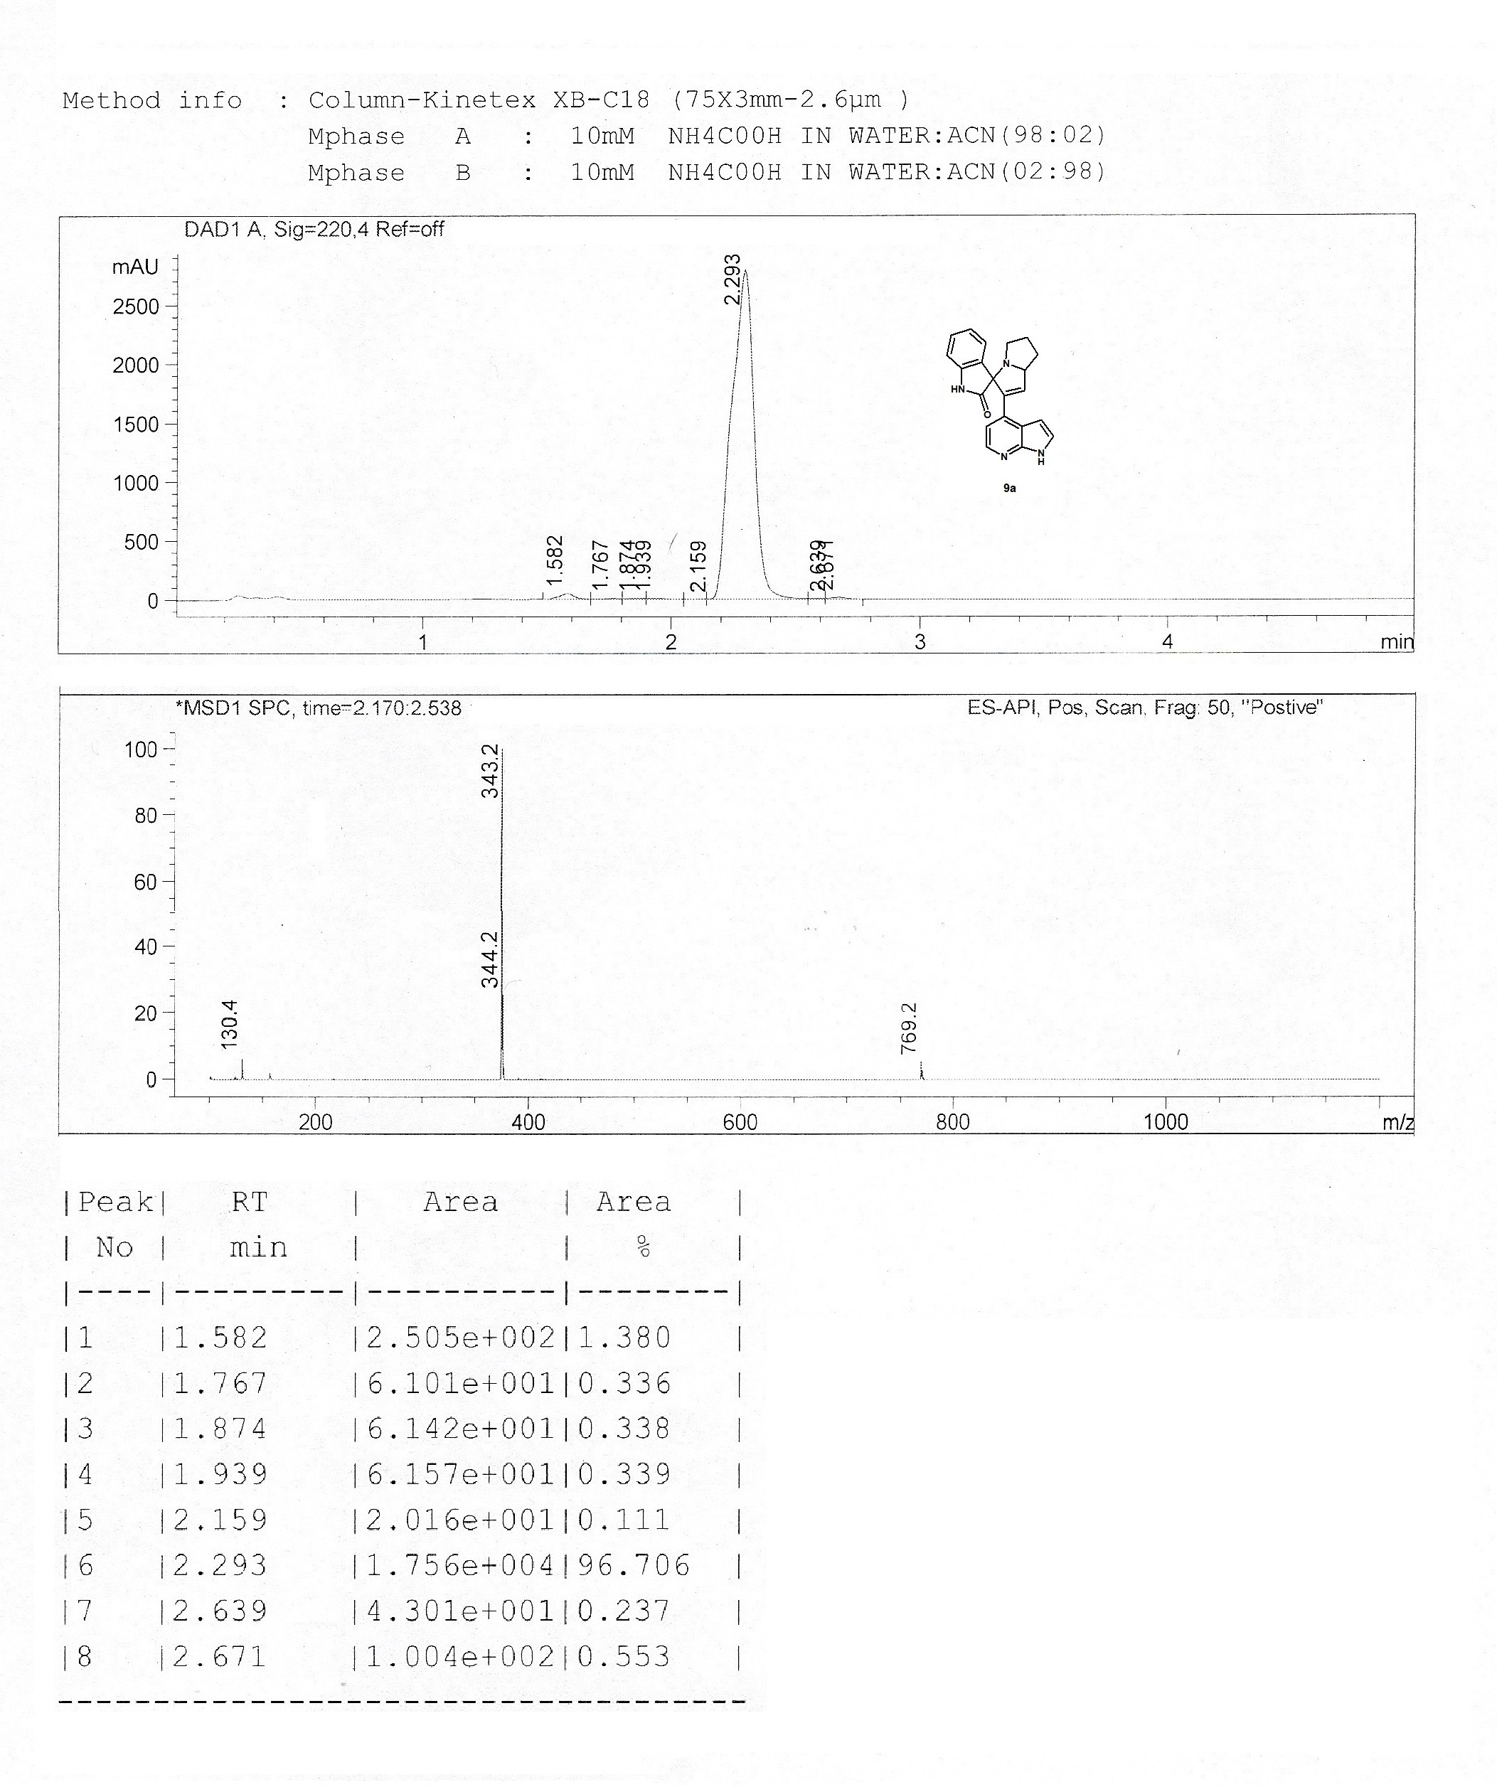

¹H NMR spectrum for 10a

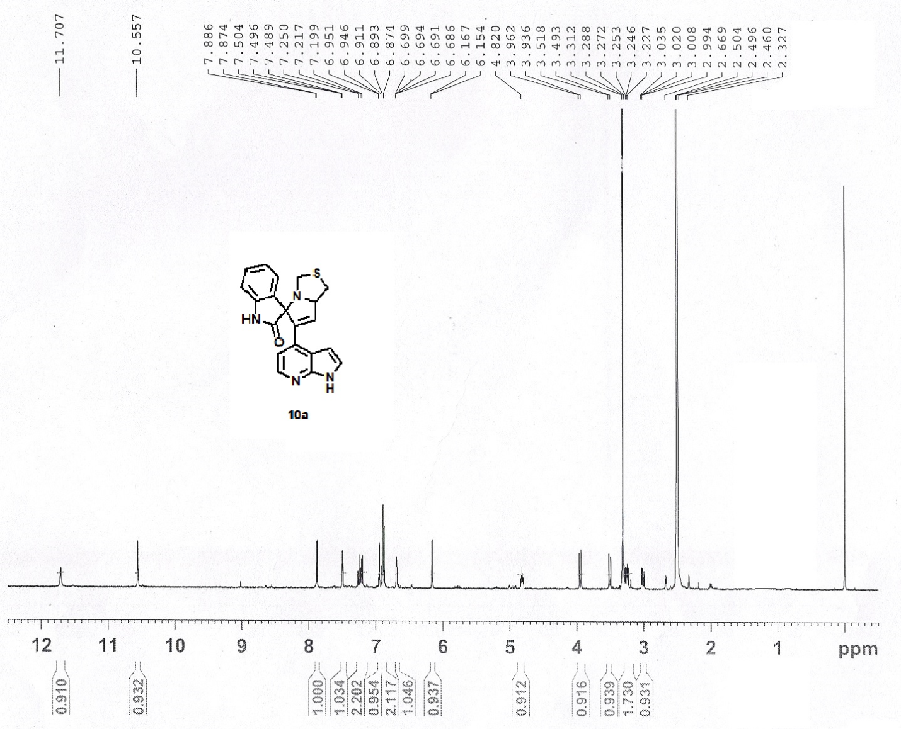

¹³C NMR spectrum for 10a

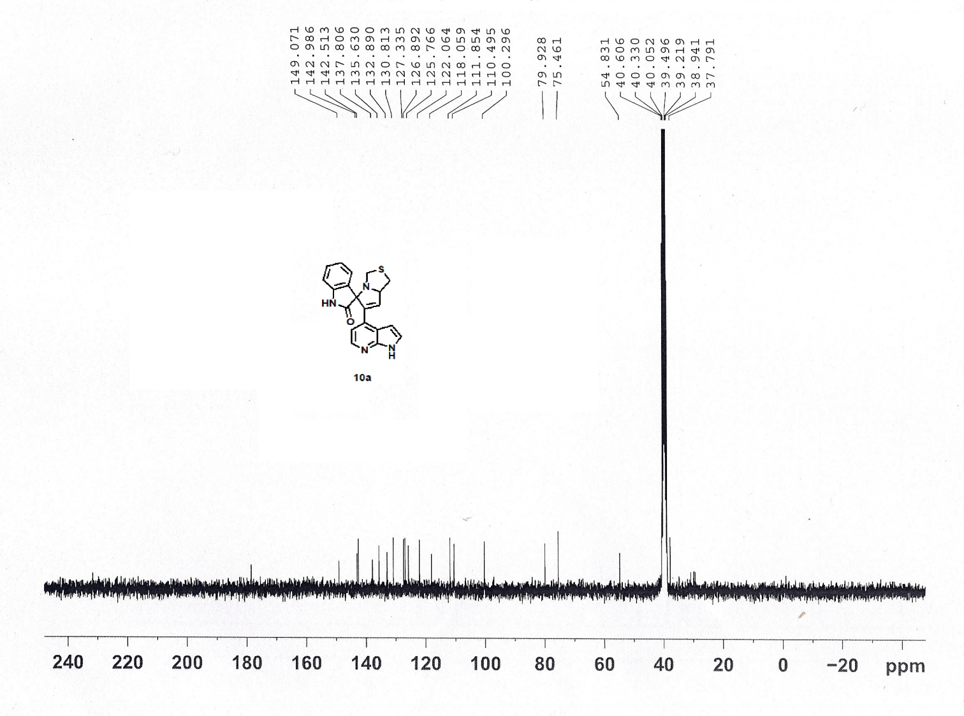

HPLC spectrum for 10a

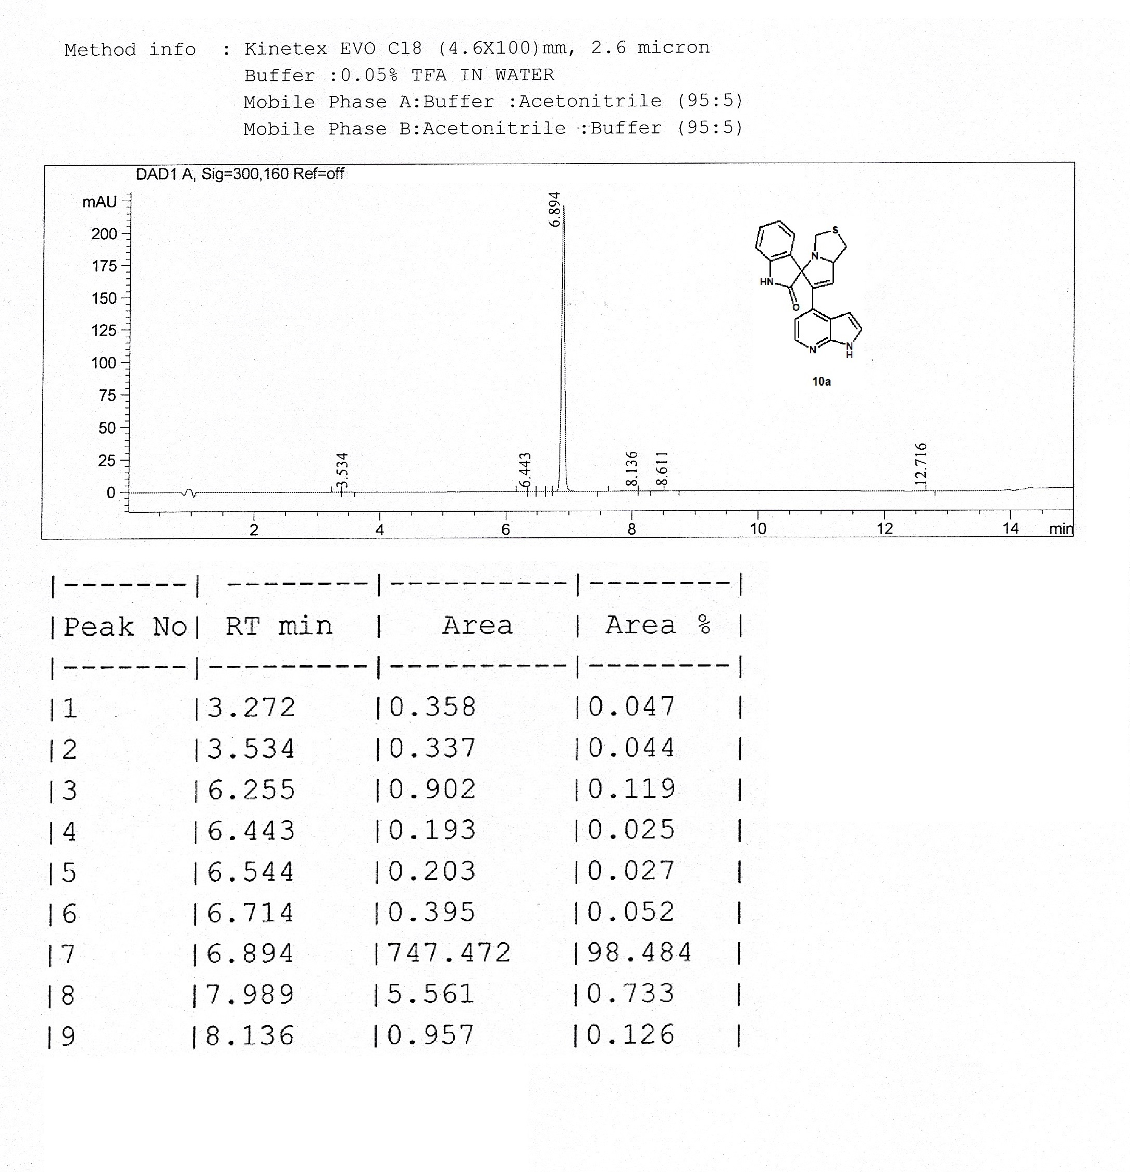

LCMS spectrum for 10a
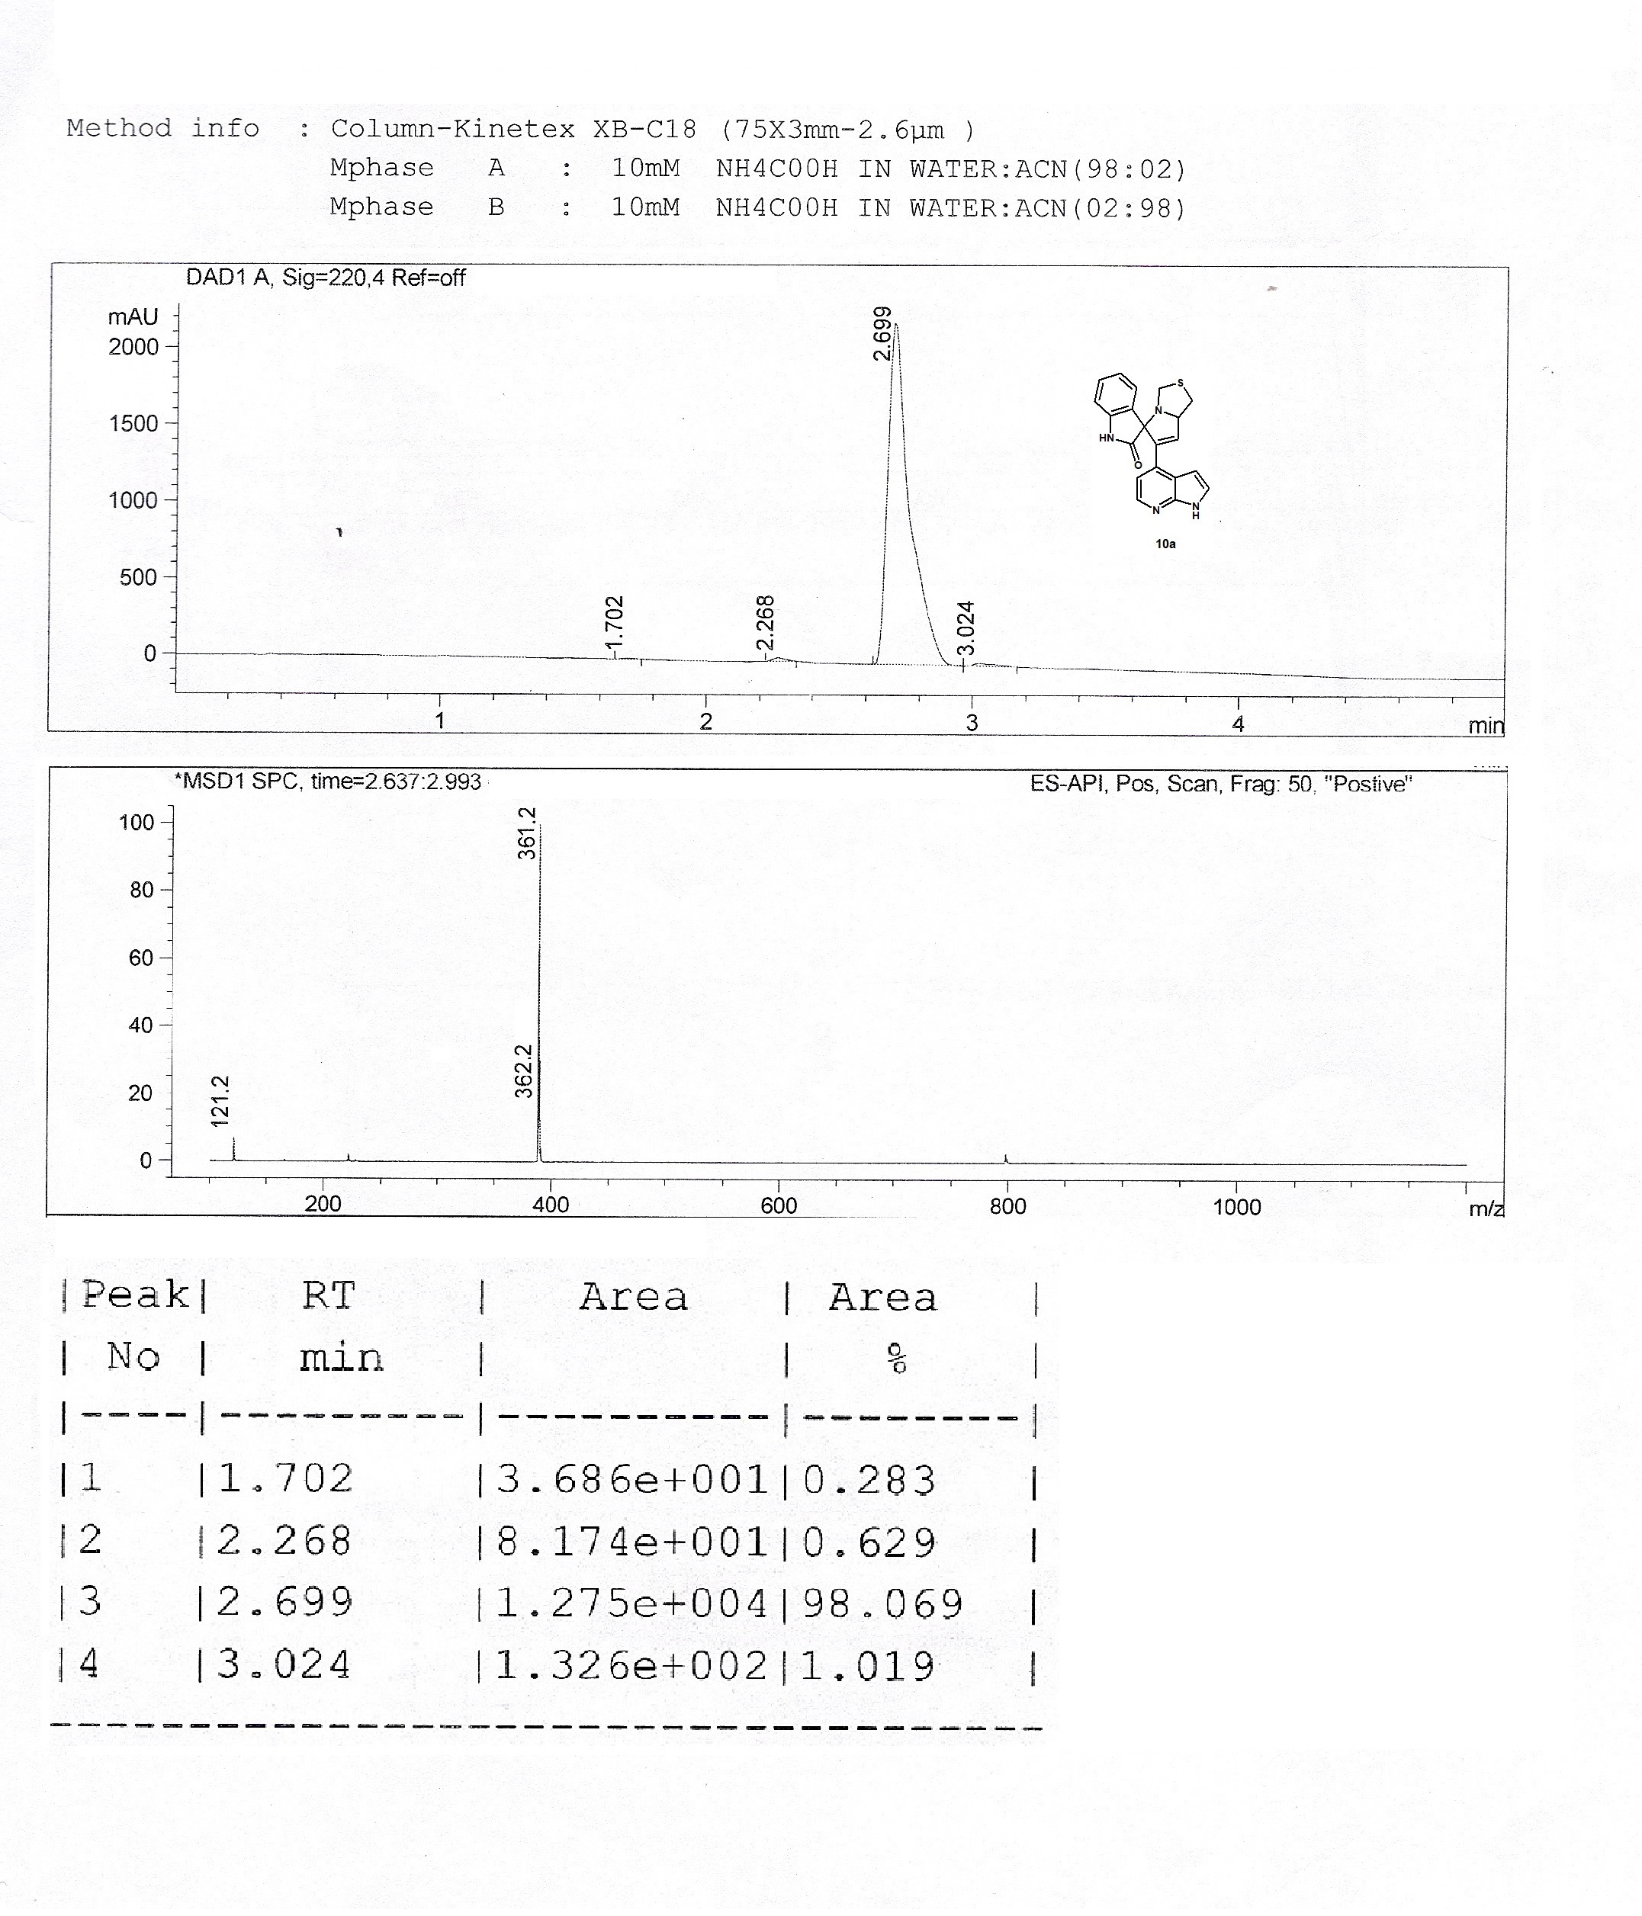

¹H NMR spectrum for 10c

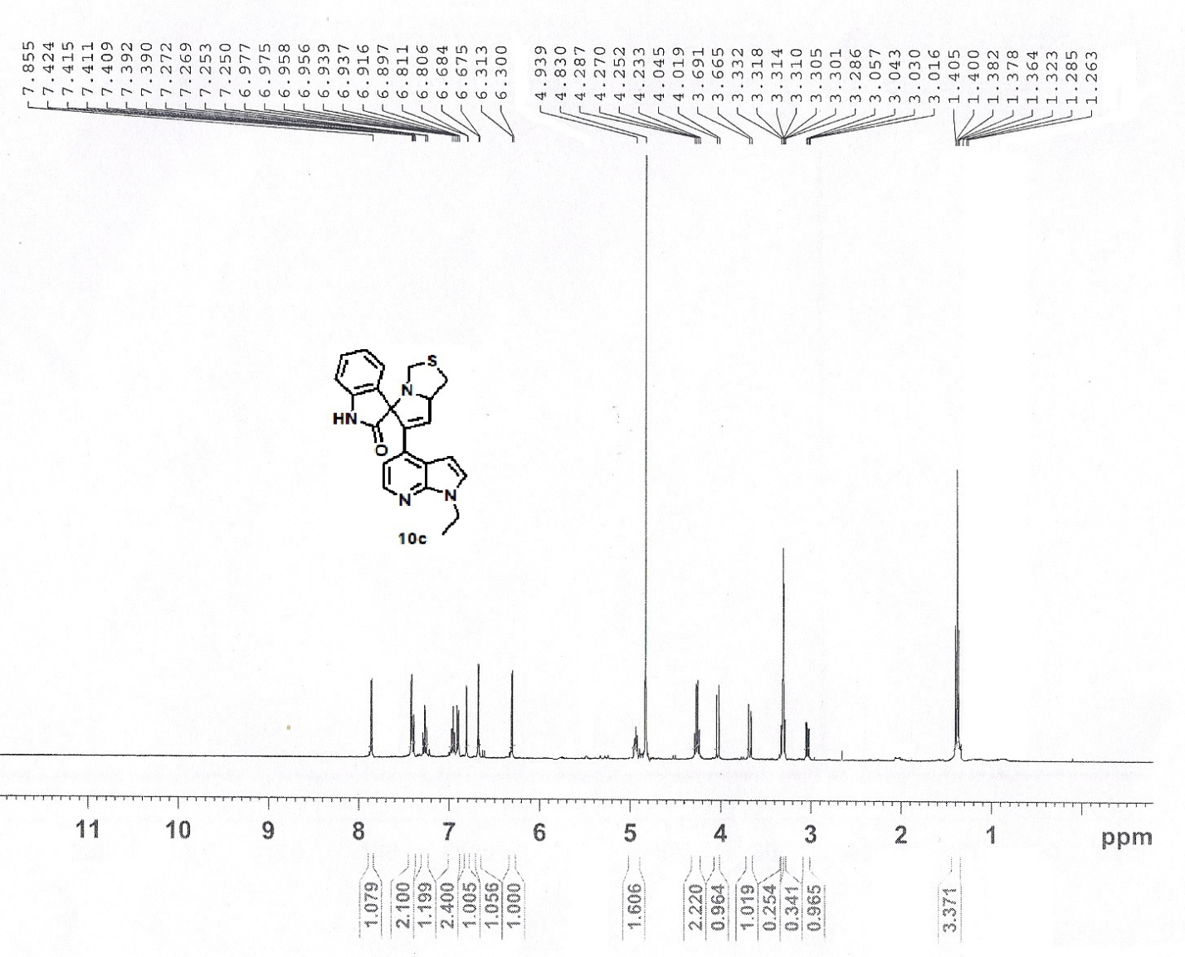

¹³C NMR spectrum for 10c

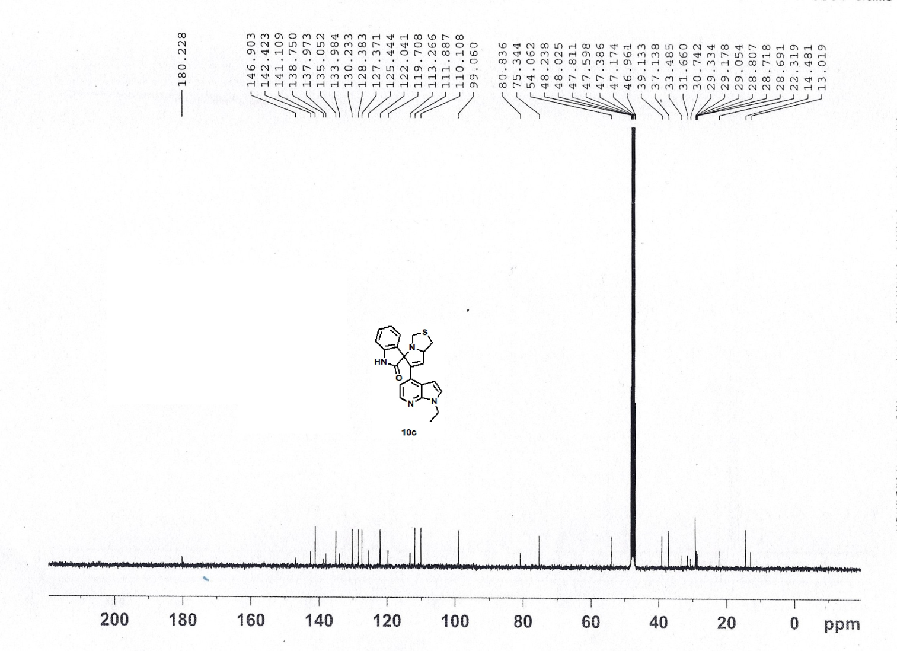

COSY spectrum for 10C
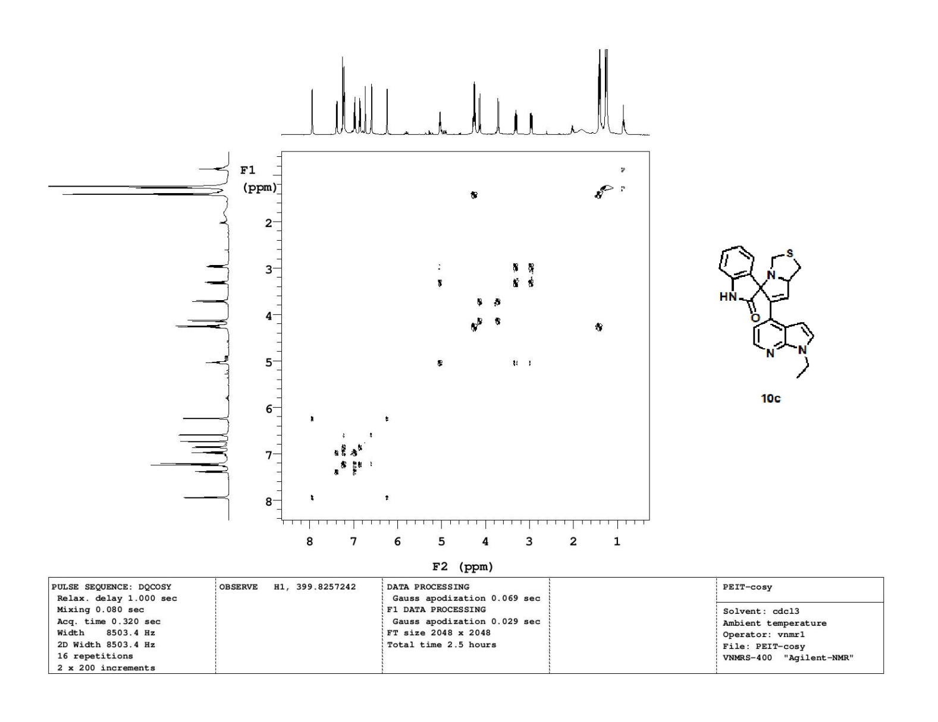

HSQC spectrum for 10C

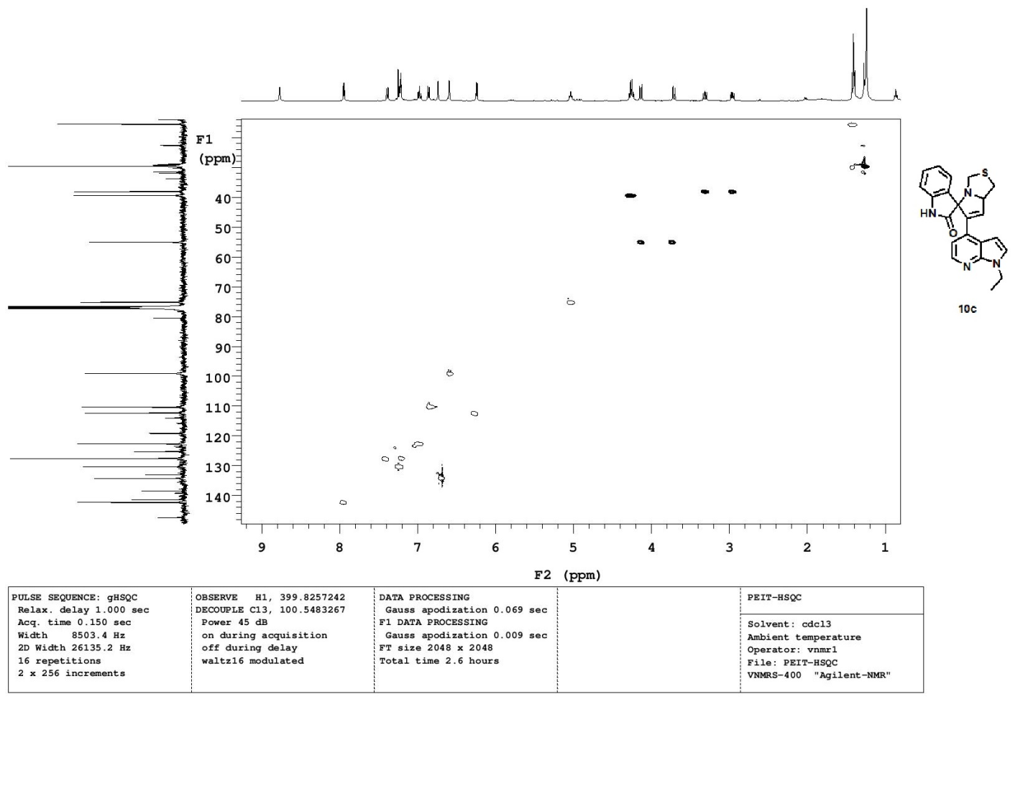

HPLC spectrum for 10C
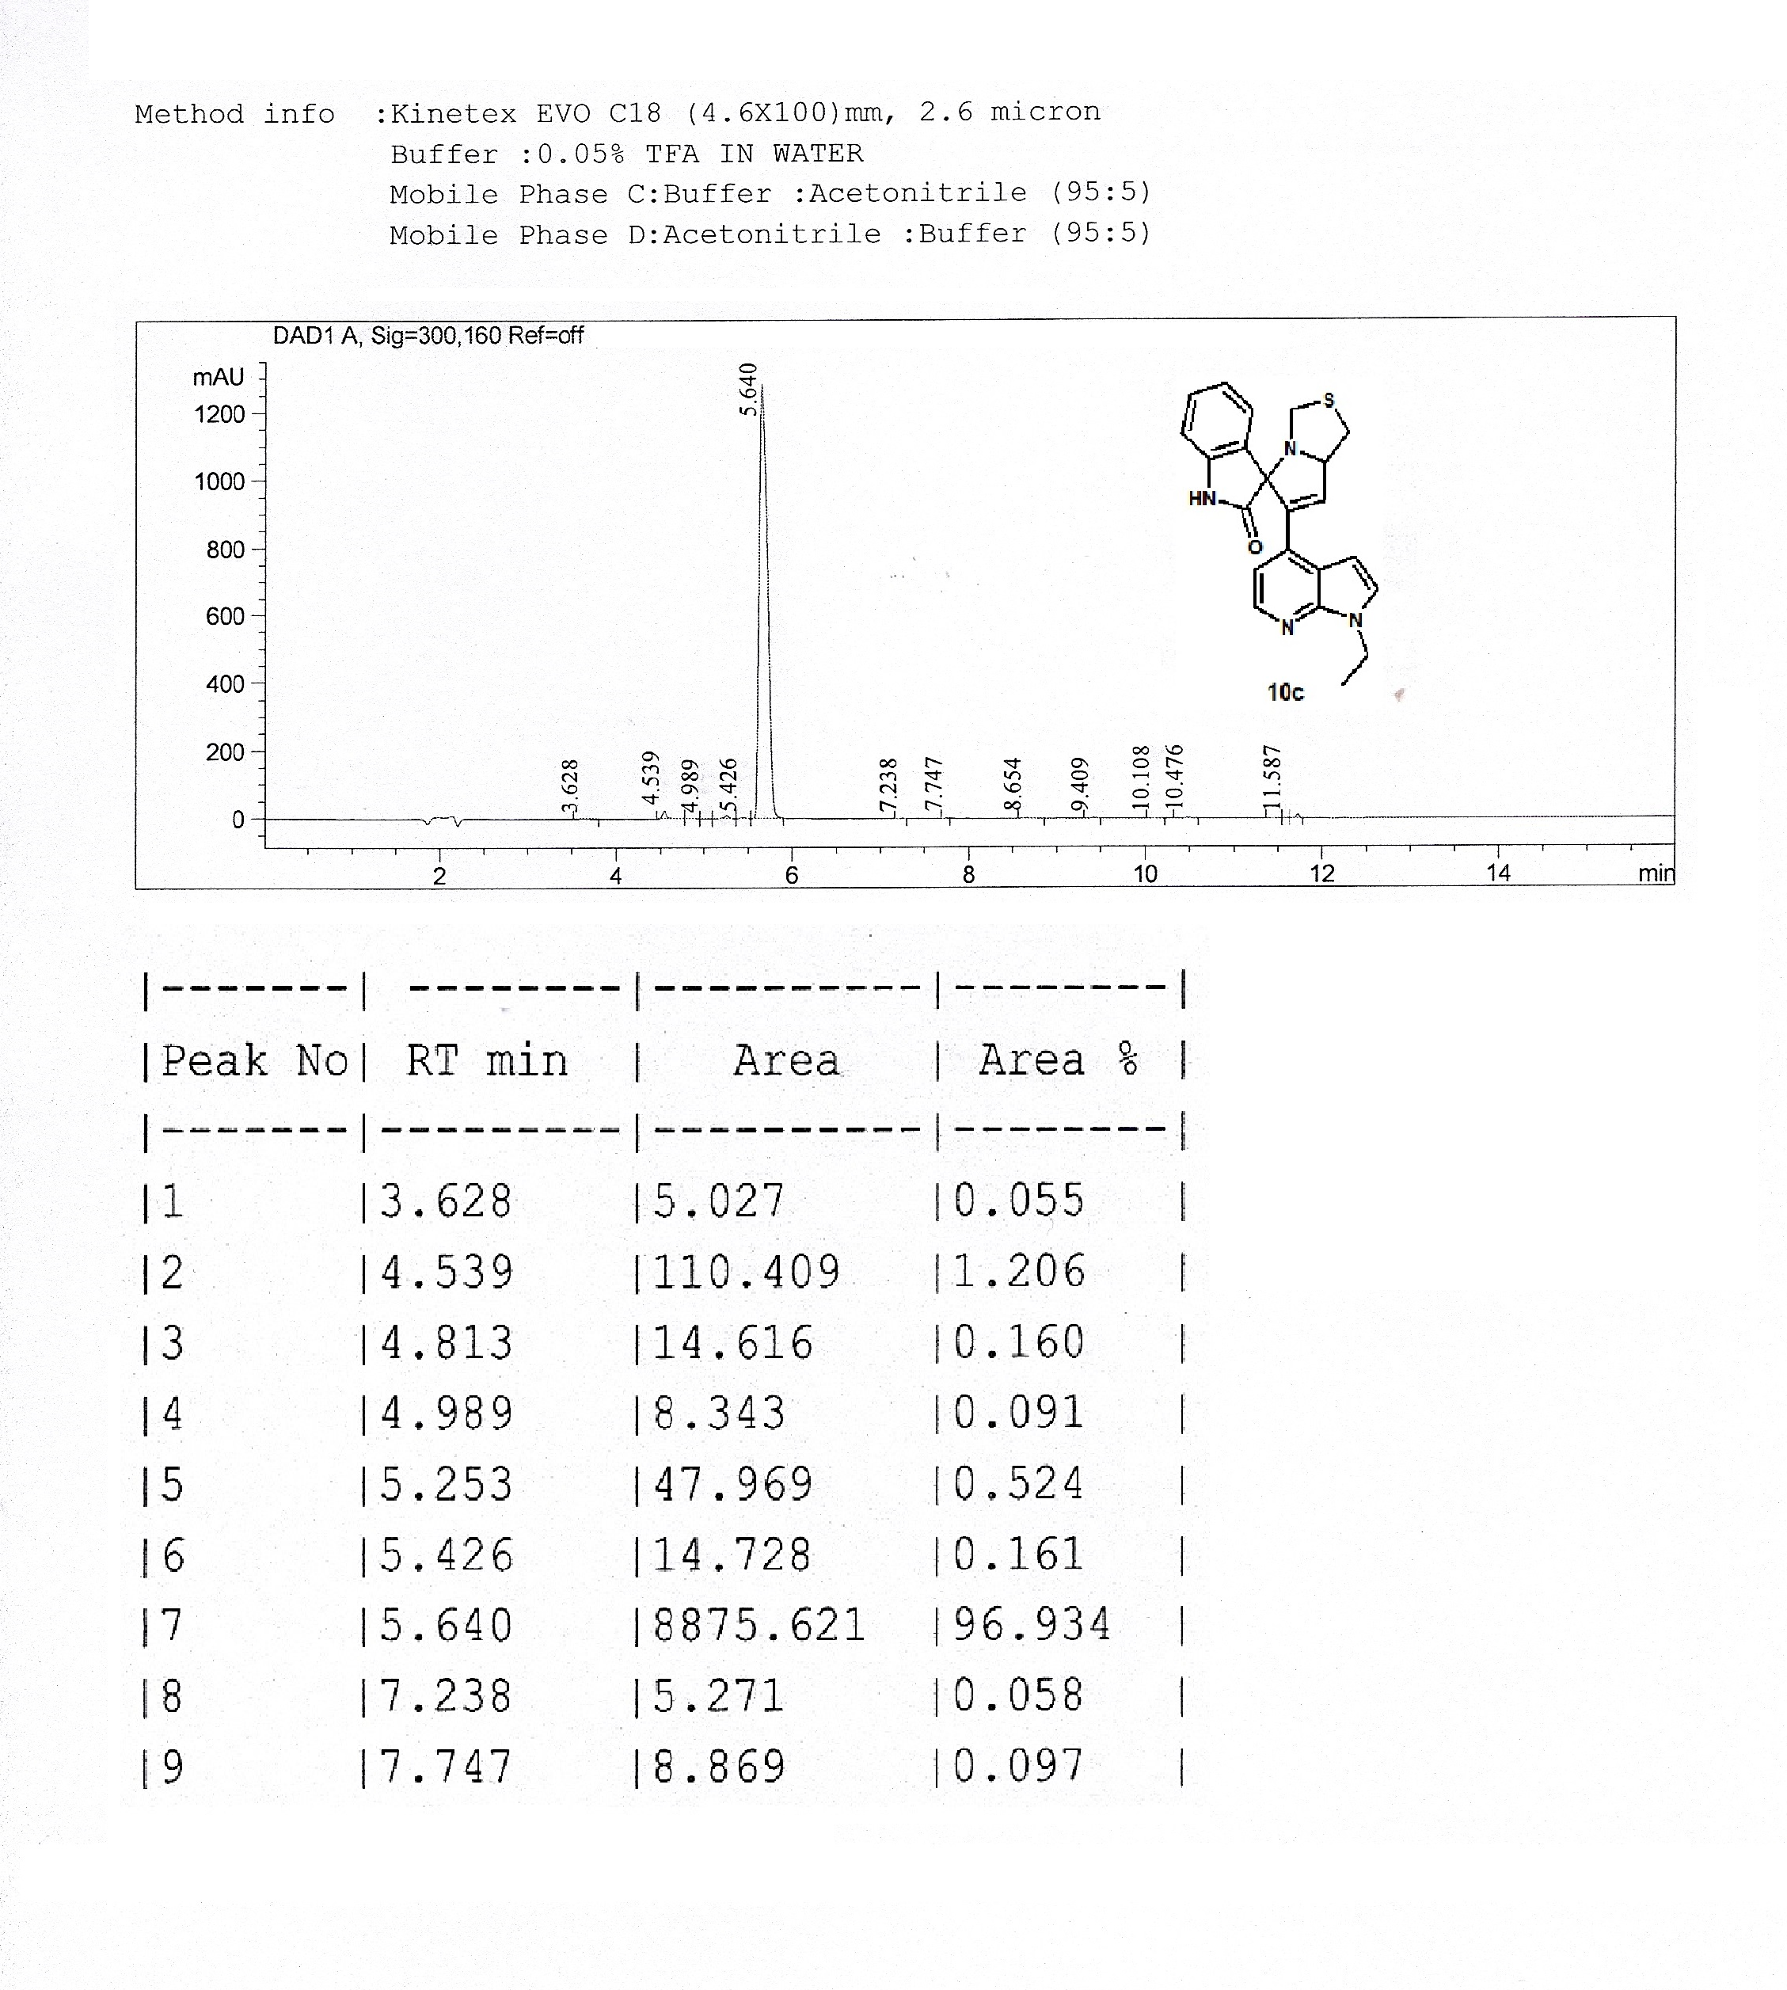

LCMS spectrum for 10C

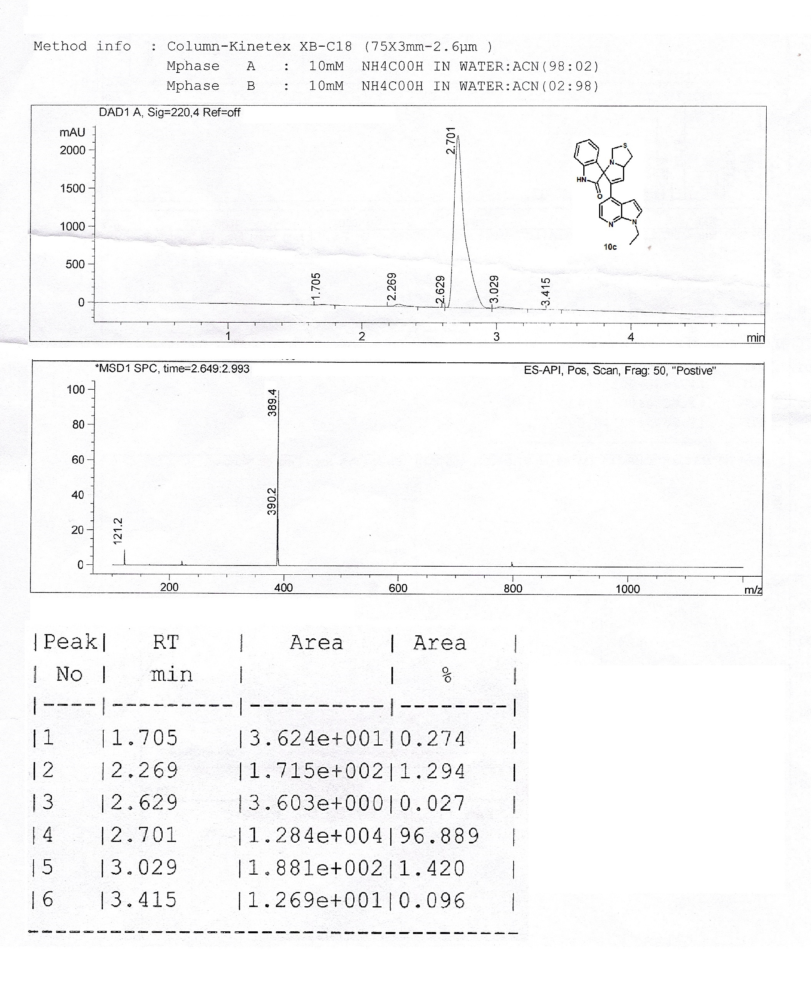

¹H NMR spectrum for 10d

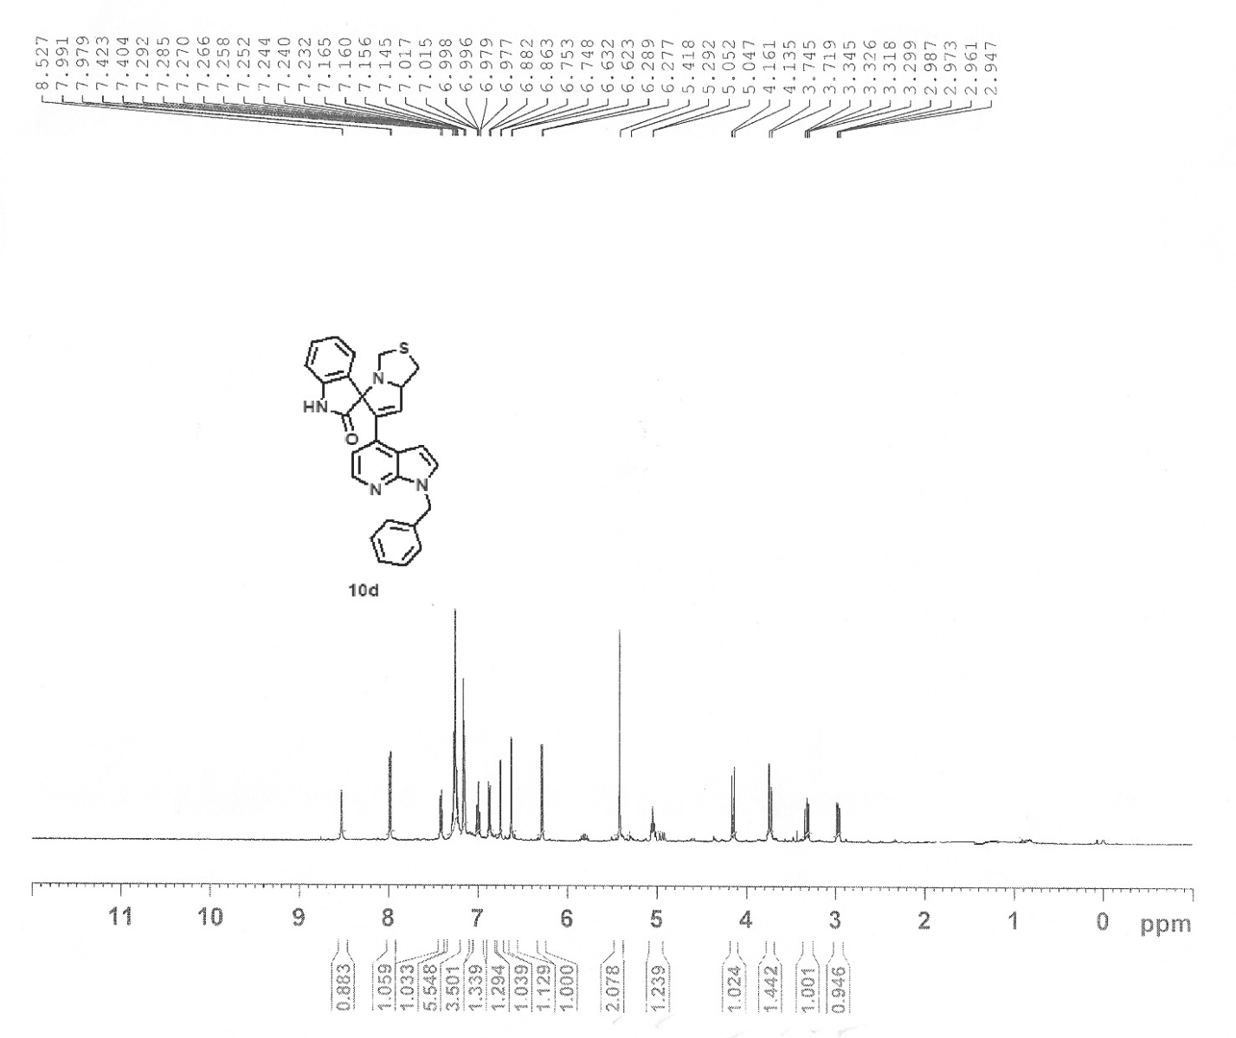

¹³C NMR spectrum for 10d

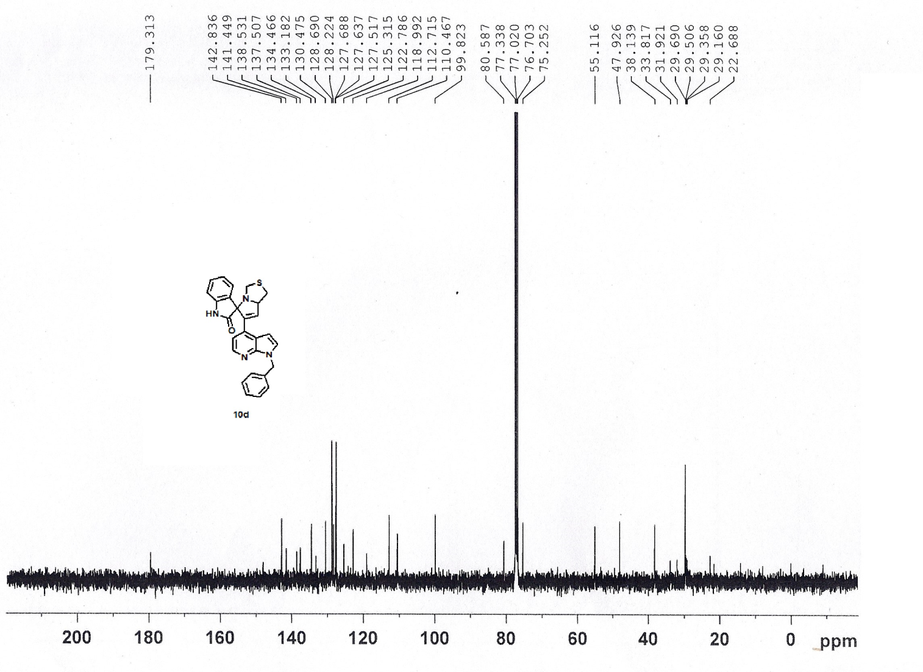

HPLC spectrum for 10d
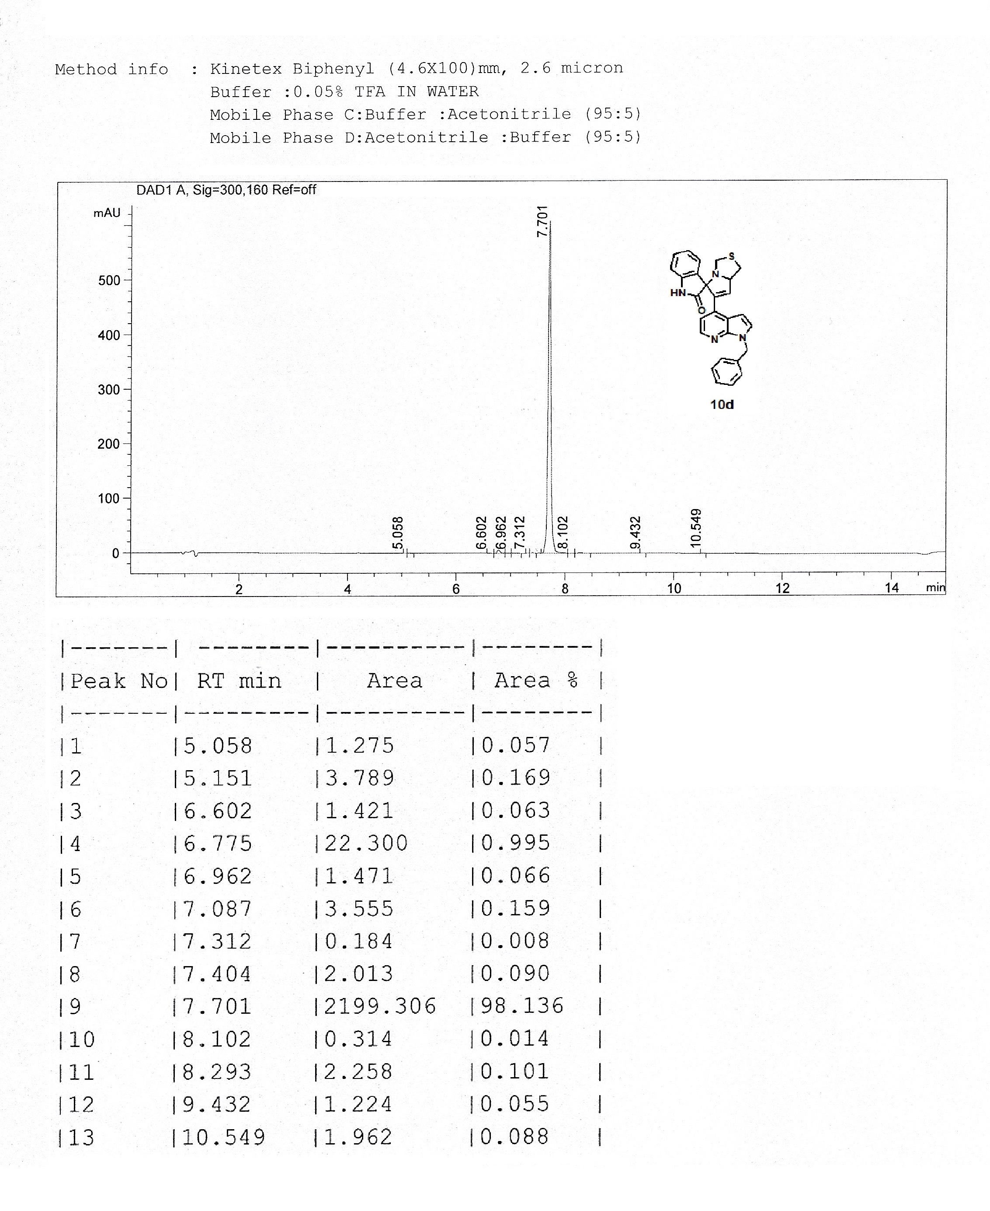

LCMS spectrum for 10d
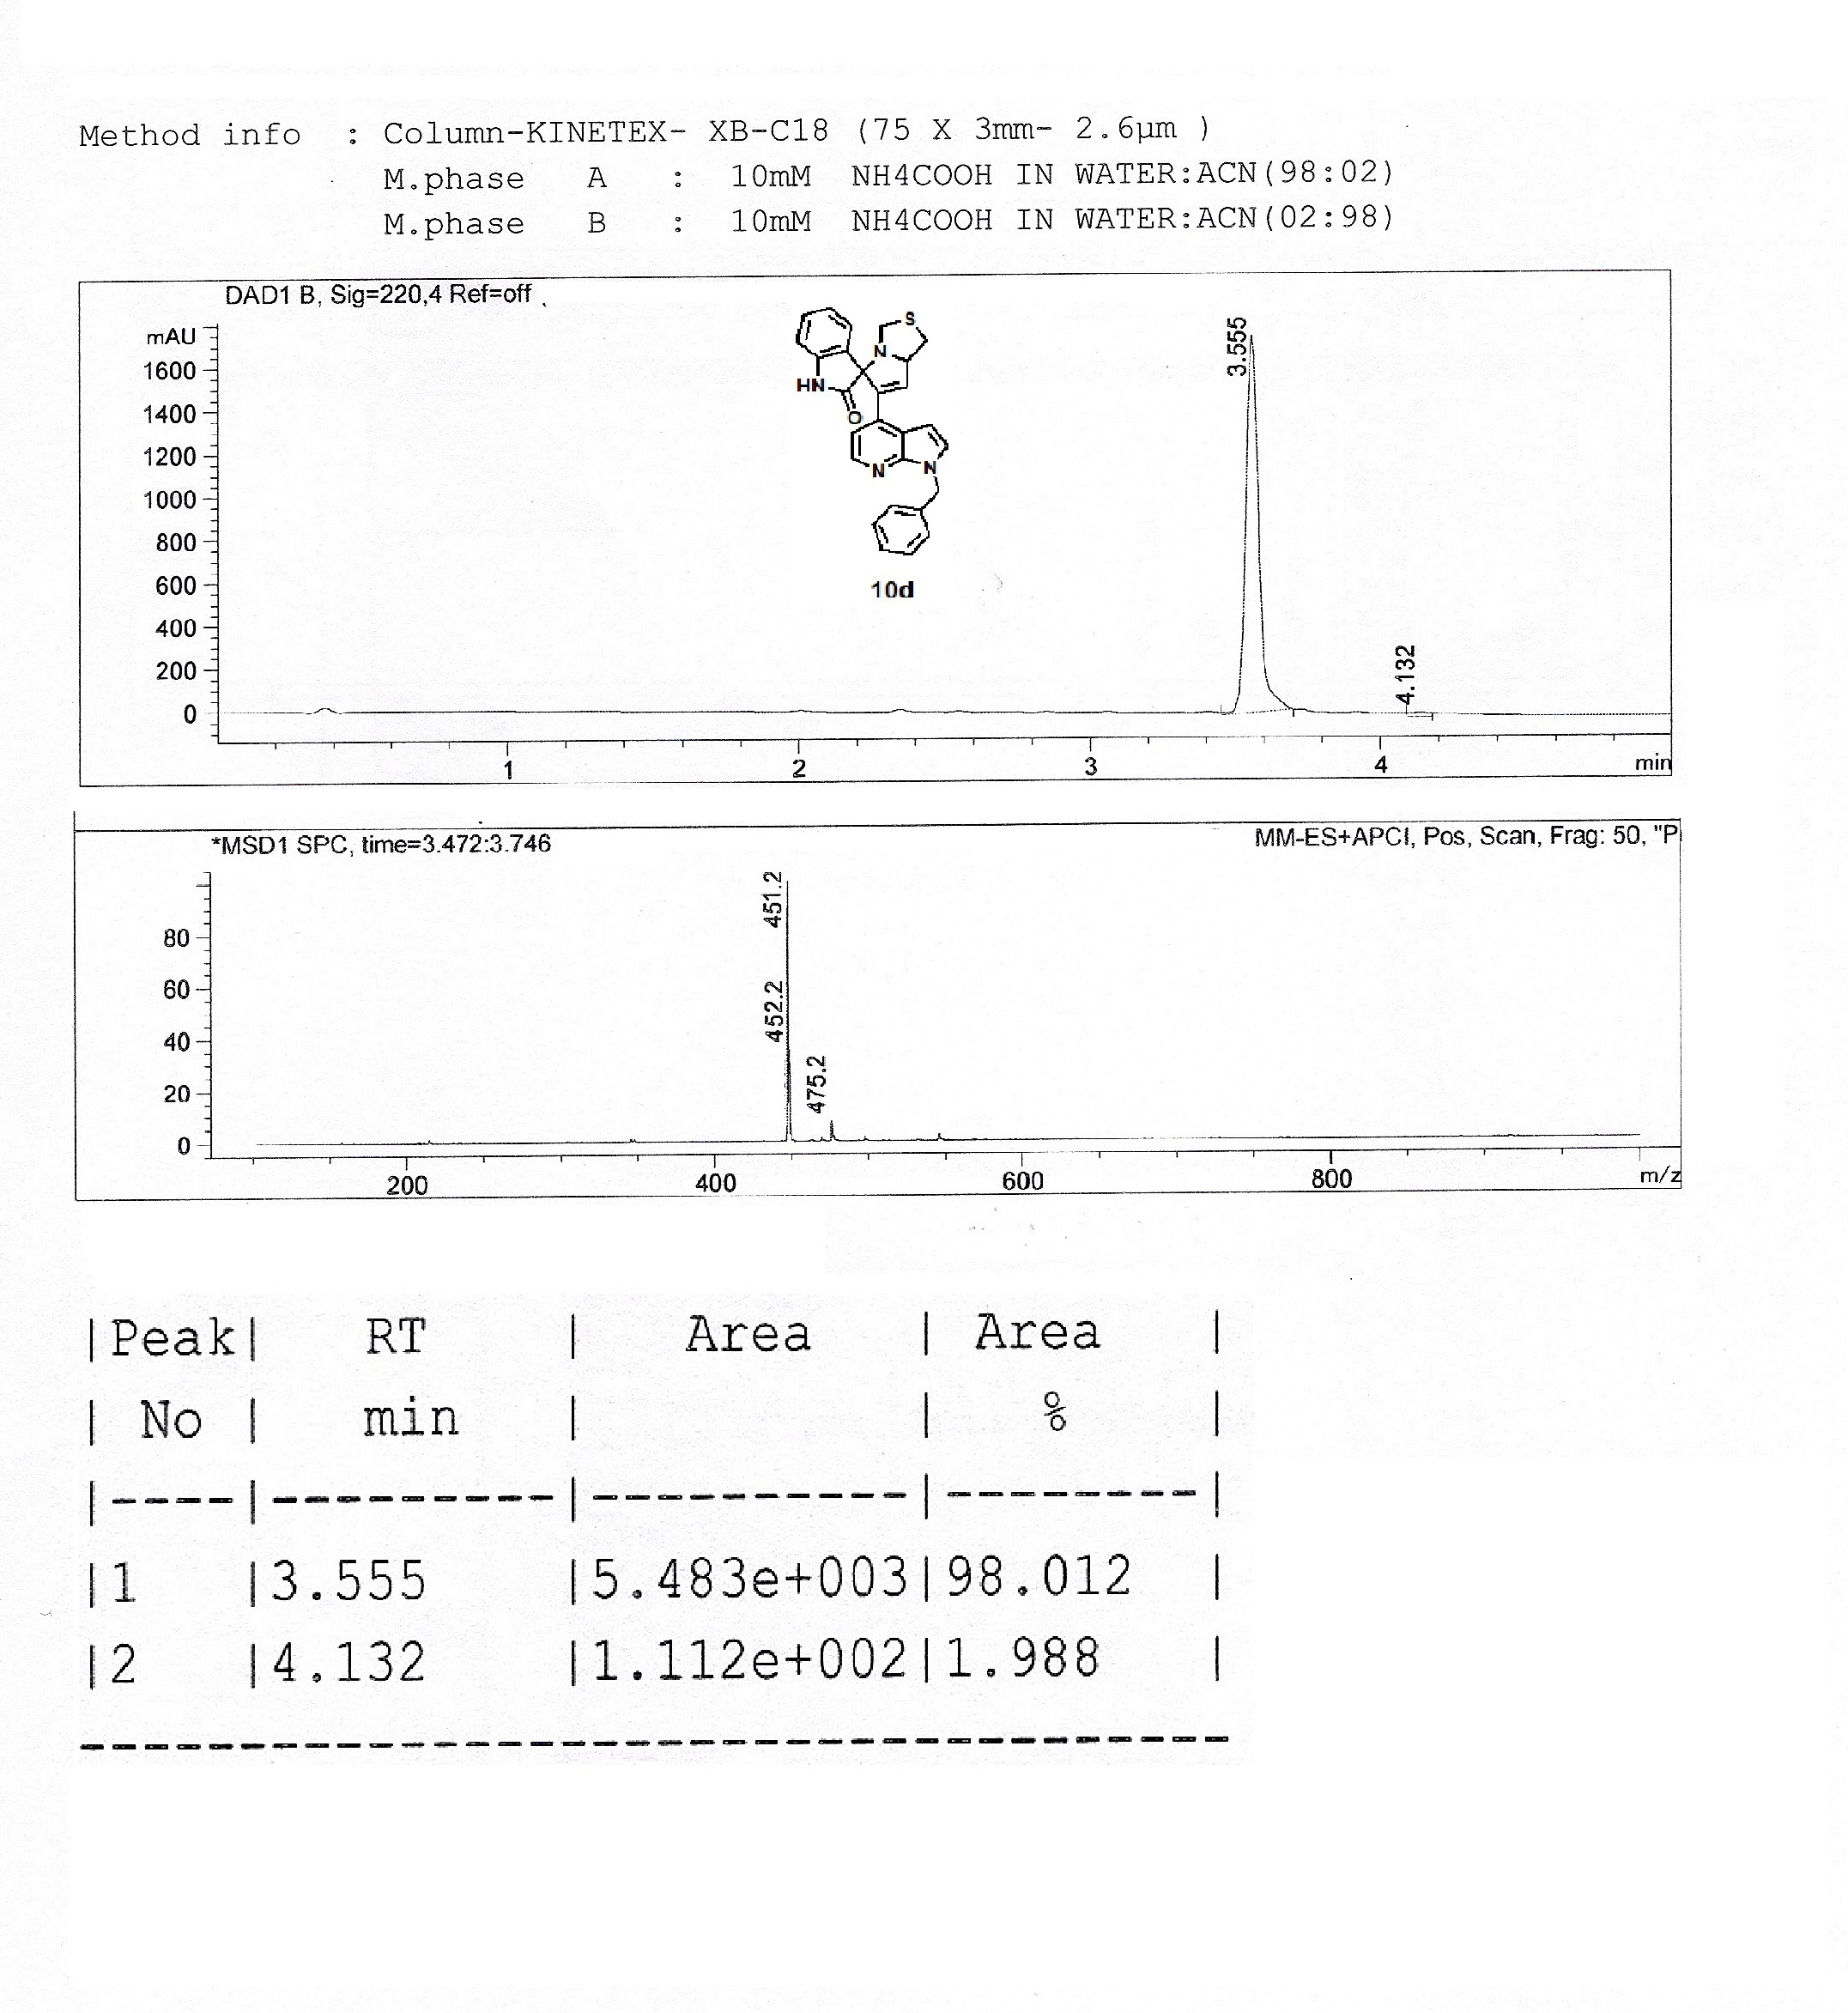

¹H NMR spectrum for 12a

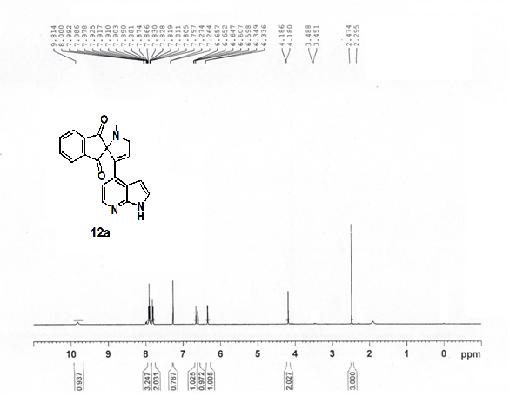

¹³C NMR spectrum for 12a

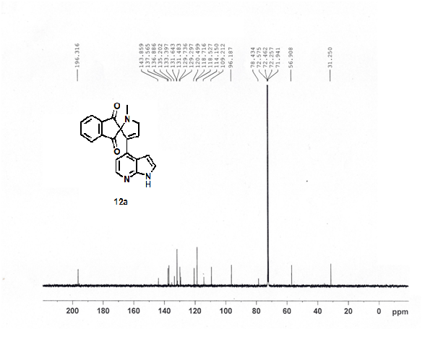

HPLC spectrum for 12a
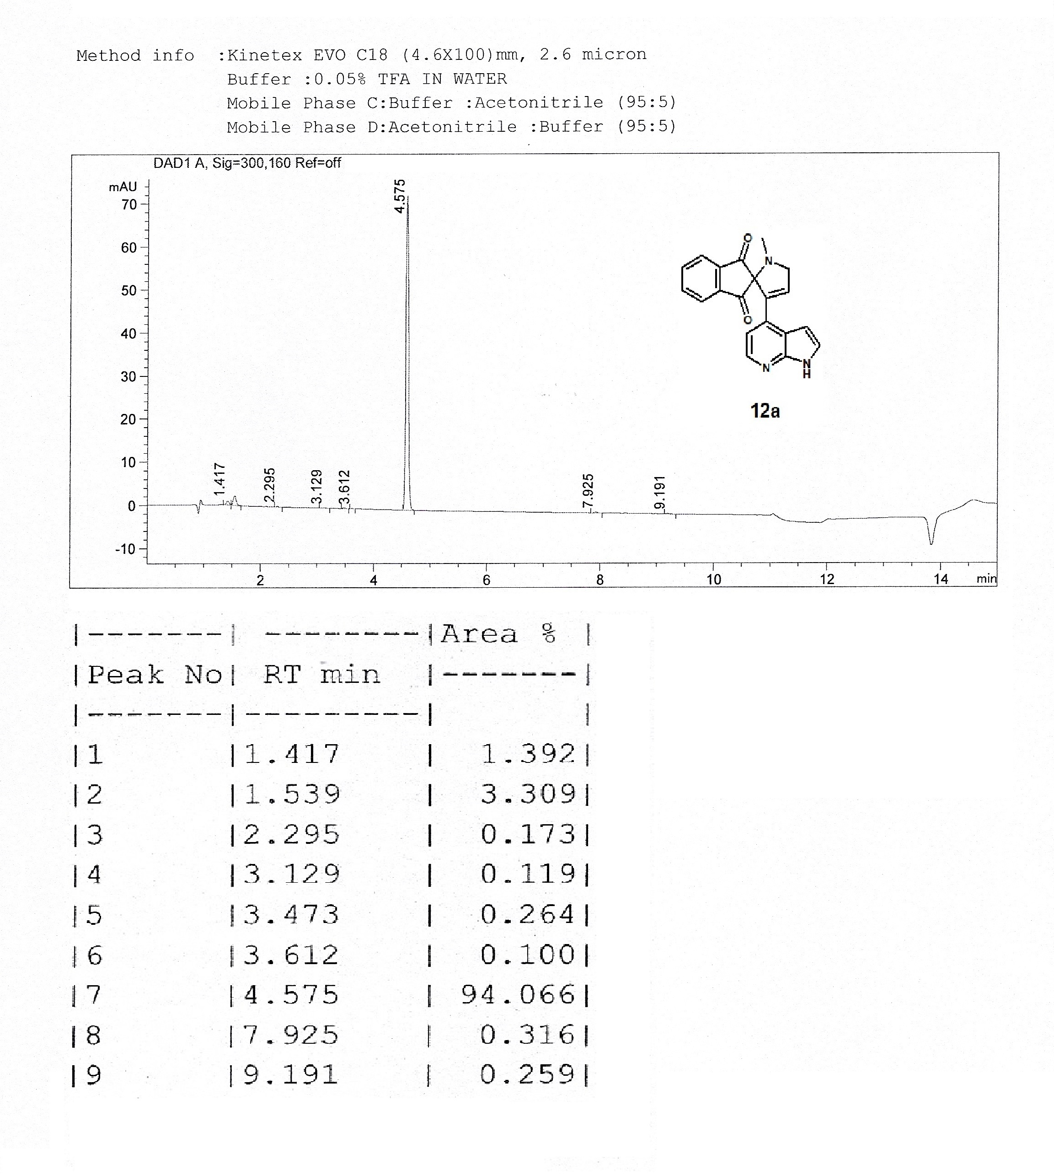

LCMS spectrum for 12a

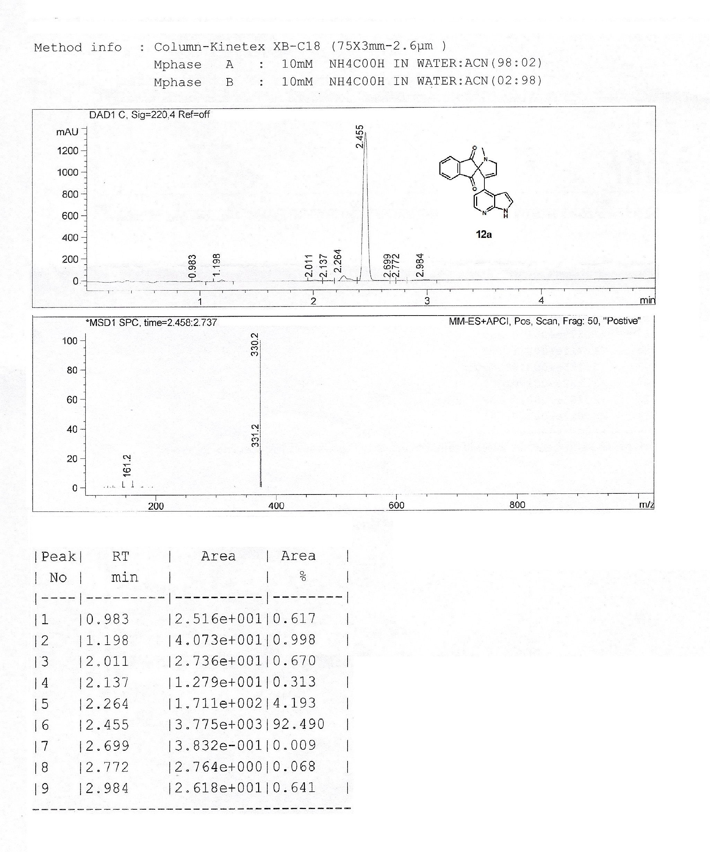
¹H NMR spectrum for 14d

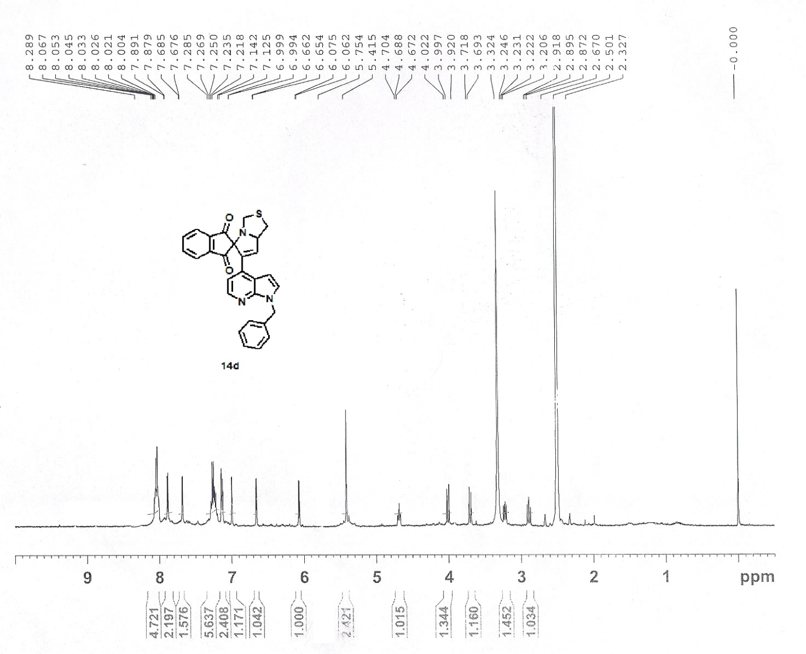

¹³C NMR spectrum for 14d

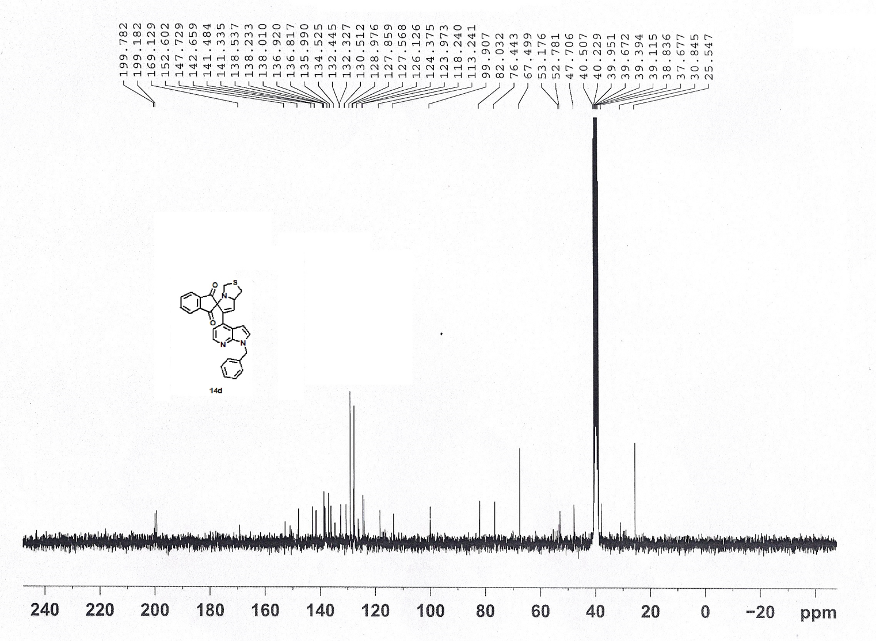

LCMS spectrum for 14d



