Supporting Information

Economical synthesis of tert-butyl (S)-3-aminopyrrolidine-1-carboxylate from L-Aspartic acid
Zhi-Jian Han¹, Yang-Bing Li¹, Bao-Hong Gu², Yu-Min Li², Hao Chen^{1, 2}
¹The Key Laboratory of the Digestive System Tumors of Gansu Province, Lanzhou University Second Hospital, Lanzhou 730000, China.
²Department of General Surgery, Lanzhou University Second Hospital, Lanzhou 730000, China

Content

1. Figure S1
2. General
3. Characterization of compounds
4. References
5. NMR Spectra of compounds

1. Figure S1.

Figure S1. Procedure of preparation of the compound 1.
2. General.
All reactions were performed under an argon atmosphere and solvents were dried according to the established procedures ahead of use. All reagents were commercial. The reactions were monitored by TLC, HPLC or LC-MS; column chromatography and preparative TLC purification were carried out using silica gel. ¹H NMR was measured on 600 MHz spectrometers and recorded as ppm. LC-MS was measured with Bruker Maxis 4G. The mobile phase A for HPLC was water with 0.1% trifluoroacetic acid, and the mobile B was acetonitrile (Ourchem, HPLC grade) with 0.1% trifluoroacetic acid.
3. Characterization of compounds
((Benzyloxy)carbonyl)-L-aspartic acid (2).⁽¹⁾ In a 1L round bottom flask, to a stirred solution of 50g of L-aspartic acid (0.376 mol) in 150 g of sodium hydroxide (20% aqueous, 0.75 mol, 2.0 eq) was added 2.5 g of benzyltriethylammonium chloride (9.6 mmol, 0.026 eq). Then benzylchloroformate (0.413 mol, 75 g, 1.1 eq) was added slowly over a period of one hour maintaining the temperature between 5-10 °C. At the same time about 37.5 g aqueous sodium hydroxide (40%, 0.376 mol, 1.0 eq) was added in portions-wise in order to maintain pH between 10-11.5. The reaction mixture was stirred for an additional 2 hours at the room temperature. Then 100 mL of water and 100 mL of ethyl acetate was added and the mixture was stirred for another 30 min. The aqueous phase was washed with 900 mL of ethyl acetate three times (300 mL × 3). To this aqueous phase about 75 mL of 37% aqueous hydrochloric acid was added in order to adjust the pH to about 1. This mixture was extracted with 900 mL of ethyl acetate three times (300 mL × 3). The organic phases were dried over anhydrous magnesium sulfate. The solid was filtered off and the solvent was removed under reduced pressure to give the product as white crystals, yield 86 g, 86%; mp 114-115 °C. The crude product was used in the next step without further purification.[α]²⁸_{D} +9.0 (c 1.0 in acetic acid); {Aldrich Chemical [α]²³_{D} +8.6 (c 7.0 in acetic acid)}; ¹H NMR (600 MHz, DMSO-d₆) δ ppm: 12.58 (brs, 2H), 7.56 (d, 1H, J = 6.0 Hz), 7.28-7.35 (m, 4H), 5.01 (s, 2H), 4.31-4.35 (m, 1H), 2.68 (dd, J = 18.0, 6.0 Hz, 1H), 2.52 (dd, J = 18.0, 6.0 Hz, 1H). ¹³C NMR (600 MHz, DMSO-d₆) δ ppm: 173.11, 172.09, 156.29, 137.34, 128.77, 128.25, 128.13, 65.92, 50.95, 36.48. HRMS cacld for (C₁₂H₁₃NO₆+Na)⁺ 290.0635, found 290.0635.
Dimethyl ((benzyloxy)carbonyl)-L-aspartate (3).⁽²⁾ In a 1.0 L round bottom flask, 17 g of acetyl chloride (0.216 mol, 1.23 eq) was added carefully to 120 mL of methanol over one hour at 8-10 °C. Then 47 g of 2 (0.176 mol, 1.0 eq) was added portion wise into the flask. The resulting mixture was stirred at the room temperature for 4 h. After that 37 g of NaHCO₃ was added into the flask to keep pH = 7~8 or so. The solvent was evaporated and the residue was taken up in 200 mL of ethyl acetate and washed with 10% sodium bicarbonate. The organic phase was separated; the aqueous phase was extracted with 500 mL of ethyl acetate twice. The combined organic phases were washed with brine and dried over anhydrous magnesium sulfate. The solid was filtered off and the solvent was removed under reduced pressure to give the product as a light-yellow oil, yield 46.5 g, 90%. The crude product was used in the next step without further purification.[α]²⁸_{D} +29.0 (c 1.0 in CHCl₃); {lit. ⁽²⁾ [α]²⁵_{D} +23 (c 4.0 in CHCl₃)}; ¹H NMR (600 MHz, DMSO-d₆) δ ppm: 7.79 (d, 1H, J = 6.0 Hz), 7.28-7.36 (m, 4H), 5.03 (s, 2H), 4.43-4.47 (m, 1H), 3.62 (s, 3H), 3.58 (s, 3H), 2.79 (dd, J = 18.0, 6.0 Hz, 1H), 2.67 (dd, J = 18.0, 6.0 Hz, 1H). ¹³C NMR (600 MHz, DMSO-d₆) δ ppm: 171.78, 156.25, 137.23, 128.77, 128.28, 128.15, 66.08, 52.64, 52.10, 50.83, 36.07. HRMS cacld for (C₁₄H₁₇NO₆+Na)⁺ 318.0948, found 318.0953.
Benzyl (S)-(1,4-dihydroxybutan-2-yl) carbamate (4).⁽³⁾ In a 1 L round bottom flask, to a stirred solution of 50 g of 3 (0.168 mol, 1.0 eq) in 300 mL of tetrahydrofuran was added 12.2 g of sodium borohydride (0.31 mol, 1.9 eq) in an ice-water bath. Then 40 mL of methanol was added slowly into the flask for 3 h while maintaining the temperature below 10 °C. After completion of the addition, the reaction mixture was stirred at 20 °C for 2 h and monitored by TLC. When the reaction was completed, 100 mL of brine was added and stirred for 30 min, and evaporated under reduced pressure to give a viscous liquid which was taken up in 200 mL of ethyl acetate and 200 mL of water. The organic phase was separated and the aqueous layer was extracted with 500 mL of ethyl acetate twice (500 mL × 2). The combined organic phases were washed with brine and dried over magnesium sulfate. The solid was filtered off and the solvent was evaporated under reduced pressure to give the product as a white solid, yield 36.4 g, 90%. The crude product was used in the next step without further purification. [α]²⁸_{D} -28.0 (c 1.0 in EtOH); {lit. ⁽³⁾ [α]¹⁵_{D} -27.6 (c 0.145 in EtOH)}; ¹H NMR (600 MHz, DMSO-d₆) δ ppm: 7.27-7.35 (m, 4H), 6.93 (d, 1H, J = 12.0 Hz), 4.99 (s, 2H), 4.60 (t, 1H, J = 6.0 Hz), 4.36 (t, 1H, J = 6.0 Hz), 3.52-3.54 (m, 1H), 3.38-3.43 (m, 2H), 3.33-3.36 (m, 1H), 3.27-3.29 (m, 1H), 1.65-1.69 (m, 1H), 1.43-1.47 (m, 1H). ¹³C NMR (600 MHz, DMSO-d₆) δ ppm: 156.34, 137.73, 128.75, 128.14, 128.09, 65.50, 63.85, 58.36, 50.62, 34.65. HRMS cacld for (C₁₂H₁₇NO₄+Na)⁺ 262.1050, found 262.1053.
(S)-2-(((Benzyloxy)carbonyl)amino)butane-1,4-diyl dimethanesulfonate (5).⁽⁴⁾ In a 1.0 L round bottom flask, to a stirred solution of 68.2 g of MsCl (0.56 mol, 2.8 eq) in 60 mL of ethyl acetate was added 50 g of 4 (0.2 mol, 1.0 eq) and 56.8 g of triethylamine (0.56 mol, 2.8 eq) in 300 mL ethyl acetate dropwise for 2 h below 5 °C in an ice-water bath. Then the reaction was stirred at room temperature for another 2 h. When the reaction was finished, 200 mL of water was added and stirred for 30 min. The organic phase was separated and the aqueous layer was extracted with 500 mL of ethyl acetate twice (500 mL × 2). The combined organic phases were washed with brine and dried over magnesium sulfate. The solid was filtered off and the solvent was evaporated under reduced pressure and washed with 100 mL cold methanol to give the product as a white solid, yield 67.2 g, 85%. The crude product was used in the next step without further purification. [α]²⁸_{D} -32.0 (c 1.0 in CHCl₃); ¹H NMR (600 MHz, DMSO-d₆) δ ppm: 7.50 (d, 1H, J = 6.0 Hz), 7.28-7.36 (m, 4H), 5.03 (s, 2H), 4.10-4.25 (m, 4H), 3.86-3.88 (m, 1H), 3.14 (s, 3H), 3.12 (s, 3H), 1.91-1.93 (m, 1H), 1.78-1.82 (m, 1H). ¹³C NMR (600 MHz, DMSO-d₆) δ ppm: 156.29, 137.36, 128.80, 128.27, 128.14, 71.32, 67.45, 65.97, 47.25, 37.07, 36.94, 30.24. HRMS cacld for (C₁₄H₂₁NO₈S₂+Na)⁺ 418.0601, found 418.0596.
tert-Butyl (S)-3-(((benzyloxy)carbonyl)amino)pyrrolidine-1-carboxylate (6).⁽⁵⁾ In a 5.0 L stainless steel autoclave, to a mixture of 50 g of 5 (0.126 mol, 1.0 eq) in 400 mL ethanol was added about 500 g of liquid ammonia. The reaction mixture was stirred at 40 ℃ overnight. The solid was filtered and washed with ethanol. The solvent was evaporated under reduced pressure to about 200 mL and 33 g of (Boc)₂O (0.151 mol, 1.26 eq) and 20 mL of triethylamine (0.144 mol, 1.0 eq) was added into the residue. The mixture was stirred at the room temperature for 3 h. Then the reaction mixture was evaporated and the residue was dissolved in 500 mL of ethyl acetate and 200 mL of water. The aqueous layers were extracted with 300 mL of ethyl acetate three times (300 mL × 3). The combined organic phases were washed with brine and dried over magnesium sulfate. The solid was filtered off and the solvent was evaporated under reduced pressure to give the crude product. The crude product was purified by silica gel column chromatography eluted with n-hexane: ethyl acetate = 3:1 to give the product as a yellow oil, yield 26.2 g, 65%. [α]²⁸_{D} + 4.5 (c 2.0 in CHCl₃); ¹H NMR (600 MHz, DMSO-d₆) δ ppm: 7.55 (d, 1H, J=6.0Hz), 7.28-7.34 (m, 4H), 5.01 (s, 2H), 3.99 (t, 1H, J = 6.0 Hz), 3.39-3.42 (m, 1H), 3.30-3.32 (m, 1H), 3.20-3.23 (m, 1H), 3.04-3.07 (m, 1H), 1.96-1.98 (m, 1H), 1.71-1.74 (m, 1H), 1.37 (s, 9H). ¹³C NMR (600 MHz, DMSO-d₆) δ ppm: 156.17, 153.92, 137.43, 128.76, 128.27, 128.23, 78.66, 65.79, 51.59, 51.23, 50.91, 50.13, 44.37, 44.10, 31.35, 30.43, 28.58. HRMS cacld for (C₁₇H₂₄N₂O₄+Na)⁺ 343.1628, found 343.1629.

4. References
(1) Castaño, A. M.; Echavarren, A. M. Tetrahedron 1992, 48, 3377-3384.
(2) Hernández, J. N.; Martín, V. S. J. Org. Chem. 2004, 69, 3590-3592.
(3) Xie, X.; Stahl, S. S. J. Am. Chem. Soc. 2015, 137, 3767-3770.
(4) Tomori, H.; Shibutani, K.; Ogura, K. Heterocycles 1997, 213-225.
(5) Tang, T.; Ruan-Y.-P.; Ye, J.-L.; Huang, P.-Q. Synlett 2005, 231-234.

5. NMR spectra of compounds (all in DMSO-d₆)
Compound 1
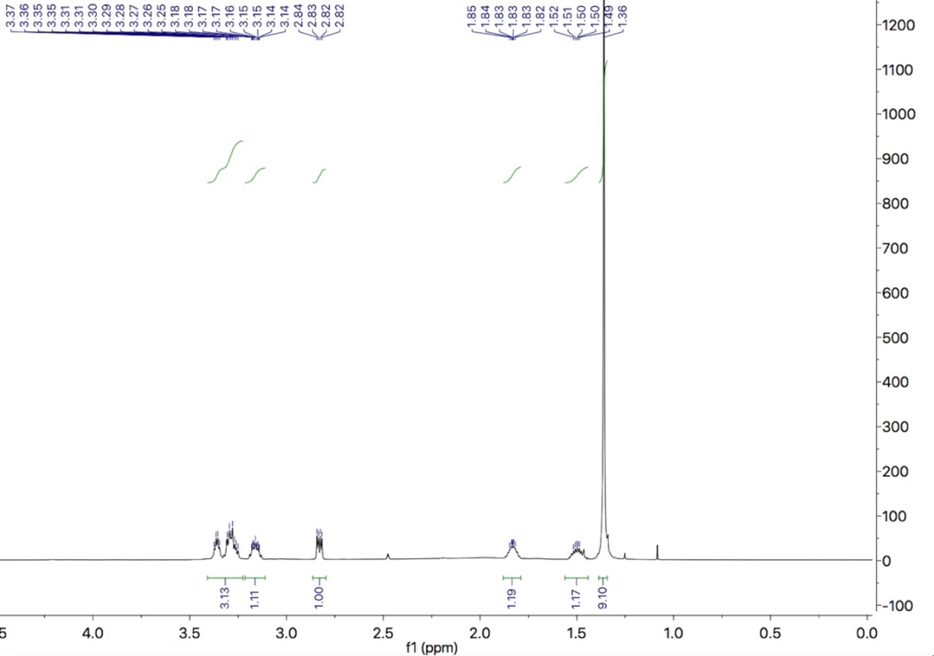
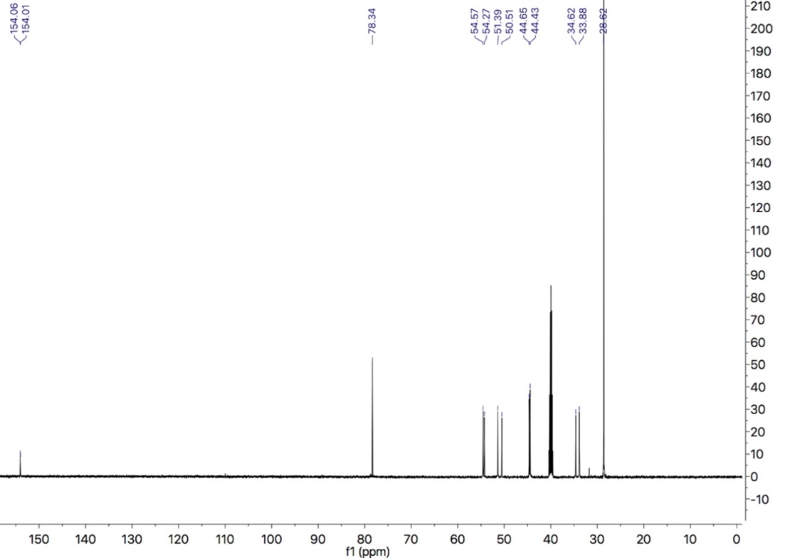

Compound 2
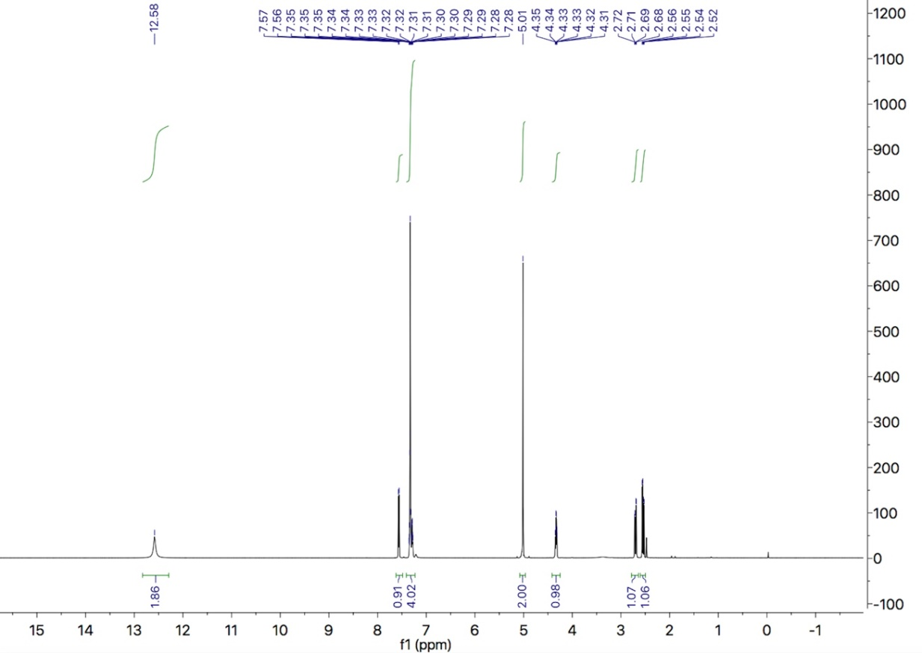
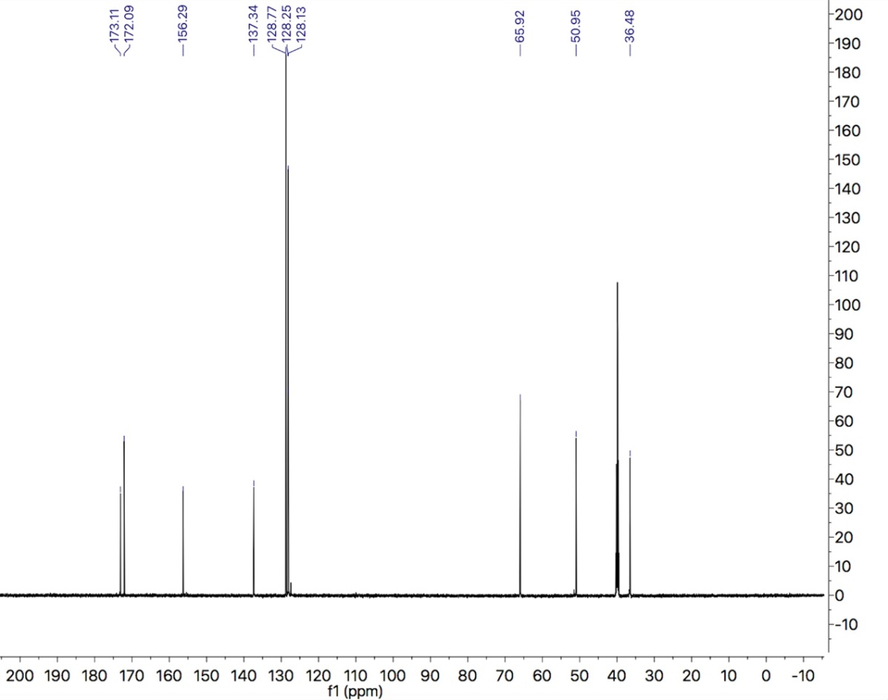

Compound 3
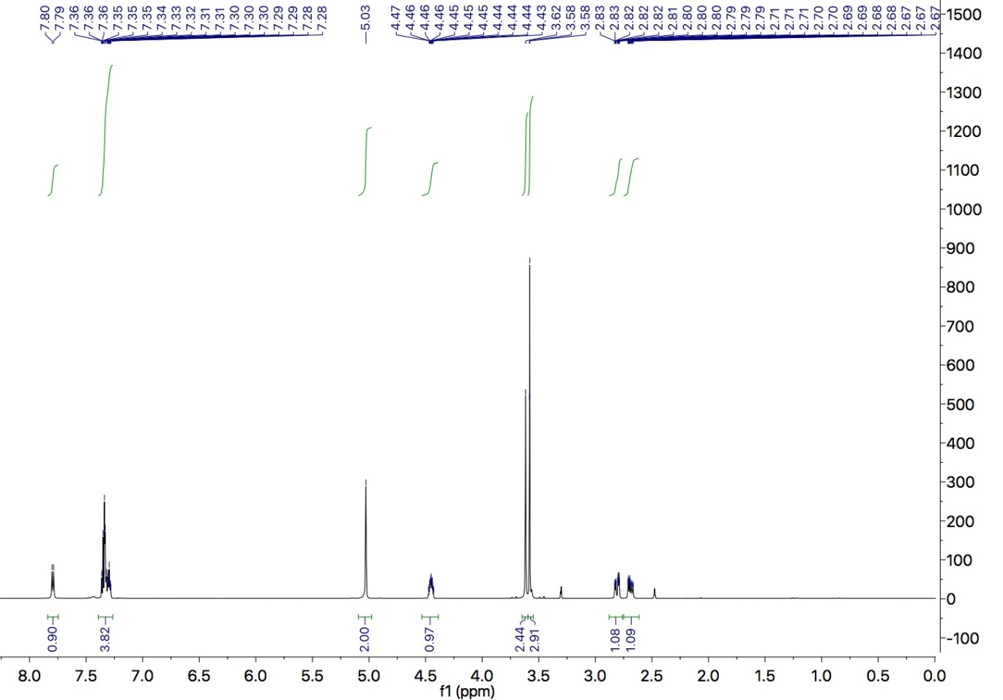
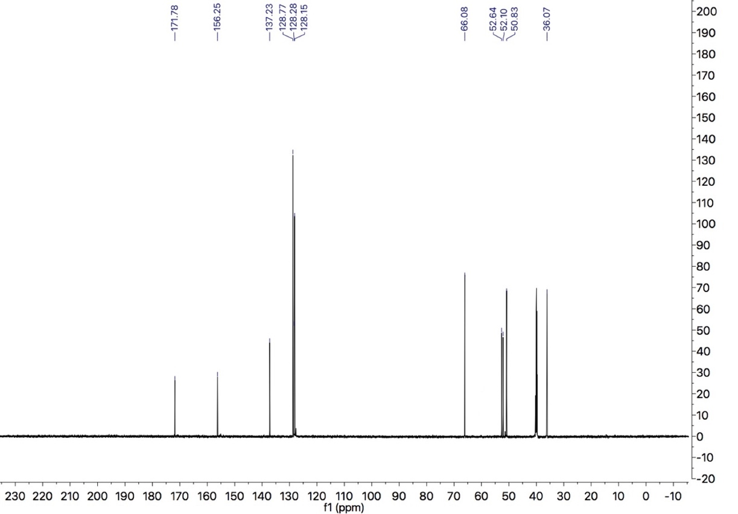
Compound 4
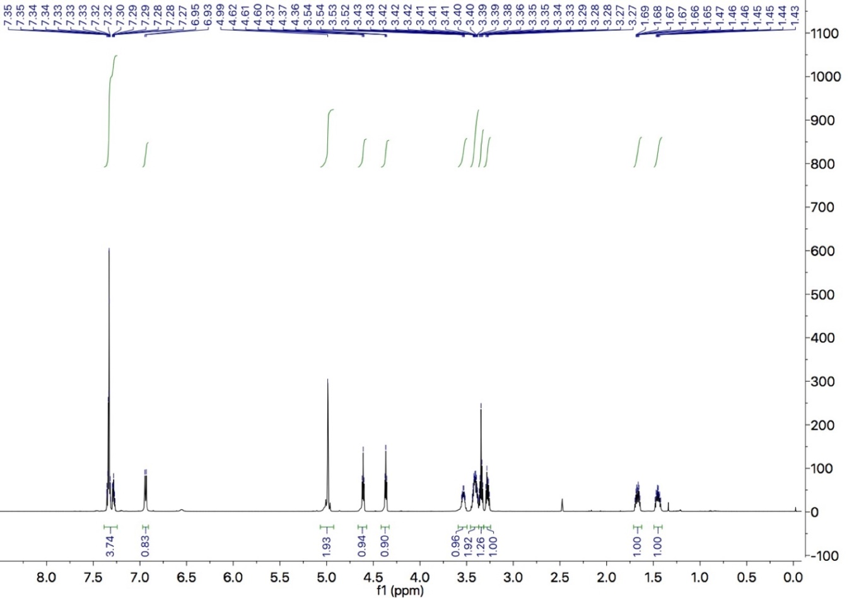
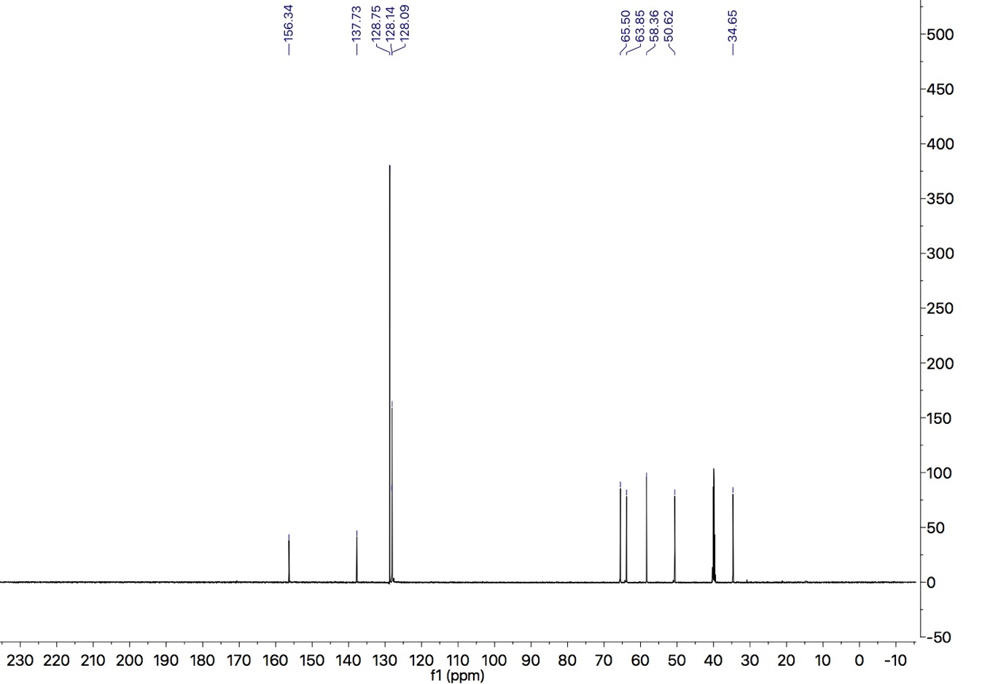
Compound 5
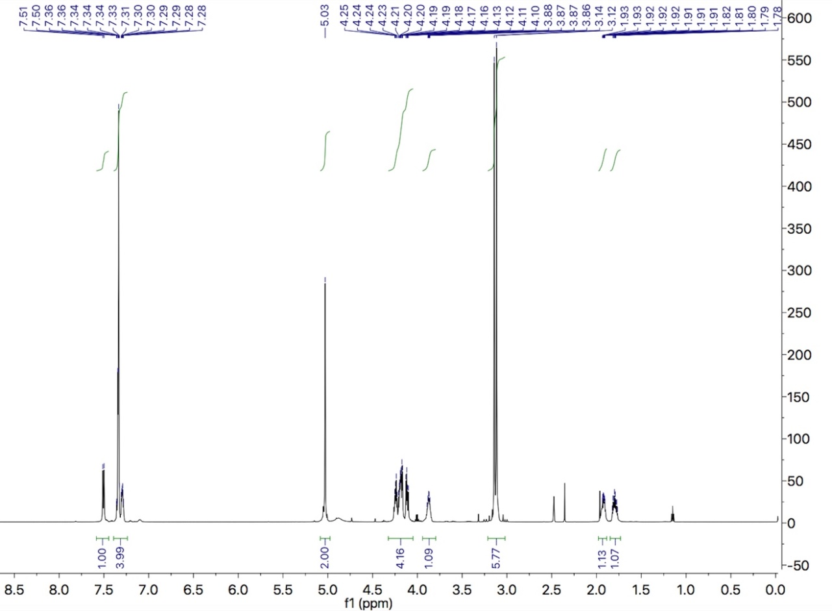
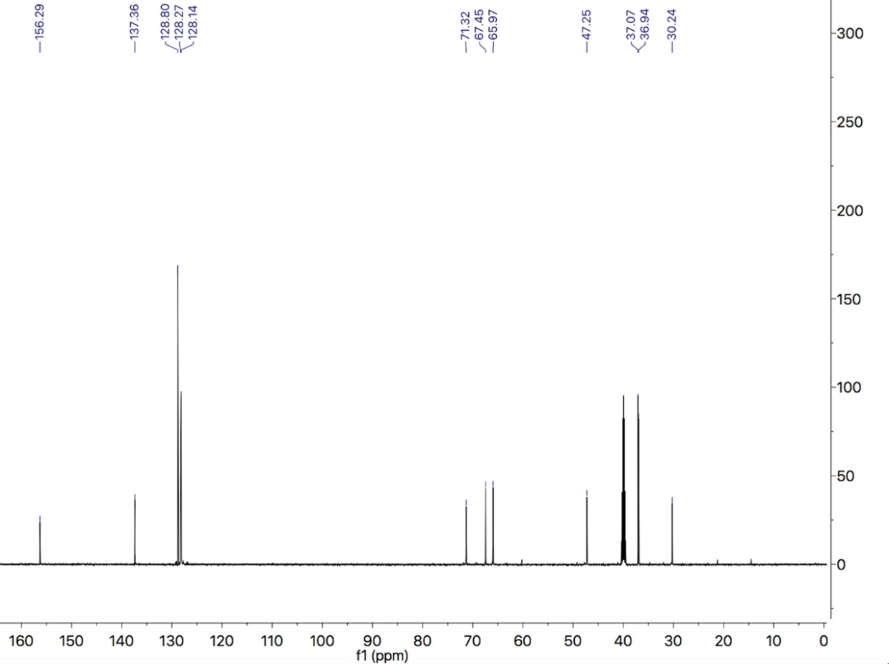
Compound 6
