Supporting information
A Solvent-free Synthesis of 1-(4-Chlorophenyl)pyrazolidin-3-one in a Ball Mill
Xiong Zhangª, Biao Wang^{b}, Binbin Zhang^{b}, Yifeng Wang^{b}
ªSchool of Science & Technology, Zhejiang International Studies University, Hangzhou, People’s Republic of China; ^{b}State Key Laboratory Breeding Base of Green Chemistry-Synthesis Technology, Key Laboratory of Green Pesticides and Cleaner Production Technology of Zhejiang Province, Zhejiang University of Technology, Hangzhou, People’s Republic of China
CONTACT: Yifeng Wang, wangyifeng@zjut.edu.cn
General methods
Flash chromatography (FC) was carried out using silica gel (200-300 mesh). Monitoring of reactions was performed by TLC on silica gel precoated on glass plates, and spots were visualized with UV light at 254nm.¹H and ¹³C NMR were recorded in CDCl₃ on Bruker AVANCE III (500 MHz for ¹H NMR and 126 MHz for ¹³C NMR). TMS served as internal standard (δ = 0 ppm) for ¹H NMR and CDCl₃ was used as internal standard (δ = 77.0 ppm) for ¹³C NMR; ¹H NMR data are reported as follows: chemical shift, multiplicity (s = singlet, d = doublet, t = triplet, m = multiplet), coupling constants (Hz) and integration. IR were recorded on an EQUINOX 55. High-resolution electrospray ionization mass spectra (HR-ESI-MS) were recorded on an Agilent 6545 Q-TOF LCMS spectrometer equipped with an ESI source and controlled by using MassHunter software. All experiments were carried out under air. Reactions in the ball mill were conducted using a Fritsch Planetary Micro Mill model “Pulverisette 7”. The milling instrument accommodates two grinding bowls (45 mL) which are made of stainless steel.
General procedure for the synthesis of 1-(4-Chlorophenyl)pyrazolidin-3-one
A clean, dry ball milling vessel was charged with 6 Φ10 mm stainless steel balls, 4-chlorophenylhydrazine (0.2 g), methyl acrylate (0.22 g, 1.8 mol equiv.) and KOH powder (0.2 g, 2.5 mol equiv.) were ball milled over periods of 12 cycles (1 cycle = 5 min. rotation + 4 min. pause). Afterwards, the vessel and the balls were rigorously washed with 30ml water; adjust to a pH of 7 using 5% HCl. The aqueous phase was extracted 3 times with ethyl acetate, and the combined organic phase were dried over Na₂SO₄, filtered off, and was concentrated to dryness under reduced pressure. The residue was purified via silica gel column chromatography.
Characterization data
White solid; mp: 108.5-110.5 °C; ¹H NMR (500 MHz, Chloroform-d) δ 8.96 (s, 1H, NH), 7.29 (m, part AA’ of the AA’BB’ system, J = 9.0 Hz, 3.0 Hz, 2H, H-2 and H-6, ClPh), 6.99 (m, part BB’ of the AA’BB’ system, J = 9.0 Hz, 3.0 Hz, 2H, H-3 and H-5, ClPh), 3.93 (t, J = 8.0 Hz, 2H, NCH₂), 2.60 (t, J = 8.0 Hz, 2H, COCH₂). ¹³C NMR (126 MHz, Chloroform-d) δ 175.38, 149.93, 129.22, 127.77, 117.59, 55.34, 29.85. IR (film) 1685, 1594, 1497, 1465, 1276 cm⁻¹. HRMS (ESI) exact mass calculated for C₉H₈ClN₂O ([M-H]⁻) requires m/z 195.0331. Found m/z 195.0327.
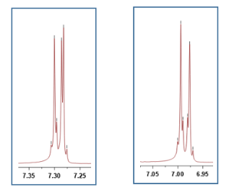
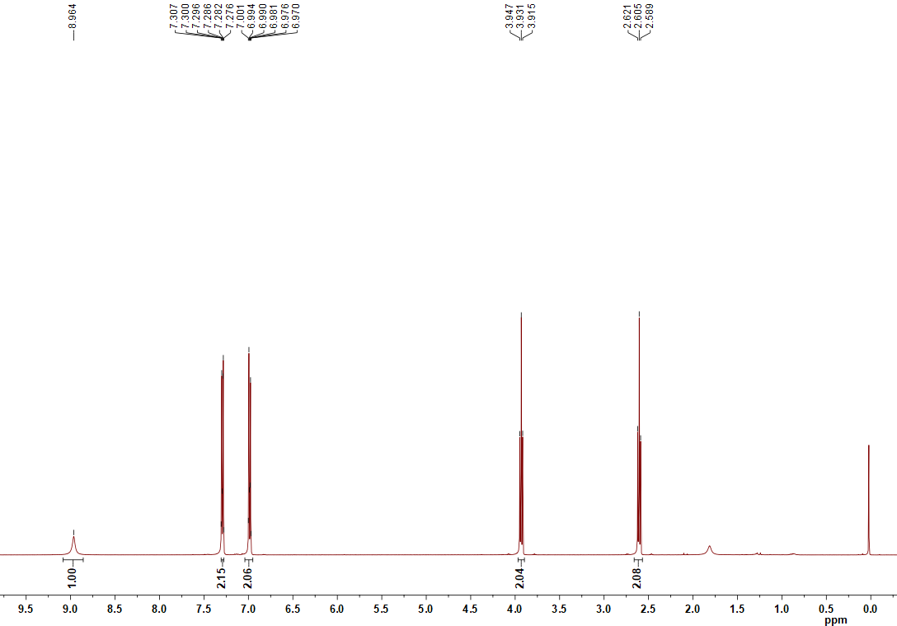
Fig S1: ¹H-NMR spectra for 1-(4-Chlorophenyl)pyrazolidin-3-one
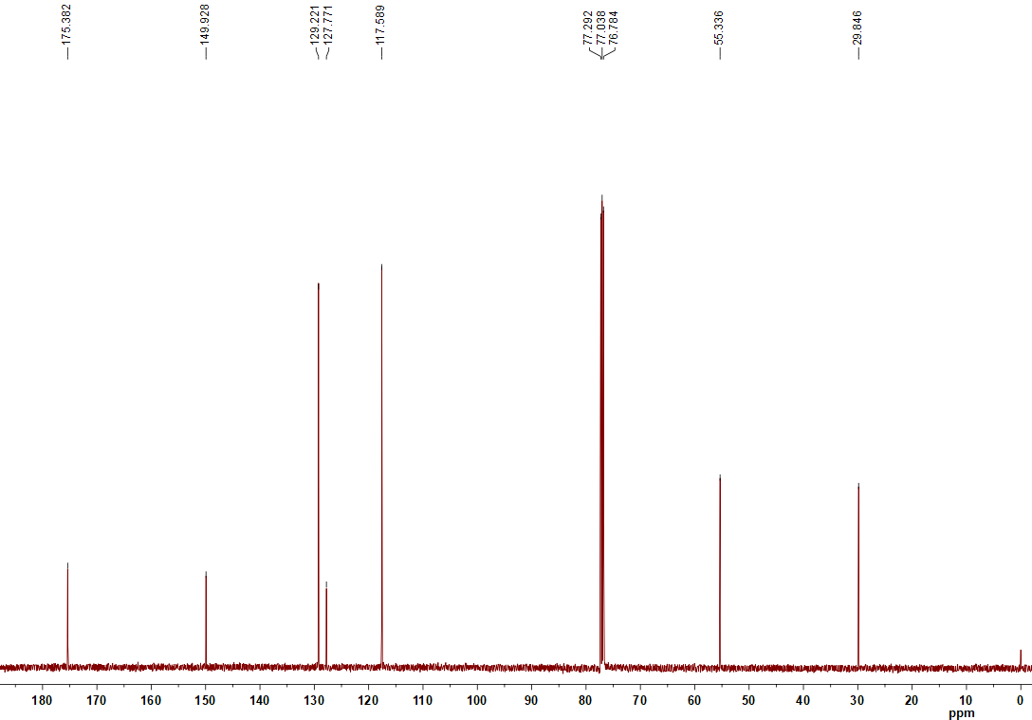
Fig S2: ¹³C-NMR spectra for 1-(4-Chlorophenyl)pyrazolidin-3-one
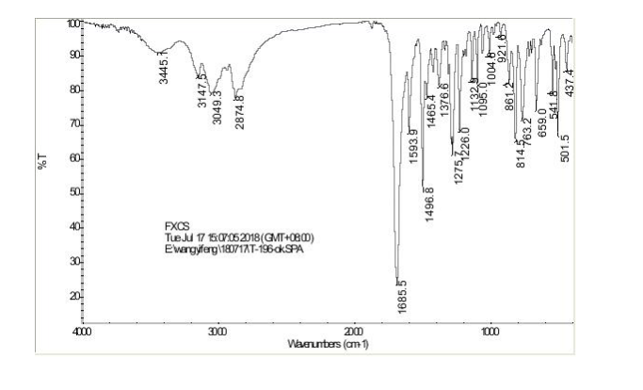
Fig. S3: FTIR spectrum of 1-(4-Chlorophenyl)pyrazolidin-3-one
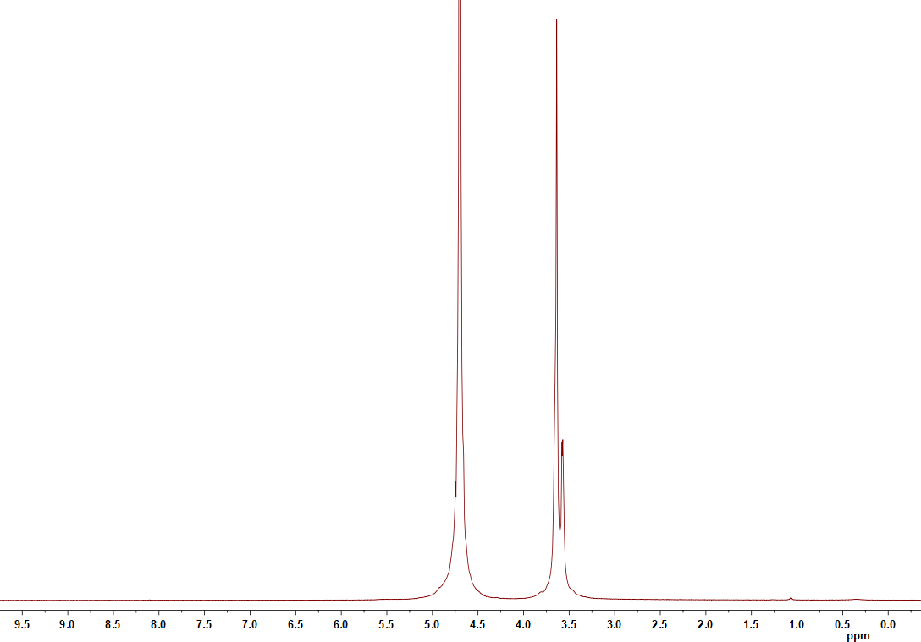
Fig S4: ¹H-NMR spectra for PEG200
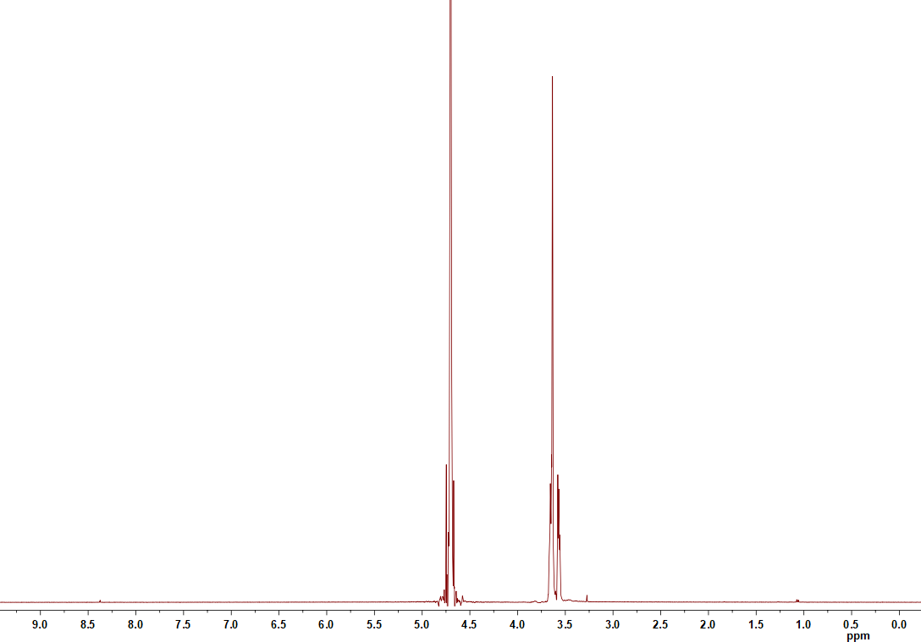
Fig S5: ¹H-NMR spectra for [PEG200 K⁺][OH⁻]
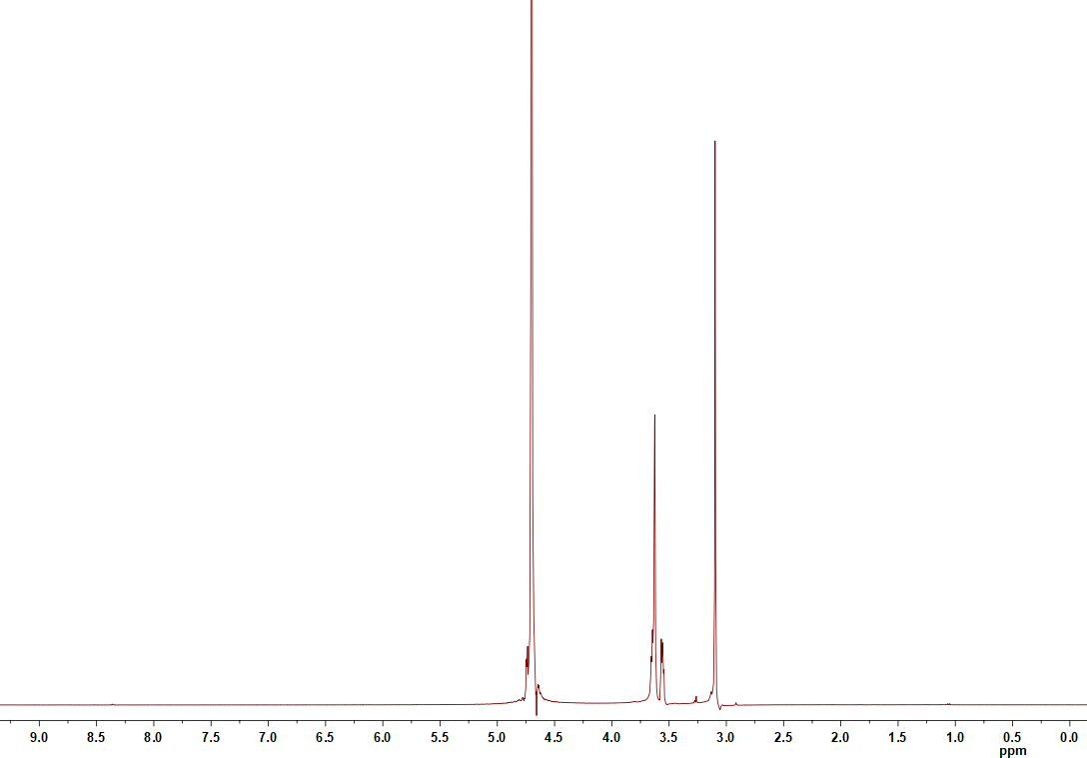
Fig S6: ¹H-NMR spectra for
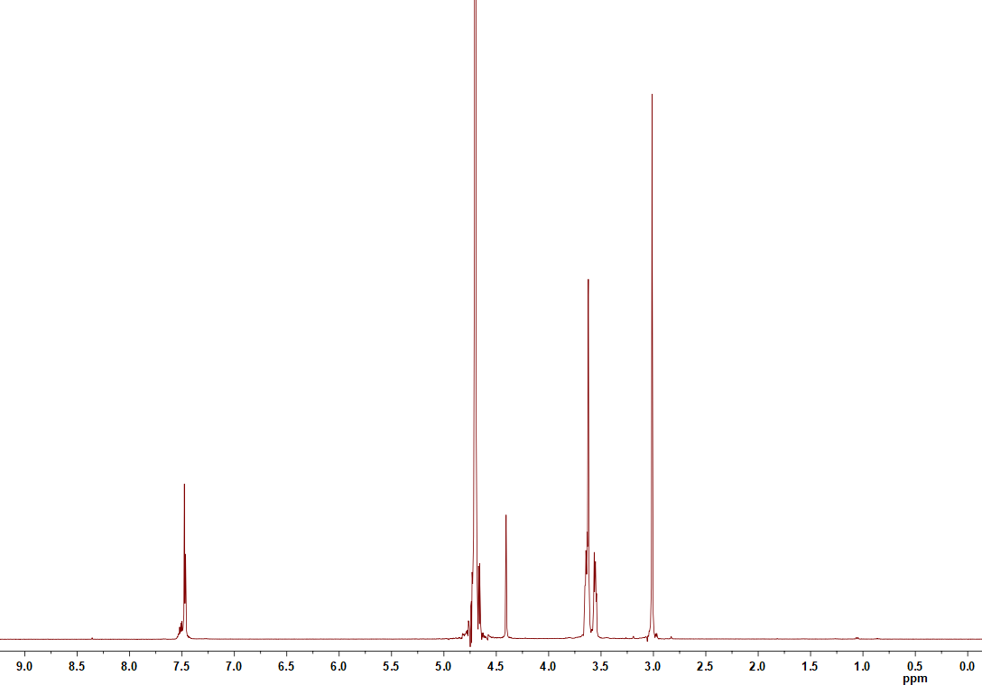
Fig S7: ¹H-NMR spectra for
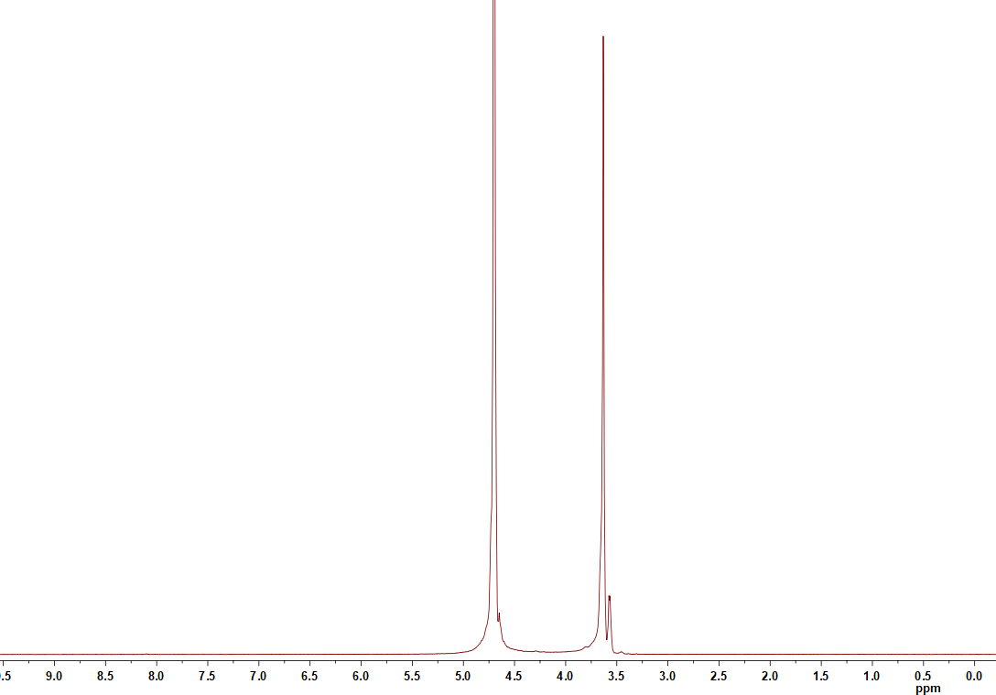
Fig S8: ¹H-NMR spectra for PEG400
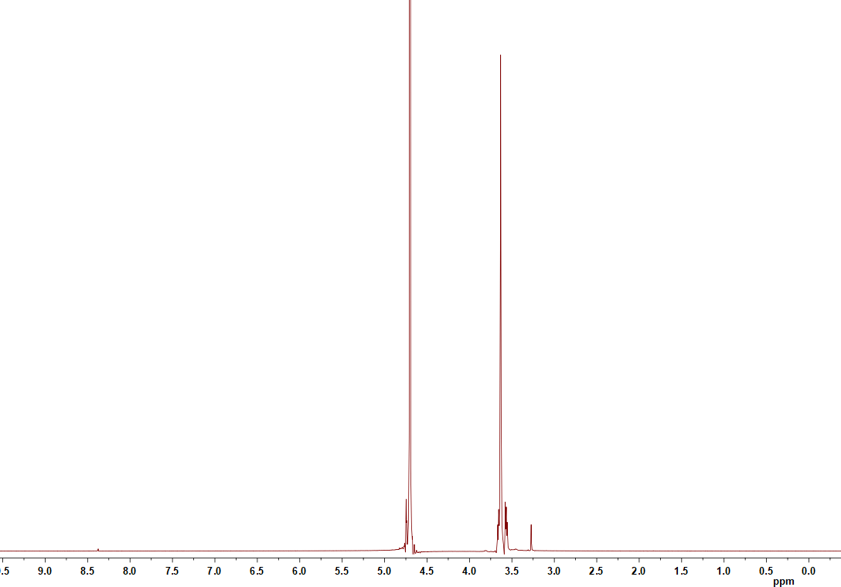
Fig S9: ¹H-NMR spectra for [PEG400 K⁺][OH⁻]
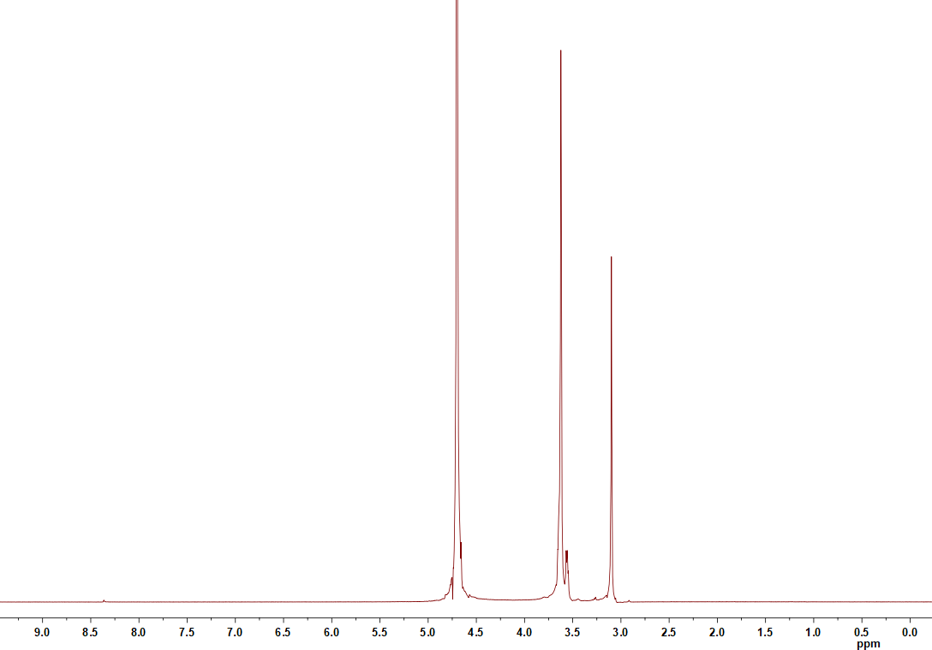
Fig S10: ¹H-NMR spectra for
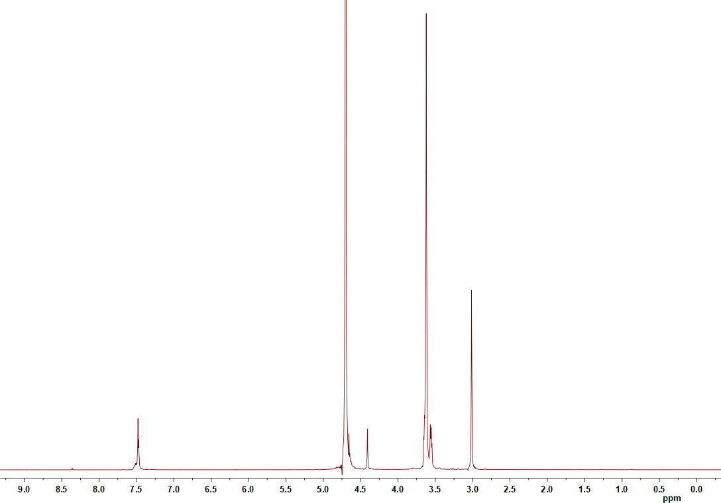
Fig S11: ¹H-NMR spectra for
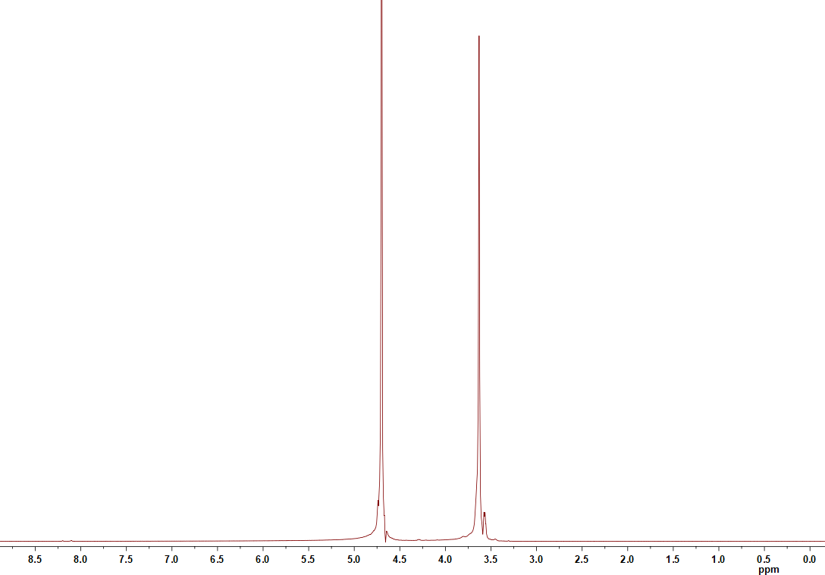
Fig S12: ¹H-NMR spectra for PEG600
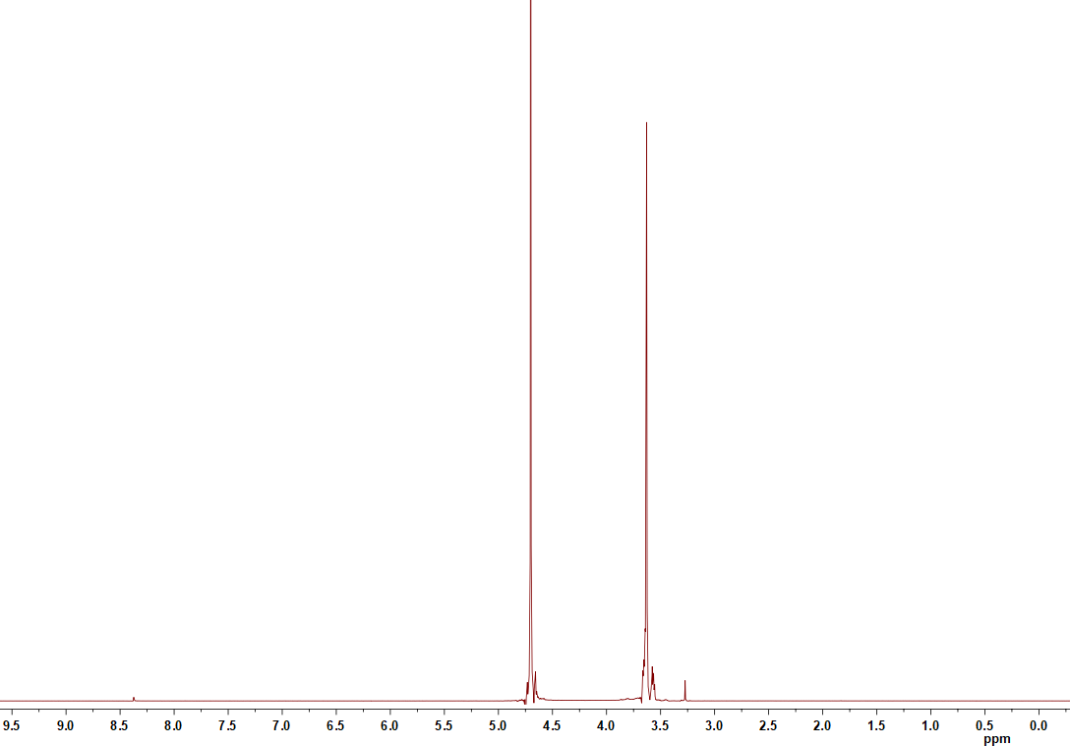
Fig S13: ¹H-NMR spectra for [PEG600 K⁺][OH⁻]
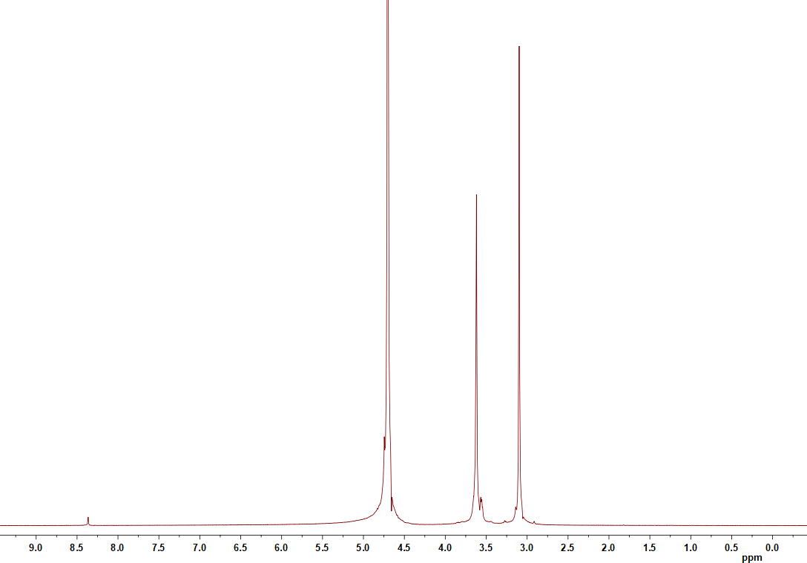
Fig S14: ¹H-NMR spectra for
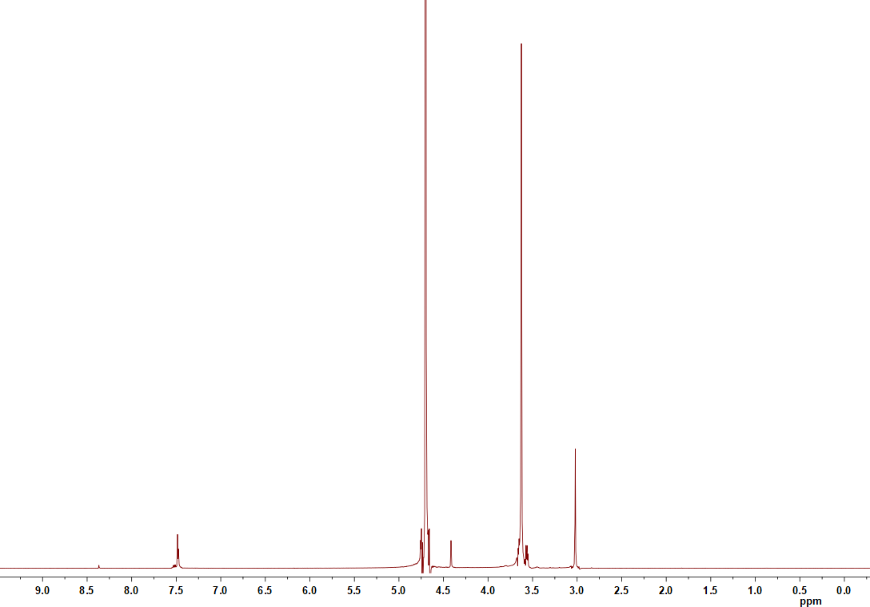
Fig S15: ¹H-NMR spectra for
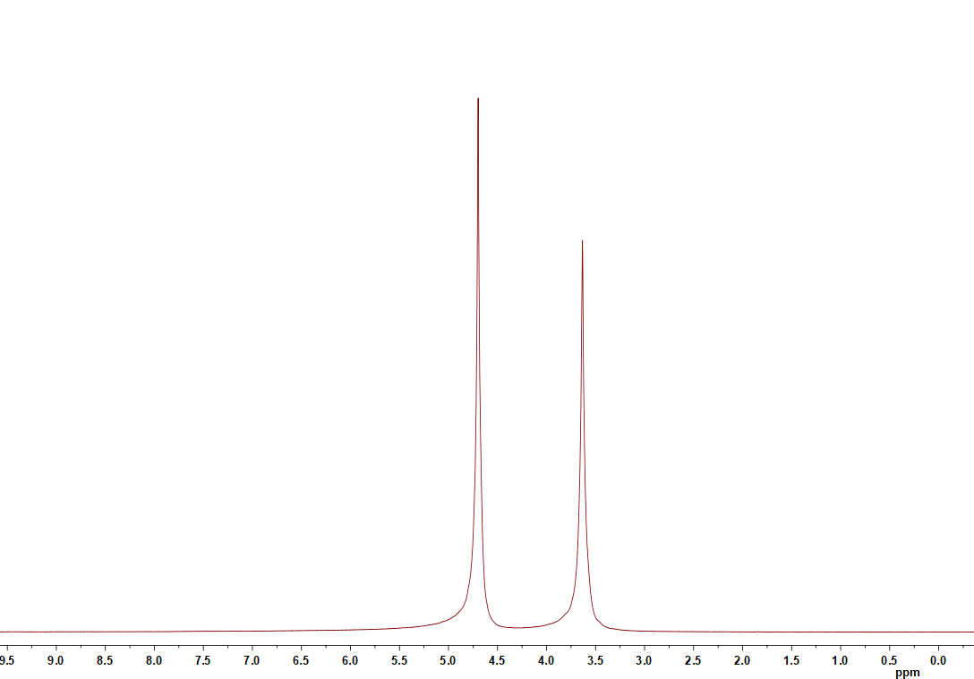
Fig S16: ¹H-NMR spectra for PEG800
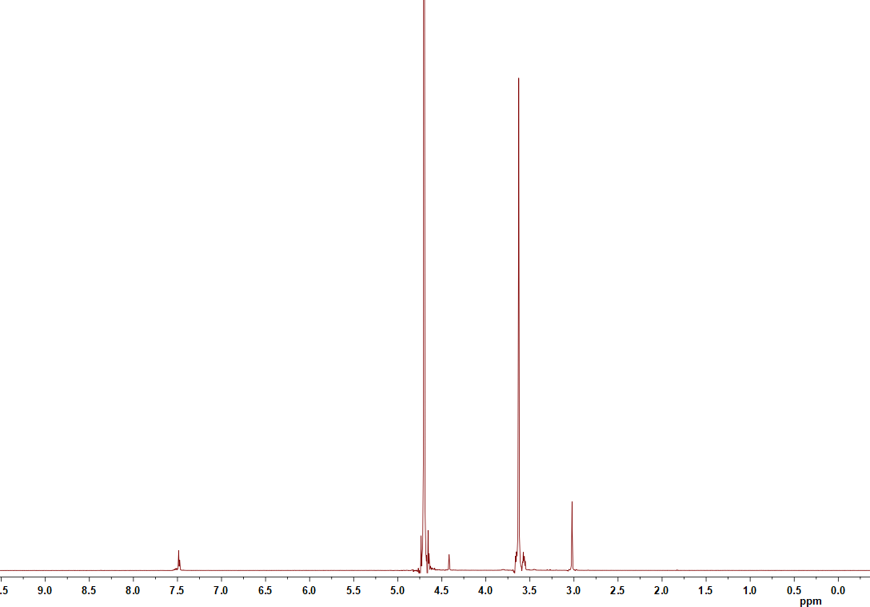
Fig S17: ¹H-NMR spectra for

