5

4

3

2

1

Fig. S1. (a) Agarose gel electrophoresis of PEGylated sequences. Lane 1: ladder (50 bp), lane 2: PEGylated sequence 2, lane 3: sequence 2, lane 4: PEGylated sequence 3, lane 5: sequence 3.

7

6

5

4

3

2

1

a)

2

1

b)

Fig. S2. (a) Agarose gel electrophoresis of cruciform DNA nanostructure. Lane 1: sequence 1, lane 2: sequence 2, lane 3: sequence 1 + sequence 2, lane 4: sequence 3, lane 5: sequence 1 + sequence 2 + sequence 3, lane 6: sequence 4 and lane 7: sequence 1 + sequence 2 + sequence 3 + sequence 4. (b) Serum stability of DNA nanostructure. Lane 1: DNA nanostructure after treatment with serum for 7 h and lane 2: DNA nanostructure.

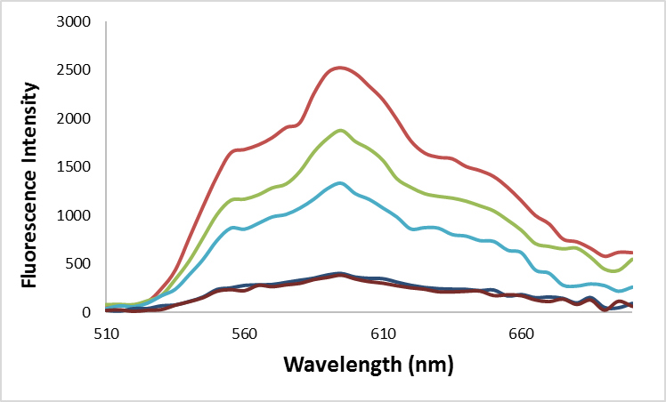

Fig. S3. Fluorescence spectra of Dox (7 μM) after incubation with different amounts of DNA nanostructure (from top to bottom 0, 0.3, 0.9, 2, 5 μM).

