**Supplementary information (S1):**

Figures A and B show SEM images of ZnO particles in the bulk and nano forms with approximately **<**1000 nm and 21.5 nm average sizes, respectively. SEM image (SEM, 15.0kV, MIRA3, TESCAN, Lorestan University).

**A)** **Bulk ZNO < 1000 nm, (D, diameter).**

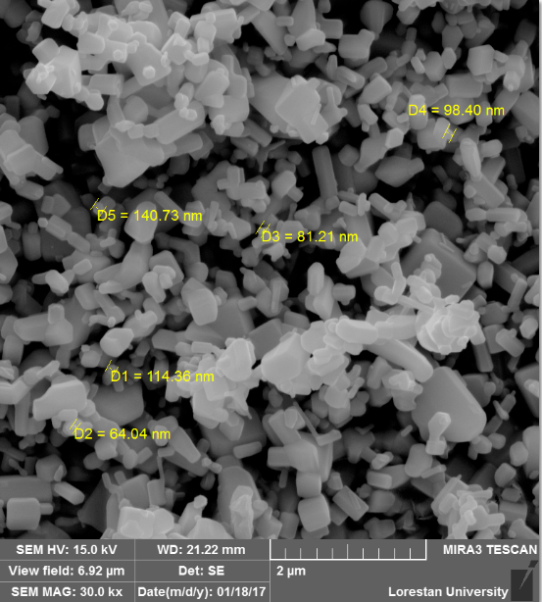

**B) NPs ZNO ~ 21.52± 4.05 nm, (D, diameter).**

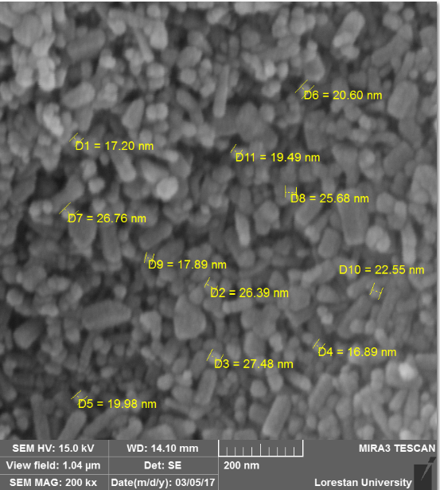

# C) Specification of XRD *(*X-ray diffraction); (X'PertPro, Holland, Panalytical company, Wavelength of x-ray beam [Cu Kα ]:1.54 angstrom, Anod material: Cu, Voltage: 40 kV, Current: 30mA);

|  |  |  |  |  |  |
| --- | --- | --- | --- | --- | --- |
|  | **Scherrer equation -XRD-Nano ZnO** | | |  |  |
|  |  |  |
| No. | Pos. [ｰ2Th.] | FWHM [ｰ2Th.] |  | Cos |  |
| 1 | 31.9755 | 0.2952 | 15.98775 | 0.96132 | 27.99571 |
| 2 | 34.6241 | 0.2952 | 17.31205 | 0.954699 | 28.18987 |
| 3 | 36.4629 | 0.3542 | 18.23145 | 0.9498 | 23.61539 |
| 4 | 47.7483 | 0.3542 | 23.87415 | 0.914437 | 24.52865 |
| 5 | 56.801 | 0.3542 | 28.4005 | 0.879644 | 25.49884 |
| 6 | 63.0496 | 0.4133 | 31.5248 | 0.85241 | 22.5508 |
| 7 | 66.5727 | 0.4133 | 33.28635 | 0.835938 | 22.99516 |
| 8 | 68.1302 | 0.4133 | 34.0651 | 0.828402 | 23.20435 |
| 9 | 69.2904 | 0.3542 | 34.6452 | 0.822688 | 27.26416 |
| 10 | 72.7185 | 0.2362 | 36.35925 | 0.805316 | 41.76667 |
| 11 | 77.1658 | 0.504 | 38.5829 | 0.781707 | 20.16515 |
|  |  |  |  | NPs ZnO (nm) | 26.16134 |

**Figures D and E show, energy dispersive analysis (EDX) of particles in both bulk and nano forms. Clearly, there is a homogeneous dispersion for zinc and oxygen elements in both cases.**

**D) Energy Dispersive Spectroscopy (EDX) of NPs ZnO.**

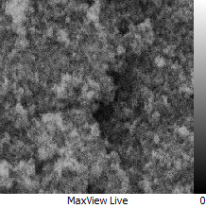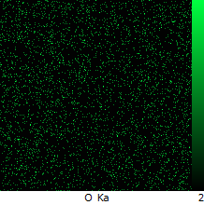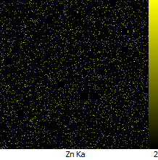

**EDX spectrum of NPs ZnO**



**E) Energy Dispersive Spectroscopy (EDX) of Bulk ZnO.**

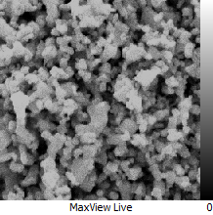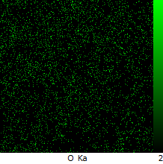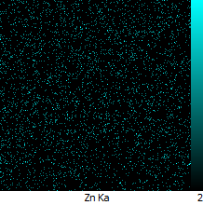

**EDX spectrum of Bulk ZnO**

## 