Reduced graphene oxide-polyaniline nanocomposite as an efficient adsorbent for solid phase extraction of Co²⁺ followed by electrothermal atomic absorption spectrometry
Somayeh Karandish¹, Mahmoud Chamsaz¹*, Mohammad Hossein Arbab-Zavar¹, Mohammad Gheibi²
¹Department of Chemistry, Faculty of Sciences, Ferdowsi University of Mashhad, Iran
²Department of Civil and Environmental Engineering, Ferdowsi University of Mashhad, Iran.

Supplementary information

Modeling

To carry out the mathematical modeling along with the optimization of variables including pH (A), amounts of adsorbent (B), extracting time (C) and desorption time (D); the central composite design (CCD) as a subdivision of the response surface methodology (RSM) was employed. Table S1 shows variables and their levels in CCD methodology and Table S2 demonstrates the related experiments which included 30 analyses designed by the Design Expert 7.0.0. The stirring rate and centrifuge time were kept constant at 400 rpm and 10 min at 4000 rpm, respectively.
The analysis of different models including: Linear, 2FI, Quadratic and Cubic show that Quadratic model provides better R-Square and predicted R-Square; Therefore, this model was chosen to the experimental data. In order to determine the coefficients of the quadratic equation Analysis of Variance (ANOVA) was performed. The parameters of F-value and P-value were used to determine the significance of the model. The data analysis was performed using Design-Expert Version 7.0.0 software (Stat-Ease Inc., Minneapolis, MN55413, USA). For an experimental design with four factors, this model is shown in Equation 1S.

Equation 1S

The results of ANOVA analysis for quadratic model with four variables are presented in Table 3S. As the results show, pH (parameter A) has a high significant effect (P value<0.0001) and the parameters of amounts of adsorbent (B) and extraction time (C) have significant effect (P value<0.05) on the response (RP) of the suggested model. Desorption time (D) has no significant effect on the RP which shows that desorption of Co²⁺ from adsorbent takes place immediately.
According to the Table 3S, the model F value for response is 55.5 and shows the significance of the model. Also, the lack-of-fit P-value was 0.3316 showing that this parameter is not significant. To evaluate how the model satisfies the assumptions of ANOVA, a normal probability plot of the residuals provided by the Design Expert software and the result is illustrated in Fig. 1S. As it shows, the points on this plot lie close to the straight line which confirms that it obeys a normal distribution.
Using Design Expert software, these variables and their values were processed through full quadratic multiple linear regression model to calculate and plot the response surface of central composite experimental design (Fig. 2S(a–f)). As Fig. 2S(a) shows, RP reaches to its maximum value at pH 8 – 8.5; the results of pH shows that weak basic solutions are more preferable for solid phase extraction of Co²⁺ which may be due to the protonation of N atom in poly-aniline in acidic mediums. As it was predicted by ANOVA test; pH is highly significant on the RP of Co²⁺. Also, Fig. 2S(a) shows the RP changes by variation of amounts of adsorbent; however, as it can be seen, its effect is not highly significant on RP of Co²⁺ (it was predicted as significant parameter by ANOVA test) which may be due to the high surface area of rGO-PANI adsorbent. Fig. 2S(b) shows the effect of pH and extraction time on the RP of Co²⁺. As it was predicted by ANOVA test, extraction time has significant effect on RP and again, high significant effect of pH on the RP of Co²⁺ can be seen in Fig. 2S(b). The results of Fig. 2S(c) shows the effect of pH and desorption time on the RP of Co²⁺. As Fig. 2S(c) shows, desorption time has no significant effect on the RP of Co²⁺; this parameter was predicted as no significant by ANOVA test. Fig. 2S(d) shows the effect of extraction time and amounts of adsorbent as significant parameters on the RP of Co²⁺ and Fig. 2S(e) shows that desorption time has no significant effect on the RP of Co²⁺. Finally, Fig. 2S(f) shows that extraction time has significant effect on the RP of Co²⁺ but desorption time has no significant effect on the RP of Co²⁺.
The optimum conditions predicted by RSM-CCD method are: pH: 8, amounts of adsorbent: 5.8 mg, extraction time: 15 min and desorption time of 8 min.

Table 1S. The CCD variables and their levels. (A: pH, B: Amounts of adsorbent, C: Extraction time, D: Desorption time)
Table 2S. The responses and related experiments of CCD methodology designed by the Design Expert 7.0.0 software.
Table 3S. Analysis of variance (ANOVA) for CCD.

Table 1S.

Variables | Symbol | -1.2 (Low) | Coded factors level  -1 0 +1 | 1.2 (High)
pH | A | 2.5 | 3 5.5 8 | 8.5
Amounts of adsorbent (g) | B | 0.0014 | 0.002 0.005 0.008 | 0.0086
Extraction time (min) | C | 4 | 5 10 15 | 16
Desorption time (min) | D | 1.4 | 2 5 8 | 8.6

Table 2S.

Run | pH | Amounts of adsorbent (mg) | Ext. Time (min) | Des. Time (min) | Recov. (%)
1 | 8 | 2 | 15 | 8 | 87
2 | 3 | 8 | 5 | 8 | 43
3 | 5.5 | 5 | 16 | 5 | 67
4 | 3 | 8 | 15 | 8 | 46
5 | 3 | 8 | 5 | 2 | 40
6 | 5.5 | 5 | 10 | 5 | 62
7 | 3 | 2 | 5 | 2 | 40
8 | 5.5 | 5 | 10 | 5 | 65
9 | 5.5 | 5 | 4 | 5 | 61
10 | 5.5 | 5 | 10 | 8.6 | 63
11 | 5.5 | 5 | 10 | 5 | 66
12 | 8 | 2 | 5 | 8 | 83
13 | 3 | 2 | 5 | 8 | 39
14 | 5.5 | 8.6 | 10 | 5 | 71
15 | 5.5 | 5 | 10 | 1.4 | 58
16 | 8 | 8 | 15 | 2 | 96
17 | 3 | 2 | 15 | 8 | 42
18 | 5.5 | 5 | 10 | 5 | 63
19 | 5.5 | 5 | 10 | 5 | 63.5
20 | 5.5 | 1.4 | 10 | 5 | 50
21 | 2.5 | 5 | 10 | 5 | 32
22 | 3 | 8 | 15 | 2 | 42
23 | 8 | 8 | 5 | 2 | 90
24 | 8 | 8 | 5 | 8 | 88
25 | 8.5 | 5 | 10 | 5 | 94
26 | 8 | 2 | 5 | 2 | 80
27 | 5.5 | 5 | 10 | 5 | 71
28 | 3 | 2 | 15 | 2 | 40
29 | 8 | 2 | 15 | 2 | 83
30 | 8 | 8 | 15 | 8 | 97

Table 3S.

Source | Sum of Squares | df | Mean Square | F Value | P value Prob > F
Model | 11028.2246 | 14 | 787.7303289 | 55.52165221 | < 0.0001 | significant
A | 10554.71186 | 1 | 10554.71186 | 743.9284992 | < 0.0001
B | 283.8050847 | 1 | 283.8050847 | 20.00345376 | 0.0004
C | 73.29661017 | 1 | 73.29661017 | 5.166170133 | 0.0382
D | 21.18644068 | 1 | 21.18644068 | 1.493285389 | 0.2406
AB | 49 | 1 | 49 | 3.453670449 | 0.0828
AC | 12.25 | 1 | 12.25 | 0.863417612 | 0.3675
AD | 0.25 | 1 | 0.25 | 0.017620768 | 0.8962
BC | 6.25 | 1 | 6.25 | 0.44051919 | 0.5169
BD | 0.25 | 1 | 0.25 | 0.017620768 | 0.8962
CD | 4 | 1 | 4 | 0.281932282 | 0.6032
A^2 | 4.393468506 | 1 | 4.393468506 | 0.30966515 | 0.5861
B^2 | 3.445076739 | 1 | 3.445076739 | 0.242819586 | 0.6293
C^2 | 13.51974837 | 1 | 13.51974837 | 0.952913376 | 0.3445
D^2 | 3.445076739 | 1 | 3.445076739 | 0.242819586 | 0.6293
Residual | 212.8170626 | 15 | 14.18780417
Lack of Fit | 160.6087292 | 10 | 16.06087292 | 1.538152235 | 0.3316 | not significant
Pure Error | 52.20833333 | 5 | 10.44166667
Cor Total | 11241.04167 | 29

Fig. 1S. Normal plot of probability (%) versus studentized residuals.
Fig. 2S. The response surface model of the proposed method versus the affecting parameters (A-D). Conditions: 0.5 µg L⁻¹ Co²⁺, 10 min at 4000 rpm.

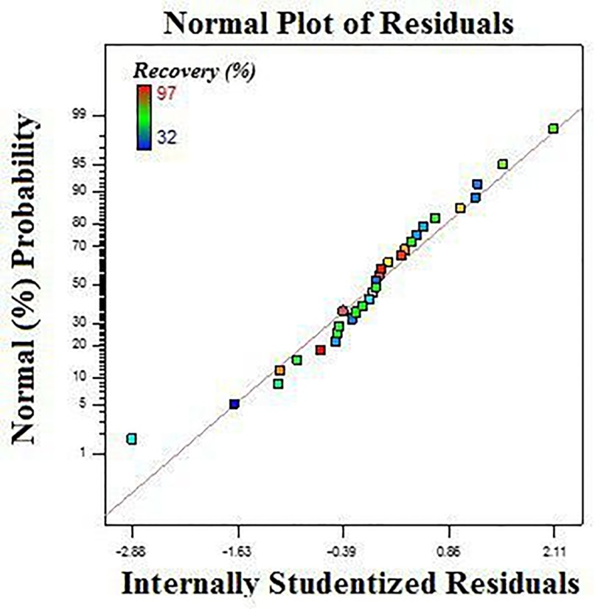
Fig. 1S.

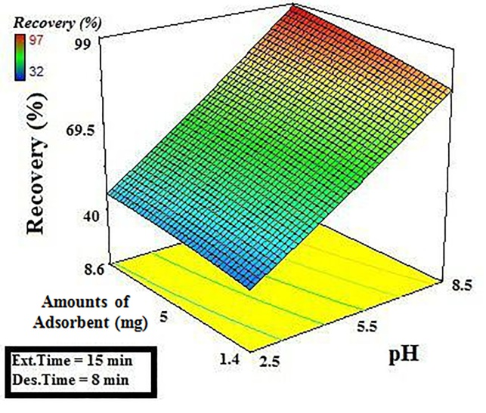
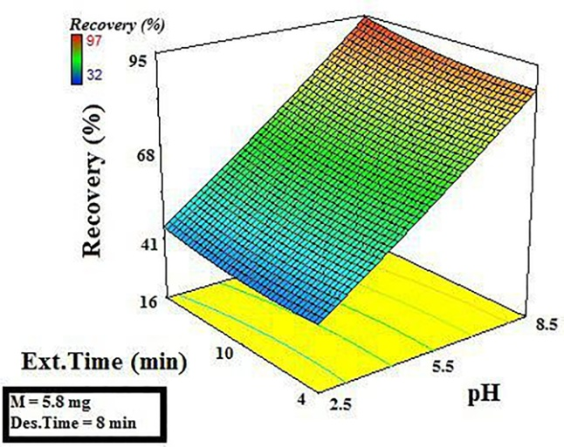
(a) (b)
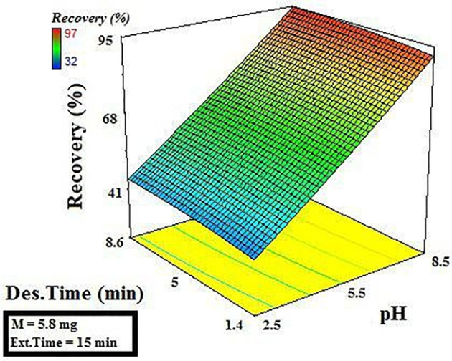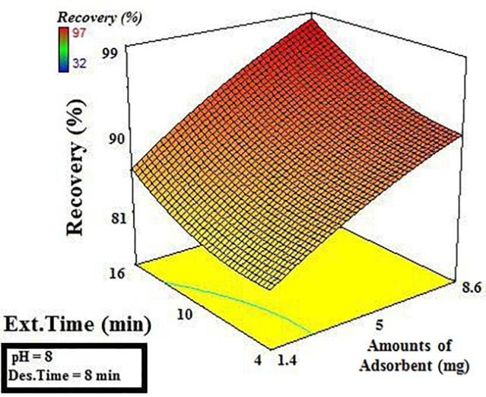
(c) (d)
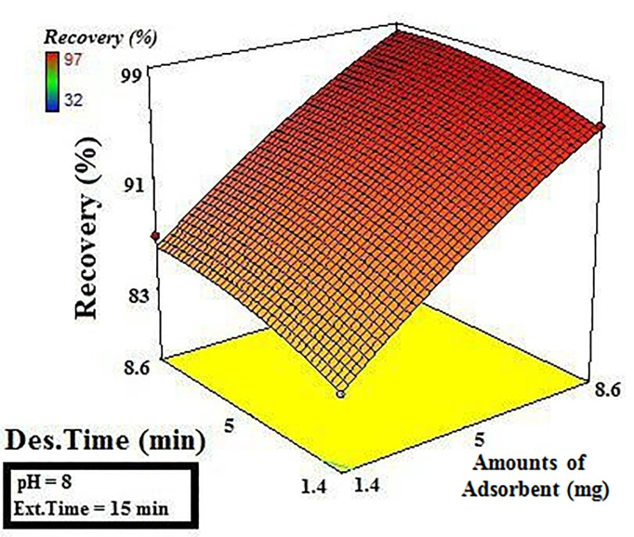
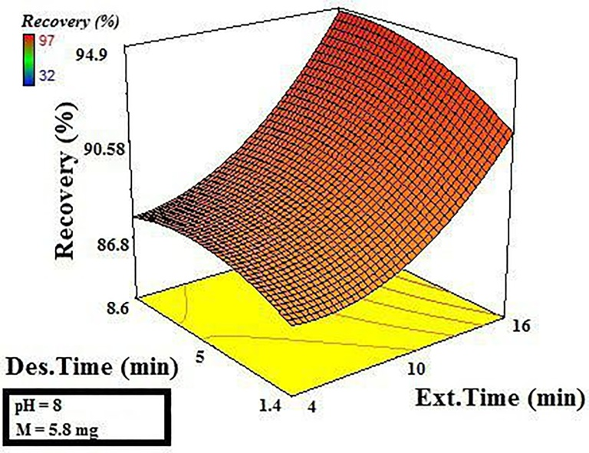 (e) (f)
Fig. 2S

