Supporting Information
Effervescent-Assisted Dispersive Liquid-Liquid Microextraction Based on the Solidification of Floating Organic Droplet for the Determination of Fungicides in Vinegar and Juice
Xu Jing^{1,2}, Jiaying Zhang¹, Junling Zhu¹, Zhenjia Chen¹, Li Yi¹, Xiaowen Wang^{1,2,}*
¹ College of Food Science and Engineering, Shanxi Agricultural University, Taigu, Shanxi 030801, P.R. China
² Shanxi Functional Food Research Institute, Taigu, Shanxi 030801, P.R. China

*Corresponding author:
Xiaowen Wang, College of Food Science and Engineering, Shanxi Agricultural University, Shanxi 030801, P.R. China; Tel: +86-0354-6289670; E-mail: wwxw11@163.com

Number of Pages: 6
Number of Figures: 5

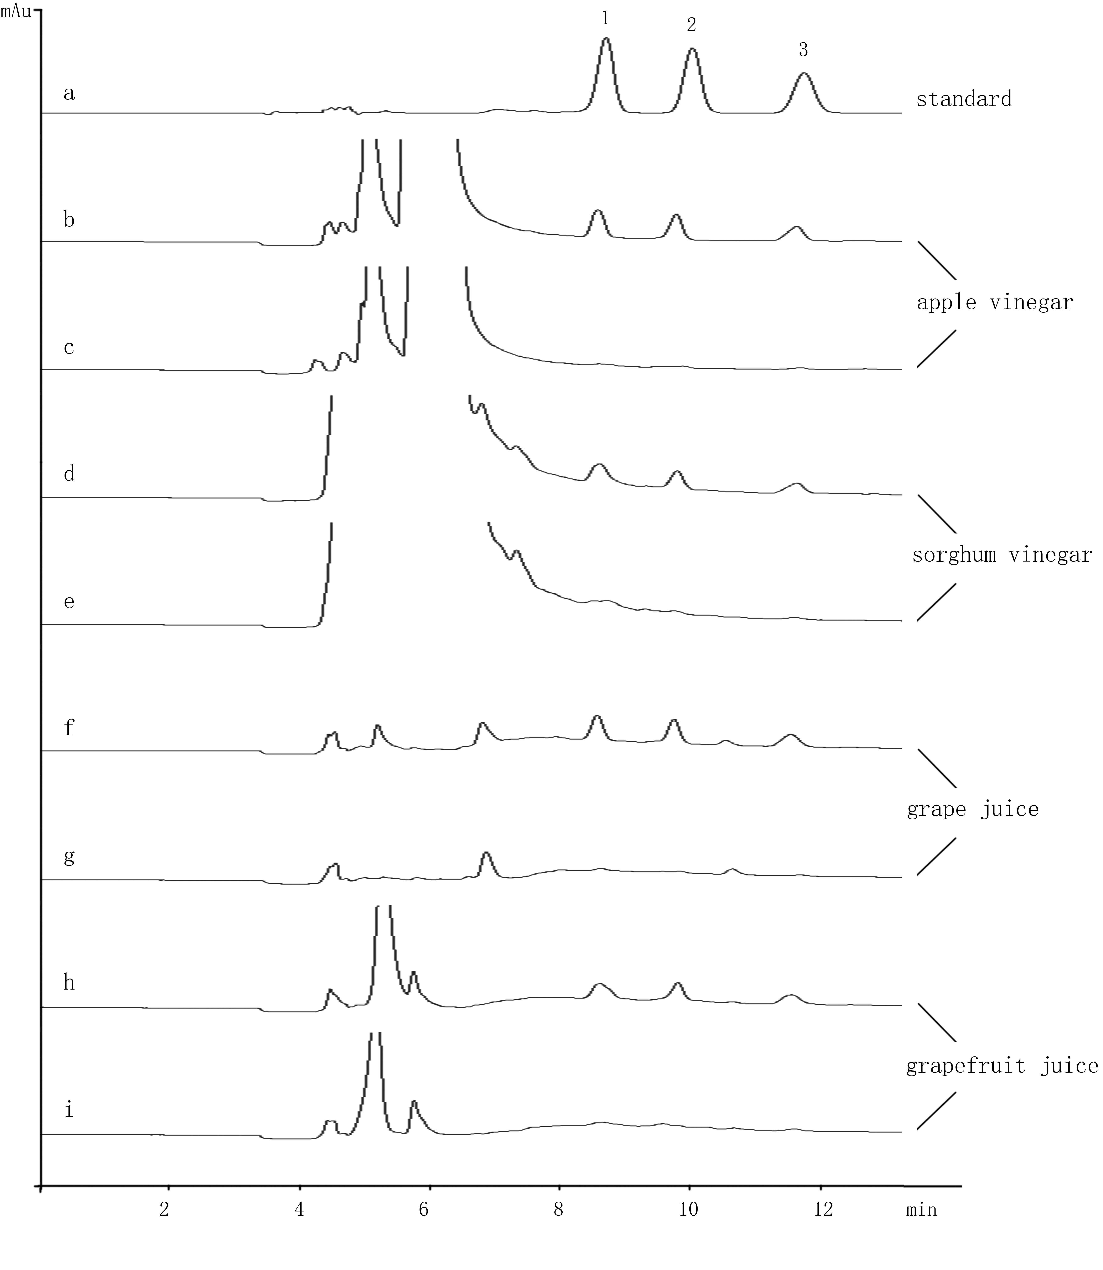
Figure S1 The chromatograms of (a) a standard mixture at 2500 ng mL⁻¹, (b, d, f, h) samples spiked with 100 ng mL⁻¹ of fungicides and (c, e, g, i) blank samples. Peak identification: 1, myclobutanil; 2, epoxiconazole; and 3, tebuconazole.

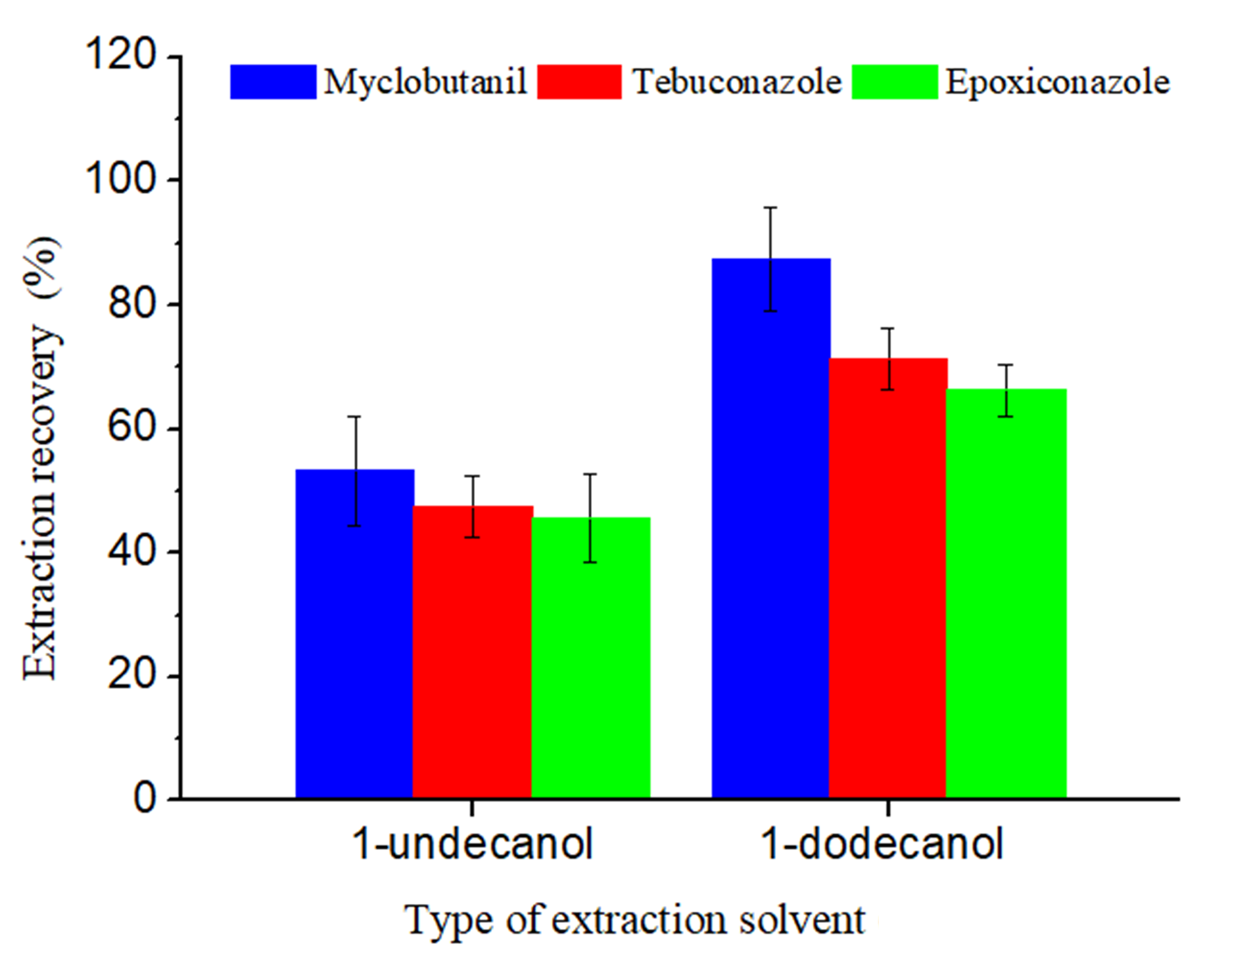
Figure S2 Effect of extraction solvent on recovery.

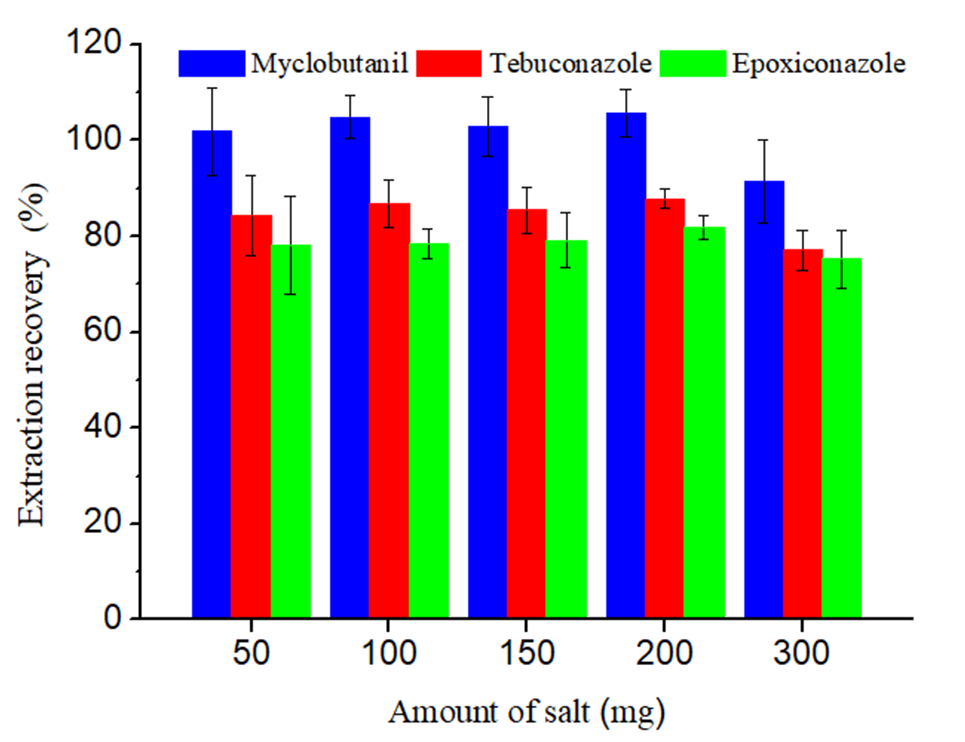
Figure S3 Effect of salt on recovery.

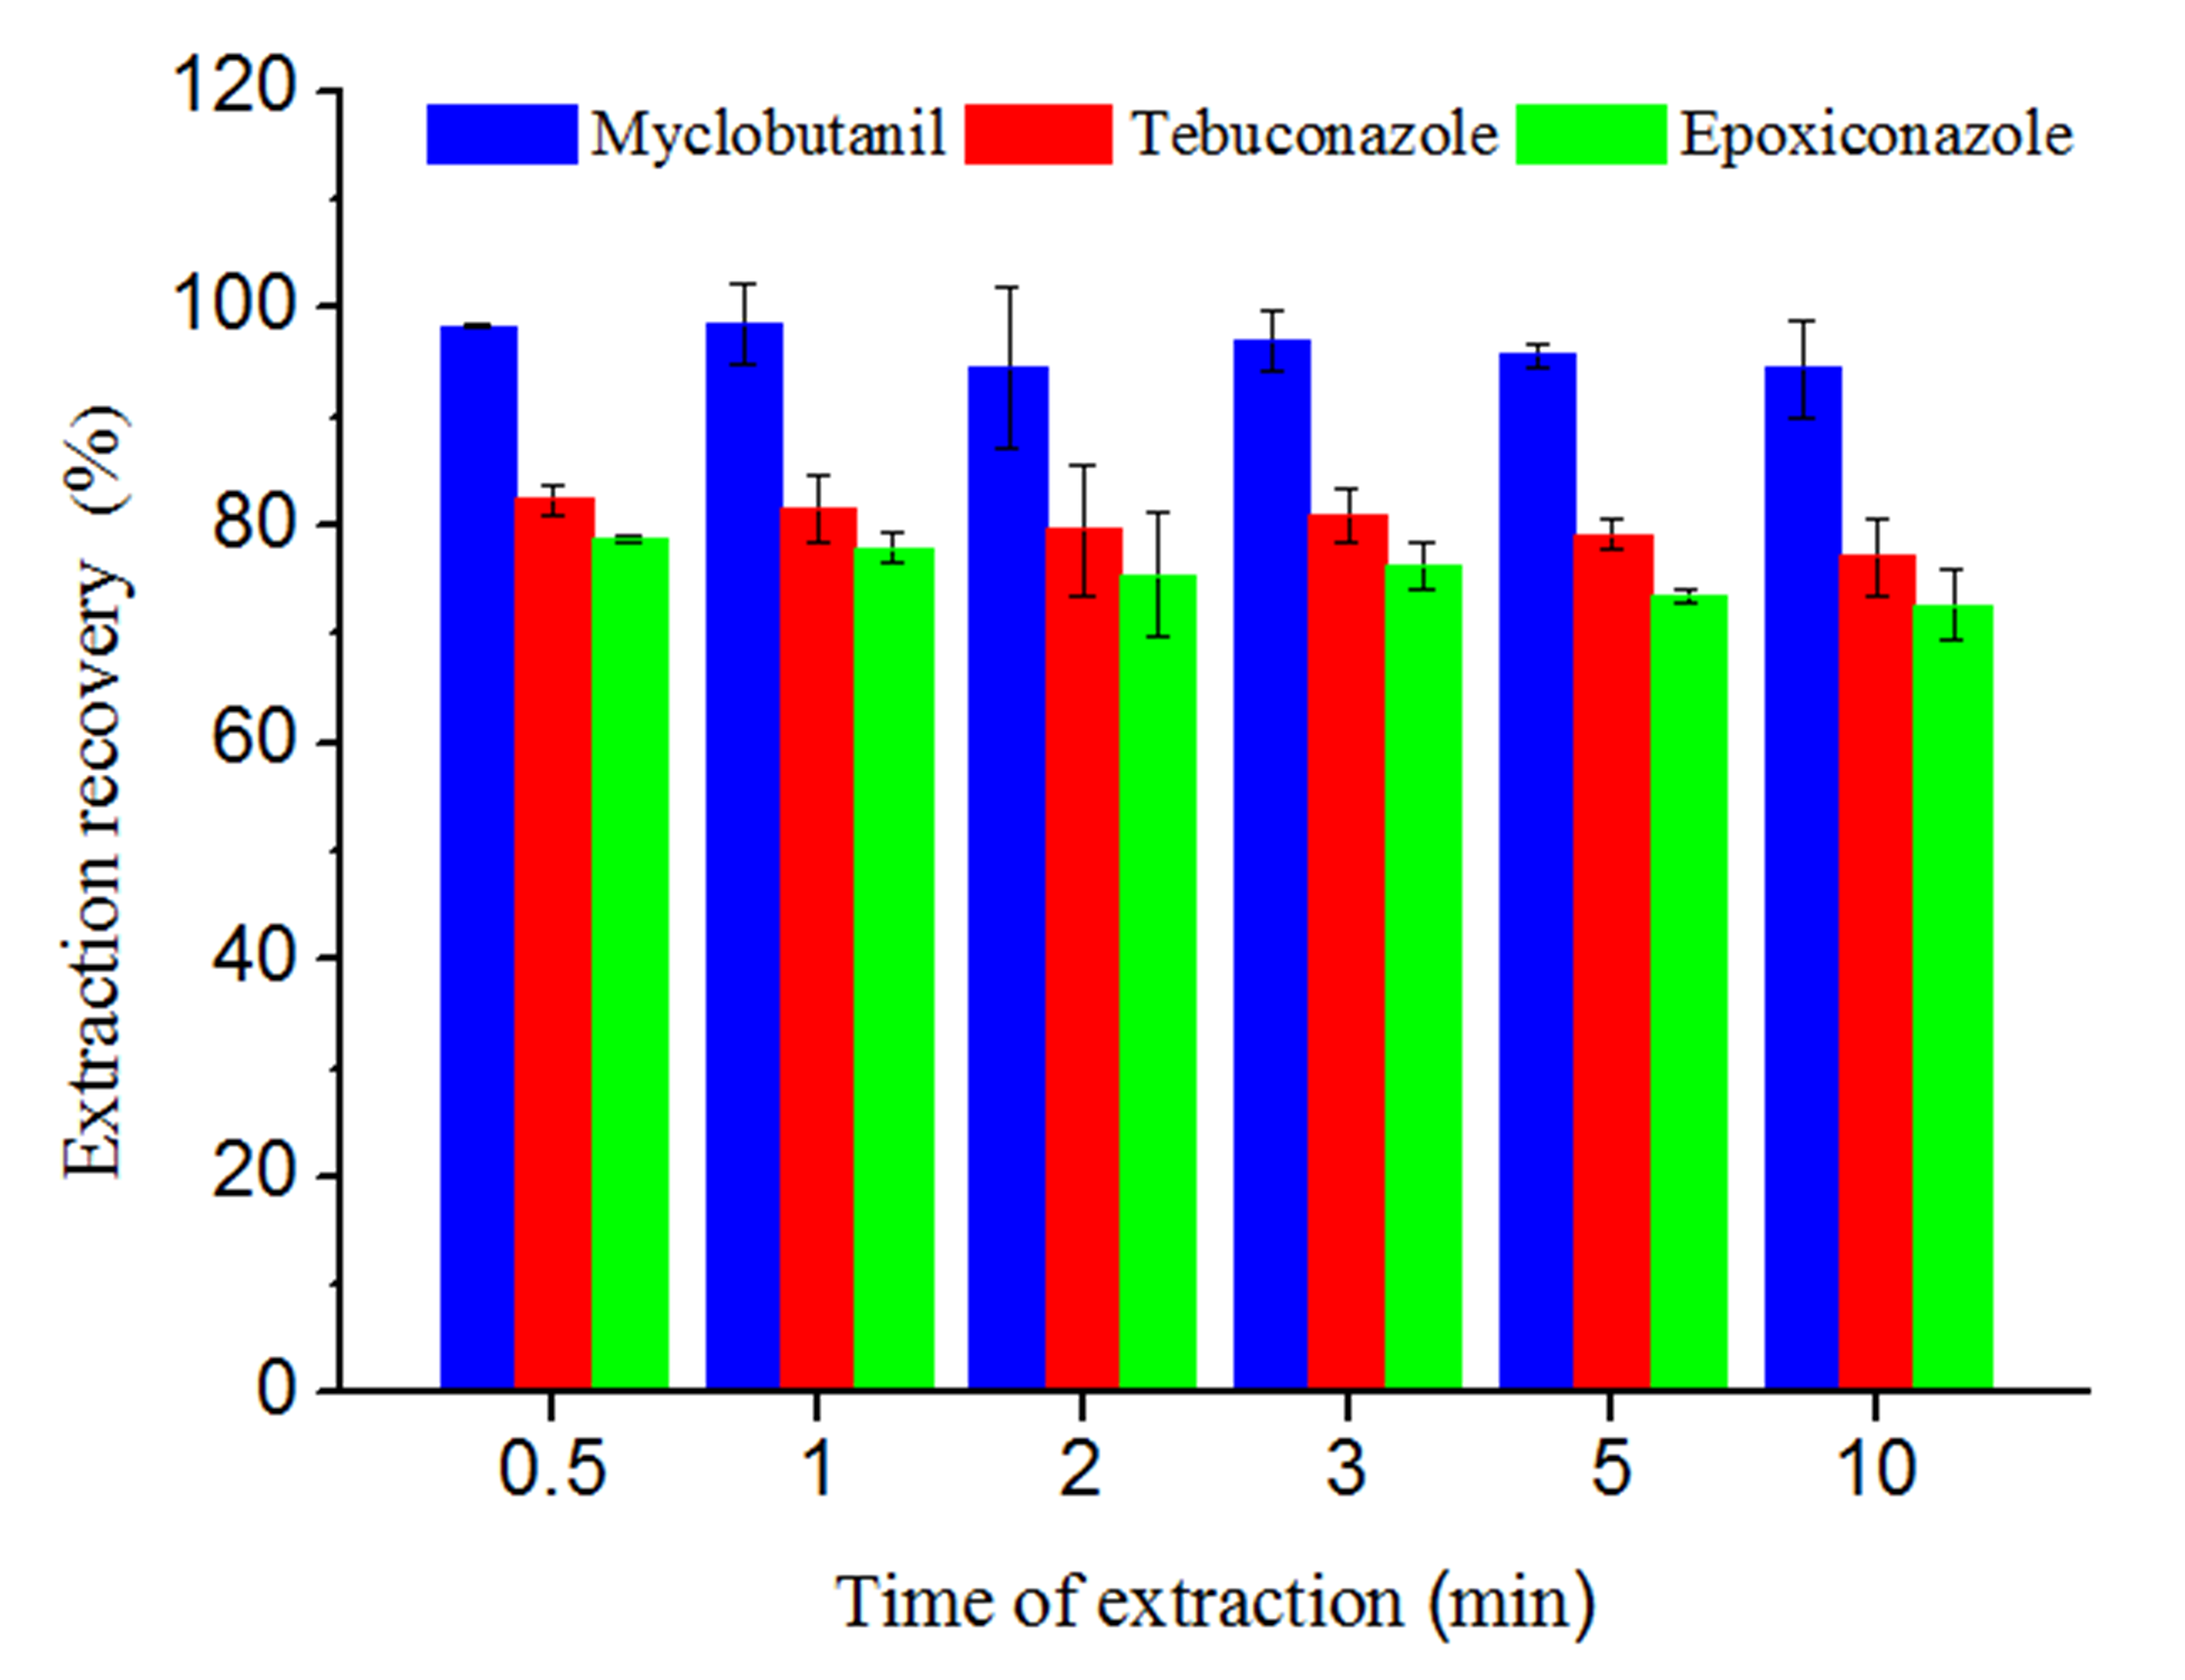
Figure S4 Effect of extraction time on recovery.

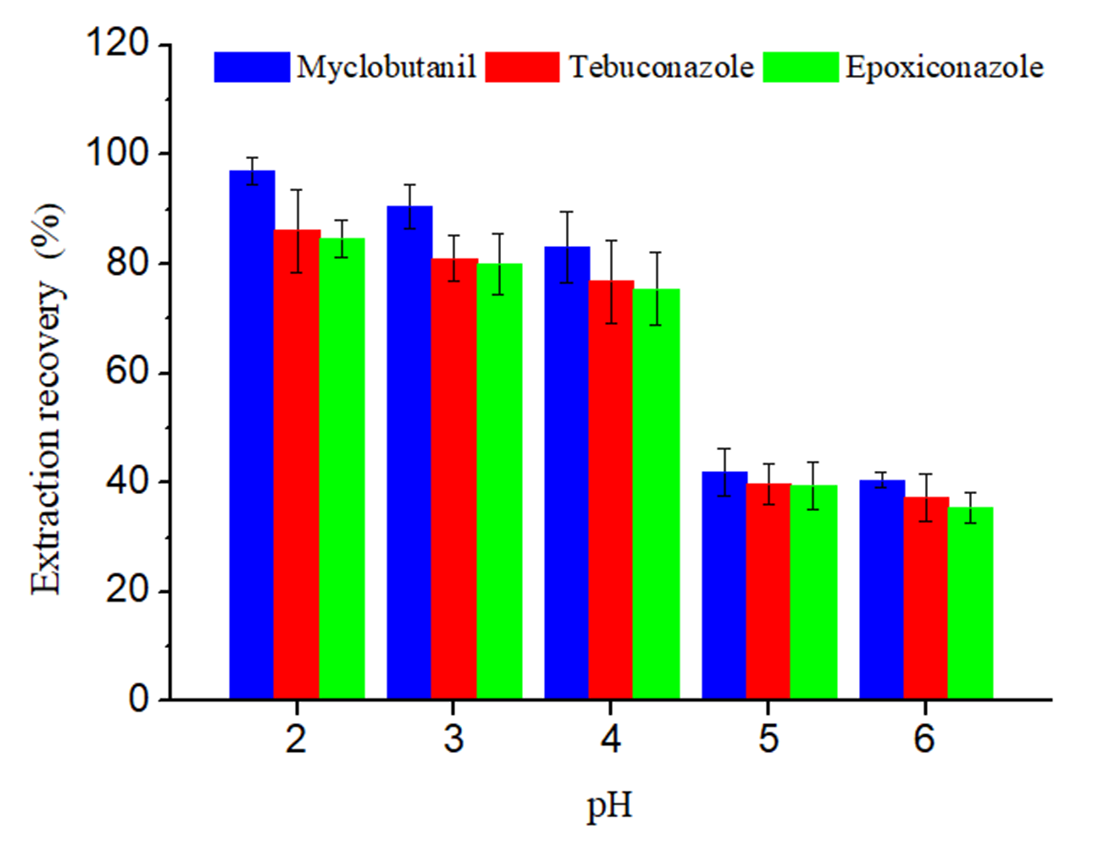
Figure S5 Effect of pH on recovery.

