Supplementary Information for

**Effect of small water retention structures on diffusive CO2 and CH4 emissions along a highly impounded river**

Lluís Gómez-Gener1, 2, Marina Gubau2, Daniel von Schiller3, Rafael Marcé4 and Biel Obrador2

*.1 Department of Evolutionary Biology, Ecology and Environmental Sciences, University of Barcelona, Av. Diagonal 643, 08028 Barcelona, Spain.*

*2 Department of Ecology and Environmental Science, Umeå University, Umeå, Linnaeus väg 6, 90187 Umeå, Sweden.*

*3 Department of Plant Biology and Ecology, University of the Basque Country, Apdo. 644, 48080 Bilbao, Spain.*

*4 Catalan Institute for Water Research (ICRA), Carrer Emili Grahit 101, 17003 Girona, Spain.*

**Supplementary Figures**

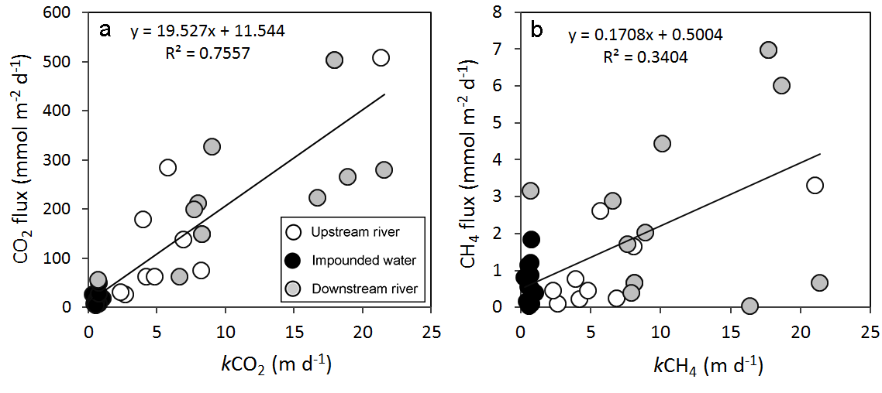**Fig. S1. a** CO2 emission flux (CO2 flux) as a function of the gas transfer velocity of CO2 () and b CH4 emission flux (CH4 flux) as a function of the gas transfer velocity of CH4 () of the 11 study sites for the three different impoundment units (i.e., upstream river, impounded water and downstream river) during the three sampled seasons (i.e., spring, summer and winter). The solid lines correspond to the regression model lines best fitting the data. Model equations are also shown close to model lines.

**Supplementary Tables**

**Table S1.** Overview of the potential explanatory variables of *p*CO2,w and *p*CH4,w included in the partial least square (PLS) models.



Mean water velocity, mean width and mean depth of the impounded water of each SWRT and their adjacent riverine section was determined in the field every sampling campaign. The discharge of each riverine section (upstream and downstream to the SWRS) was derived by combining the mean water velocity with the mean width and depth.

The *surface area* (***Area***) impounded at each SWRT was derived from a high resolution orthophoto by using the geometrical tool of Google Earth Pro (<https://www.google.com/intl/es/earth/index.html>).

The *volume (****Volume****)* impounded at each SWRT was derived from the mean depth and the surface area of each impoundment. Further validation of the surface area and volume was performed from digitized bathymetric maps using a geospatial-processing software (ArcMap 10, ArcGis, USA).

The *water residence time (****WRT****)* of the water impounded at each SWRT was obtained by dividing the impounded water volume by the inflowing water discharge at each system.

Reported surface water physico-chemical parameters are means of three measurements (n=3) made at the same location where the flux measurements were carried out.

*Surface water temperature (****Temp****)*, *electrical* *conductivity (****EC****)*, *pH* ***(pH)*** and *oxygen saturation (****DO Sat****)* were measured with a portable probe (WTW, Germany).

*Dissolved organic carbon (****DOC****) and total dissolved nitrogen (****TDN****)* concentration in water was measured from 0.45 µm-filtered water samples with a total organic carbon analyzer (TOC-V CSH, Shimadzu, Japan). The samples for *DOC* determination were previously acidified to eliminate dissolved inorganic constituents. The filters were air-dried and packed into plastic bags for transportation; *particulate organic carbon* (***POC***) concentrations were determined by loss on ignition (at 375ºC for 16 h). An additional filter was used to quantify the photosynthetic pigments (***Chl-a***) spectrophotometrically after their extraction with 90% acetone.

*Total nitrogen (****TN****) and phosphorus samples (****TP****)* were analyzed spectrophotometrically following alkaline persulfate digestion.

*Alkalinity (****Alk****)* was measured following Gran method. We used an automatic Metrohm 672 Titoprocessors provided with a pH electrode and HCl (0.01N).

**Table S2.** Summary of partial least square (PLS) models produced for *p*CO2,w and *p*CH4,w and Pearson’s correlations.

