Supplementary Material
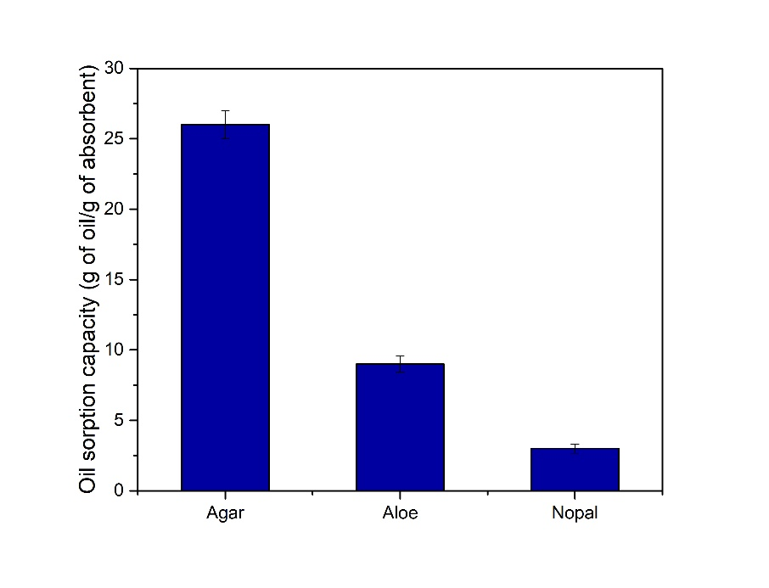
Figure S1. Absorption capacity of lyophilized natural sorbents.
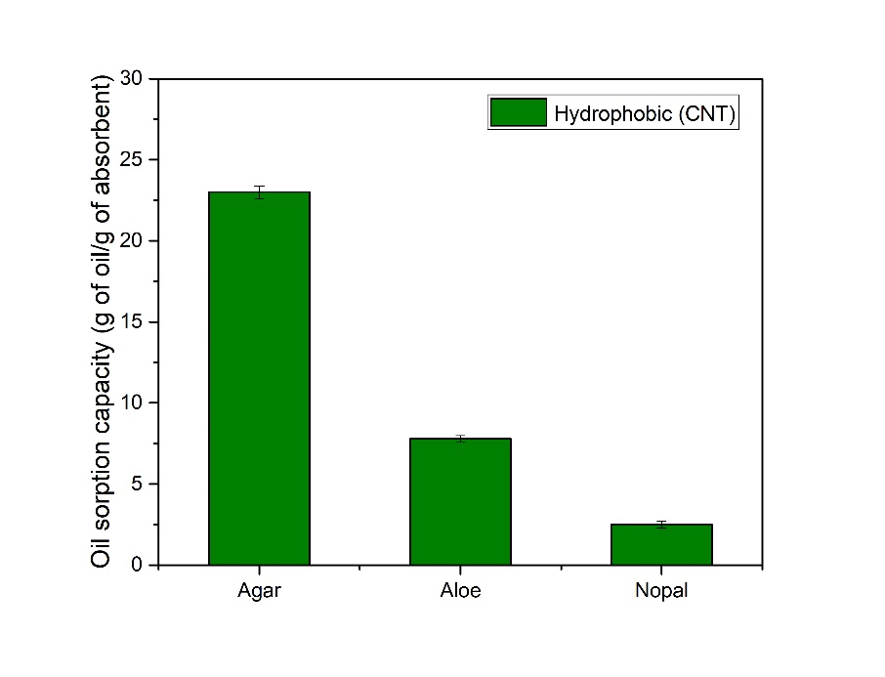
Figure S2. Absorption capacities for the MWCNT composites.
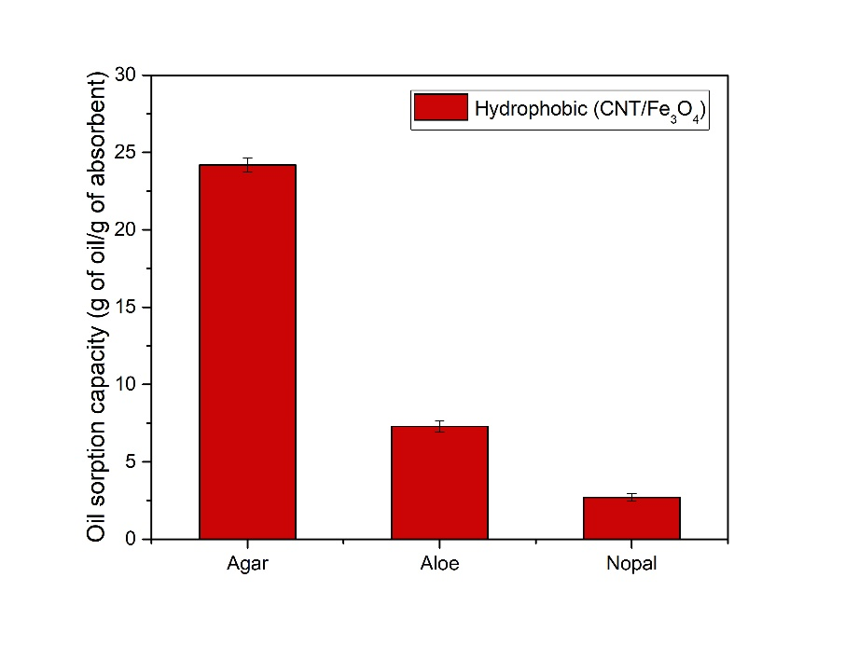
Figure S3. Absorption capacities of composites hydrophobized with MWCNTs-Fe₃O₄.
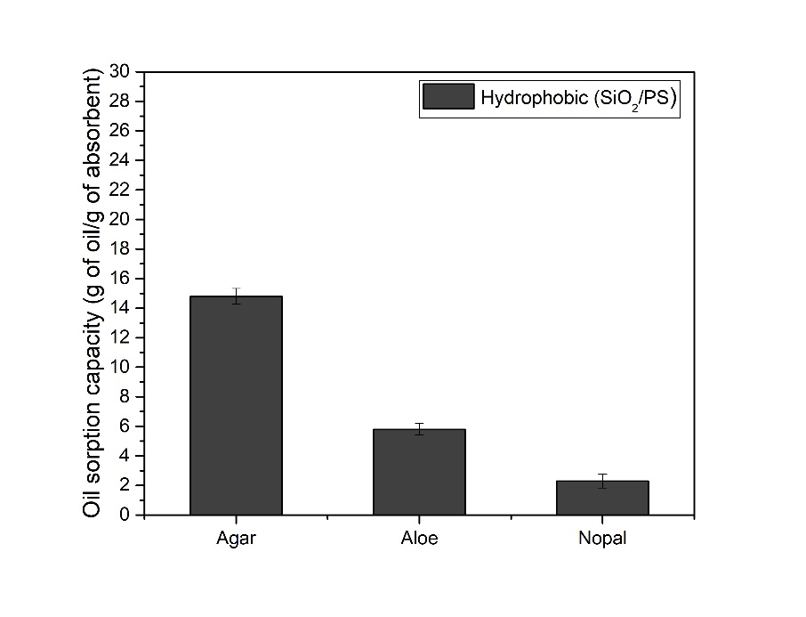
Figure S4. Absorption capacity for samples hydrophobized with PS/SiO_{2.}
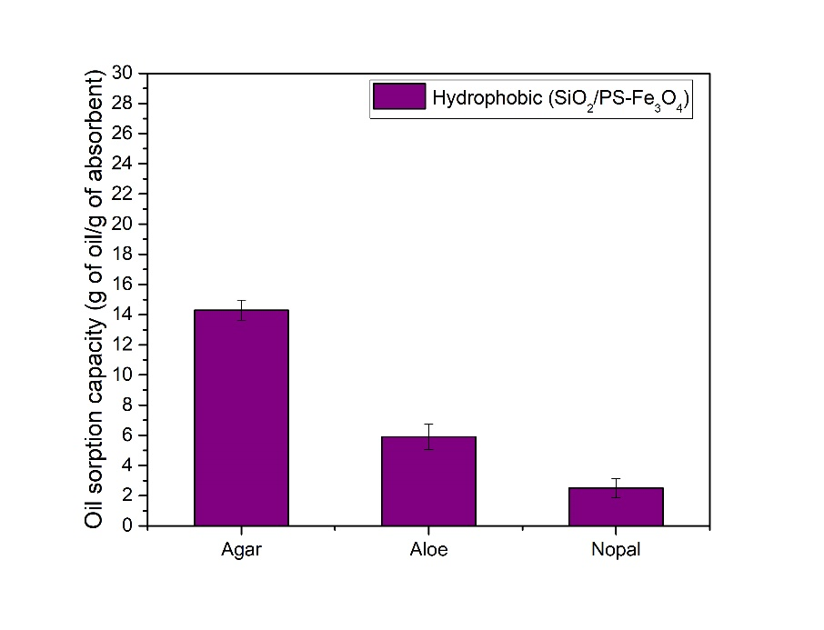
Figure S5. Absorption capacities of samples hydrophobized with PS/SiO₂ -Fe₃O_{4.}

