Supporting Information

Green and efficient determination of ʟ-dopa in complex polypill formulations using a magnetic microplate

Hweiyan Tsai^{a,b*} , Chia-Yi Chenª , Yi-Hsuan Lu^{c} , Ya-Yun Lai^{d} , and Chwan-Bor Fuh^{c*}

ª Department of Medical Applied Chemistry, Chung Shan Medical University, Taichung, Taiwan
^{b} Department of Medical Education, Chung Shan Medical University Hospital, Taichung, Taiwan
^{c} Department of Applied Cosmetology, National Tainan Junior College of Nursing, Tainan, Taiwan
^{d} Department of Applied Chemistry, National Chi Nan University, Nantou, Taiwan

*Corresponding Authors
No. 110, Sec. 1, Jianguo N. Rd., Southern District, Taichung 402, Taiwan
Tel: +886 4 24730022 ext. 12135; Fax: +886 4 23248189
Email: annetsai@csmu.edu.tw (H. Tsai); cbfuh@ncnu.edu.tw (C. Fuh)

- Synthesis of iron oxide (Fe₃O₄) nanoparticles
The iron oxide nanoparticles were prepared from the chemical precipitation of ferric chloride and ferrous chloride using a solution of ammonium hydroxide; FeCl₃·H₂O (0.27 g), FeCl₂·4H₂O (0.1 g), and deionized water (25 mL) were mixed vigorously using ultrasonication for 10 min at room temperature (25–28 °C). The mixture was then purged with N₂ and stirred using a Thermolyne® Cimarec®-top stirring hotplate (on speed 8) at room temperature (25±1 °C) for 5 min prior to the addition of NH₄OH (4.5 mL), after which stirring continued for 2 min. The resulting product was magnetically separated and washed three times with deionized water, then washed once with 50% ethanol prior to drying under a vacuum at room temperature.

2. Synthesis of the Fe₃O₄@SiO₂ nanoparticles
Iron oxide (0.03 g), deionized water (4 mL), and isopropyl alcohol (20 mL) were mixed vigorously using ultrasonication for 30 min at room temperature to give a homogeneous solution to which tetraethoxysilane (120 μL) was added. The resulting mixture was then stirred using a Thermolyne® Cimarec®-top stirring hotplate (on speed 8) at room temperature for approximately 2 min, then NH₄OH (0.5 mL) was added and stirring continued for 3 h. The resulting product was magnetically separated and washed three times with 50% ethanol, prior to drying under a vacuum at room temperature. Figure S1 shows a transmission electron microscope (TEM) image of the resulting Fe₃O₄@SiO₂ nanoparticles, which exhibited an average particle diameter of approximately 30 nm (Fig. S2).

Figure S1. TEM images of the Fe₃O₄@SiO₂ nanoparticles

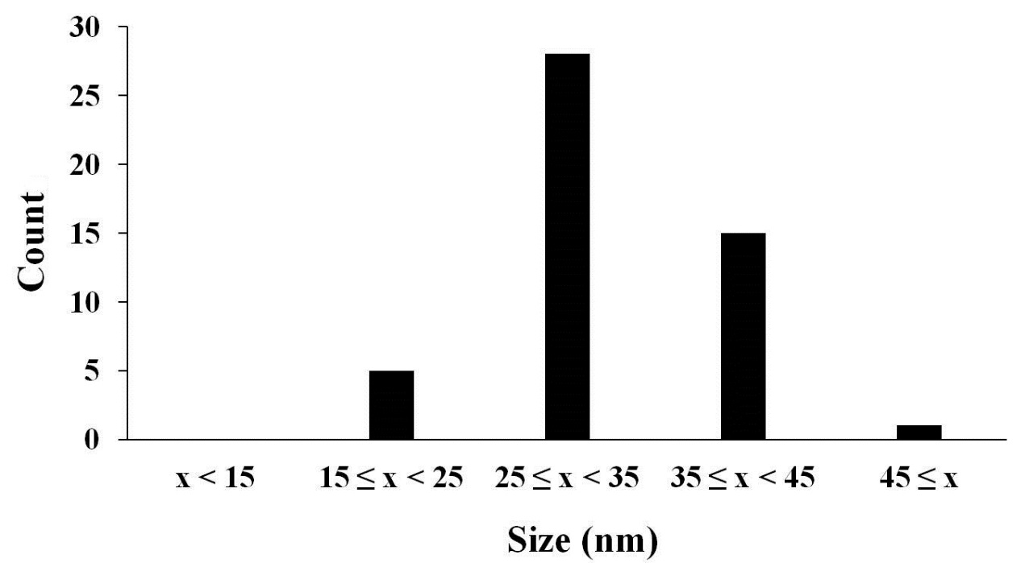
Figure S2. Particle size distribution of the prepared Fe₃O₄@SiO₂ nanoparticles

3. Synthesis of the Fe₃O₄@SiO₂-NH₂ nanoparticles

The Fe₃O₄@SiO₂ nanoparticles (30 mg), deionized water (4 mL), and isopropyl alcohol (20 mL) were mixed vigorously using ultrasonication for 5 min, after which time (3-aminopropyl)triethoxysilane (1 mL) was added. The resulting mixture was stirred using a Thermolyne® Cimarec®-top stirring hotplate (on speed 8) at room temperature for approximately 2 min, then NH₄OH (1 mL) was added, and the mixture was stirred for a further 2 h. The resulting product was magnetically separated and washed three times with 50% ethanol, prior to drying under a vacuum at room temperature.

4. FTIR spectra of iron oxide, silica (SiO₂), and Fe₃O₄@SiO₂
The infrared spectra of iron oxide, silica (SiO₂), and the Fe₃O₄@SiO₂ nanoparticles are shown in Fig. S3. In all spectra, the broad absorption bands at 3200–3400 cm⁻¹ correspond to O–H stretching mode, which indicates that many OH groups were present on the surface of the particles. The spectrum of SiO₂ shows Si–O–Si stretching vibrations at 466 and 1093 cm⁻¹. The spectrum of iron oxide (Fe₃O₄) shows absorption at approximately 586–631 and 1612 cm⁻¹, which is assigned to Fe–O stretching vibration. The absorption also appears in the spectrum of Fe₃O₄@SiO₂, but with lower intensity, likely due to the covering of SiO₂ layers. The SiO₂ layers in the Fe₃O₄@SiO₂ spectrum are also indicated by the feature peaks at 466 and 1093 cm⁻¹ corresponding to Si-O-Si stretching vibrations(1).
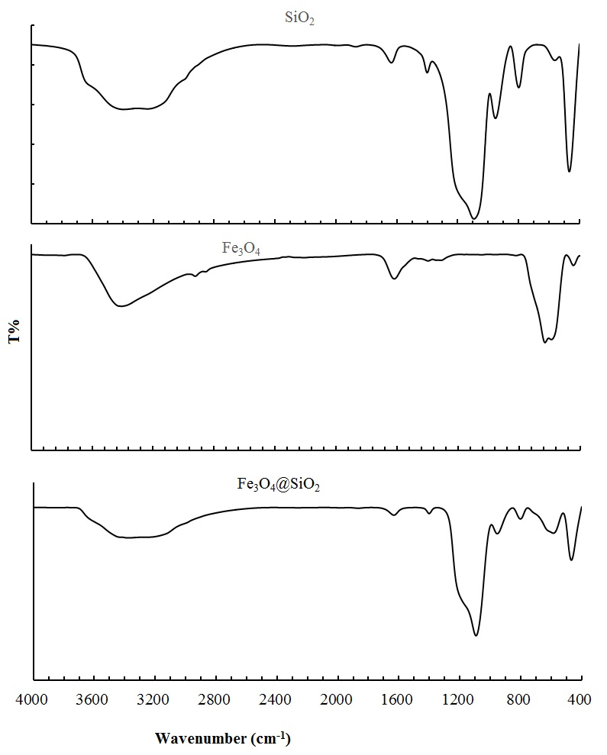

Figure S3. FTIR spectra of silica (SiO₂), iron oxide (Fe₃O₄), and the Fe₃O₄@SiO₂ nanoparticles, obtained using a Spectrum 100 FTIR Spectrometer (Perkin Elmer, Wellesley, UK).

5. Immobilization of tyrosinase on the magnetic nanoparticles (TYR-MNPs)
An aliquot of 2.5 % glutaraldehyde in 0.1 M phosphate buffer (PB) (10 mL, pH 6.0) and the Fe₃O₄@SiO₂-NH₂ nanoparticles (MNPs, 1 mg) were added to a centrifuge tube, and the tube was gently rotated using a MACSmixTM tube rotator for 1 h at room temperature. The resulting glutaraldehyde-linked MNPs were washed three times with PB to remove any unreacted glutaraldehyde, and an aliquot of tyrosinase-containing PB (10 mL, 100 U ʟ-dopa activity) was added to the centrifuge tube, which was gently rotated again for 24 h at 4 °C. The resulting TYR-MNPs were magnetically separated, then washed three times with PB to remove any unreacted tyrosinase. Finally, the TYR-MNPs were reconstituted using PB (10 mL) and divided into aliquots of 1 mL, which were stored at 4 °C prior to use. TYR-MNPs were prepared twice (labelled batch 1 and batch 2) to verify the repeatability of the preparation.

6. Preparation of the magnetic microplate
Neodymium magnets, 6 mm in diameter and 13 mm in length, were fixed into the wells of a 96-well microplate. The magnetic field strength of these magnets was 4.1 (±0.2) kG at the top of the microplate.

7. Optimization of the reaction time between ʟ-dopa and the TYR-MNPs

Fig. S5. Relationship between the formation of dopachrome and the reaction time

Reference
(1) Liu, L.; Yuan, M.; Huang, S.; Li, J.; Li, D.; Zhao, L., Appl. Sci. 2018, 8, 158 ( doi:10.3390/app8020158)

