Supplemental content

Supplementary Table 1. Full search strategy
Note: In the database searches, squamous cell carcinoma was also added as search term to make sure that studies with mixed populations of patients with both adenocarcinoma and squamous cell carcinoma were not missed.
PubMed
1 | "Esophageal Neoplasms"[Mesh] OR "Stomach Neoplasms"[Mesh] OR "Carcinoma, Squamous Cell"[Mesh]
2 | (esophag*[tiab] OR oesophag*[tiab] OR gastric[tiab] OR gastroesophag*[tiab] OR gastrooesophag*[tiab] OR stomach[tiab] OR squamous[tiab] OR barrett*[tiab]) AND (cancer*[tiab] OR neoplas*[tiab] OR tumor*[tiab] OR tumour*[tiab] OR malignan*[tiab] OR carcino*[tiab] OR adeno*[tiab] OR metastas*[tiab])
3 | #1 OR #2
4 | "Receptor, ErbB-2"[Mesh] OR "Genes, erbB-2"[Mesh]
5 | HER2[tiab] OR HER 2[tiab] OR epidermal growth factor receptor 2[tiab] OR ERBB2[tiab] OR ERBB-2[tiab] OR ERB B 2[tiab] OR c-erbb-2[tiab] OR cerbb2[tiab] OR neu[tiab] OR neu protein[tiab] OR neu receptor[tiab] OR receptor neu[tiab] OR neuregulin receptor[tiab]
6 | #4 OR #5
7 | #3 AND #6

EMBASE
# | Searches
1 | exp *esophagus tumor/ or exp *stomach tumor/ or exp *squamous cell carcinoma/ or ((esophag* or oesophag* or gastric or gastroesophag* or gastrooesophag* or stomach or squamous or barrett*) adj3 (cancer* or neoplas* or tumor* or tumour* or malig* or carcino* or adeno* or metastas*)).ti,ab,kw.
2 | epidermal growth factor receptor 2/ or proto oncogene/ or (epidermal growth factor receptor 2 or HER2 or HER 2 or epidermal growth factor receptor 2 or ERBB2 or ERBB-2 or ERB B 2 or c-erbb-2 or cerbb2 or neu protein or neu receptor or receptor neu or neuregulin receptor).ti,ab,kw.
3 | 1 and 2

Cochrane Central Register of Controlled Trials
#1 MeSH descriptor: [Esophageal Neoplasms] explode all trees
#2 MeSH descriptor: [Stomach Neoplasms] explode all trees
#3 MeSH descriptor: [Carcinoma, Squamous Cell] explode all trees
#4 (esophag* or oesophag* or gastric or gastroesophag* or gastrooesophag* or stomach or squamous or barrett*) near/3 (cancer* or neoplas* or tumor* or tumour* or malignan* or carcino* or adeno* or metastas*):ti,ab,kw (Word variations have been searched)
#5 #1 or #2 or #3 or #4
#6 MeSH descriptor: [Receptor, ErbB-2] explode all trees
#7 MeSH descriptor: [Genes, erbB-2] explode all trees
#8 epidermal growth factor receptor 2 or HER2 or HER 2 or epidermal growth factor receptor 2 or ERBB2 or ERBB-2 or ERB B 2 or c-erbb-2 or cerbb2 or neu protein or neu receptor or receptor neu or neuregulin receptor:ti,ab,kw (Word variations have been searched)
#9 #6 or #7 or #8
#10 #5 and #9 in Trials
ASCO
trastuzumab AND gastric
ESMO
trastuzumab AND gastric
Supplementary Table 2. Quality assessment
Non-randomized studies
Category | Selection |  |  | Design |  | Comparability of studies | Outcome |  |  | Published | Overall quality
Items | 1 | 2 | 3 | 4 | 5 | 6 | 7 | 8 | 9 | 10
Narita 2016 | Yes | Yes | Yes | Yes | Yes | Yes | Yes | No | Yes | Yes | High
Li 2016 | Yes | Yes | Yes | Yes | Yes | No | Yes | Yes | Yes | Yes | High
Palle 2017 | Yes | Yes | Yes | No | Yes | Yes | Yes | Yes | Yes | Yes | High
Makiyama 2017 | Yes | Yes | Yes | No | Yes | NA/No | Yes | Yes | Yes | No | Moderate
Randomized studies
Items | A | B | C | D | E | F
Makiyama 2018 | Unclear | Unclear | Low | Low | Low | Unclear (conference abstract) |  |  |  |  | Unclear

Legend
Modified version of the Newcastle Ottawa Scale for single-arm cohort studies. Studies were scored as low (0-4 points), moderate (5-8 points) or high quality (9-10 points).
1. Representativeness of exposed cohort: drawn from target population and at least baseline age and performance status should be described
2) The non exposed cohort: drawn from the same community as the exposed cohort and at least baseline age and performance status should be described
3. Ascertainment of exposure: description of number of patients who actually received treatment
4. Prospective study
5. Multicenter study
6. Majority of patients (>80%) in the study received second-line taxane- or irinotecan-based chemotherapy regimens
7. Assessment of outcome was adequate
8.Follow-up long enough for events to occur: if the upper bound of the 95%CI of the median OS was reached, the follow-up time was deemed long enough.
9. Adequacy of follow-up: state reasons for dropout
10.Published report in peer reviewed journal
Cochrane Risk of Bias tool for randomized controlled trials. Studies were scored as Low, High or Unclear risk of bias.
A. Random sequence generation
B. Allocation concealment
C. Blinding of outcome
D. Incomplete outcome data
E. Selective Reporting
F. Other bias

Supplementary Figure 1. Flowchart of included studies

References derived from ASCO (n = 222) and ESMO (n = 296) until June 2018
Total n = 518
References derived from Pubmed (n = 3275), EMBASE
(n = 5944) and CENTRAL (n = 575) until June 2018
Total n = 9478

Removed duplicates
n = 2664

Unique references for screening based on title and abstract
n = 6814

Excluded based on title and abstract
n = 516
Excluded based on title and abstract
n = 6800

Additional studies identified from conference meetings
n = 2

References for full-text assessment
n = 14

Excluded after detailed assessment: n = 11
- Trastuzumab-naïve patients: n = 1
- No comparison with chemotherapy-alone: n = 8
- Case report: n = 2

Studies eligible for systematic review
n = 3

Studies derived from both database and conference search: n = 5

Supplementary Figure 2. Funnel plot for the assessment of publication bias.
(A) Overall Survival
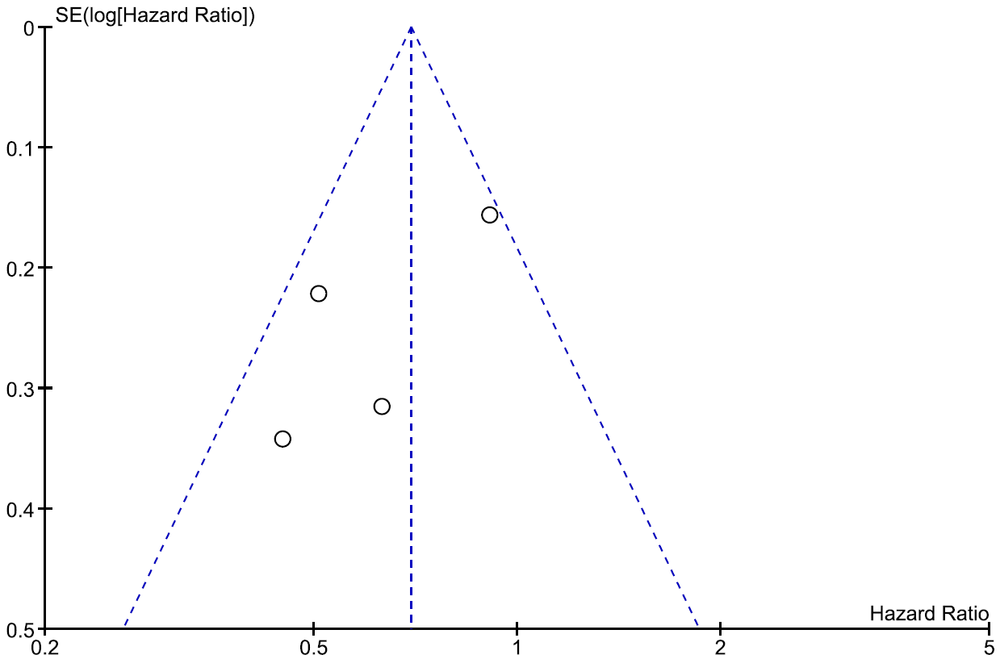
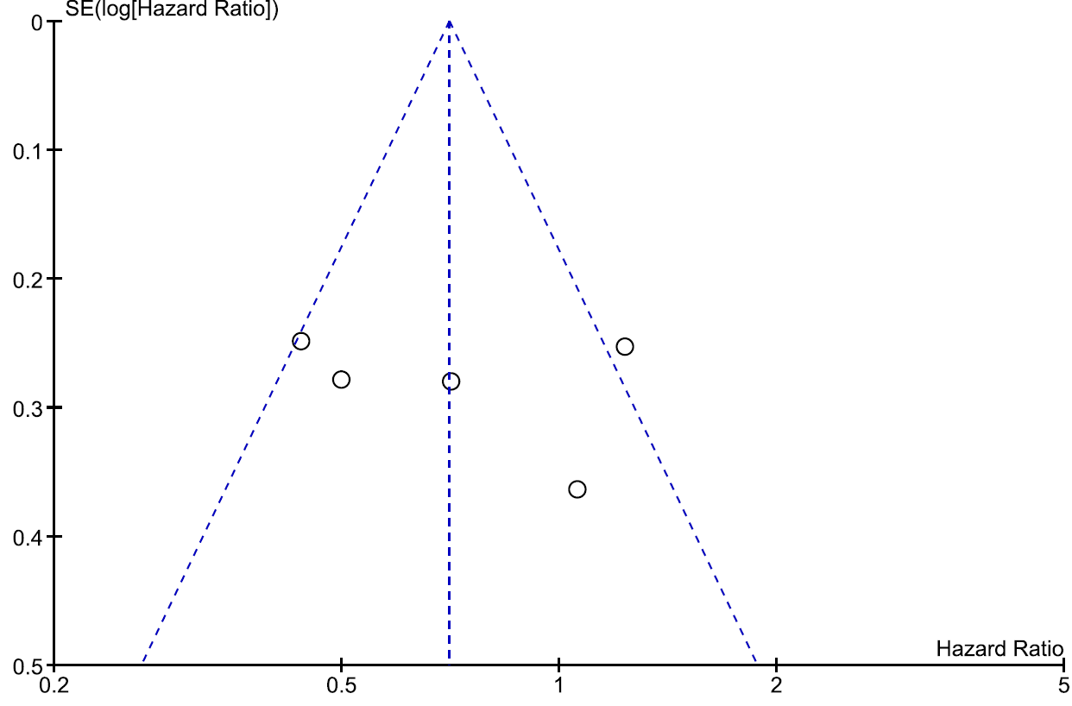
(B) Progression Free Survival
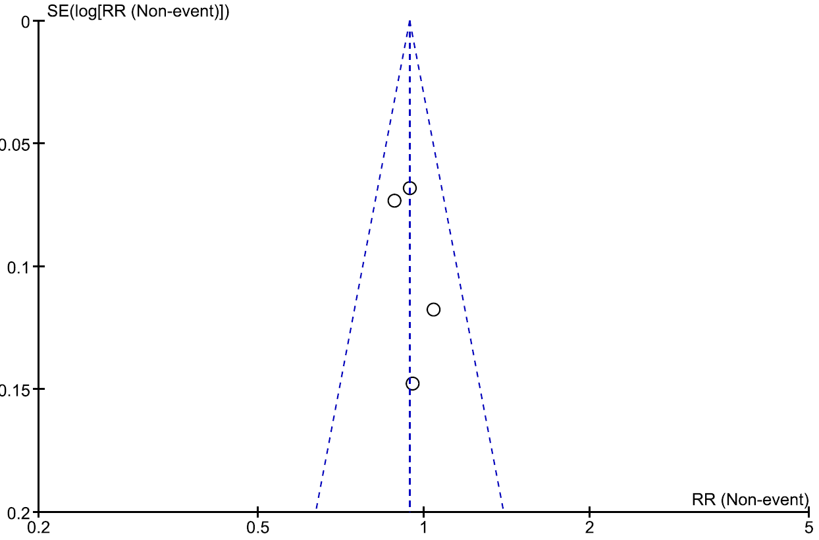
(C) Objective Response Rate

Supplementary Table 3. Grade 1-2 Adverse Events
Grade 1-2 toxicity | Tmab + CT |  | CT-alone |  | Estimate |  |  | Heterogeneity
 | n/N | % | n/N | % | RR (95%CI) | P | Trials | I² (%) | P
Haematological
Neutropenia | 26/70 | 37% | 20/65 | 31% | 1.20 (0.75-1.92) | 0.46 | 2 | 0 | 0.33
Leukopenia | 30/70 | 43% | 24/65 | 37% | 1.16 (0.77-1.77) | 0.48 | 2 | 0 | 0.90
Anemia | 24/70 | 34% | 19/65 | 29% | 1.13 (0.69-1.85) | 0.62 | 2 | 0 | 0.79
Thrombocytopenia | 4 | 6% | 7 | 11% | 0.55 (0.17-1.83) | 0.33 | 2 | 0 | 0.41
Non-haematological
Nausea | 14/70 | 20% | 16/65 | 25% | 0.75 (0.25-2.27) | 0.62 | 2 | 66 | 0.09
Diarrhea | 14/70 | 20% | 14/65 | 22% | 0.97 (0.50-1.87) | 0.92 | 2 | 0 | 0.40
Stomatitis | 3 | 12% | 2 | 10% | 1.15 (0.21-6.26) | 0.87 | 1 | NA | NA
Mucositis | 7 | 16% | 3 | 7% | 2.39 (0.66-8.64) | 0.19 | 1 | NA | NA
Anorexia | 23/70 | 33% | 16/65 | 25% | 1.08 (0.30-3.97) | 0.90 | 2 | 75 | 0.06
Fatigue | 23/70 | 33% | 22/65 | 34% | 0.98 (0.55-1.77) | 0.96 | 2 | 27 | 0.24
Neuropathy | 32/70 | 46% | 33/65 | 51% | 0.91 (0.64-1.28) | 0.58 | 2 | 0 | 0.58
Febrile neutropenia | 0/70 | 0% | 0/65 | 0% | NA | NA | 2 | NA | NA
Cardiovasculair | 1/168 | 1% | 2/156 | 1% | 0.51 (0.02-16.03) | 0.70 | 4 | 60 | 0.11
Nephrotoxicity | 0/32 | 0% | 0/27 | 0% | NA | NA | 1 | NA | NA
Allergic reaction | 1 | 2% | 0/26 | 0% | 1.35 (0.06-32.08) | 0.85 | 1 | NA | NA
Infusion related events | 10 | 12% | 3 | 7% | 1.47 (0.44-4.90) | 0.53 | 2 | NA | NA
No significant differences were detected between the trastuzumab-continuation arm and the chemotherapy-alone arm. A Risk Ratio < 1 indicates less adverse events for trastuzumab-continuation. A Risk Ratio > 1 indicates more adverse events for trastuzumab-continuation.
Abbreviations: 95%CI: 95% confidence interval, CT: chemotherapy, n: number of patients with an adverse event, N: sample size, NA: Not available, RR: Risk Ratio, Tmab: trastuzumab.

