Analysis of the similarity among tested isolates and PMEN strains (highlighted) made by eBURSTv3 software

eBURST Report - Mon Sep 12 13:45:31 CEST 2016
No. isolates = 68 | No. STs = 57 | No. re-samplings for bootstrapping = 1000
No. loci per isolate = 7 | No. identical loci for group def = 6 | No. groups = 6

Group 1: No. Isolates = 6 | No. STs = 3 | Predicted Founder = 15
Average ST Bootstrap
ST FREQ SLV DLV TLV SAT Distance Group Subgrp
15 2 2 0 0 0 1.0 34% 0%
423 2 1 1 0 0 1.5 0% 0%
9 2 1 1 0 0 1.5 0% 0%

Group 2: No. Isolates = 3 | No. STs = 2 | Predicted Founder = None

ST FREQ SLV DLV TLV SAT Distance
87 2 1 0 0 0 1.0
10342 1 1 0 0 0 1.0

Group 3: No. Isolates = 3 | No. STs = 2 | Predicted Founder = None

ST FREQ SLV DLV TLV SAT Distance
81 2 1 0 0 0 1.0
2033 1 1 0 0 0 1.0

Group 4: No. Isolates = 3 | No. STs = 2 | Predicted Founder = None

ST FREQ SLV DLV TLV SAT Distance
320 2 1 0 0 0 1.0
9062 1 1 0 0 0 1.0

Group 5: No. Isolates = 2 | No. STs = 2 | Predicted Founder = None

ST FREQ SLV DLV TLV SAT Distance
374 1 1 0 0 0 1.0
63 1 1 0 0 0 1.0

Group 6: No. Isolates = 3 | No. STs = 2 | Predicted Founder = None

ST FREQ SLV DLV TLV SAT Distance
143 2 1 0 0 0 1.0
10340 1 1 0 0 0 1.0

Singletons: size 44
230
199
135
53
20
193
615
327
191
384
289
448
18
156
124
75
185
41
315
180
377
376
344
218
217
505
242
273
270
37
113
177
67
433
496
175
173
338
306
304
90
205
268
236

Figure S1 Diagram MLST - comparison of tested strains and 43 PMEN strains.
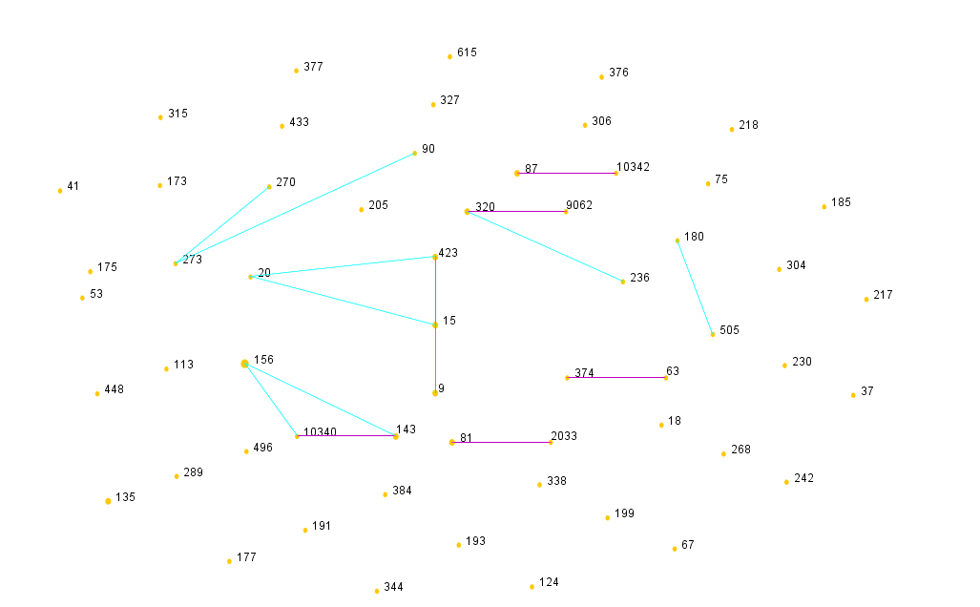
The size of the circle (symbolizing STs) corresponds to the number of isolates belonging to a ST. Single-locus variant and double-locus variant links are represented by pink and blue lines, respectively.

