Appendix S1. Example of the manure heap where farmland birds were surveyed a) and foraging Yellowhammers at the manure heap b).

a)
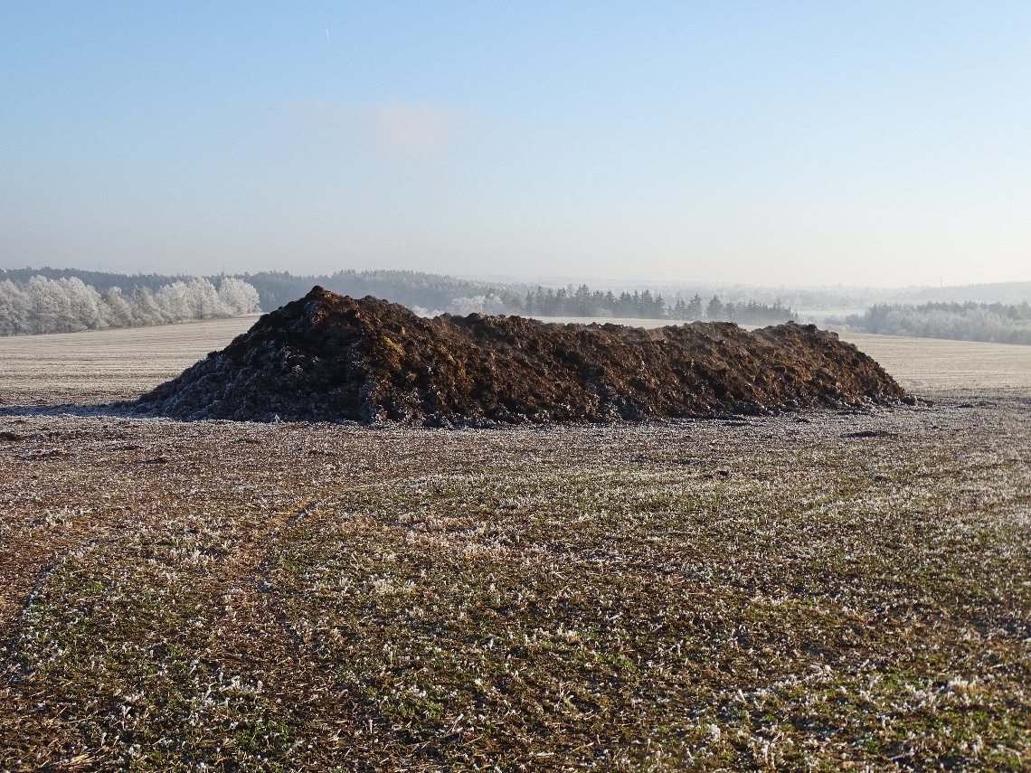

b)
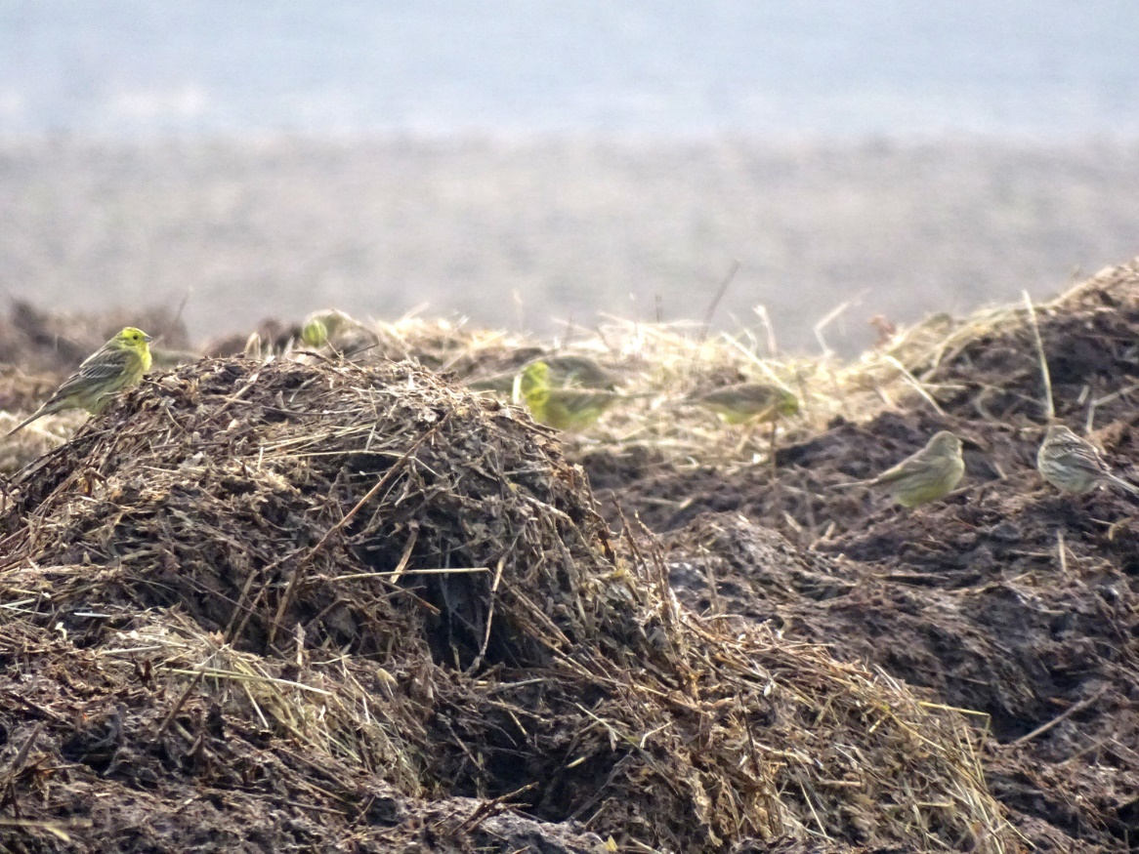

Appendix S2. List of farmland bird species recorded during point counts at 43 farmland sites and 43 manure heaps. For each species sum of individuals, mean abundance per point and SD are given for the two habitats. The species of conservation concern are given in red.

Species | Farmland |  |  |  | Manure heap
 | sum | mean | SD |  | sum | mean | SD
Emberiza citrinella | 11 | 0.256 | 1.241 |  | 1124 | 26.140 | 32.023
Passer montanus | 3 | 0.070 | 0.334 |  | 313 | 7.279 | 17.847
Corvus corone | 0 | 0.000 | 0.000 |  | 89 | 2.070 | 7.531
Carduelis cannabina | 104 | 2.419 | 15.069 |  | 82 | 1.907 | 11.037
Columba livia | 0 | 0.000 | 0.000 |  | 56 | 1.302 | 6.385
Fringilla coelebs | 4 | 0.093 | 0.362 |  | 56 | 1.302 | 3.217
Carduelis carduelis | 0 | 0.000 | 0.000 |  | 31 | 0.721 | 3.854
Emberiza calandra | 0 | 0.000 | 0.000 |  | 28 | 0.651 | 3.110
Buteo buteo | 10 | 0.233 | 0.474 |  | 27 | 0.628 | 1.276
Pica pica | 7 | 0.163 | 0.428 |  | 25 | 0.581 | 1.262
Streptopelia decaocto | 0 | 0.000 | 0.000 |  | 18 | 0.419 | 2.295
Perdix perdix | 1 | 0.023 | 0.151 |  | 10 | 0.233 | 1.507
Anthus pratensis | 0 | 0.000 | 0.000 |  | 8 | 0.186 | 0.539
Carduelis chloris | 2 | 0.047 | 0.301 |  | 6 | 0.140 | 0.632
Corvus cornix | 0 | 0.000 | 0.000 |  | 6 | 0.140 | 0.765
Falco tinnunculus | 3 | 0.070 | 0.255 |  | 6 | 0.140 | 0.347
Corvus corax | 0 | 0.000 | 0.000 |  | 5 | 0.116 | 0.492
Motacilla alba | 0 | 0.000 | 0.000 |  | 2 | 0.047 | 0.211
Phasianus colchicus | 1 | 0.023 | 0.151 |  | 2 | 0.047 | 0.301
Accipiter nisus | 0 | 0.000 | 0.000 |  | 1 | 0.023 | 0.151
Alauda arvensis | 0 | 0.000 | 0.000 |  | 1 | 0.023 | 0.151
Circus cyaneus | 1 | 0.023 | 0.151 |  | 1 | 0.023 | 0.151
Galerida cristata | 0 | 0.000 | 0.000 |  | 1 | 0.023 | 0.151
Lanius excubitor | 2 | 0.047 | 0.211 |  | 1 | 0.023 | 0.151
Motacilla cinerea | 0 | 0.000 | 0.000 |  | 1 | 0.023 | 0.151

