Internal RNAs overlapping coding sequences can drive the production of alternative proteins in archaea

Felipe ten-Caten^{1*#}, Ricardo Z. N. Vêncio^{2#}, Alan Péricles R. Lorenzetti¹, Lívia Soares Zaramela^{1$}, Ana Carolina Santana³, Tie Koide^{1&}

Legends are located at the end of this document, after all figures, to facilitate reading. References are numbered (superscript) according to the main text and listed in Reference section.
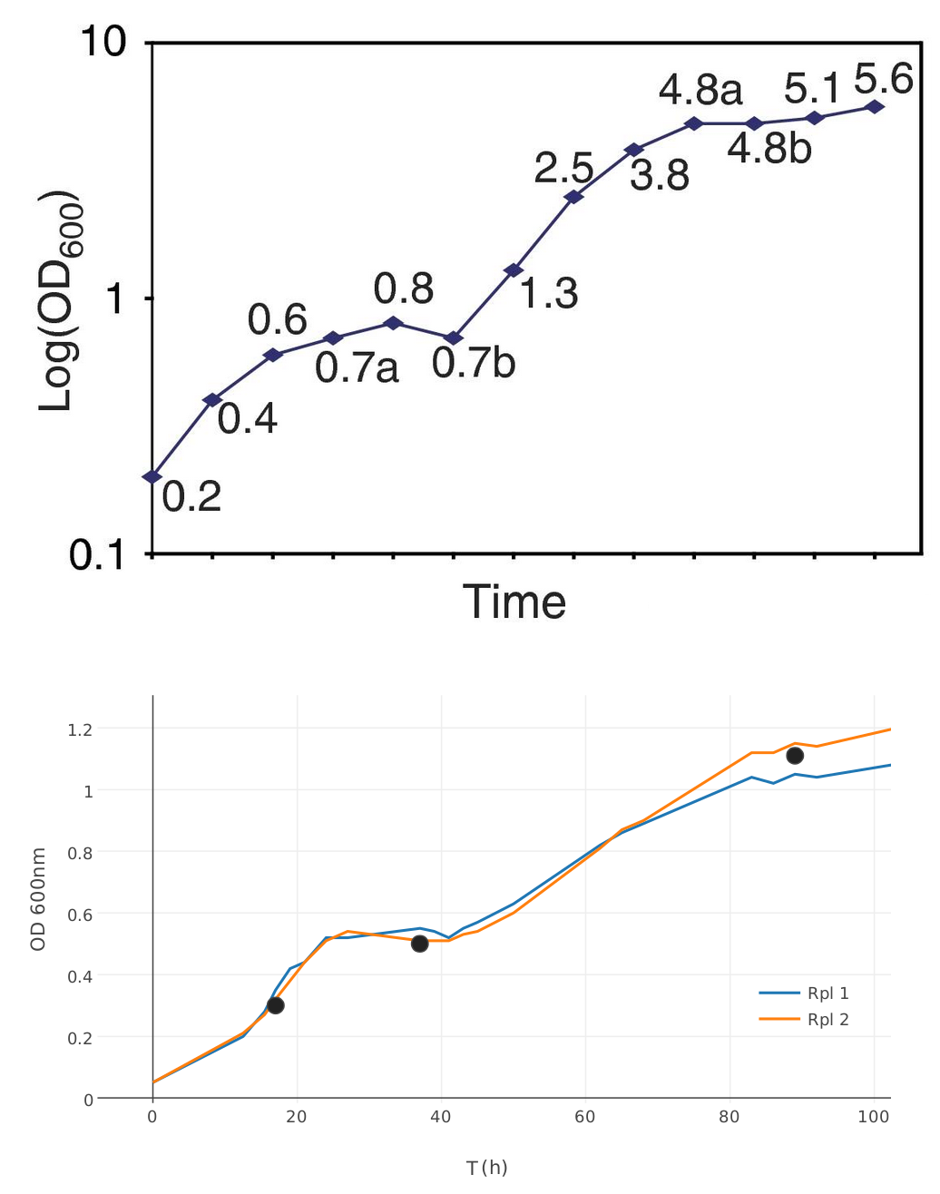

Supplemental Figure 01.

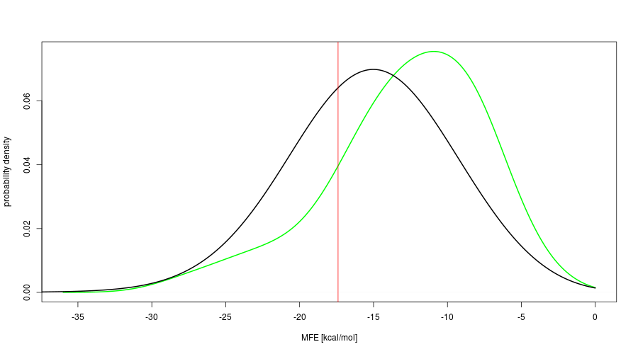
Supplemental Figure 02.

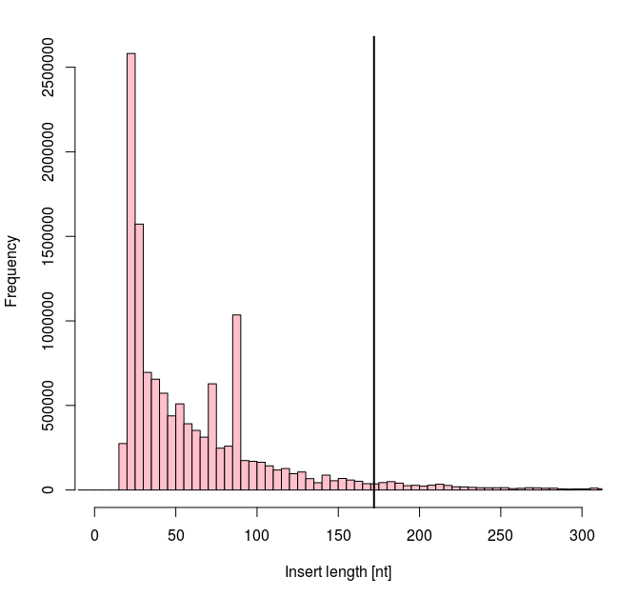
Supplemental Figure 03.

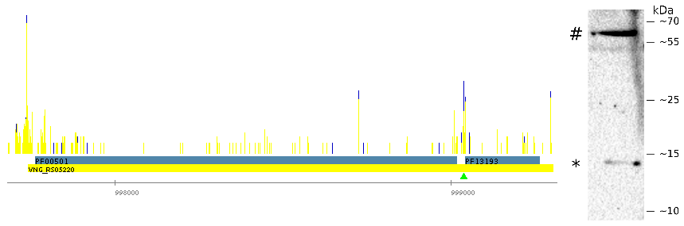
Supplemental Figure 04.

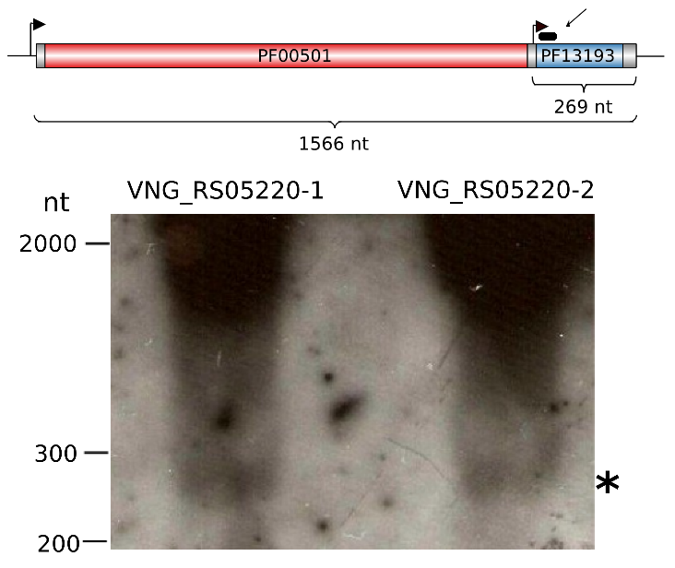

Supplemental Figure 05.

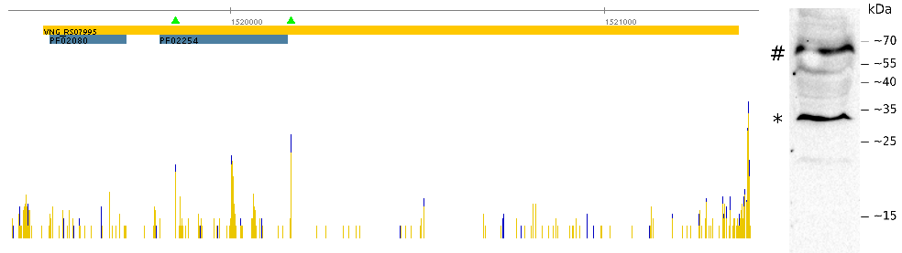
Supplemental Figure 06.

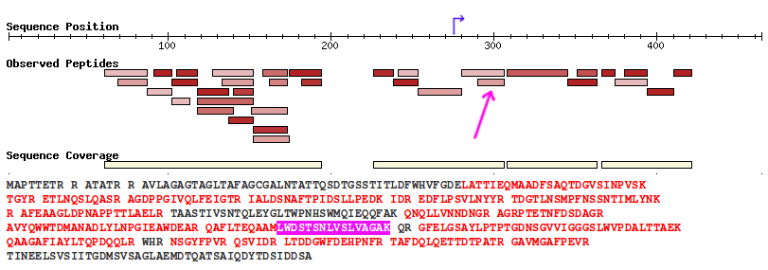
Supplemental Figure 07.

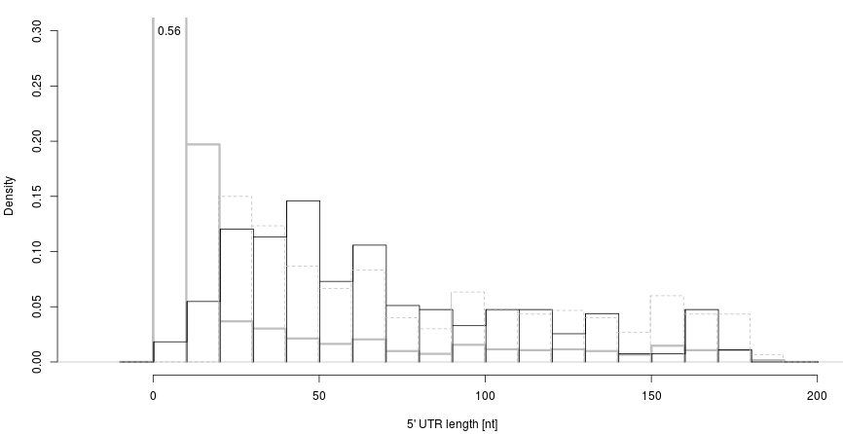
Supplemental Figure 08.

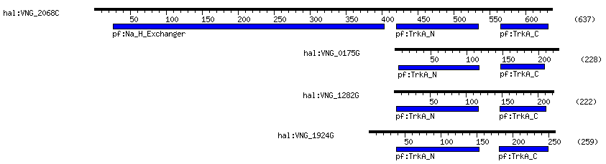
Supplemental Figure 09.

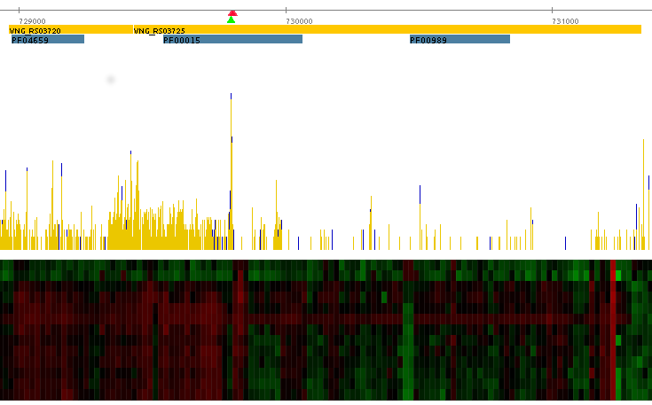
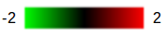
Supplemental Figure 10.

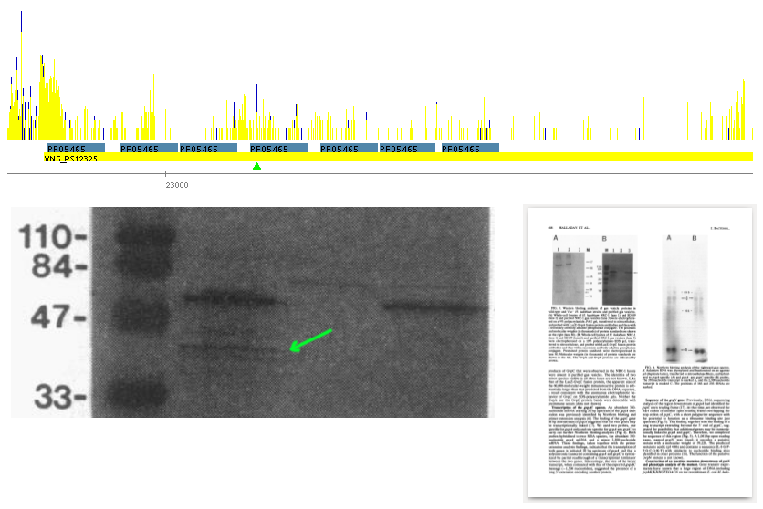
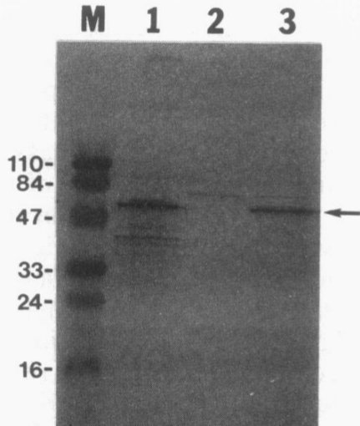

23147 **** * **
| 3'-aaucCUCCaCuAG (...) M N S T 3
uucuggcugcgauuGAGGcGcUCcgaacagagAUGaacucaacc 2
tCGcTAcagATATcgcagacaaacaagaTATcggcaatCttctggctgcgattGAGGcGcTCcgaacagagATGaactcaacc 1
| | | | | |
-30 -10 -1 -20 -9 0

Supplemental Figure 11.
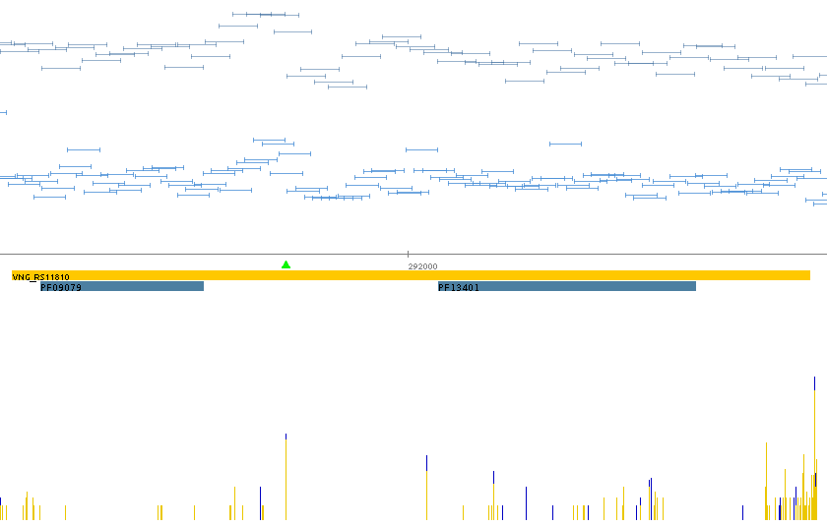
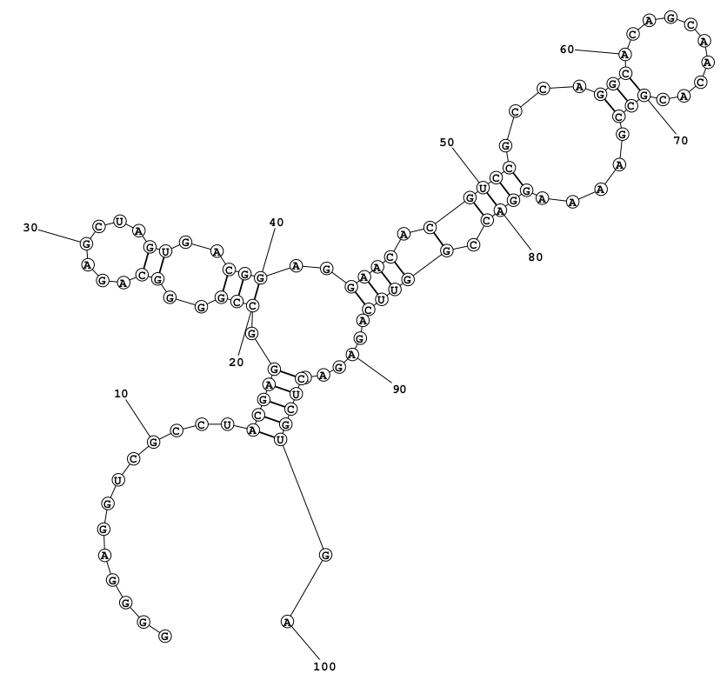
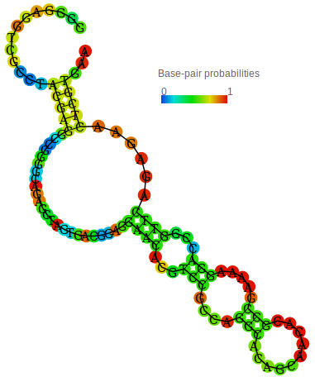

Supplemental Figure 12.

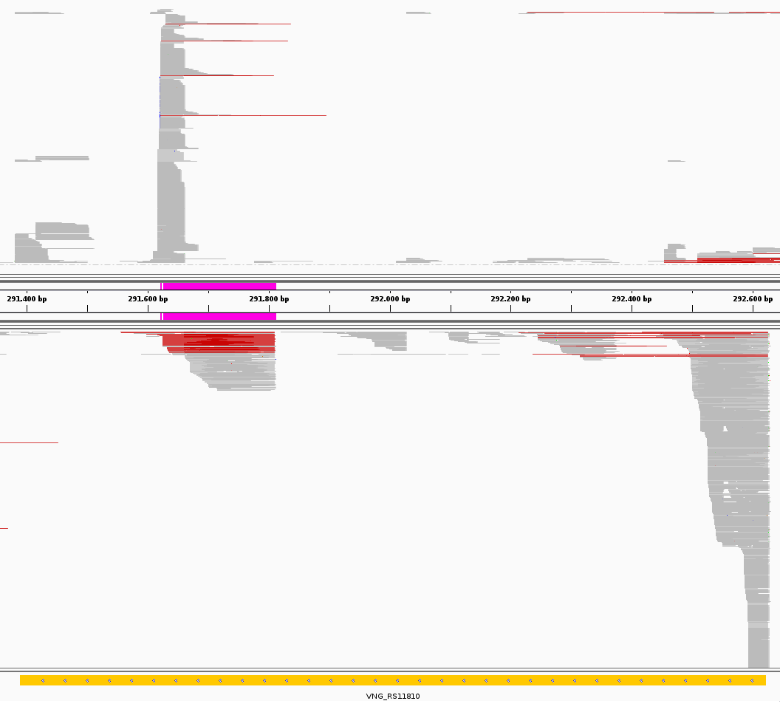
Supplemental Figure 13.

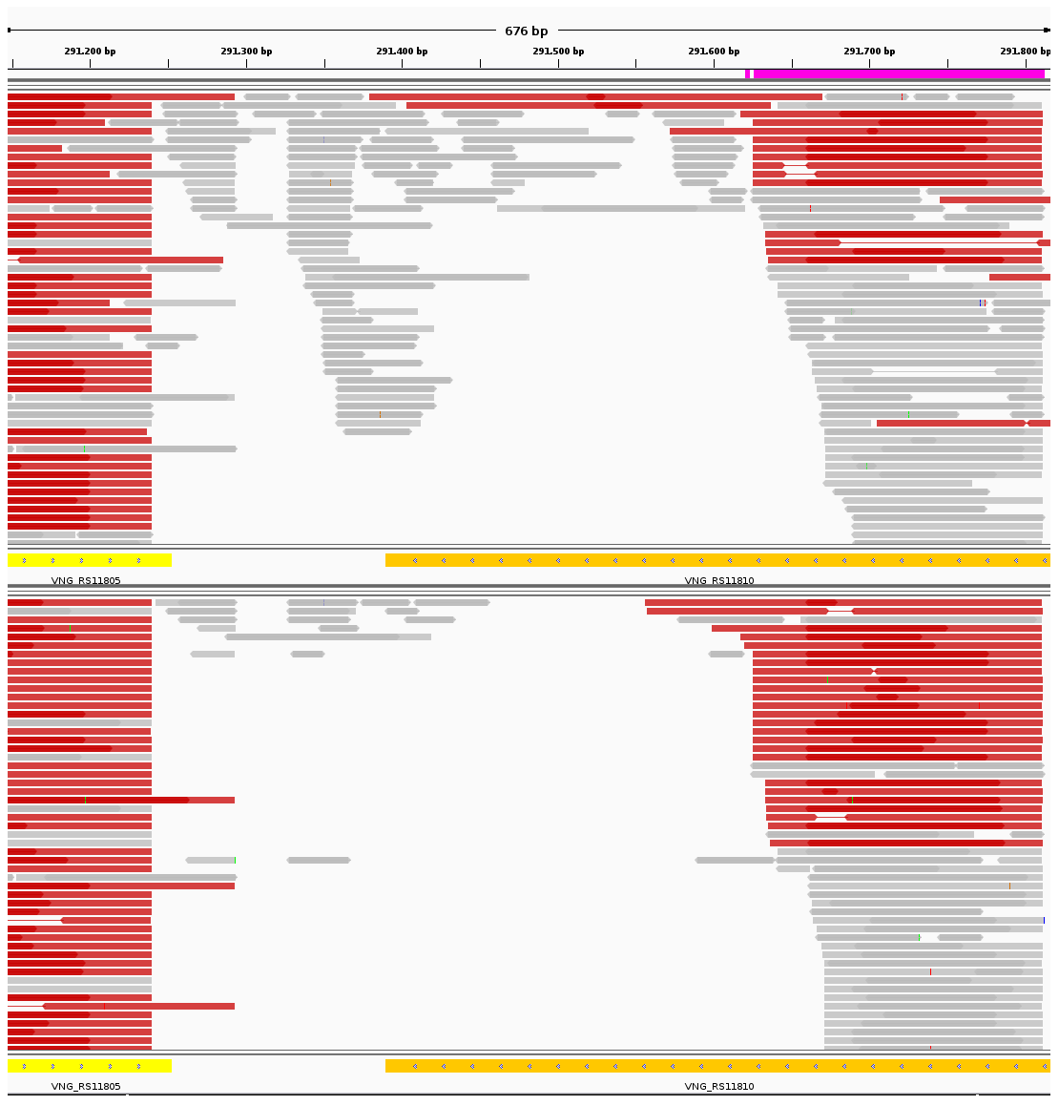
A
B

Supplemental Figure 14.

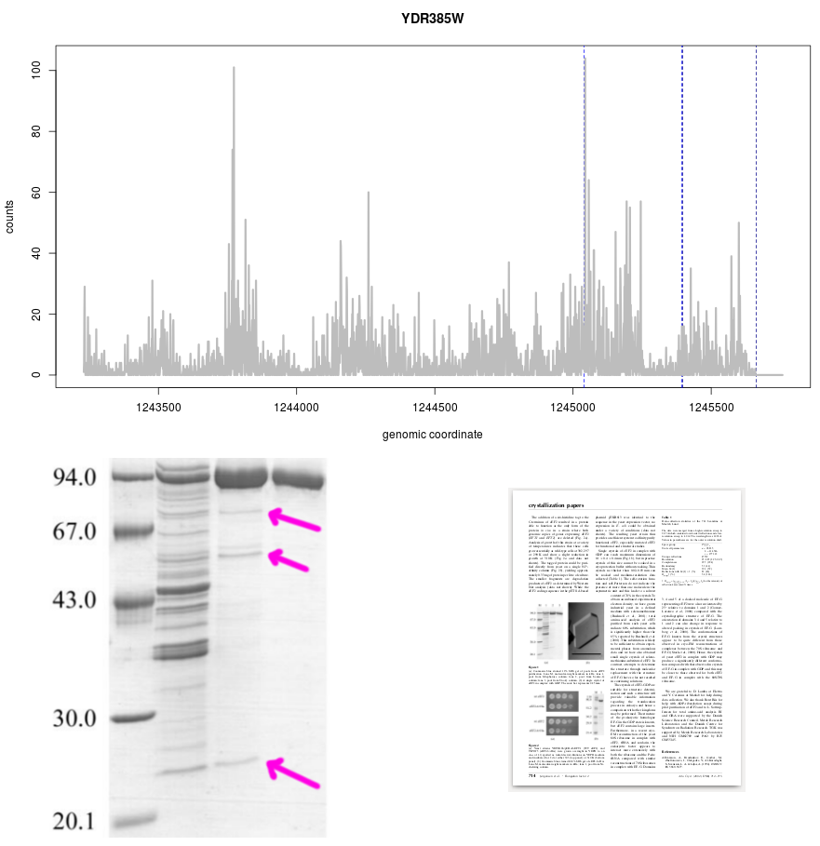
Supplemental Figure 15.

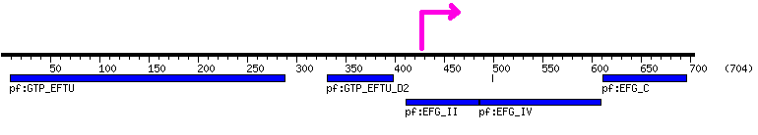
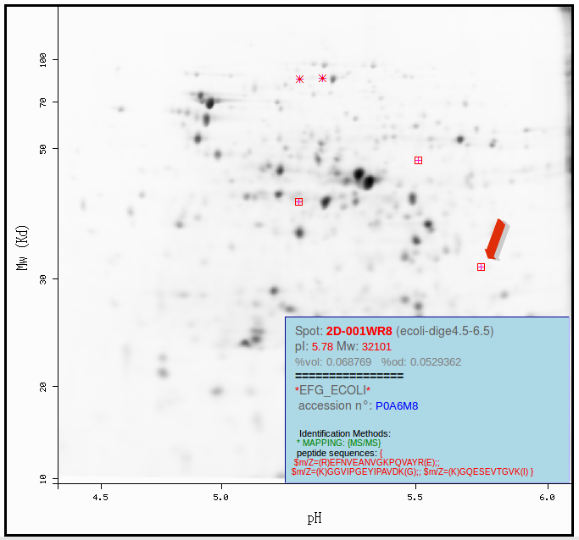

Supplemental Figure 16.

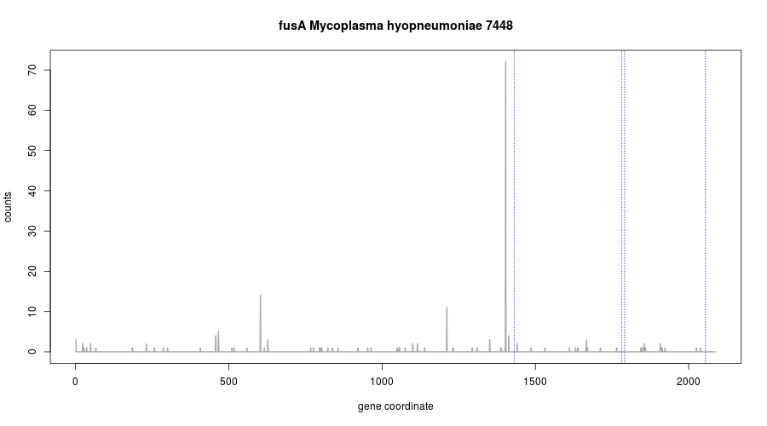
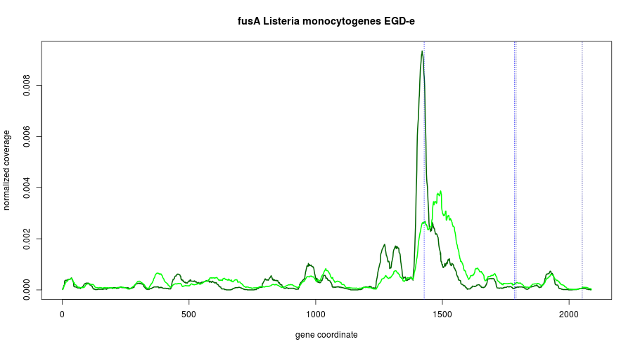
Supplemental Figure 17.

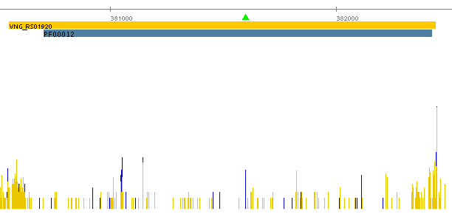

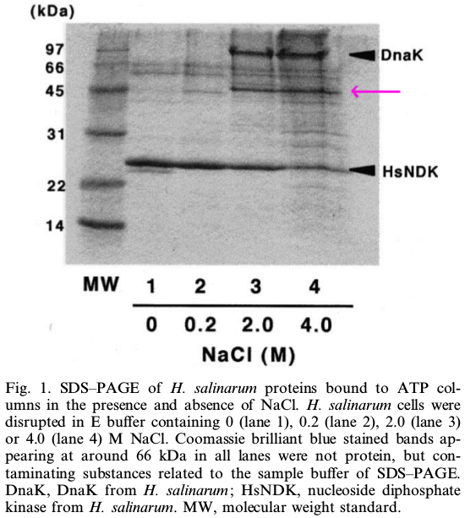
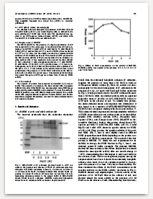

-21 0
16S tail 3'-AAUCCUCCACUAG|(…) |
intraRNA 5'-ACC(...)GACAUCGACGACGUGAUCCUCGUCGGCGGGUCCACGAGAAUGCCACAGGTCCAG 120
* ** ****** M P Q V Q 5

Supplemental Figure 18.
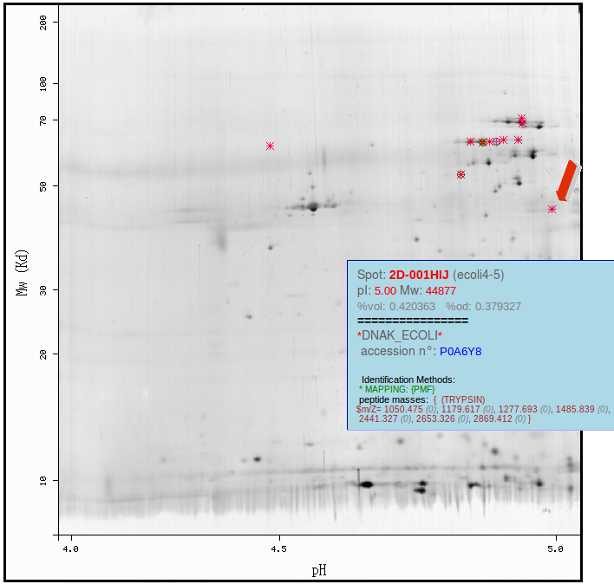
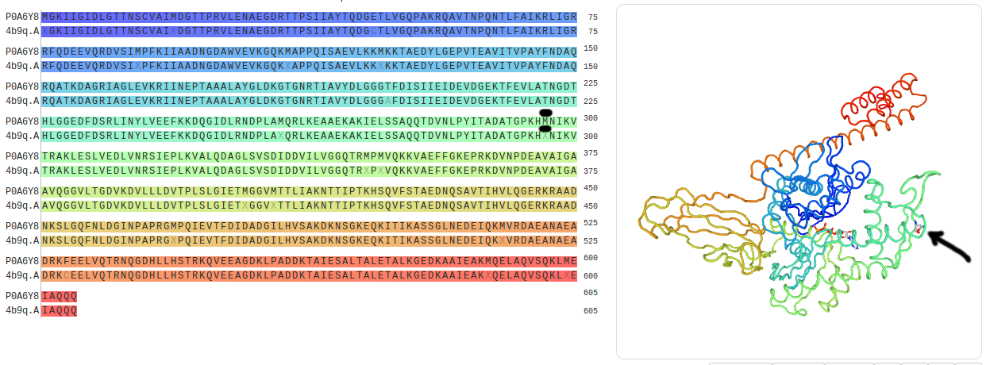
Supplemental Figure 19.
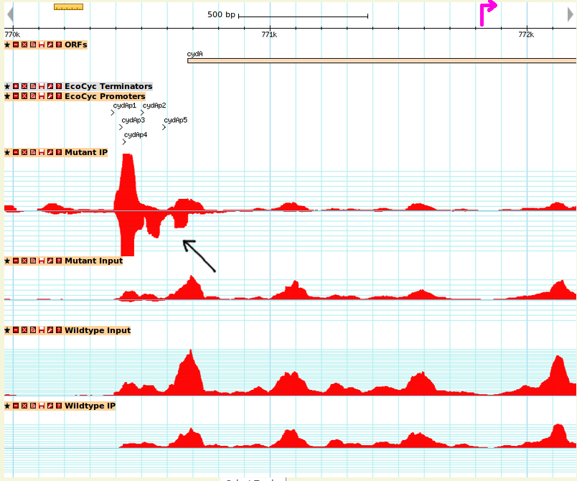

Supplemental Figure 20.

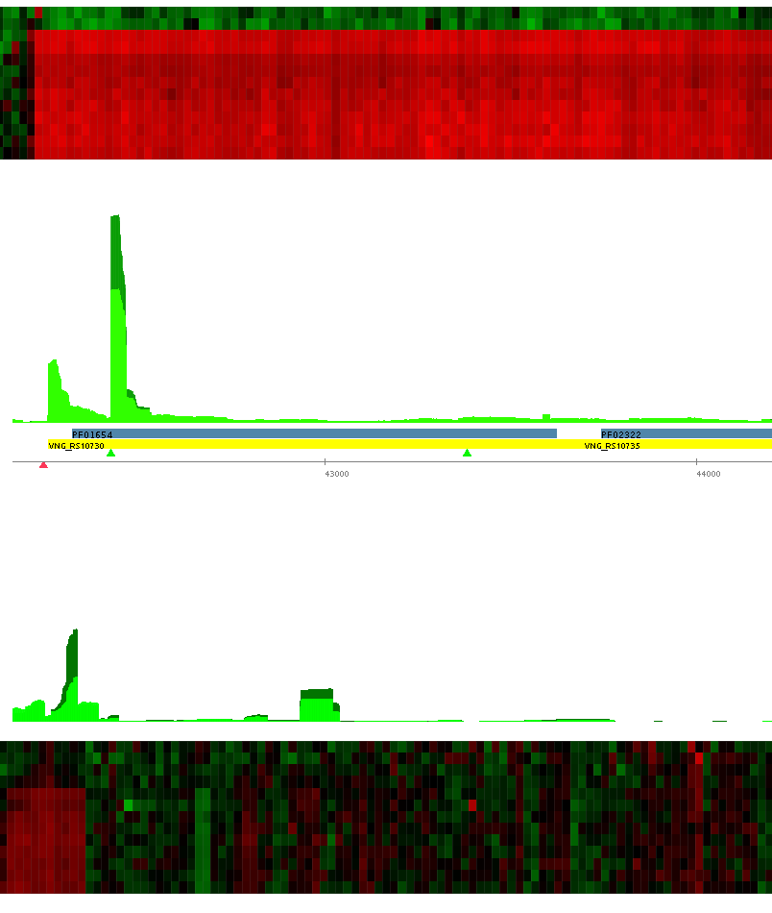
-15 0
16S tail 3'-AAUCCUCCACUAG| (…) |
intraRNA 5'-ACG(...)UCGUUUUGGGUGAAGGUGUUCGCCGUUGGCUUCGUGAUGGGAACGGUCACC 85
* ***** ** M G T V T 5

Supplemental Figure 21.
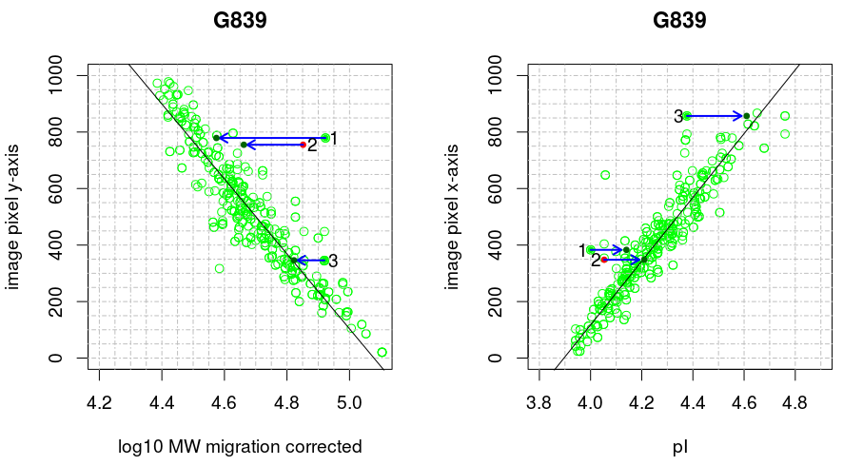
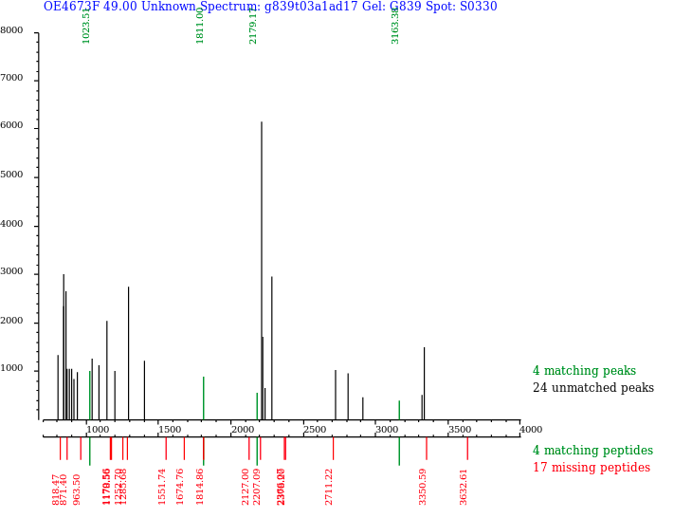

Supplemental Figure 22.

Supplemental Figures

Supplemental Figure 01.
Correspondence between dRNA-seq and tiling array growth curve sampling.
(A) Time-point samples (t₁ to t₁₃) used for tiling microarray differential expression analysis during the growth curve taken directly from Koide et al. (2009) Figure 1B ⁴. (B) Replicated time-point samples (3, black circles) used for dRNA-seq: middle of exponential phase (17h, OD₆₀₀  0.3), end of stationary phase (37h, OD₆₀₀  0.5) and gas vesicles release phase (86h, OD₆₀₀  1.1). Correspondence between datasets is: 17h ↔ t₂, 37h ↔ t₆, 86h ↔ t₁₁.

Supplemental Figure 02.
Filtering putative false positive iTSS due to structure forming sequences
Distribution (kernel smoothed) of minimum free energy (MFE) calculated for 51 nt long sequences tiled with 10 nt offset sliding window along the H. salinarum NRC-1 genome. Set comprising all genome is in black and the subset comprising sequences immediately downstream of statistically significant iTSS is in green. Quantile 33.3% cutoff (red vertical bar) obtained in all genome set was applied to the iTSS subset. Sequences with MFE below cutoff were filtered out as potential false positive intraRNAs.

Supplemental Figure 03.
Length distribution of TEX+ libraries inserts
Distribution of sequenced insert length inferred by paired-end reads. Treated libraries TEX+ were used in order to consider only putative primary RNAs. The 95% quantile is 173 nt (vertical black line).

Supplemental Figure 04.
IntraRNA translation validation for the acs3 gene.
(A) Distribution of relative numbers of aligned reads starting at a given genomic coordinate for TEX+ (blue) and TEX- (yellow) datasets (arbitrarily scaled log₂ of normalized counts). Vertical bars that present blue and yellow are superimposed counts at the same position. Coding sequence is in forward strand (yellow rectangle, locus ID inside, 5’→3’ direction is left to right). Domain annotation according to PFAM database is shown (blue rectangle, ID inside). Identified iTSS (green triangle) is TSS_2633_3. (B) Western blot of C-terminally FLAG-tagged Acs3 protein (# symbol) and isoform (* symbol). Original molecular weight markers cropped for clarity but depicted approximately at the right margin. Acs3 (57.0 kDa) corrected apparent MW is 58.0 kDa. Isoform (8.1 kDa) corrected apparent MW is 12.1 kDa.

Supplemental Figure 05.
Northern blot detection of cognate mRNA and intraRNA for the acs3 gene.
Northern blot detects mRNA and intraRNA for acs3 (VNG_RS05220). Upper panel shows VNG_RS05220 with its PFAM domains. The TSS mapped from dRNAseq experiments (black arrows) indicate a transcript of 1566 nt for acs3 mRNA and an intraRNA of 269 nt. Total RNA from two biological replicates (lanes VNG_RS05220-1 and VNG_RS05220-1) were run in 1.5% agarose gel and transferred to nylon membranes, crosslinked and hybridized with radioactive labeled probe. The probe position is indicated by a black line (probe sequence: 5’-GGCGGCGTCCGCGATGGCGTCGTGCTCGAACAGCAACTCC-3’). Signals corresponding to a ~1500 nt and ~270 nt were detected (indicated by *).

Supplemental Figure 06.
IntraRNA translation validation for the kef1 gene.
(A) Distribution of relative numbers of aligned reads starting at a given genomic coordinate for TEX+ (blue) and TEX- (yellow) datasets (arbitrarily scaled log₂ of normalized counts). Vertical bars that present blue and yellow are superimposed counts at the same position. Coding sequence is in reverse strand (orange rectangle, locus ID inside, 5’→3’ direction is right to left). Domain annotation according to PFAM database is shown (blue rectangle, ID inside). Identified iTSS (green triangles) are, from left to right, TSS_9086_3 and TSS_9088_3. (B) Western blot of C-terminally FLAG-tagged Kef1 protein (# symbol) and main isoform (* symbol) are highlighted. Original molecular weight markers cropped for clarity but depicted approximately at the right margin. Kef1 (64.7 kDa) corrected apparent MW is 67.1 kDa. Main isoform (23.4 kDa) corrected apparent MW is 31.1 kDa.

Supplemental Figure 07.
IntraRNA translation validation for the ugpB gene.
PeptideAtlas database graphical display returning all peptides mapped into ugpB locus (VNG_RS11500). The semi-tryptic peptide LWDSTSNLVSLVAGAK (PAp00368925, magenta arrow and highlight) is predicted to be translated from an intraRNA starting at TSS_11337_3 (blue arrow represented in the protein coordinate system). All theoretical trypsin cuts are shown along the UgpB sequence and observed peptides are marked in red.

Supplemental Figure 08.
5’ intraUTR length distribution.
Distribution of distances between transcription start sites (TSS) and translation initiation sites (TIS) for sample of annotated genes with identified gTSS (5’ UTR, solid grey) and intraRNAs (5’ intraUTR, black). Renormalized 5’ UTR set without leaderless (<10nt) cases (dashed grey) is plotted for overall comparison with the 5’ intraUTR set. The gTSS set is restricted to <173 nt for a normalized comparison with 5’ intraUTR, which, by definition, do not go beyond this threshold, thus the fraction of 0.56 leaderless genes instead of the overall 0.71 (see text).

Supplemental Figure 09.
Comparison among genes composed by the RCK domain and kef1.
Comparison among trkA1 (VNG_RS00720/VNG_0175G), trkA5 (VNG_RS05015/VNG_1282G), trkA6 (VNG_RS07475/VNG_1924G) and kef1 (VNG_RS07995/VNG_2068C) protein products (in scale). The regulator of K⁺ conductance domain (RCK) is composed by two sub-domains: TrkA_N (PF02254) and TrkA_C (PF02080).

Supplemental Figure 10.
intraRNA and cognate gene expression profile for htr15
Distribution of relative numbers of aligned reads starting at a given genomic coordinate for TEX+ (blue) and TEX- (yellow), arbitrarily scaled log₂ of normalized counts. Vertical bars that present blue and yellow are superimposed counts at the same position. Coding sequence in reverse strand (orange rectangle, 5’→3’ direction is right to left). Domain annotation (blue rectangle), identified iTSS (green triangle) and transcription factor binding sites (red triangles) are shown. Heat map shows tiling array expression profiles over the growth curve (time points are shown from top to bottom, Supplemental Figure 01) 4. VNG_RS03725 (htr15) and VNG_RS03720 (flaD) are in operon. Color scale shows log₂(time point / reference) from 4-fold down-regulated (green) to 4-fold up-regulated (red) symmetrical around 1:1 ratio (black).

Supplemental Figure 11
IntraRNA translation validation for the gvpC1 gene.
(A) Distribution of relative numbers of aligned reads starting at a given genomic coordinate for TEX+ (blue) and TEX- (yellow) datasets (arbitrarily scaled log₂ of normalized counts). Vertical bars that present blue and yellow are superimposed counts at the same position. Coding sequence in forward strand (yellow rectangle, locus ID inside, 5’→3’ direction is left to right). Domain annotation according to PFAM database is shown (blue rectangle, ID inside). Identified iTSS (green triangle) is TSS_13451_3. (B) Western blot of whole-cell lysates (lane 1), negative control (lane 2) and purified gas vesicles (lane 3) adapted from Halladay et al. 1993 ⁵³ Figure 3B. GvpC1 probed with antibodies raised against recombinant protein without tag. Zoom in, rotated MW guidelines and isoform highlight (magenta arrow) were made over the original published figure. Left margin vertical axis represents MW markers. GvpC1 (42.4 kDa) corrected apparent MW is 62.2 kDa. Putative isoform (29.4 kDa) corrected apparent MW is 43 kDa. (C) Probable regulatory elements in gvpC1 internal promoter region and putative ribosome binding site (BRE, red and green; TATA box, gray; PPE, black; pirymidine upstream TSS, dark blue; iTSS position, light green; RBS, cyan; TIS, magenta). Local genomic sequence (C1), RNA sequence (C2), 16S ribosome tail (C3) and first isoform amino-acid residues (C3), are schematically show for clarity. Ribosome and 5’ intraUTR complementarity are denoted by *.

Supplemental Figure 12.
iTSS validation for the orc4 gene.
(A) Replicated tiling array signal, arbitrarily scaled log₂ of normalized intensities (blue horizontal bars represent probes), were taken directly from Koide et al. (2009) ⁴ and shown above the genome ruler. Signal intensity shows an increase at the iTSS (green triangle) in independent preivous TEX free experiments. Below the genomic ruler is the distribution of relative numbers of aligned reads starting at a given genomic coordinate for TEX+ (blue) and TEX- (yellow) (arbitrarily scaled log₂ of normalized counts). Vertical bars that present blue and yellow are superimposed counts at the same position. Coding sequence is in reverse strand (orange rectangle, locus ID inside, 5’→3’ direction is right to left). Domain annotation according to PFAM database is shown (blue rectangle, ID inside). Identified iTSS (green triangle) is TSS_13093_3. (B) Two representative examples of predicted secondary structures obtained with different methods for the first 100 nt of the intraRNA: ProbablePair (https://rna.urmc.rochester.edu) base pairing probabilities >50% (left); RNAfold (http://rna.tbi.univie.ac.at) thermodynamic ensemble centroid, default parameters (right). The identified iTSS is not predicted to be involved in strong base pairing thus is probably not a dRNA-seq false positive.

Supplemental Figure 13.
Visual inspection of VNG_RS11810 locus (orc4 gene and antisense) paired-end reads.
Integrative Genomics Viewer visualization of paired-end reads for VNG_RS11810 locus (orc4 in reverse strand, orange rectangle). Read pairs (gray horizontal lines) are superimposed representing the locus to which they mapped onto and are split in reverse reads (below genomic ruler, orc4 orientation) and forward (above ruler, antisense orientation). Superimposed regions are in darker shades. Read pairs representing RNA inserts >173 nt long are highlighted in red. Region ranging from iTSS to intraRNA’s estimated end and predicted intraORF’s TIS (ATG start codon) are highlighted (long and small magenta rectangles, respectively).

Supplemental Figure 14.
Visual inspection of orc4 gene transcripts in TEX+ and TEX- libraries.
Integrative Genomics Viewer visualization of paired-end reads for the region between VNG_RS11810 (orc4) and VNG_11805 loci for TEX+ (A) and TEX- (B) datasets. Displayed region starts at iTSS and shows reverse strand data only. VNG_RS11810 (orange rectangle, 5’→3’ is right to left) and VNG_RS11805 (yellow rectangle, 5’→3’ is left to right) are zoomed in for clarity. Read pairs (gray rectangles) are superimposed representing the locus to which they mapped onto and superimposed regions are in darker shades. Read pairs representing RNA inserts >173 nt long are highlighted in red. Region ranging from iTSS to intraRNA’s estimated end and predicted intraORF’s TIS (ATG start codon) are highlighted (long and small magenta rectangles, respectively). Most reads mapped between VNG_RS11805’s end and intraRNA’s end vanished after TEX enzymatic treatment indicating probable processing origin.

Supplemental Figure 15.
IntraRNA translation of several putative EFT2 gene product isoforms in yeast.
(A) Distribution of aligned reads starting at a given genomic coordinate of Saccharomyces cerevisiae (PRJNA408327). Coding sequence in forward strand (YDR385W locus, 5’→3’ direction is left to right). Elongation factor IV and V domains boundaries are shown (blue and dark blue vertical dashed lines, respectively). The three highest counting peaks would translate isoforms of 24.9, 53.7 and 67.1 kDa (right to left). (B) Coomassie blue stained SDS gels of eEF-2 purification rounds from Jorgensen et al. 2002 ⁵⁸ Figure 1A. Left margin vertical axis indicates MW markers. Protein isoforms detected before last purification round (magenta arrows).

Supplemental Figure 16.
IntraRNA translation of fusA gene product isoforms in Escherichia coli K-12.
(A) Domain architecture of EF-G protein (b3340 locus) in Escherichia coli K-12 (blue rectangles, PFAM names below). RegulonDB iTSS is TSS_3889 and is 1 bp away from an ATG putative internal start codon (magenta arrow shown converted to protein coordinates). (B) SWISS-2DPAGE entry for EF-G protein showing an isoform signature: gel spots at unexpected pI and MW locations but confidently identified by its peptide contents via mass spectrometry. Predicted pI, MW and acidity-correct apparent MW for the intraRNA translated isoform are 5.79, 30.1 kDa and 32.7 kDa, respectively, consistent with the 2D-gel positioning.

Supplemental Figure 17.
IntraRNA overlapping fusA gene conserved in Mycoplasma hyopneumoniae 7448 and Listeria monocytogenes EGD-e.
(A) Distribution of aligned reads starting positions along internal fusA gene coordinate of Mycoplasma hyopneumoniae (PRJNA255516). (B) Normalized coverage along internal fusA gene coordinate of Listeria monocytogenes (PRJNA151809) for TAP+ (dark green) and TAP- (green). Elongation factor IV and V domains boundaries are shown (blue and dark blue vertical dashed lines, respectively).

Supplemental Figure 18.
IntraRNA translation validation for the dnaK gene in H. salinarum.
(A) Distribution of relative numbers of aligned reads starting at a given genomic coordinate for TEX+ (blue) and TEX- (yellow) datasets (arbitrarily scaled log₂ of normalized counts). Vertical bars that present blue and yellow are superimposed counts at the same position. Coding sequence in reverse strand (orange rectangle, locus ID inside, 5’→3’ direction is right to left). Domain annotation according to PFAM database is shown (blue rectangle, ID inside). Identified iTSS (green triangle) is TSS_6356_3. (B) SDS-PAGE gel adapted from Ishibashi et al. 2001 ⁶⁷ Figure 1. DnaK (67.4 kDa) corrected apparent MW is 88.9 kDa. Putative isoform (32.9 kDa) corrected apparent MW is 45.2 kDa. (C) Probable ribosome binding site (cyan) located in the 5’ intraUTR 21 nt upstream of the TIS (magenta). Local RNA sequence (up to 120 nt), 16S ribosome tail and first isoform amino-acid residues (up to 5), are schematically show for clarity. Ribosome and 5’ intraUTR complementarity are denoted by *.
Supplemental Figure 19.
IntraRNA translation validation for the dnaK gene in E. coli.
(A) Rainbow representation of DnaK sequence and 3D structure (PDB ID 4b9q) from SWISS-MODEL database (violet to red is N- to C-terminal). Isoform sequence initial methionine is pointed in black (arrow and highlight). (B) SWISS-2DPAGE entry for DnaK/Hsp70 (69.1 kDa, corrected: 78.1 kDa) protein showing an isoform signature: gel spots at unexpected pI and MW locations but confidently identified by its peptide contents via mass spectrometry. Predicted pI, MW and acidity-correct apparent MW for the intraRNA translated isoform are 4.84, 37.0 kDa and 42.6 kDa, respectively, consistent with the 2D-gel positioning.

Supplemental Figure 20.
mRNA/asRNA interaction inferred by dsRNA-seq for the cydA gene in E. coli.
Coverage signal along cydA gene’s 5’ UTR and CDS initial portion directly from http://alu.abc.univie.ac.at/fgb2_public/gbrowse/dsrna/ browser interface ⁷¹. Tracks are, from top to bottom: genomic ruler; CDS (5’→3’ is left to right); five known promoters; coverage map of total RNA (input) and immunoprecipitated double-stranded RNA (IP) from wild type (WT) and RNase III mutant strains. Counts are shown in different y-axis scales and forward and reverse strands are always shown on top and on the bottom, respectively. Black arrow indicates evidence of 5’UTR/asRNA interaction. The iTSS (magenta arrow) is TSS_873.

Supplemental Figure 21.
Expression patterns of cydA and asRNA in H. salinarum.
(A) Heat map shows tiling array expression profiles over the growth curve (time points are shown from top to bottom, Supplemental Figure 01) ⁴. (B) Aligned reads coverage along genomic coordinates for TEX+ (dark green) and TEX- (green) (arbitrarily scaled and normalized). Coding sequence in forward strand (yellow rectangle, 5’→3’ direction is left to right). Domain annotation (blue rectangle), identified iTSS (green triangle) and transcription factor binding sites (red triangles) are shown. Forward and reverse signals are shown above and below horizontal genomic ruler axis, respectively. (C) RBS (cyan) between iTSS and TIS, 16S ribosome tail and first amino-acid residues of intraRNA translated isoform.

Supplemental Figure 22.
Correction of “outlier” HaloLex 2D-gel spots for citB, cxp, and rpoB2 considering intraRNA translated isoforms.
(A left) Scatter plot of apparent acidity-correct MW vs vertical pixel coordinate in 2D-gel image G839. The y-axis coordinate system in images is from top to down, therefore, lighter proteins show up on image bottom with higher pixel coordinates. (A right) Scatter plot of isoelectric point vs pixel coordinate in 2D-gel image G839. The linear fit (black diagonal trace) considered only spots classified as “reliable” in HaloLex database (light green points). Highlighted “outlier” points are proteins encoded from genes: citB (OE4613F locus, which encodes for an aconitate hydratase) (arrow 1); cxp (OE4673F, carboxypeptidase M32) (arrow 2); and rpoB2 (OE4742R, RNA polymerase subunit B’’) (arrow 3). The blue arrows denote the re-assignment of nominal acidity-correct MW when considering isoforms instead of cognate proteins. Cxp protein was not part of the line fitting since it is not a “reliable” identification in HaloLex database ⁷³, but rather have “unknown spectrum” status (solid red). (B) Fingerprint peptide spectrum from Cxp spot. The relative low number of fingerprint peptides used to identify Cpx leads to an “unknown spectrum” status but is compatible with a truncated isoform. All 4 peptide masses are compatible with tryptic peptides from Cxp’s portion predicted to be part of the isoform. All three genes are not “outliers” anymore if MW and pI are re-assigned to isoform MW and pI.

Supplemental Tables

Supplemental Table 01: Halobacterium salinarum NRC-1 gene annotation used in this work and Transcription Start Sites (TSS) mapped

Supplemental Table 02: Internal transcription start sites (iTSS) in Halobacterium salinarum NRC-1

Supplemental Table 03: Genes that present internal transcription start sites (iTSS) in Halobacterium salinarum NRC-1

Supplemental Table 04: Internal open reading frames (intraORFs) in Halobacterium salinarum NRC-1

Supplemental Table 05: 5’ intraUTR sequences containing Shine-Dalgarno-like signatures

Supplemental Table 06: PFAM domains architecture comparison between intraORFs and CDS

Supplemental Table 07: Genes that present sec signal in Halobacterium salinarum NRC-1

Supplementary Table 08: internal RNAs that present transcription factor binding sites mapped from ChIP-Seq experiments in the upstream region

Supplemental Table 09: Heat-map indicating differential expression of intraRNAs and cognate genes over the growth curve

Supplemental Table 10: TSS identification in other archaea. Publicly available dRNA-seq data were analyzed using TSSAR for Haloferax volcanii DS2, Thermococcus onnurineus NA1, Thermococcus kodakarensis KOD1 and Methanocaldococcus jannaschii DSM 2661

Supplemental Table 11: Summary of all genes considered.

