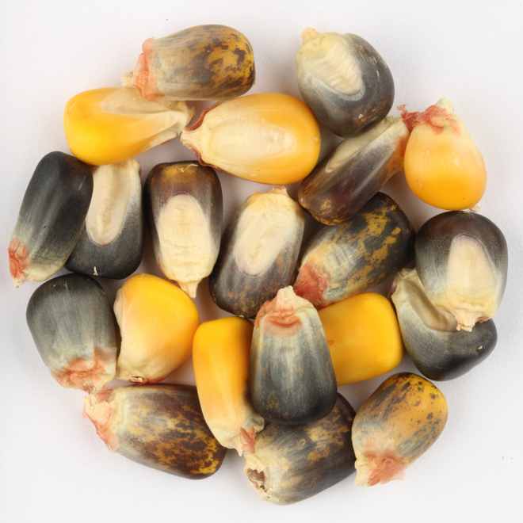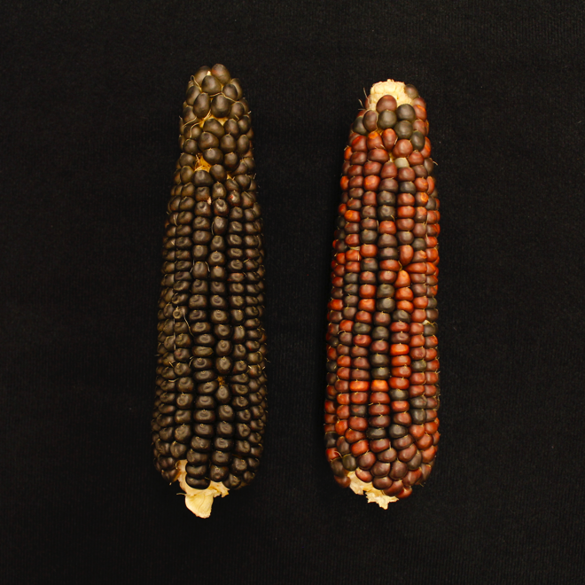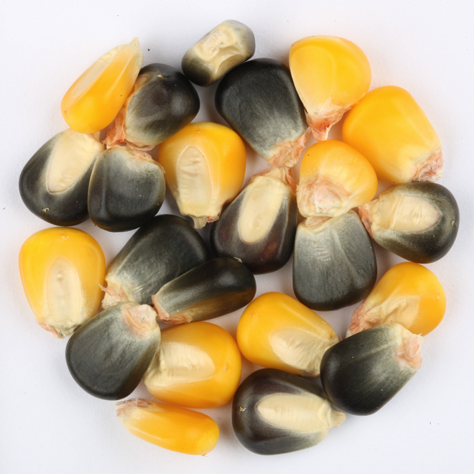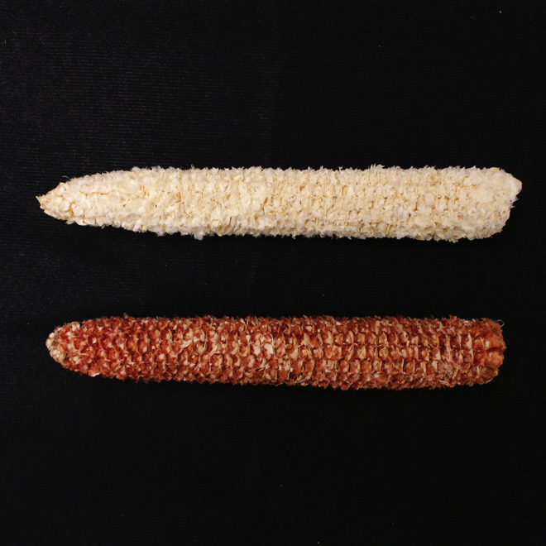
A
D
C
B
Figure S1: Phenotypes segregating in the mapping population. A) Cobs segregating for alleles at the Pericarp1 locus: P1-ww (top, white) and P1-wr (bottom, red). B) Pigmented ears segregating for Intensifier1 alleles in a recessive purple aleurone1 background. Top: fully recessive intensifier1 displaying enhanced aleurone pigmentation. Bottom: Mendelian segregation of Intensifier1 alleles displaying ¼ enhanced pigmentation. C) Kernels segregating at the Colorless1 locus. D) Kernels segregating at the R1 locus displaying the speckled kernel phenotype.

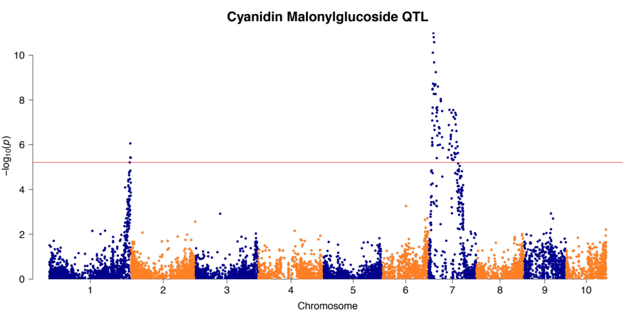
Figure S2: Manhattan plot for anthocyanin compound cyanidin 3-(6''-malonyl) glucoside. Here, significant QTL for in1 and the acyltransferase candidate could be distinguished at a Bonferroni significance threshold of p<6.203×10⁻⁶.

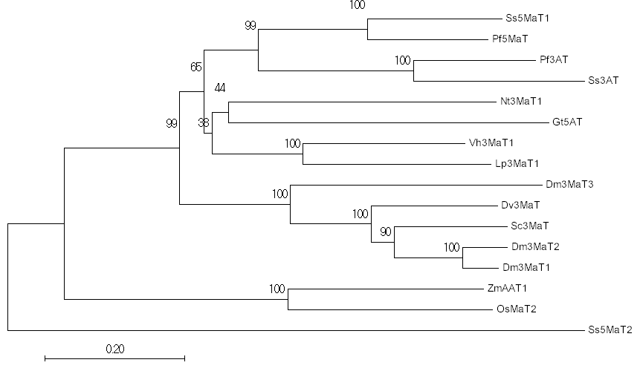Figure S3: Phylogenetic tree of flavonoid acyltransferases. Neighbor-Joining phylogenetic tree of S. splendens 5MaT1 (AAL50566.1), P. frutescens 5MaT (AAL50565.1), P. frutescens 3AT (Q9MBC1.1), S. splendens 3AT (AAR28757.1), N. tabacum 3MaT1 (BAD93691.1), V. hybrida 3MaT1 (AAS77402.1), L. purpureum 3MaT1 (AAS77404.1), G. trifolium 5AT (BAA74428.1), D.× morifolium 3MaT3 (BAF50706.1), D. variabilis 3MaT (Q8GSN8.1), S. cruentus 3MaT (AAO38058.1), D.× morifolium 3MaT2 (AAQ63616.1), D.× morifolium 3MaT1 (AAQ63615.1), Z. mays AAT1 (NP_001148286.2), O. sativa (NP_001046855.1), and S. splendens 5MaT2 (AAR26385.1) (Saitou and Nei 1987). The bootstrap consensus tree inferred from 10,000 replicates is drawn to scale, with branch lengths in the same units as those of the evolutionary distances used to infer the phylogenetic tree. The percentage of replicate trees in which the associated taxa clustered together in the bootstrap test are shown next to the branches (Felsenstein 1985). The evolutionary distances were computed using the Poisson correction method and are in the units of the number of amino acid substitutions per site (Zuckerkandl and Pauling 1965). Fewer than 25% alignment gaps, missing data, and ambiguous bases were allowed at any position. There were a total of 437 positions in the final dataset. Evolutionary analyses were conducted in MEGA7 (Kumar et al. 2016).

