The Effect of Barium-Promoted for Microsphere Ru/CeO₂ Catalysts in Ammonia Synthesis
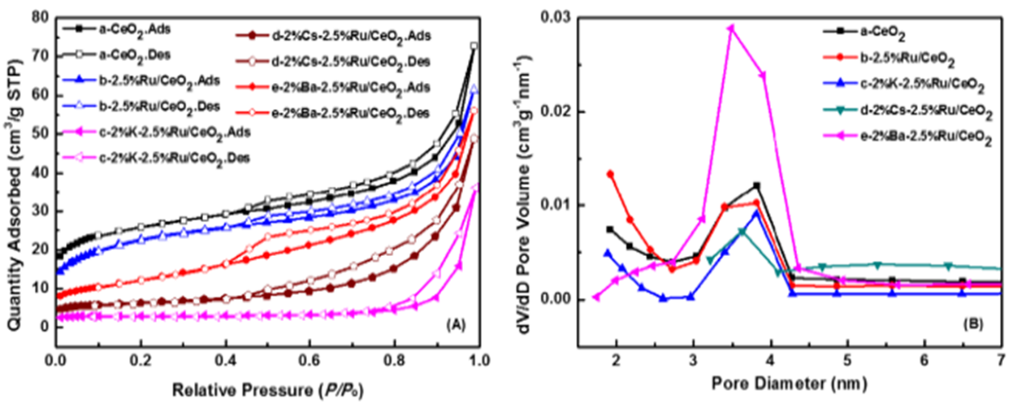
Figure S1. Nitrogen adsorption/desorption isotherms (A) and pore size distribution curves (B) for CeO₂-MS, 2.5%Ru/CeO₂ and 2%M-2.5% Ru /CeO₂ catalysts.
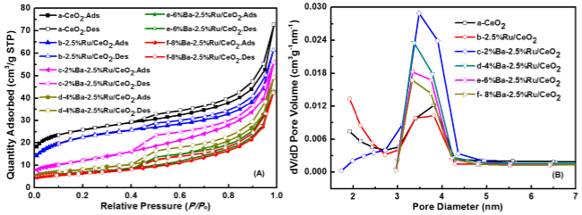
Figure S2. Nitrogen adsorption/desorption isotherms (a) and pore size distribution curves (b) for CeO₂-MS, 2.5%Ru/CeO₂-MS and X%Ba-2.5%Ru/CeO₂-MS catalysts.
Figure S3. Catalytic activity curves of the 2.5%Ru/CeO₂-MS and the X%Ba 2.5%Ru/CeO₂-MS（X=2/4/6/8）catalysts under 3.8 MPa, 375-450 ℃, 60 mL·min⁻¹ (H₂/N₂=3)

