Supplemental Information

Effect of venting range hood flow rate on size-resolved ultrafine particle concentrations from gas stove cooking

Liu Sunª, Lance A. Wallace^{b}, Nina A. Dobbinª, Hongyu Youª, Ryan Kulkaª, Tim Shinª, Melissa St-Jeanª, Daniel Aubin^{c}, Brett C. Singer^{d}
ª Air Health Science Division, Water and Air Quality Bureau, Health Canada, Ottawa, ON, Canada
^{b} Consultant, Santa Rosa, CA, USA
^{c} Indoor Air Quality Group, NRC Construction Research Centre, National Research Council Canada, Ottawa, ON, Canada
^{d} Indoor Environment Group, Energy Technologies Area, Lawrence Berkeley National Laboratory, Berkeley, CA, USA

Corresponding author
Liu Sun
269 Laurier Ave. West, 4903 C, Ottawa
Ontario, Canada, K1A0K9
Phone: +1 613-941-0316
Email: liu.sun@canada.ca

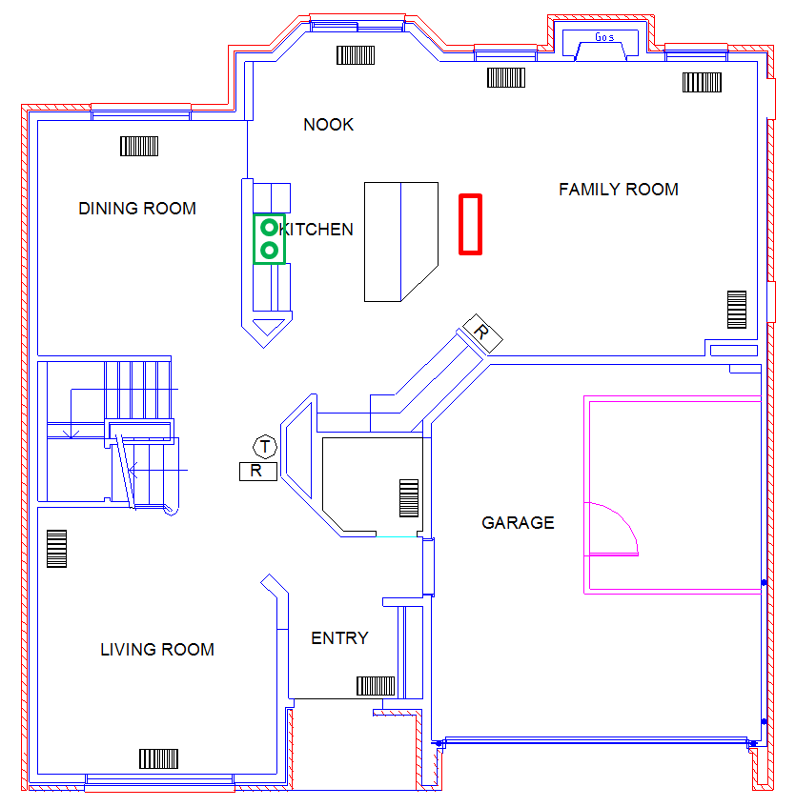
Figure S1. Floorplan of the main floor of both test homes. The location of the gas stove and range hood is indicated by the green rectangle. The monitoring equipment was placed on a table next to the kitchen island, indicated by the red rectangle, about three meters away from the gas stove.

Calculation of volume flow rate

Experimental volume flow rate was calculated as:
${ F}_{experiment}= α v$ [S1]
where $F_{experiment}$ is the experimental volume flow rate (m³/h), $α$ is the measured air exchange rate (h⁻¹) and $v$ is the mixing volume (m³).

The volume flow rate calculated using the LBL method (Sherman 1992):
$F_{LBL}=\sqrt{{(α_{inf}v)}^{2}+{(F_{fan})}^{2}}$ [S2]
where $α_{inf}$ is the house infiltration rate (h⁻¹), and $F_{fan}$ is the range hood air flow rate (m³/h).

The volume flow rate calculated using the Palmiter and Bond method (Palmiter and Bond 1991):
$F_{Palmiter}= \left\{\begin{aligned} F_{fan } if F_{fan}≥2 α_{inf}v \\ \frac{F_{fan}}{2}+α_{inf}v if F_{fan}<2 α_{inf}v\end{aligned}\right.$ [S3]

Table S1. Summary statistics for air exchange rates associated with different venting range hood flow rates, measured under Fan Always On test condition.
Flow rate (L/s) | Mean (h⁻¹) | SE (h⁻¹) | N
36 | 0.72 | 0.33 | 2
69 | 1.46 | 0.11 | 4
75 | 0.99 | 0.11 | 7
84 | 1.30 | 0.15 | 8
120 | 2.03 | 0.23 | 8
146 | 2.30 | 0.23 | 7

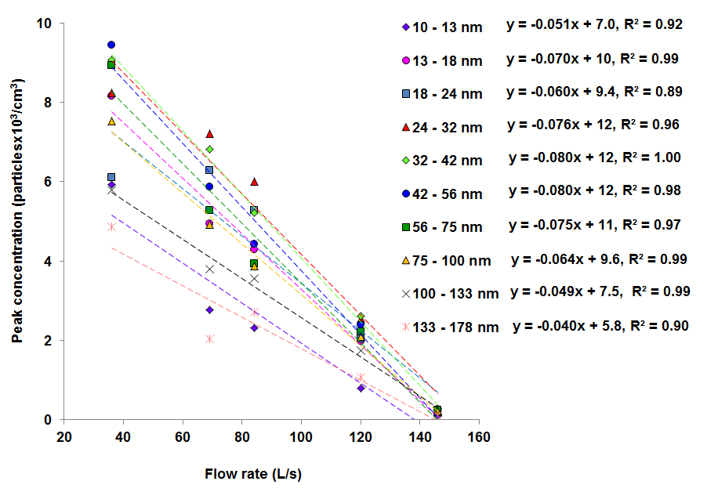
Figure S2. Linear regression of particle peak concentration against range hood flow rate (excluding range hood A at 75 L/s) by particle size category.

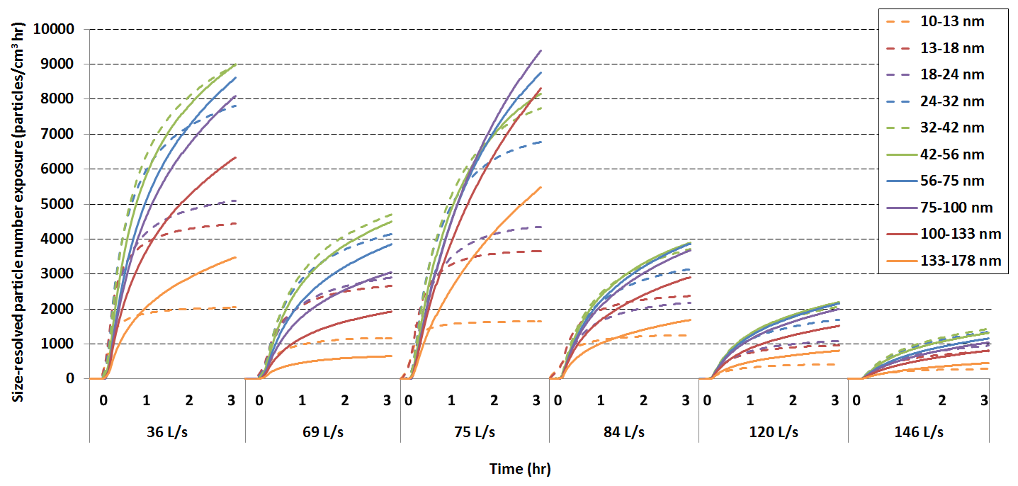
Figure S3. Size-resolved particle number exposures due to cooking over the entire monitoring period, measured under Fan Off After Cooking test condition. The x-axis represents the time relative to the end of cooking by range hood flow rate.

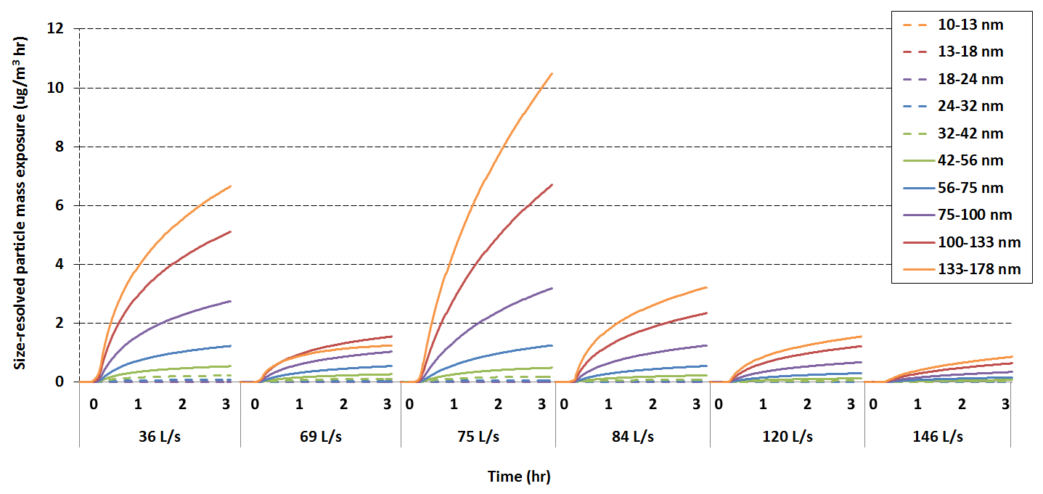
Figure S4. Size-resolved particle mass exposures due to cooking over the entire monitoring period, measured under Fan Off After Cooking test condition. The x-axis represents the time relative to the end of cooking by range hood flow rate.

Table S2. Percent contribution of background to total exposure for each hour after cooking, measured under Fan Off After Cooking test condition.
Time of exposure | E_{b} to E_{t} (%)
 | 36 L/s |  | 69 L/s |  | 75 L/s |  | 84 L/s |  | 120 L/s |  | 146 L/s
 | Mean | SE | Mean | SE | Mean | SE | Mean | SE | Mean | SE | Mean | SE
1st hr | 4.37 | 1.26 | 7.05 | 1.10 | 8.52 | 4.17 | 6.22 | 1.28 | 10.58 | 1.35 | 5.75 | 2.45
2nd hr | 13.93 | 4.16 | 18.59 | 2.52 | 20.34 | 9.78 | 17.40 | 3.73 | 24.86 | 3.17 | 12.21 | 3.86
3rd hr | 22.39 | 6.54 | 29.76 | 4.15 | 21.66 | 19.96 | 27.45 | 5.82 | 35.97 | 4.36 | 18.53 | 5.30

Decay and Deposition Rates
Measured decay rates (a+k) and estimated deposition rates (k) are presented in Tables S3 and S4. The deposition rates are compared with previous studies in Figure S5. The experimental conditions of the studies are summarized in Table S5.

All studies agree that the deposition of particles is a function of particle size; however, the log-linear slopes of regression lines in this study ranged from -0.5 to -0.3, which was smaller than the range (-1.1 to -0.8) found in other studies. The causes of this variability are not yet well understood. In studies by Wallace et al. (2004), Rim et al. (2012) and Lee et al. (2014), deposition was a dominated removal mechanism compared to particle loss due to air exchange. In this study, the loss of particles due to air exchange was more significant than deposition during the operation of a venting range hood. Probably due to this effect, the difference in deposition rates across particle size was reduced.

Despite the differences, the deposition rates found in this study (0.34 to 2.67 h⁻¹) were within the range of values reported by other studies. Wallace et al. (2004) studied the effect of central fans and in-duct filters on deposition rates of ultrafine and submicrometer particles in an occupied townhouse. They found the use of central fan with no filter or with a standard furnace filter increased particle deposition rates by 0.1—0.5 h⁻¹ compared with central fan off conditions. In that study, the deposition rates decreased as particle size increased, from 4.1 h⁻¹ for 12 nm particles to 0.57 h⁻¹ for 100 nm particles. Their results were very close to those found by Benes and Holub (1996), who studied the plate-out of the radon daughter ²¹⁸Po in mines, both theoretically and experimentally. For the theoretical approach, they considered a bulk volume and a boundary layer with a fractal surface, selecting a Koch curve as the boundary. Thus they extended previous work from smooth to rough surfaces. For the experimental work, they employed a chamber of 3.865 m³ and measured particle deposition rates in the 1-300 nm size range (Holub 1984). For UFP, the deposition rates decreased from 97.2 h⁻¹ for 1 nm particles to 0.72 h⁻¹ for 100 nm particles. Rim et al. (2012) estimated the deposition rates of particles (5-100 nm) with the central fan operating, which included particle losses to the furnace filter and to the ductwork as well as to interior surfaces. The deposition rates decreased from 2.8 h⁻¹ for 5 nm particles to 0.3 h⁻¹ for 100 nm particles. Lee et al. (2014) estimated the deposition of size-resolved ultrafine and submicrometer particles in a well-mixed residential environment. For UFP, the average deposition rates across three ventilation conditions decreased from 4.75 h⁻¹ (< 20 nm) to 1.24 h⁻¹ (80-100 nm). The results in Lee et al. study were higher than those from the others, possibly because of the effects of enhanced air mixing using portable fans.

Table S3. Summary statistics for size-resolved and total UFP decay rates (k+α) associated with different range hood flow rates, measured under Fan Always On test condition (only decay rates with linear regression R²>0.9 were included). N is the number of tests.
Particle diameter (nm) | Decay rate (h⁻¹)
 | Fan Off |  |  | 36 L/s |  |  | 69 L/s |  |  | 75 L/s |  |  | 84 L/s |  |  | 120 L/s |  |  | 146 L/s
 | Mean | SE | N | Mean | SE | N | Mean | SE | N | Mean | SE | N | Mean | SE | N | Mean | SE | N | Mean | SE | N
10 - 13 | 2.24 | 0.11 | 16 | 2.97 | 0.22 | 4 | 3.18 | 0.24 | 4 | 3.67 | 0.88 | 3 | 3.46 | 0.21 | 5 | 3.96 | 0.19 | 4 | 4.53 | - | 1
13 - 18 | 1.89 | 0.09 | 26 | 2.71 | 0.24 | 4 | 3.07 | 0.14 | 4 | 2.84 | 0.32 | 3 | 3.36 | 0.15 | 5 | 3.90 | 0.29 | 5 | 4.03 | 0.11 | 2
18 - 24 | 1.71 | 0.07 | 24 | 2.39 | 0.22 | 4 | 2.89 | 0.19 | 4 | 2.27 | 0.21 | 3 | 3.12 | 0.17 | 5 | 3.54 | 0.15 | 5 | 3.99 | - | 1
24 - 32 | 1.49 | 0.05 | 25 | 2.32 | 0.28 | 3 | 2.60 | 0.24 | 4 | 1.85 | 0.16 | 3 | 2.88 | 0.18 | 5 | 3.37 | 0.18 | 5 | 3.98 | - | 1
32 - 42 | 1.34 | 0.04 | 25 | 2.11 | 0.21 | 4 | 2.38 | 0.27 | 4 | 1.62 | 0.18 | 3 | 2.74 | 0.17 | 5 | 3.23 | 0.23 | 4 | 3.75 | 0.58 | 2
42 - 56 | 1.20 | 0.04 | 26 | 2.02 | 0.22 | 4 | 2.25 | 0.31 | 4 | 1.33 | 0.15 | 3 | 2.61 | 0.18 | 5 | 3.24 | 0.29 | 4 | 3.77 | 0.44 | 2
56 - 75 | 1.10 | 0.04 | 24 | 1.90 | 0.23 | 4 | 2.18 | 0.28 | 4 | 1.11 | 0.12 | 3 | 2.48 | 0.16 | 5 | 3.05 | 0.26 | 4 | 3.39 | 0.05 | 2
75 - 100 | 1.03 | 0.04 | 21 | 1.89 | 0.26 | 4 | 2.14 | 0.30 | 3 | 1.09 | 0.17 | 3 | 2.50 | 0.18 | 5 | 2.91 | 0.33 | 4 | 3.37 | 0.03 | 2
100 - 133 | 1.04 | 0.05 | 13 | 2.11 | 0.14 | 3 | 2.39 | 0.23 | 4 | 1.05 | 0.11 | 3 | 2.60 | 0.19 | 5 | 3.10 | 0.35 | 4 | 3.64 | 0.03 | 2
133 - 178 | 1.06 | 0.09 | 8 | 2.32 | 0.17 | 3 | 2.53 | 0.29 | 3 | 1.12 | 0.17 | 3 | 2.89 | 0.20 | 4 | 3.35 | - | 1 | - | - | 0
total particles | 1.20 | 0.03 | 23 | 2.21 | 0.13 | 4 | 2.43 | 0.23 | 4 | 1.38 | 0.09 | 3 | 2.64 | 0.17 | 5 | 3.12 | 0.20 | 5 | 3.79 | 0.33 | 2

Table S4. Summary statistics for size-resolved and total UFP deposition rates (k) associated with different range hood flow rates, measured under Fan Always On test condition.
Particle diameter (nm) | Deposition rate (h⁻¹)
 | Fan Off |  | 36 L/s |  | 69 L/s |  | 75 L/s |  | 84 L/s |  | 120 L/s |  | 146 L/s
 | Mean | SE | Mean | SE | Mean | SE | Mean | SE | Mean | SE | Mean | SE | Mean | SE
10 - 13 | 2.16 | 0.11 | 2.25 | 0.39 | 1.72 | 0.26 | 2.67 | 0.88 | 2.16 | 0.25 | 1.93 | 0.30 | 2.22 | -
13 - 18 | 1.81 | 0.09 | 1.99 | 0.41 | 1.61 | 0.17 | 1.84 | 0.34 | 2.07 | 0.21 | 1.77 | 0.37 | 1.72 | 0.26
18 - 24 | 1.63 | 0.07 | 1.67 | 0.39 | 1.43 | 0.21 | 1.28 | 0.24 | 1.82 | 0.22 | 1.51 | 0.27 | 1.69 | -
24 - 32 | 1.41 | 0.05 | 1.60 | 0.43 | 1.15 | 0.26 | 0.86 | 0.19 | 1.58 | 0.23 | 1.34 | 0.29 | 1.68 | -
32 - 42 | 1.26 | 0.05 | 1.39 | 0.39 | 0.93 | 0.29 | 0.62 | 0.21 | 1.45 | 0.23 | 1.20 | 0.33 | 1.45 | 0.63
42 - 56 | 1.11 | 0.04 | 1.31 | 0.39 | 0.79 | 0.32 | 0.34 | 0.18 | 1.32 | 0.23 | 1.21 | 0.37 | 1.47 | 0.50
56 - 75 | 1.02 | 0.04 | 1.19 | 0.40 | 0.73 | 0.30 | 0.11 | 0.17 | 1.18 | 0.22 | 1.02 | 0.35 | 1.08 | 0.24
75 - 100 | 0.95 | 0.05 | 1.18 | 0.42 | 0.68 | 0.31 | 0.10 | 0.20 | 1.20 | 0.23 | 0.88 | 0.40 | 1.06 | 0.24
100 - 133 | 0.96 | 0.05 | 1.39 | 0.35 | 0.93 | 0.26 | 0.06 | 0.16 | 1.30 | 0.24 | 1.07 | 0.42 | 1.34 | 0.23
133 - 178 | 0.98 | 0.09 | 1.61 | 0.37 | 1.07 | 0.31 | 0.12 | 0.20 | 1.59 | 0.28 | 1.32 | 0.23 | - | -
total particles | 1.12 | 0.03 | 1.50 | 0.35 | 0.97 | 0.26 | 0.39 | 0.15 | 1.34 | 0.22 | 1.09 | 0.31 | 1.49 | 0.40

Table S5. A summary of the experimental conditions of selected studies on size-resolved particle deposition rates.
Study |  | Experiment environment | Particle source | Particle size range (nm) | Mixing  mechanism | Monitor | Air exchange rate (h⁻¹)
Wallace et al. (2004) | an occupied three-story townhouse |  | cooking, candle, kitty litter | 11 – 5,424 | central fan (on/off) | SMPS, APS, OPC | 0.2 – 1.2
Rim et al. (2012) | an unoccupied single-storey house |  | gas and electric stoves, candle, hair dryer, belt sander, power saw | 5 - 100 | central fan (on/off) | SMPS | 0.14 – 0.51
Lee et al. (2014) | an occupied apartment |  | Sodium chloride (NaCl) nebulization | 15 - 533 | portable fans (on) | SMPS | 0.61 – 1.24
Benes and Holub (1996) | an experimental chamber |  | 218Po (RaA) | 1 - 300 | - | - | -
This study | twin unoccupied 2-storey houses |  | cooking | 10 - 420 | range hood (on/off) | SMPS | 0.08 – 2.3
OPC: optical particle counter; APS: aerodynamic particle sizer; SMPS: scanning mobility particle sizer.
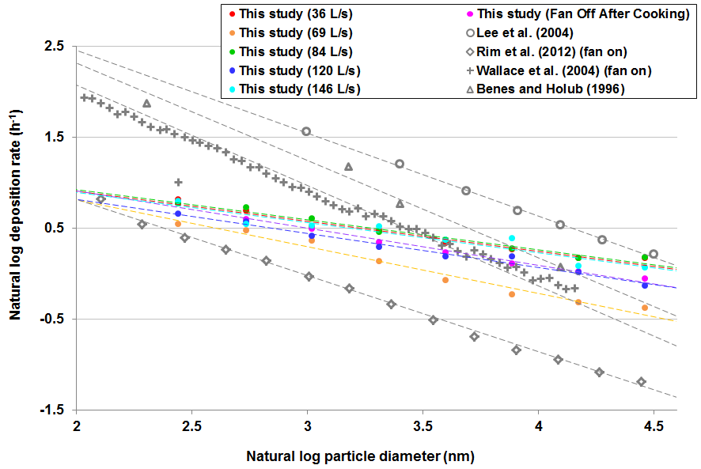
Figure S5. A comparison of deposition rates of particles less than 100 nm between current and previous studies. The flow rate of 75 L/s was excluded due to large uncertainties.
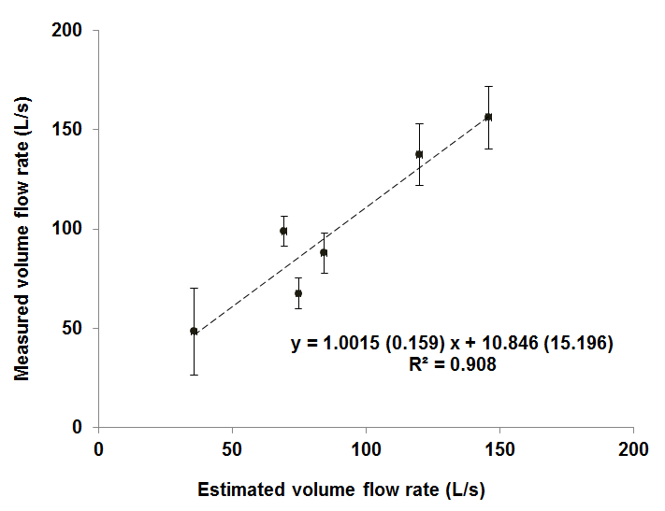
Figure S6. Measured versus estimated volume flow rates for range hood operated at six different flow rates under a volume of 244 m³. The error bars represent standard errors of the mean based on replication tests. The estimated volume flow rates were identical using the LBL and Palmiter and Bond methods.
References
Benes, M., and R. F. Holub. 1996. Aerosol wall deposition in enclosures investigated by means of a stagnant layer. Environ. Int. 22:883-889.
Holub, R. F. 1984. Turbulent plateout of radon daughters. Radiation Protection Dosimetry 7(1-4):155–158.
Lee W. C., J. M. Wolfson, P. J. Catalano, S. N. Rudnick, and P. Koutrakis. 2014. Size-resolved deposition rates for ultrafine and submicrometer particles in a residential housing unit. Environ. Sci. & Technol. 48:10282-10290.
Palmiter, L., and T. Bond. 1991. Interaction of mechanical systems and natural infiltration, in: 12th AIVC Conference, Ottawa, Canada, pp. 285-295.
Rim, D., M. Green, L. A. Wallace, A. Persily, and J. Choi. 2012. Evolution of Ultrafine Particle Size Distributions Following Indoor Episodic Releases: Relative Importance of Coagulation, Deposition and Ventilation. Aerosol Sci. Technol. 46:494–503.
Sherman M. H. 1992. Superposition in infiltration modeling. Indoor Air, 2:101-114.
Wallace, L. A., S. J. Emmerich, and C. Howard-Reed. 2004. Effect of central fans and in-duct filters on deposition rates of ultrafine and fine particles in an occupied townhouse. Atmos. Environ. 38:405–413.

