Supplementary Material
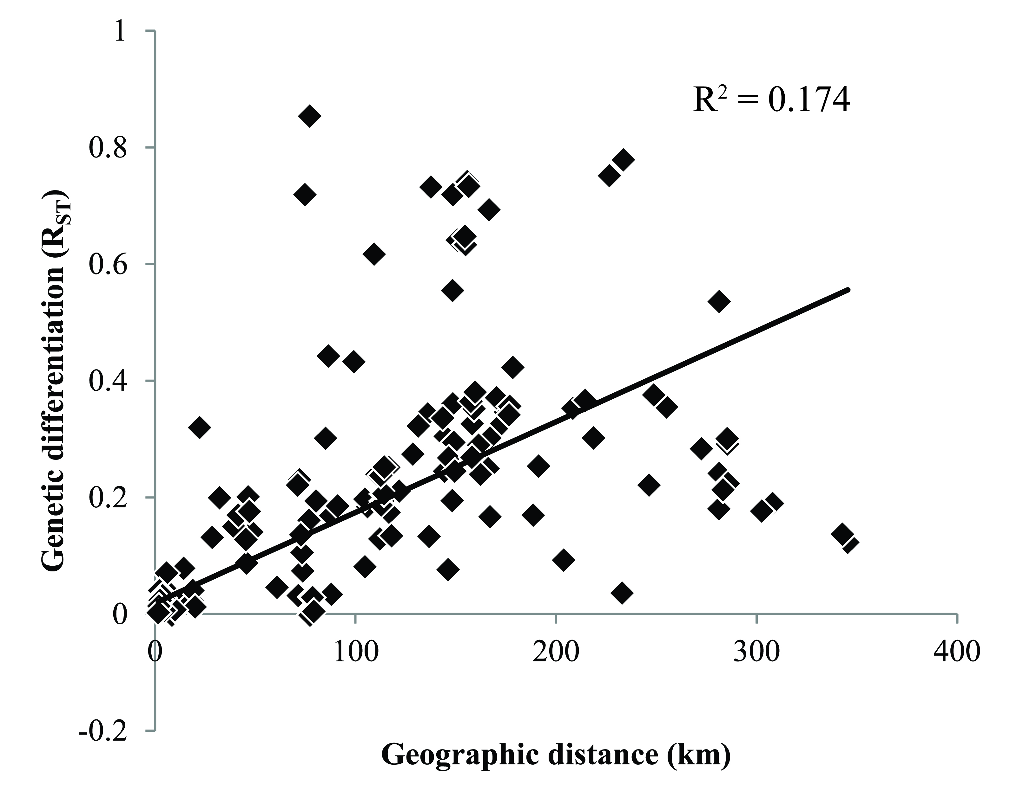
Figure S1. Plot of correlation between genetic differentiation and geographic distance. Genetic differentiation was estimated as R_{ST} based on microsatellite data, and geographic distance was Euclidean distance measured in kilometers (km). The relationship between the two axes was significant based on Mantel test (P = 0.043; 30,000 permutations).

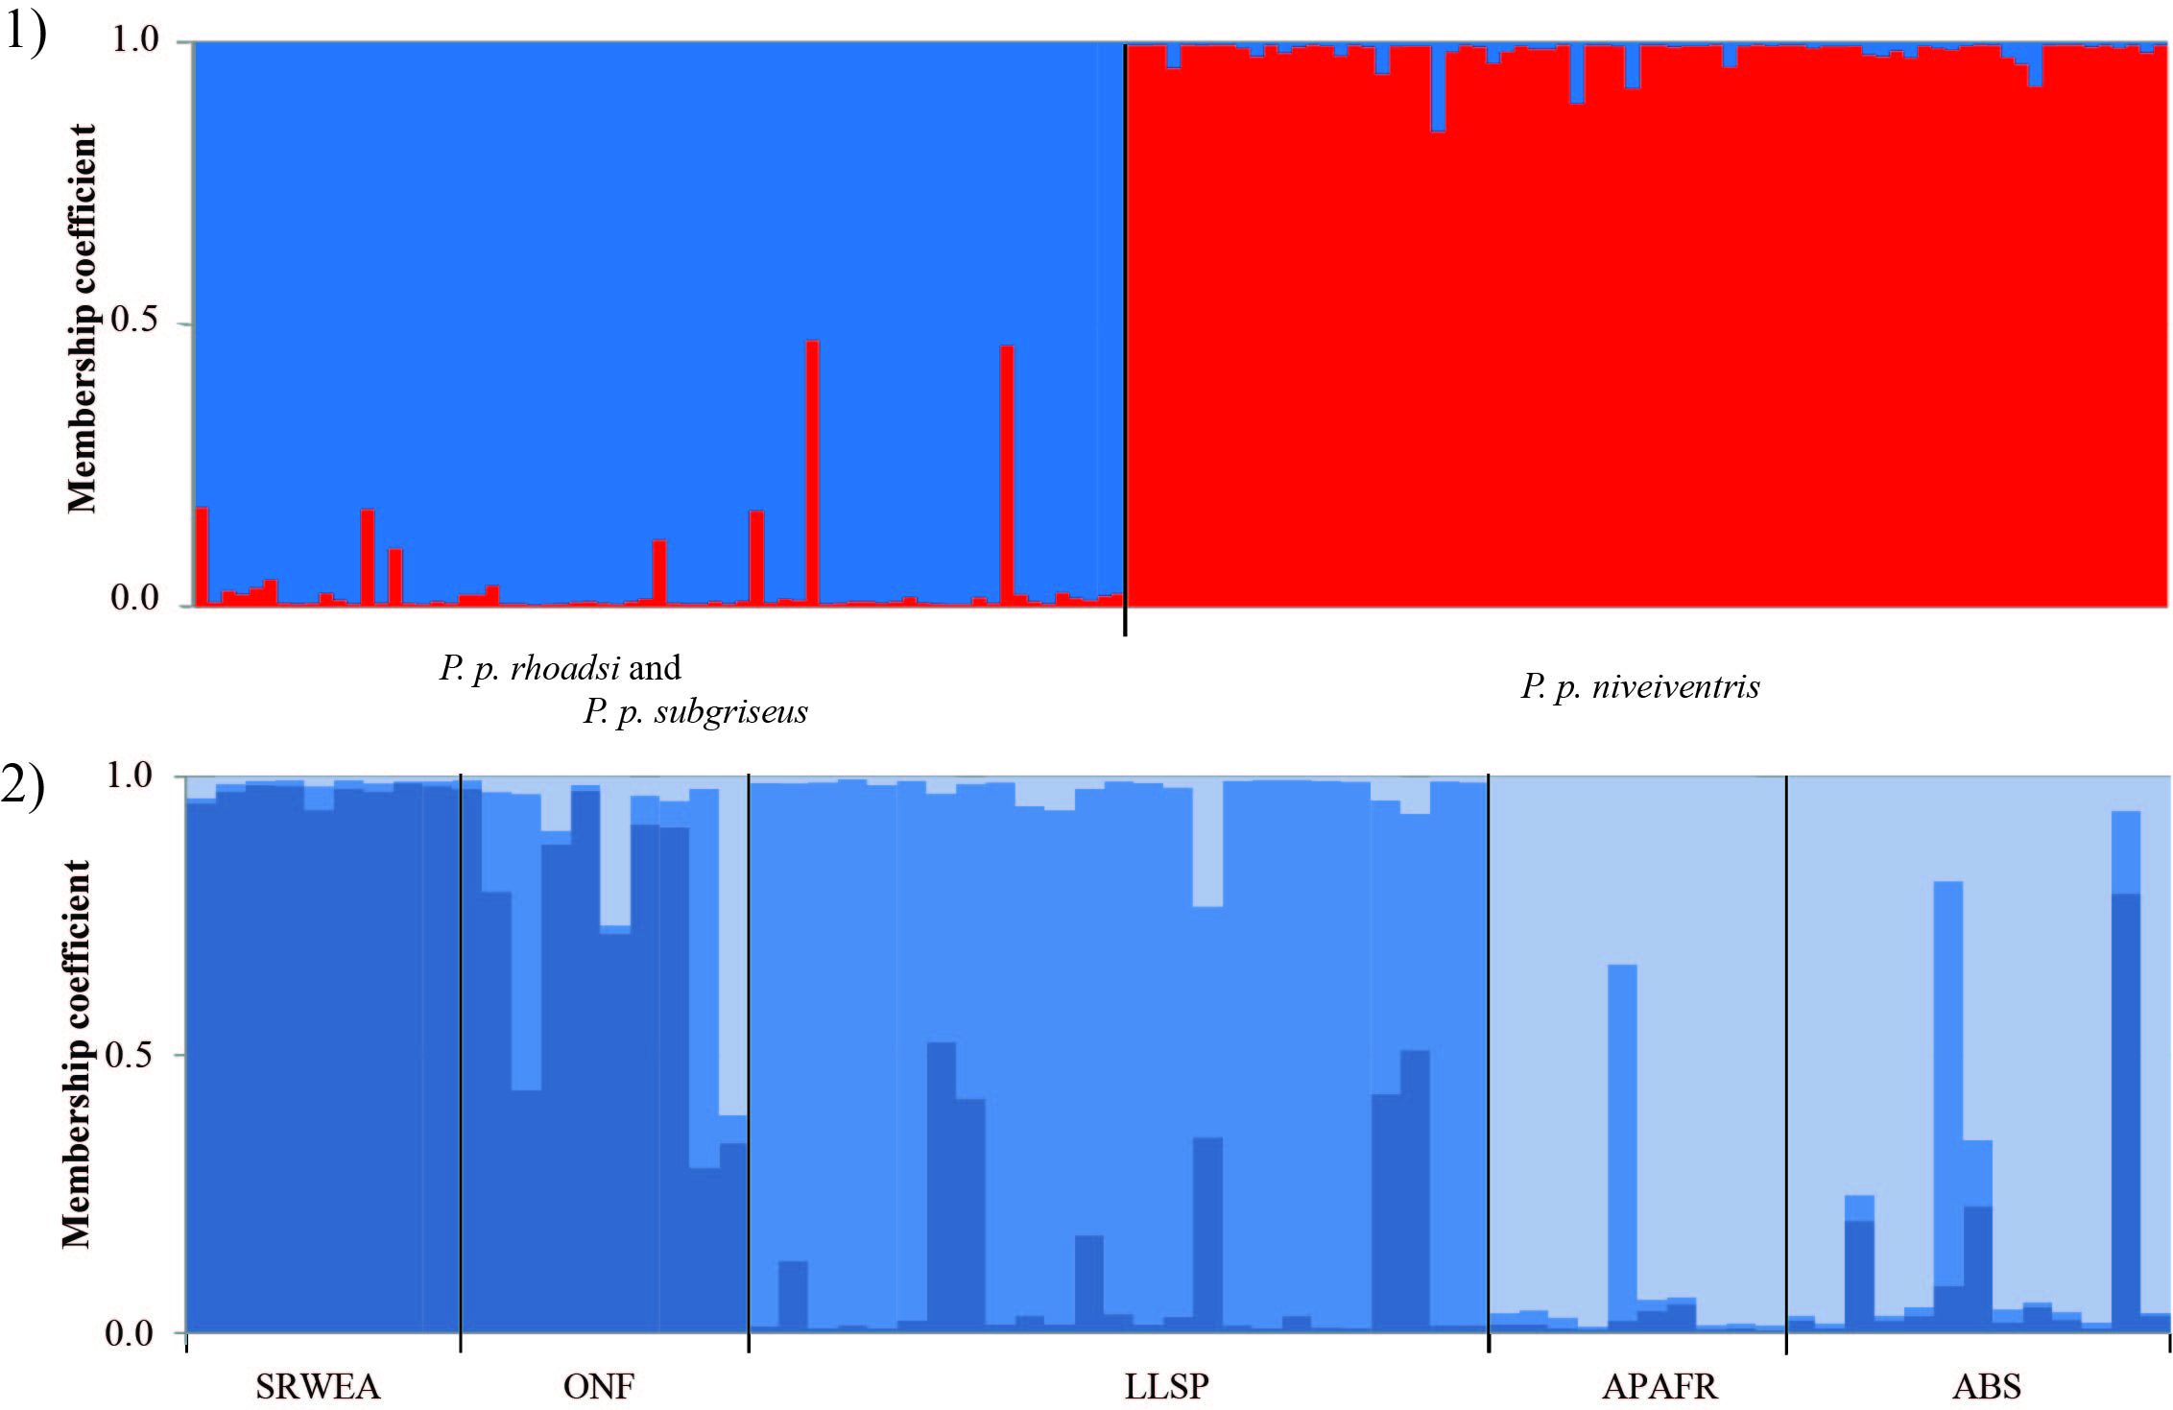
Figure S2. Membership coefficients for hierarchical STRUCTURE analyses including (1) mainland spp (P. p. rhoadsi and P. p. subriseus) and 10 randomized subsamples of P. p. niveiventris for even sample size, and (2) mainland spp. (P. p. rhoadsi and P. p. subriseus) individuals only. Different colors indicate different clusters: (1) K = 2, (2) K = 3.

Table S1. Samples of P. polionotus included in study, with location name, county, sample ID (ID), geographic coordinates (in decimal degrees), sample size, and samples used for cytochrome b (cyt b) and microsatellite analyses for each sample location.
 |  |  |  |  |  |  | Samples used
Location |  | County | ID | Latitude | Longitude | n | Cyt b | Microsat.
P. p. subgriseus
Suwannee Ridge Wildlife and Environmental Area |  | Suwannee Co. | SRWEA | 29.9591 | -82.9296 | 10 | 10 | 10
Ocala National Forest |  | Marion Co. | ONF | 29.2406 | -81.7837 | 9 | 7 | 9
P. p. rhoadsi
Lake Apopka Restoration Area |  | Orange Co. | LARA | 28.6660 | -81.5770 | 2 | 2 | 0
Lake Louisa State Park |  | Lake Co. | LLSP | 28.4517 | -81.7388 | 25 | 14 | 25
Avon Park Air Force Range |  | Highlands Co. | APAFR | 27.6104 | -81.2591 | 10 | 10 | 10
Archbold Biological Station |  | Highlands Co. | ABS | 27.1833 | -81.3493 | 13 | 13 | 13
P. p. phasma
Anastasia State Park |  | St. Johns Co. | ASP | 29.9018 | -81.2910 | 40 | 14 | 40
Frank Butler Park |  | St. Johns Co. | FBP | 29.7723 | -81.2483 | 3 | 3 | 0
Crescent Beach |  | St. Johns Co. | CB | 29.8091 | -81.2582 | 1 | 1 | 0
Fort Matanzas National Monument |  | St. Johns Co. | FM | 29.7091 | -81.2285 | 33 | 13 | 33
P. p. decoloratus
Daytona Beach |  | Volusia Co. | DB | 29.2106 | -81.0231 | 2 | 2 | 0
P. p. niveiventris
Smyrna Dunes Park |  | Volusia Co. | SDP | 29.0721 | -80.9142 | 19 | 7 | 19
Canaveral National Seashore |  | Volusia Co. | CNS | 28.8196 | -80.7520 | 31 | 8 | 31
Merritt Island National Wildlife Refuge |  | Brevard Co. | MINWR | 28.6044 | -80.5908 | 32 | 0 | 32
Cape Canaveral Air Force Station
 | Beach Grid 1 | Brevard Co. | BG1 | 28.4351 | -80.5661 | 35 | 6 | 35
 | Beach Grid 2 | Brevard Co. | BG2 | 28.4239 | -80.5776 | 41 | 0 | 41
 | Beach Grid 3 | Brevard Co. | BG3 | 28.5117 | -80.5539 | 28 | 0 | 28
 | Scrub Grid 1 | Brevard Co. | SG1 | 28.4756 | -80.5854 | 43 | 0 | 43
 | Scrub Grid 2 | Brevard Co. | SG2 | 28.4365 | -80.5933 | 44 | 0 | 44
 | Scrub Grid 3 | Brevard Co. | SG3 | 28.4495 | -80.5490 | 56 | 0 | 56
Pelican Island National Wildlife Refuge |  | Indian River Co. | PINWR | 27.7997 | -80.4215 | 15 | 15 | 15
Table S2. Genetic diversity for cyt b sequence data across sample locations of P. polionotus captured in peninsular Florida U.S.A. Diversity reported for all mainland subspecies (P. p. subgriseus and P. p. rhoadsi), all samples of beach mouse subspecies P. p. phasma and P. p. decoloratus, all beach mouse subspecies P. p. niveiventris, and for each sample location for each of these groups (not reported for P. p. phasma and P. p. decoloratus as they share the same single haplotype). For each location we reported sample size (N), number of haplotypes, number of polymorphic sites, haplotype diversity, nucleotide diversity (π) , and average nucleotide differences (k).
Group | Sample location | N | # haplotypes | # polymorphic sites | haplotype diversity | π | k
Mainland subspecies | All | 56 | 19 | 26 | 0.885 | 0.005 | 5.098
 | SRWEA | 10 | 4 | 7 | 0.644 | 0.002 | 2.378
 | ONF | 7 | 5 | 6 | 0.857 | 0.002 | 2.381
 | LARA | 2 | 2 | 1 | 1.000 | 0.001 | 1.000
 | LLSP | 14 | 9 | 14 | 0.934 | 0.004 | 4.615
 | APAFR | 10 | 2 | 10 | 0.467 | 0.003 | 4.667
 | ABS | 13 | 3 | 8 | 0.295 | 0.002 | 1.231
P. p. phasma/  P. p. decoloratus | All | 33 | 1 | 0 | 0.000 | 0.000 | 0.000
P. p. niveiventris | All | 36 | 3 | 3 | 0.538 | 0.001 | 0.624
 | SDP | 7 | 1 | 0 | 0.000 | 0.000 | 0.000
 | CNS | 8 | 2 | 1 | 0.536 | 0.004 | 0.536
 | CC | 6 | 3 | 3 | 0.600 | 0.001 | 1.000
 | PINWR | 15 | 1 | 0 | 0.000 | 0.000 | 0.000

Table S3. Data summary for ten microsatellite loci across the sampled locations of P. polionotus; mainland subspecies (P. p. subgriseus and P. p. rhoadsi), P. p. phasma, and P. p. niveiventris. For each sample location sample size (n) is reported, in addition to measures of genetic diversity: number of alleles (A), allelic richness (AR), and observed (H_{o}) and expected (H_{e}) heterozygosity. For each measure of diversity values are reported as averages and standard deviations.
Group | Sample location | n | A | AR | H_{o} | H_{e}
Mainland subspecies | SRWEA | 10 | 8.2 ± 2.6 | 7.1 ± 2.1 | 0.764 ± 0.170 | 0.785 ± 0.166
 | ONF | 9 | 7.8 ± 1.9 | 7.0 ± 1.6 | 0.760 ± 0.162 | 0.801 ± 0.067
 | LLSP | 25 | 11.7 ± 3.5 | 7.5 ± 1.2 | 0.774 ± 0.122 | 0.855 ± 0.035
 | APAFR | 10 | 7.1 ± 2.0 | 6.3 ± 1.4 | 0.739 ± 0.218 | 0.782 ± 0.073
 | ABS | 13 | 9.2 ± 2.3 | 7.1 ± 1.4 | 0.735 ± 0.203 | 0.822 ± 0.055
P. p. phasma | ASP | 40 | 5.7 ± 1.8 | 3.8 ± 1.0 | 0.478 ± 0.223 | 0.615 ± 0.144
 | FM | 33 | 3.0 ± 1.8 | 2.2 ± 1.1 | 0.206 ± 0.233 | 0.290 ± 0.245
P. p. niveiventris | SDP | 19 | 4.2 ± 1.3 | 3.5 ± 1.2 | 0.588 ± 0.237 | 0.525 ± 0.212
 | CNS | 31 | 7.7 ± 3.3 | 5.1 ± 1.8 | 0.598 ± 0.232 | 0.673 ± 0.251
 | MINWR | 32 | 7.6 ± 3.4 | 5.4 ± 1.9 | 0.671 ± 0.263 | 0.718 ± 0.201
 | BG3 | 28 | 8.9 ± 4.1 | 5.8 ± 2.0 | 0.709 ± 0.191 | 0.733 ± 0.187
 | SG1 | 43 | 8.1 ± 3.0 | 5.3 ± 1.8 | 0.707 ± 0.261 | 0.713 ± 0.235
 | SG3 | 56 | 9.7 ± 4.3 | 5.8 ± 1.8 | 0.711 ± 0.206 | 0.735 ± 0.204
 | SG2 | 44 | 9.1 ± 3.7 | 5.7 ± 2.0 | 0.691 ± 0.222 | 0.729 ± 0.217
 | BG1 | 35 | 9.1 ± 3.0 | 6.0 ± 1.8 | 0.706 ± 0.193 | 0.747 ± 0.191
 | BG2 | 41 | 9.5 ± 4.0 | 5.8 ± 2.1 | 0.716 ± 0.270 | 0.721 ± 0.252
 | PINWR | 15 | 4.2 ± 1.6 | 3.7 ± 1.3 | 0.600 ± 0.229 | 0.583 ± 0.188

