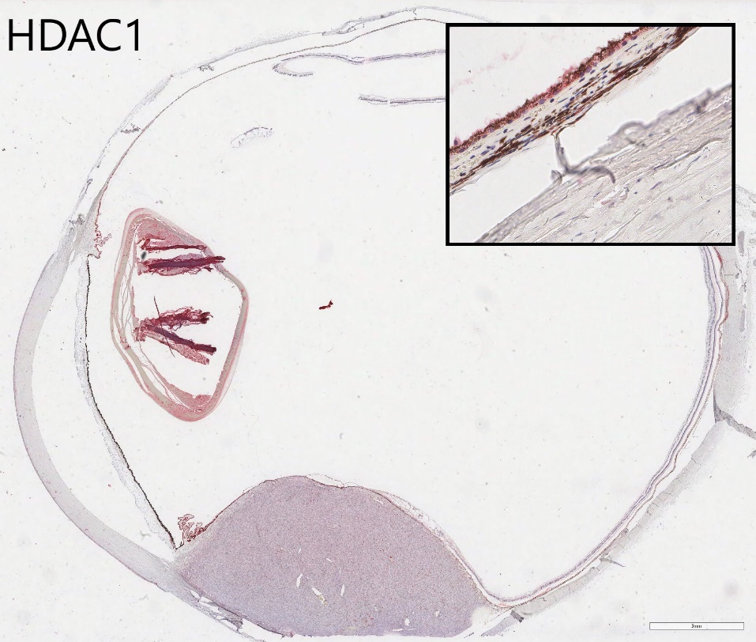
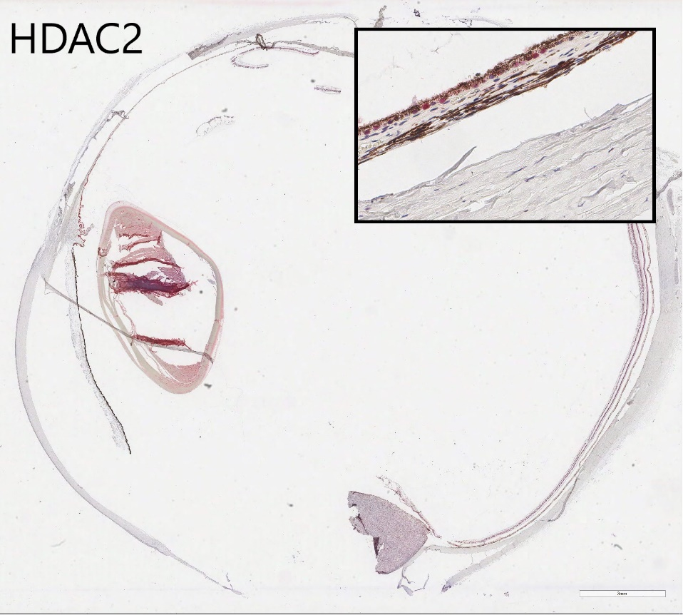
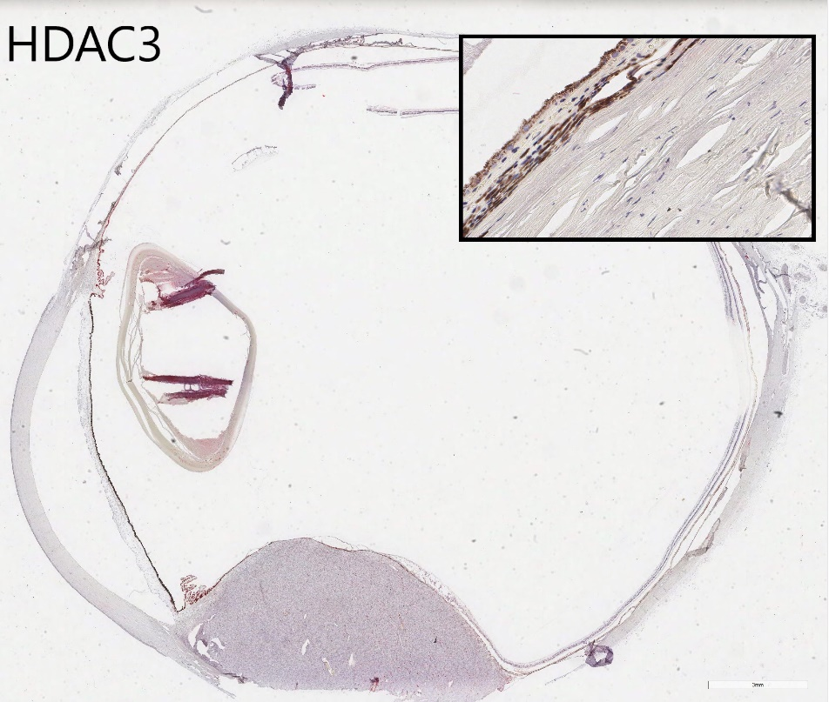
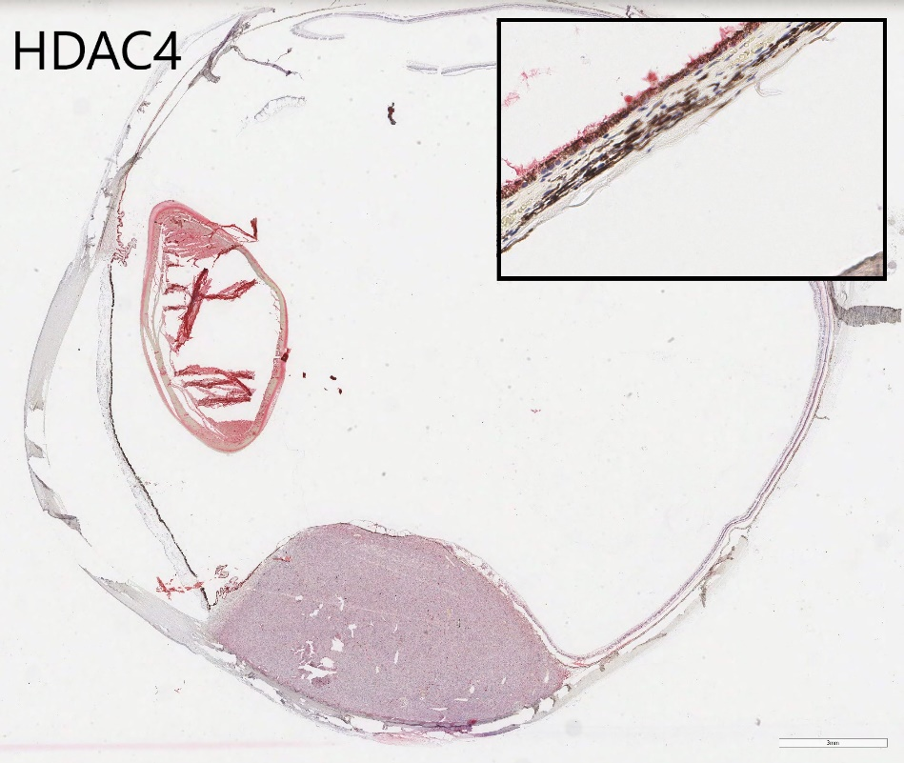
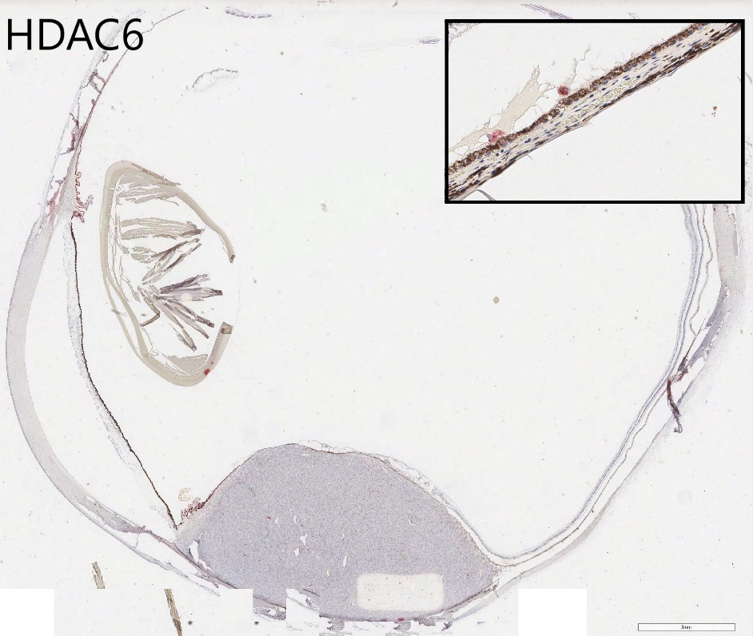
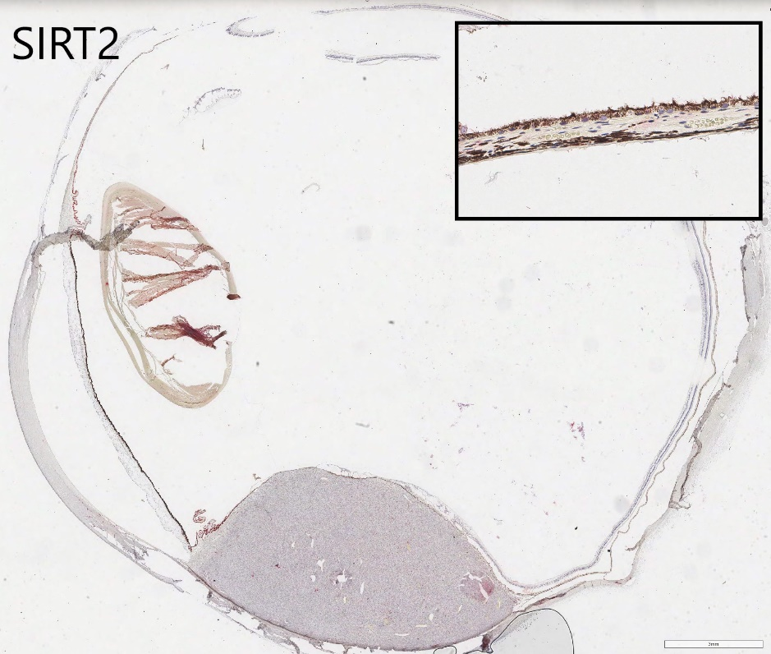
Supplementary Figure 1 – Photomicrographs of global HDAC staining of uveal melanoma eyes for HDACs 1, 2, 3, 4, 6 and SIRT2. Insert at higher magnification of nearby choroid demonstrating melanocyte staining as a control. Scale bar 3mm. (Fast Red chromogen; haematoxylin counterstain).

