Epitaxial La_{0.7}Sr_{0.3}MnO₃ thin films on silicon with excellent magnetic and electric properties by combining physical and chemical methods
José Manuel Vila-Fungueiriño¹*, Jaume Gázquez², César Magén³, Guillaume Saint-Girons⁴, Romain Bachelet⁴, and Adrián Carretero-Genevrier¹*
¹Institut d’Électronique et des Systèmes (IES), UMR 5214, CNRS – Université de Montpellier, 860 rue Saint Priest, 34095 Montpellier, France.
²Institut de Ciència de Materials de Barcelona ICMAB, Consejo Superior de Investigaciones Científicas CSIC, Campus UAB 08193 Bellaterra, Catalonia, Spain.
³Instituto de Ciencia de Materiales de Aragón (ICMA), Universidad de Zaragoza-CSIC, Facultad de Ciencias, Universidad de Zaragoza, Pedro Cerbuna 12, 50009 Zaragoza, Spain.
Laboratorio de Microscopías Avanzadas (LMA), Instituto de Nanociencia de Aragón (INA), Universidad de Zaragoza, Mariano Esquillor, Edificio I+D, 50018 Zaragoza, Spain.
⁴Institut des Nanotechnologies de Lyon (INL) CNRS - Ecole Centrale de Lyon, 36 avenue Guy de Collongue, 69134 Ecully, France.
e-mail: adrien.carretero@ies.univ-montp2.fr, jose-manuel.vila@ies.univ-montp2.fr

Supporting Information

High temperature stability of STO buffer layers on Si
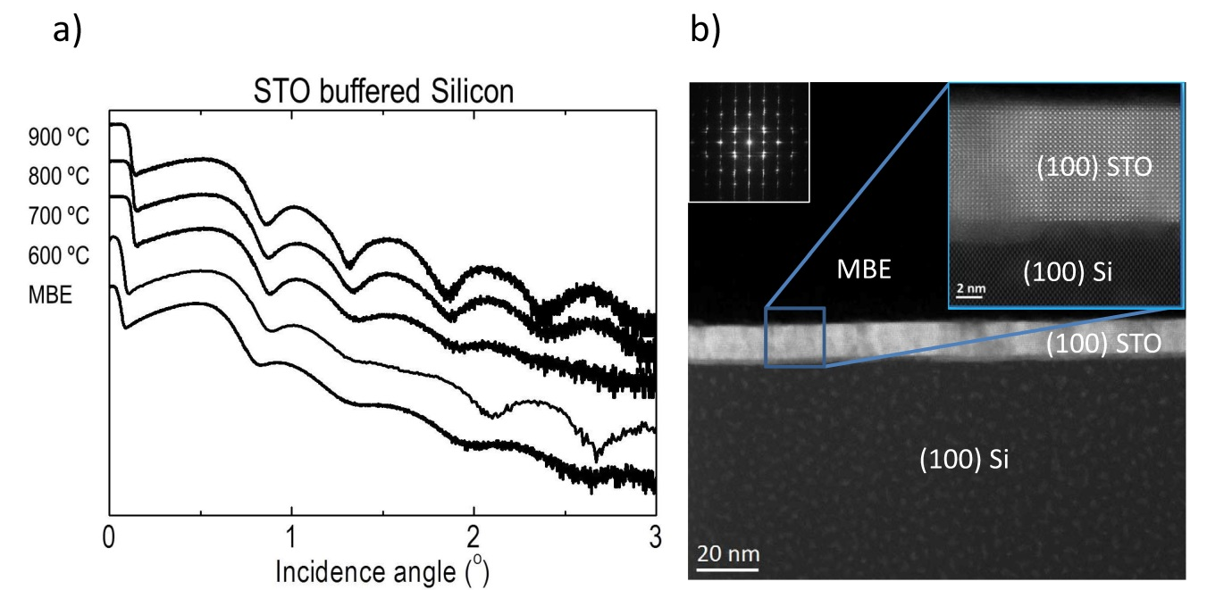
Figure S1. a) XRR curves of STO/Si substrates. STO-buffered Si substrates were annealed at 600ºC, 700ºC, 800ºC, and 900 ºC in air during 2h. b) Low and high resolution STEM images of non-annealed epitaxial STO film on Si substrate grown by MBE.

Growth of LSMO films on top of non-annealed STO/Si substrates
Figure S2. XRR curves for LSMO films deposited on non-annealed STO-buffered Si substrates at 600ºC, 700ºC, 800ºC, and 900ºC in air during 2h. The R_{q} values obtained by AFM are 1.16, 1.20, 0.65, and 0.81 nm, respectively.

Chemical analysis of the interface LSMO-STO
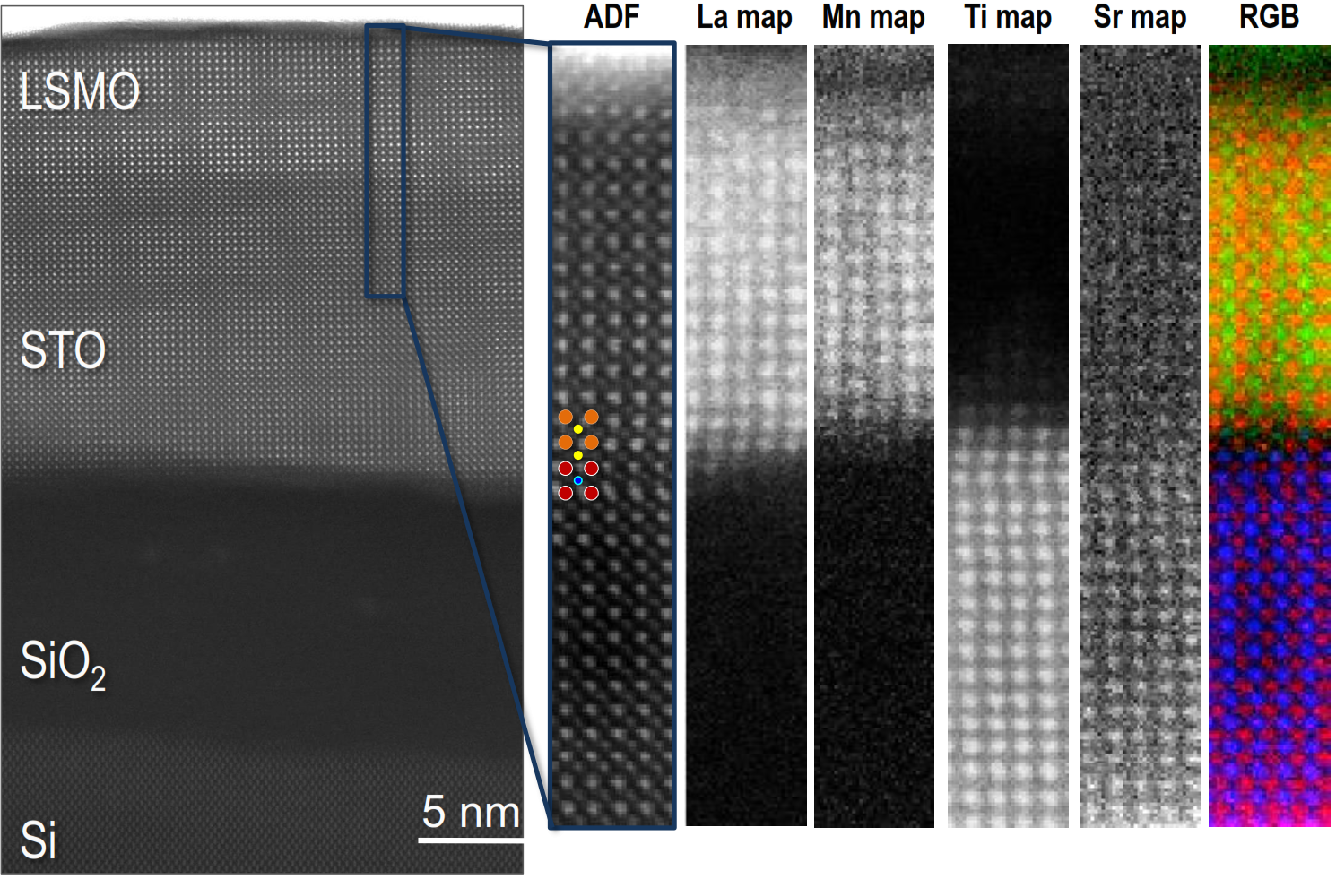
Figure S3. EELS analysis for Lanthanum, Manganese, Titanium, and Strontium of the LSMO-STO interface in the LSMO/STO/Si heterostructure.

Low magnification of cross-sectional TEM image of the LSMO/STO/Si nanostructure
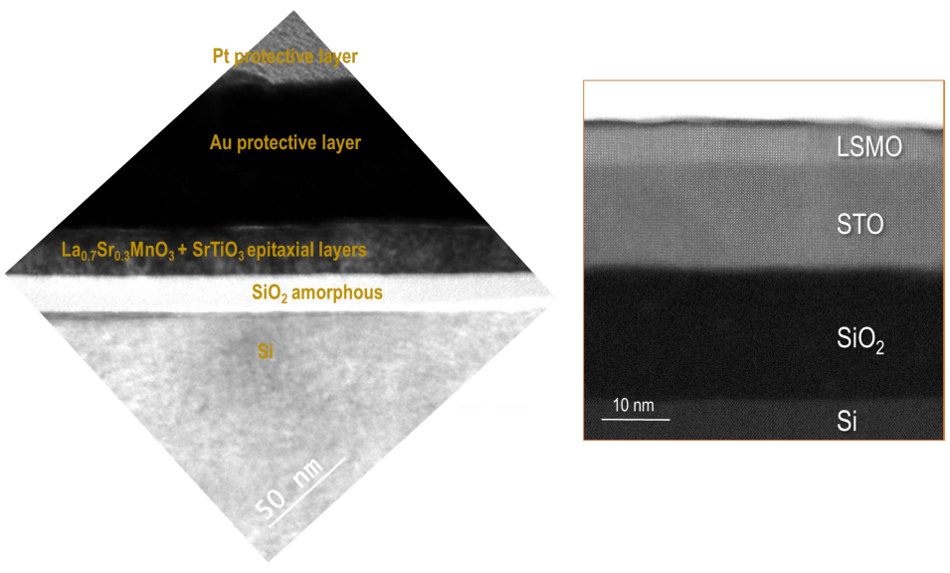
Figure S4. Low magnification cross-sectional TEM image of a specimen lamella of the LSMO/STO/Si nanostructure.

Crystallographic orientation of the LSMO/STO layers with respect to Silicon substrate
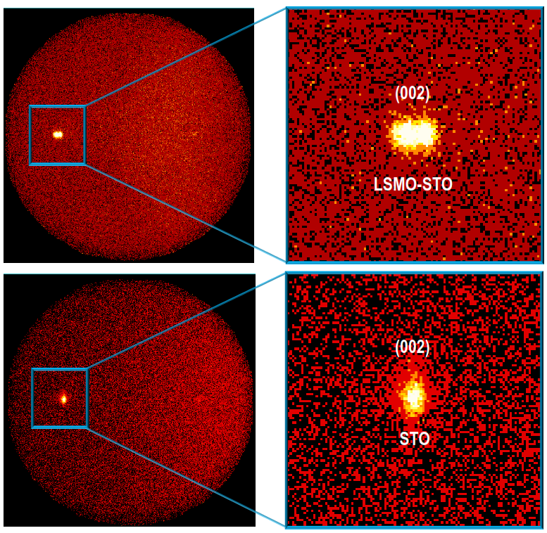
Figure S5. 2D XRD pattern (from 18º to 52º) for a LSMO/STO/Si layer (up) and a preannealed STO/Si layer (bottom).
Magnetotransport characterization
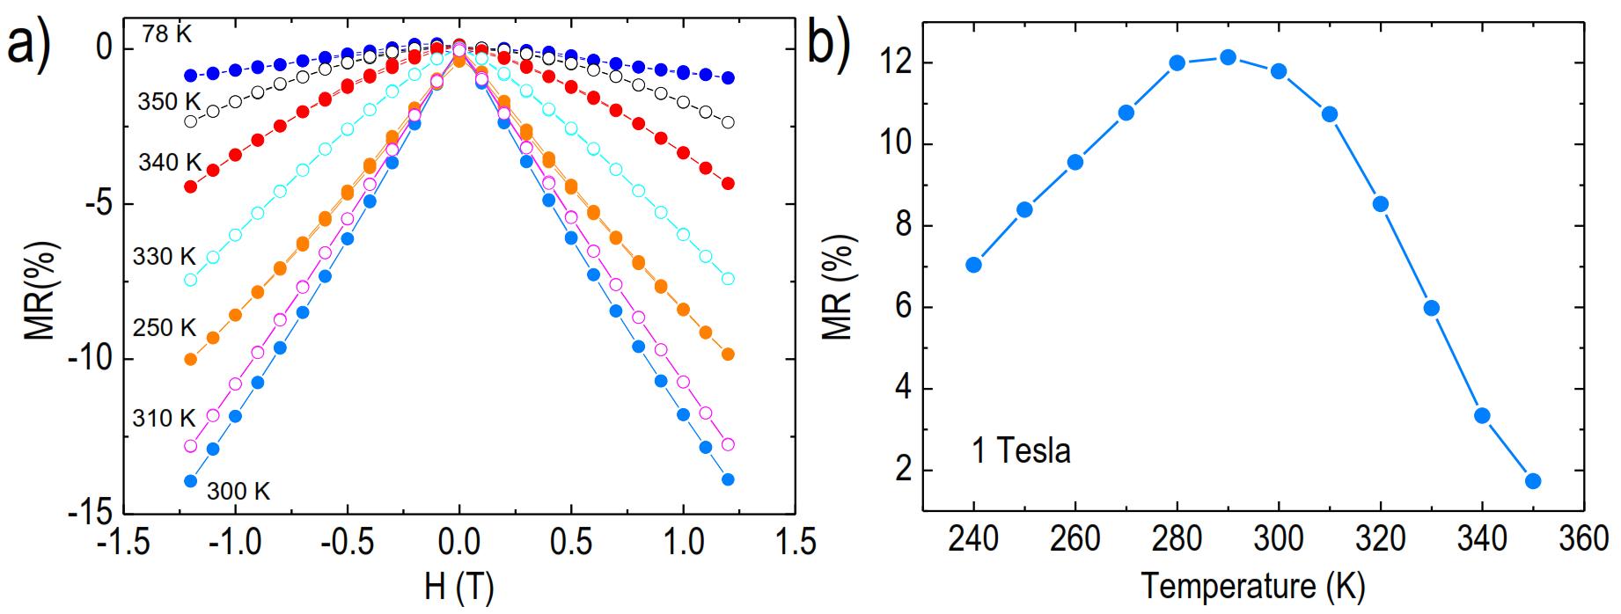
Figure S6. a) Magnetoresistance at 78, 250, 300, 310, 330, 340 and 350 K for LSMO/STO/Si b) Temperature dependence of the MR at 1 T around the MIT extracted from MR characterization from 240 to 350 K.
Table S1. Surface roughness obtained from AFM measurements and XRR fittings of the MBE STO-buffered Si substrates annealed at different temperatures.
MBE SrTiO₃ buffered Si substrate | Roughness Rq AFM (nm) | Roughness XRR (nm)
900ºC | 1.00 | 0.73
800ºC | 0.97 | 0.61
700ºC | 0.87 | 0.72
600ºC | 1.03 | 0.79
MBE as deposited | 1.49 | 0.73

