**Insight into the Reaction Mechanism of Ethanol Steam Reforming Catalyzed by Co-Mo6S8**

**[supporting information]**

Qian Zhanga,b, Ling Guo* a,b, Xiaoli Zhenga,b, Minmin Xinga,b, Zijun Haoa,b

a. Key Laboratory of Magnetic Molecules & Magnetic Information Materials Ministry of Education, Shanxi Normal University. Linfen, China, 041004.

b. The School of Chemical and Material Science, Shanxi Normal University, No. 1, Gongyuan Street, Linfen, China, 041004.



**Fig. S1** Potential energy surfaces of CH3CH2OH* decomposition catalyzed by Co-Mo6S8.

The solid line represents the PBE level with 6-31G (d, p) and LANL2DZ basis set and the dashed line represents the PBE-D3(BJ) level with 6-311++G (d, p) and SDD basis set.



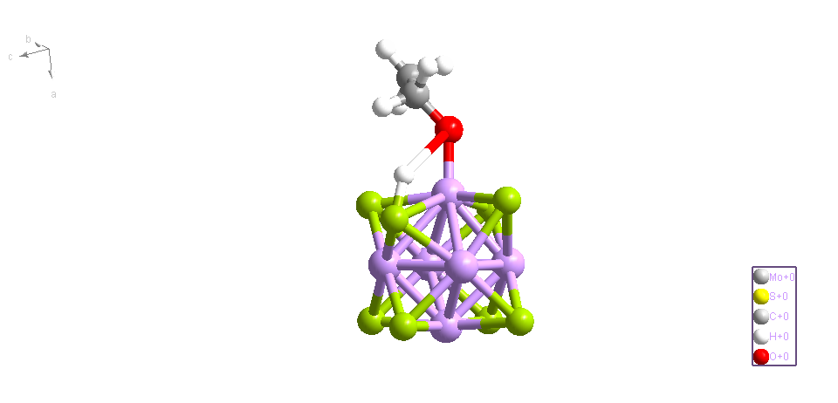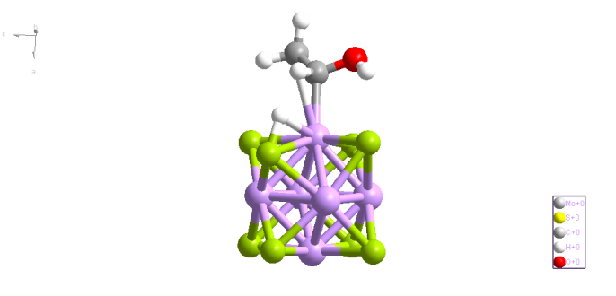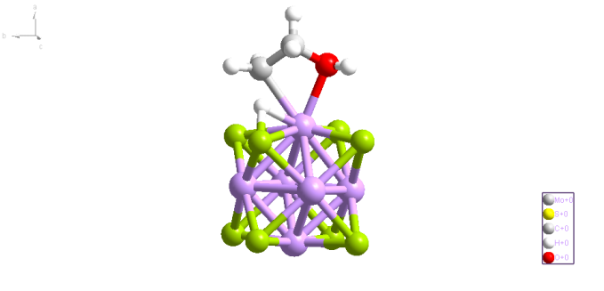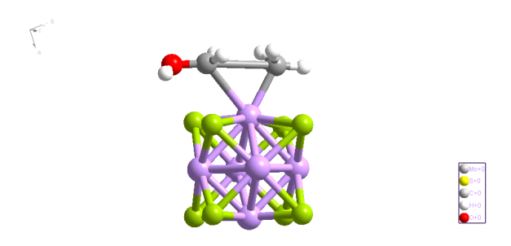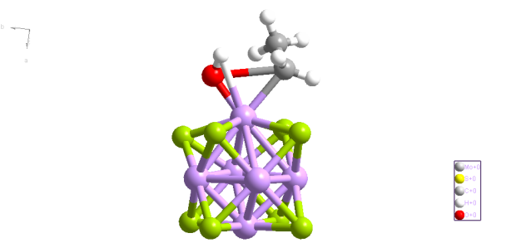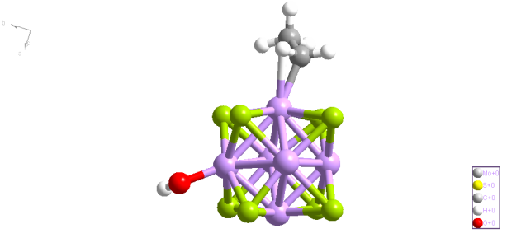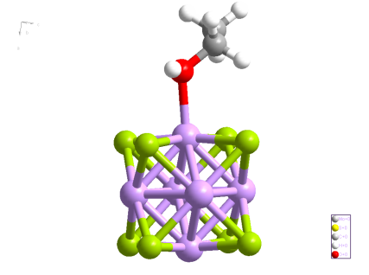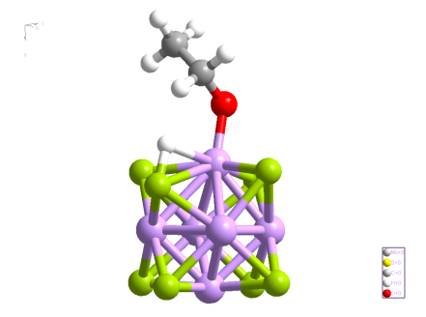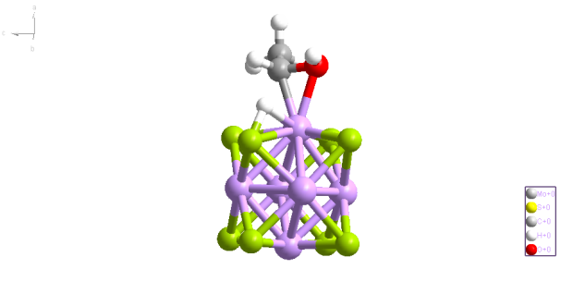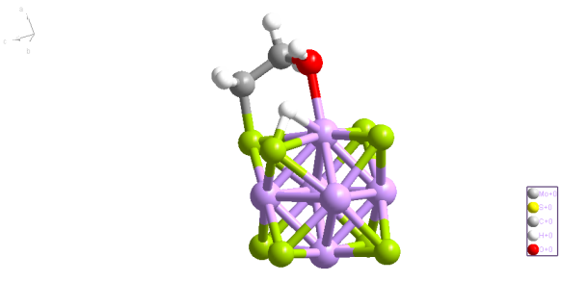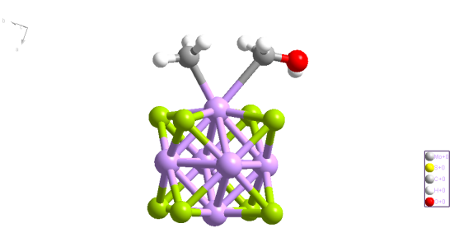

TS1’ TS2’ TS3’ TS4’ TS5’

CH3CH2OH* CH3CH2O*+H* CH3CHOH*+H* CH2CH2OH*+H* CH3*+CH2OH*  CH3CH2*+OH*

**Fig. S2** Potential energy surfaces and geometrical structures of CH3CH2OH* decomposition catalyzed by Mo6S8. Atom colors are Mo (pink), S (green), O (red), C (black), and H (white).



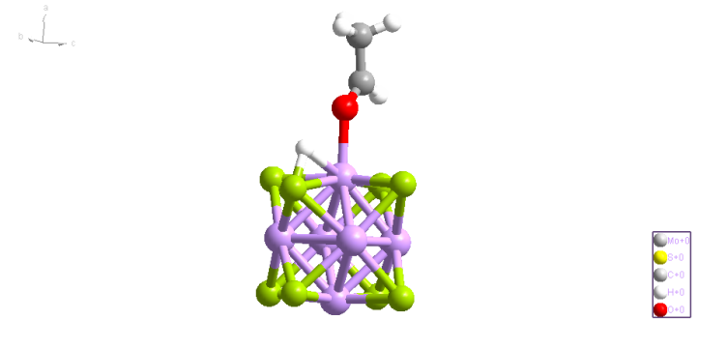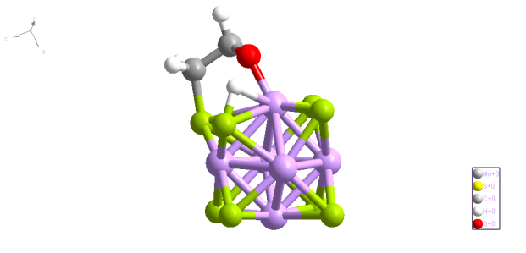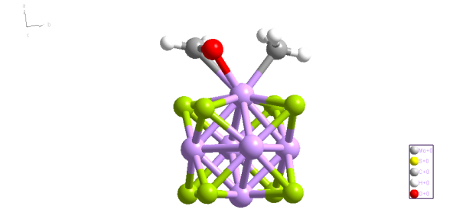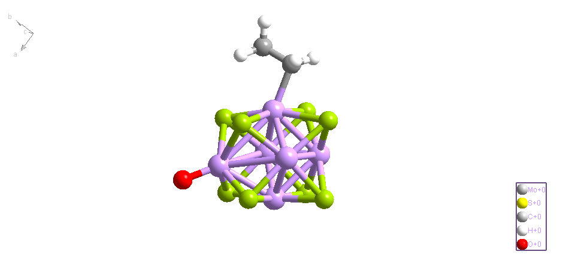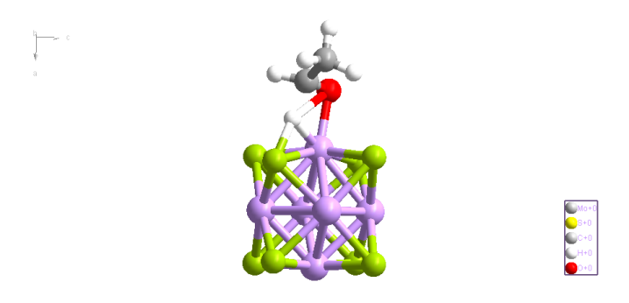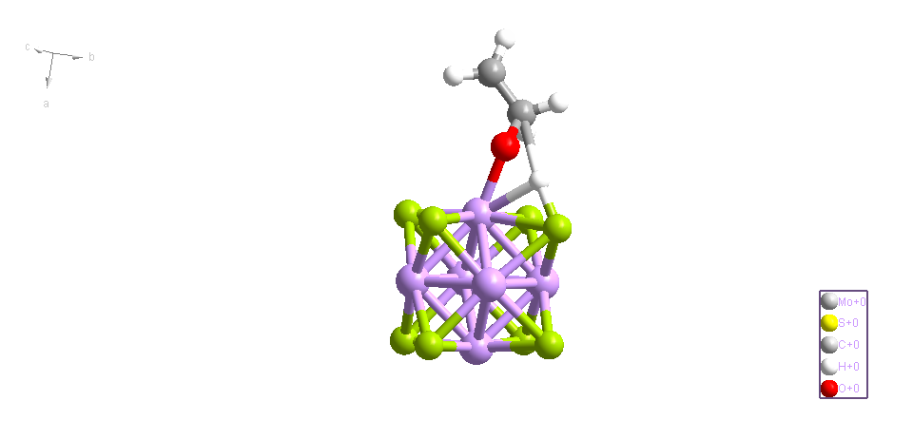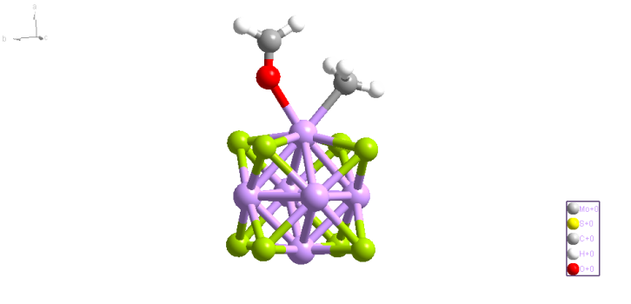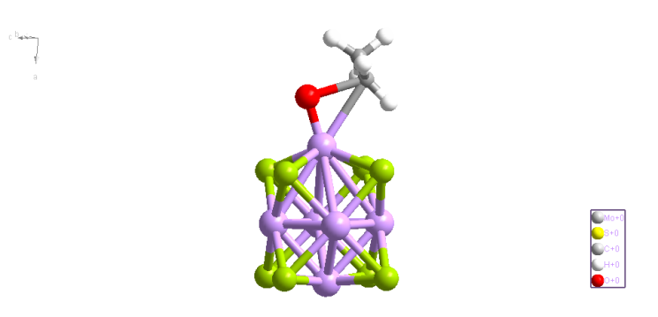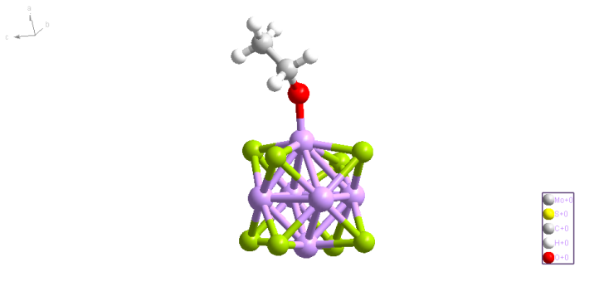

TS6’ TS7’ TS8’ TS9’

CH3CH2O* CH3CHO*+H* CH2CH2O*+H* CH3*+CH2O* CH3CH2*+O*

**Fig. S3** Potential energy surfaces and geometrical structures for CH3CH2O* decomposition catalyzed by Mo6S8. Atom colors are Mo (pink), S (green), O (red), C (black), and H (white).



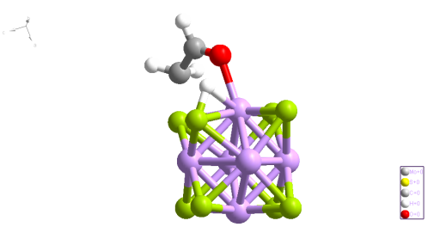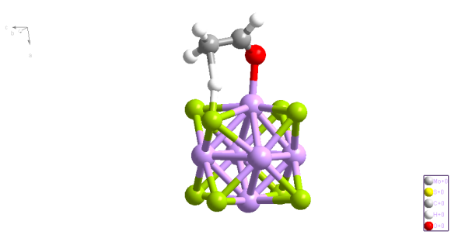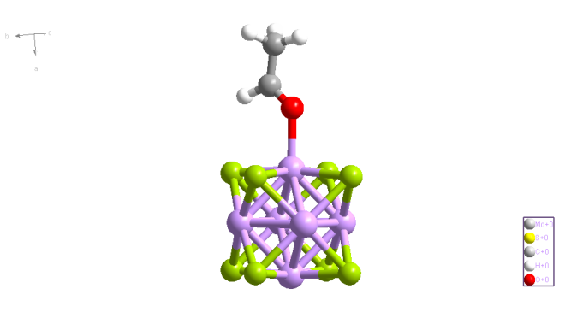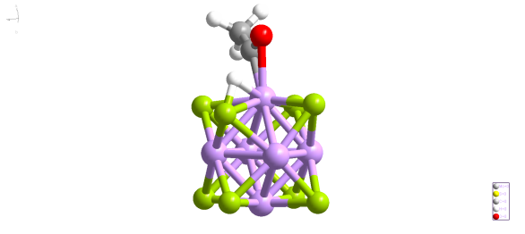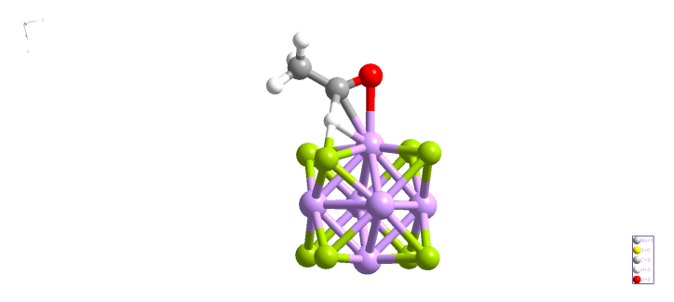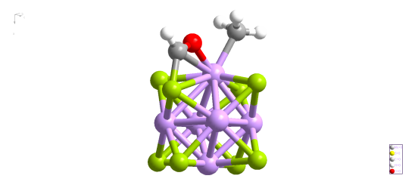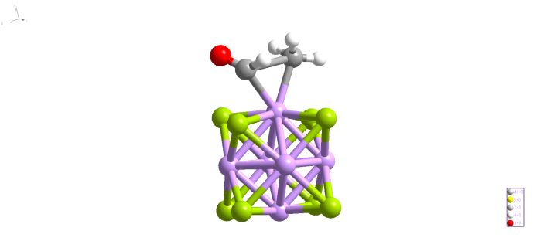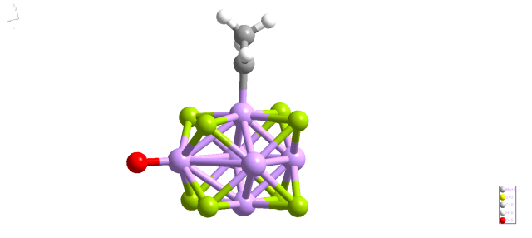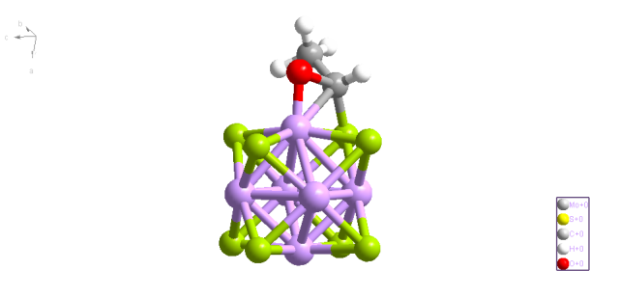

TS10’ TS11’ TS12’ TS13’

CH3CHO* CH2CHO*+H* CH3CO*+H* CH3*+CHO* CH3CH*+O*

**Fig. S4** Potential energy surfaces and geometrical structures for CH3CHO* decomposition catalyzed by Mo6S8. Atom colors are Mo (pink), S (green), O (red), C (black), and H (white).



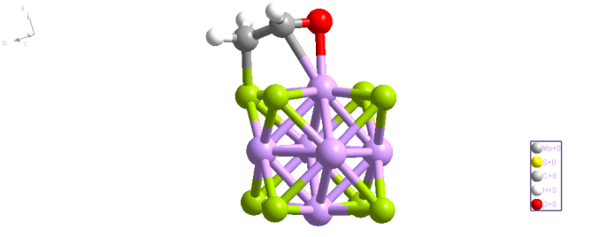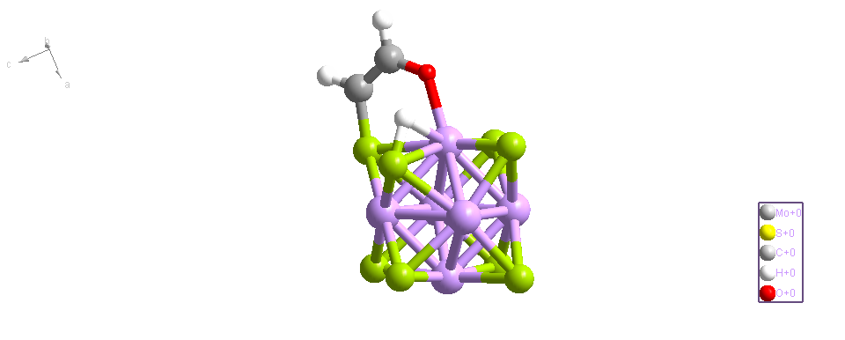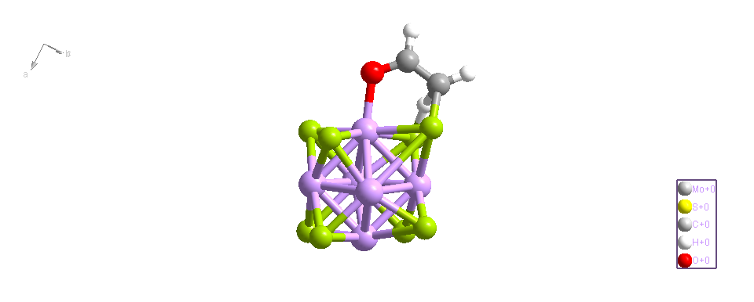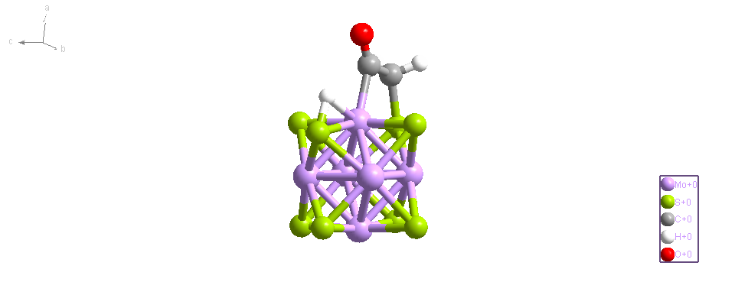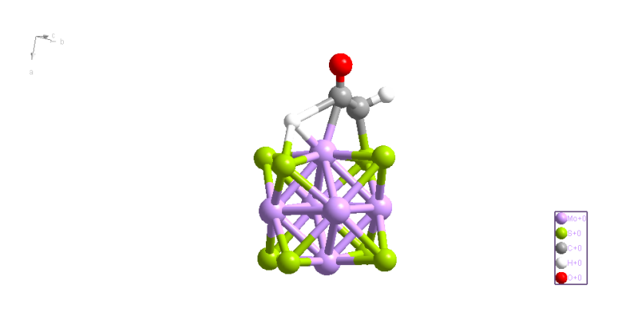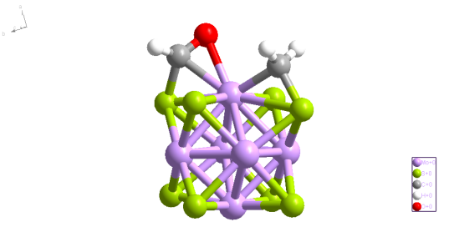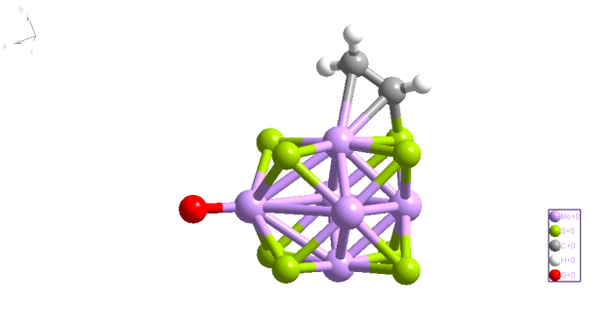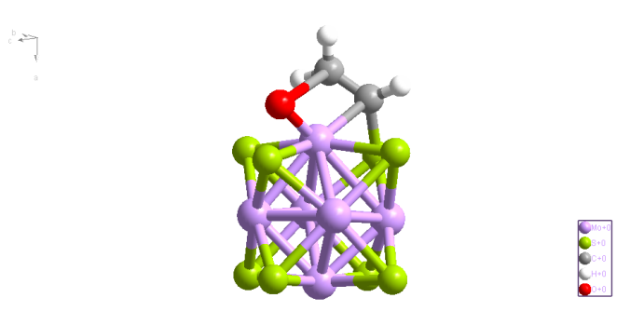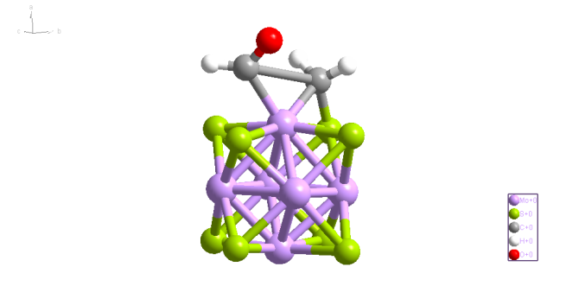

TS14’ TS15’ TS16 ’ TS17’

CH2CHO* CHCHO*+H* CH2CO*+H* CH2*+CHO* CH2CH*+O*

**Fig. S5** Potential energy surfaces and geometrical structures for CH2CHO* decomposition catalyzed by Mo6S8. Atom colors are Mo (pink), S (green), O (red), C (black), and H (white).

2



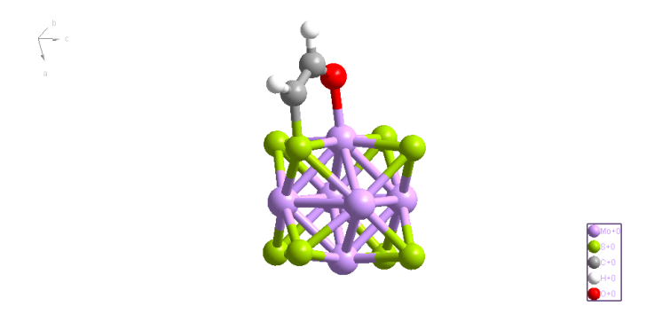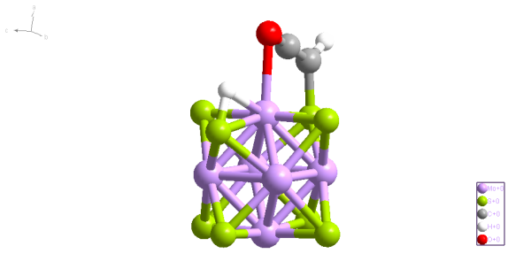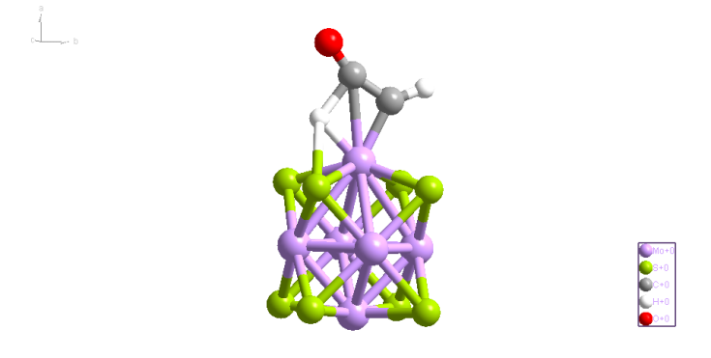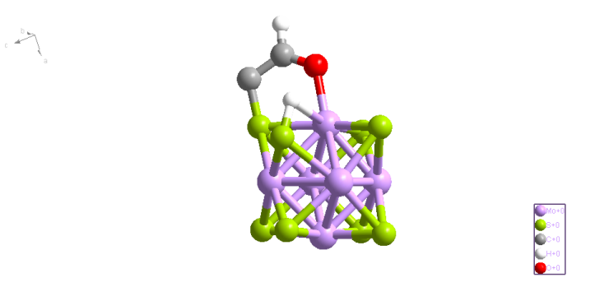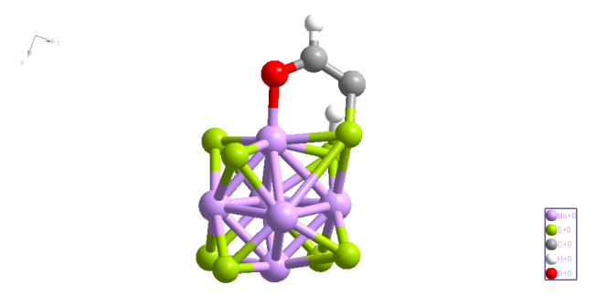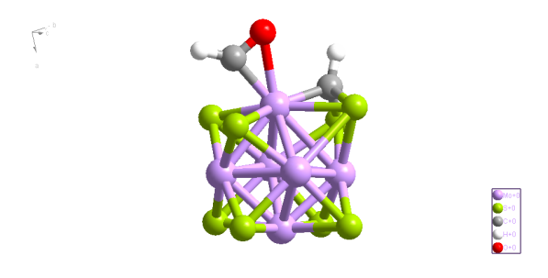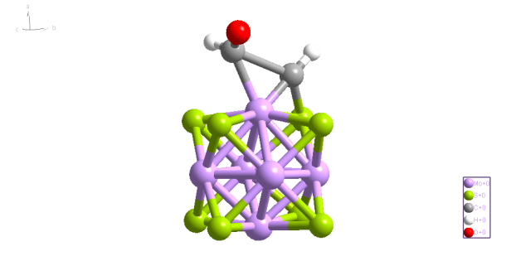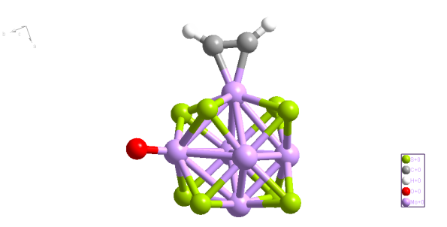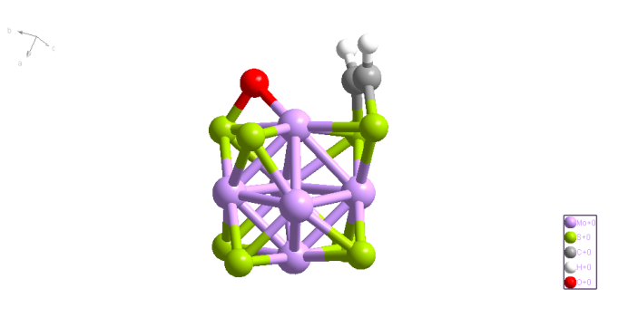

TS21’ TS22’ TS23’ TS24’

CHCHO* CHCO*+H* CCHO*+H* CH*+CHO* CHCH*+O*

**Fig. S6** Potential energy surfaces and geometrical structures for CHCHO* decomposition catalyzed by Mo6S8. Atom colors are Mo (pink), S (green), O (red), C (black), and H (white).



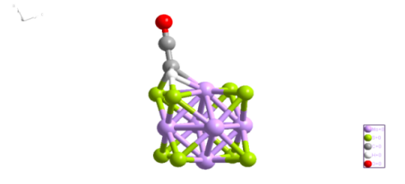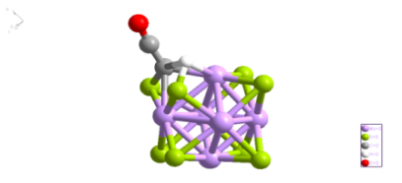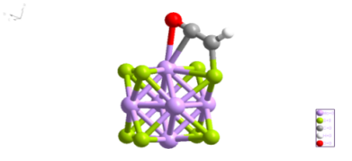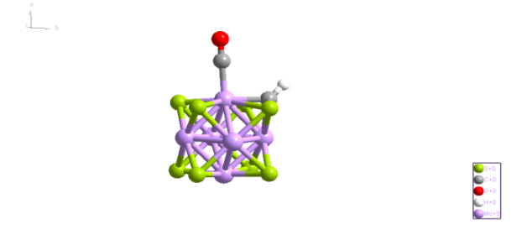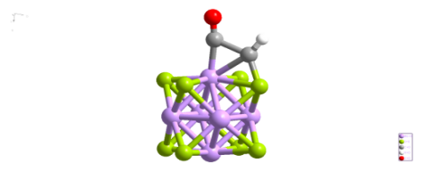

**Fig. S7** Potential energy surfaces and geometrical structures for CHCO* decomposition catalyzed by Mo6S8. Atom colors are Mo (pink), S (green), O (red), C (black), and H (white).



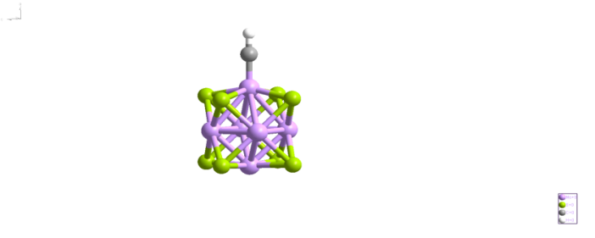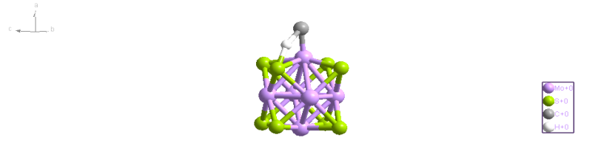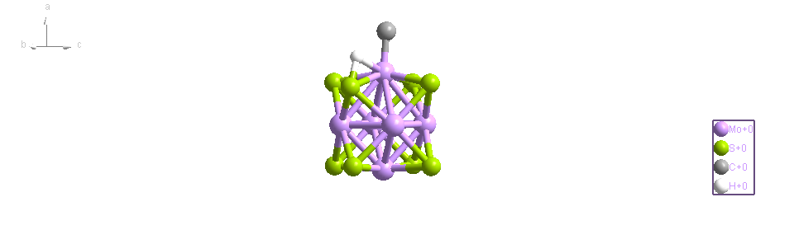

**Fig. S8** Potential energy surfaces and geometrical structures for CH* decomposition catalyzed by Mo6S8. Atom colors are Mo (pink), S (green), and H (white).

|  |  |  |  |  |
| --- | --- | --- | --- | --- |
| Elementary reactions | PBE PBE-D3(BJ)  6-31G (d , p) and LANL2DZ 6-311++G (d, p) and SDD | | | |
| Ea  (kcal/mol) | ΔE  (kcal/mol) | Ea  (kcal/mol) | ΔE  (kcal/mol) |
| CH3CH2OH* → CH3CH2O* + H* | 15.69 | 12.24 | 13.56 | 10.47 |
| CH3CH2OH* →CH3CHOH*+ H* | 31.6 | 27.83 | 27.79 | 24.98 |
| CH3CH2OH*→CH2CH2OH*+ H* | 25.70 | 18.64 | 22.99 | 18.49 |
| CH3CH2OH* → CH3* +CH2OH* | 54.38 | 32.85 | 51.23 | 30.18 |
| CH3CH2OH* → CH3CH2* +OH* | 26.72 | 21.95 | 22.68 | 18.32 |

**Table S1** Possible elementary reactions involved in CH3CH2OH* decomposition catalyzed by Co-Mo6S8 together with the activation energies (*Ea*), reaction energies (*ΔE*).

**Table S2** Optimized structures and relative energetics with respect to the most stable for Mo6S8 and Co-Mo6S8. Atom colors are Co (blue), Mo (pink), and S (green).

|  |  |  |  |  |
| --- | --- | --- | --- | --- |
|  | Mo6S8 | Co-Mo6S8 | | |
| Mo-S-S-Mo 4-fold site | Mo top site | S-S bridge site |
| Structure  bond length (Å) |  |  |  |  |
| Energy (Hartree) | -3590.113548 | -3735.227828 | -3734.967875 | -3735.197779 |
| Adsorption energy (kcal/mol) | _ | -73.39 | 89.33 | -54.93 |