[Supplementary data]

Point-of-Care Coagulation Testing for Reducing In-Hospital Delay in Thrombolysis

Supplementary Figure 1. The POC-INR device (CoaguChek® XS Pro)
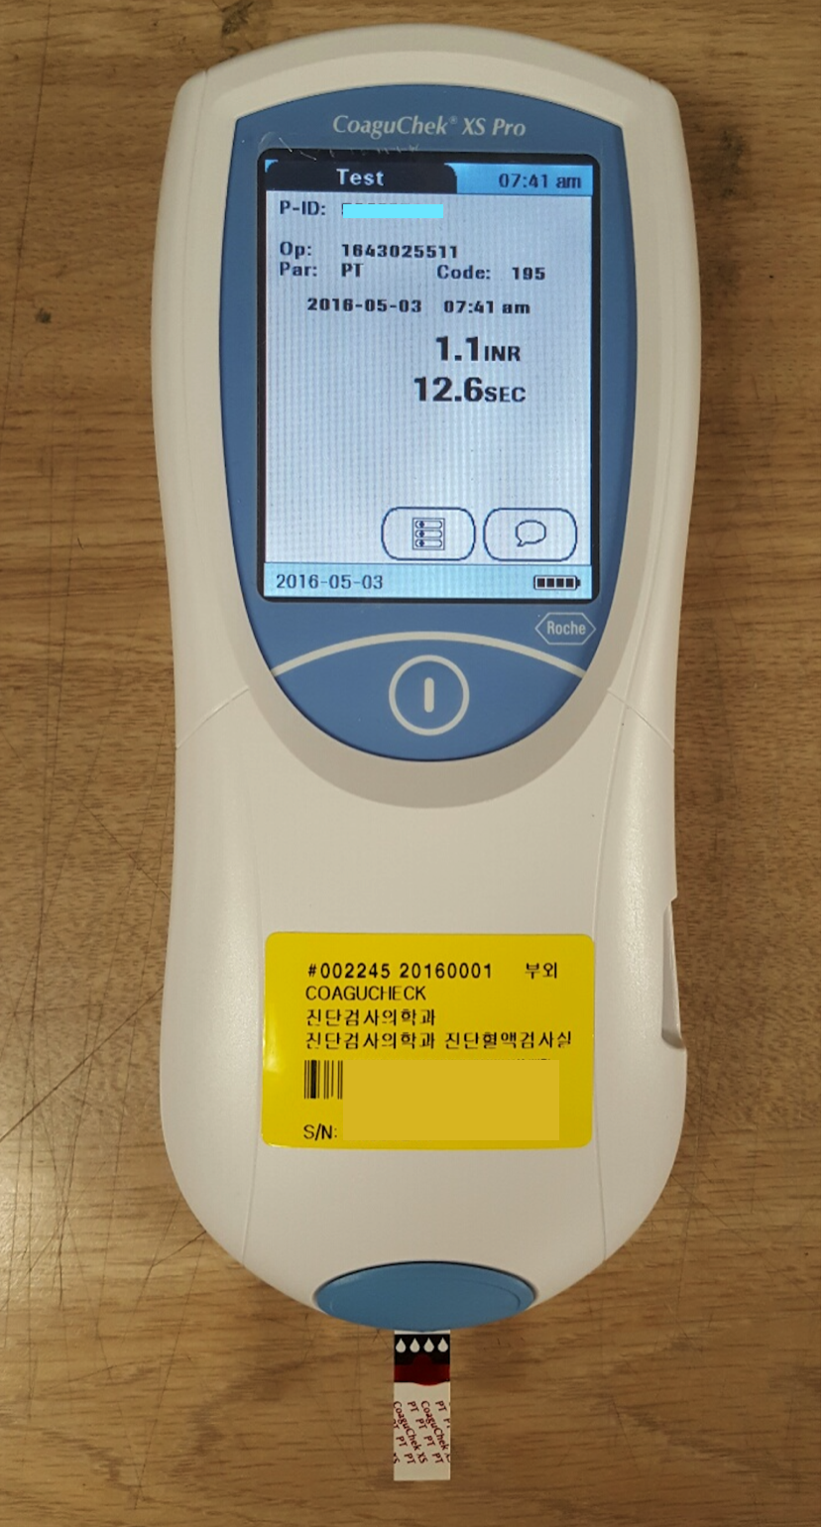
Supplementary Figure 2. Patient selection

